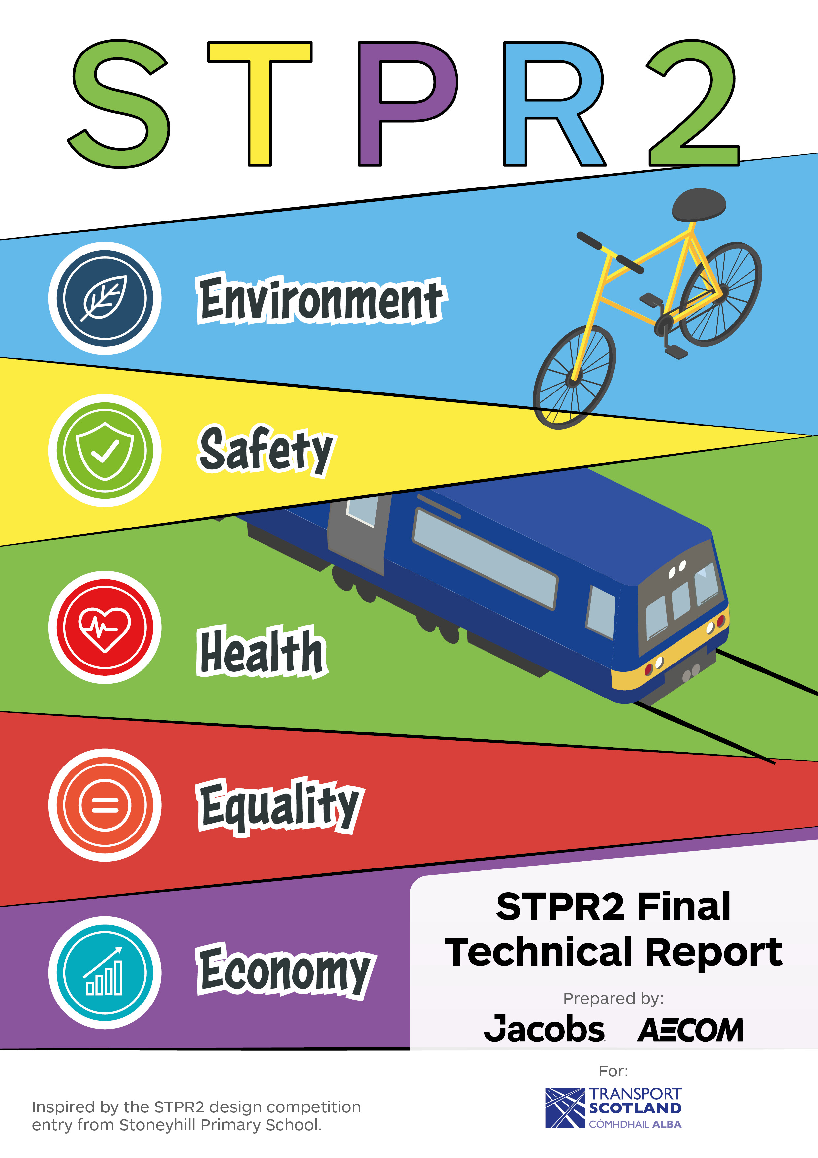

Contents
Executive Summary viii
1. Introduction - 1 -
1.1. Background - 1 -
1.2. Scope of the STPR2 - 1 -
1.3. Phased Delivery - 4 -
1.4. Engagement and Consultation - 5 -
1.5. Supporting Documents - 5 -
1.6. Report Structure - 6 -
2. Policy Context 8
2.1. Introduction 8
2.2. The NTS2 and Delivery Plans 8
2.2.1. Introduction 8
2.2.2. The Vision, Priorities and Outcomes 8
2.2.3. Embedding The NTS2 10
2.2.4. The NTS2 Delivery Plans 11
2.3. Climate Change Considerations 13
2.3.1. Climate Change Plan 13
2.3.2. Route Map to Reduce Car Use 14
2.3.3. Cleaner Air for Scotland 2: Towards A Better Place for Everyone 15
2.4. National Planning Framework 4 16
2.5. Investment Considerations 17
2.5.1. Programme for Government 17
2.5.2. The Bute House Agreement 17
2.5.3. Infrastructure Investment Plan for Scotland 19
2.5.4. Capital Spending Review 20
2.5.5. Scotland’s National Strategy for Economic Transformation 21
2.5.6. Existing Funding Commitments 22
2.5.7. Summary 23
3. The STPR2 Approach 24
3.1. Introduction 24
3.2. Application of the STAG Process 24
3.3. Integration of SEA and Impact Assessments 27
3.4. Stakeholder Engagement 30
3.5. Statutory Consultation 33
4. National Case for Change 35
4.1. Introduction 35
4.2. Challenges for Transport and Infrastructure 35
4.3. COVID-19 Pandemic 37
4.3.1. Current Behaviour As Compared To Pre-Pandemic 37
4.3.2. COVID-19 Concerns 38
4.3.3. Summary in Context for the STPR2 38
4.4. Dealing with Uncertainty 39
5. Establishing Transport Planning Objectives 41
5.1. Overview 41
5.2. Setting Objectives 41
5.3. National and Regional TPOs 42
6. Option Generation and Sifting 45
6.1. Introduction 45
6.2. Defining Strategic Interventions 45
6.3. Approach to Sifting 46
6.3.1. Generate Long List of Options 46
6.3.2. Option Cleaning 47
6.3.3. Option Sifting 47
6.4. Output from Sifting Process 48
7. Appraisal 50
7.1. Approach 50
7.2. Preliminary Appraisal 50
7.2.1. Transport Behaviour Scenarios 51
7.2.2. The STPR2 Objectives 52
7.2.3. STAG Criteria 52
7.2.4. Established Policy Directives 52
7.2.5. Deliverability 53
7.2.6. Progression to Detailed Appraisal 54
7.3. Detailed Appraisal: Packages Appraised 54
7.3.1. Overview 54
7.3.2. Packaging Approach 54
7.3.3. Packages Appraised 57
7.3.4. Appraisal Approach 58
7.3.5. Reporting 59
7.4. Consideration of Climate Change Within The STPR2 60
7.4.1. Strategic Environmental Assessment and Climate Change 60
8. Final Recommendations 62
8.1. Introduction 62
8.2. Improving Active Travel Infrastructure 63
8.2.1. Connected neighbourhoods (1) 64
8.2.2. Active freeways and cycle parking hubs (2) 64
8.2.3. Village-town active travel connections (3) 66
8.2.4. Connecting towns by active travel (4) 66
8.2.5. Long-distance active travel network (5) 67
8.3. Influencing Travel Choices and Behaviour 68
8.3.1. Behavioural change initiatives (6) 69
8.3.2. Changing road user behaviour (7) 70
8.3.3. Increasing active travel to school (8) 71
8.3.4. Improving access to bikes (9) 72
8.3.5. Expansion of 20mph limits and zones (10) 73
8.4. Enhancing Access to Affordable Public Transport 75
8.4.1. Clyde Metro (11) 75
8.4.2. Edinburgh and South East Scotland Mass Transit (12) 78
8.4.3. Aberdeen Rapid Transit (13) 80
8.4.4. Provision of strategic bus priority measures (14) 82
8.4.5. Highland Main Line rail corridor enhancements (15) 84
8.4.6. Perth-Dundee-Aberdeen rail corridor enhancements (16) 84
8.4.7. Edinburgh/Glasgow-Perth/Dundee rail corridor enhancements (17) 85
8.4.8. Supporting integrated journeys at ferry terminals (18) 86
8.4.9. Infrastructure to provide access for all at railway stations (19) 88
8.4.10. Investment in Demand Responsive Transport and Mobility as a Service (20) 89
8.4.11. Improved public transport passenger interchange facilities (21) 90
8.4.12. Framework for the delivery of mobility hubs (22) 91
8.4.13. Smart, integrated public transport ticketing (23) 93
8.5. Decarbonising Transport 94
8.5.1. Ferry vessel renewal and replacement, and progressive decarbonisation (24) 95
8.5.2. Decarbonisation of the rail network (25) 97
8.5.3. Decarbonisation of the bus network (26) 98
8.5.4. Behavioural change and modal shift for freight (27) 99
8.5.5. Zero emission vehicles and infrastructure transition (28) 100
8.6. Increasing Safety and Resilience on the Strategic Transport Network 102
8.6.1. Access to Argyll (A83) (29) 103
8.6.2. Trunk road and motorway safety improvements to progress towards ‘Vision Zero’ (30) 104
8.6.3. Trunk road and motorway climate change adaptation and resilience (31) 105
8.6.4. Trunk road and motorway renewal for reliability, resilience and safety (32) 107
8.6.5. Future Intelligent Transport Systems (33) 109
8.6.6. Traffic Scotland System renewal (34) 110
8.6.7. Intelligent Transport System renewal & replacement (35) 111
8.6.8. Strategy for improving rest and welfare facilities for hauliers (36) 112
8.6.9. Improving active travel on trunk roads through communities (37) 113
8.6.10. Speed Management Plan (38) 114
8.7. Strengthening Strategic Connections 116
8.7.1. Sustainable access to Grangemouth Investment Zone (39) 116
8.7.2. Access to Stranraer and the ports at Cairnryan (40) 117
8.7.3. Potential Sound of Harris, Sound of Barra fixed link and fixed link between Mull and Scottish mainland (41) 119
8.7.4. Investment in port infrastructure to support vessel renewal and replacement, and progressive decarbonisation (42) 120
8.7.5. Major station masterplans (43) 121
8.7.6. Rail freight terminals and facilities (44) 123
8.7.7. High speed and cross-border rail enhancements (45) 124
8.8. Achieving Desired Outcomes 125
8.8.1. Contributing to the Government’s Net Zero Target 127
8.8.2. Affordable and Accessible Public Transport 128
8.8.3. Enhancing Places, and Supporting Health and Wellbeing 129
8.8.4. Contribution Towards Sustainable Inclusive Growth 131
8.8.5. A Reliable and Resilient Strategic Transport System that is Safe and Secure for Users 132
8.9. Regional Packages 134
8.10. Additional Considerations 134
8.10.1. Island Connectivity Plan (ICP) 134
8.10.2. Aviation Strategy 134
8.10.3. Extension of Borders Railway 135
8.10.4. A96 between Aberdeen and Inverness 135
8.10.5. Fair Fares Review 136
8.10.6. Governance Review 136
8.10.7. Funding Considerations 137
8.10.8. Environmental Considerations 137
8.11. Next Steps 138
8.11.1. SEA Post-Adoption Statement 138

- Appendices
A Out of Scope Options
B Revised Draft NPF4 National Developments
C SEA and Impact Assessment Objectives
D Engagement and Consultation Details
E Appraisal Approach and Criterion Descriptions
F STPR2 Approach to Scenario Planning
G Groupings Related to Recommendations and Options Sifted Out
H Detailed Packaging - Appraisal Summary Tables
I Recommendation Appraisal Summary Tables
- Tables
Table 1 – Grouping by Mode 59
- Figures
Figure 1 – The STPR2 Regions - 3 -
Figure 2 – The STPR2 Development Process Summary - 4 -
Figure 3 – The NTS2 Priorities and Outcomes 9
Figure 4 – The NTS2 Priorities and Associated Challenges 10
Figure 5 – Sustainable Travel Hierarchy and Sustainable Investment Hierarchy 10
Figure 6 – Core Themes for Guiding Investment Decisions in Scotland 21
Figure 7 – The STPR2: Appraisal Framework and Linkage to STAG 26
Figure 8 – Relationship Between Impact Assessments, SEA and STAG 28
Figure 9 – Equality Act 2010: Protected Characteristics 29
Figure 10 – Overview of the STPR2 Engagement Process 33
Figure 11 – Factors Considered Within the STPR2 Approach 40
Figure 12 – Linkage Between the STPR2 TPOs and Scottish Government Policy and Associated Strategies 44
Figure 13 – Option Generation and Sifting Overview 46
Figure 14 – Approach to Option Generation and Sifting 48
Figure 15 – Approach to Packaging 55
Figure 16 – Packaging: Key Process Stages 57
Figure 17 – Use of Modelling Tools 59
Figure 18 – Indicative Extent of Clyde Metro 77
Figure 19 – Indicative Extent of Edinburgh and South East Scotland Mass Transit 79
Figure 20 – Network Vision from ‘Aberdeen Rapid Transit – Our Vision’ document (Source: Nestrans) 81
Figure 21 – The STPR2 Contribution of Recommendations to Benefits 126

List of Acronyms
AST Appraisal Summary Table
BSL British Sign Language
CAV Connected and Autonomous Vehicle
CCRA3 Climate Change Risk Assessment 3
CCTV Closed-Circuit Television
CEMP Construction Environmental Management Plan
CHFS Clyde and Hebrides Ferry Services
C-ITS Cooperative Intelligent Transport Systems
COSLA Convention of Scottish Local Authorities
CRWIA Child Rights and Wellbeing Impact Assessment
CSR Capital Spending Review
DMRB Design Manual for Roads and Bridges
DRT Demand Responsive Transport
DfT Department for Transport
EBR Emergency Budget Review
ECML East Coast Main Line
EqIA Equality Impact Assessment
FSDA Fairer Scotland Duty Assessment
FMS Fault Management System
GDP Gross Domestic Product
HGV Heavy Goods Vehicle
HRA Habitat Regulations Appraisal
ICIA Island Communities Impact Assessment
ICP Islands Connectivity Plan
IDM Investment Decision Making
IIP Infrastructure Investment Plan
IMS Incident Management System
ITS Intelligent Transport System
KSI Killed and Seriously Injured
LGV Light Goods Vehicle
MaaS Mobility as a Service
MSP Member of the Scottish Parliament
NaPTAT National Public Transport Accessibility Tool
NIFS Northern Isles Ferry Service
NPF4 National Planning Framework 4
NSET National Strategy for Economic Transformation
NTS2 National Transport Strategy 2
ORR Office of Rail and Road
PIA Personal Injury Accident
RTP Regional Transport Partnership
RTWG Regional Transport Working Group
SAC Special Area of Conservation
SCOTS Society of Chief Officers of Transportation in Scotland
SCSP Smarter Choices, Smarter Places
SEA Strategic Environmental Assessment
SOLACE Society of Local Authority Chief Executives and Senior Managers
SPA Special Protection Area
STAG Scottish Transport Appraisal Guidance
STPR2 Strategic Transport Projects Review 2
TELMoS Transport and Economic Land-use Model of Scotland
TMfS Transport Model for Scotland
TPO Transport Planning Objective
TSNCC Traffic Scotland National Control Centre
TSS Traffic Scotland System
WCML West Coast Main Line
WS2+1 Wide Single 2+1 (A WS2+1 road consists of two lanes of travel in one direction and a single lane in the opposite direction. This provides overtaking opportunities in the two lane direction, whilst overtaking in the single lane direction is prohibited.)

Executive Summary
Introduction
In 2019, Transport Scotland commenced the second Strategic Transport Projects Review (STPR2) to help inform transport investment in Scotland for the next 20 years. The output from the STPR2 will help to deliver the vision, priorities and outcomes for transport set out in the National Transport Strategy (NTS2), aligning with other national plans such as the Climate Change Plan Update, the National Strategy for Economic Transformation (NSET) and the Revised Draft Fourth National Planning Framework (NPF4).
The STPR2 involved conducting an evidence-based review of the performance of Scotland’s strategic transport network across walking, wheeling, cycling, bus, ferry, rail and the trunk road network. The outcomes from the STPR2 will:
- enhance accessibility across Scotland for residents, visitors and businesses;
- create better connectivity with sustainable, smart and cleaner transport options;
- highlight the vital contribution that transport investment can play in enabling and sustaining Scotland’s economic growth.
For the purpose of the STPR2, Scotland has been split into regional groupings: Argyll and Bute, Ayrshire and Arran, Edinburgh and South East Scotland, Forth Valley, Glasgow City Region, Highlands and Islands, North East Scotland, the Scottish Borders, Shetland Islands, South West Scotland and Tay Cities.
The overall approach taken during the STPR2 is presented in Figure i overleaf.

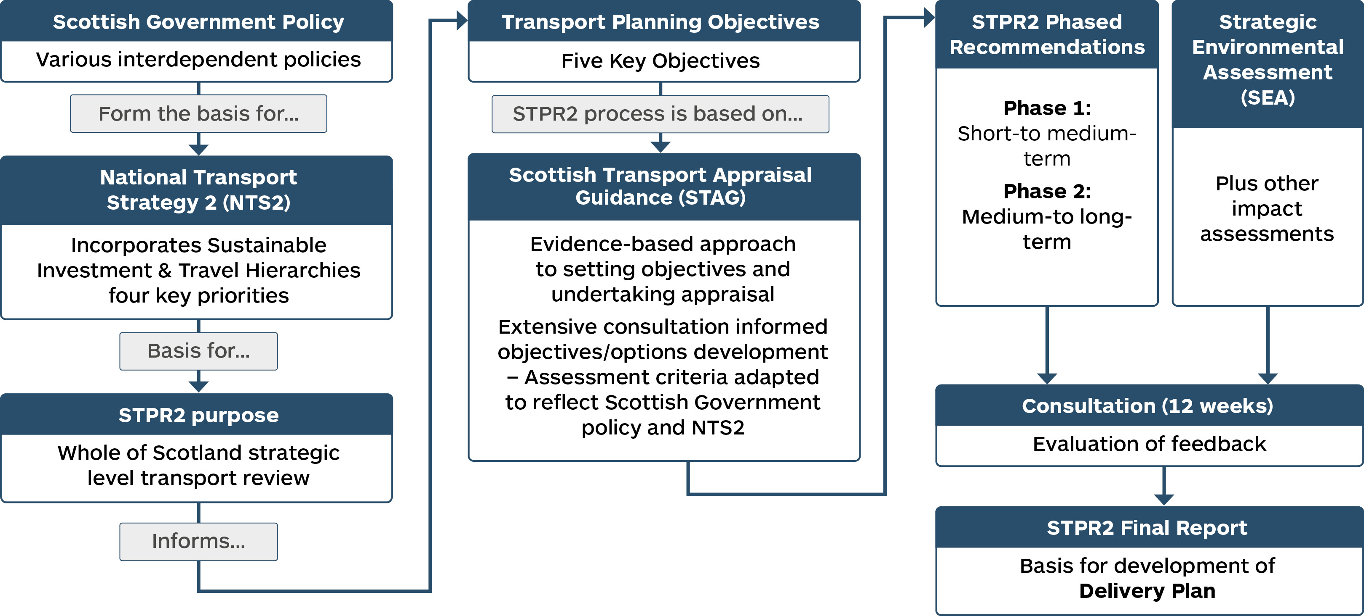
Figure i – The STPR2 Development Process Summary
Setting the Policy Context
Given the cross-cutting nature of transport, there are a number of relevant policy documents which have been considered, to ensure that the aims and objectives of the STPR2 are complementary to these and contribute to their delivery. These are summarised below.
The National Transport Strategy 2 (NTS2) sets the vision for the country’s transport system over the next 20 years. The vision is underpinned by four priorities: Reduces Inequalities, Takes Climate Action, Helps Deliver Inclusive Economic Growth and Improves our Health and Wellbeing, each with three associated outcomes.
The actions to take forward the NTS2 are outlined in the Delivery Plan 2022-23, published in June 2022 (and the previous Delivery Plan published in December 2020). As well as outlining the role of the STPR2, it also highlights other parallel workstreams that will deliver on the vision, priorities and outcomes of the NTS2.
In December 2020, the Scottish Government produced its Update to the Climate Change Plan, which sets out the approach to delivering a green recovery, with a focus on the period up to 2032. The transport-related components of the Plan build upon the NTS2, with a specific commitment to reduce car kilometres by 20 per cent by 2030.
The Scottish Government Route Map, published in January 2022, sets out a suite of policies from across Government that will be implemented to support car-use reduction in order to both address climate change and deliver a healthier, fairer and more prosperous Scotland.
In July 2021, the Scottish Government published Cleaner Air For Scotland 2: Towards A Better Place For Everyone and an associated Delivery Plan, setting out how the Scottish Government will deliver further air quality improvements over the next five years to secure the vision of Scotland having the best air quality in Europe – a quality of air that aims to protect and enhance health, wellbeing and the environment.
In August 2021, the Scottish Government and the Scottish Green Party Parliamentary Group agreed to work together over the next five years to build a green economic recovery from COVID-19, respond to the climate emergency and create a fairer country. This agreement, along with the shared policy programme, referred to as The Bute House Agreement, details collaboration on the climate emergency, economic recovery, child poverty, the natural environment, energy and the constitution.
The NPF4 has been developed alongside the Infrastructure Investment Plan (IIP) and the STPR2 and a Revised Draft document was laid in the Scottish Parliament on 08 November 2022. The NPF4 is a long-term plan for Scotland that sets out where development and infrastructure is needed. The NPF4 looks to 2045 and will guide spatial development, set out national planning policies, designate national developments and highlight regional spatial priorities.
Scotland’s National Strategy for Economic Transformation, published in March 2022, sets out the priorities for Scotland’s economy over the ten-year period to 2032. It articulates a vision to create a wellbeing economy - an economic system within safe environmental limits that serves and prioritises the wellbeing of current and future generations – and contains bold and ambitious actions to deliver prosperity for all Scotland’s people and places.
Current Funding Position
At the time of writing, Scotland is facing a severe economic upheaval, already impacting people, businesses, public services and the third sector. The Scottish Government’s 2022-23 Programme for Government, published in September 2022, sets out the immediate response to the cost crisis, as well as outlining its ambition to create a better future in the longer term. In August 2022, the Scottish Government committed to undertaking an Emergency Budget Review (EBR) to supplement normal budget processes and determine any and all opportunities to direct additional resources to support those most in need, as well as ensuring existing resources are allocated as effectively as possible in light of changing circumstances. The EBR primarily examined the scope for change within the current 2022-23 budget, alongside an assessment of the context that will inform the forthcoming Scottish Budget 2023-24. The process has considered all devolved budgets, including capital investment in infrastructure, and determined where savings can be made. The EBR was published in November 2022 and the Scottish Budget 2023-24 is expected to be published in December 2022.
It should be noted that the interventions contained within the findings and recommendations are not the sole responsibility of Transport Scotland to deliver, indeed many will rely on working together with local authorities, Regional Transport Partnerships (RTPs) and other stakeholders to take forward.
Challenges for Transport and Infrastructure
Transport’s contribution to the climate emergency and net zero targets, means that there is a need to reduce unsustainable travel and deliver modal shift towards walking, wheeling, cycling and public transport. If we continue as we are now, forecasts suggest a 40 per cent increase in vehicular travel by 2037. However, recent work by the Committee on Climate Change set out the need for a 10 per cent reduction in car kilometres with a modal shift from car to walking, cycling and public transport. The Scottish Government has gone further in the recent update to the Climate Change Plan, setting a target of 20 per cent reduction in total car kilometres across Scotland.
To achieve a modal shift of the scale required to address the climate emergency will require significant changes to the complex travel behaviours of users, operators, and the public and private sectors. In accordance with the Sustainable Travel Hierarchy, the STPR2 aims to prioritise interventions that increase the modal share of shorter everyday trips by walking, wheeling and cycling; short- to medium-length trips by public transport and longer trips by rail and low emission vehicles.
Generation and Sifting of Options
An extensive process of generating and sifting options has been undertaken, involving input from stakeholder engagement and from the public through feedback exercises. Initially, around 14,000 options and ideas were collated. These were subsequently reviewed and cleaned to remove duplicates, to create a long list of approximately 2,800 options. Following an extensive sifting process, a further review was undertaken, which resulted in approximately 1,400 standalone options, which were combined (based on similar types of interventions) into 80 Groupings for the purposes of the appraisal process.
Appraisal Approach
The methodology followed Scottish Transport Appraisal Guidance (STAG) and forms the Strategic Case for the recommendations (that is, there is a robust Case for Change). It has been developed to incorporate new and emerging areas of appraisal research, guided by discussions with Transport Scotland, wider Scottish Government and other stakeholders. This has included:
- inclusion of additional components within the approach to Option Sifting;
- inclusion of the Sustainable Investment Hierarchy in the option development and appraisal processes;
- the adoption of Transport Behaviour Scenarios that capture uncertainty rather than a typical fixed Do-Minimum Scenario;
- clearer links to the NTS2, including supporting the net zero carbon emission targets;
- the approach to capturing and appraising factors of Inclusive Growth;
- inclusion of the Place Principle in the development and assessment of options;
- embedding Statutory and Duty Impact Assessments into the appraisal process, ensuring impacts on the environment, island communities and different societal groups are captured;
- the adoption of guidance around valuing the health and economic benefits of active travel;
- improving the presentation and reporting of appraisal outcomes to aid understanding.
A number of appraisal elements have been adopted to strengthen the overall approach, with a particular focus on embedding the Sustainable Investment Hierarchy. The approach taken ensures that interventions emerging from the STPR2 will contribute to delivering the NTS2 outcomes and support wider net zero commitments.
The approach has taken cognisance of updated guidance, as set out within the Scottish Transport Appraisal Guidance – Managers’ Guide published in January 2022. This includes the incorporation of the new criterion of ‘Climate Change’.

Statutory and Duty Impact Assessments
Parallel assessments have been undertaken within the STPR2 as set out
in Figure ii below.
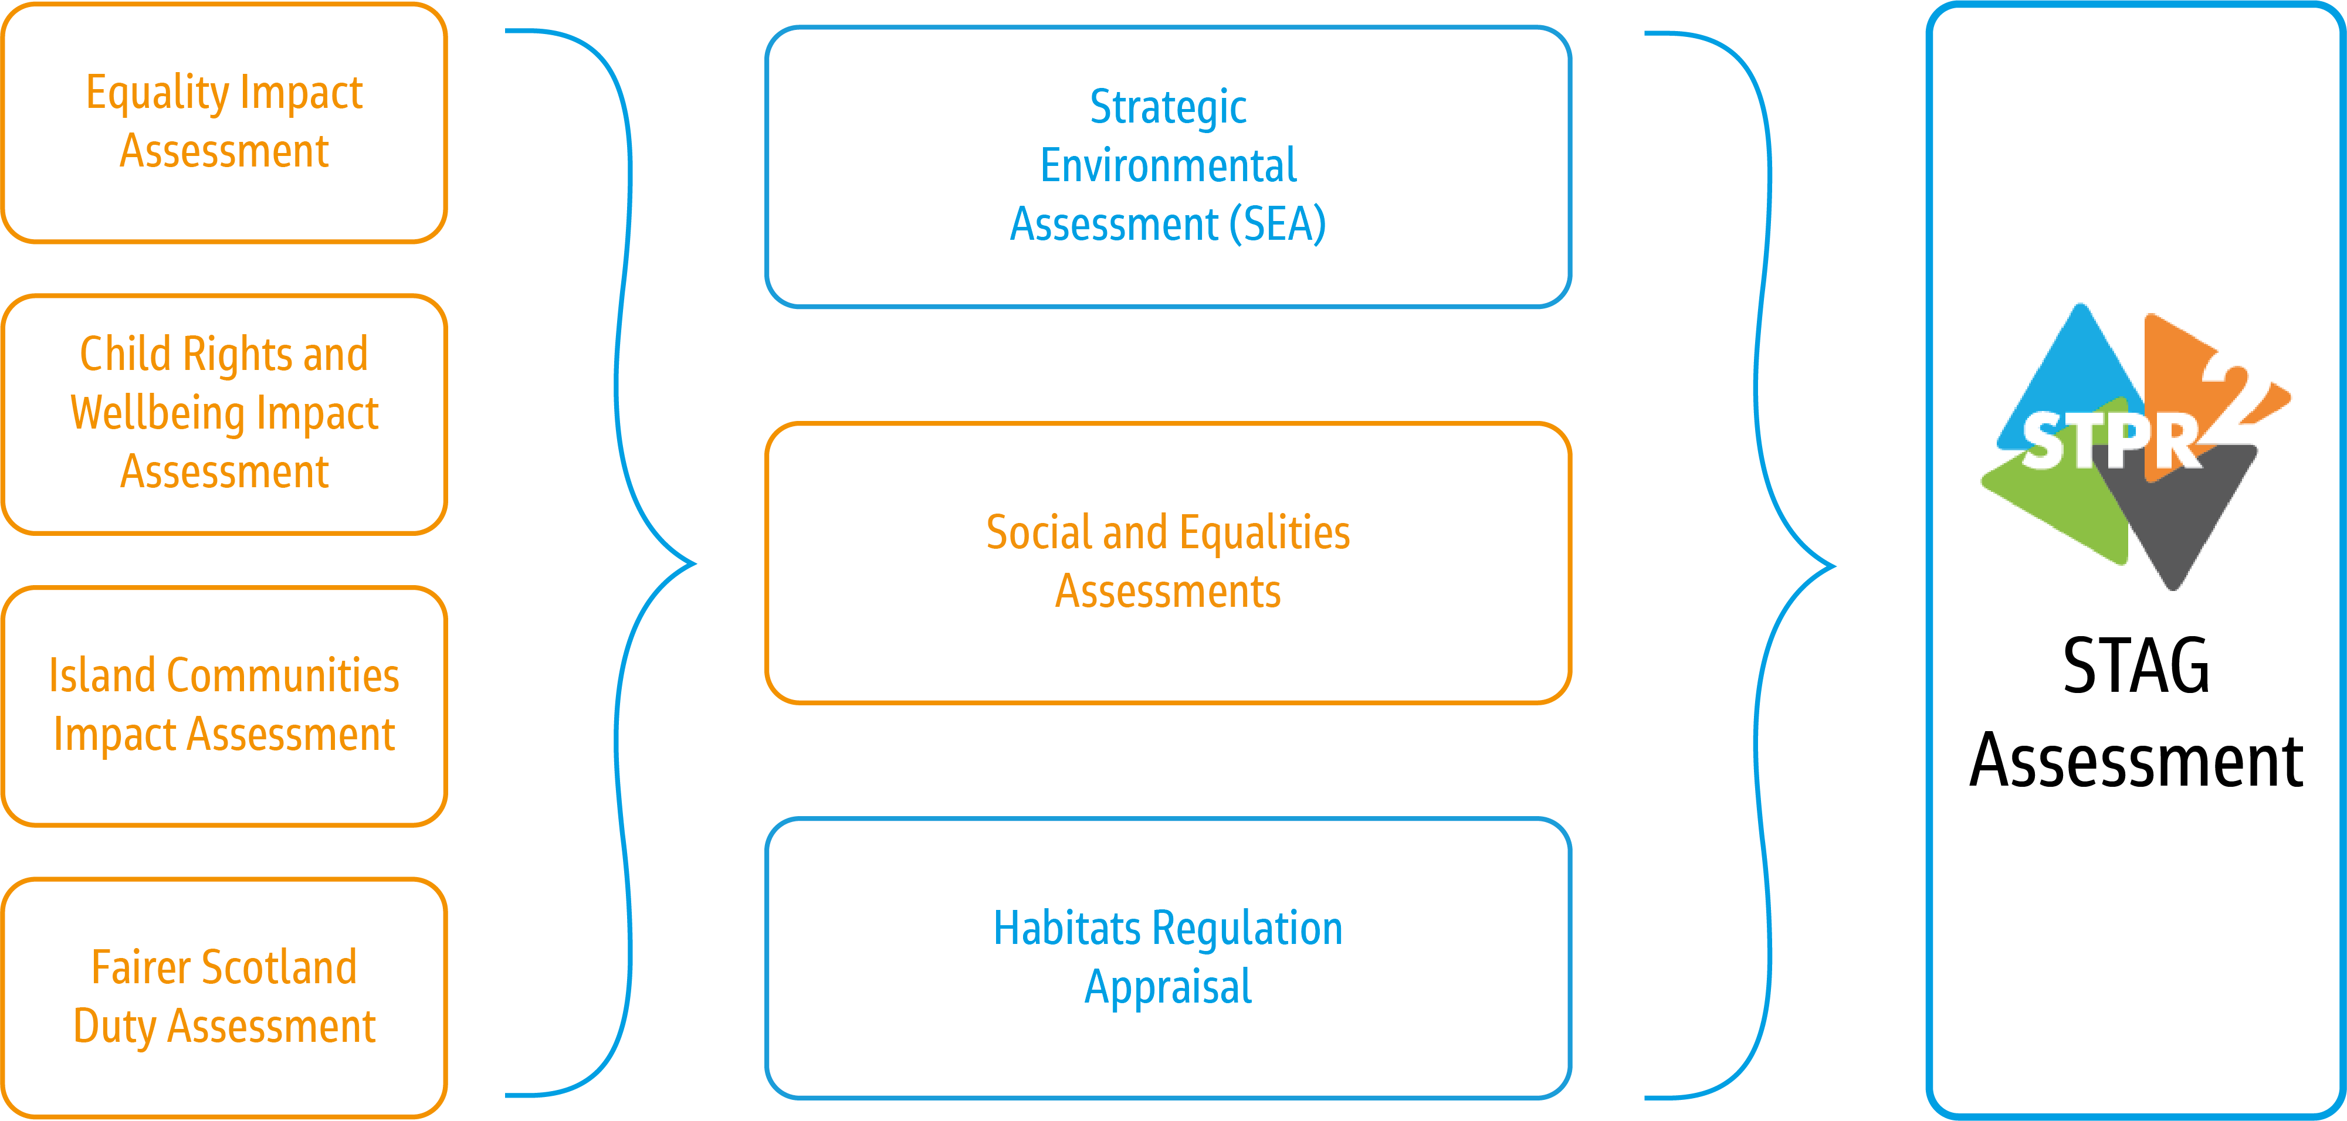
Figure ii – Relationship Between Impact Assessments, SEA and STAG
Final Recommendations
The STPR2 recommendations are grouped under six themes:
- improving active travel infrastructure;
- influencing travel choices and behaviour;
- enhancing access to affordable public transport;
- decarbonising transport;
- increasing safety and resilience on the strategic transport network;
- strengthening strategic connections.
Summaries of each theme and related recommendations are provided within this report. Figure iii, overleaf, provides a snapshot of the benefits related to the recommendations.
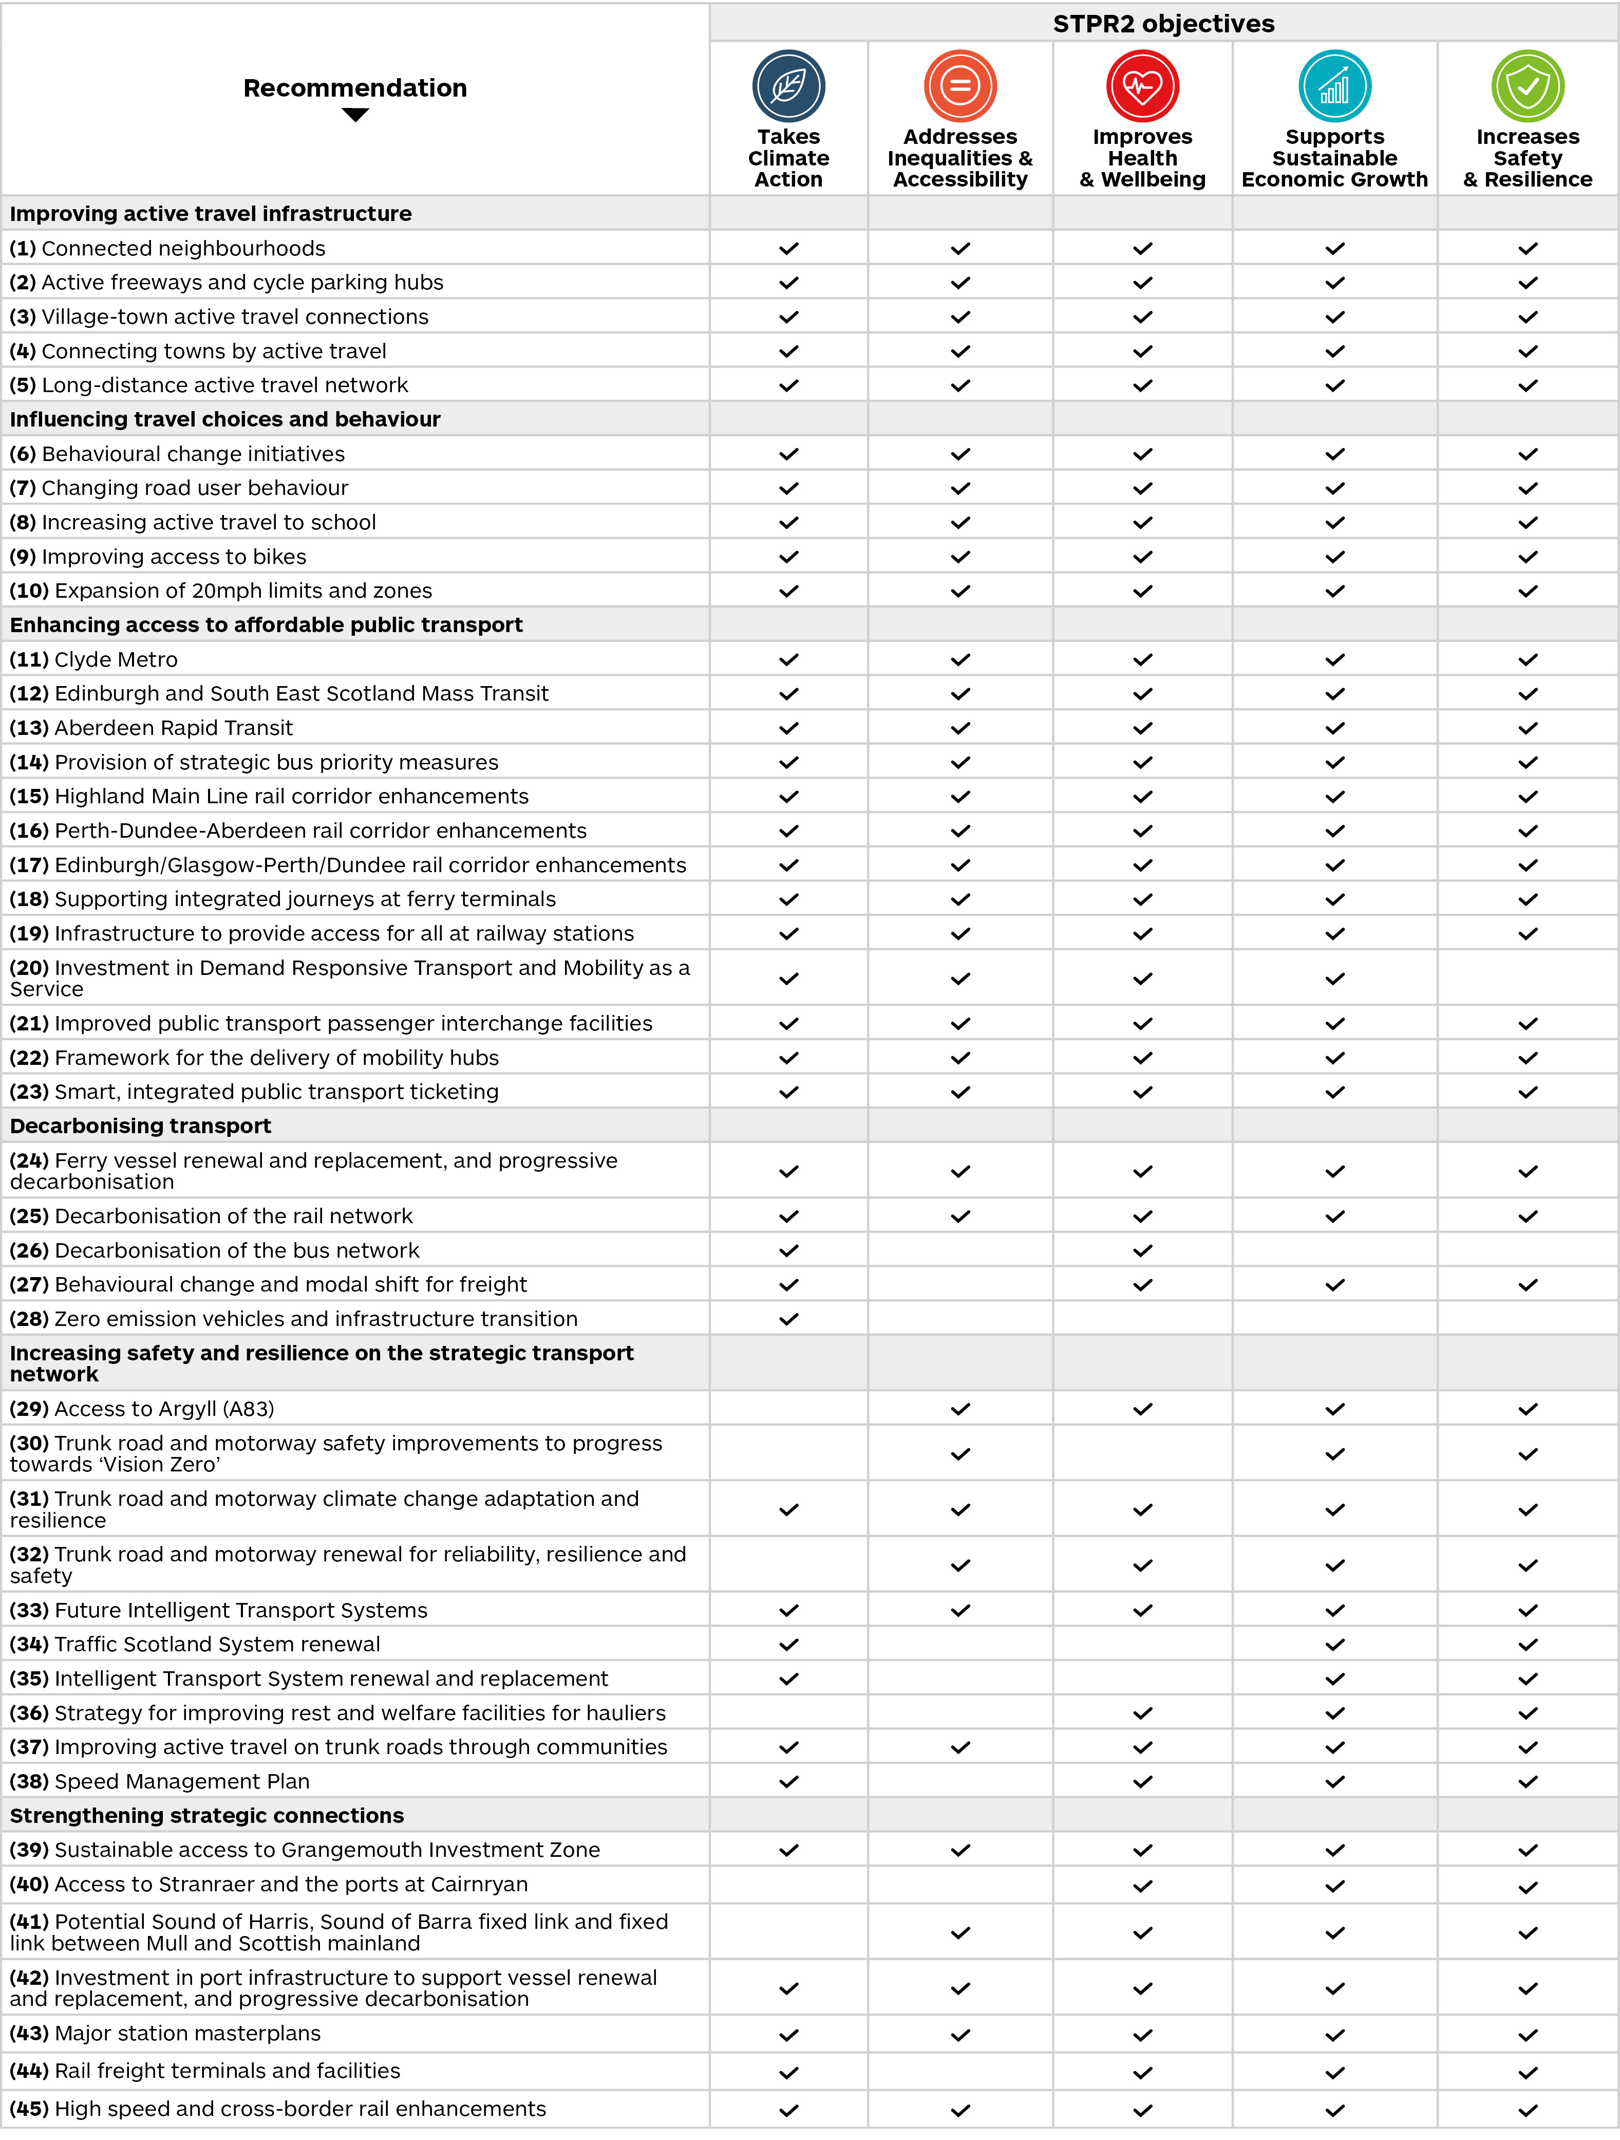
Figure iii – The STPR2 Recommendations and Key Benefits

The STPR2 recommendations do not constitute the full transport investment programme of Scottish Government. They should be considered alongside the overall Government spending commitments on transport outlined in the above documents, within Scottish Government budgets or funded by Government, for example Growth Deals. Some of the other Scottish Government transport spending commitments are out of scope for the STPR2. For example:
- measures to improve resilience of the rail network (for example operations, maintenance and renewal);
- revenue-based spending on public transport including bus, ferries and air services (for example subsides for operations and fares).
It should also be noted that transport interventions not recommended by the STPR2 may still be appropriate to be taken forward at regional and local levels, however any request for funding from the Scottish Government will require demonstration of the benefits and impacts of the transport proposal through the usual business case and transport appraisal process required by Transport Scotland.
Statutory Consultation
A 12-week statutory consultation period ended on 15 April 2022. During this period, feedback was gathered from stakeholders and the public on the recommendations.
A total of 454 responses were received during the statutory consultation period, including from RTPs and local authorities, and a number of other organisations including professional/trade bodies, charity groups/organisations, single-issue campaign groups, Community Councils and other local groups with an interest in transport.
The views of statutory consultees, wider stakeholders and the public on the processes, findings and recommendations have been used to shape this Final Technical Report. In addition, the feedback received has been used to inform and finalise the Strategic Environmental Assessment (SEA) and Impact Assessments. The feedback on the SEA Draft Environmental Report has been responded to in the final version of the Environmental Report. Each consultation response and the SEA response to it is listed in Appendix E of the Environmental Report.

The STPR2 Deliverables
This Technical Report is part of a series of materials including:
- the Summary Report;
- the Strategic Environmental Assessment Environmental Report;
- Equality Impact Assessment Report;
- Island Communities Impact Assessment Report;
- Fairer Scotland Duty Assessment Report;
- Child Rights and Wellbeing Impact Assessment Report;
- Habitats Regulations Appraisal Report;
- Consultation Analysis Report;
- Consultation Summary Report;
- online story maps, which allow users to access information that has informed the recommendations.
A Post-Adoption Statement in relation to the Strategic Environmental Assessment Environmental Report will be published in early-2023.

Introduction

Background
In early-2019, Transport Scotland commenced the second Strategic Transport Projects Review (STPR2) to help inform transport investment in Scotland for the next 20 years. The STPR2 will help to deliver the vision, priorities and outcomes for transport set out in the National Transport Strategy (NTS2), aligning with other national plans such as the Climate Change Plan Update, the second Cleaner Air For Scotland strategy, the National Strategy for Economic Transformation (NSET) and the Revised Draft National Planning Framework 4 (NPF4).
The STPR2 involves conducting an evidence-based review of the performance of Scotland’s strategic transport network across walking, wheeling, cycling, bus, ferry, rail and the trunk road network. The outcomes from the STPR2 will:
- enhance accessibility across Scotland for residents, visitors and businesses;
- create better connectivity with sustainable, smart and cleaner transport options;
- highlight the vital contribution that transport investment can play in enabling and sustaining Scotland’s economic growth.
The review will help inform Scottish Ministers on a programme of potential transport investment opportunities for the period 2022-2042. A number of approaches have been adopted to strengthen the Scottish Transport Appraisal Guidance (STAG)-based appraisal undertaken for the STPR2, with a particular focus on ensuring the identification of sustainable transport interventions that support the NTS2 priority “Takes Climate Action”. The approach taken ensures that interventions emerging from the STPR2 will contribute to delivering the outcomes of the NTS2 and support wider net zero commitments.

Scope of the STPR2
The STPR2 will guide the Scottish Government’s transport investment programme in Scotland for the next 20 years and help to deliver the vision, priorities and outcomes that are set out in the NTS2. The aim of the STPR2 is:
To conduct a Scotland-wide, evidence-based review of the performance of the strategic transport system, against multiple criteria including safety, environment, economy, integration, accessibility and social inclusion and, fundamentally, to support the Scottish Government’s aims, including sustainable inclusive growth and the move to a low carbon transport system.
It is recognised that Scotland’s geography is unique and varied, ranging from rural lowlands to remote uplands, and from large cities to sparsely inhabited islands, meaning no two parts of Scotland are the same, nor are their travel patterns and demands. For that reason, the STPR2 considered both national and regional issues in order to appraise options in the context of place.
The national focus considered the strategic links between the cities and key ports, international gateways and cross-border links, whilst the regional focus considered the role of the strategic network in the context of regional economic geographies and changes emanating from, for example, the Planning Review, Enterprise and Skills Review, and City and Regional Growth Deals. This approach enabled examination of regional issues which would have significant effects on the national strategic network, to deliver national investment priorities.
A total of 11 regions have been established for the STPR2: Argyll and Bute, Ayrshire and Arran, Edinburgh and South East Scotland, Forth Valley, Glasgow City Region, Highlands and Islands, North East Scotland, Scottish Borders, Shetland Islands, South West Scotland and Tay Cities. Within North East Scotland, the Scottish Borders and South West Scotland work was carried out in advance of the STPR2 commission, and collectively these are referred to as the STPR2 Advanced Studies. Further details of the regional structure are set out in the National Case for Change Report and the 11 regions are shown in Figure 1, overleaf.
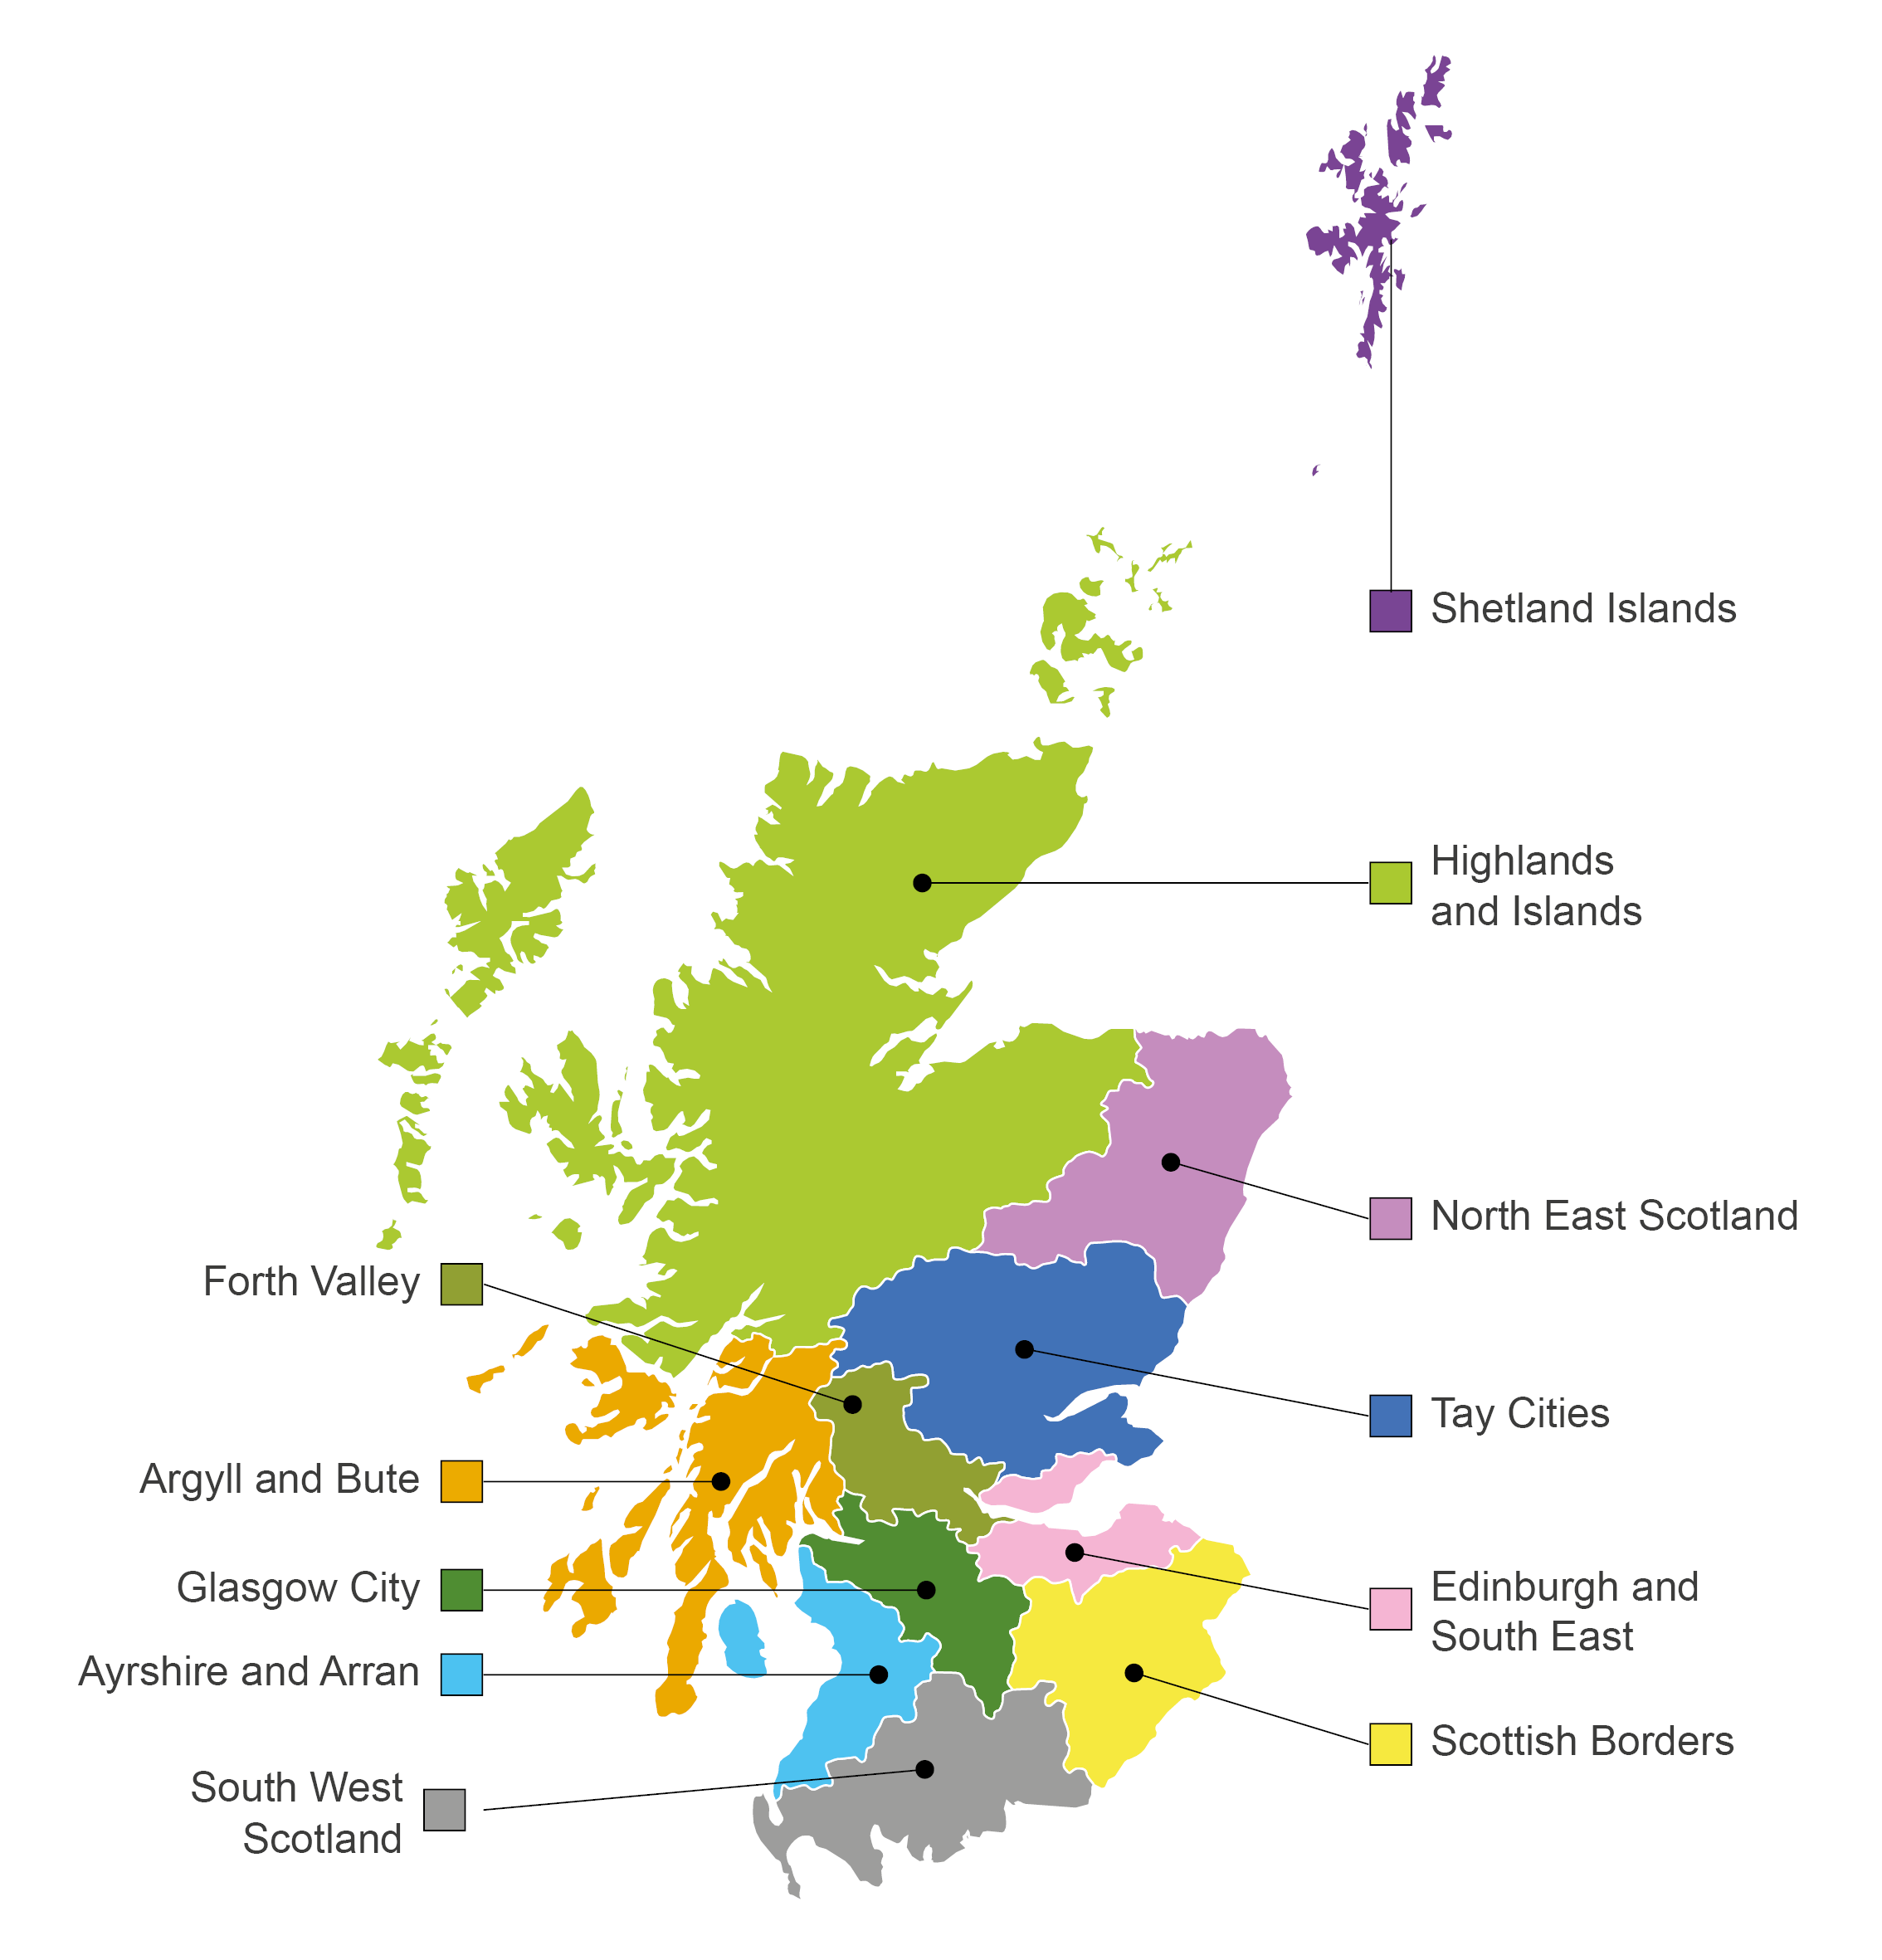
Figure 1 – The STPR2 Regions
The STPR2 specifically focusses on Scotland’s key strategic transport assets. In this context, a strategic transport project is defined as:
- any transport project that plays a significant part in supporting the priorities and related outcomes of the NTS2;
- projects or groups of projects related to transport networks owned, operated and funded directly by Transport Scotland;
- passenger and freight access to major ports and airports;
- the inter-urban bus and active travel networks and principal corridors within urban areas.
Some of the additional transport investments not covered by the STPR2 include routine day to day motorway and trunk road maintenance and committed improvements; rail network operations, maintenance and renewal; and revenue funding for public transport services. A full list of options that are out of scope is included in Appendix A. Figure 2, below, summarises the steps in the STPR2 process and how these align to current Scottish Government policy.
Figure 2 – The STPR2 Development Process Summary
It should be noted that transport interventions not recommended by the STPR2 may still be appropriate to be taken forward at regional and local levels, however any request for funding from the Scottish Government will require demonstration of the benefits and impacts of the transport proposal through the usual business case and transport appraisal process required by Transport Scotland.

Phased Delivery
As a result of the COVID-19 pandemic, the STPR2 adopted a phased approach. The initial Phase 1 focused on measures that support and extend the increase in travel by sustainable travel modes and support economic recovery. This Technical Report combines the previous Phase 1 recommendations with the medium- to longer-term recommendations. This, therefore, provides the full suite of recommendations for transport investment for the next 20 years.
Lasting responses to the COVID-19 pandemic such as increased working from home, do however, create an element of uncertainty with regards to future travel patterns, but also opportunities for increased use of sustainable travel. The review has recognised this uncertainty and has ensured that there is an element of flexibility and agility to allow specific recommendations to be reviewed or amended as travel patterns become clearer.

Engagement and Consultation
Effective collaboration with stakeholders and engagement with the public has been vital to the STPR2 and a considerable programme of activities has been undertaken at a national and regional level throughout the STPR2 process. A comprehensive Engagement Plan was developed during the inception phase to guide engagement and communications, and this is discussed further within Chapter Three.
The publication of the draft STPR2 report, associated documents and draft impact assessments in January 2022, launched a 12-week public consultation period, hosted on the Scottish Government’s consultation platform Citizen Space. The public consultation was publicised through various means including email correspondence to a wide range of organisations and authorities from across Scotland, via the Transport Scotland website and through both press and social media coverage. Organisations and authorities were also requested to publicise the consultation through their own channels.
During the 12-week consultation period, 30 information sessions were undertaken. These sessions were designed to promote the consultation exercise, by providing an overview of the STPR2 and the 45 draft recommendations and setting out further details on how stakeholders could feed into the consultation process. A total of 454 responses were received during the statutory consultation period, including from Regional Transport Partnerships (RTPs) and local authorities. Responses were also received from professional/trade bodies, charity groups/organisations, single-issue campaign groups, Community Councils and other local groups with an interest in transport.
The views of statutory consultees, wider stakeholders and the public on the processes, findings and recommendations have been used to shape this Final Technical Report. Following the statutory consultation process, all feedback received was collated and reviewed.
Further details of the statutory consultation process are provided in Chapter Three.
The feedback on the Strategic Environmental Assessment (SEA) Draft Environmental Report has been responded to in the final version of the Environmental Report. Each consultation response and the SEA response to it, is listed in Appendix E of the Environmental Report.

Supporting Documents
This report draws together all the key findings from the individual tasks and activities that have been undertaken during the review to form a succinct and accurate record of the STPR2 as a whole. It sets out the process undertaken to inform the Scottish Government's future investment plans and spending reviews. Further details of the STPR2 process and Outcomes can be found in the following documents:
- STPR2: National Case for Change Report, Jacobs/AECOM, February 2021;
- STPR2: Regional Case for Change Reports (8. No), Jacobs/AECOM, February 2021;
- STPR2: Update and Phase 1 Recommendations, Jacobs/AECOM, February 2021;
- STPR2: South West Scotland Region Option Sifting Update, Jacobs/AECOM, February 2021;
- STPR2: North East Region Option Sifting Update, Jacobs/AECOM, February 2021;
- STPR2: Borders Region Option Sifting Update, Jacobs/AECOM, February 2021;
- STPR2: Summary Report, Jacobs/AECOM, December 2022;
- STPR2: Summary Report (Easy Read Version), Jacobs/AECOM, December 2022;
- STPR2: Summary Report (Gaelic Version), Jacobs/AECOM, December 2022;
- STPR2: Strategic Environmental Assessment Environmental Report, Jacobs/AECOM, December 2022;
- STPR2 Equality Impact Assessment Report, Jacobs/AECOM, December 2022;
- STPR2 Island Communities Impact Assessment Report, Jacobs/AECOM, December 2022;
- STPR2 Fairer Scotland Duty Assessment Report, Jacobs/AECOM, December 2022;
- STPR2 Child Rights and Wellbeing Impact Assessment Report, Jacobs/AECOM, December 2022;
- STPR2 Habitats Regulations Appraisal Report, Jacobs/AECOM, December 2022;
- STPR2 Consultation Analysis Report, Jacobs/AECOM, December 2022;
- STPR2 Consultation Summary Report, Jacobs/AECOM, December 2022.
A Post-Adoption Statement in relation to the Strategic Environmental Assessment Environmental Report will be published in early-2023.
Web-based Project Pages have also been developed as a reporting tool for the commission, accessible through the STPR2 webpage. The Project Pages provide functionality to enable end-users to navigate and search for areas of interest using filters. The Project Pages include an interactive story mapping feature for the STPR2 which has been created to enable end-users to review the latest information and data which has informed the STPR2 process.

Report Structure
Following this introduction, the remainder of the report is structured as follows:
- Chapter Two sets out the Policy Context for the STPR2 and includes an overview of existing funding commitments;
- Chapter Three sets out the STPR2 study approach and provides an overview of the STAG process, SEA, Impact Assessments, stakeholder engagement, and statutory consultation process;
- Chapter Four provides details of the National Case for Change, including the challenges for transport and infrastructure and dealing with uncertainty;
- Chapter Five provides details of how Transport Planning Objectives (TPOs) have been established, both at a national and regional level;
- Chapter Six sets out the approach to option generation and sifting and the output from this process;
- Chapter Seven explains the approach and outcomes of the appraisal process;
- Chapter Eight sets out the final recommendations and next steps.
The report also includes the following appendices:
- Appendix A – Out of Scope Options;
- Appendix B – Revised Draft NPF4 National Developments;
- Appendix C – SEA and Impact Assessment Objectives;
- Appendix D – Engagement and Consultation Details;
- Appendix E – Appraisal Approach and Criterion Descriptions;
- Appendix F – STPR2 Approach to Scenario Planning;
- Appendix G – Groupings Related to Recommendations;
- Appendix H – Detailed Packaging - Appraisal Summary Tables (ASTs);
- Appendix I – Recommendation ASTs.

Policy Context

Introduction
A number of Government policies, strategies and commitments set the overall context for the STPR2. It is therefore important to highlight the key issues of direct relevance to this review and outline how these have influenced and shaped the STPR2. This includes, but is not limited to, the NTS2 and associated Delivery Plans; Climate Change Plan Update; the second Cleaner Air for Scotland strategy; the NSET; the Revised Draft NPF4; and The Bute House Agreement. This Chapter provides an overview of these policies and strategies. Consideration is also given to existing funding commitments.

The NTS2 and Delivery Plans

Introduction
The NTS2 provides the national transport policy framework, setting out a clear vision of a sustainable, inclusive, safe and accessible transport system which helps deliver a healthier, fairer and more prosperous Scotland for communities, businesses and visitors. It sets out key priorities to support that vision: reducing inequality; taking climate action; helping deliver inclusive economic growth; and improving health and wellbeing.
The NTS2 is set within the context of a climate emergency, with the Scottish Government committed to transitioning our transport system to one that is net zero in carbon emissions by 2045. Set against a backdrop of increasing amounts of travel in Scotland over recent years, particularly vehicular travel, the NTS2 clearly articulates the need for change in transport provision in Scotland. The STPR2 has a key part to play in supporting the delivery of the priorities and outcomes by outlining a range of targeted measures to achieve fundamental change in overall travel demand, a shift to more sustainable modes such as walking, wheeling, cycling and public transport, and in transitioning to a net zero economy.

The Vision, Priorities and Outcomes
The Strategy presents the vision for Scotland’s transport system over the next 20 years, which is: “We will have a sustainable, inclusive, safe and accessible transport system, helping deliver a healthier, fairer and more prosperous Scotland for communities, businesses and visitors.”
The overall vision of the NTS2 is underpinned by four priorities and each priority is expressed through a set of three outcomes which helps to explain the effect the policy is seeking to achieve, as shown in Figure 3.
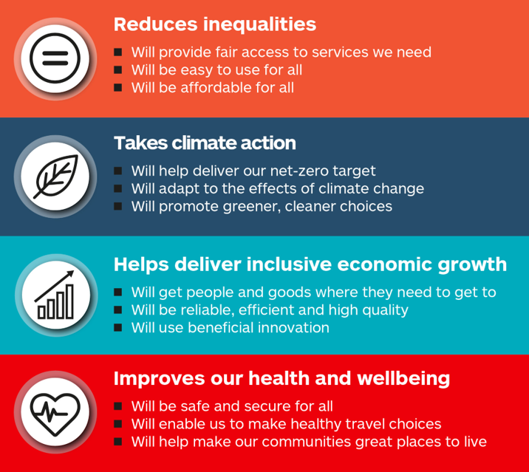
Figure 3 – The NTS2 Priorities and Outcomes
The development of the NTS2 has involved a comprehensive review of the key transport challenges facing Scotland and has included extensive engagement with a network of partners and authorities across the country comprising individuals, businesses and third sector organisations, to gather the views of a wide range of users of the transport system. Through this process, it has been identified that Scotland’s transport system continues to face a number of challenges: many people encounter problems when trying to access the services they need; vehicles continue to emit greenhouse gases and pollute the places residents live and work; businesses still face congestion and delays when reaching their customers; and people still face barriers when wanting to walk, wheel or cycle to their destination.
Figure 4 illustrates how each of the 27 key challenges identified within the NTS2 align with the four key priorities. It demonstrates that the key challenges are interlinked and can be grouped under several, if not all, of the four priority areas set out within the NTS2.
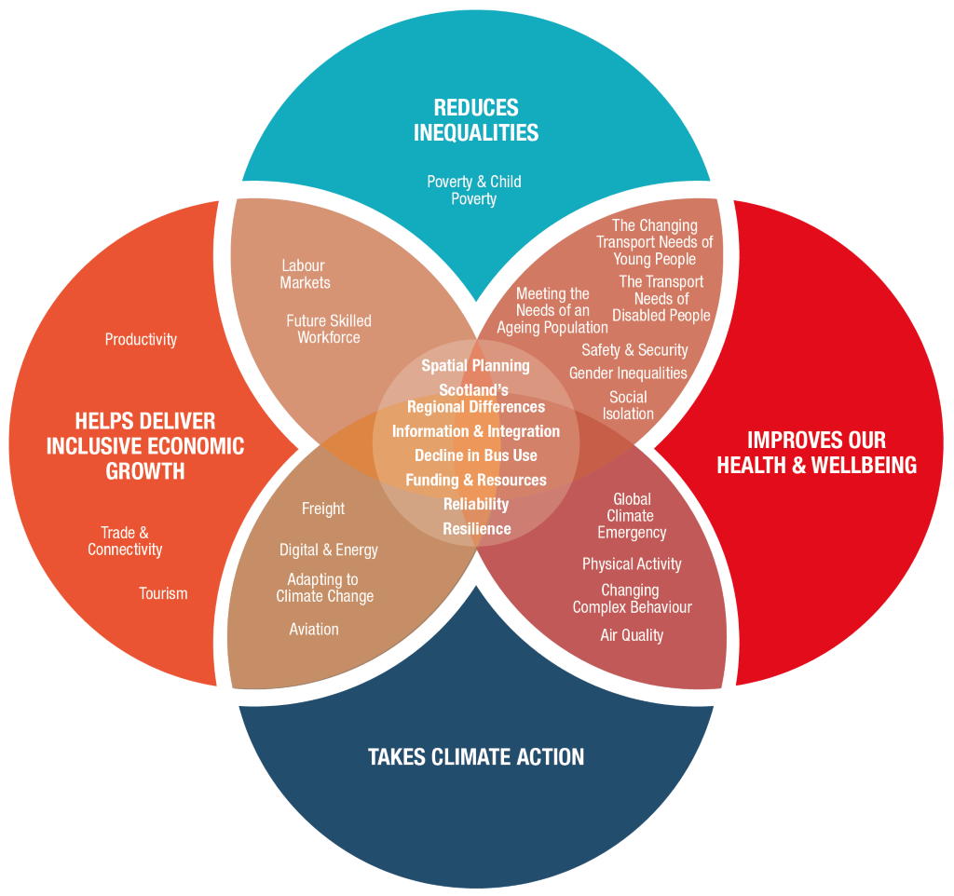
Figure 4 – The NTS2 Priorities and Associated Challenges

Embedding The NTS2
Important context is provided by the Sustainable Travel Hierarchy and Sustainable Investment Hierarchy set out in the NTS2 (see Figure 5) to manage the demand for transport and support the creation of successful places in the future.
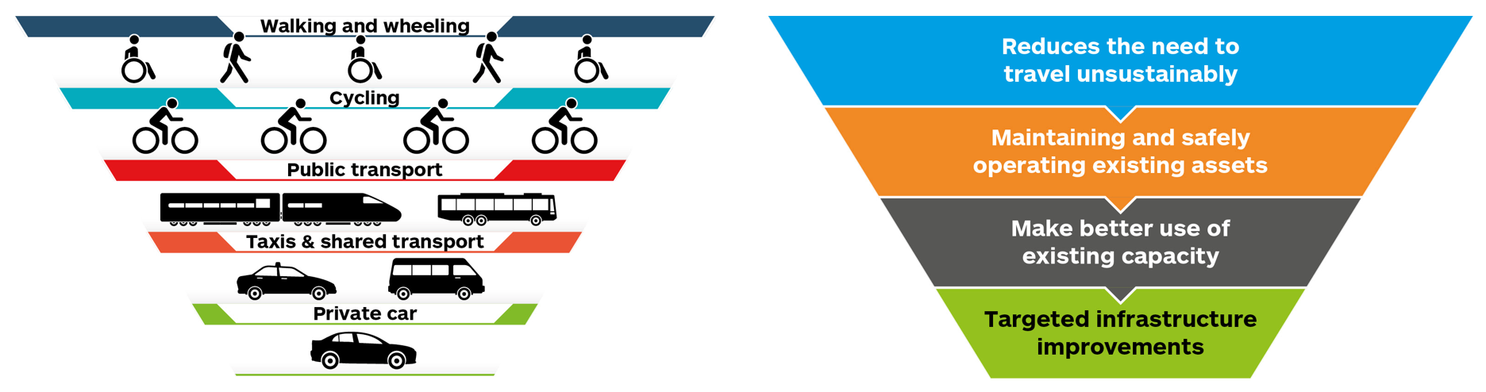
Figure 5 – Sustainable Travel Hierarchy and Sustainable Investment Hierarchy
The NTS2 states that the Sustainable Travel Hierarchy should be embedded in decision-making; promoting walking, wheeling, cycling, public transport and shared transport options, in preference to single occupancy private car use. At a national level the Sustainable Investment Hierarchy should be used to inform investment decisions, considering: investment aimed at reducing the need to travel unsustainably; investment aimed at maintaining and safely operating existing assets taking due consideration of the need to adapt to the impacts of climate change; investment promoting a range of measures, including innovative solutions, to make better use of existing capacity, ensuring that existing transport networks and systems are fully optimised (these may include technology-based, regulatory, fiscal or value engineering solutions to asset renewals); and investment involving targeted infrastructure improvements. In other words, there is an expectation that the STPR2 should not bring forward recommendations for infrastructure improvements without first considering the requirement for, and effectiveness of, interventions in the first three categories.
At the Option Generation and Sifting stage of the STPR2 (discussed further in Chapter Six), the Sustainable Travel Hierarchy has been applied to promote interventions that prioritise walking, wheeling, cycling and public transport-based modes ahead of private car trips. In addition, each option considered within the STPR2 has been assessed in terms of its position within the Sustainable Investment Hierarchy, in order to ensure that budgetary decisions are informed with sustainability in mind, in line with the approach promoted in the NTS2: for example interventions that reduce the need to travel unsustainably are prioritised over targeted infrastructure measures. Consideration has been given to whether each option being assessed is either the only option available to address the identified problems and/or opportunities or is the option that best aligns with the Sustainable Investment Hierarchy.

The NTS2 Delivery Plans
The first Delivery Plan of the NTS2 was published in December 2020. Together with the NTS2, these documents set out the vision and priorities for the transport system covering the next two decades. The second Delivery Plan of the NTS2, covering the period 2022 to 2023, sets out the practical actions which are underway, or due to begin, across Scottish Government, which will deliver the NTS2 vision, and provide a co-ordinated overview to transport investments and projects. At a local level the Regional Transport Strategies and Delivery Plans provide a detailed overview of the regional and local priorities, projects, actions and services, aligned with the NTS2 priorities.
The second Delivery Plan updates on areas around: increasing accountability, including, amongst other initiatives, the NTS2 Delivery Board, which brings together senior transport sector representatives, and reconvening of the Transport Governance and Collaboration Working Group with representation from regional transport partnerships; investing for the future, which recognises the role of the STPR2 to meet the transport challenges and changes over the next 20 years; mission zero and supporting a Just Transition, which focuses on embedding Just Transition principles through policy development and actions to support the move to net zero; and equality objectives, recognising the importance of reducing inequalities and commitments to advancing equality of opportunities across protected characteristics.
When the NTS2 was published in February 2020 it recognised the need for its implementation to be flexible to adapt to emerging and changing evidence. This is particularly relevant in light of the COVID-19 pandemic and Government response, and the impact of this on Scotland’s economy and society. As a result, the NTS2 vision and outcomes remain valid in terms of a long-term strategy setting the framework for decision-making on transport in Scotland. However, given the impacts from the pandemic, it is pertinent to take account of the emerging evidence of the impact of COVID-19 on travel demand and behaviour, and its impact in terms of exacerbating existing inequalities, including around access to, and affordability of, transport, particularly for those already experiencing disadvantage. The first Delivery Plan does this and sets out a series of commitments and actions under each of the four priorities. Whilst many of these elements are relevant to the development of the STPR2, those referencing it specifically include:
- strengthening evidence - continuing to embed the Sustainable Travel Hierarchy and Sustainable Investment Hierarchy in decision-making, STAG and the STPR2;
- the Appraisal Framework and investment decision-making for the STPR2 will have the Sustainable Investment Hierarchy at its heart;
- taking a collaborative engagement approach for the STPR2, working with the ten regional working groups and a range of stakeholders during the various stages of the appraisal process, whilst recognising the critical role of local transport and regional connections to the success of diverse towns and places, supporting thriving town centres, resilient communities and 20-minute neighbourhoods.
The second Delivery Plan sets out the progress made on the STPR2 and recognises that by focusing investment on sustainable transport options for individuals, families, communities and businesses, the STPR2 recommendations will make it easier to access the transport networks and systems that Scotland will need to meet the challenges and changes over the next 20 years.
The NTS2 sets the vision for the country’s transport system over the next 20 years. At the heart of the strategy is the recognition that we need to deliver a step-change in behaviour and provide attractive, affordable and accessible sustainable travel options. This is echoed in the second Delivery Plan for the NTS2 covering the period 2022 to 2023.

Climate Change Considerations
The approach adopted on the STPR2 will ensure that interventions emerging will contribute to delivering the outcomes of the NTS2 and support wider net zero commitments.

Climate Change Plan
The Scottish Government published “Securing a Green Recovery on a Path to Net Zero: Climate Change Plan 2018–2032 – update” in December 2020 which reflects the ambition of the new targets set in the Climate Change (Emissions Reduction Targets) (Scotland) Act 2019. These comprise the reduction of Scotland’s greenhouse gas emissions to net zero by 2045 at the latest, with interim targets of at least:
- 56 per cent by 2020;
- 75 per cent by 2030;
- 90 per cent by 2040.
The transport Chapter of the Plan sets out context around the current situation and how the shift to home working may become a longer-term trend. Coupled with the focus on 20-minute neighbourhoods, the Plan notes the opportunity to capitalise on these to reduce the need to travel, and, when travel occurs, for it to be focused on more sustainable modes.
The Plan includes the following statement in relation to transport: “By 2032 our roads will contain no new petrol and diesel cars and vans; we will have decarbonised our passenger railways; and we will have begun work to decarbonise challenging transport modes such as heavy goods vehicles (HGVs), ferries and aviation. Car kilometres will have reduced by 20 per cent, and sustainable transport will be the instinctive first choice for people.”
This statement is accompanied by a timeline to 2032 that sets out the key milestones in the intervening years.
- 2024 – majority of new buses are zero emissions.
- 2025 – need for any new petrol and diesel light commercial vehicles in public bodies phased out. Delivery of first Active Freeways: segregated active travel routes on main travel corridors.
- 2030 – conditions created to phase out the need for all new petrol and diesel vehicles in Scotland’s public sector fleet. Need for new petrol and diesel cars and vans phased out. Car kilometres reduced by 20 per cent.
- 2032 – Scotland’s passenger rail services considerably decarbonised, with just a few years to go until they are fully decarbonised.

Route Map to Reduce Car Use
In January 2022 the Scottish Government and the Convention of Scottish Local Authorities (COSLA) developed a Route Map to deliver the shift in travel behaviours required to meet the 20 per cent reduction target, recognising the need for ongoing collaboration and partnership working between national, regional and local Government, as well as public, private and third sector partners. The Route Map sets out the suite of policies from across Government that will be implemented to support car-use reduction in order to both address climate change and deliver a healthier, fairer and more prosperous Scotland, and recognises the role of the STPR2 in setting out recommendations for future investment decisions.
Successful implementation of the actions set out in the Route Map are expected to lead to a transformational way of living in Scotland, where a new localism thrives in villages, towns and city neighbourhoods; where streets become places that are safe for people of all ages to travel by walking, wheeling and cycling whilst maintaining private vehicle access for those with disabilities; where longer journeys are made by convenient and affordable public or shared transport; and with greater use of online access to key services and opportunities. This future will both enable statutory climate change targets to be met, whilst at the same time creating better ways of living, improved health and wellbeing and the associated social and economic benefits of a society less dominated by private cars.
Relevance for the STPR2
Transport remains Scotland’s biggest emitting sector (35.6 per cent of emissions) with cars accounting for around 40 per cent of emissions, and therefore significant action is required. It is also acknowledged that technological advances to green vehicles will not be enough and managing demand and behavioural change will be needed. Therefore, the STPR2 will support the development of a programme of interventions to establish conditions that work towards a reduction in car kilometres of 20 per cent by 2030.

Cleaner Air for Scotland 2: Towards A Better Place for Everyone
In July 2021, the Scottish Government published Cleaner Air For Scotland 2: Towards A Better Place For Everyone and an associated Delivery Plan. It sets out how the Scottish Government will deliver further air quality improvements over the next five years. This is considered necessary to secure the vision of Scotland having the best air quality in Europe – a quality of air that aims to protect and enhance health, wellbeing and the environment.
The Delivery Plan is structured around ten priorities, including transport, which reflect the ten high-level themes from the review of Cleaner Air for Scotland completed in 2019. Specifically relating to Transport, the Plan notes “We support a modal shift to active travel and public transport. This will mean, amongst other objectives, providing a transport system that facilitates active travel choices, better public transport provision and constraints upon private vehicle use, especially in urban centres where pollution and congestion are most acute.”
The Delivery Plan makes reference to the Sustainable Investment Hierarchy and the role of the STPR2 in contributing to a reduction in the need to travel unsustainably, making the most of existing transport strategic systems and supporting strategic investments in sustainable, smart and cleaner transport options, in accordance with Just Transition principles.
The STPR2 will align with the Transport priority of the Delivery Plan and will indirectly align with several other priorities, including Integrated Policy, Placemaking and Behavioural Change.
Relevance for the STPR2
The Scottish Government has set ambitious targets for air quality improvements to secure the vision of Scotland having the best air quality in Scotland. Amongst other objectives, it supports a transport system that facilitates active travel choices, better public transport provision and constraints upon private vehicle use, especially in urban centres where pollution and congestion are most acute. The STPR2 will have an important role to play in contributing to a reduction in the need to travel unsustainably, making the most of existing strategic transport systems and supporting strategic investments in sustainable, smart and cleaner transport options.

National Planning Framework 4
The Scottish Government’s Programme for Government highlights the significance of the National Planning Framework to put planning at the heart of delivering green, inclusive and long-term sustainable development in Scotland. The National Planning Framework includes a long-term spatial strategy to 2045. This reflects the range of Scottish Government policies, including the Infrastructure Investment Plan (IIP) 2021-22 to 2025-26. It will guide spatial development, set out national planning policies, designate national developments and highlight regional spatial priorities.
On 08 November 2022, the Revised Draft NPF4 was laid in the Scottish Parliament. Once approved by the Scottish Parliament and adopted by the Scottish Ministers, the NPF4 will become part of the statutory development plan and will directly influence planning decisions. The Revised Draft NPF4 sets out a need to “embrace and deliver radical change to tackle and adapt to climate change, restore biodiversity loss, improve health and wellbeing, build a wellbeing economy and create great places.” The NPF4 recognises the need to plan our places in a way that reduces the need to travel, especially by unsustainable modes, and promotes a shift to active and sustainable travel.
The Revised Draft NPF4 embeds, for the first time, the NTS2 Sustainable Travel Hierarchy and Sustainable Investment Hierarchy into planning decision making and development planning. The Revised Draft NPF4 spatial strategy sets out a local living approach whereby future places, homes and neighbourhoods will be connected, livable, thriving places with sustainable travel options and where car dominance is reduced.
To meet many of the future needs of society it is crucial that services and facilities are easily and affordably accessed. Therefore, the Revised Draft NPF4 advocates the infrastructure-first approach in planning for future development to provide communities with the opportunity to travel sustainably from the outset. The STPR2, and the Islands Connectivity Plan (ICP), represent the national transport investment needed to support the NPF4. In turn some of the Revised Draft NPF4 National Developments respond to the STPR2 recommendations.
The National Developments identified within the Revised Draft NPF4 are set out within Appendix B.
Relevance for the STPR2
The Revised Draft NPF4 sets the context for developing a spatial strategy that is aligned with the Sustainable Travel Hierarchy and Sustainable Investment Hierarchy presented in the NTS2. It recognises that a collaborative approach that aligns interests will play a central role in delivering the spatial strategy and acknowledges the important role of the STPR2 in generating national programmes and projects to deliver improved outcomes for our places. The STPR2, and the ICP, represent the national transport investment needed to support the NPF4. In turn some of the Revised Draft NPF4 National Developments respond to the STPR2 recommendations.

Investment Considerations

Programme for Government
The Scottish Government’s - Programme for Government is published every year at the beginning of September and sets out the actions that the Scottish Government will take in the coming year and beyond. It includes the legislative programme for the next parliamentary year to drive forward change across all levels of society.
Transport features annually in the Programme for Government as it is a devolved matter and reflects the Government’s priorities in terms of policy development and transport investment priorities. Over the last six to seven years, strategic transport investment has been a particular feature of the priorities from transport given the Government’s wider aims around achieving Net Zero. The STPR2 has featured heavily within recurring Programme for Government documents including in the recent 2021-22 document. The “Cost of Living Crisis” that has emerged throughout 2022 and the Scottish Government response to this has seen a significantly shortened and more focussed Programme for Government for 2022-23. Whilst transport has featured in this most recent Programme for Government the focus has been on measures to support those using the transport network to get to work, travelling on business, shopping and going to education against the rising costs of travel. Therefore it should be noted that there are references within this report to different Programme for Government documents and this reflects the important links to other transport policy and strategy developments that have happened over the last few years.

The Bute House Agreement
In August 2021, the Scottish Government and the Scottish Green Party Parliamentary Group agreed to work together over the next five years to build a green economic recovery from COVID-19, respond to the climate emergency and create a fairer country. A shared policy programme, known as The Bute House Agreement, details collaboration on the climate emergency, economic recovery, child poverty, the natural environment, energy and the constitution. It is recognised that bold action is needed to increase the pace of change and the scale of investment to support the priorities and outcomes set out in the NTS2, including ambitious climate goals.
In terms of transport, it is agreed that in the face of the climate emergency there is a need to shift away from investing in new road projects that encourage more people to drive, and instead focus spending and effort on maintaining roads, improving safety and providing a realistic and affordable alternative through investing in public transport and active travel.
The Agreement sets out a number of commitments which will complement the STPR2, including to:
- align transport policy with climate targets and the goal of reducing car kilometres by 20 per cent by 2030;
- increase the proportion of Transport Scotland’s budget spent on active travel initiatives so that by 2024-25 at least £320 million or 10 per cent of the total transport budget will be allocated to active travel;
- during this parliamentary session, invest over £5 billion in maintaining, improving and decarbonising Scotland’s rail network;
- commission a Fair Fares Review to ensure a sustainable and integrated approach to public transport fares. This will look at the range of discounts and concessionary schemes which are available on all modes including bus, rail and ferry. The review will consider options against a background where the costs of car travel are declining and public transport costs are increasing, exacerbating the impact on those living in poverty;
- progress the ongoing review of transport governance in Scotland to ensure it is fully aligned with the climate and traffic reduction targets, and to ensure that the national and local capacity is in place to deliver active travel goals.
It is also agreed that new roads projects will normally only be taken forward where they reduce the maintenance backlog; address road safety concerns; adapt the network to deal with the impacts of climate change; or benefit communities such as bypassing settlements. Furthermore, it is agreed that road infrastructure will not be built to cater for forecast unconstrained increases in traffic volumes.
The shared policy programme acknowledges the role of the STPR2 to direct future transport infrastructure investment.

Relevance for the STPR2
The shared draft policy programme acknowledges the role of the STPR2 to direct future transport infrastructure investment. It is agreed that in the face of the climate emergency there is a need to shift away from new road projects that encourage more people to drive, and instead focus money and effort on maintaining roads, improving safety and providing a realistic and affordable alternative through investing in public transport and active travel.
The Agreement sets out a number of commitments which will complement the STPR2, including to reduce car kilometres by 20 per cent by 2030; increase the proportion of Transport Scotland’s budget spent on active travel initiatives; invest in the maintenance, improvement and decarbonisation of Scotland’s rail network; commission a Fair Fares Review; and progress the ongoing review of transport governance in Scotland.
New roads projects will normally only be taken forward where they reduce the maintenance backlog; address road safety concerns; adapt the network to deal with the impacts of climate change; or benefit communities such as bypassing settlements. Furthermore, it is agreed that road infrastructure will not be built to cater for forecast unconstrained increases in traffic volumes.

Infrastructure Investment Plan for Scotland
The Infrastructure Investment Plan 2021-22 to 2025-26, published on 4 February 2021, focuses on three core strategic themes for guiding investment decisions in Scotland:
- enabling the transition to net zero emissions and environmental sustainability;
- driving inclusive economic growth;
- building resilient and sustainable places.
The IIP also introduces the Common Investment Hierarchy, which is aligned to Transport Scotland’s Sustainable Investment Hierarchy. This thereby provides overall alignment between the outcomes of the STPR2 and the Scottish Government’s investment priorities.
The investment in infrastructure is targeted to maximise wider economic benefits and the delivery of the National Outcomes. The investment is often made by the Scottish Government or in partnership with Local Government. Where possible, however, the Scottish Government looks to create opportunities and the right conditions to leverage additional private sector investment across Scotland.
Relevance for the STPR2
The IIP provides additional detail on expenditure in the next few years to support the commitments made within the Programme for Government and sets the context of future investment in transport to deliver an effective response to the COVID-19 pandemic. The themes have a good strategic fit with the STPR2 objectives. The IIP recognises the need to invest in the areas of the transport sector being considered through the STPR2, including both an effective response to COVID-19 and the key longer-term trends of climate change, technological developments and demographic changes.

Capital Spending Review
In February 2021, the Scottish Government published a five-year Capital Spending Review (CSR) alongside the IIP, with the aim of providing a strong and coherent framework for directing future commitments and giving confidence and certainty to sectors across Scotland.
Since publication, there have been changes in three key factors which have a bearing on the Scottish Government’s infrastructure investment pipeline of projects and programmes – including changes in funding allocations, market conditions and fresh commitments outlined in the 2021 Programme for Government and the Bute House Agreement. Consequently, a Targeted Review of the CSR was published in May 2022. The three core strategic themes for guiding investment decisions in Scotland, as set out within both the IIP and the CSR, are displayed within Figure 6.
The Targeted Review of the CSR, alongside the IIP, demonstrates how the Scottish Government will deliver the National Infrastructure Mission commitment to boost economic growth by increasing annual investment in infrastructure by one per cent of 2017 Scottish Gross Domestic Product (GDP) by 2025-26. The economic rationale for the National Infrastructure Mission is founded on the important role that infrastructure investment plays in improving the productive capacity of the economy and delivering long-term economic benefits.
At the time of writing, Scotland is facing a severe economic upheaval, already impacting people, businesses, public services and the third sector. The Scottish Government’s 2022 -23 Programme for Government, published in September 2022, sets out the immediate response to the cost crisis, as well as outlining its ambition to create a better future in the longer-term. In August 2022, the Scottish Government committed to undertaking an Emergency Budget Review (EBR) to supplement normal budget processes and determine any and all opportunities to direct additional resources to support those most in need, as well as ensuring existing resources are allocated as effectively as possible in light of changing circumstances. The EBR primarily examined the scope for change within the current 2022-23 budget, alongside an assessment of the context that will inform the forthcoming Scottish Budget 2023-24. The process has considered all devolved budgets, including capital investment in infrastructure, and determined where savings can be made. The EBR was published in November 2022 and the Scottish Budget 2023-24 is expected to be published in December 2022.
Figure 6 – Core Themes for Guiding Investment Decisions in Scotland
Relevance for the STPR2
The challenges outlined in the Capital Spending Review Update, published in May 2022, and the EBR, published in November 2022, have a bearing on the investment pipeline of projects and programmes which form part of the STPR2 considerations.

Scotland’s National Strategy for Economic Transformation
Scotland’s National Strategy for Economic Transformation, published in March 2022, sets out the priorities for Scotland’s economy over the ten-year period to 2032. It articulates a vision to create a wellbeing economy: an economic system within safe environmental limits that serves and prioritises the wellbeing of current and future generations. The Strategy’s programmes have been chosen based on evidence and engagement to deliver fairer, greener prosperity for all Scotland’s people and places, and to make our economy more sustainable and resilient in the long-term. The programmes focus on: stimulating entrepreneurship; opening new markets; increasing productivity; developing the skills we need for the decade ahead; and ensuring fairer and more equal economic opportunities. The Strategy aims to maximise Scotland’s strengths and natural assets to deliver economic growth that significantly outperforms the last decade, both in terms of economic performance and tackling structural economic inequalities, so that the Scottish economy is more prosperous, more productive and more internationally competitive.
The Strategy offers renewed clarity of vision and focus on delivery, and a robust governance structure, co-led by business, to oversee its successful implementation. On 31 October 2022, prioritised and affordable delivery plans for each of the Strategy’s programmes were published, and the Scottish Government is working in partnership across the public, private and third sectors, as well as with individuals and communities, in a “Team Scotland” approach to deliver these plans.
The Strategy commits to delivering the STPR2 to help make Scotland more accessible for residents, visitors, and businesses; create better connectivity with sustainable, smart and cleaner transport options; and highlight the vital contribution that transport investment can play in enabling and sustaining Scotland’s economic growth.
The STPR2 is a key project within the NSET Programme 3, “Productive Businesses and Regions”. STRP2 is wired fully into the governance arrangements for the NSET and this particular Programme, to reflect not only the importance of the transport agenda itself, but also the fact that transport is a crucial facilitator of economic growth.
Relevance for the STPR2
The NSET aims to deliver a more prosperous, more productive and more internationally competitive Scottish economy and recognises the role of the STPR2 in delivering inclusive economic growth.

Existing Funding Commitments
The STPR2 recommendations set out within this report do not constitute the full investment programme of Transport Scotland. They should be considered with the overall Government spending commitments on transport outlined in the above documents and Scottish Government budgets. Some of the other Scottish Government transport spending commitments are out of scope for the STPR2 (see Appendix A). For example:
Measures to improve resilience of the rail network – Transport Scotland is committed to measures to improve the resilience of the rail network. In Control Period 6 (2019 to 2024), it will invest circa £3.8 billion in the operation, maintenance and sustainable renewal of a high performing rail network for passengers and freight. The investment of this funding is prescribed by the Office of Rail and Road (ORR) and therefore it is outwith the scope of the STPR2 to make recommendations on this investment. However, evidence gathered throughout the course of the Review, and in setting the themes for the STPR2, has demonstrated the importance of this investment.
Investment in public transport subsidies – Transport Scotland invests in public transport services through various forms of subsidy and states in the Delivery Plans for the NTS2 that it will continue to consider additional support required for public transport and keep this under review in light of the uncertainty and other challenges presented by COVID-19. Support of circa £1 billion has been provided to support public transport operators during the pandemic to ensure that services remained in place for those who depend on them.

Summary
The current policy, plan and investment landscape is complex and multi-layered. There is an overarching and urgent imperative to address climate change and to achieve net zero carbon emissions by 2045. A number of approaches have been adopted to strengthen the STAG-based appraisal undertaken for the STPR2, with a particular focus on ensuring the identification of sustainable transport interventions that support the Revised Draft NPF4, priorities of the NTS2, including the priority “Takes Climate Action’, and to achieve the 20 per cent reduction in car kilometres supportive of the Climate Change Plan. Alongside this are the needs to improve our health and wellbeing. There is also a clear need to deliver inclusive economic growth and to reduce inequalities. The STPR2 process has taken cognisance of the constraints to funding and presents an ambitious, but realistic, set of recommendations which will set the strategic direction of transport investment in the next 20 years.
The following Chapter will set out the STPR2 approach.

The STPR2 Approach

Introduction
This Section provides a summary of the STPR2 approach. It sets out how STAG has been used to conduct a whole-Scotland, evidence-based review of the performance of the strategic transport network across all transport modes to identify problems and opportunities; set objectives; generate, sift and package options; and undertake the preliminary and detailed appraisals to identify recommended options. Due cognisance has been given to new and emerging areas of appraisal research and the STAG updates published in January 2022. An overview of the approach taken to integrating the SEA and Impact Assessments is also provided.
The STAG process is firmly founded on participation and consultation. Accordingly, stakeholder participation and engagement has been pivotal to informing the STPR2 at all key stages. A comprehensive stakeholder engagement plan was developed at an early stage in the STPR2 process and has been carefully devised to ensure general inclusivity and representation of key sectors. Further details regarding the approach to stakeholder engagement and statutory consultation are set out in Section 3.4 and Section 3.5, below.

Application of the STAG Process
As noted above, the STPR2 process has been developed to be consistent with STAG. STAG is Transport Scotland’s formal option appraisal toolkit and methodology to guide the development and assessment of transport options in Scotland and is compliant with the UK Government’s Green Book. It provides an evidence-based and objective-led framework for identifying transport problems and/or opportunities in a study area; setting objectives to address the transport problems/opportunities; and identifying and appraising options in a consistent manner with the potential to meet the objectives. STAG is integral to the investment decision-making process at the Strategic Business Case stage. The four stages of STAG are: Initial Appraisal Case for Change (formerly Pre-Appraisal), Preliminary Options Appraisal (formerly Part 1), Detailed Options Appraisal (formerly Part 2) and Post-Appraisal (Monitoring and Evaluation).
Whilst consistent with the version of STAG at the commencement of the STPR2 (the 2008 version incorporating periodic updates to the STAG Technical Database, the last of which was dated January 2018), the STPR2 approach, where appropriate, has sought to supplement the appraisal process by:
- reflecting Transport Scotland’s current policy position by embedding the vision, priorities and outcomes of the new NTS2;
- taking on board new and emerging areas of appraisal research, including research into inclusive growth and valuing the health benefits of schemes which increase active travel;
- ensuring the outcomes from the wider suite of Impact Assessments being undertaken are fully integrated into the STPR2 appraisal process.
Figure 7, overleaf, presents an overview of the STPR2 Appraisal Framework, reinforcing that the appraisal has been undertaken using STAG, albeit a number of areas are highlighted where this tried and tested methodology have been strengthened and supported by the adoption of updated tools and appraisal criteria, as well as improved forms of reporting.

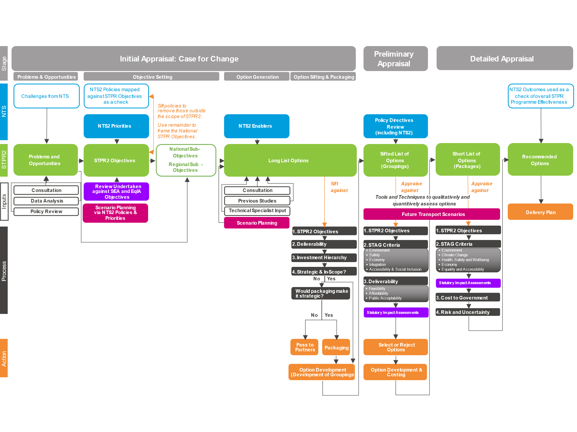
Figure 7 – The STPR2: Appraisal Framework and Linkage to STAG

As shown in Figure 7, the methodology follows STAG but has been developed to incorporate new and emerging areas of appraisal research, guided by discussions with Transport Scotland, wider Scottish Government, and other stakeholders. This includes research and discussions around:
- a more robust approach to Option Sifting;
- inclusion of the Sustainable Investment Hierarchy in the option development and appraisal processes;
- the adoption of Transport Behaviour Scenarios that capture uncertainty rather than a typical fixed Do-Minimum Scenario;
- clearer links to the NTS2, including supporting the net zero carbon emission targets;
- the approach to capturing and appraising factors of Inclusive Growth;
- inclusion of the Place Principle in the development and assessment of options;
- embedding Statutory and Duty Impact Assessments into the appraisal process, ensuring impacts on the environment, island communities and different societal groups are captured;
- the adoption of guidance around valuing the health and economic benefits of active travel;
- improving the presentation and reporting of appraisal outcomes.
The above approach aligns with the latest STAG updates designed to address the key challenges identified since the last substantial update to STAG in 2008. A specific example is the use of the new revised criteria in the detailed appraisal. See Chapter Seven for further details.

Integration of SEA and Impact Assessments
Parallel to the STAG process, an SEA, Habitat Regulations Appraisal (HRA) and Impact Assessments have been undertaken. Further details can be found within the STPR2 SEA Environmental Report, the STPR2 Impact Assessment Non-Technical Summary, the STPR2 Equality Impact Assessment Report, the STPR2 Island Communities Impact Assessment Report, the STPR2 Fairer Scotland Duty Assessment Report, the STPR2 Child Rights and Wellbeing Impact Assessment Report and the STPR2 Habitat Regulations Appraisal Report. Figure 8 shows the relationship between the SEA, Impact Assessments and STAG assessment. These assessments have been undertaken to further inform the STAG process for the STPR2 and to ensure that the impact of the STPR2 transport interventions on the environment is minimised; opportunities for environmental enhancement are identified for implementation; and options have a positive impact on different groups in society, including groups with protected characteristics, as defined by the 2010 Equality Act (see Figure 9), children and young people, island communities and those experiencing inequalities as a result of socio-economic disadvantage.
Figure 8 – Relationship Between Impact Assessments, SEA and STAG
It should be noted that the Equalities Impact Assessment (EqIA) is just one of the Duty Impact Assessments and that the 'EqIA' has been used as an umbrella term for the various equalities-based assessments. Details of the parallel assessments that have been undertaken on the STPR2 are set out below.
- SEA - an SEA is required under European Union Directive 2001/42/EC and a key objective of the SEA process is to afford a high level of protection to the environment and to ensure environmental considerations feature in the decision-making process.
- EqIA - identifies and assesses any likely disproportionate or differential effects on people with characteristics protected by the Equality Act 2010. This includes sex, age, disability, race, religion/belief, gender reassignment, sexual orientation, pregnancy and maternity, and marriage and civil partnership.
- The Fairer Scotland Duty Assessment (FSDA) - identifies and assesses how to reduce inequalities of outcome caused by socio-economic disadvantage when making strategic decisions. In broad terms, ‘socio-economic disadvantage’ means living on a low income compared to others in Scotland, with little or no accumulated wealth, leading to greater material deprivation, restricting the ability to access basic goods and services.
- Child Rights and Wellbeing Impact Assessment (CRWIA) - considers impacts on children and young people. It covers individual children, groups of children, and all children up to age 18. It also considers young people up to the age of 24.
- Island Communities Impact Assessment (ICIA) - considers likely impacts on an island community which is significantly different from its effect on other communities (including other island communities).
- HRA - considers potential impacts on European Union-designated ‘Natura 2000’ sites. These sites include Special Areas of Conservation (SACs) designated under the Habitats Directive (92/43/EEC) and Special Protection Areas (SPAs) designated under the Birds Directive (2009/147/EEC), together with candidate and possible SACs, potential SPAs and Ramsar wetlands.
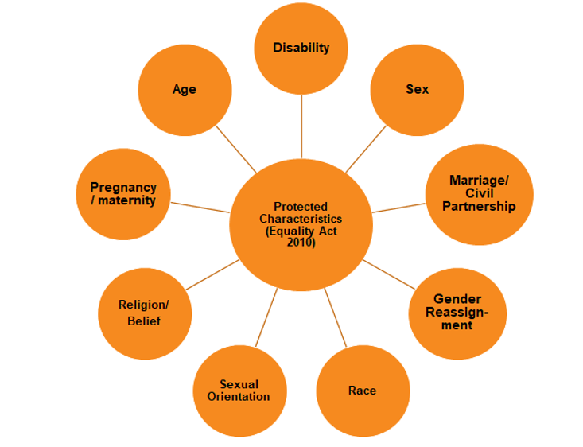
Figure 9 – Equality Act 2010: Protected Characteristics
Whilst the legislation and guidance around SEA and Impact Assessments is well-established, the STPR2 has provided an opportunity to demonstrate how value can be added, and efficiencies gained, from early consideration and integration of SEA/Impact Assessment outputs into the STAG appraisal of transport projects. Indeed, whilst these Duties involve completion of their own independent assessments, including against specific SEA and Impact Assessment objectives (see Appendix C), these assessments also interact and complement each other, and have been fed into the STAG process to ensure that the STPR2 is environmentally sustainable and socially equitable.
Key influence points of the SEA and Impact Assessments on the STPR2 appraisal process are set out below.
- At Preliminary Appraisal stage, high-level assessments of options against STAG criteria, SEA objectives and Impact Assessment objectives have been undertaken. These objectives are listed in Appendix C. The SEA objectives used in the option assessment were developed to incorporate the STAG environment criterion and sub-criteria. The SEA topics generally map well against the STAG environmental criteria and therefore provided an opportunity for appraisal efficiency, although the opportunity was also taken to strengthen the STAG environmental appraisal by incorporating added value from the SEA. For example, the SEA objectives used in the environmental assessment include detailed underlying assessment guide questions across all of the SEA topics. These allow for a more comprehensive environmental assessment than an appraisal using the STAG environment criterion and sub-criteria alone would provide.
- At Detailed Appraisal stage, an assessment of interventions and packages of interventions across all environmental topic areas using the SEA objectives was undertaken. This included providing inputs to the Appraisal Summary Tables (ASTs). The SEA and Impact Assessment objectives have been used to assess interventions and packages of interventions, and to develop mitigation and enhancement measures tailored to meet or exceed legislative requirements and policy aspirations, particularly in the context of achieving an ‘inclusive net zero carbon economy’.
- These findings have been used to provide robust and bespoke inputs to the ‘Environment’, ‘Climate Change’ and ‘Equality and Accessibility’ criteria within the Detailed STAG appraisal.
- At Detailed Appraisal stage, the Impact Assessments fed into the appraisal of Equality and Accessibility and the Economy, as summarised below.
- Within the Equality and Accessibility appraisal, emphasis has been given to the ‘accessibility impacts’ on different societal groups resulting from transport changes including groups with protected characteristics, children and young people, island communities and socio-economically disadvantaged groups. Specifically, this includes: access to work, education, health services and food shops, as well ‘assessing opportunities’ for such groups to walk, wheel or cycle to local services, such as: post offices, health centres, shops and leisure facilities. Moving beyond appraising how proposed transport changes impact on the ability of different societal groups and island communities to simply reach core services, the appraisal has gone beyond this and considered the issues people face when interacting with transport infrastructure and services.
- For Equality, the purpose of the Impact Assessment involvement has been to demonstrate that the implications for all people have been considered in the STPR2, and that interventions are consistent with policies for Equality. This has been done by identifying high-level positive and negative impacts on groups with protected characteristics, children and young people, island communities and socio-economically disadvantaged groups and potential mitigation to minimise or enhance impacts.
- In the Economy appraisal, consideration has been given to how socio-economic impacts from transport schemes fall to different groups of the population.
The commonly used quantitative approach (for example mapping and economic analysis) in Detailed Appraisal has limitations for appraising certain factors such as interaction of different societal groups with infrastructure. However, by considering the SEA and Impact Assessments as embedded processes to the development of the STPR2, the appraisal process moves beyond standard STAG appraisal and can support delivery of improved environmental and equalities outcomes.

Stakeholder Engagement
Effective collaboration with stakeholders and engagement with the public has been vital to the STPR2 and a considerable programme of activities has been undertaken at a national and regional level throughout the STPR2 process. A comprehensive Engagement Plan was developed during the inception phase to guide engagement and communications, with principles agreed to set the tone of the message portrayed to key stakeholders and ensure the project team adhered to best practice and offered a consistent approach across all engagement activities. The principles agreed were as follows:
- a fully transparent and auditable approach to capturing engagement through promotion of fair access - an equal opportunity to become involved - using a range of engagement and communications approaches;
- a proactive approach to elicit responses from diverse stakeholders, including hard to reach groups;
- a consistent approach whilst responding to the diverse geography of Scotland;
- an efficient approach to make best use of finite resources and timescales and minimise engagement/consultation fatigue;
- an integrated approach between engagement on the NTS2, the STPR2 and the NPF4 where possible and appropriate.
As part of Transport Scotland’s commitment to collaborative working, Regional Transport Working Groups (RTWGs) were established across Scotland with local authorities, National Park authorities, RTPs and other regional stakeholders, such as Enterprise Agencies and Growth Deal representatives, to inform and guide the review in their respective areas. RTWGs feature representatives covering a variety of remits, including transportation, planning and economic development. The STPR2 RTWGs and the STPR2 regions they cover are as follows:
- Argyll and Bute RTWG – Argyll and Bute Region;
- Ayrshire and Arran RTWG – Ayrshire and Arran Region;
- Edinburgh and South East Scotland RTWG - Edinburgh and South East Scotland Region;
- Forth Valley RTWG – Forth Valley Region;
- Glasgow City Region RTWG – Glasgow City Region;
- Highlands and Islands RTWG – Highlands and Islands Region;
- North East RTWG – North East Region;
- Shetland Islands RTWG – Shetland Islands Region;
- South of Scotland RTWG – South West Scotland Region and Borders Region;
- Tay Cities RTWG – Tay Cities Region.
Before the COVID-19 pandemic, the engagement with the RTWGs was complemented by a comprehensive programme of stakeholder and public engagement activities building on the engagement work undertaken for the NTS2. Regional workshops played a very important role bringing together transport users, business, equality and other representative groups to provide their input on problems and opportunities in the first round of sessions and into potential interventions in the second round of sessions. Structured interviews were also undertaken with a range of key stakeholders to provide additional inputs.
A number of national workshops were arranged focussing on all the key modes of transport including active travel, bus, rail, maritime, road and freight transport. There was also a national equalities workshop and a national environmental workshop. Breakfast seminars were arranged in different parts of Scotland for organisations representing key business sectors. Engagement activities were also undertaken with schools in different parts of Scotland.
An online survey to capture the views of the wider public, Community Councils and organisations with an interest in transport was available from 02 December 2019 to 10 January 2020. Similar surveys were undertaken as part of the three earlier Pre-Appraisal studies in the South West, the Scottish Borders and North East Regions.
All the information from the various workshop sessions and the online survey was captured and fed into the Case for Change and option generation phases of work.
From March 2020 stakeholder engagement required to be paused due to COVID-19, with Transport Scotland resources being focussed on supporting Ministers’ response to the pandemic. Stakeholder engagement was re-started in October 2020 to feed into the remainder of the STPR2 process.
Following the publication of the Phase 1 Recommendations Report and the updated regional Case for Change reports, comment forms were published in February 2021 to capture feedback. In total 276 Individuals and 118 Organisations provided feedback. The comments received were considered and helped to inform the recommendations and options taken forward for more detailed appraisal.
Figure 10 provides an overview of the key elements of the STPR2 engagement process, covering activities undertaken in the period prior to publication of the draft STPR2 report, associated documents and draft impact assessments in January 2022. It also shows that 454 responses were received during the 12-week statutory consultation process undertaken from January to April 2022. Further details of the statutory consultation process are discussed in Section 3.5, below. Details of the full range of engagement and statutory consultation activities are summarised within Appendix D.

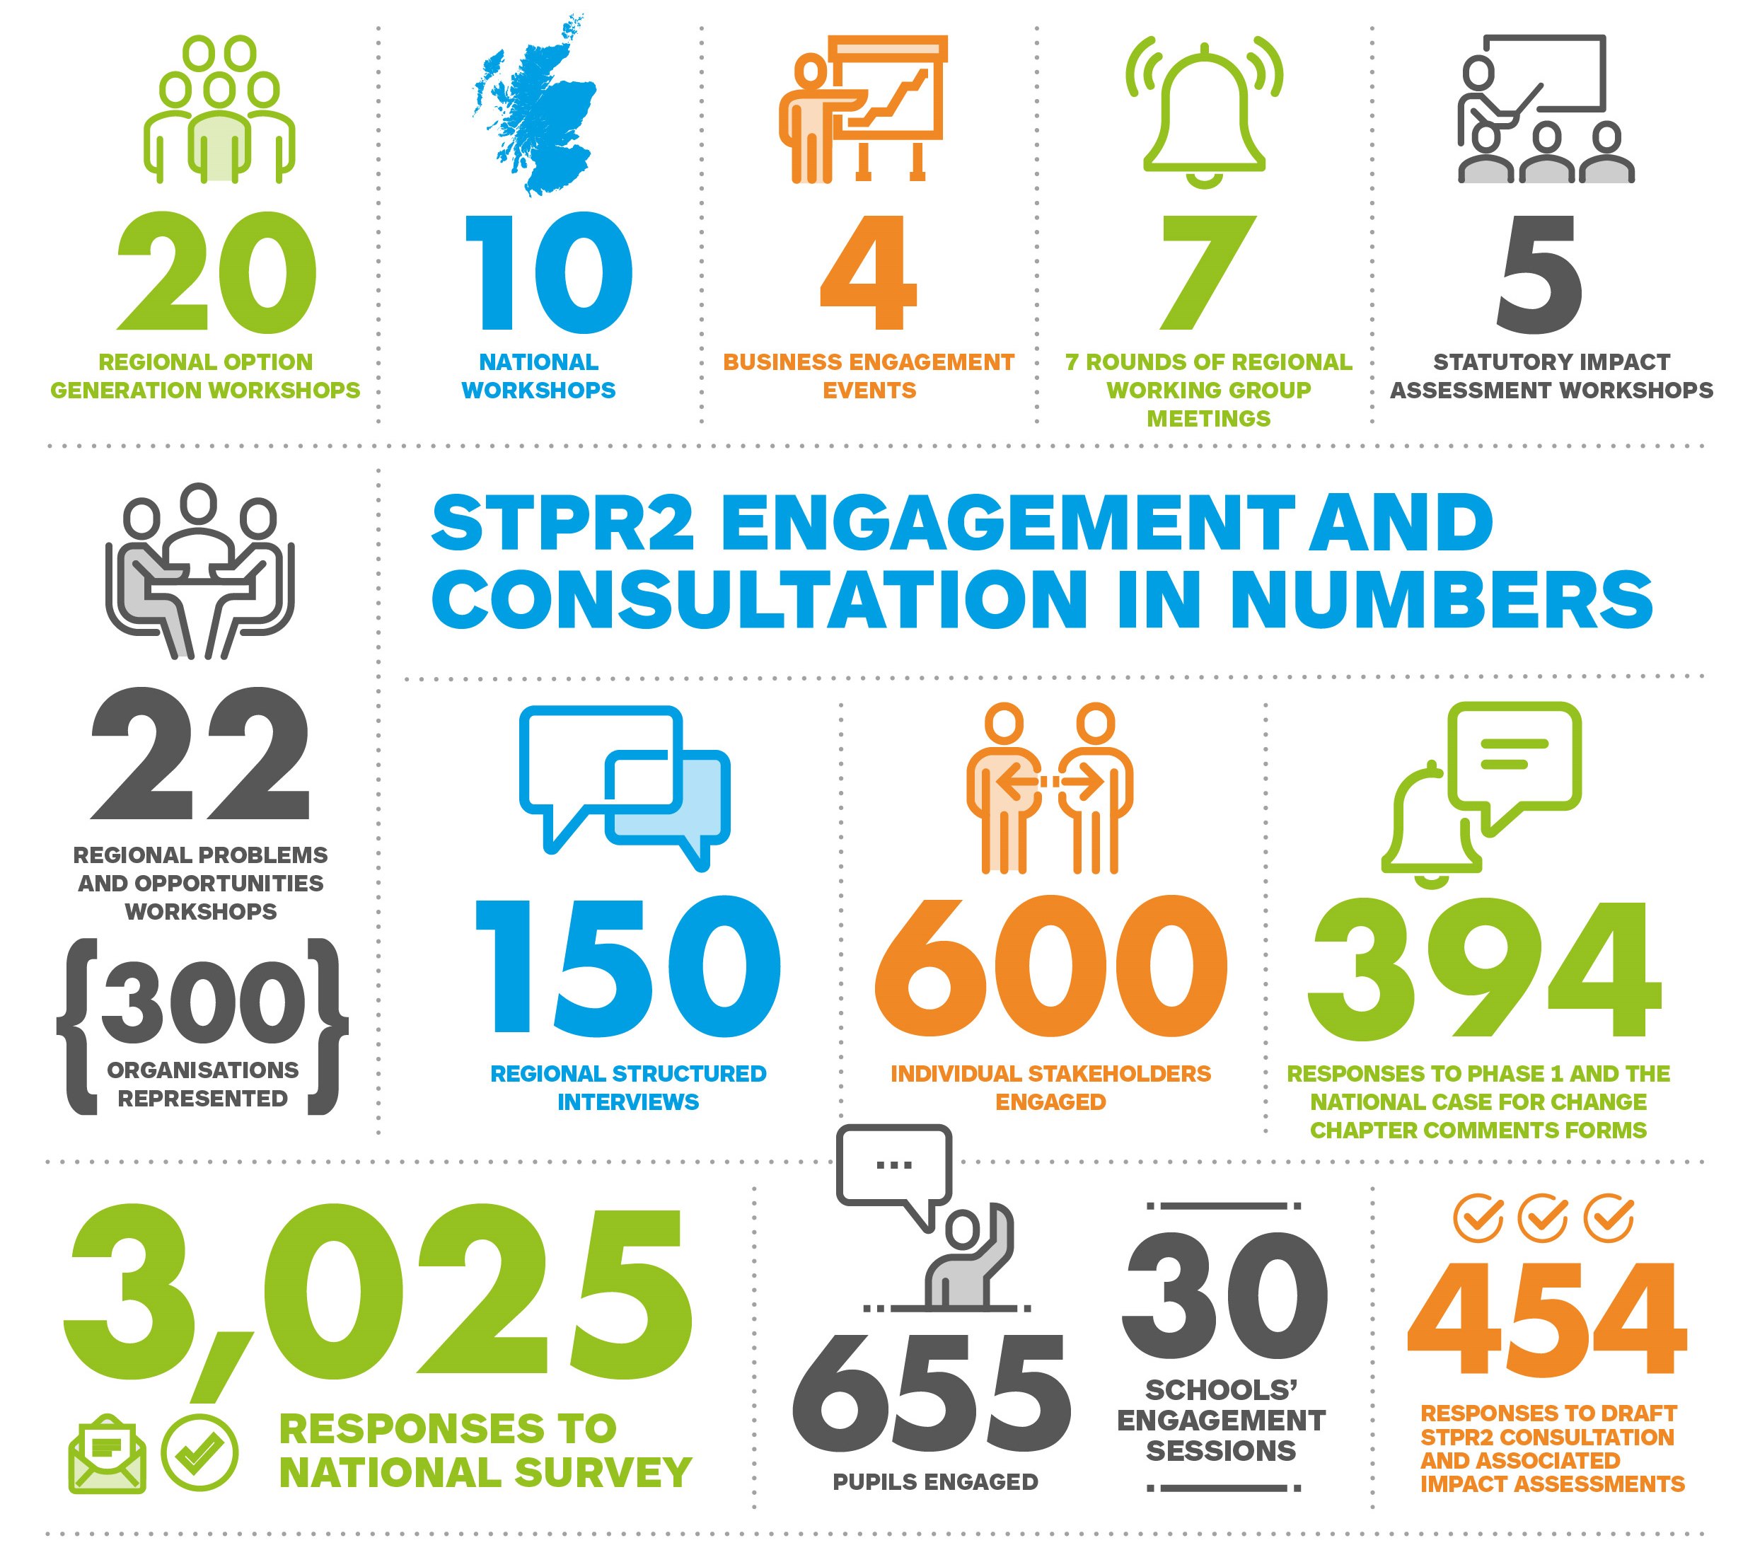
Figure 10 – Overview of the STPR2 Engagement Process

Statutory Consultation
The publication of the draft STPR2 report, associated documents and draft impact assessments in January 2022 launched a 12-week public consultation period, hosted on the Scottish Government’s consultation platform Citizen Space. Easy Read and Gaelic language versions of the draft STPR2 summary report and a Gaelic language questionnaire were also made available. A dedicated telephone number was published to allow those without good internet access to call and request a printed copy, large print or editable version to return by post or email. A webpage version of the draft STPR2 summary report was also made available to further increase accessibility. The public consultation was publicised through emails to a comprehensive list of organisations and authorities across Scotland built up through the STPR2 process, via the Transport Scotland website and through both press and social media coverage. Organisations and authorities were also requested to publicise the consultation through their own channels and a printable poster was provided to assist with this.
During the 12-week consultation period 30 information sessions were undertaken. These sessions were designed to promote the consultation exercise, by providing an overview of the STPR2 and the 45 draft recommendations and further details on how stakeholders could feed into the consultation process.
In line with the proactive approach to engagement that has been taken across the course of the review to ensure that all stakeholders have an equal opportunity to access information on the STPR2, British Sign Language (BSL) interpreters attended three of the information sessions for wider stakeholders and equalities groups. Over 160 individuals representing organisations across Scotland attended these sessions with all participants encouraged to respond to the public consultation hosted on Citizen Space.
A total of 454 responses were received during the statutory consultation period, including from RTPs and local authorities. Responses were also received from professional/trade bodies, charity groups/organisations, single-issue campaign groups, and Community Councils and other local groups with an interest in transport.
Further details are set out within the accompanying STPR2 Consultation Analysis Report and Consultation Summary Report.
The views of statutory consultees, wider stakeholders and the public on the processes, findings and recommendations have been used to shape this Final Technical Report.
Following the statutory consultation process, all feedback received was collated and reviewed.
In addition, the feedback received has been used to inform and finalise the SEA and Impact Assessments. The feedback on the SEA Draft Environmental Report has been responded to in the final version of the Environmental Report. Each consultation response and the SEA response to it is listed in Appendix E of the Environmental Report.

National Case for Change

Introduction
Building on the policy review set out within Chapter Two, this Chapter presents a summary of the case for change, with further details contained in the National Case for Change Report. It specifically covers key challenges for transport and infrastructure, and the impact of COVID-19 on current and future transport patterns.

Challenges for Transport and Infrastructure
Building on the NTS2 and the extensive data analysis and stakeholder engagement undertaken during the first stages of the STPR2, the key challenges that need to be considered when planning for strategic transport and investment have been identified.
Transport’s contribution to the climate emergency and net zero targets means that there is a need to reduce travel and deliver modal shift towards walking, wheeling, cycling and public transport. If we continue as we are now, forecasts suggest a 40 per cent increase in vehicular travel by 2037. The recent work by the Committee on Climate Change set out an assumption of a 10 per cent modal shift by 2030 within its net zero scenario and the Update to the Climate Change Plan commits to reducing car kilometres by 20 per cent by 2030.
To achieve a modal shift of the scale required to address the climate emergency will require significant changes to the complex travel behaviours of users, operators and the public and private sectors. In accordance with the Sustainable Travel Hierarchy, the STPR2 should prioritise interventions that increase the modal share of shorter everyday trips by walking, wheeling and cycling; short- to medium-length trips by public transport and longer trips by rail or coach and low emission vehicles.
Transport is a derived demand and therefore key decisions and investments are required across several other sectors to meet net zero targets and in so doing put ‘place’ at the heart of the decision-making process. Land-use planning and digital connectivity are two areas not within the scope of the STPR2 that will both have a significant part to play in meeting net zero targets.
The Revised Draft NPF4 is clear that development proposals will be supported where it can be demonstrated that the transport requirements necessary to facilitate development have been considered in line with the sustainable travel and investment hierarchies. This will help in the development of more sustainable, attractive, convenient, safe and inclusive communities which support local living. The Revised Draft NPF4 outlines policies which encourage, promote and facilitate developments that prioritise walking, wheeling, cycling and public transport for everyday travel and reduce the need to travel unsustainably. It also includes National Developments that facilitate the shift from vehicles to walking, cycling and wheeling for everyday journeys, thus contributing to reducing greenhouse gas emissions from transport and driving a change that is highly beneficial for health and wellbeing.
It is clear that efforts over the last decade have not had a sustained impact on the increase in walking and cycling, particularly as a means to travel to work or education. In recent years, the Scottish Government, working with a number of key partners, has committed significant investment into active travel to help address this issue. Whilst the outcomes of this investment are still to be realised, it is clear that to make the transformational change required, significant ongoing commitment to active travel investment is necessary, to not only deliver improved infrastructure and systems but to encourage the change needed in travel behaviours.
The decades of decline in bus use across most of Scotland are linked to a range of complex factors. Despite this, bus use makes up three-quarters of trips by public transport in Scotland. It therefore has a vital role to play in delivering interim net zero targets by 2030. The STPR2 should prioritise interventions that increase the modal share of journeys by bus over the next decade and beyond, noting that the scope of the STPR2 is on investment and does not extend to revenue funding.
Whilst bus use in Scotland has been in decline, rail use has increased by over 30 per cent in the last decade. Based on current forecasts for future housing and employment land uses there will continue to be strong demand for rail services particularly within the key corridors to, from and between Edinburgh and Glasgow. This will further heighten the current terminal station capacity issues within Scotland’s two largest cities, although this needs to be considered in light of uncertainty over future travel patterns as a result of the COVID-19 pandemic.
The safe, efficient and resilient movement of goods is vital for Scotland’s economy and related import/export market. Most freight in Scotland is moved by road. Maintaining efficient and resilient connections will continue to be important to business. However, the movement of goods, and the freight industry in general, will need to play its part in meeting net zero targets by 2045. Advances in low carbon technology for the movement of goods by maritime, rail and road will play a significant part and the STPR2 has explored further opportunities to increase rail freight and reduce the level of goods transported by road.
Scotland has strong trade links with over 100 countries across nearly 100 different industries and sectors. There is a great deal of uncertainty surrounding international trade, given the global impact of the COVID-19 pandemic and the ongoing discussions around future trade agreements following exit from the European Union. As set out in Vision for Trade, A Trading Nation, and the Inward Investment Plan, in coming years Scotland’s economic success will be increasingly realised through its ability to connect with, and compete within, a global market. Strengthening links with the global economy will mean increased trade, inward investment and creation of an environment for sharing skills, expertise and collaborating with others to support sustainable inclusive growth. Delivery of these plans is key to the NSET for Scotland.
The maintenance of safe and resilient transport networks and systems is also a vital part of the daily lives of all communities, businesses and visitors to Scotland. Recent examples of this include the A83 ‘Rest and Be Thankful’, Winchburgh Junction and tunnel on the main rail line connecting Edinburgh and Glasgow, and the CalMac Ferries Ltd ferry network, which all require further investment to maintain safe and resilient transport connections to all parts of Scotland. The Sustainable Investment Hierarchy outlined within the NTS2 makes clear that interventions should be prioritised firstly by their ability to reduce the need to travel, and secondly their ability to help maintain and safely operate existing assets. This Sustainable Investment Hierarchy is embedded within the STPR2 appraisal process.
Fundamental to the delivery of an inclusive net zero economy, and thus improving health and wellbeing, is the requirement to support and accelerate the transition to low emission vehicles. A collaborative public and private sector relationship will be crucial in achieving this transition.

COVID-19 Pandemic
The STPR2 COVID-19 Addendum which formed part of the National Case for Change Report outlines the impact on travel patterns and behaviours over time as the result of the COVID-19 pandemic and helps to provide some level of foresight on how COVID-19 will impact on behaviours in the short- to medium-term. Since publication of the Addendum in February 2021, Transport Scotland has undertaken further monitoring of public attitudes to transport and travel during the COVID-19 outbreak. Between 16 May and 01 June 2022, a telephone survey was undertaken with a representative sample of those aged over 16 across Scotland to look at attitudes to transport and travel following the easing of restrictions around COVID-19. This information helps provide an understanding of the ways in which the COVID-19 pandemic has affected travel behaviour in Scotland, as well as understanding public attitudes on topical issues relevant to transport. The key findings are summarised below.

Current Behaviour As Compared To Pre-Pandemic
Around one-third of respondents (30 per cent) said they made more car/van journeys than before the pandemic. One-quarter (25 per cent) said they were walking and wheeling more. Around 20 per cent said they were travelling more by public transport.
Conversely, around one-quarter of respondents said they were making fewer journeys by train (25 per cent), bus (25 per cent) and car/van (24 per cent). Just over one in 10 (11 per cent) said they were making fewer journeys by walking and wheeling compared to before the pandemic.
Respondents said they were more likely to: shop closer to home (44 per cent); shop for non-food items online (41 per cent); work from home (33 per cent); and shop for food online (21 per cent).
They said they were less likely to: work in an office or building (27 per cent); eat out/go to a restaurant (36 per cent); take part/attend group classes/leisure activities (30 per cent). Over one-third (36 per cent) of respondents said they were working from home more than before the pandemic.

COVID-19 Concerns
Forty-three per cent of respondents were concerned about contracting or spreading the virus when travelling by bus; 39 per cent when travelling by train; and 29 per cent when travelling by taxi. These concerns have reduced compared to the previous wave of the survey which was undertaken in October/November 2021, whereby 50 per cent of people were concerned when travelling by bus; 57 per cent by train; and 52 per cent by taxi (note that these figures are for everyone irrespective of whether they are regular users of bus, train or taxis).
One-third of respondents (33 per cent) said they were avoiding public transport and using their car more than they did before due to the pandemic. However, half (50 per cent) said they were walking, wheeling or cycling more.

Summary in Context for the STPR2
A key question for any forward-looking programme, such as the STPR2, is what the longer-term impacts of COVID-19 might be given the evidence and opinions outlined above. However, the problem at present is the significant level of uncertainty and lack of robust data, so providing any degree of certainty around these is highly challenging. There are a number of potential trends that can be identified, including:
- overall increase in the proportion of people working from home;
- reduction in office space and more split working from home/office;
- a move away from traditional “9 to 5” to more flexible working patterns;
- reduction in travel resulting from job losses from economic slowdown;
- more localisation of supply chains (which the UK exit from the European Union may further accelerate);
- increased digitisation – digital by default;
- increased automation.
Within the context of the STPR2 these issues have been addressed through the consideration of scenarios both in qualitative (Phase 1) and quantitative (Phase 2) terms, including scenario planning, utilising both the Transport Model for Scotland (TMfS) and the Transport and Economic Land-use Model of Scotland (TELMoS).
The scenarios developed for Phase 2 of the STPR2 are focussed on the medium- and longer-term, spanning several decades, and do not consider the short-term impacts of the COVID-19 crisis. It is assumed that some effective means of managing coronavirus in the longer-term will be found, whether through the ongoing vaccination programme or otherwise. Lasting responses to the crisis do, however, need to be taken into account, the most obvious example being that a major part of the economy has carried out a very large-scale experiment into the feasibility of working at home.

Dealing with Uncertainty
Accounting for risk and uncertainty is an integral part of good practice in appraisal, as outlined in STAG. It is recognised that most transport models and tools assume continuing trends and static behaviours in forecasting, however these assumptions are becoming less tenable in a world of increasing environmental, political, socio-demographic and technological change. There is therefore a need to understand how sensitive potential interventions are to a range of possible futures. Scenario planning techniques have been adopted within the STPR2 appraisal to represent a range of possible futures and form the backdrop for the policies and proposals examined. This is discussed further in Chapter Seven.
As noted earlier, the COVID-19 pandemic has resulted in an unprecedented level of uncertainty regarding transport trends in the medium- to long-term. Whilst the pandemic has had an unprecedented impact on travel since March 2020, forecasting the future medium- and long-term impacts with certainty is challenging until the duration of the pandemic and the trajectory of recovery is known. Periods of lockdown have radically changed the way people go about their daily activities, changing demand for travel, trip distribution patterns, peak profiles and choices with respect to mode of travel. To what extent these changes carry on into the future depends on a range of factors including vaccine efficacy, potential future variants of the virus and policies employed by Government to take advantage of the opportunities and mitigate the adverse impacts and uncertainties resulting from the pandemic.
Research undertaken by Institute of Transport Studies Leeds notes that exactly what the return to work patterns for those people currently working from home will be remains uncertain. It is estimated that if those working at home in October 2020 continue to do so for half of their working weeks, this could reduce miles travelled on the commute by between 15 per cent (for walking) and 27 per cent (for train journeys) in the areas studied compared to pre-pandemic levels. The reduction in car miles travelled on the commute would be 17 per cent and cycling and bus use would both see reductions of around 21 per cent. This would have a significant impact on congestion levels, crowding, fare income and the demand for parking. These reductions would potentially improve the quality of the journeys that are made and reductions in traffic could also reduce noise, air quality impacts and climate change emissions.
The STPR2 has taken cognisance of the potential impacts on travel and the economy and capitalised on the opportunities identified, as noted within Figure 11.
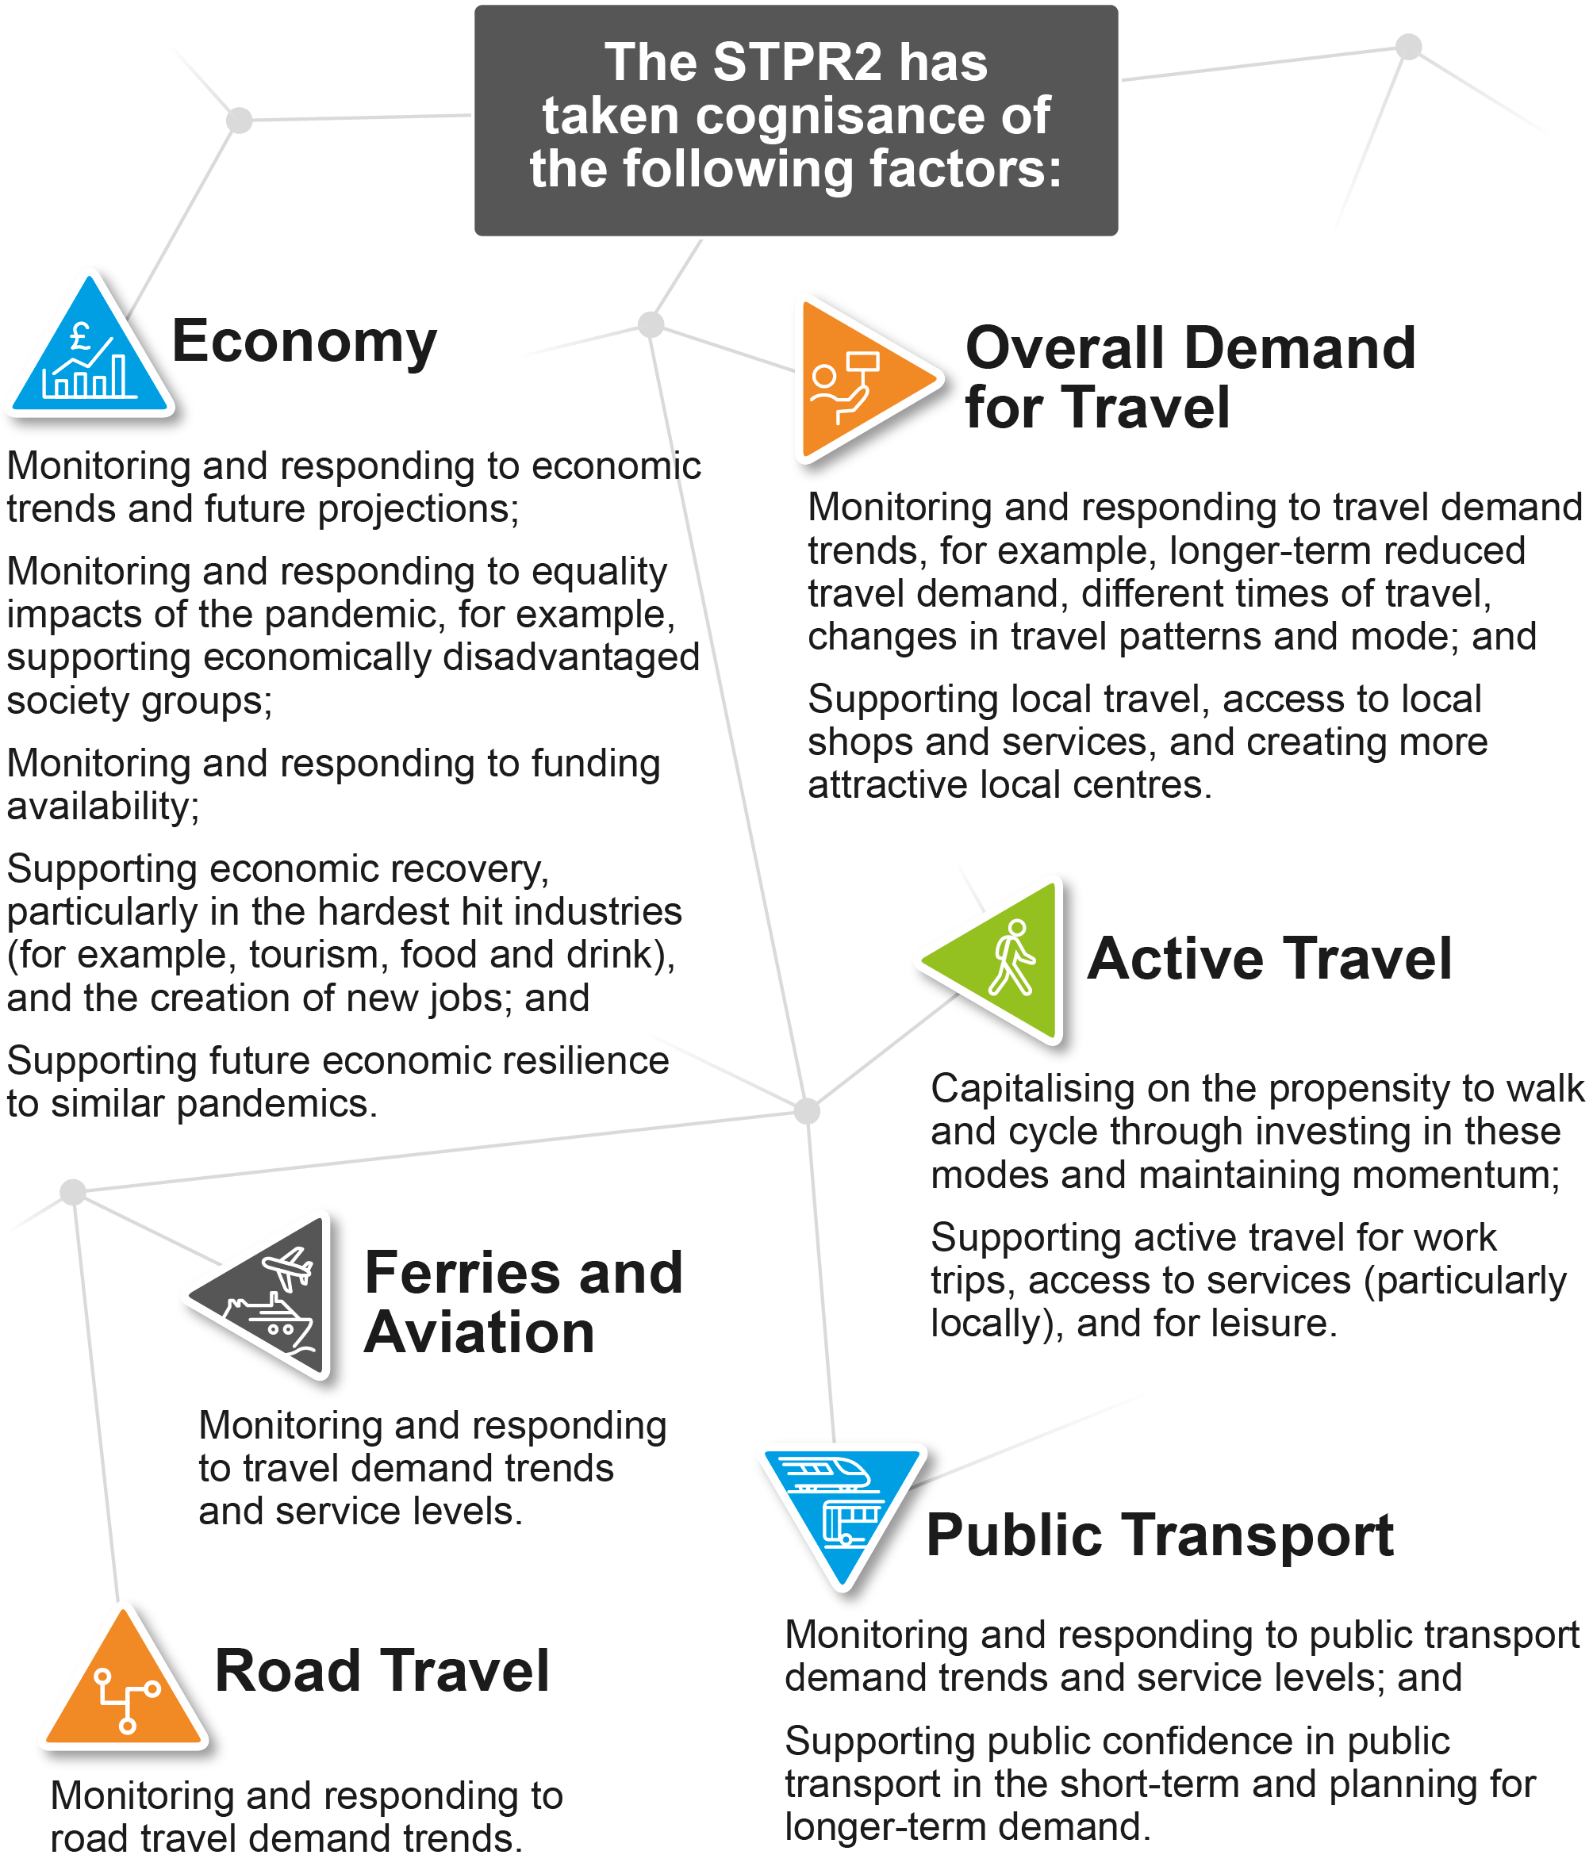
Figure 11 – Factors Considered Within the STPR2 Approach
The following Chapter will provide an overview of the process undertaken to establish TPOs for the STPR2.

Establishing Transport Planning Objectives

Overview
The evidence outlined in the previous Chapters highlights that, without intervention, current issues around higher private vehicle usage, more unreliable journey times, increasing congestion, poor air quality and climate change will continue to increase or deteriorate. Traditionally, infrastructure planning has sought to predict this increase and then plan infrastructure provision to provide for it (known as ‘Predict and Provide’). However, in order to realise the vision and priorities set out within the NTS2 - particularly around climate change and net zero - a different approach to planning infrastructure provision is required. As such, a more outcome-led approach was taken that linked infrastructure planning to the vision, priorities and outcomes set out within the NTS2. This approach was more aligned with a ‘Decide and Provide’ process that more closely supports the vision sought by the NTS2, and in so doing provides the infrastructure and assets best placed to achieve the vision, priorities and outcomes. The strategic transport options needed to support the NTS2 vision have been determined by applying a framework of objectives that clearly set out how this future will be achieved.

Setting Objectives
STAG is an objective-led appraisal process, requiring TPOs - used to express the desired transport-related outcomes in a study area - to be developed that take full account of evidence pertaining to the particular problems and opportunities identified by the study, within the context of the relevant policies and strategies and evidenced by stakeholders and data. TPOs should:
- provide a clear indication of what the STPR2 is trying to accomplish;
- introduce clarity where there may exist strong vested interests and entrenched views on priorities;
- allow the proper appraisal of candidate options to enable the decision makers to make informed choices on investment priorities.
At the national level, the NTS2 sets out the Case for Change for Scotland and is at the heart of the objective-setting process for the STPR2. A consistent set of TPOs has been developed for use across the country during the appraisal process. These objectives are directly linked to each of the NTS2 priorities and outcomes. Sitting below the five TPOs are a set of national sub-objectives.
Within this approach there is a need to reflect the regional focus from the analysis and stakeholder engagement undertaken to inform the STPR2 process. Therefore, each region has developed a set of specific sub-objectives to reflect the issues within their specific area.

National and Regional TPOs
As stated, the TPOs are based on the NTS2 priorities and associated outcomes presented in Section 2.2.2. Using these as building blocks, a framework of TPOs was created that also takes account of the problems and opportunities identified across the country. A total of five TPOs have been derived, the first four of which align directly to each of the NTS2 priorities, and a final objective that aligns with the reliability, resilience and safety of the transport network: a theme that has come out strongly through the problems and opportunities analysis.
An extensive stakeholder engagement exercise was undertaken during the development of the TPOs. The draft TPOs were then presented in the suite of Case for Change reports published in February 2021.
Sitting under each TPO is a series of sub-objectives to better define the overarching objectives and aid their application in appraisal. The STPR2 TPOs and associated sub-objectives are as follows:
A sustainable strategic transport system that contributes significantly to the Scottish Government’s net zero emissions target
- reduce the consumption of fossil fuels through a shift to more sustainable modes of transport;
- increase the mode share of active travel for shorter everyday journeys;
- increase the mode share of public transport by providing viable alternatives to single occupancy private car use;
- reduce emissions generated by the strategic transport system.
An inclusive strategic transport system that improves the affordability and accessibility of public transport
- increase public transport mode share by connecting sustainable modes of transport to facilitate integrated journeys;
- improve mobility and inclusion, recognising the specific needs of disadvantaged and vulnerable users;
- reduce transport poverty by increasing travel choice;
- reduce the reliance on private car for access to key centres for healthcare, employment and education.
A cohesive strategic transport system that enhances communities as places, supporting health and wellbeing
- reduce demand for unsustainable travel by embedding the place principle in the changes to the strategic transport system;
- increase the mode share of active travel for shorter everyday journeys;
- reduce demand for unsustainable travel arising from nationally significant growth areas, taking cognisance of the emerging NPF4.
An integrated strategic transport system that contributes towards sustainable inclusive growth in Scotland
- increase sustainable access to labour markets and key centres for employment, education and training;
- increase competitiveness of key domestic and international markets, by reducing costs and improving journey time reliability for commercial transport;
- increase resilience of accesses to key domestic and international markets to encourage people to live, study, visit and invest in Scotland;
- increase the mode share of freight by sustainable modes.
A reliable and resilient strategic transport system that is safe and secure for users
- improve resilience from disruption through adaption of Scotland's trunk road, rail and strategic ferry infrastructure;
- reduce transport related casualties in line with reduction targets;
- improve resilience through climate change adaptation within the management and maintenance of trunk road, rail and ferry infrastructure;
- improve perceived and actual security of the strategic transport system.
Figure 12 demonstrates the linkage between the TPOs and Scottish Government policy and associated strategies.
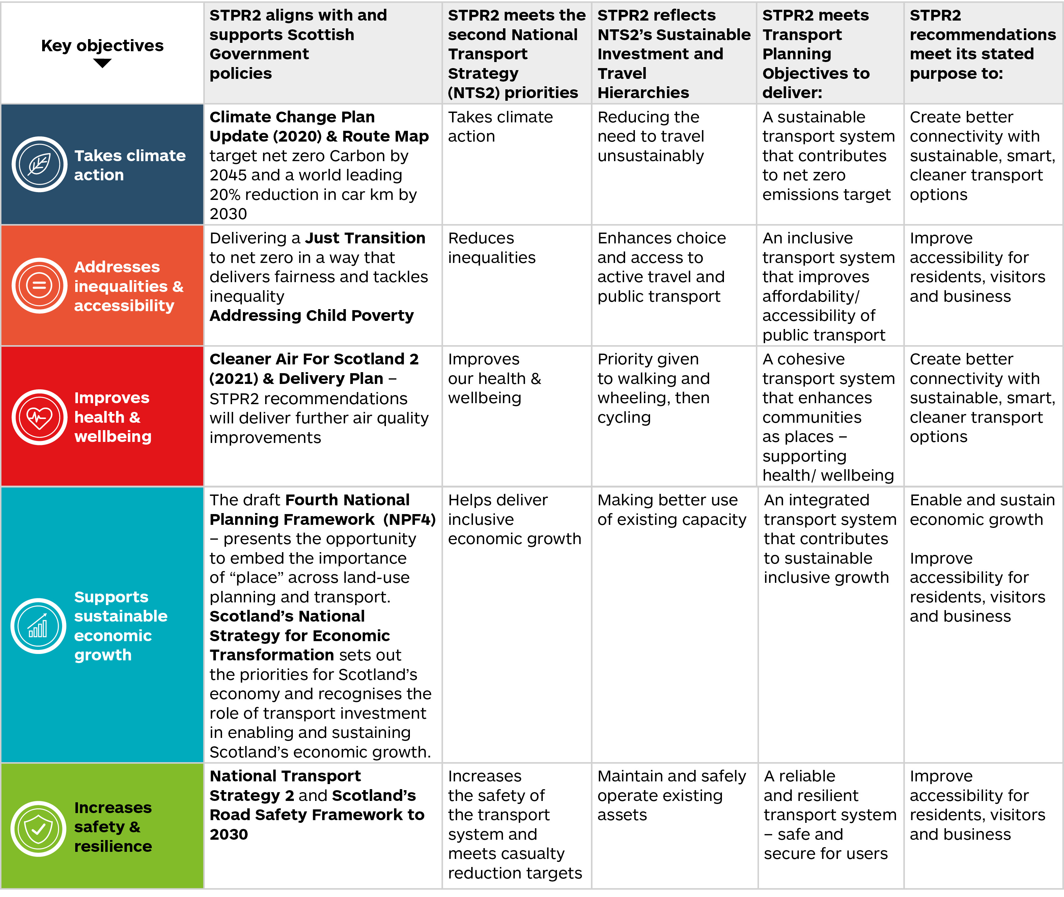
Figure 12 – Linkage Between the STPR2 TPOs and Scottish Government Policy and Associated Strategies
A top down/bottom up approach was adopted to inform the creation of regional sub-objectives that not only align directly to the outcomes sought by the NTS2 for Scotland as a whole, but that also reflect the transport and other relevant problems and opportunities within each of the 11 regions of the STPR2.
Each regional Case for Change report outlines the transport and other relevant problems and opportunities, the TPOs and the associated regional sub-objectives. In general terms the regional TPOs were derived by refining the national TPOs to reflect the specific key regional problem and opportunity themes.
The following Chapter sets out the approach taken to option generation and sifting.

Option Generation and Sifting

Introduction
This Chapter provides a summary of the option generation and sifting process undertaken to inform the STPR2. Further details are contained in the suite of Case for Change reports published in February 2021. An overview of the process undertaken to develop and assess the recommended interventions is provided, together with a summary of the output from the sifting process.

Defining Strategic Interventions
In the context of the STPR2, a strategic transport project is defined as any transport project that materially contributes to Scottish Government/Transport Scotland policies and strategies. Specifically, this includes:
- any transport project that plays a significant part in supporting the four priorities and related outcomes of the NTS2;
- projects or groups of projects related to transport networks owned, operated and funded directly by Transport Scotland;
- passenger and freight access to ports and airports of national significance;
- the inter-urban bus and active travel networks and principal corridors within urban areas.
Within the overall definition above, options considered within the STPR2 also included:
- appropriate transport policy and financial instruments (that are within the responsibility of Scottish Government);
- demand management measures, including use of technology, innovation and behavioural change;
- strategic maintenance and safety measures;
- measures to increase travel by active travel modes;
- public transport improvements, including interchanges, road space allocation, technology and ticketing;
- transport links to/from areas of economic activity of national significance;
- targeted infrastructure improvements on the transport networks owned, operated and funded directly by Transport Scotland;
- changes to the operation of ferry terminals and services that are part of the Clyde and Hebrides Ferry Service (CHFS) and Northern Isles Ferry Services (NIFS) network;
- infrastructure measures at major ports and harbours;
- improved access to major airports.

Approach to Sifting
In keeping with the principles of STAG, a robust method to generate, clean and sift options has been developed for the STPR2, ensuring a broad range of options across all modes was considered.
An overview of the option generation, cleaning and sifting approach is summarised in Figure 13, with further details provided in the remainder of this Section.
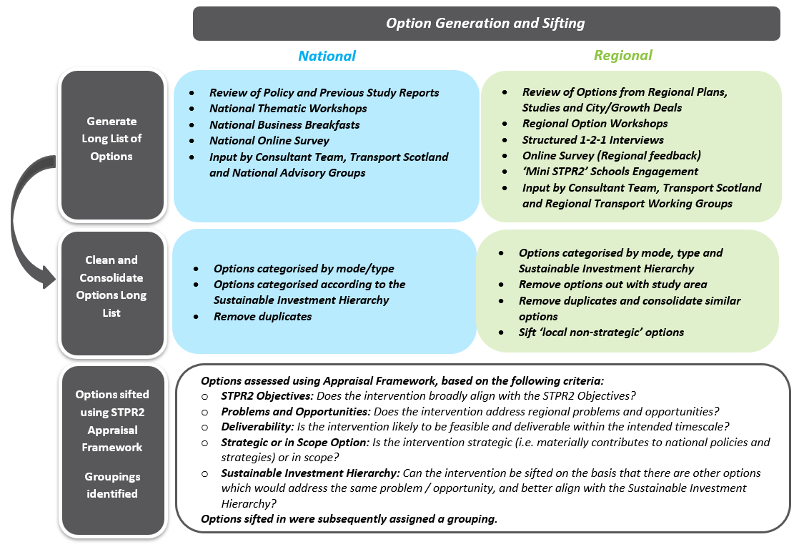
Figure 13 – Option Generation and Sifting Overview

Generate Long List of Options
A long list of initial transport options was generated based on a range of sources, including a review of options identified from recent local and regional studies and via extensive stakeholder engagement and public survey activities. This included Stakeholder Workshops, Structured Telephone Interviews, Elected Members Briefings and an Online Survey. Options were also generated through discussions with RTWGs and supplemented by the Consultant team. Some of these options were well developed and had a clearly defined output, others were suggestions and ideas. All of these ideas/suggestions/options were collated and considered.
Approximately 14,000 individual ideas/suggestions/options were identified at this stage in the process.

Option Cleaning
Although approximately 14,000 individual ideas/suggestions/options were identified, this included a number that required further definition, duplicated options and options which were broadly similar. As such, an exercise was undertaken to clean this ‘long list’. Options were reviewed at a regional level or a national level depending on the initial source of the information. Options that required further definition were developed, and similar options were consolidated.
Following the option cleaning exercise, approximately 2,800 options were retained in the long list of interventions to be sifted.

Option Sifting
Each of the 2,800 options has been reviewed using a methodology developed to drive consistency in the sifting of options across all of the STPR2 regions. Following this process options were either:
- recommended at a national level for further consideration through the STPR2 process;
- recommended as part of a route-/corridor-level intervention for further consideration through the STPR2 process; or
- sifted from the process and passed to the appropriate local/regional transport authorities and partnerships for consideration outwith the STPR2.
Options were sifted out at this stage for one of the following reasons:
- option out of scope; and/or
- option does not address the problems/opportunities in the region; and/or
- poor performance against TPOs/sifting criteria; and/or
- deliverability concerns; and/or
- the problems/opportunities are better addressed through another option; and/or
- the option is being progressed outwith the STPR2.
The option sifting approach is shown in Figure 14, on the following page.
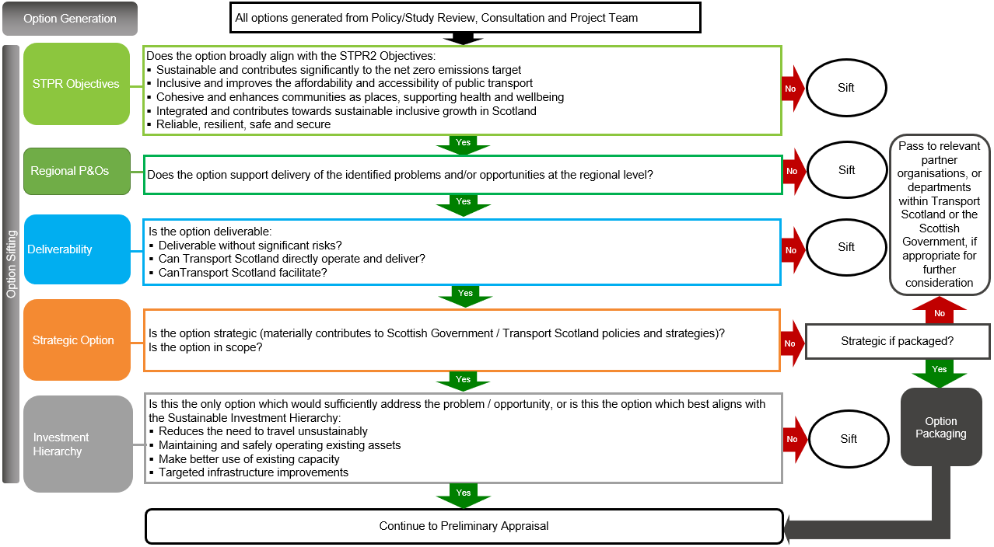
Figure 14 – Approach to Option Generation and Sifting
A full list of the options that were sifted out across all regions and at a national level is provided in the Appendix section of the National Case for Change Report.
Subsequent Chapters of this report provide further information on the interventions that have been taken forward within the STPR2.

Output from Sifting Process
Following the sifting exercise, approximately 1,400 options remained in the process. There were many options that shared common traits across the regions and many options which in isolation would not deliver the strategic improvements the STPR2 is seeking to deliver. Recognising the strategic and national dimension, options that were sifted in for further appraisal were allocated to Groupings. Groupings were established to:
- allow similar options to be collated together to provide a more manageable list for further appraisal;
- collate similar options across regions, thus aiding consistency in definition and appraisal; and, where appropriate
- allow options that may, on their own merit, not be considered strategic, however when grouped address the identified national and regional TPOs, problems and opportunities.
A total of 80 Groupings (similar types of interventions) were identified to be taken forward within the appraisal process. Table 1, overleaf, summarises the Groupings by mode.
Table 1 – Groupings by Mode
Grouping Mode | Number of Options
Active Travel | 299
Behavioural Change | 49
Bus | 40
Rail | 197
Public Transport | 168
Ferries/Island Connectivity | 95
Road | 188
Freight | 91
Technology | 59
Multi-modal | 43
Mass Transit | 27
Multiple Groupings | 172
Total Number of Options | 1,428
The Groupings represent the range of interventions considered within the STPR2 appraisal stages. It should be noted that options from the three STPR2 Advanced Studies: North East Scotland, Scottish Borders and South West Scotland, have been reviewed through the STPR2 sifting methodology and reported through Update Notes that sit alongside these Case for Change reports. Options from the three Advanced Studies have been incorporated into the list of Groupings and appraised within the STPR2.
The Groupings were reviewed from both a regional and modal/technical perspective to determine those that would meet the criteria to be considered in more detail as part of the appraisal process. The options taken forward from the option sifting process are listed within the Appendix section of the National Case for Change Report.

Appraisal

Approach
The STPR2 appraisal process has been undertaken in accordance with STAG, which sets out best practice guidance for transport appraisals. STAG is a multi-criterion framework that appraises options against the TPOs, STAG criteria and deliverability. This includes feasibility, affordability and public acceptability. The appraisal stage has been underpinned by the use of modelling and data analysis tools appropriate for the overall national review and the diverse regions.
The STPR2 appraisal process has been undertaken in two parts: a qualitative Preliminary Appraisal, followed by a more quantitative Detailed Appraisal. An overview of the approach to each is set out below.
As discussed within Chapter Two, there is an overarching and urgent imperative to address climate change and to achieve net zero carbon emissions by 2045. Recognising this, a number of approaches have been adopted to strengthen the STAG-based appraisal undertaken for the STPR2, with a particular focus on ensuring the identification of sustainable transport interventions that support the priorities of the NTS2, including the priority ‘Takes Climate Action’.

Preliminary Appraisal
The Preliminary Appraisal has involved a qualitative appraisal of all Groupings generated during the option sifting process against the following criteria:
- TPOs;
- STAG Criteria;
- Established Policy Directives;
- Deliverability Criteria.
Parallel to the STAG process, an SEA and Statutory and Duty Impact Assessments have been undertaken (see Section 3.3), also informing the Preliminary Appraisal.
In qualitatively appraising Groupings, specific consideration has been given to assessment scoring as set out in Appendix E.
It is to be noted that the scoring approach used for the Preliminary Appraisal departs from STAG guidance which adopts a seven-point assessment scale ranging from major positive (+3) to major negative (-3) impacts. The scoring scale adopted for the Preliminary Appraisal considers each Grouping against the following assessment scoring: significant positive effect; minor positive effect; neutral effect; minor negative effect; significant negative effect; uncertain effect; no or negligible relationship. The approach reflects the proportionate assessment undertaken at Preliminary Appraisal stage ahead of the more Detailed Appraisal stage at which point more is known on the Grouping in terms of its technical design and operational aspects, potential benefits for users and impacts on the wider transport network, and costs. The approach is also consistent with the assessment scale applied as part of the Statutory and Duty Impact Assessments.
The main purpose of the Preliminary Appraisal is to capture the likely impacts of Groupings, and key dependencies, with more detailed assessment undertaken at the Detailed Appraisal phase.

Transport Behaviour Scenarios
In undertaking the preparation for the NTS2, Transport Scotland recognised that the STPR2 “[will] have to deal with a future which is expected to be subject to considerably more change and uncertainty than probably ever seen before”. It is recognised that issues that are out of the direct control or influence of Transport Scotland (the “contextual environment”) have a large influence on future demand for travel. Transport Scotland therefore took the decision to adopt a scenarios approach, which looks at a range of possible futures, and how the possible interventions behave in them.
As part of that process, a number of scenarios were developed, with an objective to create a number of coherent, credible and challenging futures that explore the level of trip-making resulting from changes in the contextual environment with a focus on creating significant spatial variation.
It was recognised that the number of scenarios required to be practical, whilst at the same time able to explore the need for, and impact of, interventions. This work commenced with a review of 91 drivers of change, identified through previous projects, literature review, and consultation conducted during the preparation of the NTS2. These were reviewed and condensed into a recommendation of six scenarios:
- three variants of spatial economic growth; and, for each
- two variants of travel behaviour.
The scenarios were developed using TMfS18 and TELMoS18. Further details of these scenarios are set out in Transport Scotland’s ‘STPR2 Approach to Scenario Planning’ Information Note contained in Appendix F.
The three Economic Growth Scenarios and the two Transport Behaviour Scenarios were assessed using TMfS18 and TELMoS18. The emerging outputs from the six scenarios were analysed and compared for the 2030 forecast year. The findings of the analysis showed that:
- the impact/effect of the three spatial Economic Growth Scenarios was negligible in terms of resultant travel demand (as measured by vehicle-kilometres per mode);
- the impact/effect of the two Transport Behaviour Scenarios was much more significant and, as such, completely outstripped any effects arising from the Economic Growth Scenarios.
As a result, and following detailed discussions with Transport Scotland and the TELMoS consultants, it was agreed that the STPR2 would progress with the appraisal using just the two Transport Behaviour Scenarios. The two scenarios are broadly capturing ‘high growth sensitivity with no policy ambition on car kilometres’ (henceforth referred to as ‘high’) and ‘low growth sensitivity with a 20 per cent reduction policy ambition on car kilometres’ (henceforth referred to as ‘low’) levels of motorised traffic demand. The high Transport Behaviour Scenario is similar to a traditional ‘Do-Minimum’ forecast. The low Transport Behaviour Scenario reflects the same current policy ambitions of the Scottish Government. This provides a much broader context with which to appraise the STPR2 interventions.

The STPR2 Objectives
Each Grouping has been assessed against the five TPOs established for the STPR2 (see Chapter Five) and, where appropriate, due cognisance has been taken of the relevant national or regional sub-objectives that support these objectives. At Preliminary Appraisal stage, the Groupings have been appraised in a qualitative assessment against each of the STPR2 TPOs using the Preliminary Appraisal scoring scale (see Appendix E), that considers the relative size and scale of impacts.

STAG Criteria
At Preliminary Appraisal stage, each Grouping has been assessed qualitatively against the STAG criterion relevant at the commencement of the STPR2 – that is, the version of STAG dated 2008, incorporating periodic updates to the STAG Technical Database, the last of which was dated January 2018. The five key STAG criteria are as follows:
Environment
- supporting net zero emissions targets;
- maximising the quality of the built and natural environment for the enjoyment of all.
Safety
- reducing the risk and incidence of accidents and improving the security of the transport network for all users.
Economy
- improves connectivity, journey times and reliability to facilitate inclusive economic growth.
Integration
- fitting the transport network together and ensuring a rational relationship between transport and land-use and wider policy.
Accessibility and Social Inclusion
- increasing the accessibility of the transport network and opportunities to travel, including access to jobs, communities, shops, services and other facilities, for all users, particularly socially excluded groups.

Established Policy Directives
STAG states that the established policy directives identified during Objective Setting in the Initial Appraisal: Case for Change should also be considered during Preliminary Appraisal. A clear conflict between a Grouping and, for example, established land-use planning policy or transport targets in the area is likely to jeopardise its potential for funding, support, approval and implementation. A positive contribution towards the achievement of other relevant objectives will be to a Grouping’s credit.
As part of the Integration STAG criterion assessment, the policy integration of each Grouping has been considered. Groupings have been reviewed against the local and regional policies which were considered as part of the Initial Appraisal: Case for Change. In particular, this review has considered whether a Grouping actively supports policies, or whether conflict with policies may jeopardise the feasibility of a Grouping. Accordingly, the appraisal against policy objectives has been undertaken as part of the Integration appraisal.

Deliverability
Each Grouping has been assessed qualitatively against the Deliverability criteria summarised in Appendix E, using the Preliminary Appraisal scoring scale.
Feasibility
The Feasibility criterion involves a Preliminary Assessment of the feasibility of construction or implementation and operation (if relevant) of a Grouping and the status of its technology (for example proven, prototype, in development) as well as any cost, timescale or deliverability risks associated with the construction or operation of the Grouping, including consideration of the need for any departure from design standards that may be required. Whether a Grouping can be progressed within current legislation has also been considered. For the STPR2, this has included consideration of whether Transport Scotland can directly deliver and operate the interventions within the Grouping, or whether they would require to work with external partners, such as local authorities, RTPs, or transport operators, to facilitate delivery.
Affordability
The scale of the financing burden on the promoting authority and other possible funding organisations, and the risks associated with these, have been considered together with the level of risk associated with a Grouping’s ongoing operating or maintenance costs and its likely operating revenues (if applicable). At Preliminary Stage, a high-level indication of the cost band of the Grouping has been provided. The cost bands developed for use within the appraisal are set out within Appendix E.
Public Acceptability
An assessment of whether there are likely to be any issues around public acceptability of the Grouping has been undertaken at the Preliminary Appraisal stage. To support this, reference has been given to supporting evidence drawing on the findings from public and stakeholder surveys undertaken, and feedback sought, during the development of the Initial Appraisal: Case for Change in early-2020 (including the stakeholder engagement workshops and national online survey), as well as surveys undertaken and feedback sought on the published Case for Change documents in February 2021.

Progression to Detailed Appraisal
Decisions on whether or not to take Groupings forward from Preliminary to Detailed Appraisal were made based on overall performance against the TPOs, STAG criteria, and deliverability criteria, with consideration of alignment with established policy directives, Impact Assessments and performance against Transport Behaviour Scenarios. If, during the appraisal process, it was found that some constituent options within a Grouping performed well but others performed relatively poorly, this was reflected either in the reporting or by reconstituting the contents of the Groupings to amalgamate or disaggregate them. Appendix G summarises whether or not the respective Grouping has been taken forward to the final recommendations, and the rationale behind that decision. It also sets out the options set aside at this stage in the process.

Detailed Appraisal: Packages Appraised

Overview
The Groupings, and the interventions included within the Groupings, that have been identified to be taken forward from the Preliminary Appraisal have been developed into multi-modal ‘Packages’ for the Detailed Appraisal. The appraisal has involved supplementing the qualitative approach adopted at the Preliminary Appraisal stage, with quantitative appraisal as appropriate. In doing so, it should be recognised that at this stage of the overall process (Strategic Business Case) some interventions will still be defined at a high level meaning that detailed quantification will not be appropriate. The Section below summarises the approach taken.

Packaging Approach
The outputs from the process have resulted in the following Packages that have been subject to Detailed Appraisal:
- eleven Regional Packages;
- one Package of National Interventions (representing all of the recommendations).
The approach to Packaging has varied depending on whether the Grouping is applicable only in a specific location(s) and circumstance(s) (for example railway stations, fixed links) or whether the Grouping may be broadly applicable to certain types of location (for example active freeways, mobility hubs). This approach is displayed within Figure 15.
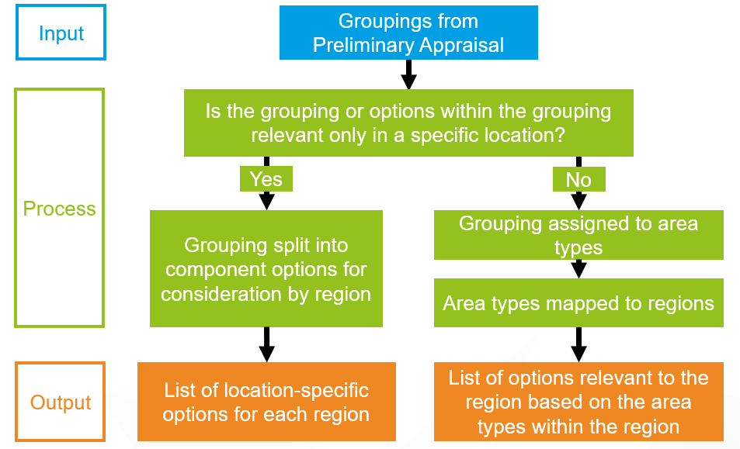
Figure 15 – Approach to Packaging
Groupings made up of location-specific interventions have been assigned directly to regions based on the location of the component interventions, ensuring that region-specific problems and opportunities are addressed. Groupings whose component interventions are not currently location-specific have been assigned to applicable area-based categories, which have then been mapped to regions, driving consistency in the types of measures that have been considered in regions made up of similar area-based categories. The area-based categories are described as follows:
Island Connectivity
This area-based category is primarily aimed at improving connections between the islands and the mainland, but also includes some improvements to island-island connectivity. Note: remote and accessible rural areas and any relevant towns and surrounding communities on islands are covered in the relevant area-based categories below.
Remote and Accessible Rural Areas
This area-based category is aimed at improving connections and transport provision between remote rural areas and accessible rural areas with key strategic services.
Towns and Surrounding Communities
This area-based category is aimed at improving active travel provision and placemaking within towns, addressing specific road infrastructure constraints, and improving strategic connections between towns.
Cities and City-Regions
This area-based category is focussed on Scotland’s seven cities and aligns with the City-Regions’ areas.
Inter-urban Corridors
This area-based category is aimed at improving safety, resilience and climate adaptation on the inter-urban corridors, and, where appropriate, targeted infrastructure investment to support sustainable inclusive growth.
Connections to Major Gateways
This area-based category is aimed at improving connections and transport provision to major international gateways and cross-border destinations.
National (for interventions that are Scotland-wide)
This area-based category is applicable across all areas of Scotland and includes behavioural change initiatives and investment in technological solutions to improve the performance of the transport system.
The key process stages of the Packaging approach are shown in
Figure 16.
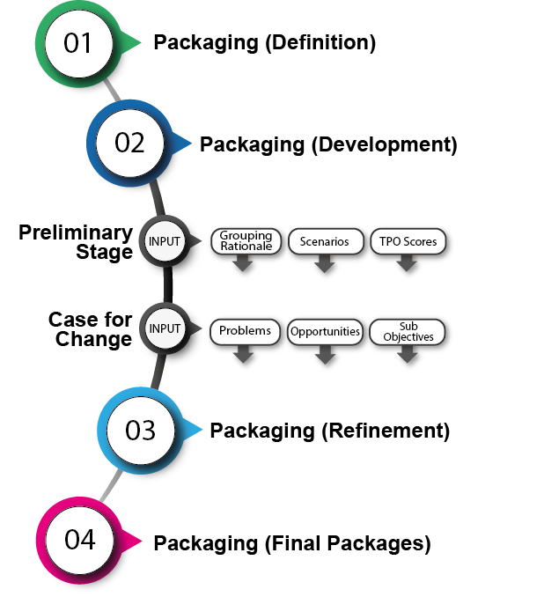
Figure 16 – Packaging: Key Process Stages

Packages Appraised
As discussed above, the Groupings and the interventions included in the Groupings that have been identified to be taken forward from the Preliminary Appraisal have been developed into multi-modal ‘Packages’ for the Detailed Appraisal. Eleven regional Packages and one Package of national interventions have been developed. The Packages are summarised within the ASTs contained in Appendix H.

Appraisal Approach
The Detailed Appraisal has appraised each Package under the two defined future scenarios noted above (the high and low Transport Behaviour Scenarios) with specific consideration given to the performance of Packages against the established policy directives, defined TPOs for the STPR2, the STAG criteria including the Statutory and Duty Impact Assessments, and Deliverability.
The scoring approach used for the Detailed Appraisal adopts a seven-point assessment scale ranging from major positive (+3) to major negative (-3) impacts, in line with STAG guidance and as shown within Appendix E.
The Detailed Appraisal has taken cognisance of updated guidance, as set out within the Scottish Transport Appraisal Guidance - Managers Guide published in January 2022. Appendix E shows how the updated STAG criteria maps with the previous criteria.
Candidate interventions emerging through the STPR2 development process have been appraised in a consistent and robust way to identify and address the key challenges of the STPR2, namely:
- achieving consistency and fairness across regions and nationally;
- fairly assessing across modes and interventions (both infrastructure and non-infrastructure interventions);
- the treatment of options that are considered viable but outwith the remit of the STPR2 to deliver;
- providing a robust audit trail of work, effectively tracking interventions through the process;
- dealing with uncertainty and the potential impacts of alternative future scenarios on option appraisal.
As discussed within Section 3.2, the Detailed Appraisal has followed STAG guidance, and, where appropriate, has supplemented the appraisal process by:
- reflecting Transport Scotland’s current policy position by embedding the vision, priorities and outcomes of the NTS2;
- taking on board new and emerging areas of appraisal research;
- ensuring the outcomes from the wider suite of Statutory and Duty Impact Assessments are fully integrated into the STPR2 appraisal process.
One of the key challenges for the Detailed Appraisal has been to capture the overall modal changes that are likely to occur as a result of the multi-modal Packages. The relevant appraisal tools identified for each component mode of transport, and in which the respective interventions for that mode have been assessed, are shown in Figure 17.
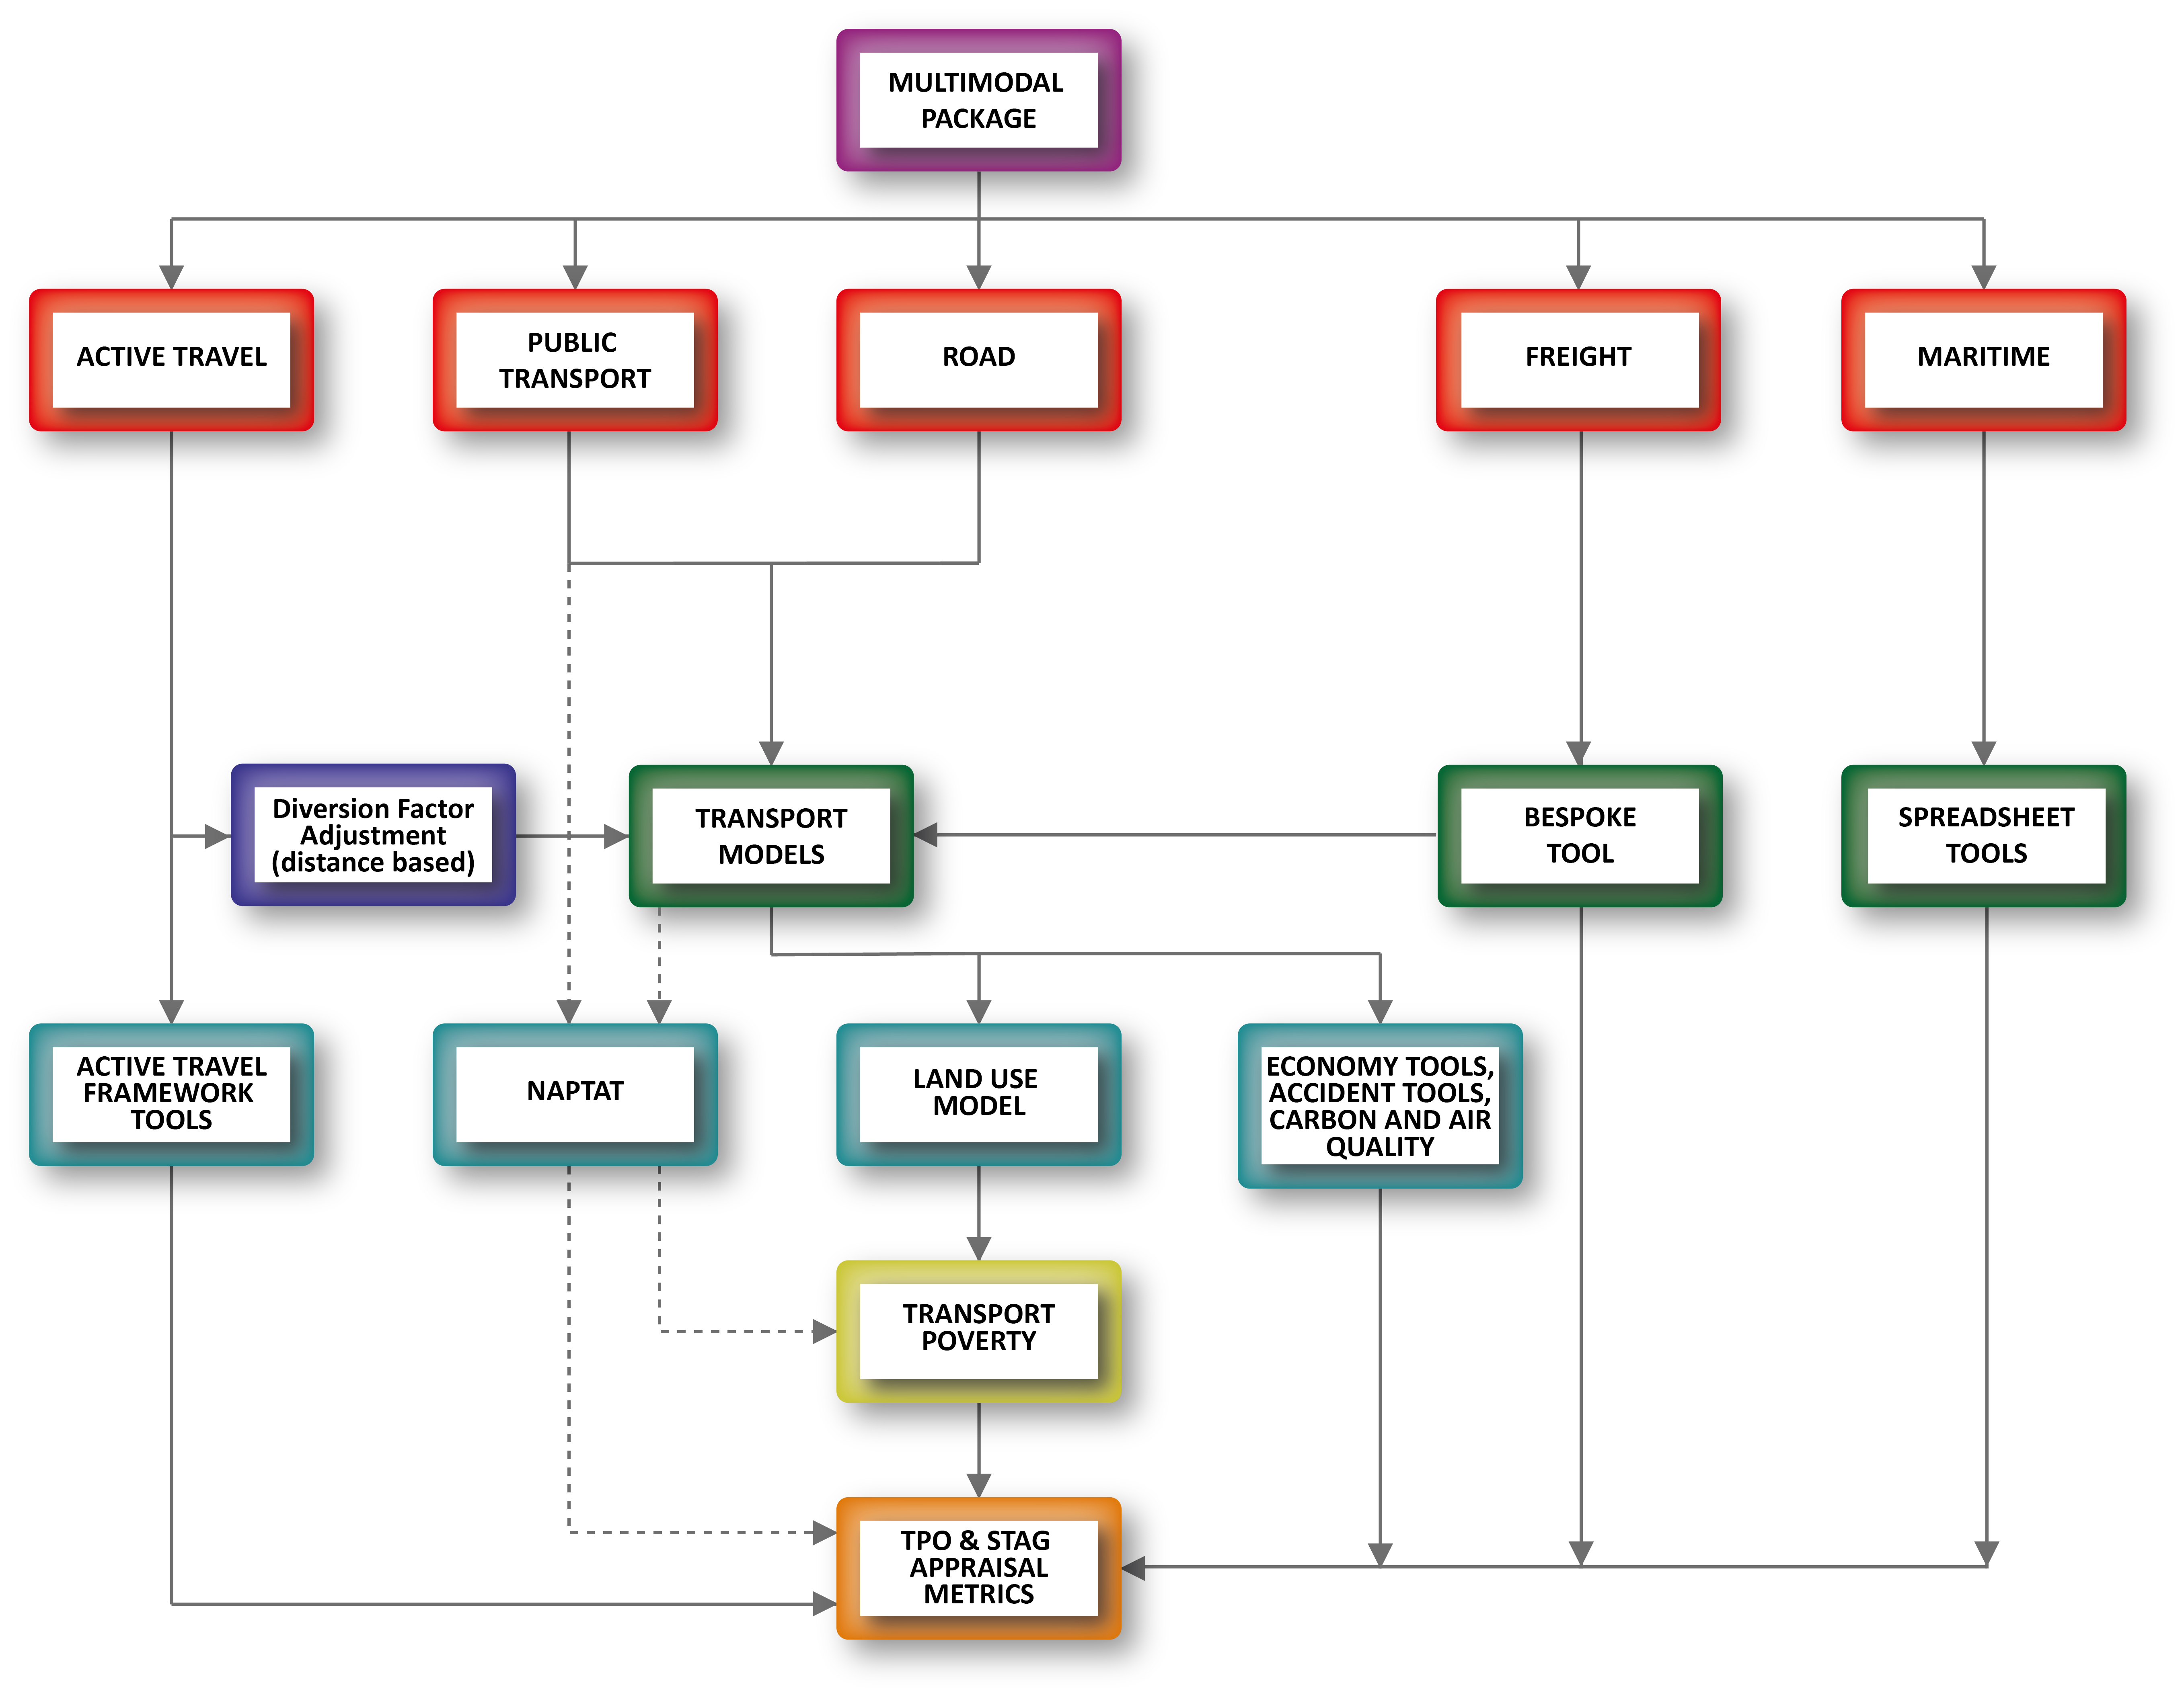
Figure 17 – Use of Modelling Tools
(The National Public Transport Accessibility Tool (NaPTAT) was developed to report on the accessibility and travel time level across Scotland, to assist with the appraisal stage of sustainable travel-related interventions.)

Reporting
Detailed ASTs have been prepared to provide a clear and concise record of the performance of each Package under the high and low Transport Behaviour Scenarios against the relevant TPOs and STAG criteria, policy alignment, and the Statutory and Duty Impact Assessments, with a summary of the appraisal metrics considered under each. Detailed Packaging ASTs are contained within Appendix H.
Similar to other stages of the project, the STPR2 webpage has been used as the landing page for content on appraisal.

Consideration of Climate Change Within The STPR2
The policy backdrop, upon which the STPR2 has been developed, sets out an overarching and urgent imperative to address climate change and to achieve net zero carbon emissions by 2045. The STPR2 has sought to embed these factors into the appraisal process from the very beginning, ensuring that interventions emerging from the STPR2 help to deliver the outcomes of the NTS2 and support wider net zero commitments.
The Detailed Appraisal has taken cognisance of updated STAG guidance, as set out within the Scottish Transport Appraisal Guidance - Managers Guide published in January 2022. This includes the new criterion of ‘Climate Change’, against which all Packages have been appraised.
Earlier stages of the STPR2 process, undertaken prior to the publication of the new STAG guidance, have adopted a number of approaches to strengthen the STAG-based appraisal, with a particular focus on ensuring the identification of sustainable transport interventions that support the priorities of the NTS2, including the priority ‘Takes Climate Action’. For example, at the Option Generation and Sifting stage (see Chapter Six), the Sustainable Travel Hierarchy and Sustainable Investment Hierarchy have been applied to promote interventions that prioritise walking, wheeling, cycling and public transport-based modes ahead of private car trips, and to ensure that interventions that reduce the need to travel unsustainably are prioritised over targeted infrastructure measures. Groupings and Packages (of interventions) assessed through the STPR2 work have been appraised against a set of TPOs (see Chapter Five) which have been directly informed by the priorities of the NTS2, including ‘Takes Climate Action’. This includes assessing interventions against the following TPO: A sustainable strategic transport system that contributes significantly to the Scottish Government’s net zero emissions target.
Groupings and Packages taken through the appraisal process have been assessed using a Scenario approach, as noted within Section 7.2.1 above, with consideration given to a range of possible futures and how interventions behave in them. One scenario describes a future in which the 20 per cent reduction in car kilometres by 2030 and net zero by 2045 are achieved. Performance of the Groupings and Packages under these scenarios has informed the Preliminary Appraisal and the Detailed Appraisal.
Details of the SEA are set out within the following Section.

Strategic Environmental Assessment and Climate Change
From the outset of the STPR2, an SEA has been undertaken to help avoid or minimise any potential negative environmental effects and maximise any opportunities for environmental enhancement (see Section 3.3 for further discussion). Under the Environmental Assessment (Scotland) Act 2005, an SEA of plans that are likely to have significant environmental effects, if implemented, is required. The first stage of the SEA was to produce a Scoping Report for public consultation. This included baseline data and a review of plans, programmes and strategies relevant to a range of environmental topics, including climate change. The baseline data included a regional and national review of relevant climate change data, including trends in greenhouse gas emissions and the projected impacts of climate change in each region of Scotland.
The baseline data and policy review informed the development of a set of SEA objectives to be used to assess the environmental performance of the STPR2. These were refined following public consultation and feedback from Transport Scotland and the statutory SEA Consultation Authorities: SEPA, NatureScot and Historic Environment Scotland. The SEA objectives have been used to undertake the environmental assessment of each stage of the STPR2. The SEA objectives used in relation to climate change are as follows:
- reduce emissions from Scotland’s transport sector by reducing the need to travel and encouraging modal shift and help meet Scotland’s wider targets to reduce greenhouse gas emissions;
- adapt the transport network to the predicted effects of climate change.
The whole suite of SEA objectives has been used to assess the STPR2 transport themes, recommendations and potential interventions. The assessment has involved a scoring of each of these, a cumulative effects assessment and a narrative to explain the scoring.
The assessment stage of the SEA has been used to inform the development of avoidance, mitigation and enhancement measures in relation to all environmental topics, including climate change. This has included SEA advice on how the STPR2 transport themes, recommendations and potential interventions may need to be changed in order to reduce any potential negative environmental effects and maximise any positive effects.
Opportunities for greenhouse gas emission reductions are discussed in the SEA, including opportunities to minimise any construction-related emissions. These opportunities are included in an SEA Chapter focused on strategic mitigation and enhancement measures for a range of SEA topics.
The SEA aims to ‘future-proof’ the STPR2 in relation to the projected impacts of climate change, including sea level rise, flooding from all sources, rainfall trends, storminess, temperature extremes and changes to seasons. It has emphasised the key risks of these climate impacts to the transport sector and identified opportunities for the STPR2 policies and interventions to avoid or minimise these risks. As all of the environmental topics considered in the SEA are inter-related, enhancement opportunities for other environmental topics, for example the protection of high-carbon soils and the implementation of biodiversity enhancements, will also have benefits in terms of climate change mitigation and adaptation.
The following Chapter sets out the recommendations from the STPR2 process.

Final Recommendations

Introduction
The role of the STPR2 is to provide the evidence base to recommend the transport investment priorities for Scottish Ministers for the next 20 years, in the face of great uncertainty and challenges. As we continue to emerge from the short-term impacts associated with the COVID-19 pandemic, it is vitally important to consider transport investments around the overall vision set out in the NTS2 to ensure that we continue, at pace, towards the delivery of a sustainable, inclusive, safe and accessible transport system, helping deliver a healthier, fairer and more prosperous Scotland for communities, businesses and visitors.
A total of 45 recommendations are presented in Section 8.2. These consist of some interventions that are specific to a particular location, others apply to certain regions in the country, and finally some of the recommendations are applicable across the whole country. In line with the regional approach underpinning the STPR2, a number of regional packages have been developed and appraised as set out in Section 7.3. Further details on the performance of the regional packages are contained in a number of ASTs which set out how each regional package performs against the TPOs and other criteria including the Impact Assessments (see Appendix H).
Within the list of recommendations, there are no specific priorities, as each component is important in addressing the complex needs of our nation, nor are these interventions the sole responsibility of Transport Scotland to deliver; indeed many will rely on working together or for others to take forward. However, by including these in the STPR2, Transport Scotland has confirmed its commitment to supporting and working in partnership with others to develop the recommended interventions. In many cases the interventions build on the individual investment and policy decisions taken in recent years, but the overall balance of the recommendations will help deliver the NTS2 and meet the commitments contained within the associated Delivery Plans.
The following Sections provide further details on the recommendations. For presentational purposes the recommendations have been grouped into six themes, as follows:
- Improving Active Travel Infrastructure;
- Influencing Travel Choices and Behaviour;
- Enhancing Access to Affordable Public Transport;
- Decarbonising Transport;
- Increasing Safety and Resilience on the Strategic Transport Network;
- Strengthening Strategic Connections.
It should be noted that, whilst the interventions have all been allocated to an individual theme, there are many that are complementary and indeed would deliver beneficial outcomes across several themes. Therefore, the individual theme that each intervention is assigned should not be interpreted too rigidly.
The following Sections introduce the 45 recommendations, grouped as outlined above. This covers the overall context for the particular category, then an explanation and rationale for each of the relevant recommendations. To demonstrate alignment to the NTS2 and the associated Delivery Plans, the text highlights the particular TPOs that each recommendation addresses. The text also highlights alignment to other recommendations, relevant policies, strategies and relevant documents.

Improving Active Travel Infrastructure
Encouraging more people to walk, wheel and cycle (active travel) more often:
- cuts carbon emissions;
- reduces inequalities by improving access to jobs, services and leisure;
- creates more pleasant communities;
- improves health;
- supports sustainable economic growth.
Better active travel routes create particular opportunities for people vulnerable to social exclusion such as disabled, young and older people, and those without access to a car.
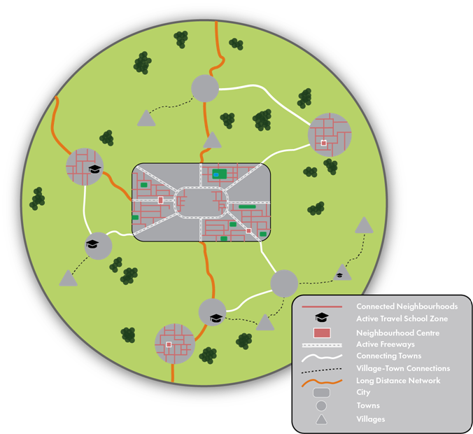
The STPR2 active travel infrastructure recommendations would work together, and with existing networks and links, to provide high-quality connections for people walking, wheeling and cycling within and between Scotland’s communities, aiming to be accessible and inclusive to as many people as possible. Three recommendations of the STPR2: Village-town active travel connections (3), Connecting towns by active travel (4) and Long-distance active travel network (5), would combine to provide a high-quality, safe nationwide active travel network connecting Scotland’s communities. These would integrate with existing networks including the National Cycle Network and provide links into and within urban areas via connected neighbourhoods and active freeways (the STPR2 Recommendations 1 and 2). Each of the five recommendations are described in more detail below.
To be effective, implementation of the STPR2 active travel infrastructure recommendations would require a partnership approach, principally with the local authorities and RTPs.

Connected neighbourhoods (1)
Connected neighbourhoods are the transport components of 20-minute neighbourhoods which are a mechanism of achieving better connected and more accessible communities designed in such a way that as many people as possible can meet the majority of their daily needs within a reasonable walk, wheel or cycle of their home. The principle can be adjusted to include varying geographical scales, and is also a key feature of the Revised Draft NPF4 in delivering Liveable Places. Connected neighbourhoods would encourage walking, wheeling and cycling for short everyday journeys, by delivering comprehensive, cohesive networks of high-quality active travel routes radiating (for approximately 800 metres) from key locations in town or neighbourhood centres, better connecting with nearby residential areas and public transport nodes.
The STPR2 recommends delivering connected neighbourhoods within towns and cities: the transport components of 20-minute neighbourhoods. They would consist of packages of improvements to active travel infrastructure in and around town and neighbourhood centres, for example to footways, road crossings and the urban realm, aiming to create more accessible and inclusive environments for people walking, wheeling, cycling and spending time in their local areas. In large urban areas, different connected neighbourhoods could be linked by active freeways (Recommendation 2).
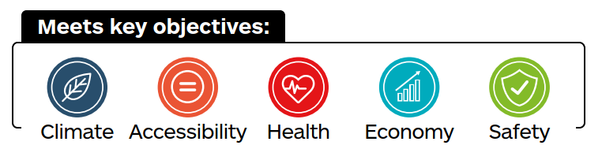
This recommendation aligns with:
- Recommendations 2, 3, 4, 5, 8, 9, 10 and 37;
- 2020 Programme for Government and the Revised Draft NPF4 Liveable Places – this promotes the value of 20-minute neighbourhoods, which include retail, education and health opportunities alongside transport improvements;
- Transport Scotland’s Active Travel Framework which sets out a vision that “Scotland’s communities are shaped around people, with walking or cycling the most popular choice for shorter everyday journeys.”

Active freeways and cycle parking hubs (2)
Active freeways would encourage more people to walk, wheel and cycle more often by providing high-quality direct active travel routes, segregated from traffic, on busy corridors in large urban areas. By improving safety, active freeways would help to address fear of road danger, the biggest single barrier to increasing active travel. Secure cycle parking hubs would be created at key locations in settlements that have active freeway networks in order to cater for increased cycle usage.
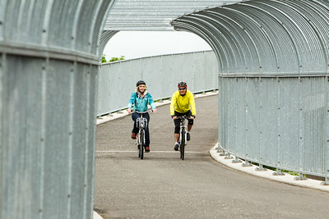
The STPR2 recommends development of active freeways on radial routes and other high-demand corridors in Scotland’s large urban areas, with priority given initially to the larger cities. Comprehensive networks of active freeways would connect outlying neighbourhoods, including those with poor existing links, to city/town centres and other important destinations.
Supporting connections (including those delivered by Connected neighbourhoods (1)) would allow people to readily access active freeways from their homes, schools and workplaces, and other busy locations. Active freeways would also connect to other routes to provide links to neighbouring settlements.
To cater for the increased demand for bike parking that the freeways would create, high-quality, secure cycle parking hubs could be developed in urban centres and other busy locations that would be served by active freeway networks.
This recommendation aligns with:
- Recommendations 1, 3, 4, 5 and 9;
- Transport Scotland’s Active Travel Framework which sets out a vision that “Scotland’s communities are shaped around people, with walking or cycling the most popular choice for shorter everyday journeys.”;
- the Revised Draft NPF4 National Development 8: National Walking, Cycling and Wheeling Network.
Inter-urban Active Travel Routes (3,4,5)
The following three recommendations combine to provide a nationwide network connecting Scotland’s communities for people walking, wheeling and cycling.
Providing high-quality, safer and more convenient routes will encourage more walking, wheeling and cycling. A key factor is addressing safety fears through effective segregation from traffic, only making use of on-road routes if they are quiet and have low traffic speed limits.
These routes would deliver environmental improvements and provide health benefits to people walking, wheeling and cycling. They would also help address social exclusion faced by people often excluded from transport, such as disabled, young and older people, and those without access to a car.

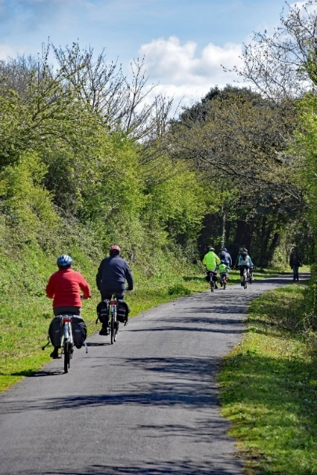
Village-town active travel connections (3)
The STPR2 recommends the creation of new and improved active travel routes to connect smaller rural communities with nearby towns, using high-quality active travel infrastructure that segregates users from busy roads but makes use of quiet roads where appropriate, to ensure that active travel becomes a more attractive option for local travel. Village-town active travel connections would be developed to support journeys by active modes, encourage a switch from short rural car trips and allow people to benefit from improved access to local goods and services.
This recommendation aligns with:
- Recommendations 1, 2, 4, 5 and 9;
- Transport Scotland’s Active Travel Framework which sets out a vision that “Scotland’s communities are shaped around people, with walking or cycling the most popular choice for shorter everyday journeys.”;
- the Revised Draft NPF4 National Development 8: National Walking, Cycling and Wheeling Network;
- The National Cycle Network – any new routes would be integrated with existing networks, building on the good work that has been done to date on the National Cycle Network and other active travel routes.

Connecting towns by active travel (4)
The STPR2 recommends creating new and improved active travel routes between Scotland’s towns using high-quality active travel infrastructure, segregated from traffic. Connecting towns’ routes would ensure that towns not served by the Long-distance active travel network (5) are linked to nearby cities and towns. Priority would be given to connecting settlements that are relatively close, and where opportunities for modal shift from car to active travel are greatest.
This recommendation aligns with:
- Recommendations 1, 2, 3, 5, 9 and 39;
- Transport Scotland’s Active Travel Framework which sets out a vision that “Scotland’s communities are shaped around people, with walking or cycling the most popular choice for shorter everyday journeys.”;
- the Revised Draft NPF4 National Development 8: National Walking, Cycling and Wheeling Network;
- The National Cycle Network – any new routes would be integrated with existing networks, building on the good work that has been done to date on the National Cycle Network and other active travel routes.

Long-distance active travel network (5)
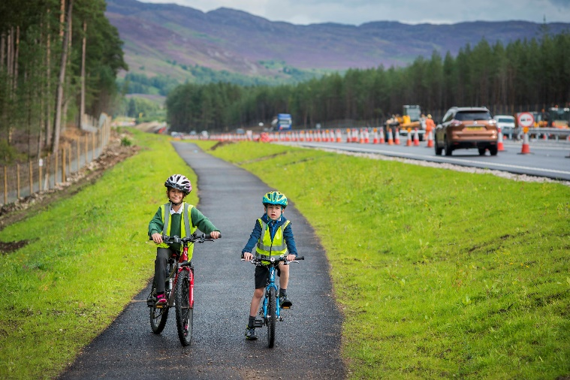
The STPR2 recommends creating new, and improving existing, active travel routes to connect Scotland’s cities, regions and major gateways, using high-quality active travel infrastructure that segregates users from busy roads, but makes use of quiet roads where appropriate. Although available for long-distance active journeys, it is anticipated that most benefit is likely to arise from use of the routes for relatively short journeys between or within the communities that the network would pass through. The long-distance active travel network would enhance the existing National Cycle Network to create a strategic national network of active travel routes mirroring in part the trunk road and rail networks.
This recommendation aligns with:
- Recommendations 1, 2, 3, 4, 6 and 9;
- Transport Scotland’s Active Travel Framework which sets out a vision that “Scotland’s communities are shaped around people, with walking or cycling the most popular choice for shorter everyday journeys.”;
- the Revised Draft NPF4 National Development 8: National Walking, Cycling and Wheeling Network;
- The National Cycle Network – any new routes would be integrated with existing networks, building on the good work that has been done to date on the National Cycle Network and other active travel routes.

Influencing Travel Choices and Behaviour
The recommendations in this theme focus on influencing people to make healthier, more sustainable and safer travel choices.
Some - Behavioural change initiatives (6), Increasing active travel to school (8), and Improving access to bikes (9) - seek to encourage and enable more people to make use of active, public and shared modes of transport. As well as delivering benefits in their own right, these interventions would also improve the value provided by many other recommendations of the STPR2 by enabling more people to make use of the infrastructure and services provided.
Other recommendations in this theme - Changing road user behaviour (7), and Expansion of 20mph limits and zones (10) - seek to improve road safety by reducing traffic speeds and promoting more responsible road use. These would not only generate benefits of fewer accidents, but also help overcome perceptions of road danger, which can be a key barrier to use of active modes.
To be effective, implementation of these recommendations of the STPR2 would require a partnership approach between the many public, private and community organisations involved in delivering changes in travel choices and behaviour.
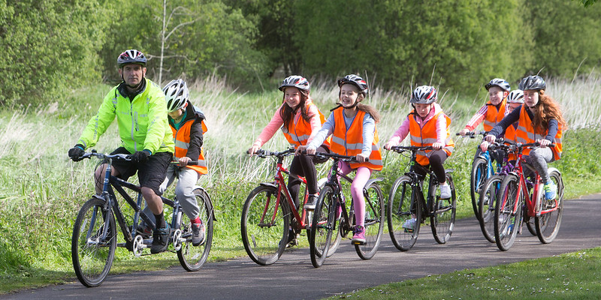

Behavioural change initiatives (6)
Encouraging more people to make active and sustainable transport choices more often would have significant health, inclusion and environmental benefits. There is growing evidence of the effectiveness of behavioural change initiatives to increase awareness and use of active and sustainable modes.
The STPR2 recommends building on existing programmes to deliver local, regional and national initiatives that provide encouragement, enablement and incentivisation for more people to make use of active and sustainable choices more often. Activities would raise awareness of sustainable transport options and encourage individuals to make the most appropriate transport choice for their journeys, such as walking, wheeling, cycling, public transport or shared mobility services, or to encourage use of systems such as Mobility as a Service (MaaS). Activity would build upon successful experience in Scotland, much of which is delivered by the Transport Scotland-funded Smarter Choices, Smarter Places (SCSP) programme.
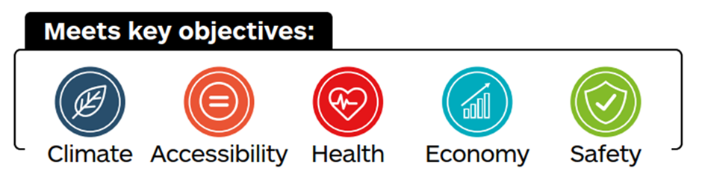
Initiatives would include providing information, campaigns and promotional activities, financial incentives and community events. These initiatives are likely to be most effective if they raise awareness of new infrastructure and services, including those delivered by other recommendations of the STPR2; if they influence people experiencing life events (such as starting a family, changing job or starting/leaving school); and if the interventions being promoted are of high-quality and relevant to that individual.
This recommendation aligns with:
- many other recommendations of the STPR2 across a range of transport modes and types of activity: Recommendations 1, 2, 3, 4, 5, 7, 8, 9, 10, 11, 12, 13, 20, 22, 23 and 37;
- Transport Scotland’s Active Travel Framework which sets out a vision that “Scotland’s communities are shaped around people, with walking or cycling the most popular choice for shorter everyday journeys.”;
- Transport Scotland-funded SCSP programme – this recommendation of the STPR2 would build on this and similar successful programmes;
- the Scottish Government’s Individual, Social, Material (ISM) Tool which identifies that changing people’s behaviours relies on amending individual, social and material factors that influence their choices.

Changing road user behaviour (7)
Scotland’s Road Safety Framework has a vision for Scotland to have the best road safety performance in the world by 2030. The framework is aligned with the NTS2 and embeds the Safe System approach to road safety delivery, which consists of five key pillars focusing efforts not only on road traffic casualty reduction (vulnerability of casualties) but also on road traffic danger reduction (sources of danger). This recommendation seeks to address three of the five pillars: Safe Speeds, Safe Road Use and Safe Roads and Roadsides. Ensuring all road users understand their road safety responsibilities can increase respect between users and improve attitudes and behaviours for the safety of themselves and others. This results in more responsible behaviour which, combined with speed enforcement, leads to fewer road casualties. This recommendation complements a broad range of other recommendations of the STPR2 seeking to promote inclusive accessibility by healthy and sustainable modes.
The STPR2 recommends implementation of speed enforcement technology, in line with the Scottish Safety Camera Programme Handbook, and national road safety behaviour change campaigns, education and training initiatives (for example, Give Cycle Space and Road Safety Week) to enable all users to understand their road safety responsibilities. These interventions would contribute towards the Scottish Government’s Vision Zero strategy to help to deliver the outcomes of Scotland’s Road Safety Framework. They would contribute to reducing traffic speeds and increasing understanding and respect between all road users. This would reduce road casualties and create safer environments which promote inclusivity and encourage people to make more active travel choices.
Improving safety is particularly important given other recommendations of the STPR2, which also seek to encourage more walking, wheeling and cycling. This would mean that the need for safer travel for everyone becomes more important as the interactions between all types of road users increase.
This recommendation aligns with:
- many other recommendations of the STPR2, in particular those that seek to promote inclusive accessibility by healthy and sustainable modes: 6, 8, 10, 30, 35, 37 and 38;
- Scotland’s Road Safety Framework – this is based on a vision for Scotland to have the best road safety performance in the world by 2030. The framework is based on the Safe System; this recommendation seeks to address three of the five pillars of the Safe System: Safe Speeds, Safe Road Use and Safe Roads and Roadsides;
- changes to the Highway Code introduced in early-2022: this includes the ‘Hierarchy of Road Users’ that places road users most at risk in the event of a collision (including pedestrians and cyclists) at the top of the hierarchy. The rules also highlight “…the responsibility of ALL road users, including pedestrians, cyclists and horse riders, to have regard for their own and other road users’ safety”.

Increasing active travel to school (8)
Increasing walking, wheeling and cycling to school leads to health and wellbeing benefits for young people, their family groups and carers. This can help create healthy active travel habits for life.
The school run is a significant contributor to traffic levels and rates of walking to school in Scotland have been steadily declining over the past decade, only partly offset by increased cycling and scooting. Concern about road safety is one of the barriers to active travel most reported by parents and carers. This recommendation would seek to improve active travel routes, reduce traffic volumes and speeds, tackle congestion and thereby increase the uptake of active travel to schools.

The STPR2 recommends improved and safer walking, wheeling and cycling routes to primary and secondary schools, created through a comprehensive package of local infrastructure schemes such as reallocation of road space, improved crossing points, improved surfacing and lighting, and supported by traffic speed reduction measures and School Streets schemes where appropriate (School Streets schemes are sections of roads around schools that are closed to vehicular traffic during school drop-off and pick-up times, creating pedestrian- and cycle-only zones in the vicinity of schools). This recommendation would also include behavioural change measures to promote better driver behaviour around schools (such as safe parking and no engine idling initiatives) and to provide encouragement for pupils and their families to travel safely and actively.
Where schools are in or close to neighbourhood centres, improvements would be planned jointly with Connected neighbourhoods (1).
Interventions would build upon the work that local and regional partners have been leading, to plan and implement measures at and around schools across Scotland. Evidence from where school active travel schemes have been implemented has shown that considerable benefits can be realised for social inclusion, safety, and health and wellbeing for young people and their family groups, as well as modal shift and environmental improvements.
This recommendation aligns with:
- Recommendations 1, 6, 7, 9, 10 and 37;
- Transport Scotland’s Active Travel Framework which sets out a vision that “Scotland’s communities are shaped around people, with walking or cycling the most popular choice for shorter everyday journeys.”;
- the Scottish Government and Scottish Green Party draft shared policy programme (The Bute House Agreement) – committed to working in partnership with local authorities to “deliver more Safe to School initiatives, with the aim of ensuring every child who lives within two miles of school is able to walk or wheel safely”;
- local and regional partners’ active travel schemes around schools across Scotland;
- the Revised Draft NPF4 20-minute neighbourhoods supporting Liveable Places.

Improving access to bikes (9)
The benefits of any investment in new or existing cycle route infrastructure can only be realised by people that have access to a bike. The cost of a bike and associated accessories – such as lights, locks and helmets – can be significant for many people, especially families or people who need more specialist cycles. Research shows that people experiencing social and economic hardship are less likely to use active modes of travel. Only one-third of Scottish households have access to one or more cycles; this falls to under one-fifth of households with a net annual income of below £15,000,. Furthermore, many households will not have cycles that suit every individual, nor have all appropriate accessories to safely use and store cycles.
There is also often a lack of access to training or support that would give people the necessary confidence and skills to cycle.
As such, providing access to bikes, training and support would play a key role in enabling more people to cycle. In addition to health, environmental and accessibility benefits, this would also realise the benefits of investment in cycle routes.
The STPR2 recommends improving access to bikes through a multi-faceted programme of interventions to enable people to cycle (and also to support walking and wheeling as appropriate) and to give them confidence and skills to do so, such that they can make use of new or existing active travel infrastructure.
Interventions would build on existing successful programmes and the work of established support groups. Interventions could include community bike libraries, cycle repair schemes, cycle hire schemes, cycle storage for flats and tenements, and free and subsidised access to cycles and accessories for organisations and lower-income households. Measures would be designed to meet local community needs and address inequality by targeting the specific socio-demographic groups who would most benefit from cycling (and walking and wheeling as appropriate), including young people, women, older people, disabled people, individuals with health problems and people from more deprived communities.
This recommendation aligns with:
- Recommendations 1, 2, 3, 4, 5, 6, 8, 20 and 22;
- Transport Scotland’s Active Travel Framework which sets out a vision that “Scotland’s communities are shaped around people, with walking or cycling the most popular choice for shorter everyday journeys.”;
- existing programmes including those being developed by Transport Scotland - these include the current free cycles for schoolchildren pilot project which would be rolled out as a national scheme, to provide cycles and accessories to children in lower-income households who cannot afford a bike.

Expansion of 20mph limits and zones (10)
The Programme for Government commitment includes delivering a safer speed limit of 20mph on appropriate roads by 2025. Good progress has been made in identifying the criteria assessment process and criteria has been agreed with the Society of Chief Officers of Transportation in Scotland (SCOTS) and COSLA. Introducing more 20mph speed limits and zones at appropriate locations in cities, towns and villages can reduce speeding traffic, thereby reducing fear of road danger, which is a significant barrier to walking, wheeling and cycling for some people.
Evidence indicates that road casualty rates fall with the introduction of 20mph zones, and accident survival rates are up to five times higher when a pedestrian is hit by a car driving at 20mph compared to 30mph,. Safer environments can encourage more people to walk, wheel and cycle more often.
In addition to benefitting people travelling by active modes, lower speeds also increase the safety of people travelling in vehicles.
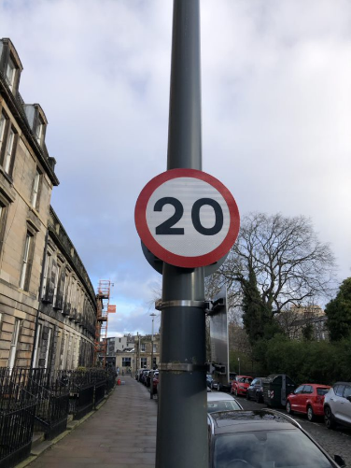
The STPR2 recommends supporting the Scottish Government’s 20mph Task Group by scaling up current local programmes and initiatives to provide new or expanded 20mph limits and zones on appropriate roads in cities, towns and villages across Scotland. These would typically be residential streets, as well as those in neighbourhood centres and near other key trip generators where there are high levels of pedestrian activity. Most 20mph measures would be on local (non-trunk) roads controlled by local authorities; a partnership working approach to delivery is therefore essential. Accompanying road safety campaigns would encourage better driver behaviour in 20mph zones.
These measures complement a broad range of other recommendations of the STPR2 seeking to create safer environments that would address one of the main barriers to people walking, wheeling and cycling.
This recommendation aligns with:
- Recommendations 1, 6, 7, 8, 37 and 38;
- the Scottish Government and Scottish Green Party draft shared policy programme (The Bute House Agreement) – states that “all appropriate roads in built up areas will have a safer speed limit of 20mph by 2025…”;
- Scotland’s Road Safety Framework to 2030 – highlights that almost half of serious injuries, and 82 per cent of serious pedestrian casualties, occur on roads with 30mph speed limits (typically urban or suburban roads), meaning measures focussing on these areas can potentially make a significant contribution to overall casualty reduction;
- the Scottish Government 20mph Task Group – established by Transport Scotland, this will plan the most effective implementation for these measures;
- Scottish local authorities’ plans and policies, many of which have already started to introduce widespread 20mph limits on their roads.

Enhancing Access to Affordable Public Transport
For many people, having access to affordable and reliable public transport is necessary, as it allows access to jobs, education and key services. This applies to those living in rural areas as well as in our towns and cities. Investment in necessary infrastructure will encourage greater use of public transport which, in turn, will result in a reduction of car-based trips and associated emissions.
Addressing the differing needs of the population requires a suite of recommendations that recognise the particular challenges and barriers to those travelling by public transport. This includes improvements to transport stations and interchanges (18, 19, 21, 22), and developing suitable Smart integrated ticketing and payment schemes (23) to enhance the overall accessibility and affordability of the services.
Complementing these are a range of measures that deal with more heavily populated city regions. These include recommendations where mass transit can provide a transformational change in the service provision (11, 12, 13) and those focusing on strategic routes or corridors where bus and rail provide the most effective service (14, 15, 16, 17). In addition, bespoke interventions can reflect the particular needs of the less heavily populated communities through an expansion of Demand Responsive Transport (DRT) and MaaS (20).

Clyde Metro (11)
The Glasgow City Region is a geographically diverse region that includes the Glasgow conurbation and wide variation in levels of deprivation. The Region accounts for the highest levels of deprivation across all of the STPR2 regions. Within the Region, availability of public transport choices varies, and the suburban rail network is serving a mix of short- and longer-distance journeys with some capacity problems and associated inefficiencies. The impact of congestion on the strategic road network, and local corridors that buses use, also impacts on the attractiveness of public transport. These challenges translate into a dominance of journeys by car across the Region.
Metro transport systems include one of, or a combination of, bus rapid transit, tram, light rail and metro rail. These options would complement the service provided by traditional railways and may include the conversion from existing railways to tram or heavy metro.
Clyde Metro is aimed to serve and improve connectivity within the Glasgow conurbation, through the development of a new modal tier which would provide high quality public transport links to key hubs (for example city centre, hospitals, major education facilities, key employment centres, retail hubs, and major leisure/sports facilities) and major transport hubs (for example Glasgow Central and Queen Street railway stations, Glasgow Airport and suburban interchanges), together with unserved or underserved areas.
Clyde Metro would have a key role to play in tackling social exclusion. Clyde Metro would also support national-level priorities such as Clyde Mission, to help drive sustainable and inclusive growth throughout both the city and Region; and would provide significant capacity for modal shift and help reduce greenhouse gas emissions and improve air quality.
Clyde Metro would offer relief for the heavy rail network, freeing rail capacity for longer-distance journeys.
The STPR2 recommends that Transport Scotland continues to work with Glasgow City Council, Strathclyde Partnership for Transport and other regional partners in the development of Clyde Metro including the business case, design and governance. This would address the gap in public transport provision in the Region, allowing more effective rail operations, creating capacity for longer-distance high speed rail connections and providing connectivity between areas of deprivation and education, employment and leisure opportunities. Priority would be given to those solutions that can connect unserved and underserved areas. By integrating with the Region’s current bus and heavy rail networks, as well as links with active travel, it would provide much improved connectivity between the city and the surrounding communities, and between the communities themselves. This would tackle deprivation issues in the Region and encourage a switch from private car use to public transport and other more sustainable travel options.

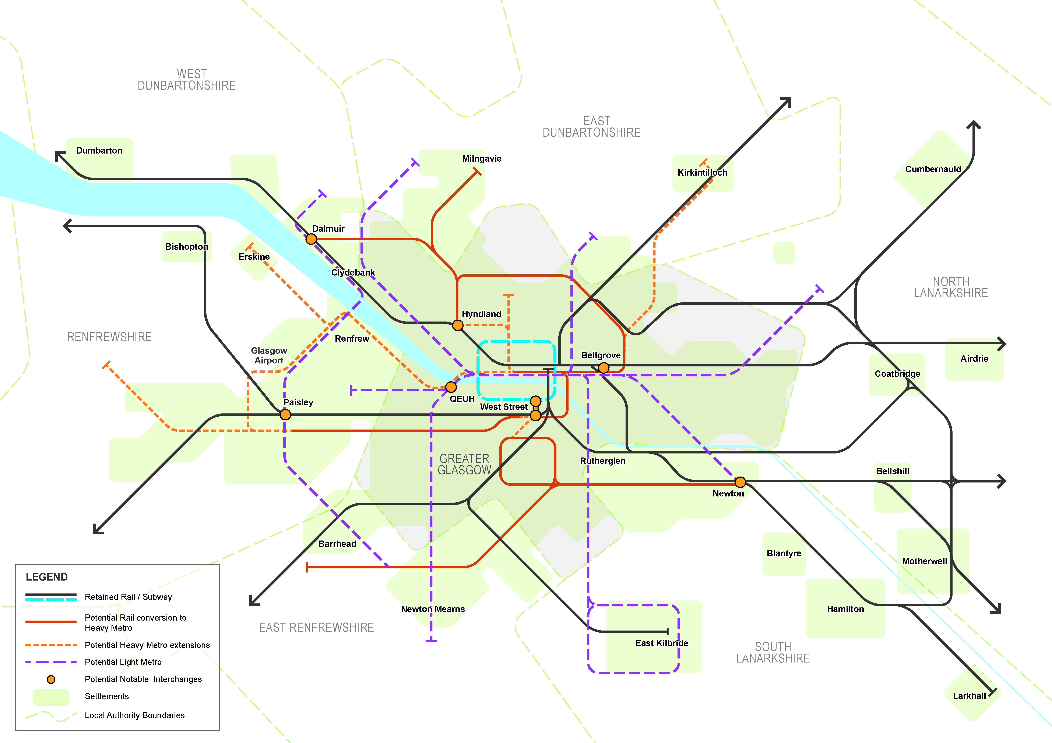
Figure 18 – Indicative Extent of Clyde Metro
This recommendation aligns with:
- Recommendations 6, 14, 17, 21, 22, 23, 43 and 45;
- the Revised Draft NPF4 National Development 6: Urban Mass/Rapid Transit Networks, 13: Clyde Mission and 18: High Speed Rail.
- the Revised Draft NPF4 Central priority area, which proposes that priorities for the area include pioneering low carbon, resilient urban living and improved low carbon transport. This recommendation contributes to these priorities and supporting actions;
- the Bus Partnership Fund – as a source of funding to reduce the negative impacts of congestion on bus services and address the decline in bus patronage;
- the Regional Transport Strategy: Strathclyde Partnership for Transport published the Regional Transport Strategy for consultation in August 2022. The draft Strategy document highlights Clyde Metro as a key opportunity for the region;
- the Strategic Development Plan within which Clydeplan, the Glasgow and Clyde Valley Strategic Development Planning Authority, sets out plans around the City Region as a successful, sustainable place, a low carbon place, a natural and resilient place and a connected place.

Edinburgh and South East Scotland Mass Transit (12)
Edinburgh and South East Scotland is a geographically diverse Region that includes a major city, urban areas and accessible and remote rural communities, with corresponding variable access to public transport throughout the Region. Within the Region, there are more limited public transport choices for cross-boundary trips and an increased need for interchange leading to longer journey times. The impact of congestion on the strategic road network and local corridors that buses use also impacts on the attractiveness of public transport. These challenges translate into a dominance of journeys by car across the Region.
A mass transit system for the Region would provide more public transport options for cross-boundary travel, reducing the need to make unnecessary changes between services, leading to lower journey times. This would improve Region-wide connectivity and encourage a switch from car to public transport and other more sustainable travel options. The system would include cross-boundary routes along key corridors within and around the City of Edinburgh, as the main population and economic area of the Region. The primary purpose would be to facilitate end-to-end sustainable transport journeys. The introduction of new Regional interchanges would also form part of the mass transit system.
The system would focus on key corridors of demand as well as where congestion impacts on bus services and where the public transport offer is more limited, including targeting more disadvantaged areas where there can be greater dependence on public transport. This would increase travel choices to access employment, education, healthcare and other services and help to address inequalities. This would also reduce the need to travel unsustainably and contribute to targets for lower emissions and the reduction in car vehicle-kilometres travelled, as well as placemaking.
The STPR2 recommends that Transport Scotland works with Regional partners to develop and enhance the cross-boundary public transport system for the Region, potentially comprising tram and bus-based transit modes including Bus Rapid Transit and bus priority measures. This would complement and integrate with the Region’s current bus, tram and heavy rail networks, to provide improved connectivity between the City of Edinburgh and the surrounding communities in the Region, as well as more direct connections between communities outside Edinburgh.
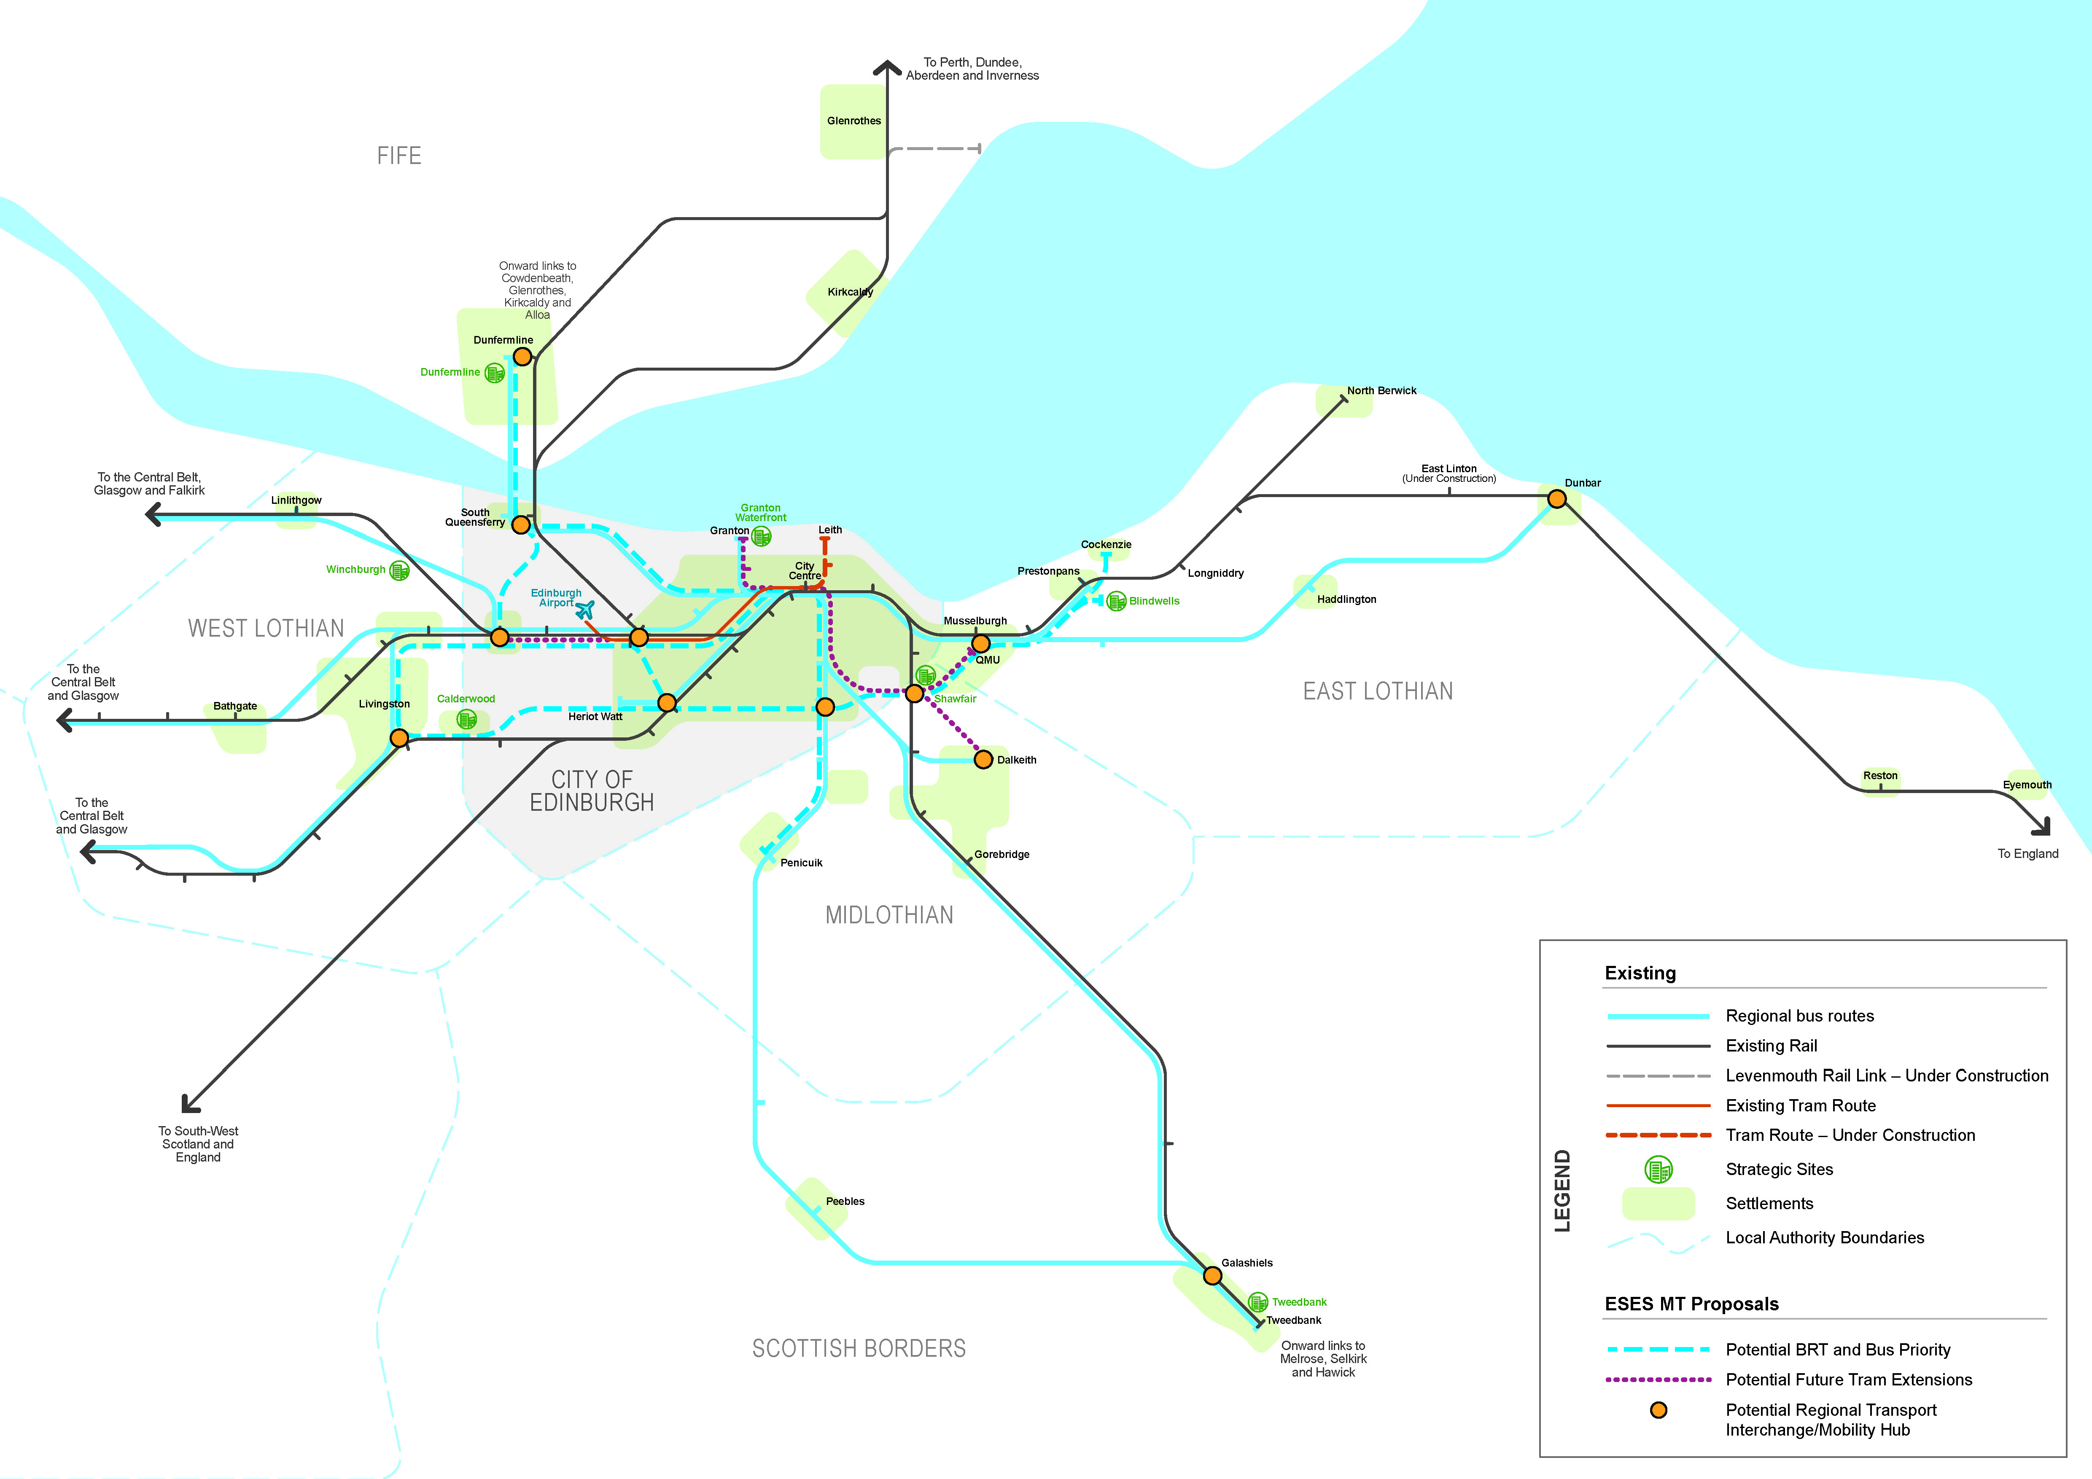
Figure 19 – Indicative Extent of Edinburgh and South East Scotland Mass Transit
This recommendation aligns with:
- Recommendations 6, 14, 17, 21, 22, 23, 43 and 45;
- the Revised Draft NPF4 National Development 6: Urban Mass/Rapid Transit Networks and 9: Edinburgh Waterfront. This recommendation sits within the Revised Draft NPF4 Central priority area which proposes that priorities for the area include pioneering low carbon, resilient urban living, and improved low carbon transport. This recommendation contributes to these priorities and supporting actions;
- Regional Development plans – enabling integrated sustainable travel within the city-region and access to existing as well as new development sites;
- Edinburgh and South East Scotland City Region Deal - complementing projects being taken forward, such as the West Edinburgh Transport Improvement Programme, elements of which may form part of the mass transit system. This recommendation would also be complemented by the commitment of Partners within the Deal to put in place a Regional Developer Contributions Framework for cross-boundary interventions;
- the Bus Partnership Fund – appraisal work to explore opportunities for bus priority and how these would align with other key transport projects in the City of Edinburgh is being funding through the Bus Partnership Fund. Funding of further stages is subject to fund criteria and evaluation processes;
- the Regional Transport Strategy – the draft Regional Transport Strategy was published by The South East of Scotland Transport Partnership (SEStran) for consultation in November 2021. This recommendation would contribute to the objectives set out in the draft strategy.

Aberdeen Rapid Transit (13)
A bus-based rapid transit system for the region would provide more competitive and efficient public transport into and around the Aberdeen City region. This would improve region-wide connectivity and encourage a switch from car to public transport and other more sustainable travel options. The system would focus on key corridors of demand as well as where congestion impacts on bus services. Travellers switching from car to public transport would reduce the congestion impacts on bus services as a result of high car usage and offer opportunities for placemaking improvements to support healthy and active lifestyles.
The system would help to deliver air quality benefits and improve public transport journey times and journey time reliability, making sustainable travel options more attractive.
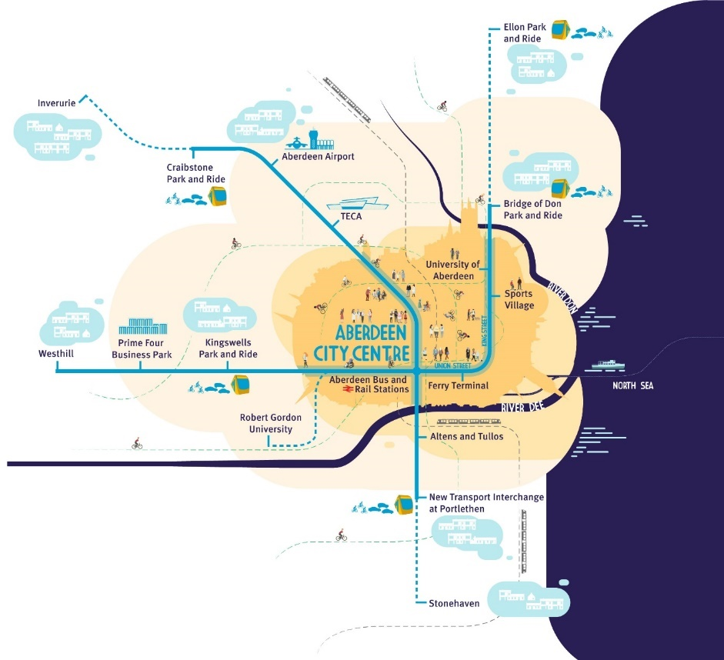
Figure 20 – Network Vision from ‘Aberdeen Rapid Transit – Our Vision’ document (Source: Nestrans)
The STPR2 recommends that Transport Scotland continues to work with Nestrans, Aberdeen City Council and Aberdeenshire Council in developing plans for Aberdeen Rapid Transit. This could be progressed using the Bus Partnership Fund. The rapid transit system would prioritise buses and connect two proposed corridors: Bridge of Don Park and Ride – Westhill (via City Centre); and Craibstone Park and Ride – (proposed) Portlethen Transport Interchange (via City Centre).
This recommendation aligns with:
- Recommendations 6, 14, 21, 22 and 23;
- the Revised Draft NPF4 National Development 6: Urban Mass/Rapid Transit Networks and 14: Aberdeen Harbour. This recommendation sits within the Revised Draft NPF4 North East priority area and proposes that priorities for the area include actively planning the transition from oil and gas to a net zero future. This recommendation contributes to these priorities and supporting actions;
- Nestrans’ Regional Transport Strategy 2040, which has as one of the desired outcomes “Providing mass transit which can support the economic aspirations, social requirements and environmental improvements necessary for a successful city region.”;
- the Bus Partnership Fund – as a source of funding to reduce the negative impacts of congestion on bus services and address the decline in bus patronage;
- continued growth in land-use across the region, particularly around the outskirts of Aberdeen – this provides an opportunity to expand the existing public transport network.

Provision of strategic bus priority measures (14)
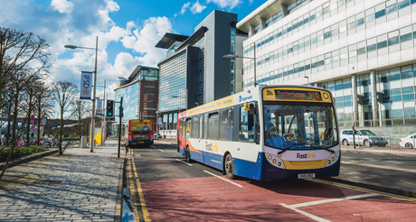
Bus priority measures, including reallocation of road space, can deliver greater punctuality and faster journey times. Research shows that such benefits would increase the attractiveness of travel by bus and help reverse the continued decline in use. Switching from car to this greener, cleaner option is essential if Scotland is to meet its net zero carbon emission target and the need for action is urgent, as confidence in the safety of travel by bus has reduced as a result of the COVID-19 pandemic.
Source: Strathclyde Partnership for Transport
The STPR2 recommends bus priority interventions are implemented within Scotland’s cities and towns where congestion is highest and that bus priority measures continue to be identified and implemented on the trunk road and motorway network. These could be taken forward within local networks using the Bus Partnership Fund process or similar.
In the case of the trunk road and motorway network, Transport Scotland would build on the current work progressing plans for the M8, M77 and M80, as well as the CAVForth project between Fife and Edinburgh. Additional locations that are recommended for further appraisal include the M90 southbound between Junctions 1C and 1B, and A90 Forfar Road southbound at the Kingsway in Dundee.
This recommendation aligns with:
- Recommendations 11, 12, 13, 33, 34, 35 and 39;
- COVID-19 pandemic economic recovery plans - bus priority measures would increase the attractiveness of bus as a mode of transport, assisting with the recovery in bus patronage;
- the Bus Partnership Fund – as a source of funding to reduce the negative impacts of congestion on bus services and address the decline in bus patronage;
- the Revised Draft NPF4 National Development 6: Urban Mass/Rapid Transit Networks, 9: Edinburgh Waterfront, 10: Dundee Waterfront and 13: Clyde Mission. It also contributes to a number of priorities and actions for the NPF4 regional spatial priorities across Scotland.
Strategic Rail Enhancements
The COVID-19 pandemic has highlighted significant challenges for rail with respect to maintaining financial viability. The sector must meet changing passenger and freight customer requirements and achieve the growth required to meet Scottish net zero, rail freight and car travel reduction targets.
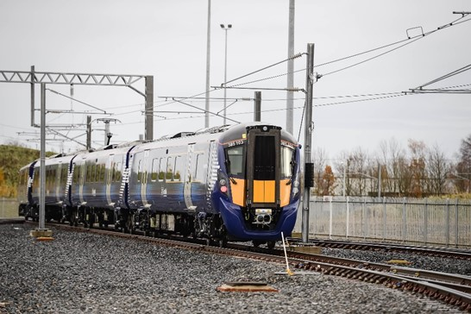
For passengers, rail is typically best suited to the higher volume ‘trunk’ element of city-to-city journeys, complementing door-to-door connectivity by bus, active travel, and, where appropriate, adequate parking facilities. For freight, rail is often suited to longer-distance bulk/inter-modal freight. Future passenger rail investment should therefore be targeted on the strongest city-to-city markets as these are the routes where the greatest value from improvements will be realised, and freight investment on corridors from the Central Belt towards Aberdeen, Inverness and cross-border routes.
The next three recommendations provide detail on the specific corridor enhancements.

Highland Main Line rail corridor enhancements (15)
The STPR2 recommends a programme of enhancements, including new and longer passing loops with more flexibility and permissible speed increases. This would achieve increases in capacity and reliability for passenger and freight services, including infrastructure to enable journey time improvments where possible. Precise interventions would be developed following more detailed work in the business case process.
This recommendation aligns with:
- Recommendations 16, 17, 25, 43, 44 and 45;
- the Revised Draft NPF4 North priority area which proposes that priorities for the area include decarbonising transport and building resilient connections. This recommendation contributes to these priorities and supporting actions;
- the Decarbonising the Scottish Transport Sector report which cited that 23 per cent of freight goods moved by road must be shifted to rail and sea by 2030 (this is expected to be predominantly on longer routes and is equivalent to all road freight moved over 400 kilometres, although exact routes shifted to rail will depend on infrastructure). Investment on the key routes of the Scottish Strategic Freight Network is critical to enable the necessary shift towards rail freight and provide a platform for more sustainable movement of goods to and from Scotland;
- COVID-19 economic recovery plans – the passenger and freight rail markets are continuing to evolve following the pandemic with ongoing uncertainty over future rail travel patterns. Significant challenges include maintaining financial viability, meeting changing passenger and freight customer requirements and achieving the passenger and freight growth required to meet Scotland’s net zero carbon emission and car travel reduction targets.

Perth-Dundee-Aberdeen rail corridor enhancements (16)
The STPR2 recommends a programme of improvements, such as junction upgrades and permissible speed increases to achieve journey time improvements and line capacity increases for passenger and freight services.
Subject to more detailed work in the business case process, potential areas for improvement could include Perth Station approaches, Tay Viaduct, local area enhancements at Arbroath and Montrose and signalling improvements. In addition, opportunities would be taken to increase gauge clearance (to permit taller and wider trains) to facilitate growth in the full range of inter-modal freight traffic.
This recommendation aligns with:
- Recommendations 15, 17, 25, 39, 43, 44 and 45;
- the Revised Draft NPF4 Central and North East priority areas, which propose that priorities include low carbon resilient urban living, transitioning away from oil and gas towards net zero, and decarbonising connectivity. This recommendation contributes to these priorities and supporting actions;
- the Decarbonising the Scottish Transport Sector report (see Recommendation 15);
- COVID-19 economic recovery plans (see Recommendation 15).

Edinburgh/Glasgow-Perth/Dundee rail corridor enhancements (17)
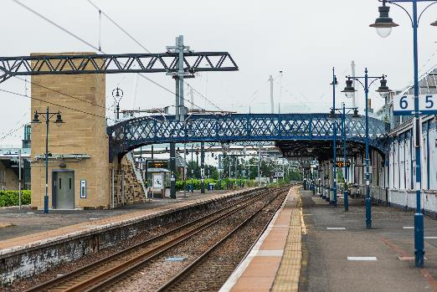
The STPR2 recommends a programme of improvements, such as junction upgrades and permissible speed increases, to achieve journey time improvements and line capacity increases for passenger and freight services, including infrastructure to enable the removal or reduction of lower differential freight speed limits where possible.
Subject to more detailed work in the business case process, potential areas for improvement could include: Greenhill Junction, Dunblane station area, Hilton Junction and Moncrieff Tunnel, Perth station approaches, and Edinburgh western station approaches. In addition, opportunities would be taken to increase gauge clearance (to permit taller and wider trains) to facilitate growth in the full range of inter-modal freight traffic.
Source: Network Rail
This recommendation aligns with:
- Recommendations 11, 15, 16, 25, 39, 43, 44 and 45;
- the Revised Draft NPF4 Central priority area which proposes that priorities for the area include pioneering low carbon, resilient urban living, and improved low carbon transport. This recommendation contributes to these priorities and supporting actions;
- the Decarbonising the Scottish Transport Sector report (see Recommendation 15);
- COVID-19 economic recovery plans (see Recommendation 15).

Supporting integrated journeys at ferry terminals (18)
One of the major historical barriers to public transport uptake has been connectivity and lack of convenient end-to-end travel options. Improving access and creating a better traveller experience at ferry terminals and interchange facilities would benefit rural and island communities as well as visitors and assist in encouraging modal shift. This would improve utilisation of, and fares income from, available passenger capacity on ferries and potentially reduce pressure on vehicle decks, freeing up space at times of scarcity for freight and other essential vehicle travel.
This would enhance the interchange facilities for all trips at ferry terminals, but especially longer-distance trips, providing more seamless travel choices and improving services, particularly for those not travelling with a car. Reducing car usage and increasing foot passenger usage also helps make more cost-effective use of existing ferry capacity, in line with the Sustainable Investment Hierarchy.
The STPR2 recommends a detailed review of key ferry terminals to consider physical integration and accessibility improvements in timetable information, signing, ticketing and other facilities required to deliver a seamless and integrated journey between different travel modes. The review would make recommendations on a programme of integration improvements to enhance the traveller experience and accessibility at ferry terminals.
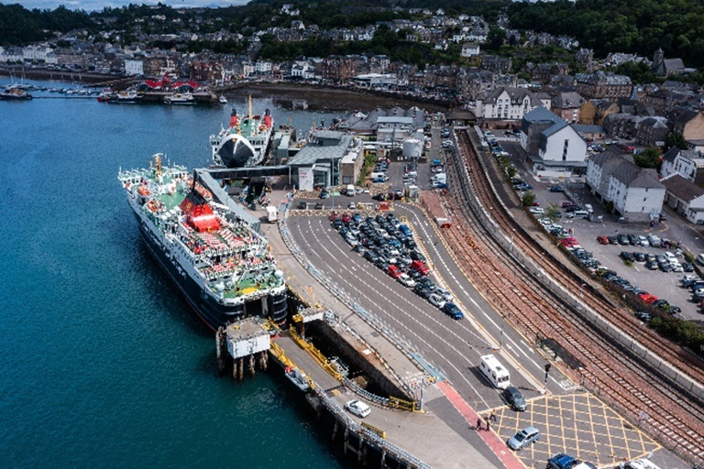
This recommendation aligns with:
Source: MBP
- Recommendations 20, 21, 22, 23, 24, 28, 41 and 42;
- the Revised Draft NPF4 North and West Coast and Islands priority area, which proposes that priorities include decarbonising transport and building resilient connections. This recommendation contributes to these priorities and supporting actions;
- Scotland’s Accessible Travel Framework – which has a strong focus on serving the needs of island and rural communities;
- The National Islands Plan, 2019 which sets out a strategic objective to improve transport services – this will ensure that existing and future transport-related policies, strategies and services are fully island-proofed so that they truly meet the needs of island communities;
- the ICP, which will replace the current Ferries Plan, and will have regard to aviation, ferries and fixed links, as well as connecting and onward travel. It will include a long-term investment programme for new ferries and development at ports that will aim to improve resilience, reliability, capacity and accessibility, while increasing standardisation, cutting emissions and meeting the needs of both remote rural and island communities whilst providing value for money.

Infrastructure to provide access for all at railway stations (19)
Implementing measures to improve the accessibility of Scotland’s railway stations can help ensure that everyone can use the transport system with as few barriers as possible. This would encourage greater use of rail and switching from car travel to support Scotland’s net zero carbon emission targets. Examples include step-free routes and platform access to passenger trains. Where possible, this would be done as part of wider rail investments.
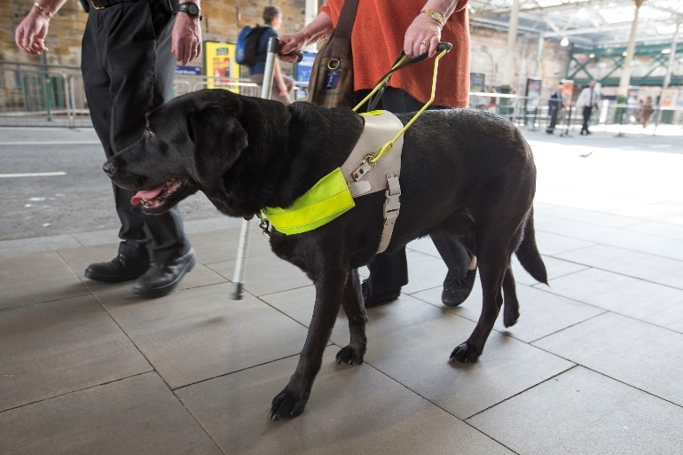
The STPR2 recommends a review of station accessibility across Scotland to identify and remove barriers to travel and improve access for all to the rail network, prioritising those stations that have particular problems. This would include investigating the opportunities for trialling new technological solutions (for example enhanced audio announcements and help points) to improve safety and accessibility at stations for people with reduced mobility.
This review would build on the national stations’ audit work being undertaken by the Department for Transport as part of the National Disability Strategy. This would provide a record of the level of accessibility of all stations in Scotland, help people with accessibility needs better plan their journeys and help shape future investment in accessible rail travel. When considering the audit data, Transport Scotland would also take account of the current connectivity issues and options available, and in doing so engage with the wider rail industry and stakeholders to identify how improvements can be best made to improve accessibility across the network.
Initial work would focus on reviewing those stations that have particular accessibility problems and it is anticipated that some projects could be accelerated for delivery by 2024.
This recommendation aligns with:
- Recommendations 21 and 22;
- Scotland’s Accessible Travel Framework – building on improvements to and within railway stations and extending beyond legal obligations to cover the enhanced levels of accessibility envisaged by the Framework;
- the Equality Act 2010 – this paved the way for a number of inclusive access strategies.

Investment in Demand Responsive Transport and Mobility as a Service (20)
Targeted investment to make it easier for people to travel, particularly those without access to a car, can help promote equality through fairer access to jobs and services. In locations with low bus network connectivity, or where conventional fixed route services may not be suitable or viable, flexible options, such as DRT and Community Transport, supported by MaaS and smart technology where appropriate, can be used to provide improved public transport connectivity.
This would be important in addressing the marked differences between and within regions.
The STPR2 recommends that capital funding is used to support pilot schemes and demonstration projects to establish how DRT and CT services can provide improved public transport connectivity and integration without increasing the need for revenue support, drawing on innovative solutions, international best practice, smart technologies and the findings from the MaaS Investment Fund schemes.
This funding would help to establish whether scarce existing resources could be better utilised across the public network, home-to-school transport, special educational needs travel and non-emergency patient travel, either on the basis of fixed route services or through flexible routeing. The potential to better inform people on journey options through the use of MaaS would also be considered.
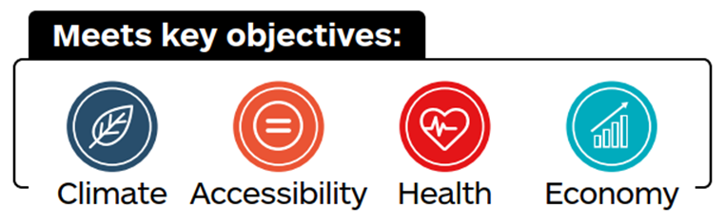
This recommendation aligns with:
- Recommendations 6, 9, 18, 22 and 23;
- the Scottish Government’s Programme for Government 2021 – this raised the issue of regional differences in service provision and the need to enhance Scotland’s connectivity;
- A Connected Scotland – a strategy for tackling social isolation and loneliness and building stronger social connections, which highlights the role transport can play;
- COVID-19 pandemic recovery - providing more cost-effective connectivity would assist with the recovery in bus usage resulting from COVID-19 which has impacted on the financial viability of many services;
- MaaS Investment Fund pilot projects.

Improved public transport passenger interchange facilities (21)
Improving the quality of passenger facilities at bus stations, railway stations and other transport interchanges encourages uptake of public transport and a switch from car use. This would include improving accessibility at bus stations and transport interchanges for people with reduced mobility.
Improvements can also be made to infrastructure design and security (to and within bus stations, railway stations and transport interchanges), as well as by enhancing the quality of the infrastructure, information, signage and wayfinding for all users of the facilities.
During stakeholder engagement for the STPR2, most regions raised the need to improve the quality and accessibility of passenger facilities for those with reduced mobility. Improvements will be particularly important in attracting passengers back to public transport following COVID-19.
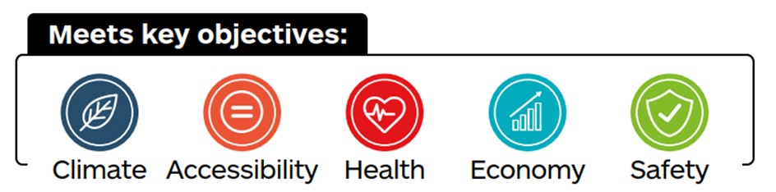
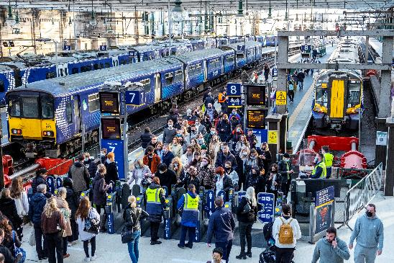
The STPR2 recommends building on Infrastructure to provide access for all at railway stations (19) and Scotland’s Accessible Travel Framework, to roll out a programme of interchange upgrades. This would focus on improved infrastructure design to, and within, bus and railway stations, and improved information, signage and wayfinding by upgrading the accessibility and quality of passenger facilities at existing bus stations and other transport interchanges, or, where needed, construction of new facilities. Opportunities to enhance interaction with active travel modes would also be considered to improve overall access to public transport services.
Source: Network Rail
This recommendation aligns with:
- Recommendations 11, 12, 13, 18, 19, 22, 23 and 43;
- Scotland’s Accessible Travel Framework – building on improvements to and within bus and railway stations and extending beyond legal obligations to cover the enhanced levels of accessibility envisaged by the Framework;
- A Connected Scotland – a strategy for tackling social isolation and loneliness and building stronger social connections, which highlights the role transport can play.

Framework for the delivery of mobility hubs (22)
Improving links between public transport services, active travel (walking, wheeling and cycling) and shared transport makes it easier for people, particularly those without a car, to get to and from their destination. This addresses one of the main barriers to uptake of public transport services.
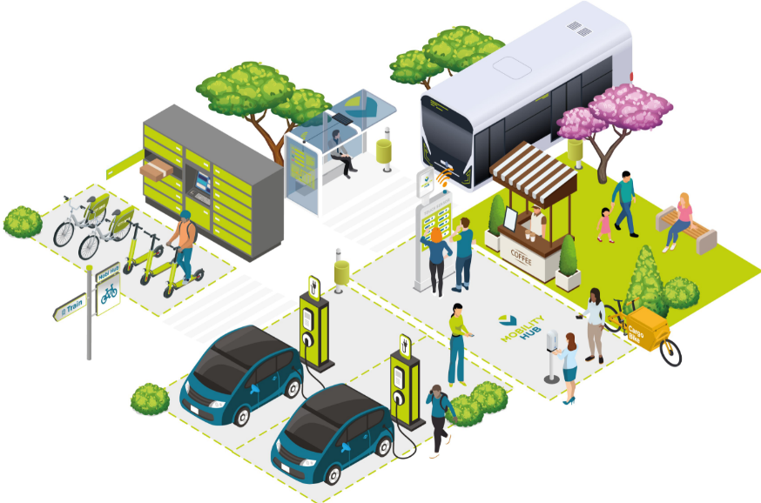
Mobility hubs are facilities where various types of transport, and, potentially, other services inter-connect. They support changing travel patterns – such as increased home-working and promotion of liveable places, including 20-minute neighbourhoods – that are resulting in a greater reliance on local facilities. Mobility hubs can be developed in various contexts, including rural and island communities, and services can be tailored to support specific local characteristics and needs.
Source: CoMoUK
The delivery of mobility hubs requires close and complex long-term multi-stakeholder partnerships from inception through to creation and ongoing maintenance, including the communities they serve, local and national Government, all bodies involved in transport planning, placemaking and regeneration, and a wide variety of public, private, and third sector transport service providers.
The STPR2 recommends that a delivery framework for mobility hubs is developed in collaboration with stakeholders to facilitate the creation of high-quality mobility hubs across Scotland. To ensure their effectiveness, the framework would include guidance, building on existing guidance produced by the CoMoUK, to allow robust assessment and coordination of future funding decisions on mobility hubs, including determination of the most appropriate locations and facilities for different mobility hub typologies (covering both urban and rural contexts), design principles, methods of community engagement and delivery models.
The creation of a recognisable network of high-quality multi-modal mobility hubs across Scotland would support the priorities of the NTS2 by increasing the attractiveness and visibility of public and shared transport, through bettering connectivity, improving links between public, active and shared transport options, and providing seamless travel opportunities, particularly for those without access to a private car. A nationally-led framework for the delivery of mobility hubs would provide all stakeholders and delivery partners with a clear template and pathway for action, and give national Government a guiding hand in planning and providing a network of hubs which is coherent, integrated, and delivers against its many social, economic, and environmental targets and policy objectives.
This recommendation aligns with:
- Recommendations 6, 9, 11, 12, 13, 18, 19, 20, 21, 23 and 28;
- Scotland’s Accessible Travel Framework – building on improvements to and within bus and railway stations and extending beyond legal obligations to cover the enhanced levels of accessibility envisaged by the Framework;
- CoMoUK Mobility Hubs Guidance, which identifies a mobility hub as being “A recognisable place with an offer of different and connected transport modes supplemented with enhanced facilities and information features to both attract and benefit the traveller”;
- the Revised Draft NPF4 20-minute neighbourhoods supporting Liveable Places.

Smart, integrated public transport ticketing (23)
Making it easier for people to reach their end destination by simplifying how they store and pay for tickets with different providers makes public transport a more convenient, flexible and attractive travel option. This encourages people to switch from private car use and supports more sustainable travel.
Improving integration involves introducing new services, technologies and systems which support easier payment and the opportunity to simplify fares, such as price capping. To fully integrate across all operators this can include electronic payment, smartcard and mobile technologies, coupled with improved administration systems.
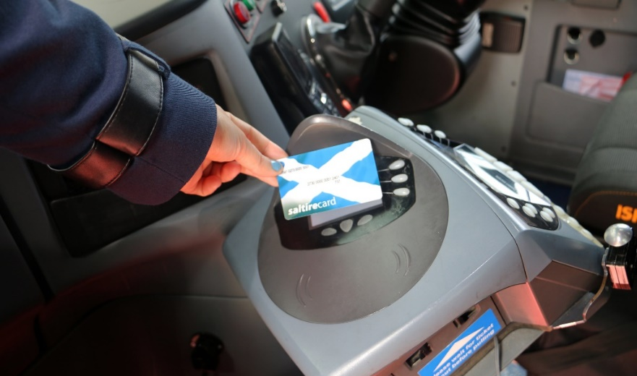
The STPR2 recommends building on the interventions and new services delivered under the 2018 Smart and Integrated Ticketing and Payments Delivery Strategy to continue with the support and ongoing delivery of fully integrated smart ticketing and payment services across all public transport modes, to support modal shift and encourage active travel. This recommendation supports the delivery of the provisions and subsequent workstreams, within the Transport (Scotland) Act 2019, which includes establishing a National Smart Ticketing Advisory Board and setting a technological standard for smart ticketing.
The Act also seeks to enhance integrated schemes to now include connecting modes and further empowers Scottish local authorities to introduce smart and integrated ticketing schemes where there is consumer demand, enabling access to, and use of, more sustainable public transport.
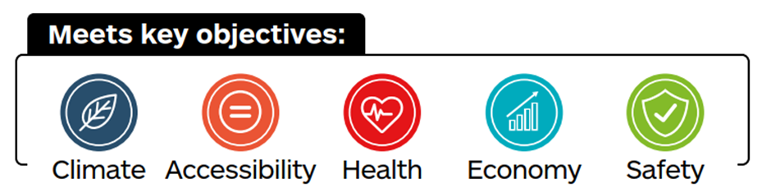
This recommendation aligns with:
- Recommendations 6, 11, 12, 13, 18, 20, 21 and 22;
- The Programme for Government 2022 commitments for Innovation/Smarter travel;
- the Smart and Integrated Ticketing and Payments Delivery Strategy – building on the interventions and new services delivered;
- the 2019 Transport (Scotland) Act - which aims to establish a National Smart Ticketing Advisory Board and set a technological standard for smart ticketing;
- the Act and Strategy combine to provide the basis for enhancing the technology, data platforms and open data rules. This will help reach the commercial agreements required to support the establishment of local smart ticketing schemes. Scottish local authorities have been further empowered to introduce smart ticketing schemes where there is consumer demand.

Decarbonising Transport
To meet its legal commitments on addressing climate change, the Scottish Government has set a target to achieve net zero carbon emissions by 2045.
Transport is now the largest single source of carbon emissions, with car traffic on major roads having tripled during the last four decades. Cars now account for 40 per cent of transport emissions while goods vehicles account for a further 25 per cent.
Studies have shown that the only way the net zero target can be achieved is by a combination of:
- rapid decarbonisation of passenger and freight transport;
- reduction in vehicle usage by switching to public transport and active travel;
- reduced demand through shorter trips and, where possible, avoiding trips.
Various recommendations of the STPR2 described in earlier themes are directed at support for active travel (walking, wheeling and cycling) and measures to improve the attractiveness of public transport.
The STPR2 recommendations aimed at rapid decarbonisation of passenger and freight transport include:
- Ferry vessel renewal and replacement and progressive decarbonisation (24);
- Decarbonisation of the rail network (25);
- Decarbonisation of the bus network (26);
- Behavioural change and modal shift for freight (27);
- Zero emission vehicles and infrastructure transition (28).
These recommendations align with, and support, the Revised Draft NPF4 where decarbonisation of connectivity is a strong theme.

Ferry vessel renewal and replacement, and progressive decarbonisation (24)
Continued investment in ferry renewals would address the needs of rural and island communities by improving the resilience, reliability, capacity, accessibility and standardisation of ferries and reducing their emissions. Progressive decarbonisation of the CHFS and NIFS ferry networks will support the 2018 – 2032 Climate Change Plan Update and the Climate Change (Emissions Reduction Targets) (Scotland) Act 2019.
The STPR2 recommends renewal and replacement of the CHFS and NIFS vessels including progressive decarbonisation by 2045.
This recommendation aligns with:
- Recommendations 18, 28, 41 and 42;
- the Revised Draft NPF4 National Development 1 – Energy Innovation Development on the Islands. This recommendation sits mainly within the Revised Draft NPF4 North and West Coast and Islands priority area and proposes that priorities for the area include decarbonising transport and building resilient connections. It also spans the North East and Central priority areas. This recommendation contributes to these priorities and supporting actions;
- 2018 – 2032 Climate Change Plan Update and the Climate Change (Emissions Reduction Targets) (Scotland) Act 2019 – which will be supported by progressive decarbonisation of the CHFS and NIFS ferry networks;
- Scottish Energy Strategy, 2017 which sets out the Scottish Government’s vision for the future energy system in Scotland;
- Carbon Neutral Islands project, which has a commitment for at least three of Scotland’s islands to become fully carbon neutral by 2040;
- Islands Growth Deal – a 10-year programme of investment for the Outer Hebrides, Orkney and Shetland, with a target of creating up to 1,300 jobs and tackling depopulation concerns;
- The National Islands Plan, 2019, which sets out a strategic objective to improve transport services – this will ensure that existing and future transport-related policies, strategies and services are fully island-proofed so that they truly meet the needs of island communities;
- the ICP, which will replace the current Ferries Plan, and will have regard to aviation, ferries and fixed links, as well as connecting and onward travel. It will include a long-term investment programme for new ferries and development at ports that will aim to improve resilience, reliability, capacity and accessibility while increasing standardisation, cutting emissions and meeting the needs of both remote rural and island communities whilst providing value for money.

Decarbonisation of the rail network (25)
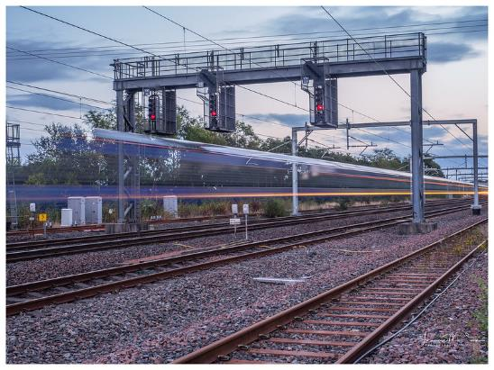
Replacing diesel trains, the largest source of rail carbon emissions, with cleaner technologies offers multiple benefits in addition to helping meet net zero targets. Electrification would improve journey times and strengthen reliability of both freight and passenger rail services. Capacity could be expanded through the use of longer trains and timetable efficiencies from improved acceleration. These measures would provide indirect benefits for passenger and freight movements and would encourage a switch from road to rail.
Electric rolling stock has lower operational and maintenance costs than diesel. Battery and hydrogen traction solutions would still enable decarbonisation of rail operations on routes where overhead wire electrification is less cost effective.
The STPR2 recommends the priorities for decarbonising key rail routes should align with the Rail Services Decarbonisation Action Plan. These would be subject to full business case assessment but are likely to include:
- East Kilbride/Barrhead-Muirhouse Junction;
- Tweedbank-Newcraighall (Borders Line);
- Edinburgh-Dunfermline-Thornton-Kirkcaldy-Edinburgh (Fife Circle);
- Thornton-Ladybank-Perth;
- Ladybank-Dundee;
- Perth-Dundee-Aberdeen-Dyce (including Raith's Farm freight terminal);
- Dunblane-Perth-Inverness-Dalcross.
This recommendation aligns with:
- Recommendations 15, 16, 17, 44 and 45;
- 2018 – 2032 Climate Change Plan Update and the Climate Change (Emissions Reduction Targets) (Scotland) Act 2019 which outline the plan to decarbonise the majority of the passenger rail network by 2032;
- The Rail Services Decarbonisation Action Plan which sets out an initial, indicative programme of interventions which will secure benefits towards climate change objectives, local environmental objectives (including air quality) and the rail network and rail users.

Decarbonisation of the bus network (26)
The Scottish Government has made funding available to accelerate the decarbonisation of the Scottish bus industry through the acquisition of zero-emission vehicles and infrastructure; working closely with industry to remove greenhouse gas emissions from the bus sector at pace to support the commitment to net zero by 2045.
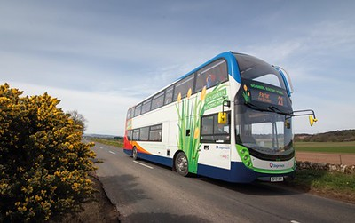
The STPR2 recommends further investment to stimulate the commercial roll out of zero emission buses, including those used by the home-to-school, community transport and tourist sectors. Further policy development may be required to ensure a Just Transition to zero emission buses across all operators. Any provision of additional funding would need to reflect the expectation that the bus and coach industry will increasingly seek to acquire zero emission vehicles commercially, without the need for Government investment.
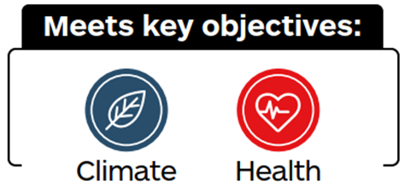
This recommendation aligns with:
- Recommendation 28; and
- 2018 - 2032 Climate Change Plan Update – this sets out the Scottish Government’s targets to reduce emissions by 75 per cent by 2030 and to net zero by 2045.

Behavioural change and modal shift for freight (27)
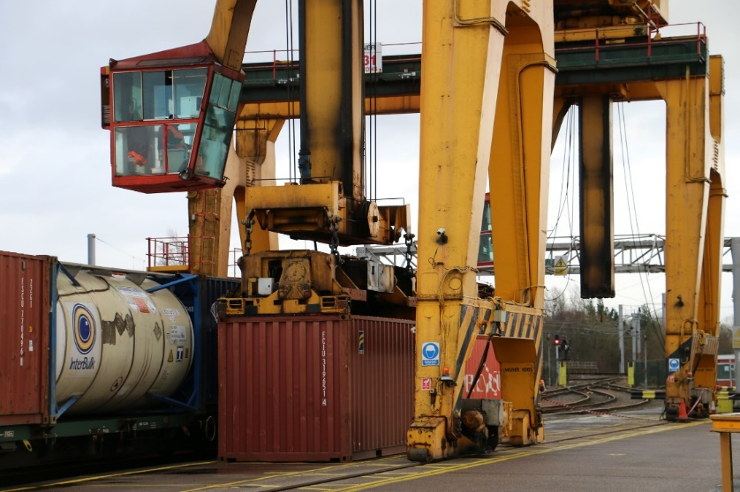
A significant amount of freight needs to shift from road to rail or water, and the overall distance travelled needs to be reduced. This is necessary if Scotland is to meet its net zero carbon emission targets as these cannot be achieved by changes in technology alone. The development of a network to facilitate behavioural change and modal shift would be enabled by the implementation of Recommendation 28 – Zero emission vehicles and infrastructure transition.
The STPR2 recommends the Scottish Government brings together public and private sector organisations to introduce incentives and best practice to establish more efficient, environmentally-friendly practices within the freight industry, including promoting sustainable transport options to encourage modal shift particularly, but not exclusively, for longer-distance movements and enable the potential to reduce the number of HGV/Light Goods Vehicle (LGV) movements on the road network.
This may involve a potential evolution of the existing grant and support schemes, such as the Modal Shift Revenue Support schemeand the Freight Facilities Grant. It is also recommended to engage with the public and private sectors to educate operators on the benefits of multi-modal best practice, promote the availability of modal shift grants, and ease the application and compliance process.
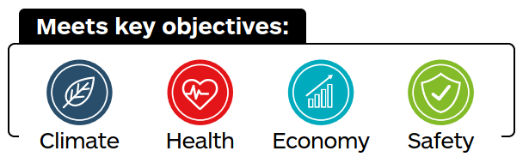
This recommendation aligns with:
- Recommendation 28, 36, 39, 42, 44 and 45;
- The Decarbonising the Scottish Transport Sector report - Policy Scenario 3 (Trucks, Rail Freight, and Shipping Freight);
- 2018 - 2032 Climate Change Plan Update – this sets out the Scottish Government’s targets to reduce emissions by 75 per cent by 2030 and to net zero by 2045;
- Scotland’s Draft Hydrogen Action Plan – this plan provides a route map to the development of a zero carbon hydrogen economy and sets hydrogen production capacity targets of 5GW by 2030 and 25GW by 2045;
- Transport Scotland’s Mission Zero for Transport programme – is investing in a net zero transport system, including by providing £2 billion, over a five-year period from 2021-22, for a Low Carbon Fund to support low emission technologies such as hydrogen powered transport;
- The National Just Transition Planning Framework – seeks to plan the transition to net zero greenhouse gas emissions in a way that does not exacerbate inequality and injustice.

Zero emission vehicles and infrastructure transition (28)
Alongside greater use of public transport and active travel, and the required reduction in travel demand, switching to zero emission vehicles is a key step in reducing greenhouse gas emissions from transport and the achievement of the Scottish Government’s net zero target. Encouraging this shift to zero emission vehicles requires a suite of options to support a Just Transition, including additional transport infrastructure across Scotland such as new and expanded recharging and refuelling networks as well as technological change.
The convening powers of Scottish Government/Transport Scotland are required to bring together key industries and sectors to work strategically with the private sector to facilitate the planning, management and delivery of the required alternative refuelling network and expansion/improvements to the charging network, and the implementation of the net zero freight and logistics network as set out in Recommendation 27. Where market failure exists, Transport Scotland will intervene to support a Just Transition by ensuring the provision of a multi-modal alternative fuel and charging network for the whole of Scotland, including consideration of rural and island communities.
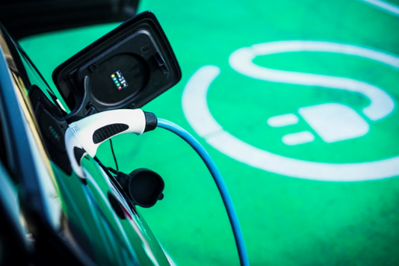
The STPR2 recommends that a national framework for zero emission vehicles is established to support and accelerate the shift to zero emission mobility through targeted funding to enable investment in fleets, facilities and emerging technologies.
In addition, collaboration with the public and private sector will develop co-ordinated investment in a zero emission transport supply network of recharging and refuelling infrastructure across Scotland, including consideration of rural and island communities, which is in line with Transport Scotland’s Mission Zero for Transport programme.
This framework would seek to maximise the impact of public expenditure and leverage commercial investment. The framework would incorporate freight, coaches and personal modes, and include capacity for longer-distance journeys.

This recommendation aligns with:
- Recommendations 18, 22, 26, 27 and 36;
- 2018 - 2032 Climate Change Plan Update – this provides an emissions reduction pathway for transport and outlines eight policy outcomes designed to achieve the required level of emissions reduction, including the phase out of petrol and diesel vehicles;
- Scotland’s Draft Hydrogen Action Plan – this plan provides a route map to the development of a zero carbon hydrogen economy and sets hydrogen production capacity targets of 5GW by 2030 and 25GW by 2045;
- Transport Scotland’s Mission Zero for Transport programme – is investing in a net zero transport system, including by providing £2 billion for a Low Carbon Fund to support low emission technologies such as hydrogen powered transport;
- The National Just Transition Planning Framework – seeks to plan the transition to net zero greenhouse gas emissions in a way that does not exacerbate inequality and injustice.

Increasing Safety and Resilience on the Strategic Transport Network
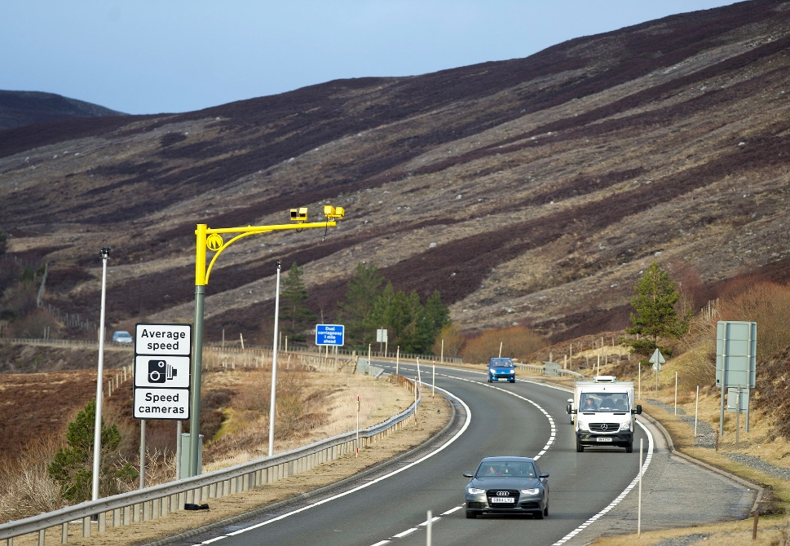
The maintenance of safe and resilient transport networks and systems is vital to facilitate the daily lives of all communities, businesses and visitors to Scotland. The Sustainable Investment Hierarchy outlined within the NTS2 makes clear that interventions should be prioritised firstly by their ability to reduce the need to travel and secondly by their ability to help maintain and safely operate existing assets.
Transport Scotland is the roads authority for the Scottish trunk road and motorway network, which is its single biggest asset. In addition, Transport Scotland is committed to measures to improve the resilience of the rail network, as prescribed by the ORR.
The recommendations within the STPR2 supplement ongoing maintenance and operational requirements by focusing on particular challenges associated with the need to operate a safe and resilient trunk road and motorway network.
Transport Scotland will continue to assess the network and implement a programme of renewals and measures that would address safety (30), climate change adaptation (31) and resilience (32). The STPR2 has considered these requirements and identified a series of routes and locations to prioritise. One specific area that is a current priority of the Scottish Government is measures to address the resilience of the A83 at the ‘Rest and Be Thankful’ (29).
Recommendations considering the management of speed on trunk roads (38) and mitigating the impact of trunk roads on local communities (37) would reduce risk of accidents and enhance the local environment.
The use of technologies will continue to play an important part in operating a safe and reliable system, and the STPR2 recommends a suite of interventions aimed at creating the next generation of Intelligent Transport Systems (ITS) (33) (34), and infrastructure (35).
Recognising the specific needs of the road haulage industry, the STPR2 recommends a national review of freight parking/rest areas to better understand barriers hampering their development (36).

Access to Argyll (A83) (29)
Ongoing closures of the A83 due to landslides at the ‘Rest and Be Thankful’ or on other sections of the road in Argyll and Bute due to accidents, flooding or roadworks have a significant negative impact on the region and its economy. Closures at the ‘Rest and Be Thankful’ can add detours of up to 50 miles for residents, businesses and visitors.
Accidents or incidents occurring on the A83 in Argyll and Bute means that for periods of time there is no continuous strategic road in the region connecting it to the rest of the country.
Closures can have a more severe impact on residents who want to make shorter journeys from one side of the A83 ‘Rest and Be Thankful’ to the other, such as Inveraray residents wanting to access services in Dumbarton or Helensburgh. New or improved road infrastructure to address these closures would improve the reliability of the route as a vital artery through Argyll, as a connection for both the Kintyre and Cowal peninsulas, and as one of only two trunk roads linking Argyll and Bute to the Central Belt.
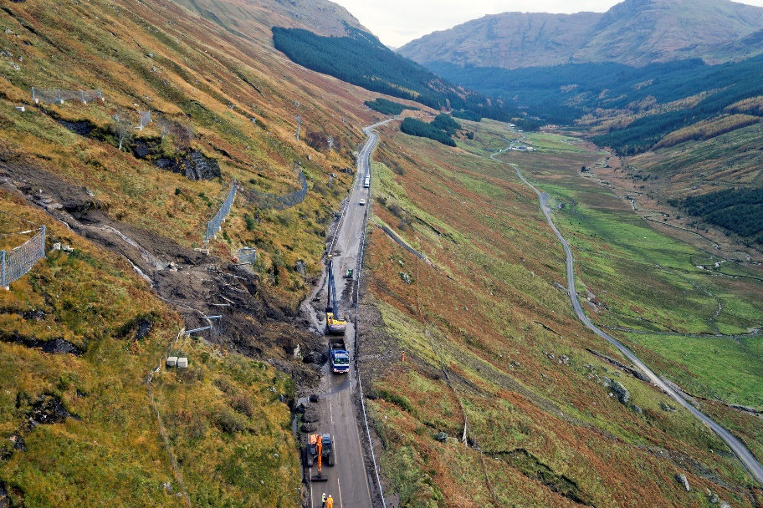
The STPR2 recommends work continues on developing a more reliable route. A preliminary assessment of 11 route corridor options has been completed, with the Glen Croe corridor emerging as the preferred corridor.
Public feedback has stressed the need to move quickly in relation to improvements in the vicinity of the ‘Rest and Be Thankful’. Work undertaken to date has been accelerated, with speed of delivery a key criteria for assessment regarding options for more extensive measures considered under this recommendation.
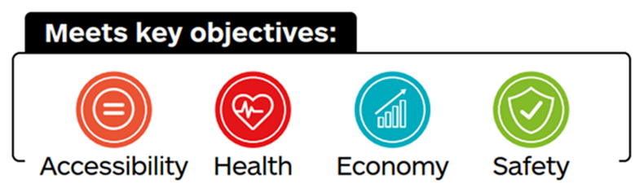

This recommendation aligns with:
- Recommendations 30, 31 and 32;
- the Revised Draft NPF4 North priority area priorities, which include growing the population, decarbonising transport and building resilient connections, making sustainable use of the areas’ world-class environmental assets;
- Development plans – the road network within the region plays a vital role in supporting the local economy, facilitating the movement of goods and services throughout the area and connecting people with economic opportunities;
- Regional strategies – improvements to address key transport constraints across the region which hamper socio-economic development.

Trunk road and motorway safety improvements to progress towards ‘Vision Zero’ (30)
Safety improvements are required across the trunk road and motorway network to help meet Scotland’s Road Safety Framework to 2030 vision for Scotland to have the best road safety performance in the world by 2030, with a long-term goal of Vision Zero, where there are zero road fatalities and serious injuries by 2050. An ambitious interim target for 2030 involves halving the number of people being killed or seriously injured on Scotland’s roads.
The Framework embeds the Safe System approach to road safety delivery, which consists of five key pillars focusing efforts not only on road traffic casualty reduction (vulnerability of the casualties) but also on road traffic danger reduction (sources of the danger). Safe Roads and Roadsides is one of the five pillars, where roads and roadsides in a Safe System are designed to reduce the risk of collision, and to mitigate the severity of injury should a collision occur.
Safety improvements would also improve route reliability and resilience, reducing delays associated with accidents. A high-quality, well maintained and efficient trunk road and motorway network also supports other Scottish Government programmes for active travel, Connected and Autonomous Vehicles (CAV) and bus priority investment, and thereby contributes to the low carbon economy.
The STPR2 recommends road safety improvements are progressed across the trunk road and motorway network with a primary, but not exclusive, focus on rural sections where accident rates and severities are typically higher. The types of improvements would include junction improvements (such as right-turn priority, signalisation, at-grade roundabout and grade-separation) as well as junction rationalisation, realignment/widening of carriageways and provision of overtaking opportunities (Wide Single Carriageway 2+1 (WS2+1) schemes or climbing lanes).
Potential examples of locations for road safety improvements on the trunk road and motorway network, include but are not limited to:
- A82 Balloch to Inverness (excluding Tarbet to Inverarnan which is already being progressed by Transport Scotland);
- A83 Tarbet to Campbeltown;
- A835 Tore Roundabout to Ullapool;
- A85 Perth to Oban;
- A87 Invergarry to Uig;
- A9 Kessock Bridge to Scrabster;
- A9 Dunblane to Perth;
- A90 Perth to Aberdeen (excluding the A90 Kingsway through Dundee - see Recommendation 32).
The location and type of improvements on specific routes requires further detailed investigation, potentially through the development of route action plans. This would also be informed by the route risk mapping process Transport Scotland is developing in addition to the more traditional reactive analysis of high accident cluster sites to assess the safety of the road network and to target investment.
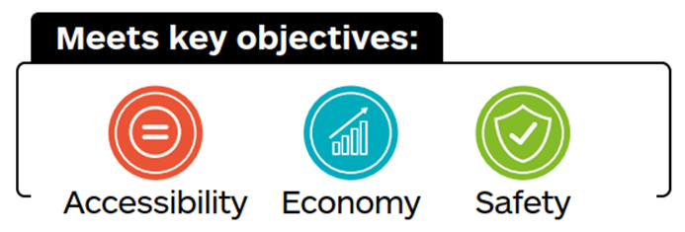
Where appropriate, these measures may be undertaken in conjunction with, and to support, the STPR2 trunk road and motorway recommendations: Trunk road and motorway climate change adaptation and resilience (31) and Trunk road and motorway renewal for reliability, resilience and safety (32).
This recommendation aligns with:
- Recommendations 7, 29, 31, 32, 33, 34, 35, 37, 38 and 40;
- Scotland’s Road Safety Framework to 2030 – over the period 2015 to 2019, Killed and Seriously Injured (KSI) and Personal Injury Accident (PIA) accident rates on sections of several routes are greater than the national average for routes of a similar nature and standard. This recommendation would support the framework and goal of Vision Zero by addressing road safety and operational concerns on areas of the trunk road and motorway network, including circumstances where problems continue despite measures having been previously implemented. Generally, the improvements proposed are of particular relevance to rural sections of the network where accident rates are typically higher;
- the Revised Draft NPF4 makes reference to improving road safety and resilience on a number of trunk roads within the North priority area.

Trunk road and motorway climate change adaptation and resilience (31)
Climate change is already having far-reaching impacts on Scotland’s weather systems, with heatwaves, intense rainfall and floods all increasing in scale and frequency. These events are already directly impacting the trunk road and motorway network as illustrated by embankment failure on the A83 ‘Rest and Be Thankful’ and the A68 at Fala, as well as the recurrence of flooding on areas of the network such as the A8 through Greenock.
Efforts to reduce greenhouse gas emissions are essential to combat future catastrophic climate change, however, due to current and historic emissions being locked in, further changes are inevitable and will continue for decades to come. Adapting to the impacts of climate change is therefore essential to ensuring that the trunk road and motorway network is safe, reliable and resilient for the people of Scotland and its visitors.
This includes developing measures to protect the operation of the network from severe weather events related to climate change such as flooding, landslides and high winds.
Whilst climate change and its impacts go far beyond the 20-year timeframe of the STPR2, adapting to climate change and investing in resilience measures now could address some of the impacts already experienced and assist in understanding how to mitigate future risks to the trunk road and motorway network as the weather and impacts become less predictable and potentially more extreme.
The STPR2 recommends building on existing evidence around vulnerable locations to develop a fuller picture of those areas on the trunk road and motorway network most at risk of disruption due to weather events. This would provide a basis for identifying, prioritising and implementing improvements to strengthen the resilience of the network. It is also recommended to build on Transport Scotland’s existing Roads Asset Management Plan, disruption management processes and incident response plans to help mitigate the impact of disruption from severe weather-related events.
Whilst the location and nature of the improvements on specific routes requires further detailed study, potential locations and measures include, but are not limited to:
- A85 Glen Ogle – geotechnical and hydrological study;
- A77, A82, A83 and A87 – sea wall improvements, strengthening or replacement;
- A78 – sea wall improvements, strengthening or replacement, and coastal fence upgrade;
- A9 – slope stability at Scrabster;
- Additional/proactive inspections/assessments such as LiDAR of embankments/hillsides/sea walls. (LiDAR is a method for determining ranges (variable distance) by targeting an object or a surface with a laser and measuring the time for the reflected light to return to the receiver. It can be used to make digital 3-D representations of areas on the Earth's surface and bottom of the intertidal and near coastal zone).
Where appropriate, these measures may be undertaken in conjunction with, and to support, the STPR2 trunk road and motorway network recommendations related to renewal (32) and safety improvements (30), with Access to Argyll A83 (29) a specific recommendation.
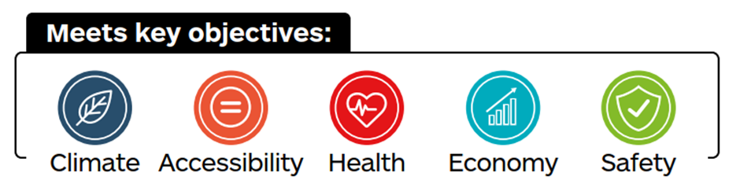
This recommendation aligns with:
- Recommendations 29, 30, 32, 33, 34, 35 and 40;
- The Climate Change Committee’s third Climate Risk Independent Assessment (CCRA3) – published in June 2021: CCRA3 highlights that net zero commitments will fail unless there is investment in adaptation across the nation and increased climate resilience. It also highlights that the gap between the level of risk faced by climate change and the level of adaptation underway has widened;
- the Revised Draft NPF4 National Developments 11: Stranraer Gateway and 16: Hunterston Strategic Asset. Elsewhere the Revised Draft NPF4 makes a number of references to resilience, however the North, North and West Coast and Islands and South priority areas all have priorities on strengthening resilience.
- Transport Scotland is in the process of preparing a report on a high-level Approach to Climate Change Adaptation and Resilience. It is envisaged a recommendation within this document will be to develop a Roads Climate Change Adaptation Plan, intended to set out specific actions required to adapt the trunk road and motorway network and establish associated costs.

Trunk road and motorway renewal for reliability, resilience and safety (32)
The trunk road and motorway network has a £21 billion gross asset value and adds £1.38 billion to the economy annually. The network comprises 3,739 route kilometres (2,323 miles) of road, 1,745 bridges and 2,492 other structures. It accounts for seven per cent of the total road network in Scotland but carries over 40 per cent of all traffic and over 60 per cent of all HGVs. Like any piece of infrastructure, the road network has a design life that can be extended by regular maintenance but that will also require significant renewal after years of permanent use to maintain the integrity of the asset and protect it for continued, unrestricted use and to avoid the need for unplanned works.
The maintenance of a safe, reliable and resilient trunk road and motorway network plays a vital part in the daily lives of all communities, businesses and visitors to Scotland. Continued and increased investment in carriageways and structures, as well as ancillary assets to address the maintenance backlog, is required in order to achieve a steady-state condition and sustain investment to maintain this level of condition and keep the network reliable and resilient for all road users.
This needs to consider changes in both technology and how we use this national asset.
A co-ordinated programme of planned renewal and refurbishment work is also less disruptive and more cost-effective than addressing network failure. A co-ordinated approach also removes the need for multiple visits to the same location to address issues and provides an opportunity to include safe system treatments to roadsides to reduce risks from strike hazards and make roadsides more forgiving to improve safety.
The STPR2 recommends continued and increased investment in the trunk road and motorway network over and above current maintenance levels. Potential measures would include carriageway and structure schemes as well as ancillary assets.
Examples include, but are not limited to, the following types of schemes and locations:
- carriageway schemes;
- M8 maintenance strategy;
- structures schemes;
- strengthening of major bridges (including the Forth Road Bridge, Erskine Bridge, Kessock Bridge and Kincardine Bridge);
- ancillary assets;
- removal of accessibility barriers;
- integrated transport plan for the A90 Kingsway through Dundee to improve reliability on the trunk road and deliver improvements for local active travel and public transport journeys: this could potentially include improvements to enable sustainable transport provision;
- integrated transport plan for Fort William to increase resilience and reliability on the trunk road to improve sustainable transport and enhance the sense of place in the local community. This could potentially include improvements online and/or a new link road to enable enhanced sustainable transport provision.
Where appropriate, these measures may be undertaken in conjunction with, and to support, the STPR2 trunk road and motorway network recommendations related to safety improvements (30) and climate change adaptation (31).
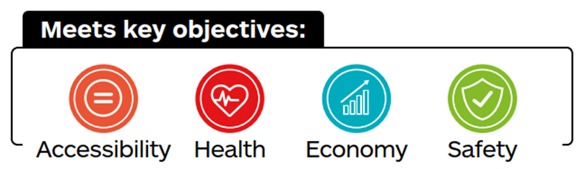
This recommendation aligns with:
- Recommendations 29, 30, 31, 33, 34, 35 and 40;
- other Scottish Government Programmes – the condition of the trunk road and motorway network is integral to wider priorities such as active travel, development of CAV infrastructure and bus priority investment. This contributes to the low carbon economy and contributes to adapting to the impacts of climate change;
- the Revised Draft NPF4 makes a number of references to resilience, however the North, North and West Coast and Islands, and South priority areas all have priorities on strengthening resilience.
Operation of the Strategic Transport Network
The following three recommendations support Transport Scotland’s management of traffic across the strategic transport network.

Future Intelligent Transport Systems (33)
This recommendation involves exploiting future technologies and services; these new technologies and services would contribute to reducing road accidents, the delivery of safer journeys, the provision of greater resilience across the networks and deliver a higher level of service to all road users.
This recommendation covers adaptions to the service provided by Traffic Scotland both in the form of the deployment of new roadside equipment and the updates required to the Traffic Scotland System (TSS). Such changes shall accommodate Scottish Government policies affecting the structure and operation of the trunk road network, along with the adoption of new technologies and services, including any disruptive technologies such as CAV and Cooperative Intelligent Transport Systems (C-ITS).
The current TSS will have to evolve new approaches beyond the current standards to adapt to these challenges and to continue to deliver the services into the future.
This recommendation would look to progressively integrate passenger and freight modes into the Traffic Scotland National Control Centre (TSNCC) as opportunities and technological advances arise. It would investigate the best way to exploit the capability of the TSNCC, and how to plan for the future renewal and replacement of equipment, systems and services to maximise network operation.
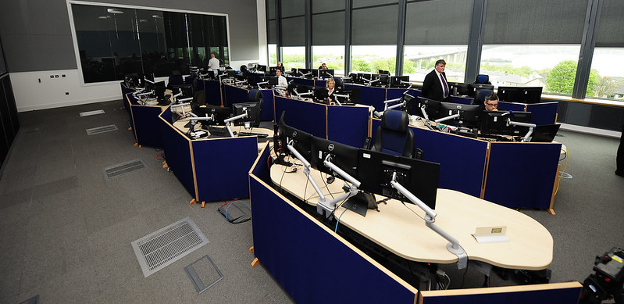
The STPR2 recommends investment to enhance and future-proof the capabilities of the current TSS, including enhancing the capability of the TSS, and planning deployment of new roadside equipment, systems and services to maximise network operations and resilience.
This recommendation focuses on the need to future-proof the current services, so they can continue to provide existing services, as well as be able to deal with challenges associated with new disruptive technology such as CAVs and C-ITS.
This recommendation aligns with:
- Recommendations 14, 30, 31, 32, 34, 35 and 38;
- Scotland’s Road Safety Framework to 2030 – the enhanced functionality of new roadside ITS services aligns closely with this long-term vision for road safety where there are zero road fatalities and serious injuries by 2050;

Traffic Scotland System renewal (34)
The TSS uses the information it collects about roadworks, accidents, congestion and weather events to reduce disruption and improve the operational efficiency and safety of the trunk road and motorway network. A business-critical part of the delivery of the service provided by Traffic Scotland is the Incident Management System (IMS): a core software system that supports the detection of incidents, the initial response and life-cycle management of those incidents, enhancing safety and network resilience. This element of the TSS is now at end of life and needs to be replaced.
The STPR2 recommends upgrading the current IMS and the related Fault Management System (FMS), including their re-architecture onto more open and supportable technologies. This recommendation extends to the other related systems that require to be upgraded as a result of the IMS and FMS re-architecture. This would address both current and future requirements in terms of both service delivery and also provide systems that could, in turn, be more easily developed to accommodate future changes to support C-ITS and CAV. The new TSS would provide Transport Scotland with the ability to enhance the coverage, level and types of services across the network.
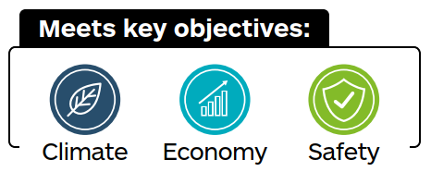
This recommendation aligns with:
- Recommendations 14, 30, 31, 32, 33, 35 and 38;
- Scotland’s Road Safety Framework to 2030 – aligns closely with this long-term vision for road safety where there are zero road fatalities and injuries by 2050;
- the Revised Draft NPF4 makes a number of references to improving road safety and resilience, in the North priority action area.

Intelligent Transport System renewal & replacement (35)
ITS can make a significant contribution to the overall safety of travel and support enhanced transport resilience, smoother journeys, quicker reaction to incidents and environmental improvements across the Scottish trunk road and motorway network.
ITS infrastructure is embedded within the transport network, and includes equipment such as variable message signage, lane control signals, Closed-Circuit Television (CCTV), emergency roadside telephones, traffic and weather monitoring devices, and the networking equipment that connect these together and to the TSNCC. This coverage helps to ensure the availability and quality of the existing transport networks and can be used to monitor traffic flow, detect incidents and hazardous weather conditions, and to manage the life-cycle of these events.
There is a significant amount of roadside ITS equipment that is now reaching or past its end of life and a substantial renewal and replacement programme is now required.
This recommendation involves investing in the renewal and replacement of the existing ITS roadside equipment to maintain the current high level of services to the road users and to provide greater resilience across the networks.
The STPR2 recommends investing in the renewal and replacement of the existing ITS roadside equipment to maintain the current high level of service to road users and to provide greater resilience across the trunk road and motorway networks. The enhanced functionality of new roadside ITS equipment would also contribute to reduced road accidents and the delivery of safer journeys.
This recommendation aligns with:
- Recommendations 7, 14, 30, 31, 32, 33, 34 and 38;
- Transport Scotland’s Vision Zero – the enhanced functionality of new roadside ITS services aligns closely with this long-term vision for road safety where there are zero road fatalities and injuries by 2050;
- the Revised Draft NPF4 makes a number of references to resilience, however the North, North and West Coast and Islands, and South priority areas all have priorities on strengthening resilience.

Strategy for improving rest and welfare facilities for hauliers (36)
Providing adequate lorry parks would contribute to improving road safety and reducing crime, and would significantly improve working conditions for HGV drivers. It would also avoid disruption in locations not designed to accommodate lorry parking. Rest and welfare facilities are a key part of national and international road freight infrastructure, and provision of these to an appropriate standard is fundamental to ensuring safe, efficient and effective supply chains. Improvements to facilities would therefore also help support the Scottish economy and its growth.
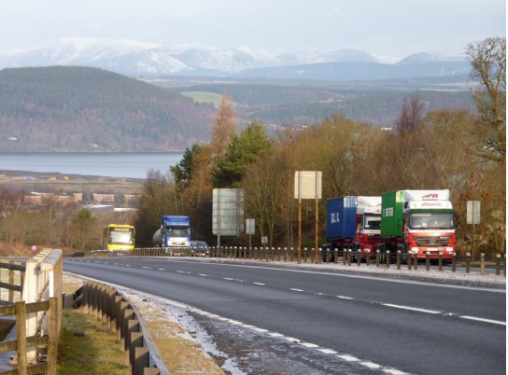
The STPR2 recommends a national review of current National Freight Parking/rest areas, with a view to develop more safe, secure, accessible and inclusive facilities across Scotland. This would inform long-term investment in driver welfare infrastructure. Alongside this recommendation there would be close integration with Recommendation 28 – to inform the delivery of an alternative fuel infrastructure network where co-location of alternative fuelling with lorry rest and welfare facilities may be appropriate, and in the delivery of Recommendation 27 – the strategic net zero freight and logistics network.
The review would indicate which routes have gaps in provision and support Transport Scotland in making future decisions on the need (or otherwise) to address market failure.
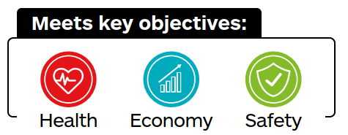
This recommendation aligns with:
- Recommendations 27, 28, 40 and 44;
- Department for Transport Circular 02/2013 – the Strategic Road Network and the Delivery of Sustainable Developments;
- Design Manual for Roads and Bridges (CD169, 2021) - the design of lay-bys, maintenance hard standings, rest areas, services areas and observation platforms.

Improving active travel on trunk roads through communities (37)
Where a trunk road passes through a community, measures may be able to be introduced to reduce the problems of severance and provide benefits for people that are currently prevented or discouraged from walking, wheeling or cycling along or across the main road. Such measures can reduce the adverse impacts of traffic, including perceived safety issues, and so improve access to key destinations for local people, creating particular opportunities for people vulnerable to social exclusion such as disabled, young and older people, and those without access to a car.
The STPR2 recommends the delivery of measures to reduce the adverse effects of trunk road traffic on people walking, wheeling and cycling in those communities that have a trunk road passing through them (for example, by reducing traffic speed, improving the width and quality of paths and upgrading road crossing facilities). Measures would be tailored to local circumstances and informed by detailed feasibility studies. Transport Scotland would work with local authorities and communities to deliver interventions on those parts of the network that it controls, to enable an increase in inclusive, sustainable travel within communities.
This recommendation aligns with:
- Recommendations 1, 6, 7, 8, 10, 30 and 38;
- Scotland’s Road Safety Framework to 2030, this recommendation would support the framework and goal of Vision Zero, aligning with the Safe Speeds pillar of the Safe System;
- Transport Scotland’s Active Travel Framework which sets out a vision that “Scotland’s communities are shaped around people, with walking or cycling the most popular choice for shorter everyday journeys.”;
- the Revised Draft NPF4 20-minute neighbourhoods supporting Liveable Places.

Speed Management Plan (38)
Scotland’s Road Safety Framework to 2030 sets out the vision for Scotland to have the best road safety performance in the world by 2030, with a long-term goal of Vision Zero, where there are zero fatalities and serious injuries on Scotland’s roads by 2050. An ambitious interim target for 2030 involves halving the number of people being killed or seriously injured on Scotland’s roads. The Framework embeds the Safe System approach to road safety delivery, which consists of five key pillars focusing efforts on road traffic casualty reduction and on road traffic danger reduction. Safe Speeds is one of the five pillars, with speed limits in a Safe System based on aiding crash-avoidance and reducing the speed at which impacts occur, thereby aiming to establish appropriate speed limits according to the features of the road, the function it serves and the physical tolerance of those who use it.
Changing how speeds are managed has the potential to help meet net zero emission targets by reducing vehicle fuel consumption. Reducing speed limits in communities can also improve the sense of place and encourage active travel, with a positive impact on emissions as well as health and wellbeing.
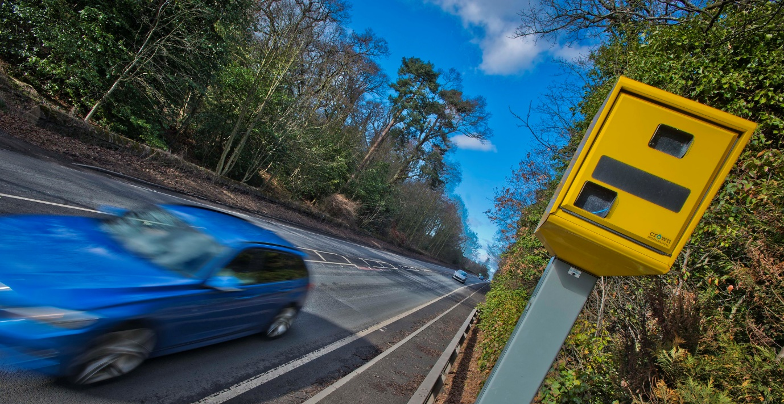
The STPR2 recommends a national review to establish appropriate speed limits for different road types within Scotland. The review would consider a range of measures such as speed management on motorways, speed limits through roadworks and rural settlements on trunk roads, and reducing speed limits in urban environments and residential areas as well as consideration of the national speed limits for HGVs over 7.5 tonnes on the trunk road network.
Depending on the extent to which speed limits may be changed, significant changes could be required to the engineering, enforcement and education framework and the resources necessary to support these. Enforcement and education forms part of the recommendation for Changing road user behaviour (7).
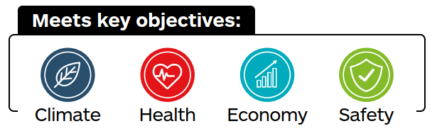
This recommendation aligns with:
- Recommendations 7, 10, 30, 33, 34, 35, 37 and 40;
- Scotland’s Road Safety Framework to 2030 - this recommendation would support the framework and goal of Vision Zero, aligning with the Safe Speeds pillar of the Safe System;
- The Climate Change (Emissions Reduction Targets) (Scotland) Act 2019 - sets targets to reduce Scotland’s emission of all greenhouse gases to net zero by 2045 at the latest, with interim targets of 75 per cent by 2030 and 90 per cent by 2040. A change to how speeds are managed could help to meet these targets, with evidence suggesting that driving at 55mph instead of 65mph can reduce fuel consumption by 10 per cent to 15 per cent. Similarly, an increase in HGV speeds to a more fuel-efficient speed could result in emissions benefits.

Strengthening Strategic Connections
It is important that long-distance strategic connections are maintained to facilitate travel within Scotland and across its border. Much of the strategic network is managed by Transport Scotland on behalf of Scottish Ministers and it is therefore appropriate for the STPR2 to make a number of recommendations in this area. It is also relevant and important that the STPR2 addresses the role that connectivity plays in supporting the National Developments presented in the Revised Draft NPF4 and in facilitating passenger and freight movements through our major gateways.
Recommendations (39) and (40) further develop the Revised Draft NPF4 National Developments of Industrial Green Transition Zones in relation to Grangemouth and Stranraer Gateway.
Addressing the needs of island communities to have reliable links to the mainland, the STPR2 recommends investment in port infrastructure (42) and the investigation of potential fixed link connections (bridges, causeways and/or tunnels) at Sounds of Harris and Barra, and between Mull and the Scottish mainland (41).
Recognising the important part that rail plays in facilitating longer-distance journeys, the STPR2 makes three core recommendations. These involve continued investment in the major railway stations in Edinburgh, Glasgow, Perth and Inverness (43), facilitating investment in future rail freight terminals (44), and Transport Scotland continuing to work with the UK Government to take forward high speed and cross-border rail connections (45).

Sustainable access to Grangemouth Investment Zone (39)
Grangemouth Investment Zone contains important strategic infrastructure, high value employment and manufacturing of materials that are currently vital for everyday life throughout Scotland. It forms part of the Revised Draft NPF4 Industrial Green Transition Zone’s national development. The industrial and economic activity at this critical hub is also vital to Scotland’s economy and will be designed to ensure that the region maintains and develops its competitiveness now and in our net zero future. A sustainable transport access strategy would contribute towards that future.
The STPR2 recommends improvements are made to transport that would enhance sustainable access to Grangemouth Investment Zone for both people and freight. Improvements are likely to include, but not be limited to:
- improved active travel connections, in line with the principles of the recommendations for Connected neighbourhoods (1) and Connecting towns by active travel (4). These connections would be to Grangemouth from key areas, including neighbouring towns and railway stations;
- bus infrastructure improvements to support and encourage improved bus connections to Grangemouth from key areas, including neighbouring towns and railway stations;
- supporting further transition to rail freight, in line with the principles of rail corridor enhancements (15, 16, 17), mode shift for freight (27), rail freight terminals and facilities (44), and cross-border rail enhancements (45) to enable more rail freight capacity;
- M9 Junction 5 improvements (including potential introduction of priority for buses and HGVs) where these provide specific freight and bus benefits.
This recommendation aligns with:
- Recommendations 1, 4, 14, 15, 16, 17, 27, 44, and 45;
- the Revised Draft NPF4 National Development 15: Industrial Green Transition Zones and 20-minute neighbourhoods supporting Liveable Places;
- the Falkirk Growth Deal – which includes funding for a number of projects in the Falkirk and Grangemouth area to aid the transition to net zero. This will partly be delivered through the Falkirk Central Sustainable Transport Hub and Green Travel Corridor project;
- Grangemouth Future Industry Board, that is working to align public sector initiatives focusing on this critical hub of industrial and economic activity that is vital to Scotland’s economy, designed to ensure that the region maintains and develops its competitiveness now and in a net zero future.

Access to Stranraer and the ports at Cairnryan (40)
Stranraer and the ports at Cairnryan act as an important gateway to Scotland for ferry passengers and freight. Improving the transport assets in this location would support regeneration of the South West of Scotland to benefit the economy and local communities.
The STPR2 recommends that safety, resilience and reliability improvements are made on the A75 and A77 strategic road corridors, in turn supporting placemaking opportunities. This would include, but is not limited to, improving junctions, enhancing overtaking opportunities with WS2+1 schemes or climbing lanes at appropriate locations where slow-moving traffic leads to risky overtaking manoeuvres, and widening or realigning carriageways to alleviate ‘pinch points’ such as narrow structures or at stretches of older standard single carriageway.
These would provide more resilient connections to the Revised Draft NPF4 National Developments at Stranraer Gateway and Chapelcross Power Station Redevelopment, in addition to more resilient connections to the ports at Cairnryan.
Examples of locations of potential improvements schemes include:
- A75 Realignment around Springholm and Crocketford;
- A75 Cuckoo Bridge Roundabout;
- A77 Turnberry to Girvan;
- A77 Ballantrae to Smyrton;
- A77 Bellfield Interchange Improvements;
- A77 Dutch House Roundabout Improvements;
- A77 Whitletts Roundabout Improvements;
- A77 Holmston Roundabout Improvements.
These examples do not form the totality of the recommendation, but are locations highlighted for further consideration for potential improvements on the A75 and A77, based on considerations of accident history and other factors.
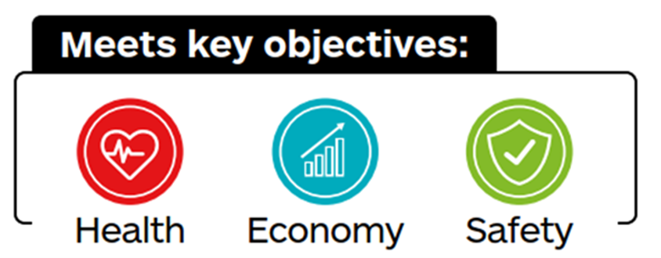
To encourage greater use of public transport and support wider town regeneration proposals, consideration should also be given to upgrading or relocating Stranraer railway station.
This recommendation aligns with:
- Recommendations 30, 31, 32, 36 and 38;
- the Revised Draft NPF4 National Developments 11: Stranraer Gateway and 17: Chapelcross Power Station Redevelopment. This recommendation sits within the Revised Draft NPF4 South priority area, where proposed priorities for the area include improving local livability, decarbonising transport, and building resilient connections. This recommendation contributes to these priorities, specifically those related to supporting sustainable development and strengthening resilience;
- the Borderlands Inclusive Growth Deal and Ayrshire Growth Deal;
- Dumfries and Galloway Local Development Plan Two also outlines plans for the regeneration masterplan for Stranraer Waterfront.

Potential Sound of Harris, Sound of Barra fixed link and fixed link between Mull and Scottish mainland (41)
The current ferry routes on the Sound of Harris, Sound of Barra and between Mull and the Scottish mainland face a number of issues and challenges. Replacing ferry services with fixed links (bridges, causeways and/or tunnels) can improve reliability, connectivity, capacity and travel times and allow for the wider reconfiguration of ferry services.
A Sound of Harris fixed link would improve connectivity between the Uists and Lewis/Harris, whilst a Sound of Barra fixed link would improve connectivity between Barra and the Uists. The provision of these fixed links would also allow for the reconfiguration of transport provision within the Outer Hebrides and to the Scottish mainland.
The main Mull ferry route (Craignure to Oban) is one of the most popular and most capacity constrained routes for vehicles on the CHFS ferry network and the service is forecast to continue to have challenges with vehicle deck capacity. The provision of a fixed link between Mull and the Scottish mainland would improve connectivity and also allow for the reconfiguration of transport provision between the island and the mainland.
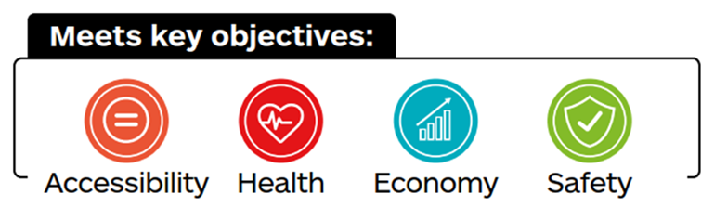
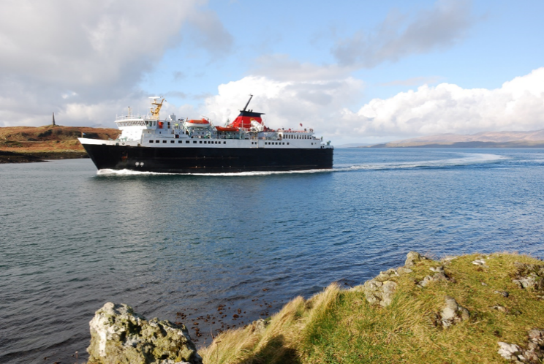
The STPR2 recommends that further work is undertaken on business cases to better understand the benefits, costs and challenges associated with these interventions. These studies would further consider the feasibility of improving island connectivity through additional fixed links by replacing existing ferry services currently delivered by CalMac Ferries Ltd as part of the CHFS contract. These studies would also analyse in further detail the potential long-term savings associated with the public sector funding required to maintain the ferry services and involve input from communities that may potentially be affected.
This recommendation aligns with:
- Recommendations 18, 24 and 42;
- the Revised Draft NPF4 North and West Coast and Islands priority area, which proposes that priorities include decarbonising transport and building resilient connections. This recommendation contributes to these priorities and supporting actions;
- Islands Growth Deal – a 10-year programme of investment for the Outer Hebrides, Orkney and Shetland, with a target of creating up to 1,300 jobs and tackling depopulation concerns;
- The National Islands Plan, 2019, which sets out a strategic objective to improve transport services – this will ensure that existing and future transport-related policies, strategies and services are fully island-proofed so that they truly meet the needs of island communities;
- the ICP, which will replace the current Ferries Plan, and will have regard to aviation, ferries and fixed links, as well as connecting and onward travel. It will include a long-term investment programme for new ferries and development at ports that will aim to improve resilience, reliability, capacity and accessibility, while increasing standardisation, cutting emissions and meeting the needs of both remote rural and island communities whilst providing value for money.

Investment in port infrastructure to support vessel renewal and replacement, and progressive decarbonisation (42)
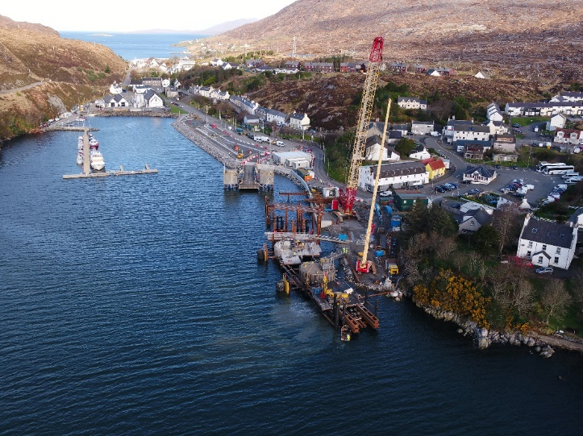
Investment in port infrastructure, including power supplies, would complement the introduction of new and upgraded ferry vessels. This would help meet the needs of rural and island communities by improving the capacity, resilience, reliability, accessibility and standardisation of ferry services and reducing their emissions.
Investment in port infrastructure means that there can be progress to standardisation and interoperability of new and existing vessels, increasing network resilience. This investment would also contribute to reducing emissions across the ferry network and support Scotland’s net zero carbon emission targets.
Source: John Quinn
The STPR2 recommends an investment programme in ferry port infrastructure, including shore power supplies to ferry vessels, to support the STPR2 recommendation Ferry vessel renewal and replacement and progressive decarbonisation (24).
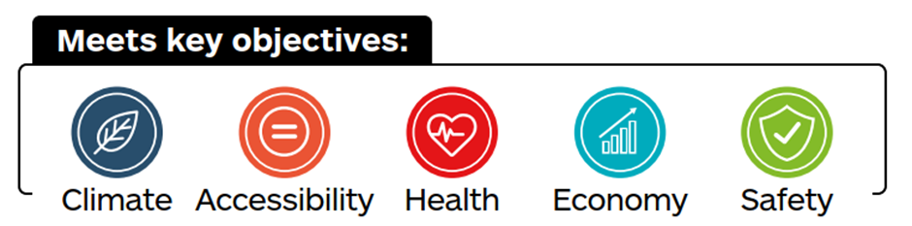

This recommendation aligns with:
- Recommendation 18, 24, 27, 28 and 41;
- the Revised Draft NPF4 North and West Coast and Islands priority area, which proposes that priorities for the area include growing the blue and green economy, decarbonising transport and building resilient connections. It also spans the North East and Central priority areas. This recommendation contributes to these priorities and supporting actions;
- 2018 – 2032 Climate Change Plan Update and the Climate Change (Emissions Reduction Targets) (Scotland) Act 2019 which will be supported by progressive decarbonisation of the CHFS and NIFS ferry networks;
- Scottish Energy Strategy, 2017, which sets out the Scottish Government’s vision for the future energy system in Scotland;
- Carbon Neutral Islands project, which has a commitment for at least three of Scotland’s islands to become fully carbon neutral by 2040;
- Islands Growth Deal – a 10-year programme of investment for the Outer Hebrides, Orkney and Shetland, with a target of creating up to 1,300 jobs and tackling depopulation concerns;
- The National Islands Plan, 2019, which sets out a strategic objective to improve transport services – this will ensure that existing and future transport-related policies, strategies and services are fully island-proofed so that they truly meet the needs of island communities;
- the ICP, which will replace the current Ferries Plan, and will have regard to aviation, ferries and fixed links, as well as connecting and onward travel. It will include a long-term investment programme for new ferries and development at ports that will aim to improve resilience, reliability, capacity and accessibility, while increasing standardisation, cutting emissions and meeting the needs of both remote rural and island communities whilst providing value for money.

Major station masterplans (43)
Following on from the successful upgrade to Glasgow Queen Street Station, as well as recent station improvements at Aberdeen and Stirling, this recommendation involves the redevelopment of four major railway stations in Scotland’s cities: Edinburgh Waverley, Glasgow Central, Perth and Inverness. Studies are continuing to progress plans to consider how re-modelling these stations can deliver specific benefits:
- Edinburgh Waverley – improving its functionality, capacity and ambience as well as enhancing connectivity with other transport modes and its integration within the city centre;
- Glasgow Central – taking forward short-term infrastructure improvements to improve capacity and considering longer-term enhancements as part of Clyde Metro proposals and future High Speed Two services to/from London and Birmingham;
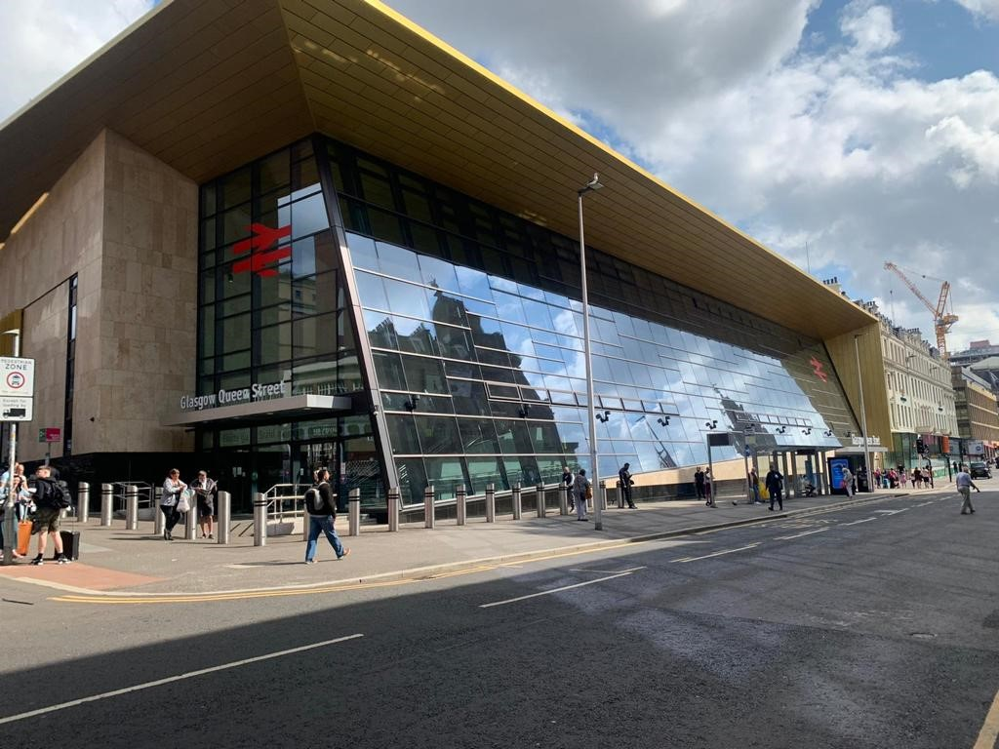
- Perth – enhancing the station to complement improvements to track and signalling on approaches to improve reliability, connectivity and enhance freight provision, as well as to better integrate with the wider city centre.
- Inverness – improving the station’s operational functionality and better integrating the station with the city centre to ensure the station can operate as part of an effective integrated transport interchange, delivering benefits for passengers and freight services.
The STPR2 recommends that station plans and masterplans are progressed to align with, and support, the investment priorities of Transport Scotland and Network Rail. The masterplan proposals would set the framework for future phases of work at the respective stations to accommodate passenger demand in line with sustainable travel, supporting net zero targets, and co-ordinate with regional activity undertaken by other strategic partners.
Source: Network Rail
This recommendation aligns with:
- Recommendations 11, 12, 15, 16, 17, 21 and 45;
- Network Rail’s Scotland Route Study which identified capacity constraints at Glasgow Central, Edinburgh Waverley, Perth and Inverness, and proposed remodelling of all four of the stations;
- Rail Corridor Period 6 – Network Rail’s investment plan over the five years of Control Period 6 (2019-2024);
- Economic growth plans of the four cities.

Rail freight terminals and facilities (44)
Sufficient provision of rail freight terminals is critical to achieving a significant shift of freight from road to rail. This would improve the sustainability and competitiveness of Scotland’s supply chain.
Rail freight is transported on a commercial basis and is carried out by private sector freight operating companies and logistical providers. The role of Government is to put policies and strategies in place that facilitate growth (with Network Rail managing the core rail infrastructure and the regulator, the ORR, regulating compliance, safety and issuing of licences).
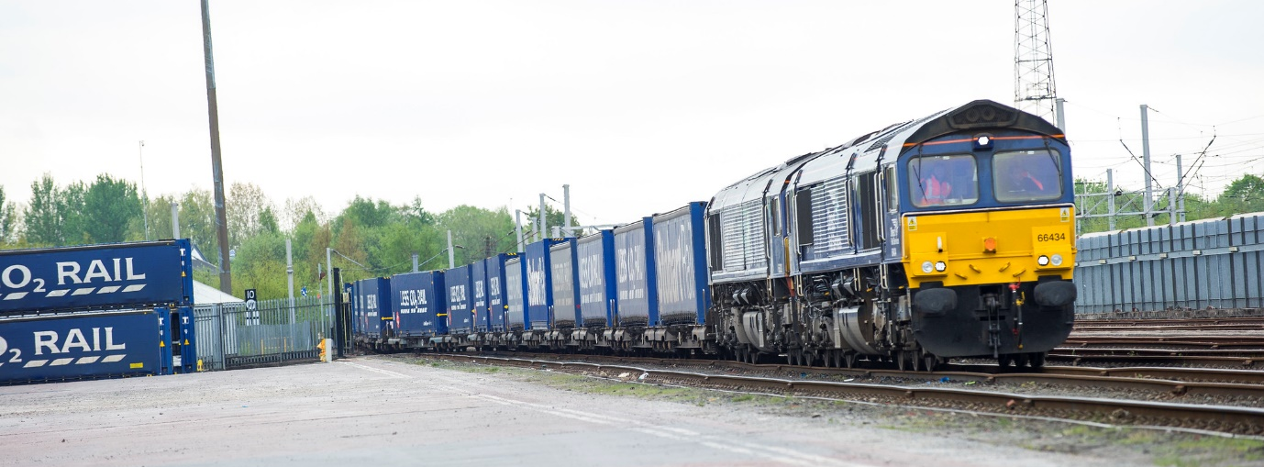
The STPR2 recommends that Transport Scotland supports industry partners in carrying out an updated market study for rail freight growth in Scotland (linked to the Industry Growth Plan for Rail Freight) including a review of rail freight terminals and hubs to confirm how to meet long-term mode shift requirements.
In recognition of the environmental and societal benefits of rail freight, the Scottish Government currently supports a range of grants to help with the transfer of freight from road to rail and will continue to explore opportunities to provide support. Freight Facilities Grants can help companies with the capital cost of providing freight handling equipment and facilities, and revenue support grants are also available: both are subject to a successful application and budget availability.
This approach to promoting and supporting the rail freight sector has previously been successful in facilitating projects such as the Highland Spring freight facility at Blackford, where Government, the rail industry and third party investors worked together to achieve significant modal shift to rail and could be a key model to follow for future projects.
The express/light logistics market (lighter freight carried on converted passenger trains) is a growing market and also has potential for capital grant support for freight handling infrastructure in selected locations including passenger stations.
This recommendation aligns with:
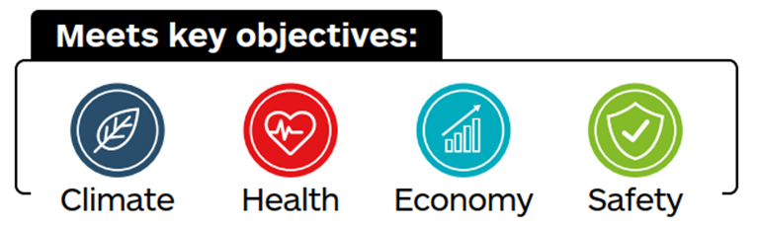
- Recommendations 15, 16, 17, 25, 27, 36, 39 and 45
- the Decarbonising the Scottish Transport Sector report which cited that 23 per cent of freight goods moved by road must be shifted to rail and sea by 2030 (equivalent to all road freight moved over 400 kilometres);
- 2018 – 2032 Climate Change Plan Update and the Climate Change (Emissions Reduction Targets) (Scotland) Act 2019 which outlines the plan to invest in measures that will encourage the growth in rail freight;
- Transport Scotland Rail Freight Strategy (2016), which sets out the vision for a competitive, sustainable rail freight sector that will play an increasing role in Scotland’s economic growth by providing a safer, greener and more efficient way of transporting products and materials.

High speed and cross-border rail enhancements (45)
Infrastructure upgrades to permit higher speeds on cross-border routes would enable journey times to London and other key destinations to be more competitive with air travel. This improved connectivity would encourage a shift from air to rail on longer-distance travel and support Scotland’s net zero emission commitments. These improvements would also release capacity for additional regional passenger and freight services.
The STPR2 recommends that Transport Scotland continues to work closely with the UK Government to take forward a programme of on-line and off-line infrastructure upgrades targeted at longer-distance cross-border routes. These would reduce long-distance passenger service journey times and increase capacity and reliability for regional passenger and freight services.
This is likely to include the following routes:
- East Coast Main Line (ECML);
- West Coast Main Line (WCML);
- Glasgow and South Western line (Glasgow to Carlisle via Dumfries).
The Glasgow and South Western route is considerably longer and would require significant upgrades to provide additional capacity and electrification, however since this route is considerably longer and geographically constrained, it is unlikely to ever achieve journey times equivalent to that currently offered by the other two routes but has value as a diversionary route. Cost effectiveness of new alignments should be judged against providing quadruple track on existing corridors, especially in respect of land acquisition. This would require further assessment at future stages of business case development.
This recommendation aligns with:
- Recommendations 11, 15, 16, 17, 25, 27, 39, 43 and 44;
- the Revised Draft NPF4 National Development 18: High Speed Rail;
- The Decarbonising the Scottish Transport Sector report, which cited that 23 per cent of freight goods moved by road must be shifted to rail and sea by 2030 (equivalent to all road freight moved over 400 kilometres);
- High Speed Two Phase Two Strategic Case, Department for Transport (2017);
- Integrated Rail Plan for the North and Midlands, Department for Transport (2021).

Achieving Desired Outcomes
The overall aim of the STPR2 has been to develop a programme of recommendations that will guide the Scottish Government’s transport investment programme in Scotland for the next 20 years to help to deliver the vision, priorities and outcomes that are set out in the NTS2.
This has been achieved by conducting a Scotland-wide, evidence-based review of the performance of the strategic transport system. Building on evidence and Groupings set out in the Case for Change Reports published in February 2021, an appraisal has been carried out on a regional and national basis against the STPR2 TPOs (which are closely aligned to the outcomes of the NTS2) and other criteria as set out in STAG. The performance of the recommendations is summarised in Figure 21. This highlights a snapshot of the benefits related to the recommendations. The ASTs provided in Appendix I present the performance of the recommendations against the TPOs.

Figure 21 – The STPR2 Contribution of Recommendations to Benefits
These recommendations, as well as performing well in their own right, combine to create a holistic package, that addresses the wide-ranging strategic transport challenges and opportunities across the country. The paragraphs below summarise the impact of the combined suite of recommendations against the five TPOs. The national AST, contained within Appendix H, provides further details of the appraisal process and outputs.

Contributing to the Government’s Net Zero Target
To achieve the Scottish Government’s commitments towards net zero emissions, there will need to be a noticeable reduction in overall travel, and a switch to more sustainable modes. Some of the levers required to address the first point are outside of the scope of the STPR2 (for example land-use planning and financial demand management measures). Nonetheless, the majority of the 45 recommendations contribute directly towards this objective. The particular focus of these recommendations is on:
- decarbonising the transport system (24)(25)(26)(27)(28);
- providing greater opportunities for people to walk, cycle or wheel (1)(2)(3)(4)(5)(8)(9) (10);
- delivering transformational change in Aberdeen, Edinburgh and South East Scotland, and Glasgow city regions through investment in mass/rapid transit (11)(12)(13);
- delivering a competitive public transport alternative to the private car, to generate mode shift (14)(15)(16)(17)(18)(19)(20)(21)(22)(23)(43)(45).
At the heart of the recommendations are those that are associated with decarbonising the transport system covering all motorised forms of transport encompassed by the review. The STPR2 is key to achieving the Government’s goals around net zero and is one of the enablers of the policy ambition to achieve a 20 per cent reduction in car kilometres by 2030. A route map to achieve this level of reduction in car kilometres by 2030 was published on 13 January 2022.
Expanding on this, the recommendations of the STPR2 are crucial to the achievement of the systemic change that is required to achieve a 20 per cent reduction in car kilometres. Whilst the STPR2 recommendations do not deliver the reduction in car kilometres needed, the recommendations of the STPR2 facilitate the wider systemic changes, particularly away from private car use to sustainable travel, that are required.
It is acknowledged that some of the recommendations of the STPR2 relate to the achievement of existing commitments and targets. For example, decarbonisation of the rail network was announced in the Rail Services Decarbonisation Action Plan in July 2020. Similarly, decarbonisation of the bus fleet has already been announced with a commitment to replace half of diesel buses by 2023 and move towards a zero emissions bus fleet. There will be further carbon savings from the decarbonisation of the ferry fleet.
The recommendations for significant investment in active travel across the country are directly targeted at the shorter-distance trips that could be made by non-motorised modes. The impacts of these will vary between urban and rural areas, but these would deliver a step-change in the number of people walking, cycling and wheeling. Output from the appraisal process indicates that the comprehensive introduction of all the active travel measures could result in an overall increase in cycling from less than two per cent currently to approximately 20 per cent of all trips; and walking from 20 per cent currently to 25 per cent of all trips.
To complement the active travel measures, a number of recommendations aim to encourage greater use of public transport in both urban and rural communities. Recognising the need to deliver a transformational change where demand for travel is at its highest, the mass/rapid transit recommendations for Aberdeen, Edinburgh and South East Scotland, and Glasgow city regions would result in a step-change in provision of public transport services delivering a modal transfer from private car and reducing levels of congestion, and consequently emissions.
In summary the overall contribution of the recommendations relating to this TPO include:
- the combination of the STPR2 recommendations, existing commitments and wider policy ambition (as illustrated in the Scottish Government Route Map published in January 2022) that will contribute to the achievement of a 20 per cent reduction in emissions by 2030 and a 90 per cent reduction by 2040 compared with taking no action;
- an increase in cycling from less than two per cent currently to almost 20 per cent of all trips;
- a reduction in distance travelled of 750 million (two per cent) car kilometres;
- a comprehensive alternative to the private car, particularly in our larger urban areas.
The STPR2 is a crucial component of Scotland’s journey to net zero emissions and would, in conjunction with existing commitments and other policy ambitions, contribute to a reduction in 90 per cent (from 2019 level) of the CO₂ equivalent emissions associated with transport. It will not do so on its own but provides the crucial infrastructure required to deliver this change.

Affordable and Accessible Public Transport
In 2020, 28 per cent of households had no access to a private car. This proportion was even higher within areas experiencing social deprivation (48 per cent in the areas ranked in the top 20 per cent most deprived SIMD data zones in Scotland). Recognising this, the recommendations from the STPR2 will make public transport more affordable and accessible by:
- expanding the availability of Demand Responsive Transport and Mobility as a Service in rural areas (20);
- creation of a national integrated ticketing system (23);
- delivering transformational change in Glasgow, Edinburgh and South East Scotland and Aberdeen through investment in mass/rapid transit (11)(12)(13);
- providing strategic bus priority measures (14);
- public transport enhancements and interchange opportunities (16)(17)(18);
- providing a more accessible and seamless interchange between modes (18)(19)(21)(22)(43).
The expansion of DRT and MaaS would achieve more equitable access to the public transport network, and could also enhance access to employment, education, healthcare and leisure activities, and integrate with other services and other modes.
Taking forward the integrated ticketing scheme and the infrastructure improvements at stations would deliver a more seamless experience for public transport users, from the point of purchasing tickets through to the completion of the journey. This would result in more affordable and better-connected journeys in comparison to those available today. Output from the appraisal process indicates that the introduction of these measures would contribute to enhancing accessibility to key services by public transport. For example, approximately 110,500 more people (2.4 percentage point increase) would be able to access an accident and emergency hospital site in under 30 minutes by public transport, and approximately 70,500 more people (1.6 percentage point increase) would be able to access a higher education site in the same time.
Although the STPR2 recommendations do not cover the direct costs of travel (for example fares, fuel price), the package of recommendations would see a small reduction in transport poverty due to the overall improvements to access and connectivity between modes (transport poverty is defined as the spend on transport as a proportion of income).
As outlined in the previous section, the expansion of mass transit in Aberdeen, Edinburgh and South East Scotland, and Glasgow city regions would deliver transformational change, with a subsequent significant increase in public transport trips across the city regions.
In summary, the overall contribution of the recommendations relating to this TPO include:
- improved access to key services;
- a more competitive and accessible public transport system for all;
- fewer people experiencing transport poverty;
- provision of effective and tailored public transport services to meet the needs of rural communities.
We live in a society where a significant proportion of the population relies on public transport. By working in collaboration with local authorities and transport providers, Transport Scotland can deliver a step-change in public transport provision. Across the country there will be a noticeable improvement in terms of accessing key services by public transport. This will be most pronounced in the large urban areas.

Enhancing Places, and Supporting Health and Wellbeing
The STPR2 has been undertaken in parallel with the NPF4. The Revised Draft NPF4 and the STPR2 are aligned in seeking to develop and create:
- Sustainable places - where we reduce emissions and restore and better connect biodiversity;
- Liveable places - where we can live better, healthier lives;
- Productive places - where we have a greener, fairer and more inclusive wellbeing economy.
Although specific interventions associated with land-use and place planning are outside the scope of the STPR2, the review has focused on the transport interventions required to create successful places. The following measures support the six qualities of successful places (designed for Healthy, Pleasant, Connected, Distinctive, Sustainable and Adaptable) as outlined in the Revised Draft NPF4:
- expansion of 20mph limits and zones across communities (10);
- providing high-quality active travel routes connecting neighbourhoods to each other and to key services, including schools (3)(4)(5)(8);
- implementation of active travel measures to reduce the impact on communities with a trunk road passing through (37);
- changing road user behaviour (7);
- behavioural change campaigns to influence travel choice (6)(8)(9).
Around one-third of trips under one kilometre are currently made by motorised transport, with many of these being to local services within communities. For trips between one and two kilometres, the proportion rises to 55 per cent. The combination of recommendations associated with connected neighbourhoods, expansion of 20mph limits and zones, and behavioural change would create an environment where walking, cycling or wheeling becomes the preferred, safest and most effective mode of travel for short trips.
The expansion of the current initiatives to provide active/safe routes to school would, in many areas, complement the measures associated with connected neighbourhoods. Likewise, incorporating behavioural campaigns alongside the infrastructure measures to create attractive routes, would result in a longer-term embedded behaviour towards favouring non-motorised travel in the next generation.
In some communities, the trunk road has a negative impact on the local environment. The measures recommended will address this in locations where this issue is particularly significant. Whilst the specific nature of the recommendations will be developed following the STPR2, it is anticipated that these will reduce severance, and encourage a greater use of active modes within communities.
If the active travel and behavioural change recommendations of the STPR2 were implemented comprehensively throughout Scotland, estimated mode share of all journeys that are undertaken by walking would increase from around 20 per cent at present to 25 per cent, and those by cycling from less than two per cent to almost 20 per cent.
In summary, the overall contribution of the recommendations relating to this TPO include:
- a substantial increase in active travel, especially for short journeys, with cycling trips accounting for up to 20 per cent of all trips;
- communities less impacted by the trunk road network;
- more attractive and higher-quality places, accessible to more people;
- an estimated 260 premature deaths would be saved per annum as a result of increased physical activity, resulting in a £10-15 billion benefit over 60 years.
The Revised Draft NPF4 and the STPR2 are aligned in seeking to develop and create sustainable, liveable, productive and distinctive places. A core thread of the STPR2 recommendations is the transport components to deliver these places; primarily through the step-change in active travel, which is forecast to result in these modes accounting for a significant proportion of all trips by 2045.

Contribution Towards Sustainable Inclusive Growth
The strategic transport network plays a vital role in achieving continued inclusive growth, recognising the varied needs of the population. Much of the strategic network is managed by Transport Scotland and it is therefore appropriate for the STPR2 to make a number of recommendations in this area. It is also relevant and important that the STPR2 addresses the role that connectivity plays in supporting the National Developments as presented in the Revised Draft NPF4, and in facilitating movement of people and freight through our major gateways. This has been achieved by recommending:
- a programme of enhancements to core longer-distance rail corridors (15)(16)(17)(45);
- enhanced connectivity to island communities (18)(41)(42);
- a package of measures to enhance freight facilities (27)(36)(44);
- improved access to National Developments and gateways, at both Stranraer Gateway and Grangemouth (39)(40).
Enhancing the rail network, focusing on the longer-distance corridors connecting the cities, would result in an increase in public transport mode share and consequential reduction in overall transport emissions. The improved reliability associated with the electrification and targeted infrastructure improvements would also reduce the level of delays experienced by users.
The package of rail interventions would see enhancements to encourage the transfer of freight from road to rail, which would help to support a forecast 40 per cent increase in railway freight tonne-kilometres by 2043/44 from 2015. The most significant increase would be experienced on the cross-border route as a result of the improvements to the WCML, Glasgow and South Western line and ECML.
Many of the recommendations would result in improved access to employment opportunities, particularly by public transport. With the STPR2 recommendations in place, 66 per cent of employment opportunities in key urban areas can be accessed within 60 minutes by public transport, an increase of approximately 4.6 percentage points.
The ICP will consider detailed operation and provision of Clyde, Hebrides and Northern Isles ferry services between the islands and the Scottish mainland. In advance of this, the STPR2 has identified three potential areas where the introduction of a fixed link could transform connectivity and economic activity: Sound of Harris, Sound of Barra, and a connection from Mull to the Scottish mainland. Output from this review suggests that these connections could provide a positive economic impact, when considered against the alternative of ongoing subsidies to existing ferry services.
The STPR2 recommendations support the Revised Draft NPF4 national spatial strategy for Scotland, including its associated action areas. The Scottish Government has identified a number of National Developments within the Revised Draft NPF4, some of which are recommendations of the STPR2. Transport connectivity will play a key role in realising the benefits of these and the national spatial strategy. A number of the National Developments are already supported by transport investment, while others will be supported by the range of transport interventions that the STPR2 recommends. In addition to these, two developments within the Revised Draft NPF4 have been highlighted within the STPR2 as requiring intervention at a strategic level (Stranraer and Grangemouth), with both also acting as major gateways. The recommendations would enhance reliability and resilience, and encourage travel by sustainable modes.
In summary, the overall contribution of the recommendations relating to this TPO include:
- £15-20 billion benefits to the Scottish economy (these relate to economic, health benefits and accident savings from the appraisal tools);
- improved access to employment opportunities by public transport;
- improved transport access to National Developments proposed in the Revised Draft NPF4;
- significantly enhanced opportunities for facilitating freight movements by rail, with benefits to the economy of up to £100 million.
The strategic transport network plays a vital role in achieving continued inclusive growth. By targeting investment to improve access to employment opportunities and key services, the package of measures is forecast to generate approximately £15-20 billion benefits to the Scottish economy.

A Reliable and Resilient Strategic Transport System that is Safe and Secure for Users
Transport Scotland is the roads authority for the Scottish trunk road and motorway network. It is the Scottish Ministers’ single biggest asset, with a gross asset value of over £20 billion. Transport Scotland is committed to measures to improve the resilience of the rail network, although much of this investment lies outwith the scope of the STPR2. However, the review has identified a range of specific measures that would supplement those carried out as part of Transport Scotland’s core responsibilities:
- programme of measures on the trunk roads to improve safety, resilience, and address climate change, with immediate focus on the A83 (29)(30)(31)(32)(38);
- enhancements on the rail network to improve resilience (15)(16)(17);
- expansion of ITS across all modes (33)(34)(35);
- improving rest and welfare facilities for hauliers (36);
- addressing active travel impacts of trunk roads through local communities (37).
Plans for enhancing the rail network should be integrated, including measures to improve the reliability and resilience at key locations which are known to cause delays. Whilst there may not be any significant reduction in journey times as a result of this investment, it would be expected that the frequency and length of delays caused by engineering and operational incidents would be reduced.
On the trunk road network, the primary focus of the improvements programme is aimed at reducing the number and severity of accidents. Therefore, whilst the specific nature of the recommendations will be developed following the STPR2, it is anticipated that these would reduce both the overall number of incidents and the proportion that result in those killed or seriously injured.
ITS has an increasingly important role to play in contributing to road safety and towards the efficient management and operation of the Scottish national transport network. The upgrading of the existing TSNCC to cover all modes, and the expansion of the overall ITS, will make a significant contribution to the overall safety of travel. It will also support enhanced transport resilience, smoother journeys, quicker reaction to incidents, and environmental improvements across the strategic transport network.
The specific intervention proposed for the A83 is forecast to deliver between £40-50 million of benefits through improved resilience by avoiding closures impacting the route, as well as the businesses and communities that rely upon it for access.
Security improvements can be realised through a range of recommendations. Suitable lighting, adequate and accessible crossing points and the maintenance of dedicated active travel routes that form part of the trunk road network can improve actual and perceived traveller security. An increase in surveillance offered by interventions such as ITS can also improve traveller security, and a shift from road to rail freight can improve the surveillance and security of cargo.
In summary, the overall contribution of the recommendations relating to this TPO include:
- a resulting reduction in total accident numbers of approximately 90,000 (or approximately three per cent), at the national level (this refers to the area covered by the Transport Model for Scotland);
- a strategic transport network that is more resilient, resulting in fewer closures and impacts on those using the network, which in turn will make the network more reliable;
- an expanded ITS service that will provide greater resilience across the network and deliver a higher level of service to more road users;
- improved infrastructure and surveillance can improve the security of people and goods.
The STPR2 recommendations recognise the need for continued investment in the strategic transport network to achieve the vision for Scotland to have the best road safety performance in the world. Over the next 60 years it is forecast that there would be approximately 90,000 fewer accidents on the road network. The investment will also deliver a more reliable and resilient multi-modal network, with a particular focus on meeting the needs of rural and island communities.

Regional Packages
The principal benefit of developing a series of recommendations across the whole country is that an element of consistency is maintained, and thus the same general recommendation is developed for the same problem/opportunity in multiple locations. However, these overall recommendations then need to be tailored to respond to the regional problems and opportunities found when identifying specific locations for interventions in particular parts of the country. This has been achieved by developing a series of regional packages that incorporate those recommendations above that are relevant to that particular region.
Full details of the regional packages and the output from the appraisal are reported in the ASTs contained in Appendix H and Appendix I.

Additional Considerations

Island Connectivity Plan (ICP)
Over the course of the STPR2, significant work has been undertaken to reflect on the key problems and opportunities facing Scotland’s islands and remote communities with regards to transport connectivity. As a result of this work, and from stakeholder input and engagement, there is an evidence base to assist in shaping the future development of the CHFS network serving the Outer Hebrides, Mull, Islay, Arran and Kintyre as well as the NIFS routes to Shetland and Orkney.
Transport Scotland will use this evidence base, along with the development of the STPR2 Recommendations 18, 24, 41 and 42, to inform the development of the ICP.
The ICP, which will replace the current Ferries Plan, will support the delivery of the NTS2 priorities and The National Islands Plan. It will include a long-term investment programme for new ferries and development at ports that will aim to improve resilience, reliability, capacity and accessibility, while increasing standardisation, cutting emissions and meeting the needs of island communities whilst providing value for money.
The ICP will undertake a ferry fares policy review alongside the wider Fair Fares review. It will explore and consult on pathways to zero/low emission ferry transport. Transport Scotland will work with communities, businesses and ferry operators to explore ways of making better use of available ferry capacity for people, vehicles and freight, and to enable more sustainable travel opportunities.
Work is ongoing on the ICP, with priority being given to a long-term plan and investment programme for vessels and ports, with the aim of publishing a draft consultation by the end of 2022. Other elements of the ICP will follow, with a view to further publications in 2023.

Aviation Strategy
Aviation, globally and in Scotland, is facing two significant challenges: recovering from COVID-19 and reducing its environmental impact.
In developing Transport Scotland’s aviation strategy, consideration is being given to how to work with others to address these two challenges, paving the way for restoring and growing Scotland’s connectivity in a way that reduces the environmental impacts of aviation.
Aviation is also essential to many of the island communities, enabling access to services and helping to deliver The National Islands Plan. Although in many cases flying is already the lowest emission option (or no different to the next alternative), the aviation strategy will also consider how best to achieve the aim of having low/zero emission air services within Scotland that meet the needs of communities and help deliver sustainable economic growth.

Extension of Borders Railway
The Borderlands Inclusive Growth Deal includes up to £10 million of funding: £5 million from the Scottish Government and £5 million from the UK Government, to develop a shared understanding of the benefits and challenges of options to extend the Edinburgh – Tweedbank Borders Railway to Carlisle. This will include undertaking feasibility work to further develop the business case for the reinstatement of the railway. The Scottish Government will continue to work with Borderlands Partners on this commitment.

A96 between Aberdeen and Inverness
At the commencement of the STPR2, the dualling of the A96 between Aberdeen and Inverness was classed as a committed project and was therefore out of the scope for the STPR2.
In August 2021 the Scottish Government and Scottish Green Party Parliamentary Group published their Cooperation Agreement and shared policy programme, titled The Bute House Agreement. In the shared policy programme, various agreed principles regarding investment in the transport network were set out. In relation to the A96, the following was noted: “The Scottish National Party and Scottish Green Party have and will maintain distinct positions of the dualling of the A96. However, as part of this agreement, the Scottish Government will take forward a transport enhancements programme on the A96 corridor that improves connectivity between surrounding towns, tackles congestion and addresses safety and environmental issues. This will include:
- dualling from Inverness to Nairn;
- bypassing of Nairn, Keith, Elgin and Inverurie accompanied by measures to remove through traffic from the by-passed town centres;
- targeted road safety improvements where needed, for example between Fochabers and Huntly and Inverurie to Aberdeen;
- the development of an A96 “Electric Highway”.
The Agreement goes on to state: “The current plan is to fully dual the A96 route between Inverness and Aberdeen. We agree to conduct a transparent, evidence-based review to include a climate compatibility assessment to assess direct and indirect impacts on the climate and the environment. This will report by the end of 2022.”
Given the above, the STPR2 recommends that the A96 Corridor review is undertaken in accordance with STAG. The review should consider the transport problems and opportunities on the A96 corridor, the changing policy context and other relevant considerations such as development aspirations for the corridor and surrounding area. The review should also include a Climate Compatibility Assessment, SEA and Design Manual for Roads and Bridges (DMRB) Stage 1 Assessment.
Since the publication of the A96 Strategic Business Case in 2014, there have been updates to the policy context, including the publication of the NTS2 and Delivery Plans, 2018 – 2032 Climate Change Plan Update, the Revised Draft NPF4 and 20 per cent Car Kilometre Reduction Route Map. A policy context refresh will therefore be required. Given the strategic importance of the A96 Dualling Programme, it is particularly important that national policies are taken into consideration alongside regional and local policies.

Fair Fares Review
Transport Scotland’s Fair Fares Review is part of a broader package of work being taken forward to ensure that there is a viable and sustainable transport system for the future. Immediate priorities for this work include ensuring that our transport system is aligned with the prevailing COVID-19 conditions and the updated COVID-19 Strategic Framework, providing guidance and communications support to passengers and operators, and securing a safe and confident return to public transport as we recover from the pandemic.
The review is being undertaken in a phased approach, to enable options to be considered and trialled or delivered throughout the course of the review. The review is being undertaken to ensure a sustainable and integrated approach to public transport fares in the future. The review is looking at the range of discounts and concessionary schemes which are available on all modes including bus, rail and ferry. It is taking cognisance of the cost and availability of services and will consider options against a backdrop of declining car travel costs and increasing public transport costs. The review will conclude in 2023.

Governance Review
As part of the development of the NTS2 an initial review of transport governance identified that this work is complex and further detailed consideration is needed to develop a new regional model(s) for transport governance, allowing for spatial variation, and to develop proposals capable of implementation. Transport Scotland has convened a Transport Governance and Collaboration Review Group with representation from RTPs to take forward the further work required.
Governance arrangements must support delivery of statutory Climate Change targets. Transport Scotland is working collaboratively with COSLA, Society of Local Authority Chief Executives and Senior Managers (SOLACE) and RTPs on transport governance, looking to develop implementable models. This is within the context of the Local Governance Review.

Funding Considerations
The STPR2 presents the Strategic Business Case for the recommendations presented. The next stage will be further development of the recommendations, providing more detailed Business Cases to inform the investment decision-making process. These will inform the Scottish Government’s future spending as part of the overall investment-in-transport programmes. As development and business case work progresses, projects may become commitments with funding and a delivery programme. Or it may be determined that a recommendation is either not a priority for investment or that it is of high priority.
The STPR2 recommendations have been developed in the context of the cost of living crisis and the Scottish Government’s current budget outlook (November 2022). Therefore, the challenges outlined in the Capital Spending Review Update, published in May 2022, and the EBR, published in November 2022, have a bearing on the investment pipeline of projects and programmes that form part of the considerations.
Bringing together the implications of the Capital Spending Review Update and the EBR with the final recommendations of the STPR2, as well as current investment projects, including legal and statutory commitments, is important. This can provide a focus to future investment that is ambitious whilst recognising current constraints and the need to remain adaptable to changing circumstances where, for example, future changes to the financial situation could lead to the need to review the scale and focus of investment.
In the context of current economic challenges the immediate actions to delivery of the STPR2 recommendations are realistic, however a significant proportion of the recommendations are already underway providing investment in the transport network that will contribute to addressing the key challenges of addressing climate change, tackling child poverty and economic recovery.

Environmental Considerations
Environmental considerations are set out within the SEA Environmental Report for the STPR2. With regard to the HRA for the STPR2, initiatives brought forward under each recommendation will require scrutiny to determine whether potential for significant effects on European sites exist. Those brought forward as part of recommendations which are likely to have a potentially significant effect should undertake a project level HRA to determine whether the recommendations would have a significant effect, or adverse effect on integrity, with regards to impact pathways upon European sites within the Zone of Influence related to that impact, either alone or in combination with other plans or projects. Any recommendation which has been screened out as too broadly defined to assess within the STPR2 should be assessed through project level HRAs when the recommendations have been bought forward and are more defined. As part of the business case / development process, projects bought forward through the recommendations would need to consider the requirement to produce a Construction Environmental Management Plan (CEMP) to ensure compliance with the Habitats Regulations and the Water Environment (Controlled Activities) (Scotland) Regulations noting that this will not be applicable for all projects.

Next Steps
This report has drawn together all the key findings from the individual tasks and activities that have been undertaken during the STPR2 process to inform a succinct and accurate record of the STPR2 as a whole. It sets out the process undertaken to inform the Scottish Government’s future investment plans and spending reviews. Further details of the STPR2 process and outcomes can be found in the accompanying supporting documents set out within Chapter One and via the webpage for the STPR2.
The recommendations of the STPR2 do not constitute the full transport investment programme of Scottish Government. They should be considered alongside the overall Government spending commitments on transport, within Scottish Government budgets or funded by Government, for example Growth Deals. Some of the other Scottish Government transport spending commitments are out of scope for the STPR2. For example:
- measures to improve resilience of the rail network (for example operations, maintenance and renewal);
- revenue-based spending on public transport including bus, ferries and air services (for example subsides for operations and fares).
It should also be noted that transport interventions not recommended by the STPR2 may still be appropriate to be taken forward at regional and local levels, however any request for funding from the Scottish Government will require demonstration of the benefits and impacts of the transport proposal through the usual business case and transport appraisal process required by Transport Scotland.
The interventions contained within the findings and recommendations set out within this Technical Report are not the sole responsibility of Transport Scotland to deliver, indeed many will rely on working together with local authorities, RTPs and other stakeholders to take forward, subject to suitable funding being available.

SEA Post-Adoption Statement
A statutory requirement of the SEA is the requirement to publish a Post-Adoption Statement. This will be published in early-2023 and will:
- describe how the Environmental Report and the opinions of those consulted are taken into account in finalising and adopting the recommendations of the STPR2 and how the SEA has responded to consultation comments;
- describe the reasons for choosing the recommendations of the STPR2, in the light of other reasonable alternatives considered;
- include the final environmental monitoring programme for implementation of the STPR2.

APPENDICES

National Transport Strategy (NTS2), Transport Scotland, February 2020, https://www.transport.gov.scot/publication/national-transport-strategy-2/
Securing a Green Recovery on a Path to Net Zero: Climate Change Plan 2018–2032 - update, Scottish Government, 2020, https://www.gov.scot/publications/securing-green-recovery-path-net-zero-update-climate-change-plan-20182032/documents/
Scotland's National Strategy for Economic Transformation, Scottish Government, March 2022, https://www.gov.scot/publications/scotlands-national-strategy-economic-transformation/
National Planning Framework 4: Revised Draft, Scottish Government, November 2022, https://www.gov.scot/publications/national-planning-framework-4-revised-draft/
National Transport Strategy (NTS2) – Delivery Plan (2022 to 2023), Transport Scotland, June 2022, https://www.transport.gov.scot/publication/national-transport-strategy-nts2-second-delivery-plan-2022-2023/
National Transport Strategy (NTS2) – Delivery Plan (2020 to 2022), Transport Scotland, December 2020, https://www.transport.gov.scot/publication/national-transport-strategy-nts2-delivery-plan-2020-to-2022/
Reducing Car Use for a Healthier, Fairer and Greener Scotland: A Route Map to Achieve a 20 Per Cent Reduction in Car Kilometres by 2020, Scottish Government and COSLA, January 2022, https://www.transport.gov.scot/news/reducing-car-use-for-a-healthier-fairer-and-greener-scotland/
Cleaner Air For Scotland 2: Towards A Better Place For Everyone, Scottish Government, July 2021, https://www.gov.scot/publications/cleaner-air-scotland-2-towards-better-place-everyone/
Scottish Government and Scottish Green Party Shared Policy Programme: Working Together to Build a Greener, Fairer, Independent Scotland, The Scottish Government, August 2021, https://www.gov.scot/publications/scottish-government-and-scottish-green-party-shared-policy-programme/
A National Mission with Local Impact: Infrastructure Investment Plan for Scotland 2021-22 to 2025-26, Scottish Government, February 2021, https://www.gov.scot/publications/national-mission-local-impact-infrastructure-investment-plan-scotland-2021-22-2025-26/
Emergency Budget Review: 2022 to 2023, Scottish Government, November 2022, https://www.gov.scot/publications/emergency-budget-review-2022-23/
National Transport Strategy: Protecting Our Climate and Improving Lives (Draft for Consultation), Transport Scotland, February 2020, https://consult.gov.scot/transport-scotland/national-transport-strategy/
Net Zero: The UK's Contribution to Stopping Global Warming, Committee on Climate Change, May 2019, https://www.theccc.org.uk/publication/net zero-the-uks-contribution-to-stopping-global-warming/
Scottish Transport Appraisal Guidance – Managers’ Guide, Transport Scotland, January 2022, https://www.transport.gov.scot/media/50895/scottish-transport-appraisal-guidance-managers-guide.pdf
STPR2 Strategic Environmental Assessment Environmental Report, Jacobs/AECOM, December 2022
National Transport Strategy (NTS2), Transport Scotland, February 2020, https://www.transport.gov.scot/publication/national-transport-strategy-2/
Securing a Green Recovery on a Path to Net Zero: Climate Change Plan 2018–2032 - update, Scottish Government, 2020, https://www.gov.scot/publications/securing-green-recovery-path-net-zero-update-climate-change-plan-20182032/documents/
Cleaner Air For Scotland 2: Towards A Better Place For Everyone, Scottish Government, July 2021, https://www.gov.scot/publications/cleaner-air-scotland-2-towards-better-place-everyone/
Scotland's National Strategy for Economic Transformation, Scottish Government, March 2022, https://www.gov.scot/publications/scotlands-national-strategy-economic-transformation/
National Planning Framework 4: Revised Draft, Scottish Government, November 2022, https://www.gov.scot/publications/national-planning-framework-4-revised-draft/
Initial Appraisal: Case for Change – National – STPR2, Transport Scotland, 2021, https://www.transport.gov.scot/publication/initial-appraisal-case-for-change-national-stpr2/
STPR2 Strategic Environmental Assessment Environmental Report, Jacobs/AECOM, December 2022
Strategic Transport Projects Review 2, Transport Scotland, 2022, https://www.transport.gov.scot/our-approach/strategy/strategic-transport-projects-review-2/
Scottish Government and Scottish Green Party Shared Policy Programme: Working Together to Build a Greener, Fairer, Independent Scotland, Scottish Government, August 2021, https://www.gov.scot/publications/scottish-government-and-scottish-green-party-shared-policy-programme/
National Transport Strategy (NTS2) – Delivery Plan (2020 to 2022), Transport Scotland, 2020, https://www.transport.gov.scot/publication/national-transport-strategy-nts2-delivery-plan-2020-to-2022/
National Transport Strategy (NTS2) – Delivery Plan (2022 to 2023), Transport Scotland, June 2022, https://www.transport.gov.scot/publication/national-transport-strategy-nts2-second-delivery-plan-2022-2023/
Just Transition is both the outcome – a fairer, greener future for all – and the process that must be undertaken in partnership with those impacted by the transition to net zero. It supports a net zero and climate resilient economy in a way that delivers fairness and tackles inequality and injustice (Just Transition Commission, Scottish Government, https://www.gov.scot/groups/just-transition-commission/)
Securing a Green Recovery on a Path to Net Zero: Climate Change Plan 2018–2032 - update, Scottish Government, December 2020, https://www.gov.scot/publications/securing-green-recovery-path-net-zero-update-climate-change-plan-20182032/
Climate Change (Emissions Reduction Targets) (Scotland) Act 2019, Scottish Government, 2019, https://www.gov.scot/policies/climate-change/reducing-emissions/
Reducing Car Use for a Healthier, Fairer and Greener Scotland: A Route Map to Achieve a 20 Per Cent Reduction in Car Kilometres by 2020, Scottish Government and COSLA, January 2022, https://www.transport.gov.scot/news/reducing-car-use-for-a-healthier-fairer-and-greener-scotland/
Securing a Green Recovery on a Path to Net Zero: Climate Change Plan 2018–2032 - update, Scottish Government, 2020, https://www.gov.scot/publications/securing-green-recovery-path-net-zero-update-climate-change-plan-20182032/documents/
Cleaner Air For Scotland 2: Towards A Better Place For Everyone, Scottish Government, July 2021, https://www.gov.scot/publications/cleaner-air-scotland-2-towards-better-place-everyone/
A Fairer, Greener Scotland: Programme for Government 2021-22, Scottish Government, September 2021, https://www.gov.scot/publications/fairer-greener-scotland-programme-government-2021-22/
A National Mission with Local Impact: Infrastructure Investment Plan for Scotland 2021-22 to 2025-26, Scottish Government, February 2021, https://www.gov.scot/publications/national-mission-local-impact-infrastructure-investment-plan-scotland-2021-22-2025-26/
Investing for Jobs: Capital Spending Review 2021-2022 to 2025-2026, Scottish Government, February 2021, https://www.gov.scot/publications/investing-jobs-capital-spending-review-2021-22-2025-26/
Emergency Budget Review: 2022 to 2023, Scottish Government, November 2022, https://www.gov.scot/publications/emergency-budget-review-2022-23/
Scottish Transport Appraisal Guidance – Managers’ Guide, Transport Scotland, January 2022, https://www.transport.gov.scot/media/50895/scottish-transport-appraisal-guidance-managers-guide.pdf
The Green Book: Central Government Guidance on Appraisal and Evaluation, H.M. Treasury, 2020, https://www.gov.uk/government/publications/the-green-book-appraisal-and-evaluation-in-central-governent
STPR2 Impact Assessment Non-Technical Summary, Jacobs/AECOM, December 2022
STPR2 Equality Impact Assessment Report, Jacobs/AECOM, December 2022
STPR2 Island Communities Impact Assessment Report, Jacobs/AECOM, December 2022
STPR2 Fairer Scotland Duty Assessment Report, Jacobs/AECOM, December 2022
STPR2 Child Rights and Wellbeing Impact Assessment Report, Jacobs/AECOM, December 2022
National Transport Strategy: Protecting Our Climate and Improving Lives (Draft for Consultation), Transport Scotland, February 2020, https://consult.gov.scot/transport-scotland/national-transport-strategy/
Net Zero: The UK's Contribution to Stopping Global Warming, Committee on Climate Change, May 2019, https://www.theccc.org.uk/publication/net zero-the-uks-contribution-to-stopping-global-warming/
Trade: Our Vision, Scottish Government, January 2021, https://www.gov.scot/publications/scottish-government-vision-trade/
Scotland: A Trading Nation, Scottish Government, May 2019, https://www.gov.scot/publications/scotland-a-trading-nation/
Shaping Scotland’s Economy: Inward Investment Plan, Scottish Government, September 2022, https://www.gov.scot/publications/shaping-scotlands-economy-scotlands-inward-investment-plan/
Initial Appraisal: Case for Change – National – STPR2, Appendix B – COVID-19 Addendum, Transport Scotland, February 2021, https://www.transport.gov.scot/publication/initial-appraisal-case-for-change-national-stpr2/
Public Attitudes Survey Data: Wave 22, Transport Scotland, 04 July 2022, https://www.transport.gov.scot/publication/public-attitudes-survey-data-wave-22/
COVID-19 Transport, Travel and Social Adaptation Study: Understanding Behaviour Change with Neighbourhood Characteristics, Anable, J. & Marsden G., September 2021, https://www.creds.ac.uk/publications/covid-19-transas-understanding-behaviour-change-with-neighbourhood-characteristics/
Transport Scotland, Clyde and Hebrides Ferry Services, https://www.transport.gov.scot/public-transport/ferries/ferry-services/#45750
Transport Scotland, Northern Isles Ferry Services, https://www.transport.gov.scot/public-transport/ferries/ferry-services/#45751
https://www.transport.gov.scot/our-approach/strategy/strategic-transport-projects-review-2/
Environmental Assessment (Scotland) Act 2005, Scottish Parliament, December 2005, https://www.legislation.gov.uk/asp/2005/15/contents
Active Travel Framework, Transport Scotland, February 2020, https://www.transport.gov.scot/publication/active-travel-framework-1/
Smarter Choices, Smarter Places Programme, Paths For All, https://www.pathsforall.org.uk/smarter-choices-smarter-places-1
Scotland’s Road Safety Framework to 2030, Transport Scotland, February 2021, https://www.transport.gov.scot/media/49893/scotlands-road-safety-framework-to-2030.pdf
Scottish Safety Camera Programme Handbook, Transport Scotland, March 2019, https://www.transport.gov.scot/publication/scottish-safety-camera-programme-handbook/
Sections of roads around schools that are closed to vehicular traffic during school drop-off and pick-up times; creating pedestrian and cycle only zones in the vicinity of schools.
A review of the ‘Smarter Choices, Smarter Places’ Programme, Improvement Service, July 2020, https://www.improvementservice.org.uk/__data/assets/pdf_file/0018/22266/Review-of-Smarter-Choices-Smarter-Places.pdf
Social Prescribing: Applying All Our Health, UK Government, January 2022, https://www.gov.uk/government/publications/social-prescribing-applying-all-our-health/social-prescribing-applying-all-our-health
Evaluation of the 20mph Speed Limit Roll Out, City of Edinburgh Council, October 2019, https://www.edinburgh.gov.uk/downloads/file/26717/evaluation-of-the-20mph-speed-limit-roll-out
The Potential Impact of 20mph on Urban Roads in Scotland, Glasgow Centre for Population and Health, September 2018, https://www.gcph.co.uk/assets/0000/6964/Policy_briefing_20mph.pdf?platform=hootsuite
Clyde Mission, Scottish Government, October 2020, https://www.gov.scot/publications/clyde-mission/
Bus Partnership Fund, Transport Scotland, https://www.transport.gov.scot/public-transport/buses/bus-partnership-fund/
Strategic Development Plan, Clydeplan, July 2017, https://www.clydeplan-sdpa.gov.uk/strategic-development-plan/current-plan/current-strategic-development-plan-july-2017
City Region Deal: Accelerating Growth, Edinburgh and South East Scotland City Region, August 2018, https://static1.squarespace.com/static/55c87967e4b05aa55020f656/t/5c263201898583ec74c01146/1546007049724/ESESCR+Deal+Document+6+August+2018+signed.pdf
Aberdeen Rapid Transit – Our Vision, Nestrans, https://www.nestrans.org.uk/wp-content/uploads/2021/06/Aberdeen-Rapid-Transit-Our-Vision.pdf
Regional Transport Strategy for the North East of Scotland, Nestrans, November 2021, https://www.nestrans.org.uk/regional-transport-strategy/
Department for Transport, Traffic Advisory Leaflet 6/01, April 2001, https://webarchive.nationalarchives.gov.uk/20120606202809/http://assets.dft.gov.uk/publications/tal-6-01/tal-6-01.pdf
Decarbonising the Scottish Transport Sector, Transport Scotland, September 2021, https://www.transport.gov.scot/publication/decarbonising-the-scottish-transport-sector/
Going Further: Scotland’s Accessible Travel Framework, Transport Scotland, 2016, https://www.transport.gov.scot/our-approach/accessible-transport/accessible-travel-framework/
The National Islands Plan, Scottish Government, December 2019, https://www.gov.scot/publications/national-plan-scotlands-islands/
MaaS Investment Fund – Mobility as a Service, Transport Scotland, https://www.transport.gov.scot/our-approach/mobility-as-a-service/maas-investment-fund-mobility-as-a-service/
A Connected Scotland: our strategy for tackling social isolation and loneliness and building stronger social connections, Scottish Government, December 2018, https://www.gov.scot/publications/connected-scotland-strategy-tackling-social-isolation-loneliness-building-stronger-social-connections/
CoMoUK, Mobility hubs toolkit, 2021, https://www.como.org.uk/documents/comouk-mobility-hubs-toolkit
Smart and Integrated Ticketing and Payments Delivery Strategy, Transport Scotland, 2018, https://www.transport.gov.scot/media/42380/smart-ticketing-and-payments-delivery-strategy-2018.pdf
Transport (Scotland) Act 2019, Scottish Parliament, November 2019, https://www.legislation.gov.uk/asp/2019/17/enacted?view=plain
The Future of Energy in Scotland: Scottish Energy Strategy, Scottish Government, 2017, https://www.gov.scot/publications/scottish-energy-strategy-future-energy-scotland-9781788515276/
Zero Carbon Islands, Scottish Government, September 2021, https://www.gov.scot/news/zero-carbon-islands/
Islands Growth Deal Heads of Terms Agreement, UK Government, March 2021, https://www.gov.uk/government/publications/islands-growth-deal-heads-of-terms-agreement
Rail Services Decarbonisation Action Plan, Transport Scotland, July 2020, https://www.transport.gov.scot/publication/rail-services-decarbonisation-action-plan/
Guide to the Mode Shift Revenue Support Scheme, Scottish Government, November 2018, https://www.transport.gov.scot/media/43470/msrs-scheme-guide-updated-november-2018.pdf
Freight Facilities Grant, Transport Scotland, https://www.transport.gov.scot/our-approach/industry-guidance/freight-transport/#42454
Hydrogen Action Plan (Draft), Scottish Government, November 2021, https://www.gov.scot/publications/draft-hydrogen-action-plan/
Mission Zero For Transport, Transport Scotland, https://www.transport.gov.scot/our-approach/mission-zero-for-transport/#:~:text=Transport%20is%20the%20largest%20contributor,of%20net%2Dzero%20by%202045
Just Transition - A Fairer, Greener Scotland: Scottish Government response, Scottish Government, September 2021, https://www.gov.scot/publications/transition-fairer-greener-scotland/pages/5/
Climate Change Committee, Evidence for the third UK Climate Change Risk Assessment (CCRA3), Summary for Scotland, 2021, https://www.ukclimaterisk.org/wp-content/uploads/2021/06/CCRA-Evidence-Report-Scotland-Summary-Final-1.pdf
Strategic Road Network and the Delivery of Sustainable Development, Department for Transport, September 2013, https://www.gov.uk/government/publications/strategic-road-network-and-the-delivery-of-sustainable-development
Design Manual for Roads and Bridges: CD169 - The design of lay-bys, maintenance hard standings, rest areas, service areas and observation platforms, Standards for Highways, March 2021, https://www.standardsforhighways.co.uk/dmrb/search/bd14af00-4671-42fd-9ce8-e996004b3518
Falkirk Growth Deal, Heads of Terms Agreement, 2021, https://assets.publishing.service.gov.uk/government/uploads/system/uploads/attachment_data/file/1042665/Falkirk_Growth_Deal_-_Heads_of_Terms.pdf
https://www.gov.scot/groups/grangemouth-future-industry-board/
Borderlands Growth Deal: Full Deal Document, UK Government, March 2021, https://www.gov.uk/government/publications/borderlands-growth-deal-full-deal-document
Ayrshire Growth Deal https://www.gov.uk/government/publications/ayrshire-growth-deal
Local Development Plan Two, Dumfries and Galloway Council, October 2019, https://www.dumgal.gov.uk/media/21885/Adopted-Local-Development-Plan-2/pdf/Adopted_LDP2_OCTOBER_2019_web_version.pdf?m=637771647699370000
Scotland Route Study, Network Rail, July 2016, https://www.networkrail.co.uk/wp-content/uploads/2016/12/Scotland-Route-Study.pdf
The Scottish Ministers’ High Level Output Specification for Control Period 6, Transport Scotland, 2017, https://www.transport.gov.scot/media/39496/high-level-output-specification-hlos-for-control-period-6-final.pdf
Industry Growth Plan for Rail Freight, Scotland Freight Joint Board, March 2019, https://sacuksprodnrdigital0001.blob.core.windows.net/freight/Freight/Freight%20Scotland/Industry%20Growth%20Plan%20for%20Rail%20Freight%20-%20Scotland.pdf
Delivering The Goods: Scotland’s Rail Freight Strategy, Transport Scotland, March 2016, https://www.transport.gov.scot/publication/delivering-the-goods-scotlands-rail-freight-strategy/
High Speed Two Phase Two Strategic Case: Moving Britain Ahead, Department for Transport, July 2017, https://www.gov.uk/government/publications/hs2-phase-two-strategic-case
Integrated Rail Plan for the North and Midlands, Department for Transport, November 2021, https://www.gov.uk/government/publications/integrated-rail-plan-for-the-north-and-the-midlands
Scottish Transport Statistics No. 39 2020 Edition, Transport Scotland, February 2021, https://www.transport.gov.scot/publication/scottish-transport-statistics-no-39-2020-edition
Transport poverty defined as the spend on transport as proportion of income
Transport and Travel in Scotland 2019: Results from the Scottish Household Survey (Table TD2a), Transport Scotland, September 2020, https://www.transport.gov.scot/publication/transport-and-travel-in-scotland-2019-results-from-the-scottish-household-survey/
Rail freight forecasts: Scenarios for 2033/34 and 2043/44 (networkrail.co.uk)
Coronavirus (COVID-19): Scotland's Strategic Framework update - February 2022, Scottish Government, February 2022, https://www.gov.scot/publications/coronavirus-covid-19-scotlands-strategic-framework-update-february-2022/
The Outcome of the Targeted Review of the Capital Spending Review – Updated Spending Allocations for 2023-24 to 2025-26, Scottish Government, May 2022, https://www.gov.scot/publications/outcome-targeted-review-capital-spending-review-updated-spending-allocations-2023-24-2025-26/

