Appendix H: Detailed Packaging - Appraisal Summary Tables

December 2022
Contents
1. Regional Context 5
1.1. Geographic Context 5
1.2. Social Context 5
1.3. Economic Context 6
1.4. Environmental Context 6
2. Problems and Opportunities 8
2.1. Problems 8
2.2. Opportunities 9
3. Regional Recommendation 11
4. Fit with Established Policy 12
5. STPR2 Transport Planning Objectives (TPOs) Assessment 14
6. STAG Assessment 24
6.1. Environment 24
6.2. Climate Change 25
6.3. Health, Safety & Wellbeing 26
6.4. Economy 28
6.5. Equality & Accessibility 30
7. Deliverability 32
7.1. Feasibility 32
7.2. Affordability 32
7.3. Public Acceptability 32
8. Statutory Impact Assessment Criteria 33
8.1. Strategic Environmental Assessment (SEA) 33
8.2. Equalities Impact Assessment (EqIA) 34
8.3. Island Communities Impact Assessment (ICIA) 35
8.4. Child Rights and Wellbeing Impact Assessment (CRWIA) 35
8.5. Fairer Scotland Duty Assessment (FSDA) 36
Annexes 37
Annex A: NAPTAT Mapping 38
Annex B: Traffic Modelling Outputs 45

Edinburgh and South East Scotland Region Appraisal Summary Table
An Appraisal Summary Table (AST) has been developed for each of the eleven STPR2 Regions alongside the National AST. The ASTs are set out to provide:
- Regional Context, Problems and Opportunities – drawing on data presented in the Initial Appraisal: Case for Change reports this summarises geographic, social, economic, environmental and transport matters in the Region as well as the identified problems and opportunities. In line with STAG, appraisals are expected to explore location-specific problems and opportunities. Local problems and opportunities have been considered to gain a full understanding of the regional and national issues, however some of these may not be within the scope of this strategic study.
- Regional Recommendation – this presents the package of recommendations that were included in the detailed appraisal for the Region.
- Fit with Policy – provides a summary of how well the appraised packages fit with key national policies including the second National Transport Strategy, Climate Change Plan Update, the Revised Draft Fourth National Planning Framework (Revised Draft NPF4) and relevant Regional policies.
- Transport Planning Objectives (TPO) Assessment – An assessment against each of the five TPOs is provided with quantified metrics, where appropriate, under the Low growth sensitivity with a 20% reduction policy ambition on car kilometres scenario (hereafter referred to as Low scenario) and High growth sensitivity with no policy ambition on car kilometres scenario (hereafter referred to as High scenario) (further information about these scenarios is provided in Appendix F of the Technical Report). A seven point scoring scale is adopted for each TPO which is:
  - + + + = major positive (3 plus signs)
  - + + = moderate positive
  - + = minor positive
  - 0 = neutral
  - - = minor negative
  - - - = moderate negative
  - - - - = major negative (3 minus signs)
- STAG Criteria assessment – as above for the TPO assessment, key points regarding the performance of the package against each of the STAG criteria is presented with quantified metrics provided where appropriate.
- Deliverability – commentary is provided on the assessment of the package in terms of its feasibility, affordability and public acceptability. Note that due to the nature of a number of the STPR2 interventions, and the stage in the business case process STPR2 is at, it has not been possible to derive cost estimates on a regional basis. However, broad capital spending ranges have been estimated over the period 2022 to 2042 at a national level.
- Statutory Impact Assessment Criteria – a summary of the performance of the packages against the Strategic Environment Assessment (SEA), the Equalities Impact Assessment (EqIA), Island Communities Impact Assessment (ICIA), Fairer Scotland Duty Act (FSDA) and Child Rights and Wellbeing Impact Assessment (CRWIA) is provided. The seven point scoring scale is adopted in these assessments where appropriate.
Summary of Assumptions
Quantification of the costs and benefits in the packages has been provided through a modelling exercise. Further information is provided in Appendix F of the Technical Report on the modelling scenarios that have informed the assessment of the STPR2 interventions. A summary of the key assumptions is provided here:
- Population projections are based on the NRS Population Projections (2018-based).
- Economic projections are a combination of projections by Oxford Economics, 2019, the Scottish Fiscal Commission forecasts and more recently the OBR post-COVID estimates.
- Land-use plans are based on data collected for Transport Scotland’s Assembly of Planning Policy Inputs in 2018 from Scotland’s 34 Planning Authorities.
- Permitting of vacant office and retail floorspace to be converted or redeveloped as housing post 2030.
- Working age is taken to be 16-64 (as a constant) to avoid difficulties with changing state pension age (and to reflect non-mandatory retirement).
- The economic results are presented, as is standard within appraisal as discounted values in 2010 prices.

Modelling Tools
For the purposes of modelling accessibility by public transport, NaPTAT (National Public Transport Accessibility Tool) has been used. This allows an assessment of journey time to be compared between the with and without STPR2 package.
Due to the strategic and national nature of STPR2, the national Transport Model for Scotland (TMfS) has been used. TMfS is a national scale model with a focus on inter-urban trips. As such, whilst TMfS provides a suitable level of robustness at this stage of the appraisal for most of the larger infrastructure based interventions, there are limitations associated with the modelling of smaller/discrete interventions and also some of the larger infrastructure interventions that involve changes to the existing road network and are more urban in nature. Separate forecasts of the potential impacts of active travel recommendations on walking and cycling mode share have therefore been made. As the recommended interventions are developed through the business case process, more detailed modelling will be undertaken using regional and / or local models as appropriate.
When considering the outputs presented in this AST, please note the following metrics with respect to the model outputs:
- CO₂ emissions: Likely to underestimate the benefits associated with public transport interventions due to the more limited representation of transport systems in urban areas and a degree of insensitivity to mode shift in TMfS.
- Mode Share: Likely shift to public transport modes underestimated in the urban areas due to the more limited representation of urban transport systems and a degree of insensitivity to mode shift in TMfS.
- Change in vehicle kilometres travelled: Likely to underestimate the benefits of reducing vehicle kilometres travelled particularly for short distance journeys due to the more limited representation of urban transport systems and the relative coarseness of the model zone system.
- Lost Time due to congestion: Likely to underestimate the benefits associated with interventions that would reduce road space due to the under-representation of the local/secondary road network in TMfS.
- Change in accidents: Likely to underestimate the benefits associated with mode shift to public transport interventions due to the more limited representation of urban transport systems and a degree of insensitivity to mode shift in TMfS.
- Present Value of Benefits: Likely to underestimate the benefits to public transport users due to the more limited representation of urban transport systems. Likely to overestimate the dis-benefits to car-based trips due to the under-representation of the junctions and local/secondary road network in TMfS.

- Regional Context
  - Geographic Context
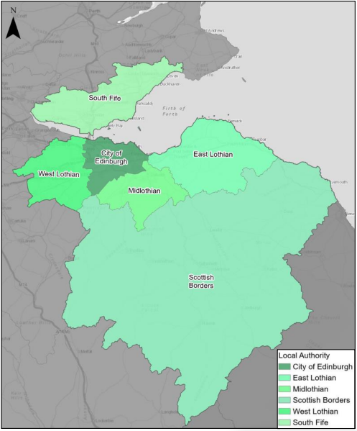
The Edinburgh and South East Scotland (ESES) region (herein referred to as ‘the Region’) is a geographically diverse region that includes a major city, urban areas and accessible and remote rural communities. The Region comprises the six local authorities of The City of Edinburgh, East Lothian, South Fife, Midlothian, West Lothian and Scottish Borders, and is a mix of urban and rural settlements and areas.
The Scottish Government Urban Rural Six-Fold Classification identifies the Region’s population residing in each category as follows: Large Urban Areas (41%), Other Urban Areas (38%), Accessible Small Towns (9%), Remote Small Towns (2%), Accessible Rural (10%) and Remote Rural (1%). This demonstrates that whilst the Region is dominated by the large densely populated urban area of the City of Edinburgh and the immediate adjacent areas, there are also areas of geographical remoteness and of a rural nature within the Scottish Borders and East Lothian. A number of ‘accessible small towns’ are spread across the Region, for example Burntisland, South Queensferry and Haddington.
The Region has an extensive transport network, including active travel, rail, tram, bus and road networks, park and ride facilities, as well as Edinburgh International Airport and a major port at Leith.
  - Social Context
According to the National Records of Scotland’s Mid-year Population Estimates Scotland, the total population in the Region was 1,320,974 in 2019 (24% of the total Scotland population) with Edinburgh, the most populous settlement, accounting for 37.5% of the Region’s population. In terms of age structure (2019 mid-year estimate), 17.1% of residents are children (15 and under), 64.7% of working age (aged 16 to 64), and 18.3% aged 65 and over.
Between 2012 and 2016, the population of ESES grew by 3.1% which is the highest rate of growth when compared to the other 3 city regions of the North East (+2.4%), Tay Cities (+1.0%) and Glasgow City Region (+1.6%).
Performance against socio-economic indicators varies across the Region. Overall, the proportion of households with access to a car is slightly higher in the Region compared to Scotland as a whole (69.8% in ESES compared to 69.5% nationally, based on 2011 Scottish Government Census). For the Region, excluding the City of Edinburgh, 75.7% of households have access to at least 1 car (31.8% have access to 2 or more cars). In the City of Edinburgh this decreases to 60.1% of households having access to at least 1 car. Compared to the national benchmark (i.e. average from across Scotland as a whole), the Region has the highest proportion of households with no car (30%).
Within the Region, 12% (71) of the total number of 2020 SIMD data zones within the City of Edinburgh (597) are ranked as being in the 20% most deprived data zones within Scotland which is lower than Glasgow (45%) and Dundee (37%) but higher than Aberdeen (10%). Similarly, across the wider region (excluding the City of Edinburgh) 14% of the data zones are ranked as being in the 20% most deprived within Scotland.
  - Economic Context
Evidence from ONS Regional GDP indicates that in 2018, the Region accounted for £42.3bn (29.7%) of Scotland’s total Gross Value Added (GVA) of £142bn and increased by 24.4% between 2013 and 2018, 9 percentage point higher growth than the national benchmark increase.
Economic activity refers to an estimation of whether the population within the Region aged 16 to 64 were in work or actively looking for work. NOMIS data indicates that, within the Region, 78.2% of the working age population (aged 16 to 64 years) in 2019 were economically active, which is 0.6 percentage points higher than the national benchmark. In the City of Edinburgh this is slightly lower at 77%, which is 1.8 percentage points higher than the Scottish city benchmark (average of the 4 larger cities of Aberdeen, Dundee, Edinburgh and Glasgow). The Region did though contribute to just over a fifth (21.2%) of Scotland’s total benefits claimants in 2019 and of all benefit claimants nationally 5.6% were in the City of Edinburgh which is low when compared to Glasgow (16.4%), but higher than Dundee (4.3%) and Aberdeen (3.3%).
According to data from the 2011 Scottish Government Census, over a third (37.3%) of the economically active population in the Region is employed within the City of Edinburgh and 52.8% of jobs are located in the city. Regional employment forecasts show that of the Region’s estimated 47,100 new jobs generated between 2019 and 2029, 85.6% (40,300 jobs) would be located in the City of Edinburgh, East Lothian or Midlothian, 10.2% (4,800 jobs) in West Lothian, 2.3% (1,100 jobs) in Fife and 2.1% (1,000 jobs) in the Scottish Borders.
  - Environmental Context
Within the Region, there are many areas classified as environmentally sensitive, with varying levels of statutory protection. Environmental designations within the Region include biodiversity, landscape and heritage designations which fall either wholly or partly within the Region. In addition, the Region contains a significant number of historic assets, including two designated World Heritage Sites (the Old and New Towns of Edinburgh and Forth Bridge between North and South Queensferry) and 20,682 Category A-C Listed buildings according to Historic Environment Scotland. The City of Edinburgh has a rich cultural heritage, with a significant number of listed assets and a high concentration of listed buildings in the city centre.
The greatest modelled noise levels are located around the City of Edinburgh, primarily associated with Edinburgh Airport and the trunk road and motorway network in the vicinity of the City of Edinburgh (including the M9, M8, A720 and A1). There are also relatively high noise levels associated with key local roads that connect to the trunk road and motorway network, as well as the Edinburgh to Glasgow via Falkirk High and the East Coast Main Line rail routes. Settlements at greatest risk of coastal flooding are located along the Firth of Forth and include Cramond, Queensferry and Dunbar with inland areas prone to river flooding predominantly located in the catchments of the River Ore, River Almond, Water of Leith and River Esk. Within the Region there are 11 Air Quality Management Areas (AQMAs), including six areas within the boundaries of the City of Edinburgh, three in West Lothian and one each in East Lothian and South Fife. In 2018, the Region’s percentage of total emissions from transport was lower than the Scotland National average (39%) at 30%.

- Problems and Opportunities
The following transport-related problems and opportunities have been identified for the Edinburgh and South East Scotland region.
  - Problems
Public Transport Connectivity: the configuration of the bus and rail networks in the Region are primarily radial in nature with a concentration on Edinburgh city centre, the main population centre, and key trip attractors (employment, education and services) in the City of Edinburgh with a lack of orbital routes connecting destinations out with the city centre. Travel between the city and the surrounding local authorities, and between the surrounding local authorities themselves can be more difficult for some areas as a result and can involve interchange leading to longer as well as less competitive and less attractive public transport journeys by bus in particular. The lack of integration between different services and modes of public transport as well as with active travel can also impact on travel choices.
Public Transport Accessibility: existing public transport provision means some areas of the Region are less well served and experience lower levels of accessibility to access employment, education, healthcare and other services by bus, rail or tram.
Relative Cost of Public Transport: there is a perception that the cost of using public transport in ESES is high when compared to the private car. The availability of integrated ticketing between modes and operators is also a factor to the cost of travel across different areas of the Region as well as between ESES and other parts of Scotland.
Active Travel: the active travel network in the Region varies in quality and type, with 40.1% of the National Cycle Network routes categorised as off road and the remaining 59.9% making use of on-road facilities. A lower active travel mode share (14% of trips in the Region are made by walking or cycling) relative to the proportion of travel to work journeys under five kilometres (37% of all travel to work trips are less than five kilometres) across the Region (2011 Scottish Government Census) suggests that the existing network is not attractive. This is a point raised by stakeholders who highlighted that either routes are not developed to the point where their quality means they attract trips by walking/cycling or they are not providing direct, safe connections between trip origins and destinations.
Operational Constraints: travel to work trips within ESES are mostly made by private car (2011 Scottish Government Census) and focused on the key routes to/from the City of Edinburgh and other employment centres (e.g. West Edinburgh, Edinburgh BioQuarter, Livingston, Dunfermline and Glenrothes) leading to operational issues at certain locations (e.g. A720, M8 and M9 approaches at Newbridge, M8 at Claylands and Hermiston Gate and the M90 approaches to the Queensferry Crossing). Similarly, prior to Covid-19 demand on the rail network within the Region was focused on routes to/from the City of Edinburgh creating pressure and impacting on service punctuality and network resilience.
Socio-Economic: higher than average property prices and rent in the City of Edinburgh is leading to lower income (and also middle income) households locating further away. This, combined with the concentration of major trip attractors in the City of Edinburgh, results in more trip making and longer journeys. With variable public transport accessibility and connectivity throughout the Region, public transport options can be limited and lead to a greater dependence on travel by private car and a greater proportion of household income spent on transport with an associated increased risk of transport poverty.
Health and Environment: all six constituent local authorities in the Region have declared a Climate Emergency and committed to reduce their carbon emissions. There are also 11 AQMAs in the Region, with over half located in the City of Edinburgh and a number in proximity to and on local corridors that connect with the trunk road and motorway network. With transport a key contributor to emissions and the predominance of travel by private car across the Region, there is an increasing need to increase the number of trips by active travel and public transport supported by alternative travel choices for more of the Region’s population to help reduce emissions that can impact the environment as well as on health and wellbeing.
Freight: operational constraints on the trunk road and motorway network are contributed to by freight movements and also directly impact on the movement of goods within the Region, including journeys to access rail, air and port freight terminals. Freight activities are also a contributing factor to CO₂ emissions and local air quality emissions (Department for Transport - Air Pollutant Emissions), particularly road freight which has seen an increasing trend in tonne-kilometres moved within the Region as well as vehicle numbers over the past 10 years (especially LGVs). The availability of services, including lorry parking and welfare facilities, is relatively sparse with 3 lorry parking facilities located in the ESES Region. In contrast, there are 11 lorry park facilities located along the M74/A74(M) route alone.
  - Opportunities
Active Travel: policy that places walking, cycling and wheeling at the top of the sustainable travel and investment hierarchies provides a very strong platform to further build on and increase the mode share of active travel in the Region.
Public Transport: building on existing bus priority such as the Forth Bridge public transport corridor, quick wins supported by the Bus Partnership Fund and as well as proposals to be taken forward through the West Edinburgh Transport Improvement Programme City Region Deal project, would encourage mode shift to more sustainable modes of travel within the Region.
Tourism: it is expected that Tourism would be one of the sectors in the Region to experience strong growth and, together with the range of attractions on offer, sustainable travel choices provide the opportunity to further enhance the Region’s attractiveness as a destination.
Changing Legislation: changes such as the introduction of a Low Emission Zone in the City of Edinburgh area, complemented by improving the public transport and active travel provision supports mode shift to sustainable modes.
Digital Connectivity and Technology: new as well as further development of existing technology offers potential for different ways to work, connect and inform people of transport choices, alongside advances in lower emission fuels.
Improved Transport Integration: including integration between transport and land use planning, provides the opportunity to increase the mode share of sustainable transport across the Region.
- Regional Recommendation
The following is a list of interventions that forms a package of recommendations that are relevant to this Region.

Regional Recommendations
- Connected neighbourhoods (Recommendation 1)
- Active freeways and cycle parking hubs (Recommendation 2)
- Village-town active travel connections (Recommendation 3)
- Connecting towns by active travel (Recommendation 4)
- Long-distance active travel network (Recommendation 5)
- Behavioural change initiatives (Recommendation 6)
- Changing road user behaviour (Recommendation 7)
- Increasing active travel to school (Recommendation 8)
- Improving access to bikes (Recommendation 9)
- Expansion of 20mph limits and zones (Recommendation 10)
- Edinburgh & South East Scotland Mass Transit (Recommendation 12)
- Provision of strategic bus priority measures (Recommendation 14)
- Edinburgh/Glasgow-Perth/Dundee Rail Corridor Enhancements (Recommendation 17)
- Infrastructure to provide access for all at railway stations (Recommendation 19)
- Investment in Demand Responsive Transport and Mobility as a Service (Recommendation 20)
- Improved public transport passenger interchange facilities (Recommendation 21)
- Framework for the delivery of mobility hubs (Recommendation 22)
- Smart, integrated public transport ticketing (Recommendation 23)
- Decarbonisation of the rail network (Recommendation 25)
- Decarbonisation of the bus network (Recommendation 26)
- Behavioural change and modal shift for freight (Recommendation 27)
- Zero emission vehicles and infrastructure transition (Recommendation 28)
- Trunk road and motorway safety improvements to progress towards ‘Vision Zero’ (Recommendation 30)
- Trunk road and motorway network climate change adaptation and resilience (Recommendation 31)
- Trunk road and motorway network renewal for reliability, resilience and safety (Recommendation 32)
- Future Intelligent Transport Systems (Recommendation 33)
- Traffic Scotland System Renewal (Recommendation 34)
- Intelligent Transport Systems renewal and replacement (Recommendation 35)
- Strategy for improving rest and welfare facilities for hauliers (Recommendation 36)
- Improving active travel on trunk roads through communities (Recommendation 37)
- Speed Management Plan (Recommendation 38)
- Major station masterplans (Recommendation 43)
- Rail freight terminals and facilities (Recommendation 44)
- High speed and cross-border rail enhancements (Recommendation 45)

- Fit with Established Policy
The interventions included within this package support a wide range of national, regional and local policy documents in which transport improvements play a key role in both the enabling and delivery of outcomes.
Key policies supported include the Programme for Government, Infrastructure Investment Plan, NTS2, the Climate Change Plan Update 2018 - 2032, SEStran Regional Transport Strategy, City of Edinburgh Local Transport Strategy, SESplan Strategic Development Plan, and SEStran Freight Study and Action Plan, as well as other non transport-specific plans, such as the Edinburgh and South East Scotland City Region Deal - Accelerating Growth (2018 to 2033).
The Scottish Government’s Revised Draft Fourth National Planning Framework (Revised Draft NPF4) identifies a spatial strategy that would be used to guide future development through identified action areas. The Region corresponds to two action areas identified by Revised Draft NPF4: central urban transformation and southern sustainability. The priorities for these action areas include decarbonising transport and connectivity, tackling congestion, support sustainable development and to create a low carbon network of town in order to help safeguard the natural systems on which our economy depends.
Interventions included in this package directly relate to the Revised Draft NPF4 national developments of Urban Mass / Rapid Transit Networks as well as High Speed Rail and would also develop and improve connections to the Revised Draft NPF4 national developments at Edinburgh Waterfront.
The policy framework for the Region has a strong emphasis on climate change, improved connectivity, addressing inequality, and addressing barriers to access employment, education and services to help deliver well-connected, sustainable communities. There is an emphasis on the promotion of modal shift away from private car, increased walking and cycling opportunities, and providing an attractive place to live and visit and for businesses to invest and grow within. Therefore, the package closely aligns with established policy directives.

Package Performance Against NTS2 Priorities and Outcomes:

Reduce inequalities
Will provide fair access to services we need: Major Positive
Will be easy to use for all: Major Positive
Will be affordable for all: Minor Positive

Takes climate action
Will help deliver our net-zero target: Major Positive
Will adapt to the effects of climate change: Minor Positive
Will promote greener, cleaner choices: Major Positive

Helps deliver inclusive economic growth
Will get people and goods where they need to get to: Major Positive
Will be reliable, efficient and high quality: Major Positive
Will use beneficial innovation: Major Positive

Improves our Health and Wellbeing
Will be safe and secure for all: Major Positive
Will enable us to make healthy travel choices: Major Positive
Will help make our communities great places to live: Major Positive

- STPR2 Transport Planning Objectives (TPOs) Assessment

TPO1 A sustainable strategic transport system that contributes significantly to the Scottish Government’s net-zero emissions target

TPO Performance Summary
Carbon dioxide equivalent (CO₂eq) is treated as a nationally important pollutant. As such, although it can be appraised at the national level (commentary below), it has not been appraised for individual regions.
The national and all regional packages would contribute to the net-zero emissions target by:
- Enabling more passenger journeys to be made by active modes and public transport.
- Decarbonising some public transport operations.
- Facilitating uptake of electric vehicles.
- Enabling some road freight to switch to rail or other low carbon modes.
Further commentary is provided below.
National CO₂eq emissions are forecasted to decrease year-on year. This is due to decreasing vehicle exhaust (non-traded) emissions as the number of internal combustion engine vehicles reduces. This is reflected in the volume of traded grid emissions from charging an increased numbers of battery-electric vehicles, and specifically in the Low scenario.
It is noted that traded emissions of Carbon Dioxide equivalence (CO₂eq) are associated with electrical generation to supply plug-in vehicles, both BEV (battery electric vehicles) and PHEV (plug-in hybrid vehicles).
The electricity grid is though expected to be using predominantly renewable sources in the future and so increasing adoption of electric vehicles and a shift from direct, non-traded, emission to traded grid-based technology (i.e. battery) would support reducing CO₂eq emissions. Across both the Low and High scenarios the interventions would reduce emissions of CO₂eq.
Significantly higher overall emissions are though predicted in the High scenario, either with, or without the national and all regional packages. There is a relatively smaller overall reduction of emissions due to the interventions in the Low scenario as a result of lower overall emissions. The economic impacts associated with air quality were assessed using the Department for Environment Food & Rural Affairs (DEFRA) Damage Costs Appraisal Toolkit. The larger economic benefit from the High scenario is due to the greater overall emissions in this scenario (either with or without the package) although the proportional change in emissions is lower compared to that achieved in the Low scenario.
If all the active travel and behaviour change interventions were fully implemented, the package has the potential to increase the walking mode share by up to 5% within the Region, and increase the cycling mode share by up to 19%. Delivery of the package in part would likely deliver only a proportion of the overall forecast change in mode share.
The change in the mode choice to active travel and public transport modes would contribute to a reduction of up to 3% in the motorised vehicle kilometres within the Region.
Overall Scoring:
Low and High Scenarios: Major Positive

Metric 1: Change in CO₂eq (non-traded and traded emissions from regional road transport inc. grid emissions from charging light-duty vehicles) - Figures below are a National calculation
Low Scenario Commentary:
- 0.5% decrease (27,700 tonnes CO₂eq) in 2030.
- 2.8% decrease (21,600 tonnes CO₂eq) in 2045.
- 1.3 million tonnes reduction, of which 1.1 million were traded, for the 60-year appraisal period from 2030 to 2089.
- The net economic benefits for the 60-year appraisal period in 2010 prices and values would be in the range £10 million to £25 million for the Low scenario.
High Scenario Commentary:
- 0.4% decrease (31,300 tonnes CO₂eq) in 2030.
- 1.3% decrease (65,300 tonnes CO₂eq) in 2045.
- 3.7 million tonnes reduction, of which 452,000 were traded, for the 60-year appraisal period from 2030 to 2089.
- The net economic benefits for the 60-year appraisal period in 2010 prices and values would be in the range £100 million to £250 million for the High scenario.

Metric 2: Change in mode share by active travel for all journeys
Low and High Scenarios Commentary:
- Potential increase in walking from 20% mode share to 25% mode share (5 percentage points).
- Potential increase in cycling from 1.4% mode share to 20% (over 18 percentage points).
The package will increase the proportions of journeys undertaken by active modes. If all the active travel and behaviour change interventions were fully implemented in every relevant location in the Region, mode shares of walking and cycling "with STPR2 package" proportions are shown alongside the mode share without package.
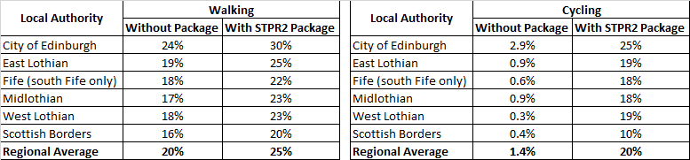
Note that the cycling and walking growth forecasts have been developed independently. Growth in use of one active mode is likely to abstract at least some trips from the other, but this effect is not accounted for within these forecasts.

Metric 3: Change in motorised vehicle kilometres travelled
Low Scenario Commentary:
- Reduction of approximately 145 million motorised vehicle kilometres (3% decrease) (see Annex B).
High Scenario Commentary:
- Reduction of approximately 220 million motorised vehicle kilometres (3% decrease) (see Annex B).

TPO2 An inclusive strategic transport system that improves the affordability and accessibility of public transport

TPO Performance Summary
The package would improve the inclusiveness of the transport system by:
- Improving conditions for people walking, wheeling and cycling, the most inclusive transport modes, with particular benefits for people most often excluded (including children, older and disabled people, and people on low incomes).
- Improving inclusive accessibility to public transport stops/stations.
- Seeking to promote public transport use and reduce operating costs, hence enhancing network sustainability.
- Provision of an ESES Mass Transit system lwould help to improve accessibility for areas and destinations less well served by public transport through providing a greater number of direct connections for cross-boundary journeys, removing the need for interchange between services. It would also integrate with wider services to improve interchange options where this forms part of a journey to help further facilitate cross-boundary connectivity within the Region..
Overall Scoring:
Low and High Scenarios: Moderate Positive

Metric 1: Change in transport poverty risk
Low and High Scenarios Commentary:
Although the STPR2 interventions don’t impact on the direct costs of travel (e.g. fares, fuel price), the package of interventions would see a small reduction in transport poverty, due to the overall improvements in public transport availability.

Metric 2: Change in Accessibility - population catchments increases to key services by journey time by public transport
The largest change in population accessibility of all the destination types considered was to an accident and emergency hospital, whereby around an additional 27,000 of the population in the Region are forecast to be able to access the nearest site in a journey time of 30 minutes or less by public transport with the STPR2 package compared to without the package. This represents a 2.4 percentage point increase in accessibility levels from 55.2% in the without package assessment to 57.6% with the package in place.
The improvements are largely forecast in the City of Edinburgh (with an additional 22,500 people able to access the nearest site within 30 minutes by public transport), particularly in South Gyle and Leith. Minor improvements are also shown in other Local Authority areas including South Fife, West Lothian and Scottish Borders with an additional 2,600, 1,200 and 600 additional people respectively forecast to be able to access an accident and emergency hospital site within a 30 minute public transport journey time.
There are also population accessibility improvements forecast in the wider Region for accessing key destinations within under 30 minutes using public transport. This includes higher education, major shopping centres, GP surgeries, large food stores, and secondary schools. These forecast benefits are typically seen in East Lothian (around Haddington, Dunbar and Prestonpans), in West Lothian (around Livingston), in Midlothian (around Bonnyrigg and Dalkeith), Fife (around Dunfermline) and in the Scottish Borders (around Peebles). This is shown by the map output in Annex A.
The accessibility improvements and the corresponding additional ESES population that are forecast to be able to access those destinations within a public transport journey time of 30 minutes with the package compared to the without package assessment are summarised below:
- 13,400 additional people are forecast to be able to access the nearest higher education site by public transport, as shown by the map output in Annex A, which represents a 1.2 percentage point increase in accessibility levels from 79.1% in the without package assessment to 80.3% with the package in place.
- 6,100 additional people are forecast to be able to access a major shopping centre by public transport, which represents a 0.5 percentage point increase in accessibility levels from 68.6% in the without package assessment to 69.1% with the package in place.
- 700 additional people are forecast to be able to access the nearest GP surgery by public transport, which represents a 0.1 percentage point increase in accessibility levels from 96.9% in the without package assessment to 97.0% with the package in place.
- 500 additional people are forecast to be able to access a large food store by public transport, which represents a less than 0.1 percentage point increase in accessibility levels from 90.7% in the without package assessment to 90.8% with the package in place.
- 300 additional children (aged 11 to 18) are forecast to be able to access the nearest secondary school by public transport, which represents a 0.4 percentage point increase accessibility levels from 86.2% in the without package assessment to 86.2% with the package in place.
In terms of additional destinations (cities, rail stations and airports) considered in the model:
- 4,700 additional people are forecast to be able to access their closest city* within a 30 minute public transport journey, which represents a 0.4 percentage point increase in accessibility levels from 48.0% without the package to 48.4% with the package in place.
- 12,800 additional people are forecast to be able to access their closest city* within a 60 minute public transport journey, representing a 1.1 percentage point increase in accessibility levels from 83.0% without the package to 84.1% with the package in place.
*both the cities of Edinburgh and Dunfermline are represented in the model as destination points.
- 10,100 additional people are forecast to be able to access their closest rail station within a 30 minute public transport journey, which represents a 0.9 percentage point increase in accessibility levels from 86.3% in the without package to 87.2% with the package in place.
- 6,800 additional people are forecast to be able to access their closest international airport within a 30 minute public transport journey time, which represents a 0.6 percentage point increase in accessibility levels from 6.6% without the package to 7.2% with the package in place.
- 37,000 additional people are forecast to be able to access their closest international airport within a 60 minute public transport journey time, which represents a 3.3 percentage point increase in accessibility levels from 47.4% without the package to 50.7% with the package in place.
- 20,800 additional people are forecast to be able to access their closest international airport within a 90 minute public transport journey time, which represents a 1.9 percentage point increase in accessibility levels from 81.8% without the package to 83.7% with the package in place.
Mapping outputs are shown in in Annex A.

TPO3 A cohesive strategic transport system that enhances communities as places, supporting health and wellbeing

TPO Performance Summary
The package would improve communities as places, supporting health and wellbeing by enabling more journeys to be made by active and sustainable modes, and by improving road safety. This would:
- Improve many people’s physical health and mental wellbeing, with particular benefits for people most often excluded (including children, older and disabled people, and people on low incomes).
- Reduce the adverse impacts of car use on communities and health (including reduced air pollution, noise, accident risk and perceived road danger).
The analysis shows that through improved uptake of walking and cycling, there would be a forecast reduction of 60 premature deaths per annum due to the health benefits arising from active travel.
Overall Scoring:
Low and High Scenarios: Major Positive

Metric 1 Change in mode share by active travel for all journeys
Low and High Scenarios Commentary:
- Potential increase in walking from 20% mode share to 25% mode share (5 percentage points).
- Potential increase in cycling from 1.4% mode share to 20% (over 18 percentage points).
These forecasts are subject to all active travel interventions being delivered in all relevant areas of the Region.
Cycling and walking growth forecasts have been developed independently. Growth in use of one active mode is likely to abstract at least some trips from the other, but this effect is not accounted for within these forecasts

Metric 2 Potential for Change in 'Place'
Low and High Scenarios Commentary:
The package will tend to improve the quality of the Region’s places by improving local accessibility and reducing the adverse impacts of road traffic.
Particular benefits may arise in neighbourhoods where active travel allows easier walking and cycling conditions in more pleasant and secure conditions. Development around interchanges and stops associated with the ESES Mass Transit system should be considered to ensure the transport provision enhances the sense of place.

Metric 3 Change in Health Benefits
Low and High Scenarios Commentary:
The health benefits of increased rates of active travel as a result of the package have been quantified using the WHOs Health Economic Assessment Tool (HEAT). HEAT estimates the health and economic impacts of increased walking and cycling, providing assessments of the impacts on premature mortality and on exposure to air pollution. Outputs from the tool shows the following benefits by Local Authority:
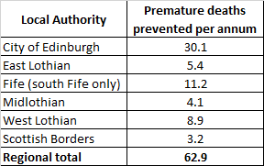

TPO4 An integrated strategic transport system that contributes towards sustainable inclusive growth in Scotland

TPO Performance Summary
The package will contribute to sustainable inclusive growth in Scotland by:
- Improving integration of transport modes (especially between active modes and public transport) and between transport and major developments.
- Improving journey time reliability.
- Enabling more people to travel by improving the accessibility and affordability of the transport system, so enabling more people to access local retail and services, and opportunities for employment and education/training.
Encouraging modal shift to sustainable modes and reducing the volume of vehicles on the road network is anticipated to improve journey time reliability for all vehicles.
Whilst the change in lost time metric shows a reduction in performance, it is considered that is largely due to modelling limitations as noted in the introduction to the appraisal summary table.
Overall Scoring:
Low and High Scenarios: Moderate Positive

Metric 1: Increased labour catchment by sustainable travel (PT/Active Travel)
Access to local employment, which represents the accessibility of nearby key employment opportunities located in the surrounding area of an origin within a 40 minute public transport journey time, showed most noticeable forecast improvements in the City of Edinburgh and Midlothian whereby the package on average would enable an additional 4,600 jobs and 1,200 existing jobs to be accessed respectively. This is shown by the map output in Annex A.
Access to regional employment, which represents the accessibility of key employment opportunities located in the City of Edinburgh within a 60 minute journey time using public transport, improved in all Local Authority areas within the Region. The modelling suggests that the package on average enables an additional 5,800 of existing jobs to be accessed in the Region within 60 minnutes journey time by public transport. Midlothian, Fife (South) and West Lothian forecast the highest increase, whereby the package enables an additional 7,600, 8,600 jobs and 14,400 of existing jobs located in the City of Edinburgh is able to be accessed within 60 minutes respectively. This is shown by the map output in Annex A.
Areas categorised as rural and remote geographies (determined using the Scottish Government Urban Rural Classification) forecast little change in journey times to the nearest employment site within the Region by public transport.

Metric 2: Change in lost time due to congestion (for business/ commercial transport)
Low Scenario Commentary:
- 12% increase (equivalent to approximately 1.3 million hours).
High Scenario Commentary:
- 7% increase (equivalent to approximately 1.3 million hours).

TPO5 A reliable and resilient strategic transport system that is safe and secure for users

TPO Performance Summary
The package will improve reliability, safety, and personal security on the transport system by:
- Improving journey time reliability, including through reduced likelihood of significant network disruptions.
- Reducing the risk of road accidents at locations on the trunk road and motorway network.
- Reducing perceived risks to road safety and to personal security, so enabling more people (particularly children, women and older people) to travel independently.
Whilst the change in lost time metric shows a reduction in performance, it is considered that is largely due to modelling limitations as noted in the introduction to the appraisal summary table.
Overall Scoring:
Low and High Scenarios: Moderate Positive

Metric 1 Change in accidents (PIA and ‘damage-only’)
Low Scenario Commentary:
- Accident reduction related to motorised vehicle kilometres is forecast to be 3%.
High Scenario Commentary:
- Accident reduction related to motorised vehicle kilometres is forecast to be 3%.
Low and High Scenarios Commentary:
Whilst the number of accidents involving motorised vehicles is anticipated to reduce following the introduction of the interventions within this package, it is anticipated that the package would increase walking and cycling journeys. The number of accidents involving these modes is therefore anticipated to increase, although each individual journey is anticipated to be significantly safer.

Metric 2 Percentage accident change for Targeted Infrastructure Improvements over 60 years, using default accident rate (PIA only)
Low and High Scenarios Commentary:
Accident benefits were estimated using the Department for Transport (DfT) recommended software programme COBA-LT (Cost and Benefit to Accidents – Light Touch) for targeted road safety improvements, based on default parameters, but using Scotland specific accident rates. A range of accident benefits were calculated for the various improvement options being considered. This provided the upper and lower bound of estimated percentage change in accidents, respectively. These ranges are shown below and provide the anticipated upper and lower bounds of impact on accidents that would be anticipated from typical interventions of this type:
- Sections of Realignment/Widening – reduction of 23% to 59%.
- Sections of Overtaking Opportunities – reduction of 35% to 73%.
- Locations of Junction Improvements – change of 42% (increase) to 64% (decrease).
It should be noted that junction accidents are forecast to increase in the event that a junction is upgraded from a priority to a signalised junction. This is due to an increase in the number of slight accidents that are likely to occur as a result of shunts in queuing traffic on the mainline approach to the traffic signals, which could previously travel unopposed. However, the accident severity can be expected to reduce as a result of this type of improvement. Any improvement scheme would be subject to further consideration.

Metric 3 Change in lost time due to congestion
Low Scenario Commentary:
- 6% increase (approximately 1.3 million hours) in lost time due to congestion (see Annex B).
High Scenario Commentary:
- 0.4% increase (approximately 0.3 million hours) in lost time due to congestion (see Annex B).

Metric 4 Journey Time Reliability/Availability of alternatives (modes/routes)
Low and High Scenarios Commentary:
This package is forecast to reduce overall motorised vehicle kilometres by 3% under both the Low and High scenarios respectively, reducing the risk of accidents occurring whilst improving resilience by reducing the number of road closures associated with accidents.
The bus priority measures and the Mass Transit would provide greater reliability for public transport journeys, particularly during peak periods when congestion can significantly impact bus services.
Targeted improvements on the trunk road and motorway network where safety is a problem is forecast to reduce accidents and the associated reduction in road closures from such incidents would also help improve reliability. Improvements in terms of renewals and climate change adaptation to protect the operation of the trunk road and motorway network would also positively impact on the reliability of the network.
Encouraging modal shift to sustainable modes and reducing the volume of vehicles on the network is anticipated to improve journey time reliability for all vehicles. Whilst the change in lost time due to congestion metric shows a reduction in performance with the package in both the Low and High scenarios, it is considered that this is likely due to the modelling underestimating the benefits associated with interventions that would reduce road space due to the under-representation of the local/secondary road network as noted in the introduction to the Appraisal Summary Table.
- STAG Assessment
  - Environment

Environment

Air Quality
Performance Summary:
Total emissions of NO_{X} (a group of gases that are mainly formed during the combustion of fossil fuels) are predicted to decrease in the future in both the High and Low scenarios.
Total emissions of NO_{X} are predicted to be effectively zero in 2045 in the Low scenario, and 2,053 tonnes in the High scenario either with or without the proposed package. It is the change brought about by the projected transition of the vehicle fleet to zero-emission vehicles that contribute to the majority of air quality benefits, and in this instance outweighs the positive mode change contributions from the regional package.
Total emissions of Particulate Matter (PM), which is made up of a collection of solid and / or liquid materials, are predicted to increase in the future predominantly due to non-exhaust emissions from road, tyre and brake-wear.
However, the package would reduce harmful emissions slightly. Over the 60-year appraisal period there was a predicted 100% reduction in NO_{X}, 1.4% reduction in PM₁₀ and PM_{2.5} in the Low scenario, and a 2.9% reduction in PM₁₀ and a 3% reduction in PM_{2.5} in the High scenario.
Low Scenario Scoring: Minor Positive
High Scenario Scoring: Minor Positive

Noise and Vibration
Performance Summary:
The anticipated modal shift to active travel (potential increase of 5% and 18% percentage points for walking and cycling respectively) is also expected to reduce levels of noise and vibration associated with the transport network. There is potential for a localised negative effect on noise and vibration due to the construction and operation of specific interventions, including ESES Mass Transit and High Speed Rail, however the magnitude of effect would depend on the design and location of the interventions.
Low Scenario Scoring: Minor Positive
High Scenario Scoring: Minor Positive

Biodiversity and Habitats; Geology and Soils; Land Use (including Agriculture and Forestry); Water, Drainage and Flooding; Historic Environment; and Landscape
Low and High Scenarios Commentary:
Please refer to SEA performance summary text in the ‘Statutory Impact Assessment Criteria’ section below. Please note the scoring has been based on the SEA methodology for scoring, which has been agreed with the SEA Consultation Authorities.
  - Climate Change

Climate Change

Performance Summary (applicable to all Climate Change Sub-Criteria)
Carbon dioxide equivalent (CO₂eq) is treated as a nationally important pollutant. As such, although it can be appraised at the national level (commentary below), it has not been appraised for individual regions.
National CO₂eq emissions are forecast to decrease year-on year (see net zero TPO commentary), with decreasing direct (non-traded) emissions and increasing traded grid emissions with increased adoption of battery-electric vehicles, and specifically in the Low scenario. It is noted that traded emissions of CO₂eq are associated with electrical generation to supply plug-in vehicles, both BEV (battery electric vehicles) and PHEV (plug-in hybrid vehicles). The electricity grid is though expected to be using predominantly renewable sources in the future and so increasing adoption of electric vehicles and a shift from direct, non-traded, emission to traded grid-based technology (i.e. battery) would support reducing CO₂eq emissions.
Key recommendations within the package have a focus on identifying vulnerabilities to the effects of climate change on the transport system, as well as identifying measures to assist in the adaptation to the effects of climate change, including unplanned events, such as flooding, landslides and high winds. Climate change adaptation and network resilience would address existing and predicted climate change impacts and support the changes that are necessary to reach the Scottish Government’s net zero target for greenhouse gas emissions. Improving the climate resilience of the transport network will also align with the Scottish Government’s commitment to develop Scotland’s next statutory climate adaptation programme.
The shift towards electrification of road passenger transport and associated infrastructure, and a greater dependency on public transport and active travel (walking, cycling and wheeling) would require significant adaptation interventions to maintain resilience of the trunk road and motorway and rail networks, and their ability to meet evolving transport needs.
Across both scenarios the STPR2 national package would reduce emissions of CO₂eq, although the change is greater in the High scenario due to overall higher emissions.

Greenhouse Gas Emissions
Low Scenario Scoring: Major Positive
High Scenario Scoring: Major Positive

Vulnerability to Effects of Climate Change
Low Scenario Scoring: Minor Positive
High Scenario Scoring: Minor Positive

Potential to Adapt to Effects of Climate Change
Low Scenario Scoring: Minor Positive
High Scenario Scoring: Minor Positive
  - Health, Safety & Wellbeing

Health, Safety & Wellbeing

Performance Summary (applicable to all Health, Safety & Wellbeing Sub-Criteria)
The package would reduce the number and severity of accidents through targeted infrastructure improvements to improve road safety and by encouraging modal shift away from private car, resulting in reduced accident risk due to reduced conflicts. Whilst the number of accidents involving motorised vehicles is anticipated to reduce following the introduction of the interventions within this package, it is anticipated that the package would increase walking and cycling journeys. The number of accidents involving these modes is therefore anticipated to increase, although each individual journey is anticipated to be significantly safer.
Mode shift to sustainable modes would, by improving natural surveillance, make paths, stops, stations and services less isolated and this, accompanied by improved quality of facilities, would improve perceived security.
The package would improve communities as places, supporting health and wellbeing, by encouraging modal shift away from private car and towards active travel. This would improve placemaking through reduced noise and better air quality due to reduced traffic, and reduced accident risk. It would also benefit many people’s physical health and mental wellbeing.

Accidents (PIA and ‘damage-only’)
Low and High Scenarios Commentary:
Accident Change in percentage of accidents (PIA and damage-only): Accident reduction related to motorised vehicle kilometres is forecast to be 1% to 2%.

Percentage accident change for Targeted Infrastructure Improvements over 60 years using default accident rate (PIA only)
Low and High Scenarios Commentary:
Accident benefits were estimated using the Department for Transport (DfT) recommended software programme COBA-LT (Cost and Benefit to Accidents – Light Touch) for targeted road safety improvements, based on default parameters, but using Scotland specific accident rates. A range of accident benefits were calculated for the various improvement options being considered. This provided the upper and lower bound of estimated percentage change in accidents, respectively. These ranges are shown below and provide the anticipated upper and lower bounds of impact on accidents that would be anticipated from typical interventions of this type:
- Sections of Realignment/Widening – reduction of 23% to 59%.
- Sections of Overtaking Opportunities – reduction of 35% to 73%.
- Locations of Junction Improvements – change of 42% (increase) to 64% (decrease).
It should be noted that junction accidents are forecast to increase in the event that a junction is upgraded from a priority to a signalised junction. This is due to an increase in the number of slight accidents that are likely to occur as a result of shunts in queuing traffic on the mainline approach to the traffic signals, which could previously travel unopposed. However, the accident severity can be expected to reduce as a result of this type of improvement. Any improvement scheme would be subject to further consideration.

Security
Low and High Scenarios Commentary:
The package would, by increasing the number of people travelling actively and by public transport, tend to improve natural surveillance. Through improvements to lighting and urban realm, the package would also tend to reduce the number of locations at which security is a concern. New public transport services proposed would be delivered under modern standards with integrated security systems (such as the incorporation of CCTV on vehicles).

Health Outcomes
Low and High Scenarios Commentary:
The package would, by increasing rates of active travel and hence physical activity, improve both health and wellbeing outcomes. The estimated value of health benefits to the Region’s population, appraised over a 60-year period, is in the range of £1 billion to £5 billion.
The package would also tend, by encouraging car journeys to switch to less polluting modes, to improve local air quality, and hence health outcomes. This would be of particular benefit in those areas with identified AQMAs.

Access to Health and Wellbeing Infrastructure
Low and High Scenarios Commentary:
An additional 27,000 of the population in the Region are forecast to be able to access an accident and emergency hospital site in a journey time under 30 minutes by public transport with the STPR2 package in place compared to the without package assessment. This represents a 2.4 percentage point increase in accessibility levels from 55.2% in the without package assessment to 57.6% with the package in place. This is shown by the map output in Annex A.
The majority of the forecasted accessibility improvements to an accident and emergency hospital are identified within the City of Edinburgh, with an additional 22,500 people able to access the nearest site within 30 minutes by public transport. The remaining accessibility improvements are reported in South Fife, West Lothian and Scottish Borders, with 2,600, 1,200 and 600 additional people respectively able to access an accident and emergency hospital site within a 30 minute public transport journey time.

Visual Amenity
Low and High Scenarios Commentary:
The package should have a positive impact on visual amenity through improvements to walking and cycling infrastructure and an improved sense of ‘place’. ESES Mass Transit would require to be designed to enhance the sense of place and not act as a visual barrier.
Care would be required in the development of rail freight facilities to ensure they did not detrimentally impact nearby communities.
  - Economy

Economy

Performance Summary
The majority of economic benefits that accrue are as a result of the sustainable transport interventions in the Region’s package to enable and encourage mode shift to public transport modes. The ESES Mass Transit intervention, in conjunction with the Bus Priority Infrastructure, Interchange and Rail interventions are the main contributors to the public transport user benefits total in the Low scenario. The remainder of the benefits are largely due to the increase in public transport operator revenue as a result of the increased patronage levels arising from the mode shift away from car.
However, the reallocation of road space that would likely be required in order to implement the mass transit intervention would result in an increased level of disbenefit to road users.
The level of public transport user benefits remains very similar in the High scenario. The significantly higher levels of car-based demand in the High scenario would however result in a larger disbenefit to road users.
In terms of accident savings, the level of benefits would be larger in the High scenario. The benefits arise as a result of the reduction in road-based vehicle kilometres travelled in the Region, with the ESES Mass Transit, active travel and public transport interventions encouraging a mode shift away from private car. As the absolute reduction in vehicle kilometres as a result of the interventions is larger in the High scenario, this directly equates to the increase in the value of accident benefits in this scenario.
Due to the nature of a number of the STPR2 interventions it has not been possible to derive indicative cost estimates on a regional basis.

User Benefits (2010 prices and values for a 60 year appraisal period)
Low Scenario Commentary:
Present Value of Benefits (PVB) of approximately £250 million to £500 million.
Accidents Present Value of Benefits (PVB) of approximately £25 million to £50 million.
High Scenario Commentary:
Present Value of Benefits (PVB) of approximately -£50 million to -£25 million.
Accidents Present Value of Benefits (PVB) of approximately £50 million to £100 million.

  - Equality & Accessibility

Equality & Accessibility

Performance Summary (applicable to all Equality & Accessibility Sub-Criteria)
The package would improve accessibility to public transport by improving the coverage of the network as well as walking and cycling routes to access the network. This would provide particular benefits for people often excluded from transport, including older and young people, women, disabled people, and people living in more deprived communities.
The package would also improve affordability by reducing car ownership, and situations where taxi is the only viable mode for people without access to a car. By encouraging modal shift to more sustainable modes, the package has the potential to increase demand for public transport and improve commercial performance/viability.

Public Transport Network Coverage
Low and High Scenarios Commentary:
The Region is expected to see major benefits from public transport coverage through the provision of ESES Mass Transit. This would extend public transport to areas not currently well served and provide connections in the Region to key services including hospitals and higher education as well as better connections for employment through providing faster and more frequent services on the corridors served as well as a greater number of direct connections for cross-boundary journeys, removing the need for interchange between services. It would also integrate with wider services to improve interchange options where this forms part of a journey to help further facilitate cross-boundary connectivity within the Region.

Active Travel Network Coverage
Low and High Scenarios Commentary:
Improvements to the Region’s active travel network, both within and between settlements, would mean that many more people would have convenient, high-quality and safe infrastructure for walking, wheeling and cycling journeys.

Comparative Access by People Group
Low and High Scenarios Commentary:
Improvements to active travel networks and public transport would provide positive impacts on groups who are less likely to have access to a car and more likely rely on public transport, walking and cycling for their journeys. This includes women, children and young people, older people, some ethnic minority groups and disabled people.

Comparative Access by Geographic Location
Low and High Scenarios Commentary:
For deprived areas in the Region, identified as part of the 20% most deprived areas in Scotland, an additional 700 people are forecast to be able to access the nearest accident and emergency hospital site in under 30 minutes by public transport with the STPR2 package compared to without the package. This represents a 0.5 percentage point increase in accessibility levels from 59.5% in the without package assessment to 60.0% with the STPR2 package in place.
Similarly, an improvement in the accessibility of higher education establishments from deprived areas in the Region is forecast, whereby an additional 1,100 people are able to access their nearest site within a 30 minute public transport journey time with the STRP2 package in place compared with the without package assessment. This represents a 0.7 percentage point increase in accessibility levels from 90.4% in the without package assessment to 91.1% with the STPR2 package in place.
For access to local employment, which represents the accessibility of key employment opportunities located nearby in the surrounding area within a 40 minute public transport journey time, the package is forecast to, on average, enable an additional 1,100 of existing jobs to be accessed in the Region from areas categorised within the 20% most deprived in Scotland. Particular improvement is forecast in deprived areas within the City of Edinburgh, whereby an additional 3,000 existing jobs are forecast to be able to be accessed within 40 minutes by public transport.
The access to regional employment, which represents the accessibility of key employment opportunities located in the City of Edinburgh within a 60 minute journey time using public transport, improved from deprived areas (20% most deprived in Scotland) in the Region with the package forecast to, on average, enable an additional 5,600 of existing jobs located in the City of Edinburgh to be accessed. There are significant improvements forecast in the access to employment located in the City of Edinburgh from both East Lothian and West Lothian Local Authorities, whereby an additional 12,800 to 17,100 existing jobs are forecast to be able to be accessed respectively.
All results are shown in the mapping outputs found in Annex A.

Affordability
Low and High Scenarios Commentary:
Although the STPR2 interventions don’t impact on the direct costs of travel (e.g. fares, fuel price), the package of interventions would see a small reduction in transport poverty, due to the overall improvements to access employment, education, healthcare and other services and connectivity between modes.

- Deliverability
  - Feasibility

Feasibility
Summary Assessment:
The package has been developed with feasibility considerations in mind. The package mostly makes use of existing, proven technology and would generally be expected to largely operate inside existing design standards. There would be further work required on the feasibility of larger infrastructure provision including ESES Mass Transit and bus priority interventions (which would need consideration if multiple modes are competing for similar road space for example). Additionally, the historical and protected nature of Edinburgh City Centre, combined with the complex nature and number of utilities, may make the delivery of some types of transport system technology within the inner-city environment difficult.
  - Affordability

Affordability
Summary Assessment:
The package would require substantial capital and operational funding. Some aspects of the package may generate revenue, which could be used to offset some of these costs. However, whilst the funding is likely to be substantial, it has to be considered in the context of the scale of the interventions being delivered as well as the number of likely users.
  - Public Acceptability

Public Acceptability
Summary Assessment:
Public acceptability of the package is likely to be mixed. The package is expected to improve accessibility, connectivity, and choice and to make transport cleaner, more efficient and more attractive. However, there may be acceptability concerns in areas of congestion where road space reallocation or bus priority measures are proposed however the behavioural change elements of the package should also help to mitigate this. There may also be acceptability concerns where construction works are expected to cause disruption or require land-take.

- Statutory Impact Assessment Criteria
  - Strategic Environmental Assessment (SEA)

SEA
Performance Summary:
The package supports modal shift to more sustainable modes of transport. An enhanced rail network, improved access to ports and airports and the creation of mobility hubs/interchanges and ESES Mass Transit seeks to encourage modal shift, and, as a result, reduce levels of transport related air pollution and greenhouse gas emissions. The decarbonisation of the rail and bus network and freight deliveries would also support a reduction in greenhouse gas emissions and improvement in air quality.
The package provides an opportunity to adapt the transport network to the predicted effects of climate change, with one intervention focused on this adaptation and promotes a more sustainable usage of the existing transport network.
Positive effects are anticipated on population and human health due to an expected increase in sustainable access to essential services, increased travel choice and improved connectivity and planning for the future capacity of public transport. Active travel interventions would also have positive outcomes for health - for example, via expected improvements in air quality and increased uptake of physical exercise through walking, wheeling and cycling.
Road interventions are anticipated to have positive effects on safety. Trunk road improvements which are focused on junction improvements, realignment / widening and overtaking opportunities are also not anticipated to have a notable impact on traffic volumes or mode share and subsequently transport-based emissions in the majority of locations. The construction and operation of these interventions may result in minor negative effects on population and human health with the potential for an increase in noise and vibration during construction and operation. This is dependent on the location and design of individual schemes. There is also potential for a negative effect on material assets due to the use of natural resources.
There is potential for negative environmental effects during construction and operation of the ESES Mass Transit, rail network enhancements and High Speed Rail interventions on population and human health (noise and vibration, public realm, safety), the water environment, biodiversity, soil, cultural heritage and landscape and visual amenity. In addition, significant quantities of materials and construction related trips would be required. Depending on the source and type of materials/natural resources used, there is the potential for negative effects on material assets.
The freight interventions are anticipated to result in minor negative effects on material assets as several interventions proposed involve enhancements to rail freight, terminals and facilities and therefore would require the use of natural resources.
Where any new infrastructure is required this could result in negative effects on biodiversity, soil, landscape, water, historic environment and material assets however the magnitude of effect is uncertain at this stage and would be determined by the design (and physical footprint) of the interventions.
As the design and development of interventions in this region progresses, further environmental assessments will determine the magnitude of the different positive and negative environmental effects and mitigation measures will be developed where appropriate.
  - Equalities Impact Assessment (EqIA)

EqIA
Performance Summary:
The package would improve public transport, including through mass transit, and active travel accessibility to key destinations and services including employment, education, healthcare and shopping for people living in the area. This would have a major positive impact on certain protected characteristic groups who are less likely to have access to a car and more likely to depend on public transport and active travel to make their journeys. This includes women, children and young people, older people, disabled people and people from certain ethnic minority groups.
By encouraging modal shift to more sustainable modes, this package could also contribute to improving local air quality. Improved health outcomes as a result of better air quality are of particular benefit to those who are more vulnerable to air pollution, including children, older people, disabled people and pregnant women.
The package would reduce the severity of accidents through targeted infrastructure improvements and by encouraging modal shift away from private car, resulting in reduced accident risk due to reduced conflicts. Some protected characteristic groups are more likely to be involved in road accidents, for example, children as pedestrian casualties and young males involved as car drivers and as such would have positive impacts on these groups.
Mode shift to sustainable modes would make paths, stops, stations and services less isolated and this, accompanied by improved quality of facilities would improve perceived security. This is likely to provide some benefit to those for whom security is of particular concern including women, the LGBTQ+ community and those from religious backgrounds most subject to hate crime.
The package would therefore be anticipated to have a moderate positive impact overall on this criterion.
  - Island Communities Impact Assessment (ICIA)

ICIA
Performance Summary:
The package is not relevant to islands and would therefore have a negligible impact on addressing this criterion.
  - Child Rights and Wellbeing Impact Assessment (CRWIA)

CRWIA
Performance Summary:
By encouraging modal shift to more sustainable modes, this package could contribute to improving local air quality. Improved health outcomes as a result of better air quality are of particular benefit to those who are more vulnerable to air pollution, including children.
The package would also improve public transport and active travel accessibility to higher education institutions and employment opportunities for young people living in the area. Safety is a key issue for children with regards to transport with child pedestrian casualties recorded in Scotland in 2019, accounting for 44% of all pedestrian casualties (Key Reported Road Casualties 2019). In particular, children from deprived areas and certain ethnic groups are more at risk.
The package would reduce the severity of accidents through targeted infrastructure improvements and, by encouraging modal shift away from private car, result in reduced accident risk due to reduced conflicts.
The package would therefore be anticipated to have a minor positive impact on this criterion.
  - Fairer Scotland Duty Assessment (FSDA)

FSDA
Performance Summary:
The Region is home to some of the most deprived areas in Scotland. The package would improve public transport connectivity, including through new mass transit and bus priority infrastructure, and can therefore support regeneration and economic development and reduce inequalities caused by socio-economic disadvantage by improving accessibility for deprived communities or communities where transport options are limited.
The package would improve access to local employment opportunities (defined as being located in the surrounding area of an origin within a 40 minute public transport journey time) from some of the 20% most deprived areas in Scotland - on average an additional 1,100 existing jobs in the Region are forecast to be accessible within a 40 minute journey time with the STPR2 package. Access to regional employment, which represents the accessibility of key employment opportunities located in the City of Edinburgh within a 60 minute journey time using public transport, is also forecast to improve - on average an additional 5,600 existing jobs found in the City of Edinburgh which is the key urban area within the Region, would be accessible within 60 minutes from parts of the Region that are within the 20% most deprived areas in Scotland.
The package would therefore be expected to have a moderate positive impact on this criterion.

Annexes

Annex A: NAPTAT Mapping
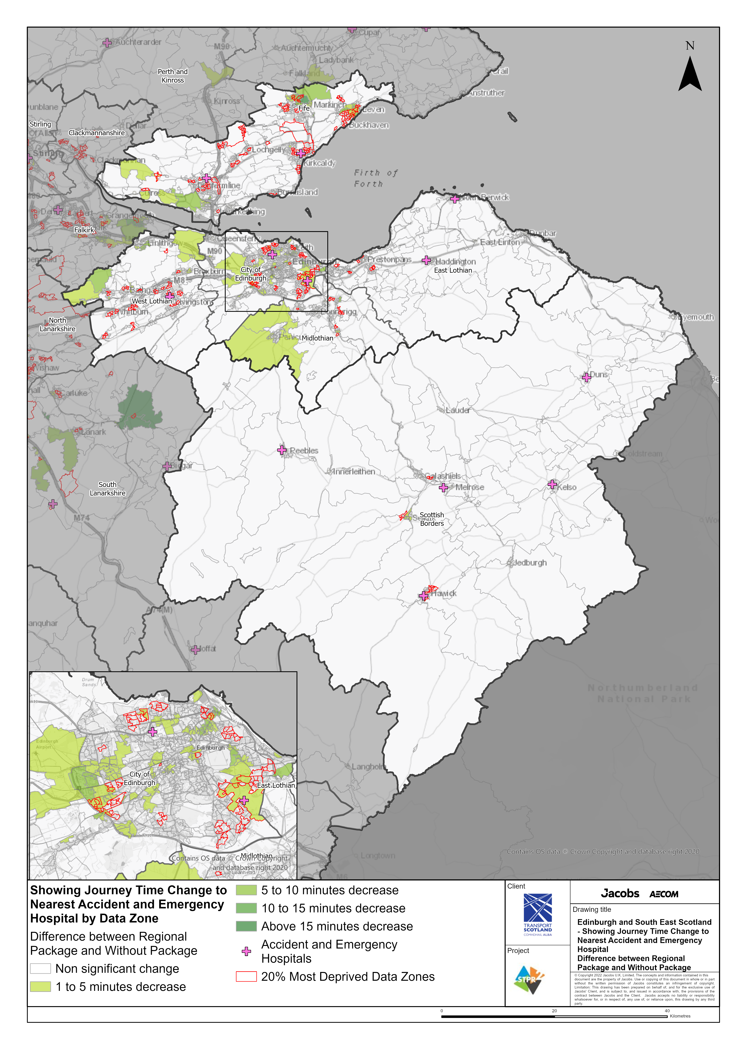
Edinburgh and South East Scotland Region - Showing Journey Time Change to Nearest Accident and Emergency Hospital Difference between Regional Package and Without Package
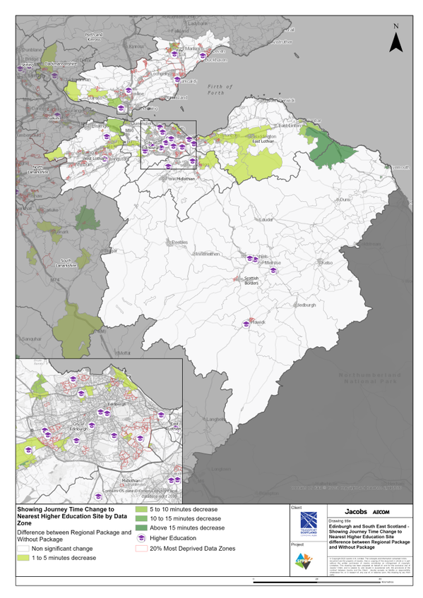
Edinburgh and South East Scotland Region - Showing Journey Time Change to Nearest Higher Education Site Difference between Regional Package and Without Package
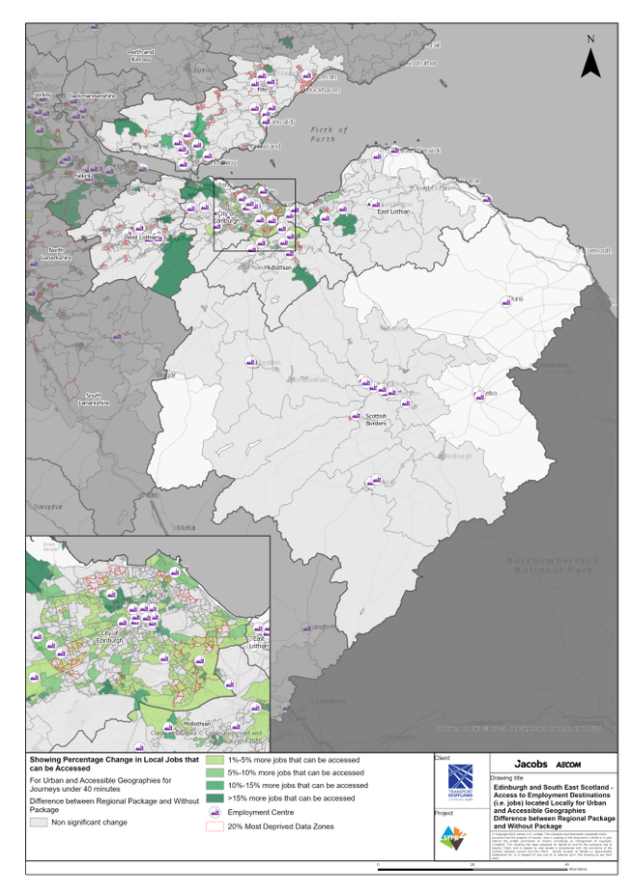
Edinburgh and South East Scotland Region – Access to Employment Destinations (i.e. jobs) located Locally for Urban and Accessible Geographies for journeys under 40 minutes difference between Regional Package and Without Package
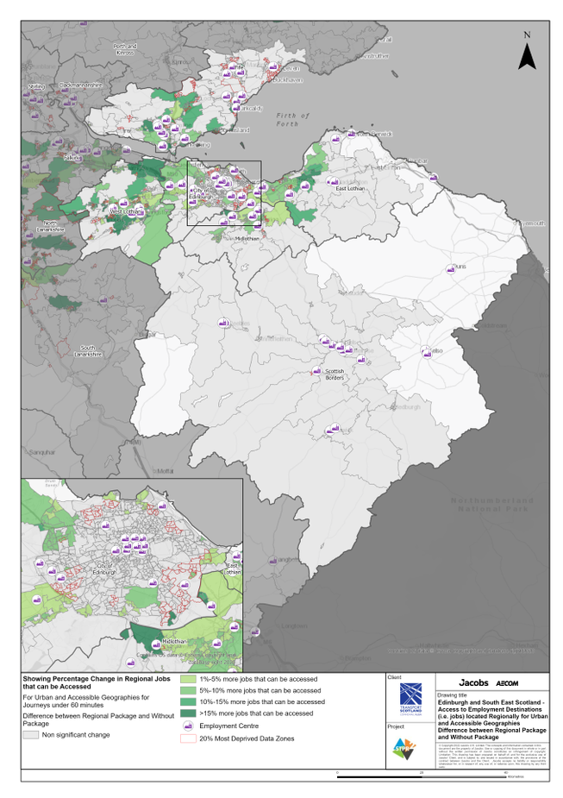
Edinburgh and South East Scotland Region – Access to Employment Destinations (i.e. jobs) located Regionally for Urban and Accessible Geographies for journeys under 60 minutes difference between Regional Package and Without Package
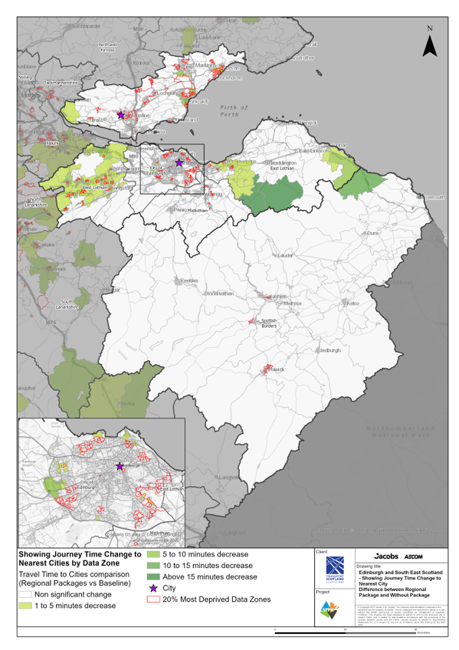
Edinburgh and South East Scotland Region – Showing Journey Time Change to Nearest City Difference between Regional Package and Without Package
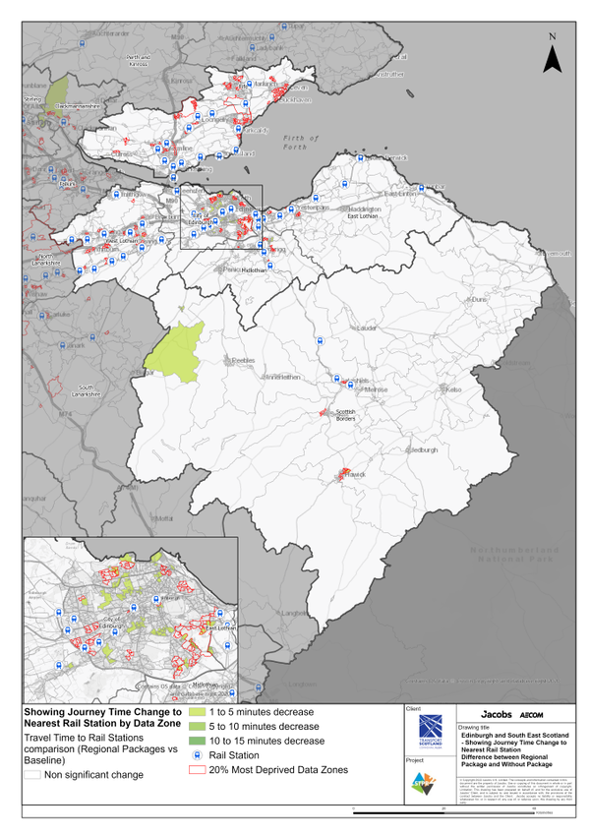
Edinburgh and South East Scotland Region – Showing Journey Time Change to Nearest Rail Station Difference between Regional Package and Without Package
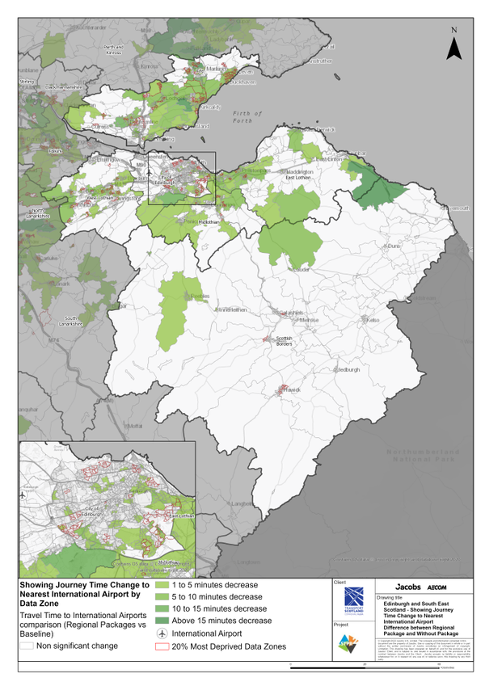
Edinburgh and South East Scotland Region – Showing Journey Time Change to Nearest International Airport Difference between Regional Package and Without Package

Annex B: Traffic Modelling Outputs
