Appendix H: Detailed Packaging - Appraisal Summary Tables

December 202

Contents
1. National Context 5
1.1. Geographic Context 5
1.2. Policy Context 5
2. Problems and Opportunities 8
2.1. Reduces Inequalities 8
2.2. Takes Climate Action 10
2.3. Helps to Deliver Inclusive Economic Growth 11
2.4. Improves our Health and Wellbeing 14
3. Detailed Recommendations 16
4. STPR2 Transport Planning Objectives (TPOs) Assessment 18
5. STAG Assessment 27
5.1. Environment 27
5.2. Climate Change 28
5.3. Health, Safety & Wellbeing 29
5.4. Economy 31
5.5. Equality & Accessibility 32
6. Deliverability 35
6.1. Feasibility 35
6.2. Affordability 35
6.3. Public Acceptability 36
7. Statutory Impact Assessment Criteria 37
7.1. Strategic Environmental Assessment (SEA) 37
7.2. Equality Impact Assessment (EqIA) 38
7.3. Islands Communities Impact Assessment (ICIA) 39
7.4. Children's Rights and Wellbeing Impact Assessment (CRWIA) 39
7.5. Fairer Scotland Duty Assessment (FSDA) 40
Annexes 41
Annex A: NAPTAT Mapping 42
Annex B: Traffic Modelling Outputs 49

National Appraisal Summary Table
An Appraisal Summary Table (AST) has been developed for each of the eleven STPR2 Regions alongside this National AST. The ASTs are set out to provide:
- National Context, Problems and Opportunities – drawing on data presented in the Initial Appraisal: Case for Change reports this summarises geographic, social, economic, environmental and transport matters in the region as well as the identified problems and opportunities. In line with STAG, appraisals are expected to explore location-specific problems and opportunities. Local problems and opportunities have been considered to gain a full understanding of the regional and national issues, however some of these may not be within the scope of this strategic study.
- Detailed Recommendations – this presents the package of recommendations that were included in the detailed appraisal across the regions.
- Fit with Policy – provides a summary of how well the appraised packages fit with key national policies including the second National Transport Strategy, Climate Change Plan Update, the Revised Draft Fourth National Planning Framework (Revised Draft NPF4) and relevant regional policies.
- Transport Planning Objectives (TPO) Assessment – An assessment against each of the five TPOs is provided with quantified metrics, where appropriate, under the Low growth sensitivity with a 20% reduction policy ambition on car kilometre scenario (hereafter referred toas Low scenario) and High growth sensitivity with no policy ambition on car kilometre scenario (hereafter referred to as High scenario) (further information about these scenarios is provided in Appendix F of the Technical Report). A seven point scoring scale is adopted for each TPO which is:
  - + + + = major positive (3 plus signs)
  - + + = moderate positive
  - + = minor positive
  - 0 = neutral
  - - = minor negative
  - - - = moderate negative
  - - - - = major negative (3 minus signs)
- STAG Criteria assessment – as above for the TPO assessment, key points regarding the performance of the package against each of the STAG criteria is presented with quantified metrics provided where appropriate.
- Deliverability – commentary is provided on the assessment of the package in terms of its feasibility, affordability and public acceptability. Note that due to the nature of a number of the STPR2 interventions, and the stage in the business case process STPR2 is at, it has not been possible to derive cost estimates on a regional basis. However, broad capital spending ranges have been estimated over the period 2022 to 2042 at a national level.
- Statutory Impact Assessment Criteira – a summary of the performance of the packages against the Strategic Environment Assessment (SEA), the Equalities Impact Assessment (EqIA), Island Communities Impact Assessment (ICIA), Fairer Scotland Duty Act (FSDA) and Child Rights and Wellbeing Impact Assessment (CRWIA) is provided. The seven point scoring scale is adopted in these assessments where appropriate.

Summary of Assumptions
Quantification of the costs and benefits in the packages has been provided through a modelling exercise. Further information is provided in Appendix F of the Technical Report on the modelling scenarios that have informed the assessment of the STPR2 interventions. A summary of the key assumptions is provided here:
- Population projections are based on the NRS Population Projections (2018-based).
- Economic projections are a combination of projections by Oxford Economics, 2019, the Scottish Fiscal Commission forecasts and more recently the OBR post-COVID estimates.
- Land-use plans are based on data collected for Transport Scotland’s Assembly of Planning Policy Inputs in 2018 from Scotland’s 34 Planning Authorities.
- Permitting of vacant office and retail floorspace to be converted or redeveloped as housing post 2030.
- Working age is taken to be 16-64 (as a constant) to avoid difficulties with changing state pension age (and to reflect non-mandatory retirement).
- The economic results are presented, as is standard within appraisal as discounted values in 2010 prices.

Modelling Tools
For the purposes of modelling accessibility by public transport, NaPTAT (National Public Transport Accessibility Tool) has been used. This allows an assessment of journey time to be compared between the with and without STPR2 package.
Due to the strategic and national nature of STPR2, the national Transport Model for Scotland (TMfS) has also been used. TMfS is a national scale model with a focus on inter-urban trips. As such, whilst TMfS provides a suitable level of robustness at this stage of the appraisal for the larger infrastructure based interventions, there are limitations associated with modelling of smaller/discrete interventions and those that are more urban in nature. Separate forecasts of the potential impacts of active travel recommendations on walking and cycling mode share have therefore been made. As the recommended interventions are developed through the business case process, more detailed modelling will be undertaken using regional and / or local models as appropriate.
Due to the strategic and national nature of STPR2, the national Transport Model for Scotland (TMfS) has been used. TMfS is a national scale mode with a focus on inter-urban trips. As such, whilst TMfS provides a suitable level of robustness at this stage of the appraisal for most of the larger infrastructure based interventions, there are limitations associated with the modelling of smaller/discrete interventions and also some of the larger infrastructure interventions that involve changes to the existing road network and are more urban in nature. Separate forecasts of the potential impacts of active travel recommendations on walking and cycling mode share have therefore been made. As the recommended interventions are developed through the business case process, more detailed modelling will be undertaken using regional and / or local models as appropriate.
When considering the outputs presented in this AST, please note the following metrics with respect to the model outputs:
- CO₂emissions: Likely to underestimate the benefits associated with public transport interventions due to the more limited representation of transport systems in urban areas and a degree of insensitivity to mode shift in TMfS.
- Mode Share: Likely shift to public transport modes underestimated in the urban areas due to the more limited representation of urban transport systems and a degree of insensitivity to mode shift in TMfS.
- Change in vehicle kilometres travelled: Likely to underestimate the benefits of reducing vehicle kilometres travelled particularly for short distance journeys due to the more limited representation of urban transport systems and the relative coarseness of the model zone system.
- Lost time due to congestion: Likely to underestimate the benefits associated with interventions that would reduce roadspace due to the under-representation of the local/secondary road network in TMfS.
- Change in accidents: Likely to underestimate the benefits associated with mode shift to public transport interventions due to the more limited representation of urban transport systems and a degree of insensitivity to mode shift in TMfS.
- Present Value of Benefits: Likely to underestimate the benefits to public transport users due to the more limited representation of urban transport systems. Likely to overestimate the dis-benefits to car-based trips due to the under-representation of the junctions and local/secondary road network in TMfS.

- National Context
  - Geographic Context
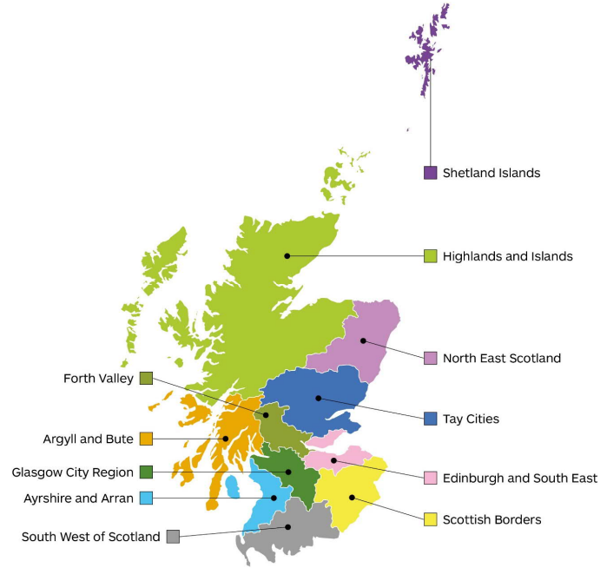
Scotland’s geography is unique and varied, ranging from rural lowlands to remote uplands, and from large cities to sparsely inhabited islands, meaning no two parts of Scotland are the same nor are their travel patterns and demands. For that reason, STPR2 has been progressed at both a national and regional level in order to appraise options in the context of place.
Detailed Appraisal Summary Tables (ASTs) present the findings from the assessment of the packages of interventions that have been developed at the regional level covering the eleven regions shown in the map opposite. The assessments undertaken through the regional ASTs inform the final recommendations for STPR2.
This National AST summarises the performance of the regional packages at a National level against key appraisal criteria including established policy objectives, the Transport Planning Objectives (TPOs), STAG Criteria (Environment, Climate Change, Health, Safety and Wellbeing, Economy, and Equality and Accessibility), and a wider suite of Impact Assessments.
Before presenting the appraisal outcomes, a brief recap is provided on the policy context and key challenges that have guided the development of STPR2.
  - Policy Context
Given the cross cutting nature of transport, there are a number of relevant policy documents which have been considered, to ensure that the aims and objectives of STPR2 are complementary and contribute to the wider policy landscape. The key policies are listed below.
The second National Transport Strategy (NTS2) sets the vision for the country’s transport system over the next 20 years. The vision is underpinned by four priorities: Reduces Inequalities, Takes Climate Action, Helps Deliver Inclusive Economic Growth and Improves our Health and Wellbeing, each with three associated outcomes. At the heart of the Strategy is the recognition that we need to deliver a step-change in behaviour and provision of attractive, affordable, accessible and sustainable travel options. Embedded within the Strategy are the Sustainable Travel Hierarchy and Sustainable Investment Hierarchy which aim to manage the demand for transport and support the creation of successful places in the future. The actions to take forward the new National Transport Strategy are outlined in the Delivery Plan 2020-22, published in December 2020. As well as outlining the role of STPR2, it also highlights other parallel workstreams that will deliver on the NTS2 vision, priorities and outcomes. This includes the Island Connectivity Plan (ICP), which is being prepared as the successor to the Ferries Plan 2013-22 and will be closely linked to the outcomes of the STPR2.
In December 2020, the Scottish Government produced its update to the Climate Change Plan (CCP), which sets out the approach to delivering a green recovery up to 2032. The transport-related components of the Plan build upon NTS2, with a specific commitment to reduce car kilometres by 20% by 2030. The Scottish Government Route Map, published in January 2022, sets out a suite of policies from across Government that will be implemented to support car-use reduction in order to both address climate change and deliver a healthier, fairer and more prosperous Scotland. The Route Map recognises the role of STPR2 in setting out recommendations for future investment decisions.
The Infrastructure Investment Plan (IIP) for Scotland 2021 to 2026, published in February 2021, provides additional detail on future spend to support the commitments made within the Programme for Government. IIP specifically sets the context of future investment in transport to deliver an effective response to the COVID-19 pandemic and also an inclusive net zero carbon economy. It highlights that future transport investment decisions will be assessed through SPTR2; embedding the NTS2 priorities and outcomes and the Sustainable Investment Hierarchy. Furthermore, the IIP also sets out the Scottish Governments Common Investment Hierarchy which aligns with the NTS2.
By aligning strategy, project and programme funding, the Capital Spending Review (CSR), published in February 2021, provides confidence that the announced plans are affordable and fully funded. The Review also sends a strong signal on the future need to adjust the balance of investment in favour of renewing and extending the life of existing infrastructure, both on environmental and value-for-money grounds.
In July 2021, the Scottish Government published Cleaner Air for Scotland 2: Towards A Better Place for Everyone and an associated Delivery Plan, setting out how the Scottish Government will deliver further air quality improvements over the next five years to secure the vision of Scotland having the best air quality in Europe – a quality of air that aims to protect and enhance health, wellbeing and the environment. It recognises the role of STPR2 in contributing to a reduction in the need to travel unsustainably, making the most of existing transport strategic systems and supporting strategic investments in sustainable, smart and cleaner transport options.
In August 2021, the Scottish Government and the Scottish Green Party Parliamentary Group agreed to work together over the next five years to build a green economic recovery from COVID-19, whilst also responding to the climate emergency and creating a fairer country. This agreement, along with the shared policy programme, referred to as The Bute House Agreement, details collaboration on the climate emergency, economic recovery, child poverty, the natural environment, energy and the constitution. It sets out a number of commitments to support the priorities and outcomes set out in NTS2, including to reduce car kilometres by 20% by 2030; increase the proportion of Transport Scotland’s budget spent on active travel initiatives; invest in the maintenance, improvement and decarbonisation of Scotland’s rail network; commission a Fair Fares Review; and progress the on-going review of transport governance in Scotland. These commitments will complement STPR2 and the shared policy programme acknowledges the role of STPR2 in directing future transport infrastructure investment.
On 08 November 2022, the Revised Draft Fourth (National Planning Framework) was laid in the Scottish Parliament. Once approved by the Scottish Parliament and adopted by the Scottish Ministers, the NPF4 will become part of the statutory development plan and will directly influence planning decisions. The Revised Draft NPF4 sets out a need to “embrace and deliver radical change to tackle and adapt to climate change, restore biodiversity loss, improve health and wellbeing, build a wellbeing economy and create great places.” The NPF4 recognises the need to plan our places in a way that reduces the need to travel, especially by unsustainable modes, and promotes a shift to active and sustainable travel
The Revised Draft NPF4 embeds, for the first time, the NTS2 Sustainable Travel Hierarchy and Sustainable Investment Hierarchy into planning decision making and development planning. The Revised Draft NPF4 spatial strategy sets out a local living approach whereby future places, homes and neighbourhoods will be connected, livable, thriving places with sustainable travel options and where car dominance is reduced.
To meet many of the future needs of society it is crucial that services and facilities are easily and affordably accessed. Therefore, the Revised Draft NPF4 advocates the infrastructure-first approach in planning for future development to provide communities with the opportunity to travel sustainably from the outset. The STPR2, and the Islands Connectivity Plan (ICP), represent the national transport investment needed to support the NPF4.
- Problems and Opportunities
The development of the NTS2 involved a comprehensive review of the key transport challenges facing Scotland and include an extensive engagement with a network of partners and areas across the country comprising individuals, businesses and third sector organisations, to gather the views of a wide range of users of the transport system. Through this process, it was identified that Scotland’s transport system faces a number of challenges including: people encountering problems when trying to access the services they need; vehicles emitting greenhouse gases and polluting the places residents live and work; businesses still facing congestion and delays when reaching their customers; and people still facing barriers when wanting to cycle or walk to their destination.
The STPR2 National Case for Change Report published in February 2021 summarised the current and future challenges identified by NTS2, which are outlined below and presented in the same order as they appear in NTS2:
  - Reduces Inequalities
- Social Isolation: Globally, advances in technology now mean we feel more connected than ever. However, despite this, many people still feel socially isolated, with 6% of adults reporting having met socially with friends, family, relatives, neighbours or work colleagues less than once a week. Many disabled people feel trapped due to the lack of accessible transport, particularly on islands and in remote and rural areas. There is increasing recognition of social isolation and loneliness as a major public health issue that can have significant impacts on a person’s physical and mental wellbeing.

- Poverty and Child Poverty: Public transport is very important to those on low incomes, yet in many areas of high social deprivation, public transport options can be limited and relatively expensive. A key challenge is providing fair and affordable access to the services people need.

- Gender Inequalities: Public transport systems tend to be designed to serve the needs of commuters with traditional ‘nine-to-five’ working patterns, hence based on a travel pattern that is primarily male. Public transport timetables and routes are, as a result, not designed to fit travel behaviour that is shaped by unpaid care work and part-time employment. Women are also more likely to travel by bus and less likely to travel by rail than men. A lack of adequate public transport provision creates further barriers to women accessing employment and educational opportunities. Evidence across the UK and Europe shows that women are constrained by a number of barriers that shape how they travel and their experiences of those journeys. Over 75% of Scotland’s part-time workforce is female, and women are more likely to be in low paid work, with 64% of people paid below the Living Wage being female. Lone parents, the vast majority of whom are women, are more likely to be living in poverty than other single working age adults in Scotland. Women who work part-time are more likely to have a multi-stop journey (e.g. to drop off / pick up children to / from school) than women that work full-time or men, whatever their working status. Women are more likely to feel very or fairly worried about being sexually assaulted and are also less likely to report feeling very or fairly safe walking alone at night compared to men (66% compared to 89%).

- The Changing Needs of Young People: Many young people are communicating more by social media rather than in person and therefore have less need to travel. More young people are in further and higher education, having to spend more on housing and delaying entering employment, therefore having less resources to spend on travel. Key issues for young people include the availability and cost of public transport, particularly to further and higher education and personal safety when using services.

- Meeting the Needs of an Ageing Population: In 2018, 455,000 people in Scotland were aged 75 or over. By 2043, this figure is projected to grow to 776,000, an increase of just over 70%. Older people are healthier, fitter, wealthier and more mobile compared with previous generations: they are likely to want to travel more and the transport system needs to support this to ensure older people, wherever they live, are not socially isolated. Factors impacting on older people include inaccessible vehicles (particularly taxis, buses and trains), journey comfort, frequency of bus services and poor integration between different transport services.

- The Transport Needs of Disabled People: The proportion of adults with a long-term limiting mental or physical health condition or disability is increasing as the population ages. Between 2008 and 2017, the proportion of women who had a long-term limiting mental or physical health condition or disability increased from 28% to 34%. Over the same period, the proportion of men increased from 23% to 29%. Furthermore, a lower proportion of disabled people are in employment compared to those who are not disabled and are therefore more likely to be affected by poverty. Key challenges disabled people face on the transport system include being able to access accurate and relevant travel information both before and during the journey; being able to access public transport interchanges; being able to access public transport vehicles; being able to interchange between all modes; and concerns regarding safety and comfort on the public transport network.

- Scotland’s Regional Differences: Transport challenges differ across areas and regions of Scotland. Limited supply of affordable city centre housing has led to an increase in the number of people living in housing developments situated in suburban areas. This population shift to suburban areas will have an impact on travel needs and patterns, particularly to city centres. If past trends continue, Scotland’s cities will see increases in housing and population over the next 20 years. Rural households tend to drive more frequently than urban households, in many cases due to the limited public transport options available. A particular issue for rural areas is the lack of public transport which acts as a barrier for young people accessing education, training and employment and the link to long-term outmigration. The minimum income that households require for an acceptable standard of living in Scotland’s island communities is well above that required in the rest of the UK, and in many cases higher than in other areas of rural Scotland. Factors resulting in additional costs for households in island communities compared to the rest of the UK include longer commuting distances compounded by higher fuel prices, issues around integrated timetabling, the additional cost of the need to make occasional trips to the mainland, and additional ferry/air costs for inter-island travel. Island communities can also face additional delivery and freight costs. Similar to remote and rural areas, transport can have an adverse impact on the long-term sustainability of island communities.

  - Takes Climate Action
- Global Climate Emergency: The Scottish Parliament committed to an ambitious target of net zero emissions by 2045 and transport needs to play its part. Transport is currently Scotland’s largest sectoral emitter, responsible for 37% of Scotland’s total greenhouse gas emissions in 2018. Since 2013 there has been an increase each year, despite more efficient vehicles, due to an increase in vehicle-kilometres driven. The largest source of transport emissions are cars, at 40%, followed by aviation and shipping which are both 15%, with a further 25% of emissions generated by a combination of Light Goods Vehicles (LGVs) and Heavy Goods Vehicles (HGVs). In addition to minimising the future impacts of transport on our climate, our transport system needs to adapt to climate change impacts.

- Adapting to Climate Change: Climate change directly affects the transport sector through the increasing number of more severe and frequent extreme weather events and the disruption they cause to the transport system. Disruption often disproportionately impacts on vulnerable communities with fewer and less resilient transport options. In recent years, there have been several weather events which have led to significant disruption and resulted in high economic costs. The ‘Beast from the East’ in February 2018 cost the UK economy at least £1 billion per day as gridlocked roads, no trains and no buses meant many workers were unable to access employment.

- Air Quality: Transport generates just over one sixth of Scotland’s total particulate matter (PM10) and over one-third of the total emissions of nitrogen oxides (NOx). The majority of these emissions are caused by road transport. Transport, and road transport in particular, remains a significant contributor to poor air quality. Air pollution increases the risks of diseases such as asthma, respiratory and heart disease, particularly for those who are more vulnerable such as the very young and the elderly or those with existing health conditions. Air quality is often worse in areas of deprivation and is a health inequality issue.

- Changing Complex Behaviours: To tackle emissions, a key challenge will involve getting people to change their travel behaviour, both in terms of reducing demand for travel and how particular journeys are made. People’s travel choices are complex and influenced by a number of factors. Choices can reflect, for example, personal characteristics (e.g. age, sex and income), and can depend on where people live/work, geography, availability of transport, convenience and the built environment. More time spent on leisure activities, for example, has meant more people travelling greater distances to undertake outdoor activities. The activities for which people travel are changing. In addition, the changing nature and location of work, land use, technology, housing and the move to more online retailing have impacted on and transformed people’s behaviour in recent years. Changing people’s travel behaviour to use more sustainable modes will have a significant impact on the environment, as well as our health and wellbeing.

- Decline in Bus Use: Bus is the dominant public transport mode in Scotland, accounting for three quarters of all public transport trips. It is particularly important to areas which are not served by the rail network, including much of rural Scotland. It can be an important element in multimodal journeys and bus continues to be a sustainable and space-efficient mode of travel. Bus use generally has been in decline since the 1960s for a number of reasons. One of these is due to longer journey times caused by congestion on the road network, particularly in urban areas. Reducing passenger numbers risks driving down revenues and making some services unviable, resulting in their cancellations and, in some cases, communities becoming isolated. In 2017-18, 388 million journeys were made on local bus services in Scotland. This is down from 487 million (-20.3%) in 2007-08. This trend coincides with an increase of 7.4% in road traffic (vehicle kilometres) in Scotland between 2007-08 and 2017-18. Reducing passenger numbers risks driving down revenues and making some services unviable, resulting in cancellations and, in some cases, communities being isolated.
  - Helps to Deliver Inclusive Economic Growth
- Productivity: The latest evidence reveals that Scotland’s productivity is ranked 16th out of 37 amongst the Organisation for Economic Cooperation and Development (OECD) member countries. This is in the second quartile but below other comparator countries such as Ireland, Belgium and Denmark. Whilst Scotland’s productivity level is not solely driven by the efficiency of its transport system, improvements in transport connectivity between businesses reduces costs and increases productivity, thus generating higher levels of economic growth.

- Labour Markets: People often need transport to access employment, education and training and therefore transport helps reduce the number of people out of work and supports Scotland’s ambitions for growth. Transport can also make sure that the skills and experience of those in the labour force are effectively matched with the needs of businesses, helping to increase incomes and improve productivity. There is evidence that some people out of work see high transport costs – as well as physical barriers to access to transport - to employment locations as a barrier, particularly for those in more rural areas, people with disabilities and long term health conditions, the young, those on low incomes and families with children, thus limiting the employment opportunities and options available.

- Future Skilled Workforce: An increasing number of workers in the transport sector are retiring or leaving the industry. With a lower number of young people entering the industry to replace them, a skills shortage is developing. The labour market also faces potential disruption through uncertainties related to the European Union (EU) Exit. There are also concerns related to the loss of technical and commercial skills and expertise, an ageing workforce and how new staff can be attracted and retained.

- Trade and Connectivity: Transport is crucial for trade and competitiveness within Scotland, across the UK and internationally. Trade and connectivity with EU and global markets is impacted by uncertainty around Scotland’s future relationship with the EU as a result of the UK EU Exit. There is a particular challenge with the lack of direct freight and logistics routes to the continent, with Scotland currently being dependent on key routes via England for the majority of imports and exports.

- Aviation: To be productive, competitive and successful economically it is important for Scotland to be well-connected and it is recognised that aviation will continue to play a key role in Scotland’s connectivity, both in international terms and within Scotland and the UK. However, the environmental impacts of aviation need to be recognised and mitigated if climate change targets are to be achieved. Opportunities for reducing emissions from the aviation sector for people travelling to, from and within Scotland must continue to be explored.

- Freight: Freight is transported around Scotland by road, rail, air, sea and inland waterways. The number of goods vehicle trips, if left unchecked, is forecast to increase by 44% between 2014 and 2037, which will negatively impact on journey times and peak-period delays. Given the economic importance of Scotland’s freight haulage industry, these factors will ultimately impact on the performance of the economy if not tackled. There will also be an impact on the environment. In 2017, HGV emissions were 3.5% higher than in 2016 and 5.2% above the 1990 baseline figure. LGV emissions were 6.5% more than 2016 and 95.6% higher than the 1990 baseline figure. The increase in emissions from light goods vehicles reflects increasing vehicle kilometres. Whilst recognising the importance of freight within Scotland’s economy, a key challenge will be to ensure that the negative impacts generated by the movement of goods vehicles are tackled.

- Tourism: Transport plays a vital part in supporting tourism. It enables people to get to and travel within Scotland and allows them to explore the many sights and experiences the country has to offer, including access to the outdoors and the historic environment. In 2018, Scotland welcomed over 3.5 million overnight visitors from overseas, an increase of over 10% on the previous year. Since 2002, the number of international visitors travelling to Scotland by air has more than doubled (+150%), whilst travelling by sea and via the Channel Tunnel have remained fairly stable over the same period, although there has been a marked increase in the number arriving by cruise vessels, with Cruise Scotland reporting a rise from 369 calls with 268,481 passengers in 2010 to an estimated 912 calls with 920,000 passengers during 2019. Ensuring Scotland can continue to welcome a growing number of international visitors requires retaining important air links and also developing new routes, whilst taking measures to minimise the environmental impacts that international tourism generates. People in a number of Scotland’s remote, rural and island communities are witnessing deteriorating road networks as traffic increases, with larger and heavier cars, caravans and motorhomes, and vehicle capacity constraints on ferries. Whilst tourism benefits are recognised, tourists should be encouraged to visit/travel using more sustainable means.

- Digital and Energy: It is recognised that transport needs to be considered alongside other strategies and initiatives, including digital and energy. The choices that people make about where and when they work, and how companies trade, will be driven as much by changing digital technologies and communications as it will be by transport. Availability of mobile connectivity across the transport system is a key enabler in the adoption of new digital technologies, whilst the availability of ubiquitous connectivity is fast becoming an expectation. Improvements in digital technology and connectivity could impact on ways in which people work and travel, and these links could be an essential part of how transport is able to contribute to Scotland’s emissions targets. Access to digital communications is also a vital factor in decisions made by disabled people about location and transport options. Scotland is taking a leading role in promoting electric and other low emission vehicles, with a commitment to phase out the need for new petrol and diesel cars and vans by 2032. In meeting this ambition, Scotland will need to develop and manage the necessary charging and other network infrastructure, whilst building consumer awareness and confidence.

- Funding and Resources: The way in which the transport system is paid for and funded is complex, but needs to be fair and sustainable and support wider outcomes. The costs of delivering Scotland’s transport system are significant. In 2018-19, total public sector spend on transport amounted to £2.1 billion. This compares with a figure of £2.72 billion in 2007-08, a decrease of 22.8%. Going forward, there will continue to be competing demands and difficult funding choices to be made for both central and local government. This includes decisions about priorities within the transport infrastructure, and also between transport and other policy areas such as housing, health, education and energy. In addition, achieving the net zero target will put further pressure on limited budgets, as increasing focus is placed on areas where greenhouse gas emissions need to be reduced. A key challenge will relate to managing transport assets effectively and investing efficiently in the resources needed to maintain and safely operate them and make better use of existing capacity.

- Reliability: Some of Scotland’s cities experience considerable congestion and associated disruption. Whilst the volume of traffic on Scotland’s road network declined between 2007 and 2011 in line with the economic downturn, there have been increases each year since then. Forecast increases in traffic volumes will impact negatively on reliability through increased congestion and more roadworks as greater pressure is placed on the operational efficiency of the network. Reliability is also an issue on the rail network and data shows that reliability has declined from a peak of 93% in 2013 to 89.2% in 2020.
  - Improves our Health and Wellbeing
- Safety and Security: Scotland’s transport system needs to be safe. Whilst the number of road accident casualties reduced by 11% between 2017 and 2018, the number of fatalities has increased. There are considerable inequalities: children in Scotland’s 20% most deprived areas are more than 3 times as likely to be injured in a traffic accident than those in the 20% least deprived areas. Women and disabled people are more likely to experience affordability barriers to transport: they are less likely to drive and more likely to use public transport, particularly buses. Many women and disabled people feel vulnerable when using public transport – particularly at bus stops, train stations or other transport interchanges.

- Spatial Planning: Spatial planning can play a key role in addressing a number of challenges for places. The places where people live and work can have important impacts on health and wellbeing. As land use has continuously evolved, some places have become less sustainable and would benefit from renewal and improvement. Buildings located in areas that are hard to reach and not well served by public transport can result in long journeys to access shopping and work, therefore discouraging walking and cycling and encouraging more car use. The current and future transport needs of people should be at the heart of planning decisions to ensure sustainable places.

- Physical Activity: The importance of active travel is becoming more evident as the consequences of physical inactivity are studied. Over the last few decades increasing reliance on cars has contributed to Scotland becoming less active as a nation. Over two thirds of commuters travel to work by car or van compared to just 12% who walk and 3% who cycle. Research found that around 31% of children in age group 2- 15 did not meet physical activity guidelines over the last seven days. There are links between poverty and the availability of bicycles: household access to bicycles increases with household income. In 2017, the national average of households that have access to at least one bike for private use is 34.4%. It is recognised that one of the most effective ways to secure the required 30 minutes of moderate activity per day is to reduce reliance on motorised transport, changing the means of everyday travel to walking and cycling.

- Information and Integration: High-quality journey planning information, both digital and physical, is important to enable a resilient transport system that allows people and goods to get to where they need to get to. Many people choose to travel by car instead of active transport and/or public transport due to the number of necessary interchanges on their journey. In some cases, journeys are not possible due to a lack of connections or accessible modes of transport. In addition, long wait times, the need for multiple tickets and complex connections deter people from some public transport services resulting in many running below capacity. This is a particular issue for wheelchair reliant transport users.

- Resilience: When there are extreme weather incidents and planned or unplanned events which result in network disruption, it is vital that information is given to the public as early as possible so that they can act accordingly. Extreme weather leads to uncertainty about travel conditions for people and businesses. Dedicated walking and cycling infrastructure must be maintained to encourage use. Both trunk and local roads face considerable maintenance backlogs and need significant investment to ensure they are appropriately maintained. Both mainland to island and intra-island ferry fleets are ageing. The effective maintenance of transport networks is important in reducing disruption and delivering a resilient and reliable transport system. A key challenge is providing a transport system that is resilient and speedily recovers from disruption, thus minimising impacts of delayed journeys on networks and users. This requires strong planning in relation to physical resilience of the transport system, how disruption is managed and the speed of recovery, together with effective maintenance regimes and investment.
- Detailed Recommendations
The following is a list of interventions that form the whole package of recommendations for STPR2.

Detailed Recommendations
- Connected neighbourhoods (Recommendation 1)
- Active freeways and cycle parking hubs (Recommendation 2)
- Village-town active travel connections (Recommendation 3)
- Connecting towns by active travel (Recommendation 4)
- Long-distance active travel network (Recommendation 5)
- Behavioural change initiatives (Recommendation 6)
- Changing road user behaviour (Recommendation 7)
- Increasing active travel to school (Recommendation 8)
- Improving access to bikes (Recommendation 9)
- Expansion of 20mph limits and zones (Recommendation 10)
- Clyde Metro (Recommendation 11)
- Edinburgh & South East Scotland Mass Transit (Recommendation 12)
- Aberdeen Rapid Transit (Recommendation 13)
- Provision of strategic bus priority measures (Recommendation 14)
- Highland Main Line Rail Corridor Enhancements (Recommendation 15)
- Perth-Dundee-Aberdeen Rail Corridor Enhancements (Recommendation 16)
- Edinburgh/Glasgow-Perth/Dundee Rail Corridor Enhancements (Recommendation 17)
- Supporting integrated journeys at ferry terminals (Recommendation 18)
- Infrastructure to provide access for all at railway stations (Recommendation 19)
- Investment in Demand Responsive Transport and Mobility as a Service (Recommendation 20)
- Improved public transport passenger interchange facilities (Recommendation 21)
- Framework for the delivery of mobility hubs (Recommendation 22)
- Smart, integrated public transport ticketing (Recommendation 23)
- Ferry vessel renewal and replacement and progressive decarbonisation (Recommendation 24)
- Decarbonisation of the rail network (Recommendation 25)
- Decarbonisation of the bus network (Recommendation 26)
- Behavioural change and modal shift for freight (Recommendation 27)
- Zero emission vehicles and infrastructure transition (Recommendation 28)
- Access to Argyll (A83) (Recommendation 29)
- Trunk road and motorway safety improvements to progress towards ‘Vision Zero’ (Recommendation 30)
- Trunk road and motorway network climate change adaptation and resilience (Recommendation 31)
- Trunk road and motorway network renewal for reliability, resilience and safety (Recommendation 32)
- Future Intelligent Transport Systems (Recommendation 33)
- Traffic Scotland System Renewal (Recommendation 34)
- Intelligent Transport System renewal and replacement (Recommendation 35)
- Strategy for improving rest and welfare facilities for hauliers (Recommendation 36)
- Improving active travel on trunk roads through communities (Recommendation 37)
- Speed Management Plan (Recommendation 38)
- Sustainable access to Grangemouth Investment Zone (Recommendation 39)
- Access to Stranraer and the ports at Cairnryan (Recommendation 40)
- Potential sound of Harris, sound of Barra fixed link and fixed link between Mull and Scottish Mainland (Recommendation 41)
- Investment in port infrastructure to support vessel renewal and replacement, and progressive decarbonisation (Recommendation 42)
- Major station masterplans (Recommendation 43)
- Rail freight terminals and facilities (Recommendation 44)
- High speed and cross-border rail enhancements (Recommendation 45)

- STPR2 Transport Planning Objectives (TPOs) Assessment

TPO1 A sustainable strategic transport system that contributes significantly to the Scottish Government’s net-zero emissions target

TPO Performance Summary
Carbon dioxide equivalence (CO2eq) is treated as a nationally important pollutant. As such, although it can be appraised at the national level (commentary below), it has not been appraised for individual regions.
At a national level the national and all regional packages will contribute to the net-zero emissions target by:
- Enabling more passenger journeys to be made by active modes and public transport.
- Decarbonising most public transport journeys.
- Facilitating uptake of electric vehicles.
- Enabling some road freight to switch to rail or other low carbon modes.
- Providing a more resilient road network that will reduce congestion and associated emissions.
- Reducing motorised vehicle kilometres under both the Low and High scenarios by 3% and 2% respectively.
Further commentary is provided below.
National CO2eq emissions are forecasted to decrease year-on-year. This is due to decreasing vehicle exhaust (nontraded) emissions as the number of internal combustion engine vehicles reduces. This is reflected in increasing traded grid emissions from charging increased numbers of battery-electric vehicles and specifically in the Low scenario. It is noted that traded emissions of CO2eq are associated with electrical generation to supply plug-in vehicles, both BEV (battery electric vehicles) and PHEV (plug-in hybrid vehicles).
The electricity grid is expected to be using predominantly renewable sources in the future and so increasing adoption of electric vehicles and a shift from direct, non-traded, emission to traded grid-based technology (i.e. battery) will support reducing CO2eq emissions.
Across both Low and High scenarios the interventions would reduce emissions of CO2eq. CO2eq emissions are predicted to be significantly higher in the High scenario, either with, or without, the national and all regional packages. There is a relatively smaller overall reduction of emissions as a result of the interventions contained in the Low scenario due to the lower overall emissions.
Overall Scoring:
Low and High Scenarios: Moderate Positive

Metric 1: Change in CO₂eq (non-traded and traded emissions from regional road transport inc. grid emissions from charging light-duty vehicles) - Figures below are a National calculation
Low Scenario Commentary:
- 0.5% decrease (27,700 tonnes CO2eq) in 2030.
- 2.8% decrease (21,600 tonnes CO2eq) in 2045.
- 1.3 million tonnes reduction, of which 1.1million were traded, for the 60-year appraisal period from 2030 to 2089.
- The net economic benefits for the 60-year appraisal period in 2010 prices and values would be in the range £10 million to £25 million for the Low scenario.
- It is noted that traded emissions of CO2eq are associated with electrical generation to supply plug-in vehicles, both BEV (battery electric vehicles) and PHEV (plug-in hybrid vehicles).

High Scenario Commentary:
- 0.4% decrease (31,300 tonnes CO2eq) in 2030.
- 1.3% decrease (65,300 tonnes CO2eq) in 2045.
- 3.7 million tonnes reduction, of which 452,000 were traded, for the 60-year appraisal period from 2030 to 2089.
- The net economic benefits for the 60-year appraisal period in 2010 prices and values would be in the range £100 million to £250 million for the High scenario.

High and Low Commentary:
The economic impacts associated with air quality were assessed using the Department for Environment Food & Rural Affairs (DEFRA) damage costs appraisal toolkit.
The larger benefit in the High scenario is due to the greater overall emissions with, or without, the package, although the proportional change is lower.

Metric 2: Change in mode share by active travel for all journeys
Low and High Scenario Commentary:
- Potential increase in walking from 20% mode share to 25% mode share (5 percentage points).
- Potential increase in cycling from 1.4% mode share to 19% (over 17 percentage points).

The package will increase significantly the proportions of journeys undertaken by active modes if all the active travel and behaviour change interventions were fully implemented in every relevant location across the Regions.
Note that the cycling and walking growth forecasts have been developed independently. Growth in use of one active mode is likely to abstract at least some trips from the other, but this effect is not accounted for within these forecasts.

Metric 3: Change in motorised vehicle kilometres travelled
Low Scenario Commentary:
- Reduction of 666 million motorised vehicle kilometres (3% decrease) (see Annex B).
High Scenario Commentary:
- Reduction of 753 million motorised vehicle kilometres (2% decrease) (see Annex B).

TPO2 An inclusive strategic transport system that improves the affordability and accessibility of public transport

TPO Performance Summary
The package will at a national level improve the inclusiveness of the transport system by:
- Improving conditions for people walking, wheeling and cycling, the most inclusive transport modes, with particular benefits for people most often excluded (including children, older and disabled people, and people on low incomes).
- Improving accessibility to public transport stops and stations.
- Seeking to promote public transport use and reduce operating costs, hence enhancing network sustainability.
- The national package would improve public transport journeys, particularly in the case of accident and emergency hospitals and higher education, with improvements in population accessibility to these destination types for public transport journeys under 30 minutes. Population accessibility improvements were found for other destinations, such as retail, nearest major shopping centres and large food stores, and also to the nearest GP.
- The most significant population accessibility improvements were observed in urban regions, particularly in the Glasgow City Region, Edinburgh and South East Region (ESES) and North East region for shorter journeys, which can be attributed to the regional mass transit elements of the national package. Significant journey time benefits were found when accessing the nearest accident and emergency hospital by public transport for journeys under 30 minutes, with populations of approximately 64,200, 27,000 and 8,900 in Glasgow City Region, ESES and North East region, respectively, now able to do so within 30 minutes.
Overall Scoring:
Low and High Scenarios: Moderate Positive

Metric 1: Change in transport poverty risk
Low and High Scenarios Commentary:
Although the STPR2 package of measures do not impact on the direct costs of travel (e.g. fares, fuel price), the package of interventions would see a small reduction in transport poverty, due to the overall improvements in public transport availability.

Metric 2: Change in Accessibility - population catchments increases to key services by journey time by public transport
Low and High Scenarios Commentary:
The largest change in population accessibility of all the destination types considered was to accident and emergency hospitals, whereby an additional 110,600 of the population in the country would be able to access the nearest site in a journey time of 30 minutes or less by public transport with the STPR2 package compared to the without package. This represents a 2.4 percentage point increase in accessibility levels from 51.2% in the without package assessment to 53.6% with the package in place.

There are also population accessibility improvements forecast in the country for accessing certain key destinations within the same time period (under 30 minutes) using public transport, which include higher education, major shopping centres, GP surgeries and large food stores. The accessibility improvements and the corresponding additional population that are forecast to be able to access those destinations within a journey time of 30 minutes with the STPR2 package compared to the without package assessment are summarised below:

- 70,500 additional people are able to access the nearest higher education site by public transport, which represents a 1.6 percentage point increase in accessibility levels from 67.4% in the without package assessment to 69.0% with the package in place.
- 27,500 additional people are able to access a major shopping centre by public transport, which represents a 0.6 percentage point increase in accessibility levels from 64.7% in the without package assessment to 65.3% with the package in place.
- 11,700 additional people are able to access the nearest GP surgery by public transport, which represents a 0.2 percentage point increase in accessibility levels from 93.5% in the without package assessment to 93.7% with the package in place.
- 8,000 additional people are able to access a large food store by public transport, which represents a 0.2 percentage point increase in accessibility levels from 85.3% in the without package assessment to 85.5% with the package in place.

In terms of additional destinations (cities, rail stations and airports) considered in the model:
- 68,000 additional people are forecast to be able to access a city centre within a 30 minute public transport journey, which represents a 1.5 percentage point increase in accessibility levels from 38.1% in the without package to 39.6% with the package in place.
- 31,600 additional people are forecast to be able to access their closest rail station within a 30 minute public transport journey, which represents a 0.7 percentage point increase in accessibility levels from 78.6% in the without package to 79.3% with the package in place.
- 110,100 additional people are forecast to be able to access their closest international airport within a 30 minute public transport journey, which represents a 2.4 percentage point increase in accessibility levels from 3.7% in the without package to 6.1% with the package in place.
- 296,700 additional people are forecast to be able to access their closest international airport within a 60 minute public transport journey, which represents a 6.5 percentage point increase in accessibility levels from 37.0% in the without package to 43.5% with the package in place.

Mapping outputs are shown in in Annex A.

TPO3 A cohesive strategic transport system that enhances communities as places, supporting health and wellbeing

TPO Performance Summary
The package will improve communities as places, supporting health and wellbeing by enabling more journeys to be made by active and sustainable modes, and by improving road safety. This will:
- Improve many people’s physical health and mental wellbeing, with particular benefits for people most often excluded (including children, older and disabled people, and people on low incomes).
- Reduce the adverse impacts of car use on communities and health (including reduced air pollution, noise, accident risk and perceived road danger).
The analysis shows that through improved uptake of walking and cycling, there would be a forecast annual reduction of around 261 premature deaths. Over the 60-year appraisal period this would be over 15,000 lives due to the health benefits arising from active travel.
Overall Scoring:
Low and High Scenarios: Major Positive

Metric 1 Change in mode share by active travel for all journeys
Low and High Scenarios Commentary:
The package at a national level will significantly increase the proportions of journeys undertaken by active modes. If all the active travel and behaviour change interventions were fully implemented in every relevant location in Scotland, rates of walking and cycling are anticipated to increase as shown below.
- Potential increase in walking from 20% mode share to 25% mode share (5 percentage points).
- Potential increase in cycling from 1.4% mode share to 19% (over 17 percentage points).
Note that the cycling and walking growth forecasts have been developed independently. Growth in use of one active mode is likely to abstract at least some trips from the other, but this effect is not accounted for within these forecasts.

Metric 2 Potential for Change in 'Place'
Low and High Scenarios Commentary:
The package will tend to improve the quality of the Nation’s places by improving accessibility and reducing the adverse impacts of road traffic.
Particular benefits may arise in neighbourhoods where active travel allows easier walking and cycling conditions in more pleasant and secure conditions.
Development around multi-modal interchanges and hubs and those associated with the Aberdeen, ESES and Clyde Metro Mass Transit systems should be considered to improve local air quality through reductions in traffic and ensure that transport provision enhances the sense of place.

Metric 3 Change in Health Benefits
Low and High Scenarios Commentary:
The health benefits of increased rates of active travel as a result of the package have been quantified using the WHOs Health Economic Assessment Tool (HEAT). HEAT estimates the health and economic impacts of increased walking and cycling, providing assessments of the health and economic impacts of walking and cycling on premature mortality and on exposure to air pollution. Outputs from the tool shows the following potential benefits, over a 60-year period:
- Premature deaths prevented per annum: 261.
- 60-year value of benefits: £10 billion to £20 billion.

TPO4 An integrated strategic transport system that contributes towards sustainable inclusive growth in Scotland

TPO Performance Summary
The package at a national level will contribute to sustainable inclusive growth in Scotland by:
- Improving integration of transport modes (especially between active modes and public transport) and between transport and major developments.
- Improving journey time reliability.
- Enabling more people to travel by improving the accessibility and affordability of the transport system, so enabling more people to access local retail and services, and opportunities for employment and education/training.
Overall Scoring:
Low and High Scenarios: Moderate Positive

Metric 1: Increased labour catchment by sustainable travel (PT/Active Travel)
Low and High Scenarios Commentary:
Access to local employment, which represents the accessibility of key employment opportunities located in the surrounding area of an origin within a 40 minute public transport journey time, showed forecast improvements in Scotland overall with a 3.8 percentage point increase with the STPR2 package in place. This equates to an additional 5,100 of existing jobs on average that could be accessed by a data zone within a 40 minute journey by public transport.
Access to regional employment, which represents the accessibility of key employment opportunities located in key urban areas within a 60 minute journey time using public transport, improved in Scotland overall. The assessment forecasts that access to employment increased by 4.6 percentage points with the national package in place. This equates to an additional 9,200 of existing jobs on average that could be accessed by a data zone within an hours’ public transport journey time.

Metric 2: Change in lost time due to congestion (for business/ commercial transport)
Low Scenario Commentary:
- Increase of 1.34 million hours.
High Scenario Commentary:
- Increase of 1.37 million hours.

TPO5 A reliable and resilient strategic transport system that is safe and secure for users

TPO Performance Summary
The package will improve reliability, safety and personal security on the transport system by:
- Reducing overall motorised vehicle kilometres by 3% and 2% respectively under the Low and High scenarios, reducing the risk of accidents occurring, whilst improving resilience by reducing the number of road closures associated with accidents.
- Changing attitudes of road users, through behavioural change campaigns. This is anticipated to increase awareness of interactions with those walking, wheeling and cycling as well as changing attitudes towards speed, making the network a safer place for all.
- Whilst the number of accidents involving motorised vehicles is anticipated to reduce following the introduction of the interventions within this package, it is anticipated that, nationally, this would increase the walking and cycling journeys with a corresponding increase in accidents, although each individual journey is anticipated to be significantly safer.
- Encouraging modal shift to sustainable modes and reducing the volume of vehicles on the network is anticipated to slightly improve journey time reliability in the high growth scenario. Whilst in the low growth scenario this metric shows an increase in hours lost, it is considered that is largely due to the modelling limitations as noted in the introduction to the appraisal summary table.
- Improving active travel provision and providing more dedicated and segregated routes for walking, cycling and wheeling.
Overall Scoring:
Low and High Scenarios: Major Positive

Metric 1 Change in accidents (PIA and Damage Only)
Low Scenario Commentary:
- Accident reduction related to motorised vehicle kilometres is forecast to be 3%.
High Scenario Commentary:
- Accident reduction related to motorised vehicle kilometres is forecast to be 3%.
Low and High Scenarios Commentary:
Whilst the number of accidents involving motorised vehicles is anticipated to reduce following the introduction of the interventions within this package, it is anticipated that it would increase walking and cycling journeys. The number of accidents involving these modes is therefore anticipated to increase, although each individual journey is anticipated be significantly safer.

Metric 2 Percentage accident change for Targeted Infrastructure Improvements over 60 years, using default accident rate (PIA only)
Low and High Scenarios Commentary:
Accident benefits were estimated using the Department for Transport (DfT) recommended software programme COBA-LT (Cost and Benefit to Accidents – Light Touch) for targeted road safety improvements, based on default parameters, but using Scotland specific accident rates. A range of accident benefits were calculated for the various improvement options being considered. This provided the upper and lower bound of estimated percentage change in accidents, respectively. These ranges are shown below and provide the anticipated upper and lower bounds of impact on accidents that would be anticipated from typical interventions of this type:
- Sections of Realignment / Widening – reduction of 23% to 59%.
- Sections of Overtaking Opportunities – reduction of 35% to 73%.
- Locations of Junction Improvements – change of 42% (increase) to 64% (decrease).

It should be noted that junction accidents are forecast to increase in the event that a junction is upgraded from a priority to a signalised junction. This is due to an increase in the number of slight accidents that are likely to occur as a result of shunts in queuing traffic on the mainline approach to the traffic signals, which could previously travel unopposed. However, the accident severity can be expected to reduce as a result of this type of improvement. Any improvement scheme would be subject to further consideration.

Metric 3 Change in lost time due to congestion
Low Scenario Commentary:
- Increase of 640,000 hours (1%).
High Scenario Commentary:
- Reduction of 1.24 million hours (-1%).

Metric 4 Journey Time Reliability /Availability of alternatives (modes/routes)
Low and High Scenarios Commentary:
This national package is forecast to reduce overall motorised vehicle kilometres by 3% and 2% under the Low and High growth scenarios respectively (see Annex B), and hence reduce the risk of accidents occurring as a result of reduced travel, whilst improving resilience by reducing the number of road closures associated with accidents.
Targeted improvements on the trunk road and motorway network where safety is a problem is forecast to reduce accidents and the associated reduction in road closures from such incidents would also help improve reliability. Improvements in terms of renewals and climate change adaptation to protect the operation of the trunk road and motorway network would also positively impact on the reliability of the network.
Bus priority measures across Scotland and mass transit interventions in Aberdeen, Edinburgh and Glasgow are anticipated to provide greater reliability to public transport journeys particularly at peak times when current bus services are often hampered by congestion.
In the high growth scenario, encouraging modal shift to sustainable modes and reducing the volume of vehicles on the network is anticipated to improve journey time reliability, as indicated by reducing time lost to congestion. Whilst in the Low growth scenario, time lost due to congestion is expected to increase.

- STAG Assessment
  - Environment

Environment

Air Quality
Performance Summary:
NO_{X} (a group of gases that are mainly formed during the combustion of fossil fuels) is assessed as a local air quality pollutant and has not been appraised at a national level. Please refer to the regional ASTs.
Low Scenario Scoring: Not appraised at the national level
High Scenario Scoring: Not appraised at the national level

Noise and Vibration
Performance Summary:
The anticipated modal shift from the package of measures is expected to reduce levels of noise and vibration associated with the transport network. There is potential for localised negative effects on noise and vibration due to the construction and operation of specific interventions such as Mass Transit, Rail and Road projects, however the magnitude of effect will depend on the design and location of the intervention.
Low Scenario Scoring: Minor Positive
High Scenario Scoring: Minor Positive

Biodiversity and Habitats: Geology and Soils; Land Use (including Agriculture and Forestry); Water, Drainage and Flooding; Historic Environment; and Landscape
Low and High Scenarios Commentary:
Please refer to SEA performance summary text in the ‘Statutory Impact Assessment Criteria’ section below. Please note the scoring has been based on the SEA methodology for scoring, which has been agreed with the SEA Consultation Authorities.

  - Climate Change

Climate Change

Performance Summary (applicable to all Climate Change Sub-Criteria)
CO2eq is treated as a nationally important pollutant. As such, although it can be appraised at the national level (commentary below), it has not been appraised for individual regions.
National CO₂eq emissions are forecasted to decrease year-on year, with decreasing direct (non-traded) exhaust emissions and increasing traded grid emissions associated with increased adoption and charging of battery-electric vehicles, and specifically in the Low scenario. It is noted that traded emissions of Carbon Dioxide equivalence (CO2eq) are associated with electrical generation to supply plug-in vehicles, both BEV (battery electric vehicles) and PHEV (plug-in hybrid vehicles).
Across both scenarios the package will reduce emissions of CO₂eq compared to the corresponding without package, although the change is greater in the High scenario due to overall higher emissions.
Key recommendations within the package have a focus on identifying vulnerabilities to the effects of climate change on the transport system, as well as identifying measures to assist in the adaptation to the effects of climate change, including unplanned events, such as flooding, landslides and high winds. Climate change adaptation and network resilience would address existing and predicted climate change impacts and support the changes that are necessary to reach the Scottish Government’s net zero target for greenhouse gas emissions. Improving the climate resilience of the transport network will also align with the Scottish Government’s commitment to develop Scotland’s next statutory climate adaptation programme.
The above summary is applicable across all the sub-criteria, as outlined below. The specific performance against each sub-criteria is scored against both the Low and High scenarios.

Greenhouse Gas Emissions
Low Scenario Scoring: Major Positive
High Scenario Scoring: Major Positive

Vulnerability to Effects of Climate Change
Low Scenario Scoring: Minor Positive
High Scenario Scoring: Minor Positive

Potential to Adapt to Effects of Climate Change
Low Scenario Scoring: Minor Positive
High Scenario Scoring: Minor Positive

  - Health, Safety & Wellbeing

Health, Safety & Wellbeing

Performance Summary (applicable to all Health, Safety & Wellbeing Sub-Criteria)
The package will reduce the number and severity of accidents through:
- Targeted infrastructure improvements, such as carriageway realignment and widening, the provision of overtaking opportunities and junction improvements are anticipated to reduce the number and severity of accidents on the trunk road network in the region. It should be noted that replacing a priority junction with a signalised junction could increase the overall number of accidents, however the severity of accidents occurring should reduce.
- Encouraging modal shift away from private car, resulting in reduced accident risk due to reduced time on the network.
- Modal shift to sustainable modes will, by improving natural surveillance, make paths, stops, stations and services less isolated and this, accompanied by improved quality of facilities will improve perceived security, however this is only likely to improve safety and security in more populated areas.
- Modal shift is also likely to improve communities as places, supporting health and wellbeing, by reducing the number of trips by unsustainable modes. This will improve placemaking through reduced noise and better air quality due to reduced traffic, and reduced accident risk. It will also benefit many people’s physical health and mental wellbeing.

Accidents (PIA and ‘damage-only’)
Low Scenario Commentary:
- Accident reduction related to motorised vehicle kilometres is forecast to be 3% (85,700 accidents).
High Scenario Commentary:
- Accident reduction related to motorised vehicle kilometres is forecast to be 3% (98,500 accidents).
Low and High Scenarios Commentary:
Whilst the number of accidents involving motorised vehicles is anticipated to reduce following the introduction of the interventions within this package, it is anticipated that it would increase walking and cycling journeys. The number of accidents involving these modes is therefore anticipated to increase, although each individual journey is anticipated to be significantly safer.

Percentage accident change for Targeted Infrastructure Improvements over 60 years using default accident rate (PIA only)
Low and High Scenarios Commentary:
Accident benefits were estimated using the Department for Transport (DfT) recommended software programme COBA-LT (Cost and Benefit to Accidents – Light Touch) for targeted road safety improvements, based on default parameters, but using Scotland specific accident rates. A range of accident benefits were calculated for the various improvement options being considered. This provided the upper and lower bound of estimated percentage change in accidents, respectively. These ranges are shown below and provide the anticipated upper and lower bounds of impact on accidents that would be anticipated from typical interventions of this type:
- Sections of Realignment / Widening – reduction of 23% to 59%.
- Sections of Overtaking Opportunities – reduction of 35% to 73%.
- Locations of Junction Improvements – change of 42% (increase) to 64% (decrease).

It should be noted that junction accidents are forecast to increase in the event that a junction is upgraded from a priority to a signalised junction. This is due to an increase in the number of slight accidents that are likely to occur as a result of shunts in queuing traffic on the mainline approach to the traffic signals, which could previously travel unopposed. However, the accident severity can be expected to reduce as a result of this type of improvement. Any improvement scheme would be subject to further consideration.

Security
Low and High Scenarios Commentary:
The package will, by increasing the number of people travelling actively, tend to improve natural surveillance and will, through improvements to lighting and urban realm, tend to reduce the number of locations at which security is a concern.
Development around multi-modal interchanges and hubs and those associated with the Aberdeen, ESES and Clyde Metro Mass Transit system should consider security as part of stop/halt/station design and may provide improved security through higher frequency services than currently provided.

Health Outcomes
Low and High Scenarios Commentary:
The package will, by increasing rates of active travel and hence physical activity, improve both health and wellbeing outcomes. The estimated value of health benefits to the region’s population, appraised over a 60-year period, is in the range £10 billion to £20 billion.
The package will also tend, by encouraging car journeys to switch to less polluting modes, to improve local air quality, and hence health outcomes. This would be of particular benefit in areas across Scotland with identified AQMAs.

Access to Health and Wellbeing Infrastructure
Low and High Scenarios Commentary:
An additional 111,600 of the population in the country are forecast to be able to access an accident and emergency hospital in a journey time of under 30 minutes by public transport with the package in place compared to the without package assessment. This represents a 2.4 percentage point increase in accessibility levels from 51.2% in the without package assessment to 53.6% with the package in place.

An additional 11,700 of the population in the country are forecast to be able to access their nearest GP by public transport, with the STPR2 package compared to the without package.

Visual Amenity
Low and High Scenarios Commentary:
The package should have a positive impact on visual amenity through improvements to walking and cycling interventions and an improved sense of ‘place’. The Mass Transit interventions in Aberdeen, Edinburgh and Glasgow would require to be designed to enhance the sense of place and not act as a visual barrier.
Care would be required in the development of rail and road freight facilities to ensure they did not detrimentally impact nearby communities.
  - Economy

Economy

Performance Summary
The package of measures at a national level is expected to have wide ranging economic benefits across Scotland due to reduced cost and improved efficiency of travel, as well as expanded travel to work catchments.
Significant economic benefits accrue from the sustainable transport interventions in the package that enable and encourage mode shift to public transport modes.
The package at a national level will, by increasing rates of active travel and hence physical activity, improve health and wellbeing outcomes by £10 billion to £20 billion.
The mass transit interventions in Aberdeen, Edinburgh and Glasgow in conjunction with the Bus Priority Infrastructure, Interchange and Rail interventions are the main contributors to the public transport user benefits. The remainder of the benefits are largely due to public transport operator revenues as a result of the increased patronage levels arising from the mode shift away from car.
However, the reallocation of road space that would likely be required in order to implement mass transit interventions would result in an increased level of disbenefit to road users. In terms of accident savings, the benefits arise as a result of the reduction in road-based vehicle kilometres travelled, with the mass transit, active travel and public transport interventions encouraging a mode shift away from private car.
Whilst STPR2 is looking at a wide range of interventions at a strategic level that are at various stages of development we have estimated broad capital spending ranges over the period 2022 to 2042. Standard appraisal processes require costs and benefits to be discounted and deflated to 2010 prices to ensure consistency across projects. Applying the discounting process outlined in the HM Treasury Green Book, the Present Value of capital spend is estimated to be in the range £10 billion to 20 billion (at 2010 prices).

User Benefits (2010 prices and values for a 60 year appraisal period)
Low Scenario Commentary:
- Present Value of Benefits (PVB) of approximately £1 billion to £5 billion.
- Accidents Present Value of Benefits (PVB) of approximately £100 million to £250 million.
- Present Value of Health Benefits (PVB) due to increased rates of walking and cycling of approximately £10 billion to £20 billion.
High Scenario Commentary:
- Present Value of Benefits (PVB) of approximately £1 billion to £5 billion.
- Accidents Present Value of Benefits (PVB) of approximately £100 million to £250 million.
- Present Value of Health Benefits (PVB) due to increased rates of walking and cycling of approximately £10 billion to £20 billion.
  - Equality & Accessibility

Equality & Accessibility

Performance Summary (applicable to all Equality & Accessibility Sub-Criteria)
The package at a national level will improve accessibility to public transport by improving the coverage of the walking, cycling and public transport networks. This will provide particular benefits for people often excluded from transport, including older and young people, women, disabled people, and people living in more deprived communities.
The package will also improve affordability by reducing forced car ownership, and situations where taxi is the only viable mode for people without access to a car.
By encouraging modal shift to more sustainable modes, the package has the potential to increase demand for public transport, improving commercial performance/viability, which could indirectly reduce ticket costs.

Public Transport Network Coverage
Low and High Scenarios Commentary:
Major benefits to public transport coverage are expected through the delivery of Mass Transit in Aberdeen, Edinburgh and Glasgow. This will extend Public Transport to areas not currently served or not well served and provide connections to key services including hospitals and higher education as well as better connections for employment.
The implementation of Clyde Metro in Glasgow will also free up capacity on the heavy rail network which will facilitate better services for those areas as well as potential high speed rail connections.
Improving the active travel network and interchanges may provide users with access to a wider public transport network, by enabling easier access to multimodal trips.

Active Travel Network Coverage
Low and High Scenarios Commentary:
Improvements to the nation’s active travel network, both within and between settlements, mean that many more people will have convenient, high-quality and safe infrastructure for walking, wheeling and cycling journeys.

Comparative Access by People Group
Low and High Scenarios Commentary:
Improvements to active travel networks and public transport will provide positive impacts on groups who are less likely to have access to car and more likely rely on public transport, walking and cycling for their journeys. This includes women, children and young people, older people, some ethnic minority groups and disabled people.

Comparative Access by Geographic Location
Low and High Scenarios Commentary:
For the 20% most deprived data zones in Scotland, around an additional 18,900 people are forecast to be able to access their nearest accident and emergency hospital within a 30 minute journey time by public transport, which represents a 2.2 percentage point increase in accessibility levels from 59.9% in the without package assessment to 62.1% with the STPR2 package in place.
Similarly, an additional population of approximately 12,700 in th 20% most deprived areas are forecast to be able to access their nearest higher education site within a 30 minute public transport journey, which represents a 1.5 percentage point increase in accessibility levels from 84.4% in the without package assessment to 85.9% with the STPR2 package in place.
For access to employment, the package would be anticipated to improve the access to employment opportunities by public transport from the 20% most deprived areas in Scotland. The package would enable on average an additional 7,600 of existing jobs to be accessible within 40 minutes (referred to as local) across the country, and on average an additional 13,000 of existing jobs found in key urban areas to be accessible within 60 minutes (referred to as regional) from areas categorised within this deprived group.
Glasgow City Region, North East Region and ESES are expected to see the biggest increases in the average number local employment opportunities that are accessible from the 20% most deprived data zones (approximately an additional 12,800, 7,300 and 1,100 of existing jobs, respectively). The largest improvements in access to regional employment opportunities are expected in the Glasgow City Region whereby approximately an additional 19,900 of existing jobs can be accessed from the 20% most deprived data zones within an hour, followed by Ayrshire and Arran (approximately an additional 8,200 existing jobs) and Forth Valley (approximately an additional 7,500 existing jobs).
All results are shown in the mapping outputs found in Annex A.

Affordability
Low and High Scenarios Commentary:
Although the STPR2 package of measures do not impact on the direct costs of travel (e.g. fares, fuel price), the package would see a small reduction in transport poverty, due to the overall improvements to public transport availability.

- Deliverability
  - Feasibility

Feasibility
Summary Assessment:
The overall package has been developed with feasibility considerations in mind. The package mostly makes use of existing, proven technology and would generally be expected to operate inside existing design standards. There will be further work required on the feasibility of larger infrastructure projects including Fixed Links, Aberdeen Rapid Transit, Edinburgh and South East Mass Transit, Clyde Metro, CHFS and NIFS ferry renewal and Decarbonisation and High Speed Rail. Additionally, road space allocation across modes will need consideration if multiple modes are competing for similar road space.
A number of the technological, decarbonisation and net-zero measures will rely on technology and innovations that are not as yet available.
As individual interventions are taken forward, further work will be required to consider the detailed feasibility and associated technical risks.
  - Affordability

Affordability
Summary Assessment:
The STPR2 presents the Strategic Business Case for the recommendations presented. The next stage will be further development of the recommendations, providing more detailed Business Cases to inform the investment decision-making process. These will inform the Scottish Government’s future spending as part of the overall investment-in-transport programmes. As development and business case work progresses, projects may become commitments with funding and a delivery programme. Or it may be determined that a recommendation is either not a priority for investment or that it is of high priority.
The STPR2 recommendations have been developed in the context of the cost of living crisis and the Scottish Government’s current budget outlook (November 2022). Therefore, the challenges outlined in the Capital Spending Review Update, published in May 2022, and the Emergency Budget Review (EBR), published in November 2022, have a bearing on the investment pipeline of projects and programmes that form part of the considerations.
Bringing together the implications of the Capital Spending Review Update and the EBR with the final recommendations of the STPR2, as well as current investment projects, including legal and statutory commitments, is important. This can provide a focus to future investment that is ambitious whilst recognising current constraints and the need to remain adaptable to changing circumstances where, for example, future changes to the financial situation could lead to the need to review the scale and focus of investment.
In the context of current economic challenges the immediate actions to delivery of the STPR2 recommendations are realistic, however a significant proportion of the recommendations are already underway providing investment in the transport network that will contribute to addressing the key challenges of addressing climate change, tackling child poverty and economic recovery.
  - Public Acceptability

Public Acceptability
Summary Assessment:
The package of measures at a national level is multi-modal, wide ranging and significant in scale and ambition. Several measures can be expected to improve accessibility, connectivity, and choice and to make transport cleaner, more efficient and more attractive across Scotland. There may however be concerns in areas of congestion where road space reallocation or priority measures are proposed, however the behavioural change elements of the package should also help to mitigate this. There may also be acceptability concerns where construction works are expected to cause disruption or require land-take.
It should be noted that any draft findings or recommendations of STPR2 are not committed to by the Scottish Government. They will be subject to a statutory consultation period. The recommendations will then be finalised and commitment will be subject to prioritisation of available budgets.

- Statutory Impact Assessment Criteria
  - Strategic Environmental Assessment (SEA)

SEA
Performance Summary:
Overall, most of the measures included in the package at a national level are anticipated to result in positive effects on reducing greenhouse gas emissions and improving air quality as the package of measures seek to promote a modal shift to more sustainable transport options and decarbonising the transport network. The package of measures also provide an opportunity to adapt the transport network to the predicted effects of climate change, with one measure focused specifically on adaptation.
The package of measures, particularly the ones focused on active travel, will have positive outcomes for population and human health - for example through expected improvements in air quality and increased uptake of physical exercise through walking, wheeling and cycling. The package of measures are also broadly expected to improve quality of life and increase sustainable access to essential services, places of employment and the natural and historic environment. The modal shift is also expected to reduce levels of noise and vibration associated with the transport network. Most of the package of measures are anticipated to result in minor positive effects on safety as these interventions will help improve safety on the transport network by potentially reducing the likelihood of transport-related road accidents and casualties, for example through encouraging modal shift and the expansion of 20mph zones and limits.
Several measures in the package will not have a significant effect on the ‘material assets’ topic, with most likely to have a positive effect as they promote a more sustainable usage of the existing transport network. Many of the packages of measures will not require any physical construction and therefore land-take and construction impacts will not generally be significant. However, the construction of any new transport infrastructure, including fixed links to islands, rail corridor enhancements, mass transit or trunk road and motorway improvements, has the potential to require significant quantities of natural resources, which could also potentially affect Scotland’s greenhouse gas reduction targets. These same interventions could also cause negative impacts on landscape, soil, cultural heritage, biodiversity and the water environment. Any redevelopment of major railway stations could also potentially lead to negative impacts on cultural heritage, including cumulative effects across Scotland. Due to the uncertain impacts on many SEA topics, a series of strategic mitigation and enhancement recommendations are provided in the SEA, including the requirement for further environmental assessment.
  - Equality Impact Assessment (EqIA)

EqIA
Performance Summary:
Protected characteristic groups such as children, younger people, women, ethnic minority groups, disabled people and older people are less likely to own a car and more likely to depend on public transport to make their journeys and access important services such as education, employment, healthcare and shopping. Measures that improve active travel or public transport would have positive impacts on these groups.
By encouraging modal shift to more sustainable modes and decarbonising the transport network, the package of measures would also contribute to improving local air quality. Improved health outcomes as a result of better air quality are of particular benefit to those who are more vulnerable to air pollution, including children, older people, disabled people and pregnant women. Mode shift to sustainable modes will reduce the perception of isolation on paths, bus stops, stations and services, and this, accompanied by improved quality of facilities, will improve perceived security. This is likely to provide some benefit to those for whom security is of particular concern including women, the LGBTQ+ community and those from religious backgrounds most subject to hate crime.
Further benefits may be realised through the procurement of new vehicles and infrastructure which would typically be designed to improved accessibility standards. This would be of benefit to those with accessibility limitations including older people, disabled people and pregnant women or travellers with pushchairs or young children. Improvements to public transport interchanges and new stations/stops would be required to be compliant with inclusive design standards and there would be an opportunity with new infrastructure to design-in level access. This would potentially provide greater access and positive impacts to the public transport network for those who are currently excluded due to accessibility barriers.
Accident risk would be reduced through targeted infrastructure improvements and by encouraging modal shift away from private car, resulting in reduced accident risk due to reduced conflicts. Some protected characteristic groups are more likely to be involved in road accidents, for example, children as pedestrian casualties and young males involved as car drivers and as such would have positive impacts on these groups.
  - Islands Communities Impact Assessment (ICIA)

ICIA
Performance Summary:
The renewal of vessels and related harbour infrastructure is likely to have a positive impact on island communities. Residents of island communities would benefit from improved accessibility at ports and on new vessels. Increased capacity and enhancements for freight would improve the transportation of goods to the island which is of particular benefit to those who have more barriers to travel such as affordability or mobility restrictions or those who live in remote locations.
Decarbonisation of bus and the progressive decarbonisation of ferry travel and the transition to zero emission infrastructure would all have potential positive impacts on island communities by reducing emissions at ferry terminals and to some extent, along bus routes. The installation of charge points at ferry terminals, leading to improved multi-modal integration would have also have a positive impact on island communities. The development of renewable energy systems could also lead to the development/installation of infrastructure that can target the natural renewable assets of the Island Communities.
The investment into decarbonisation of the ferry network would drive island connectivity improvements across the Clyde and Hebrides Ferry Service (CHFS) and Northern Isles Ferry Service (NIFS) networks leading to a beneficial impact on island communities. Further benefits may be realised through the procurement of new vessels and infrastructure which would potentially be designed to improve accessibility standards relative to those currently provided.
The implementation of fixed links between islands and to the mainland will increase connectivity and access to services as well as potentially supporting job growth on the islands.
  - Children's Rights and Wellbeing Impact Assessment (CRWIA)

CRWIA
Performance Summary:
By encouraging modal shift to more sustainable modes, the package of measures would contribute to improving local air quality. Improved health outcomes as a result of better air quality are of particular benefit to those who are more vulnerable to air pollution, including children.
Improvements to public transport and active travel accessibility to higher education institutions and employment opportunities would also benefit young people.
Safety is a key issue for children with regards to transport with child pedestrian casualties recorded in Scotland in 2019, accounting for 44% of all pedestrian casualties. In particular children from deprived areas and certain ethnic groups are more at risk. Accident risk would be reduced through targeted infrastructure improvements and by encouraging modal shift away from private car, resulting in reduced accident risk due to reduced conflicts and as such would have positive impacts on children and young people.
  - Fairer Scotland Duty Assessment (FSDA)

FSDA
Performance Summary:
Active travel and public transport infrastructure and interventions could potentially have a positive impact on socioeconomically disadvantaged groups with regards to improving access to key services such as education, healthcare, employment, shopping and recreational activities as well as connecting towns and villages. Interventions could target many urban and suburban communities across Scotland, including deprived communities, and could have a positive impact on those with no access to a private vehicle or those who may benefit from more affordable travel options.
The package of measures considered would improve public transport connectivity including through new mass transit and High Speed Rail services and can therefore support regeneration and economic development and reduce inequalities caused by socio-economic disadvantage by improving accessibility for deprived communities or communities where transport options are limited.
For access to employment, the package would improve the access to employment opportunities by public transport from the 20% most deprived areas in Scotland. The package would enable an additional 7,600 of existing jobs to be accessible within 40 minutes (referred to as local), and an additional 13,000 of existing jobs found in key urban areas to be accessible within an hour (referred to as regional).
Behaviour change initiatives and activities would focus on promoting inclusive transport choices. Financial incentives/discounts can help people find cheaper alternatives to private car travel resulting in more affordable access to essential services such employment, education, healthcare and leisure facilities. Therefore, such interventions could provide positive impacts for socio-economically disadvantaged groups, who experience cost barriers to transport.

Annexes

Annex A: NAPTAT Mapping
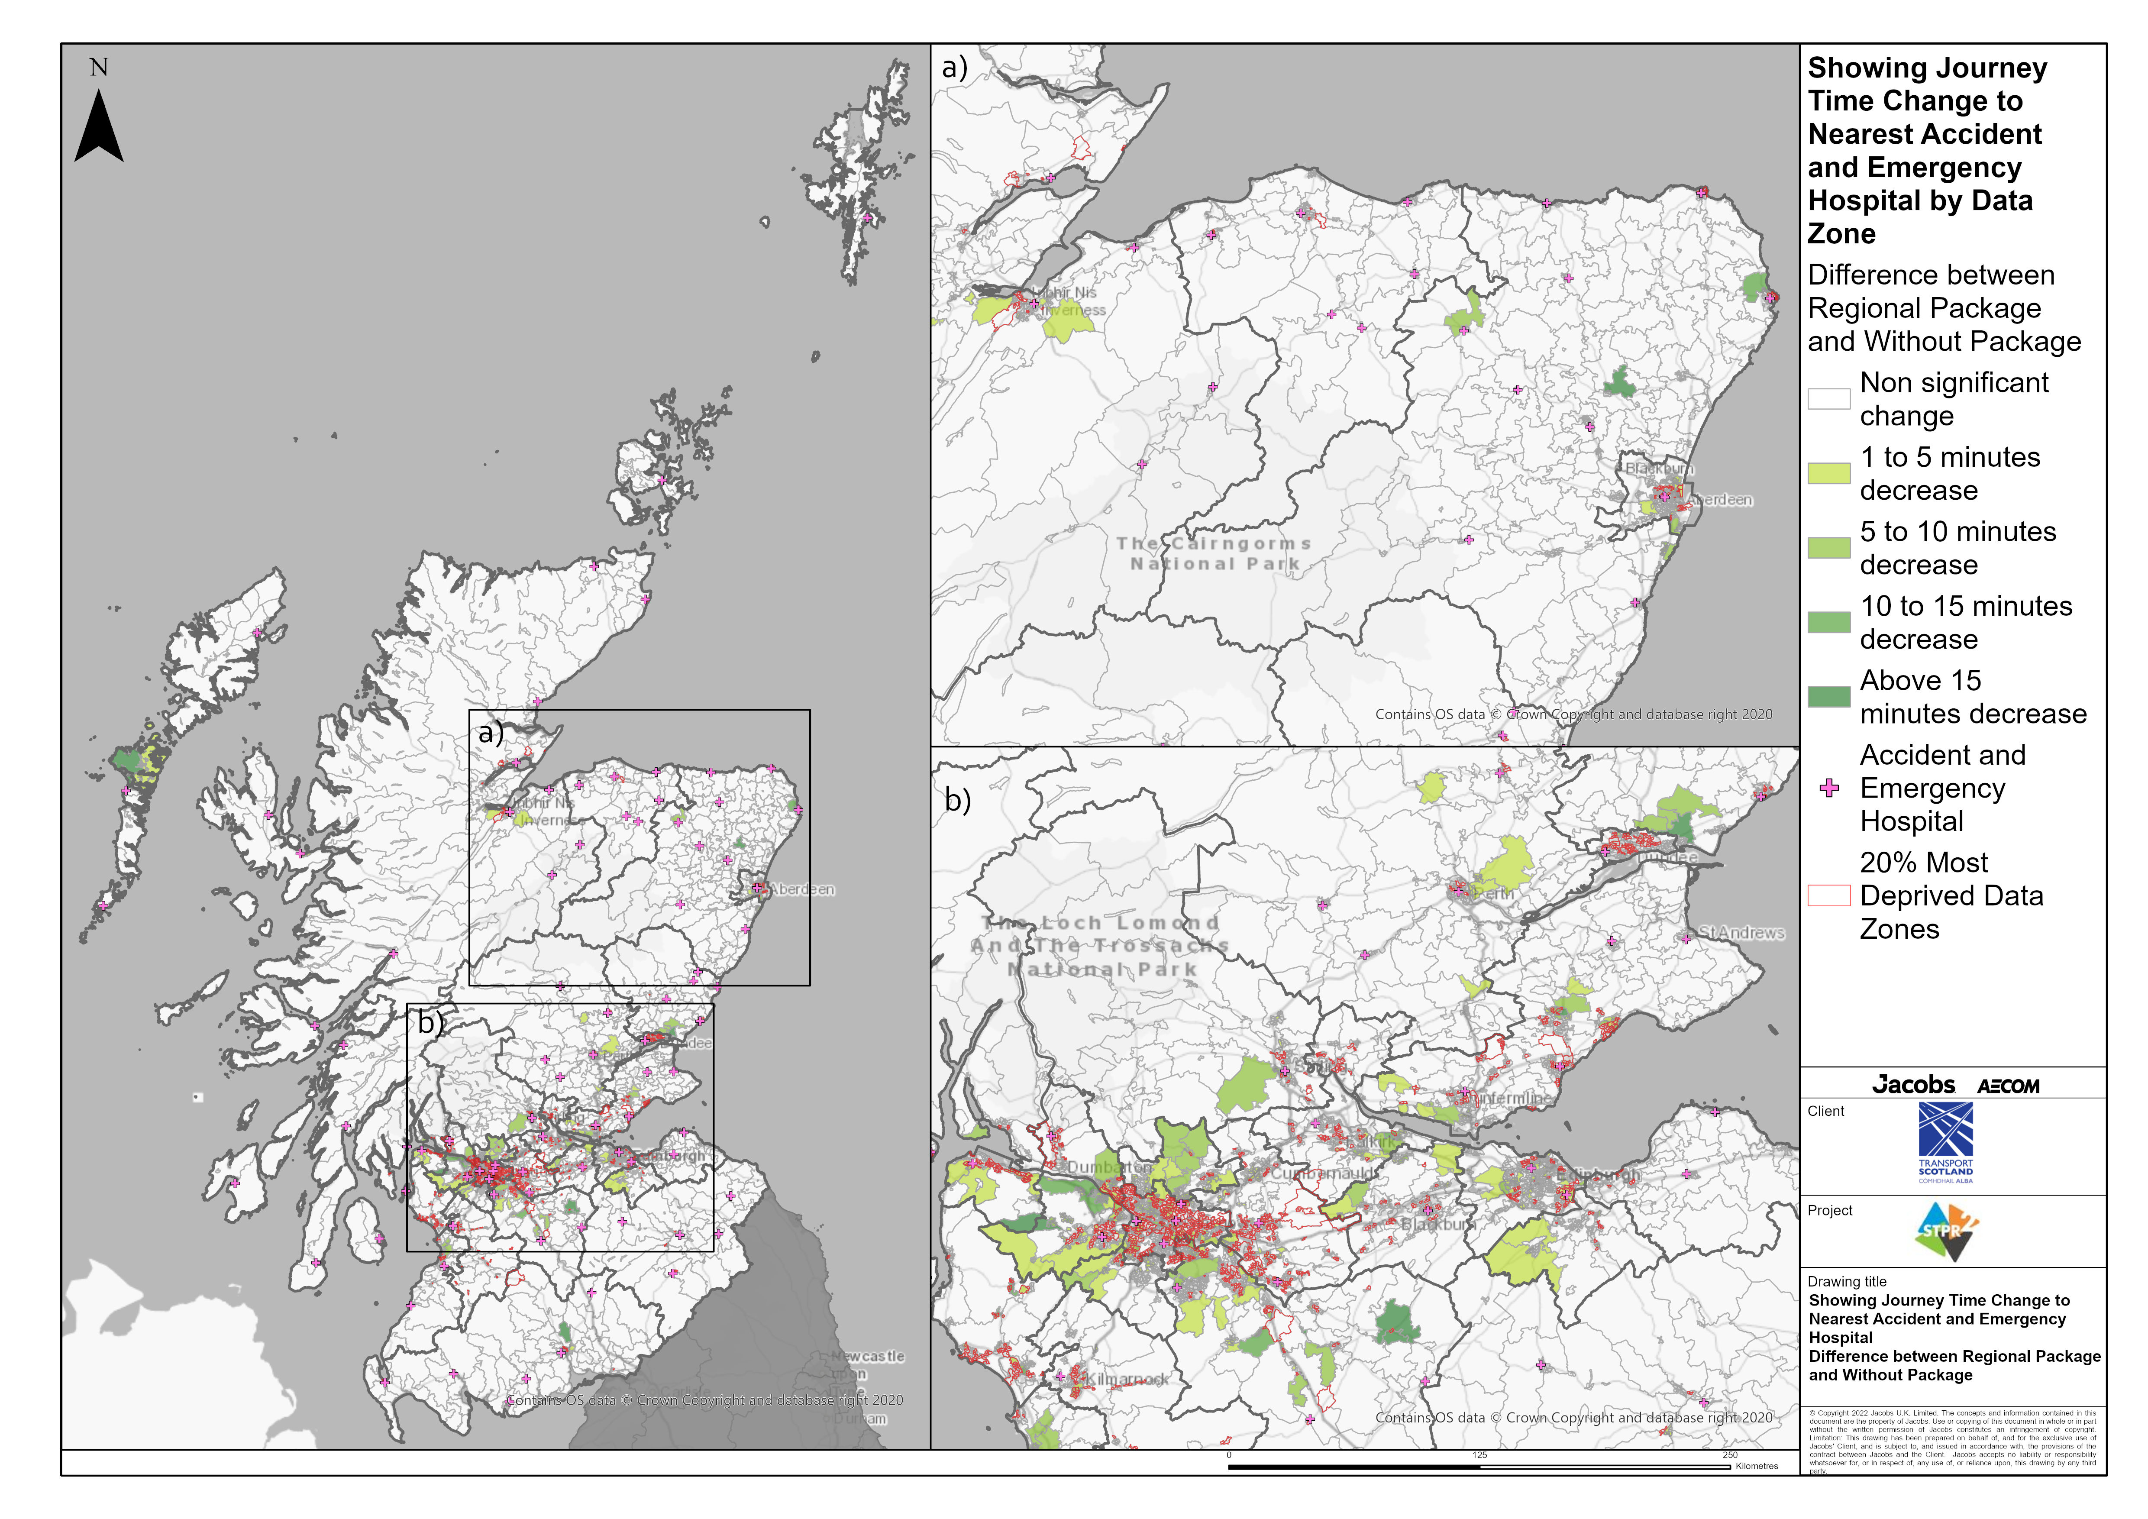
National Region – Showing Journey Time Change to Nearest Accident and Emergency Hospital Difference between STPR2 Package and Without Package
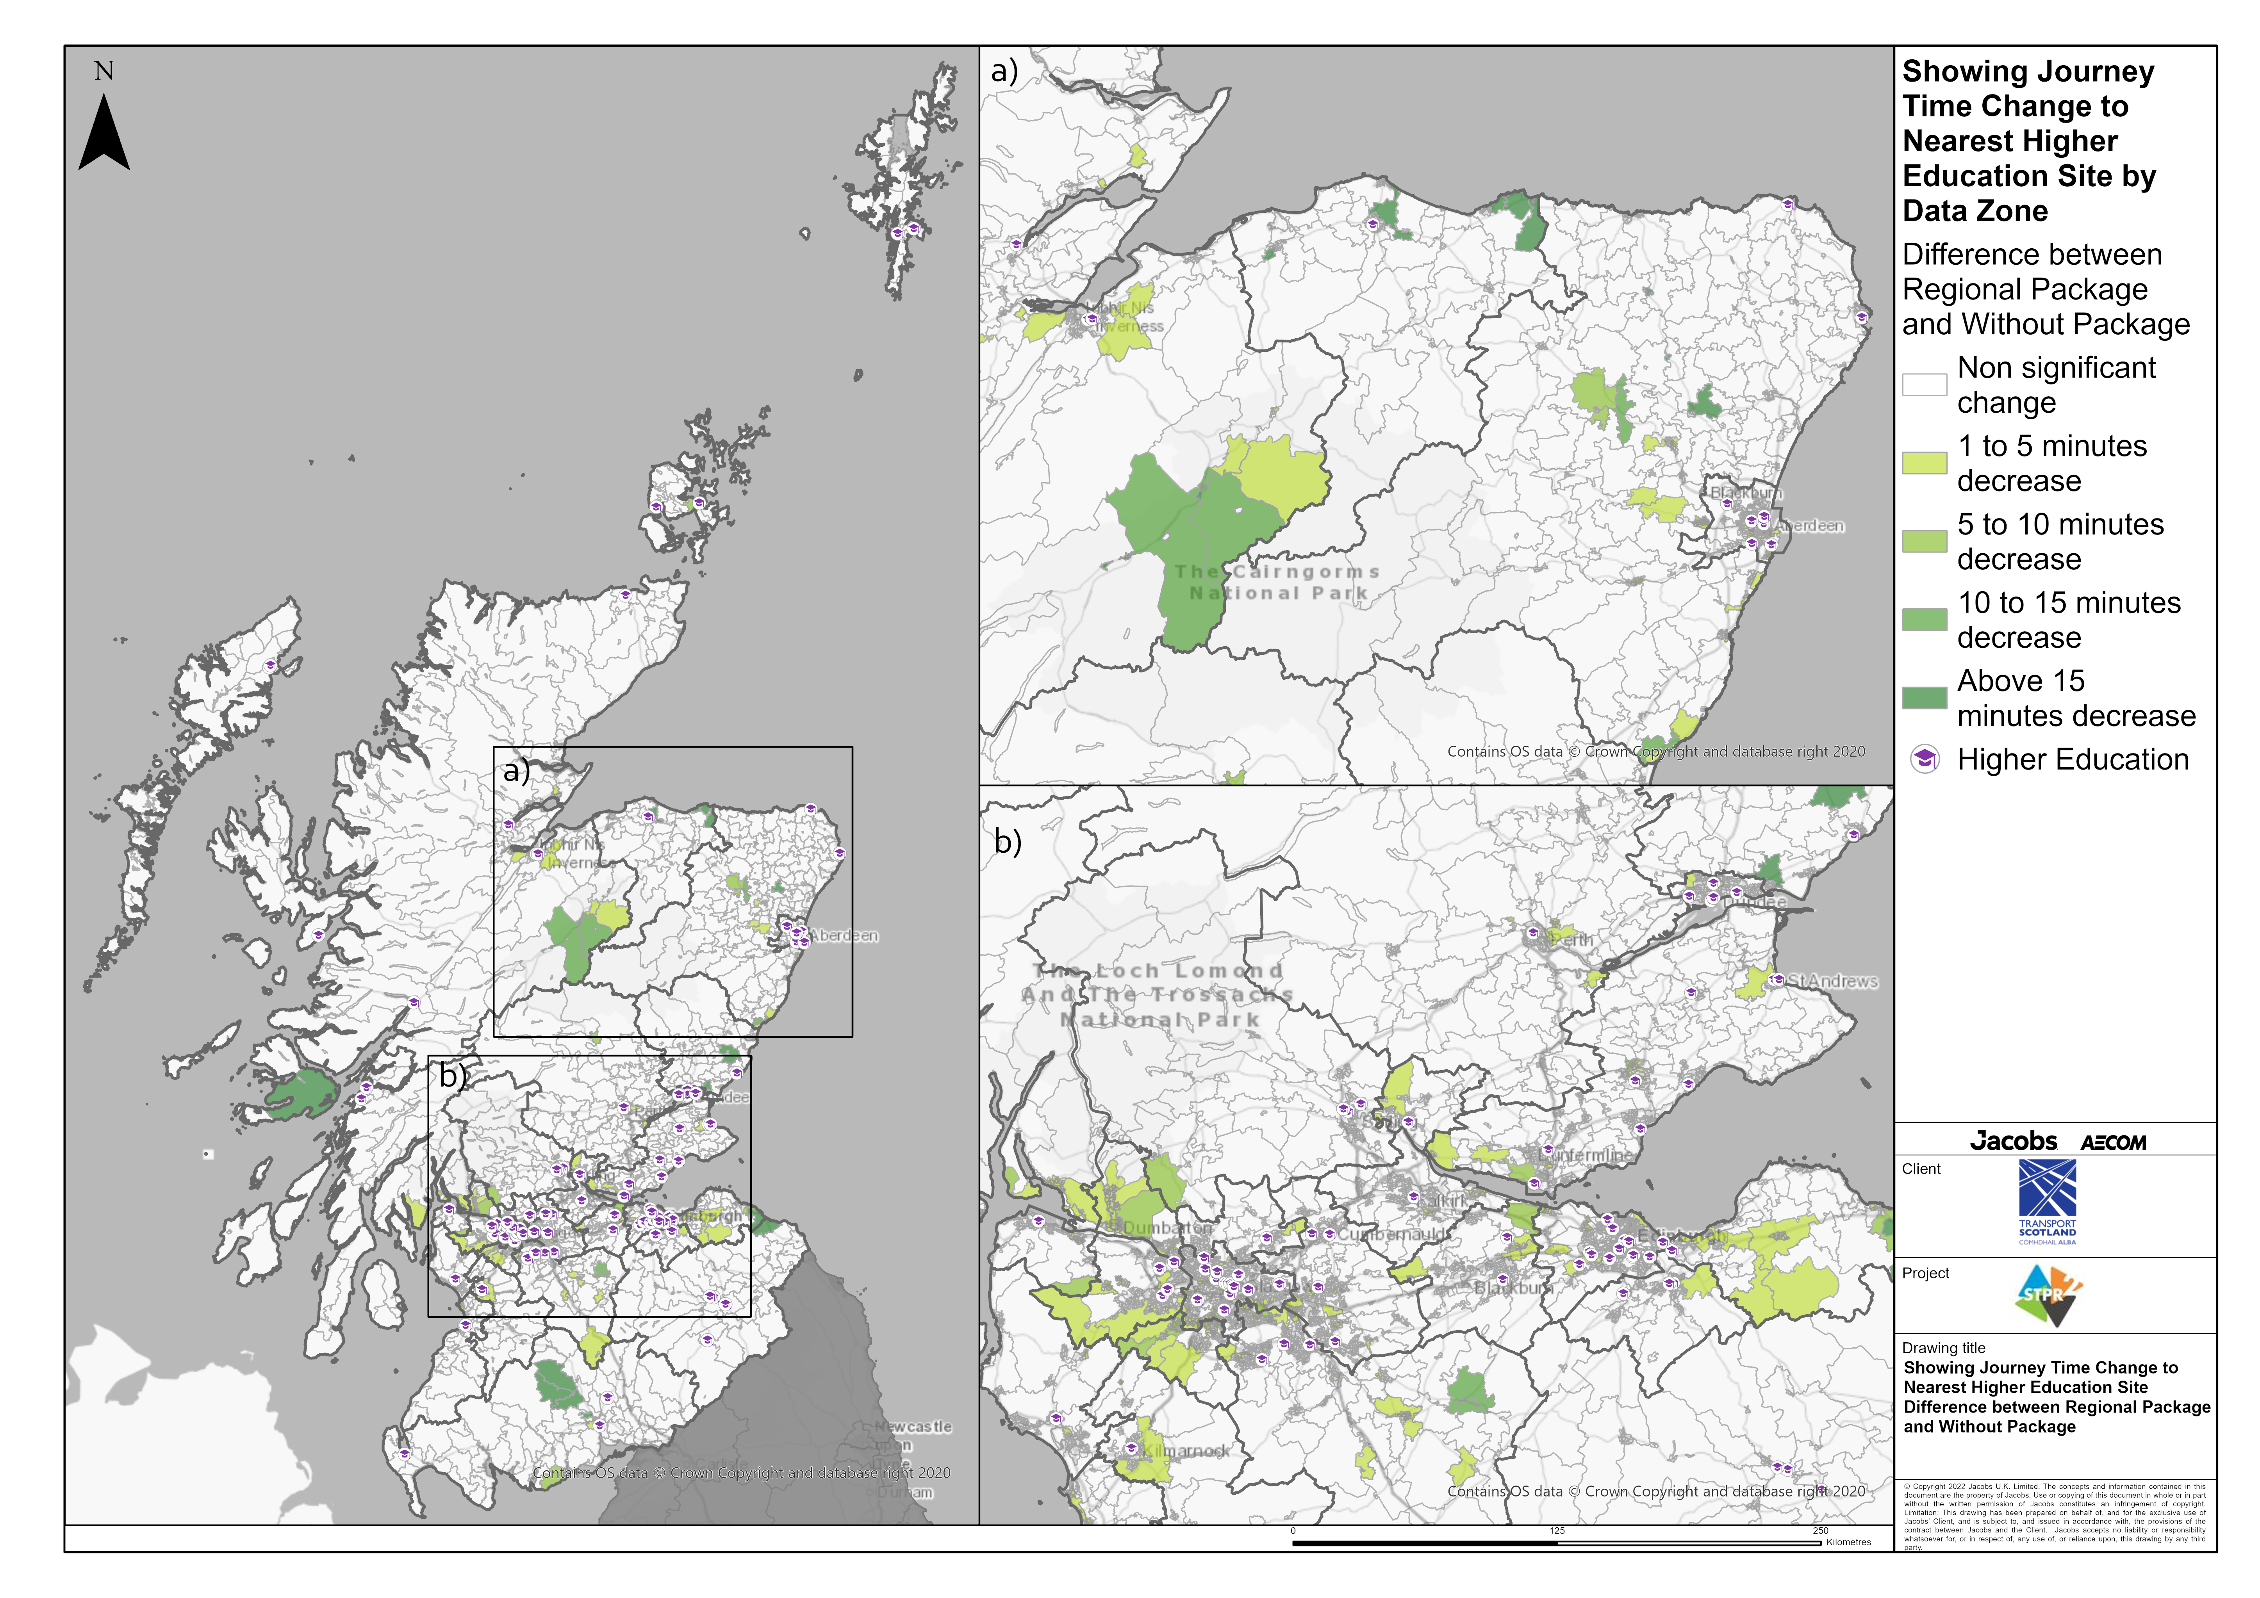
National Region – Showing Journey Time Change to Nearest Higher Education Site Difference between STPR2 Package and Without Package
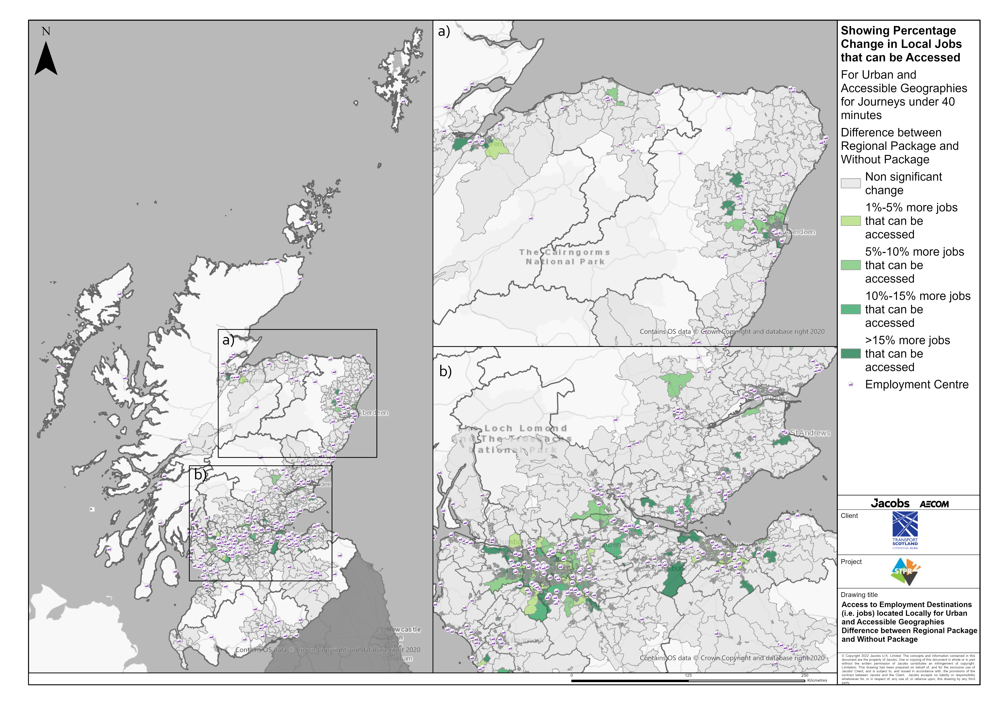
National Region – Access to Employment Destinations (i.e. jobs) located Locally for Urban and Accessible Geographies for journey times under 40 minutes Difference between STPR2 Package and Without Package
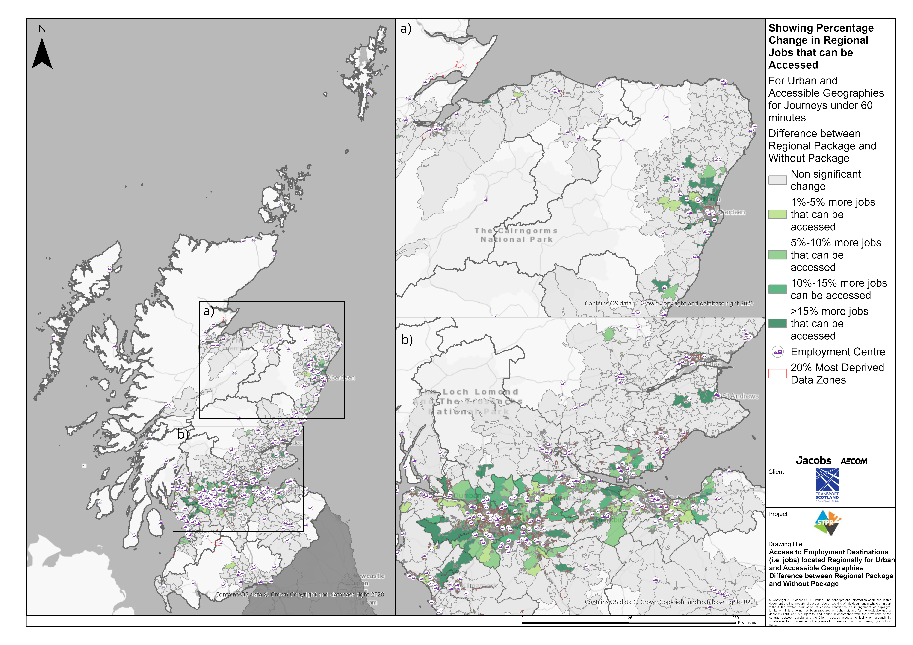
National Region – Access to Employment Destinations (i.e. jobs) located Regionally for Urban and Accessible Geographies for journey times under 60 minutes Difference between STPR2 Package and Without Package
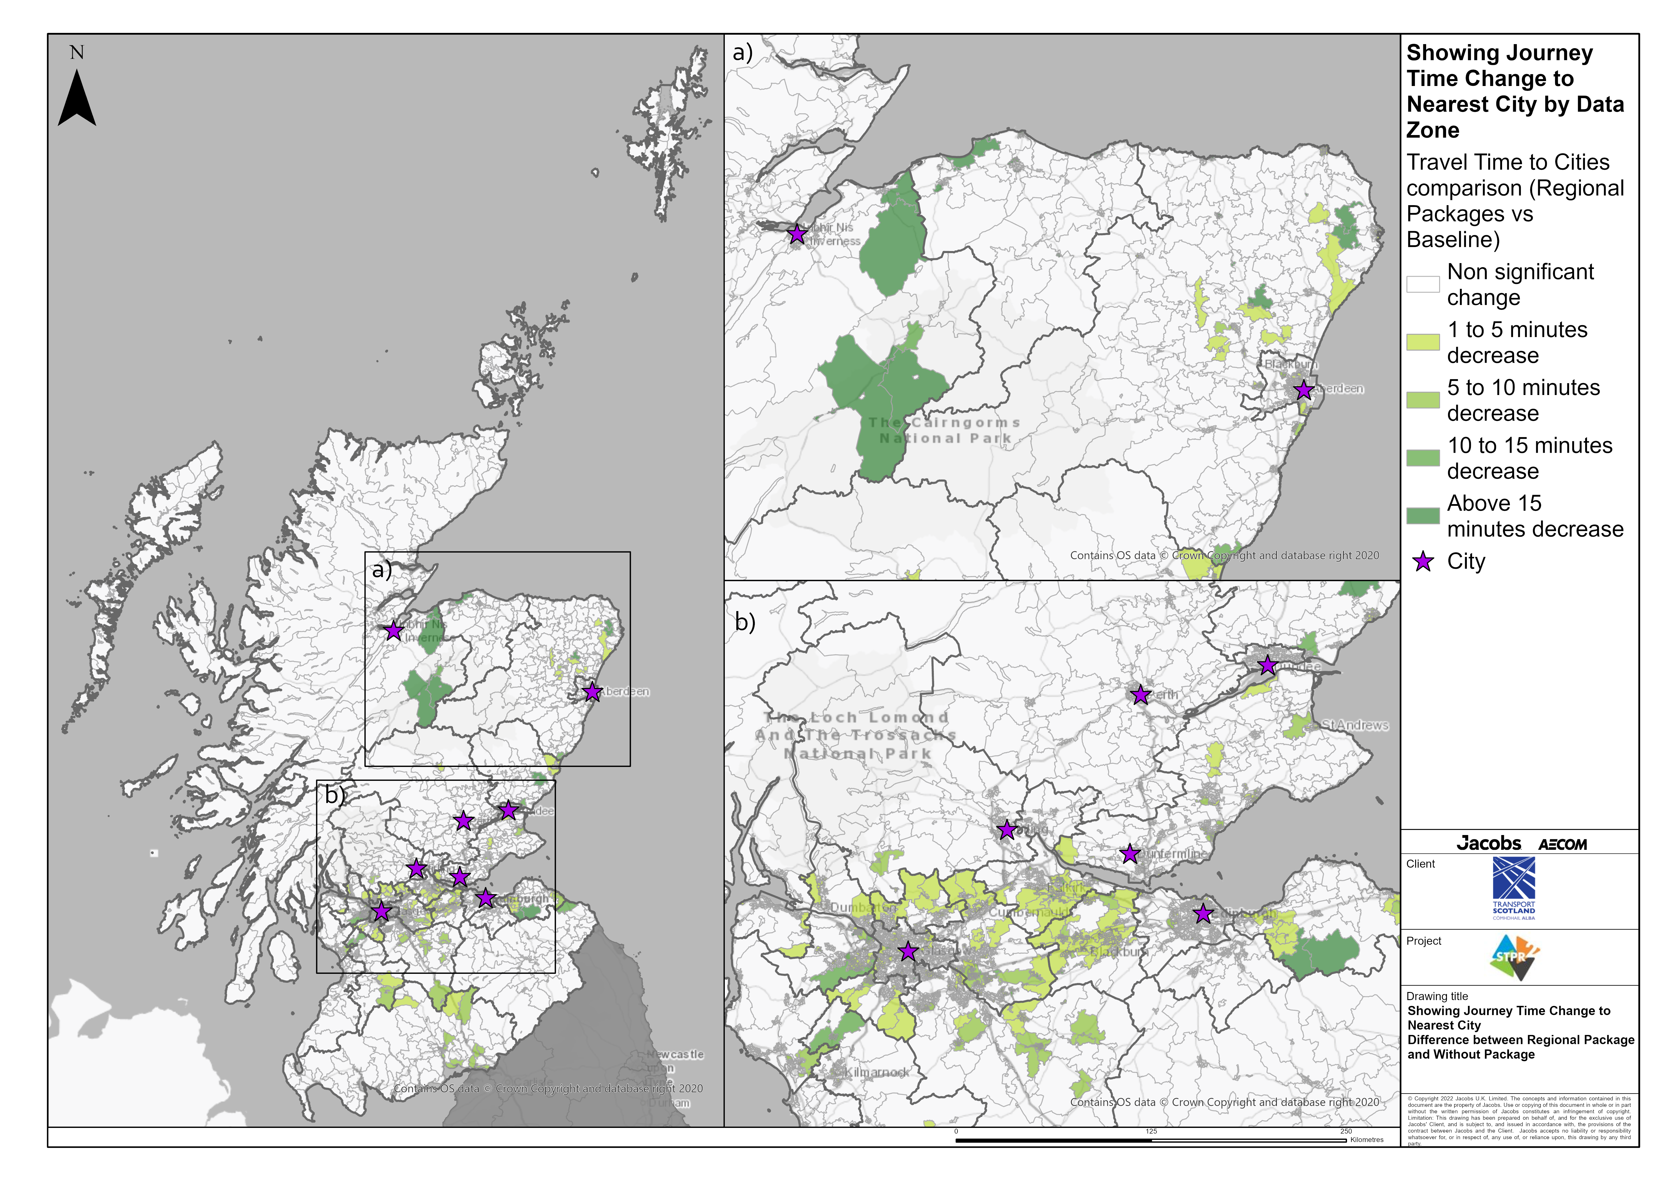
National Region – Showing Journey Time Change to Nearest City Difference between STPR2 Package and Without Package
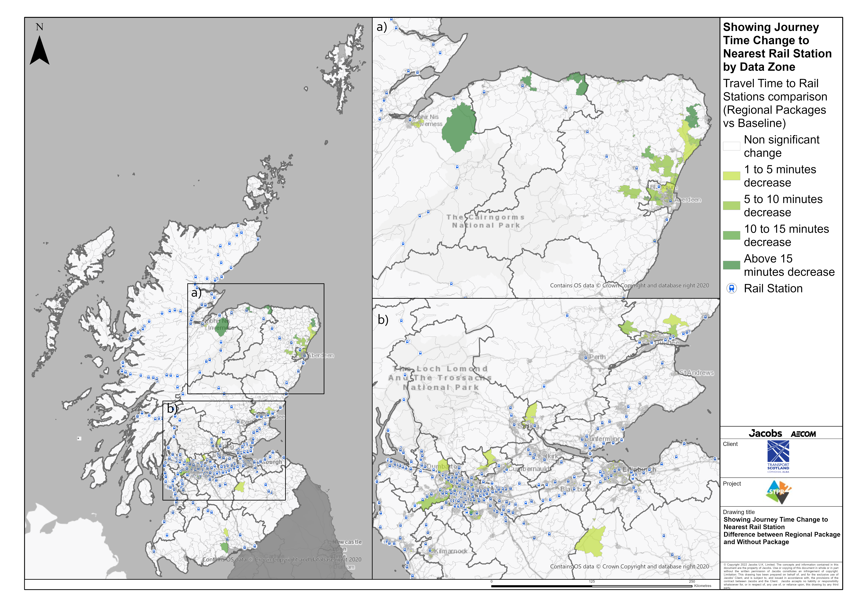
National Region – Showing Journey Time Change to Nearest Rail Station Difference between STPR2 Package and Without Package
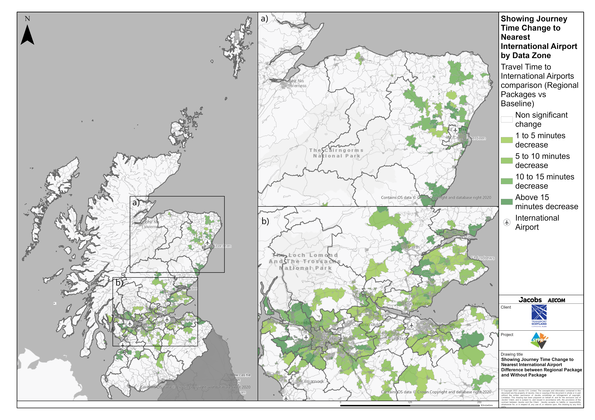
National Region – Showing Journey Time Change to Nearest International Airport Difference between STPR2 Package and Without Package

Annex B: Traffic Modelling Outputs
