**Policy Assessment Framework (PAF) Guidance**

1. **Background and Context**
2. The Policy Assessment Framework (PAF) is a tool to assist early appraisal of a number of intervention options and to present outputs in a clear visual format. This will improve the ease of comparing or prioritising intervention options and make the assessment against the full range of key objectives more balanced. PAF will help to redress the balance away from Benefit to Cost Ratio decision-making in appraisal and give more equal consideration to all of the 5 High Level Objectives of the National Transport Strategy (NTS).
3. PAF facilitates the assessment of the performance of interventions against Scottish transport policies. The policy framework is made up from a range of published policy documents which form a hierarchy of policy objectives. There is also a functionality within PAF to assess how options perform against criteria relating to deliverability and risk on a three point scale.
4. PAF is used to assess the options against policy objectives. For instance, in the case of the environment, PAF assesses how options perform against predefined environment policies. The performance of options against the Environment Criteria is not covered by PAF.
5. The first tier of objectives are taken from the National Transport Strategy (NTS) (2006) High Level Objectives:



and map up to the three Key Strategic Outcomes of:

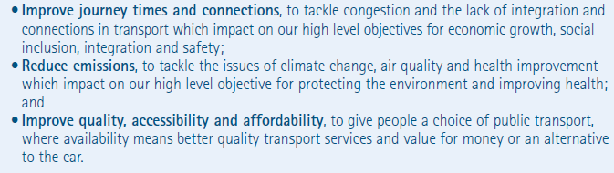

1. The secondary objectives have been compiled from: the Strategic Transport Projects Review [(STPR, (2008)]; the National Performance Framework and a specific objective relating to transport integration originates from Scottish Transport Appraisal Guidance (STAG).
2. **When to use PAF**

2.1 PAF should be used as part of the STAG process, both in the Initial Appraisal and in the Detailed Appraisal. The PAF spreadsheet should be used when considering the Policy Integration aspect of the STAG criteria. Figure 2.0 below demonstrates how PAF aligns with the appraisal process, which is at the Policy Integration Stage. Policy Integration relates to how well potential options align with transport policies and wider policies of the central and local government.

STAG Criteria

Environment

Safety

Economy

Integration

Accessibility and Social Inclusion

Transport

Transport and Land Use

Policy

**PAF**

Figure 2.1 – When to use PAF

2.2 As well as being used by Transport Scotland and its consultants, PAF is also recommended to be used by local authorities who are seeking the input or funding from Transport Scotland. External users who do not follow the STAG procedure can still use the PAF to add value to their own appraisal process.

1. **Initial Appraisal**

3.1 The Initial Appraisal considers all of the options taken forward from the Pre-Appraisal and is a qualitative assessment of each of the options potential to realise the Transport Planning Objectives and to meet the STAG criteria. PAF features a defined set of policy objectives which must be considered in each appraisal.

3.2 At this stage, the outputs from the PAF should be used to help decision makers sift options. The outputs from a PAF assessment and are intended to be presented alongside the Appraisal Summary Tables (ASTs) and to compliment the ASTs.

3.3 PAF also has a function which allows the decision makers to consider the deliverability and risk associated with each option. This aspect of the PAF is optional, but if undertaken it also returns outputs in a graphical form and can be used as part of the sifting exercise.

1. **Part 2 Appraisal**

4.1 Detailed Appraisal looks more closely at the options brought forward from Initial Appraisal and requires refinement of the predicted performance of each option against the Transport Planning Objectives; the STAG Criteria; the Cost to Government; and Risk and Uncertainty.

4.2 At the Detailed Appraisal stage PAF is used when focusing on the Policy Integration aspect of the STAG criteria. At this stage, the PAF should draw upon any quantitative data that is available.

4.3 The PAF functionality referring to Deliverability, Risk and Cost should also be used at this stage if the decision was made to utilise it as part of the Initial Appraisal.

1. **Undertaking the assessment – principles**

5.1 The PAF spreadsheet is composed of the five High Level Objectives and their associated secondary objectives. Related questions and indicators are provided next to each lower tier objective in order to assist the scoring process. The intervention options are scored next to each other in order to enable easy comparison. The score is selected from a dropdown menu within the matrix and this is reflected by colour coding. Part of the spreadsheet is shown below, the spreadsheet can incorporate up to six options.

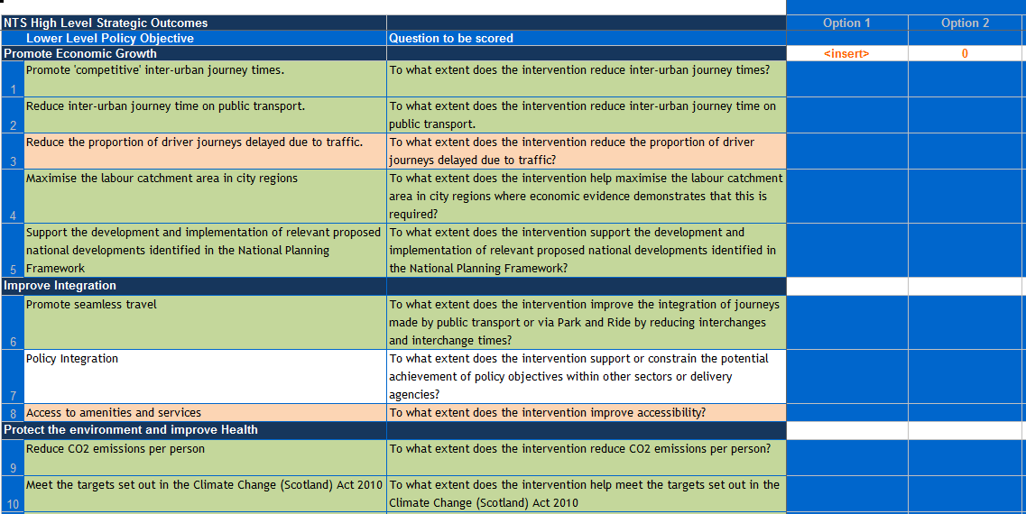

Figure 5.1 – PAF Spreadsheet

5.2 The PAF scoring system uses a seven point scale. A similar seven point scale is already used within the STAG process when assessing options against the STAG criteria.

|  |  |  |  |  |  |  |
| --- | --- | --- | --- | --- | --- | --- |
| **-3** | **-2** | **-1** | **0** | **+1** | **+2** | **+3** |
| Strong Negative Impact | Moderate Negative Impact | Slight Negative Impact | Neutral Impact | Slight Positive Impact | Moderate Positive Impact | Strong Positive Impact |

Figure 5.2 – seven point scale

5.3 Each option should be judged against all of the secondary objectives, but any objective that does not apply to the options should be given a neutral score. Indicators are provided for each of the objectives and these should be considered during scoring.

5.4 When possible, quantitative data should be used to inform the scoring, however this is a qualitative assessment. In order to maintain fairness, it is recommended that scoring should be carried out through a workshop involving key members of the project team and the transport authority/consultant, as appropriate.

5.5 When carrying out the PAF assessment, options of a similar scale should be considered together. Smaller scale options can be packaged together and taken through PAF if appropriate. It is recommended that options of a similar scale should be compared using one PAF spreadsheet.

1. **Deliverability, risk, cost and timescale**

6.1 The PAF spreadsheet has a functionality to assess the performance of options against deliverability and risk indicators. This is an optional aspect of the PAF assessment. The practitioner is required to determine whether a number of considerations present a high, medium or low risk whilst cost information can also be utilised. The scoring of the criteria on this spreadsheet is represented on charts.

1. **Outputs**

7.1 The scoring of options from the PAF exercise are represented in spider diagrams. These diagrams have been designed to allow quick comparison and assessment of the options which can supplement the decision making process. The charts are shown below.

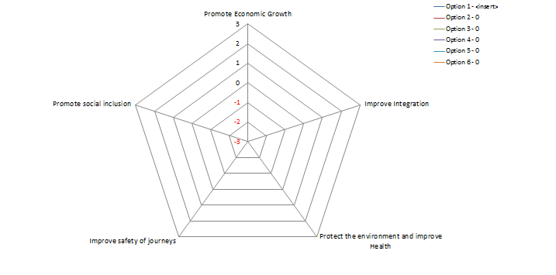

Figure 7.1: Outputs against the high level NTS Objectives.

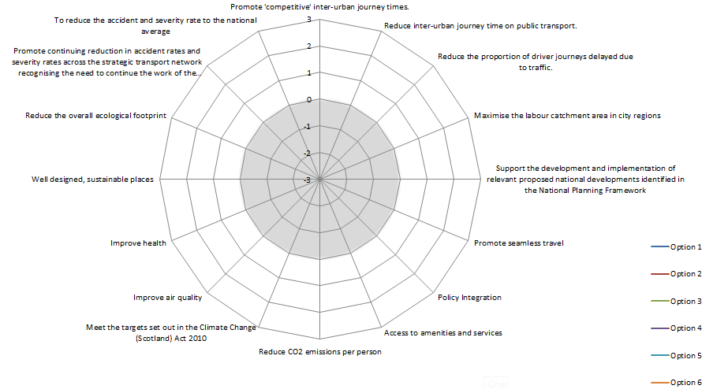 Figure 7.2: Outputs against the second tier objectives

7.2 The charts automatically map based on the scores entered into the PAF spreadsheet. The high level chart takes an average of the scores within each Higher Level Objective, whereas the lower level chart maps each individual score. The scoring from the lower level spreadsheet averages scoring for each objective under the five higher level objective categories and is represented in the higher level objective chart.

1. **Reporting**

8.1 The outputs produced from PAF should be included within the STAG report which should be structured as follows:

Introduction

Analysis of Problems and Opportunities

Objective Setting

Option Generation, Sifting and Development

Part 1 Appraisal

**Part 1 Policy Assessment Framework charts**

Part 2 Appraisal

Cost to Government

Risk and Uncertainty

Option Summary Table

**Part 2 Policy Assessment Framework charts**

Monitoring Plan

Evaluation Plan

Conclusions

There is no requirement for further reporting on PAF.