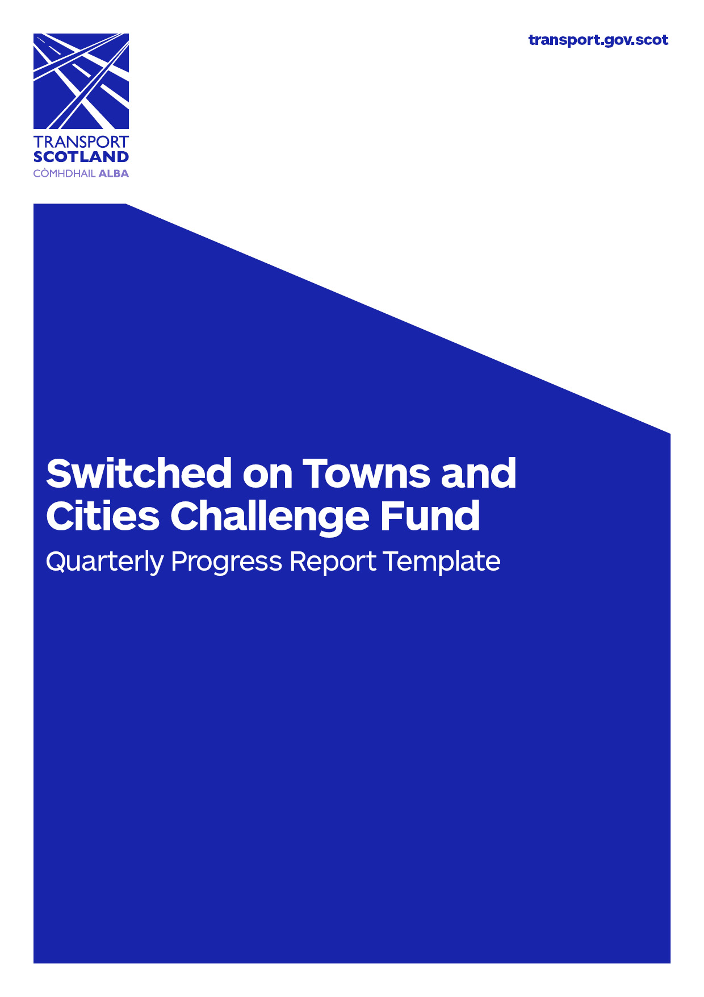
Project reference number: | << R1/2018/0 >>
Local authority name:
Project name:
Reporting period: | << Quarter (MMM ’YY – MMM ’YY) >>
Copies of the updated Expenditure Profile and Project Plan should be provided along with this report.

Sufficient information should be provided in the sections below to cover all points raised in the guidance notes. (Text boxes can be expanded if required).

1. Milestones
Please provide summary information on progress against the project milestones up to the end of this quarter based upon the agreed project plan. You should use this section to highlight:

- which milestones have been completed on time

- whether the project is running on time and to budget and is on track to meet all milestones

- whether problems have been identified with delivery and/or resourcing and if a plan is in place to address these.
As well as providing an updated project plan with this report, where there has been slippage against milestones, please ensure that this is highlighted with commentary on any implications and mitigation plans.

2. Activity planned for next quarter:
Please provide summary information planned for the next quarter making reference to the milestones set out in the project plan and any updated version of this.

3. Financial performance
Please provide summary information on the financial performance of the project up to the end of the quarter, based upon the agreed quarterly expenditure profile. Please highlight where there has been slippage in profiled expenditure or variation between agreed budget lines. An updated expenditure profile should be included with this report.

4. Project outputs
Please provide summary information on progress against achieving project outputs. This should make reference to the project outputs set out in the grant agreement in Schedule One.

5. Project outcomes
Use this section to provide summary information on activities relevant to the monitoring and evaluation of project outcomes (e.g. activities relevant to the development of a monitoring and evaluation plan/data capture etc). Please note that monitoring and evaluation of project outcomes is subject to separate reporting.

6. Communication/outreach activities
Please report on any publicity and/or outreach activity that has taken place during the quarter. This may include publicity material, leaflets, press releases, newspaper articles, public engagement events etc.

7. Project risks
Please provide details of any on-going or newly identified risks this quarter. Please note that risks should be taken from the project’s risk register using the RAG description key below.
Date identified | Risk description | RAG/  score | Mitigation strategy

8. Project/Key issues
Please provide details of any on-going or newly identified issues this quarter. Please note that issues should be taken from the project’s issues register.
Date identified | Issues description | Mitigation strategy

RAG description key (from risk register)
5 | Almost certain | 5 | 10 | 15 | 20 | 25
4 | Likely | 4 | 8 | 12 | 16 | 20
3 | Possible | 3 | 6 | 9 | 12 | 15
2 | Unlikely | 2 | 4 | 6 | 8 | 10
1 | Rare | 1 | 2 | 3 | 4 | 5
 |  | Insignificant | Minor | Moderate | Major | Catastrophic
 |  | 1 | 2 | 3 | 4 | 5

Completed by:

Position:

Contact Details:

Date:

Once completed, please post this form, along with the updated expenditure profile and project plan to:

Switched on Towns and Cities
Ultra-Low Emission Vehicle Delivery Unit
Low Carbon Economy Directorate
Transport Scotland
8th Floor
Buchanan House
58 Port Dundas Road
Glasgow
G4 0HF

