MaaS INVESTMENT FUND  BUSINESS CASE  Company name:  Date: Click to enter date  Completed by: | 
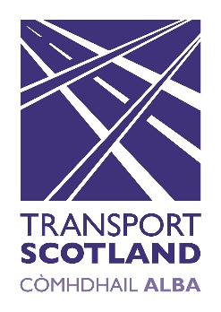
Please complete the Business Case in conjunction with the information contained in the Guidance Note and return with your completed Application Form and supporting documentation.

1. Describe the Scottish public transport network related challenge that you aim to address with your MaaS solution | Evaluation weighting  5%
2.a. What is your MaaS technological solution? | Evaluation weighting  15%
2.b How will it be applied within the realm of Scotland’s public transport (traditional, active or emerging) and travel networks

2.c If there is any additional work required to bring this MVP to a competent state for pilot progression, please provide details below and outline key deliverables for this and the accompanying timeframe (to be ready for launch no later than 31 March 2020).

2.d. what is innovative about your solution?

3. Which Scottish Government agenda(s) are you looking to address with your maas pilot (modal shift, active/sustainable transport, digital innovation within public transport arena) | Evaluation weighting  15%
3.a How does your MaaS pilot address this agenda(s)?

4. Which of the thematic area(s) are you looking to address with your maas pilot (Rural, Islands & Communities, Tourism, Tackling inequalities, accessibility and mobility barriers) | Evaluation weighting  15%
4.a How does your MaaS pilot address the thematic area?

5. What is the intended impact(s) and benefits of your MaaS solution to the end user (eg. passengers)? Provide evidence based assessment or research. | Evaluation weighting  10%
6. Where is your intended MaaS solution pilot location within Scotland and explain why you have chosen this location? | Evaluation weighting  5%
7. Outline your commercial strategy, demonstrating a sustainable and scalable business model, expected growth and/or development potential, within current Scottish market conditions. | Evaluation weighting  5%
8. If a co-creative or similar approach to the pilot has been taken, please outline your key stakeholders, their role within the project pilot and provide letters of commitment (or equivalent). | Evaluation weighting  5%
9. Explain how your MaaS solution will be inclusive and accessible? | Evaluation weighting  5%
10. What are your key risk and mitigations in delivering your MaaS solution project? (for example unintended impacts, technology, finance, commercials etc) | Evaluation weighting  5%
11. Demonstrate how your MaaS solution is compatible with, or working towards integration with, exisiting Scottish public transport smart technology infrasture/specification (e.g. cEMV, mobile and/or ITSO). | Evaluation weighting  5%
12. How will you effect sustained behavioural change with your target audience and stakeholders? | Evaluation weighting  5%
13. What monitoring and evaluation process do you have planned to assess success, and in which areas – for example uptake, behavioural change, rate etc - for both stakeholder and public? | Evaluation weighting  5%

