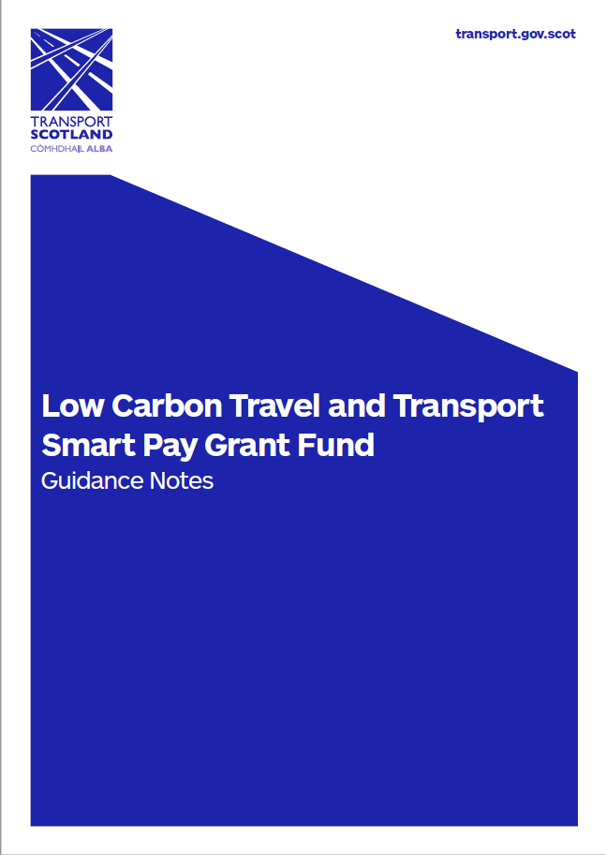

Guidance Notes

INTRODUCTION

The European Regional Development Fund (ERDF) Low Carbon Travel & Transport (LCTT) Programme matched by Transport Scotland is offering a Smart Pay Grant Fund (SPGF) to support smaller bus operators to now accept contactless (cEMV) payments.

The SPGF will provide support to eligible private and public sector bus operators with a financing package that will contribute towards the initial one off infrastructure investment costs of replacing existing or procuring new Electronic Ticketing Machine(s) (ETM) or, where appropriate, upgrading existing ETMs to accept cEMV payments. In addition, financial support towards recurring cEMV licence or subscription fees will be provided for a three year period.

The fund will have a maximum value of £1.1 million and it is projected that the fund will be made available for distribution over a three year period, from November 2018, or until funds have been fully expended, whichever is soonest.

By enabling more bus operators to accept this convenient more modern payment method, the SPGF is intended to broaden access to public transport by making bus travel an easy, more attractive option.

BACKGROUND

The Ministerial vision is that ‘all journeys on Scotland’s public transport networks can be made using some form of smart ticketing or payment.’

The Smart and Integrated Ticketing operation was established specifically to support the development of smart ticketing and smart electronic payment across Scotland.

It is considered that the convenience of smart payment methods will help make public transport more appealing to the user. Making public transport journeys simpler, more convenient, and attractive to passengers is key to growing patronage for the bus industry and supports Scottish Government aims to reduce reliance on cars by encouraging modal shift to more sustainable public transport and improve our air quality.

As such, in November 2017 it was agreed with the then Minister for Transport and The Islands, Mr Yousaf, that Transport Scotland should support cEMV acceptance as the smart payment method of choice.

This Smart Pay Grant Fund, approved by the Cabinet Secretary for Transport, Infrastructure and Connectivity in November 2018, is the next stage of this project. It is intended that this financial support for all operators will complement the major Scottish bus operators’ strategies, most of whom now accept cEMV on at least some of their routes, as well as the rail network, which already accepts cEMV payments. Finally, it also has the benefit of being a facility that customers are actively seeking, having already used it regularly in their day to day retail payment transactions.

This fund also supports the previous funding for improved ETMs and the support services Transport Scotland offers for smaller operators in relation to smart ticketing. For more information on other services please refer to the smart section and Smart Delivery Strategy found on the Transport Scotland website.

ELIGIBILITY

Organisations

The SPGF is available to all bus operators, local authorities, RTP organisations and other public transport bodies that demonstrate they meet basic ERDF eligibility requirements and whom wish to accept cEMV smart payments through their smart ticketing equipment.

The self-assessment checklist, provided at Section 2 in the Application Form, is also intended to help organisations to decide whether they should proceed with an application.

Criteria

In order to be a participant in the pilot scheme you must fulfil the criteria below:

- Be a Scottish bus operator of “local services” or a local authority/regional transport partnership registered with the Traffic Commissioner for Scotland;

- Provide a commercial service(s) in Scotland available to the general public;

- Have a cEMV agreed merchant account or be in the process of arranging one;

- Be applying to the fund for a maximum of 250 ETMs across all rounds of funding;

- Have not already ordered the goods or services you are applying to the fund for;

- Currently operate or be in a position to procure, upgrade, and manage, as per above funding package, ITSO compliant ETM cEMV compatible equipment;

- Have reliable connectivity at depot or on service route to permit transaction data periodically as a minimum;

- Agree to provide quarterly smart travel data to Transport Scotland for European Funding audit purposes;

- Be able to demonstrate that cEMV will be sustainable on eligible services for a 5 year period from date of receipt of initial funding;

CONSIDERATIONS

Business Case

Prior to completing the application form, applicants to the SPGF are requested to note and consider the following, based on user experience and advice of similar schemes elsewhere in the UK.

Applicants are to submit a Business Case in support of their application. Applications will be assessed and scored based on their ability to mitigate the considerations below.

The Business Case template can be downloaded at www.transport.gov.scot/spgf

- Understand the problem you face and the reason for wanting to implement cEMV.
- Is there a customer requirement for cEMV and do you have the ability to maintain or improve the customer proposition?
- Are your commercial fares and tickets cEMV compatible as the current cEMV payment limit is capped at £30? If the majority of your commercial revenue is attributed to sales of products £30+ (period passes), this offer may not be suitable.
- Will cEMV be compatible with your existing infrastructure, fleet, area of operations?
- Assess concession / commercial activity per service to ensure viability and longevity of the service and your ability to meet monthly minimum fees.
- Assess your ability to mitigate initial fraudulent activity of 1-1.3%. Anecdotal evidence suggests that after 6 weeks of debt recovery, fraud is reduced to 0.3%.
- Assess your ability to provide appropriate customer service and ability to cope with a potential increase in customer issues arising from introduction of new technology.
- Do you have reliable access to depot or on route connectivity for transaction up-linking?
- Calculate administration increase to ensure compliance with funding requirements, auditing and accountability.
- Reflect on your five year business plan in terms of maintaining status quo, possible areas for growth or decline concerns, risk and mitigations.

Calculators

To assist you in your assessment of affordability and viability, Transport Scotland has developed two calculators. These calculators are intended to show indicative costs based on a Ticketer ETM partnered with LittlePay as the Payment Service Provider. Applicants are to note that these are examples and reflect costs provided by Ticketer and LittlePay to Transport Scotland. Actual costs may vary. Other suppliers are available and the Grant Fund is not supplier specific.

Infrastructure | Transaction Fees

GRANT FUNDING SUPPORT

To support your expansion into cEMV payment acceptance a grant funding package has been developed. It includes financial contributions as summarised below.

Infrastructure Support

The SPGF can be used to support eligible applicants finance new or replacement ETMs or upgrade existing ETMs to accept cEMV payments.

ETMs must be of ITSO 2.1.4 standard and the operator must be applying to the SPGF to provide a cEMV capability.

Applicants should contact their existing ETM provider to enquire if current platforms are capable of upgrade or replacement ETMs will be required.

The following funding is available per ETM:

- £1,000 towards the cost of new or replacement equipment to offer a cEMV service,
or
- £350 towards existing equipment upgrade to cEMV compatibility.

On Going Support

In addition to the one off infrastructure support, the SPGF will also provide:

- £100 per operational ETM towards cEMV licence or subscription fees for years 1-3.

cEMV Transaction Fees

If you are concerned the cEMV transaction rate maybe a blocker to affordability, please contact the SPGF project managers to discuss.

Reimbursement

SPGF reimbursement in to your account will occur once you have cleared down your supplier invoice and submitted the required supporting documentation to Transport Scotland. Should you agree a payment plan for licence fees, eg monthly or quarterly, SPGF reimbursement will occur upon submission of the required documentation following final payment of that year’s fees. Hardware and licence fee reimbursement can occur independently.

Financing

Should you be considering a hire purchase or finance plan to procure hardware, you are advised to contact the SPGF Manager to discuss prior to placing your order as this may affect the reimbursement process.

APPLICATIONS

Applications will be considered and assessed on a first come first served rolling basis.

Round 1 applications were taken from 12 November to 14 December 2018 and Round 2 16 January to 14 June 2019 with awards made.

Round 3 applications are being accepted from 20 August 2019. Assessments, notifications and awards will be made on a rolling basis. Round 2 will close on 15 November 2019 or should the fund be expended, whichever is soonest. Further rounds are dependent on stakeholder interest and continued securing of finances and, as such, will be officially announced in due course.

Timeline

It is intended that the £1.1m SPGF will be available for distribution over three financial years, from November 2018, but will close if the fund is expended. In addition, as noted above, further rounds are dependent on interest and continued securing of Scottish Government finances.

Expected timelines are shown below.

Action | Dates
Round 3 application window | 20 August – 15 November 2019
Round 3 TS assessment | As received
Round 3 notifications | As assessed
Round 3 Invoices cleared by | Latest 31 March 2020

To note for successful applications: If by 31 March 2020 the applicant has not drawn on the grant as per the outlined process (i.e. submitted Schedule 2, the provider’s invoice and proof of payment) the application will be automatically transferred into the following round noting that subsequent rounds are not guaranteed funding.

State Aids

State Aids colleagues have been engaged throughout to ensure requisite criteria for levering ERDF is met as well as enabling growth without distorting the market.

For Public Sector applicants, contracts must either be competitively tendered or procured in line with an organisation’s standing orders and/or National Rules Procurement Policy to ensure value for money.

Assessment Process

SPGF applications will be subject to a two-stage process comprising:

- Basic eligibility check
- Panel assessment

Basic eligibility check

To be eligible for the SPGF, the eligibility criteria must be met and all boxes of the Application Form completed. This stage will be completed by one of the Transport Scotland SPGF project managers.

Panel assessment

Transport Scotland smart project team will carry out an assessment of eligible applications using the following key criteria;

- Assessment of the Application Form and Business Case.
- The Business Case should clearly demonstrate that the applicant has considered the points highlighted in Section 4.1 of this guidance.
- Full audited or accountant signed Annual Accounts, including Balance Sheet and P&L/Income Statement, will be accessed for risk.
- Confirmation of merchant account arrangements and understanding of the financial impact of implementing cEMV payment acceptance.

As noted above, clarification on some or all of the eligibility criteria and your business and financial assessments may be sought.

If your application meets the criteria and demonstrates robust consideration of the above, we expect to offer you grant.

NEXT STEPS

What to do now.

- Consider the viability of cEMV with your operation.

- If required, discuss with a Transport Scotland SPGF Manager.

- If not already acquired, apply for a cEMV merchant account.

- Engage with preferred ETM provider and Payment Service Providers.

- Complete the Application Form and submit with supporting documentation:

  - Application Form in Word format
  - Recent full Annual Accounts including Balance Sheet and Income Statement. If the company is exempt from audit, the accounts are to be prepared and signed by the accountant
  - Business Case (template supplied)
  - If received, ETM supplier quote

- You will be notified of the outcome or further information requested.

- If approved, place your order with your preferred ETM supplier.

- The applicant will be reimbursed from the SPGF upon submission of Schedule 2 (Grant Claim Form) including receipt of invoice from the provider and proof of payment from the applicant’s bank account in the form of a redacted bank statement. The goods must be received, receipted and installed (or an installation schedule agreed with the provider) and the supporting invoice and payment proof submitted to Transport Scotland by 31 March 2020.

- Following receipt, SPFG funds will be released within 10 working days to the applicant in accordance with Transport Scotland payment terms and conditions.

- Provide quarterly cEMV smart journey data to Transport Scotland upon request.

Submissions

Please email the completed application form and supporting documentation to SPGF@transport.gov.scot

Once your application is submitted you will receive an acknowledgement email. If you do not, please contact us immediately.

Applications for Round 3 must be received by midnight on Friday 15 November 2019.

If you have any queries about the Smart Pay Grant Fund or would like to discuss before submitting an application, please send an email to SPGF@transport.gov.scot with an outline of your query and your contact details and a member of the team will get back to you

Visit www.transport.gov.scot/spgf for more information.

ERDF and Managing Authority Requirements

Successful applicants will be obliged to:

a) Recognise the ERDF and Scottish Government in any publicity around the project, please see http://www.gov.scot/Resource/0049/00499194.pdf for full details; and

b) Retain copies of all project documentation, facilitate and make available the project documentation for audit by the Managing Authority, please see http://www.gov.scot/Resource/0047/00475915.pdf for full details and http://www.gov.scot/Resource/0048/00489832.pdf

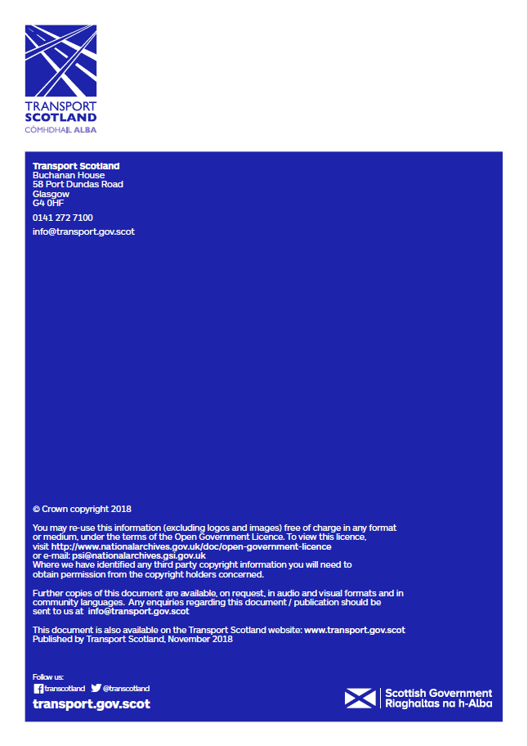

Based on feedback from the TS Public Transport – Smartcard & Travel Research Survey, July 2018.
UK Finance estimate 63% of people in the UK use contactless payments (Independent 18 June 2018)
The £30 capped limit is applicable to all contactless cards. Mobile payment methods (Apple Pay, GPay, Android Pay, etc) generally do not have a cap limit, although T&Cs may vary.

