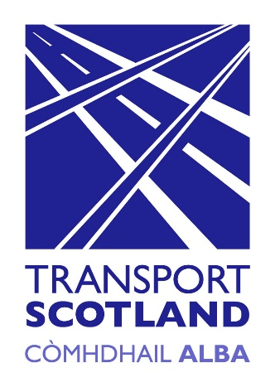
transport.gov.scot
Easy read version
Consultation on free bus travel for people resident in Scotland aged under 19
Free bus travel for people resident in Scotland aged under 19 Consultation Easy Read

What is this easy read about?

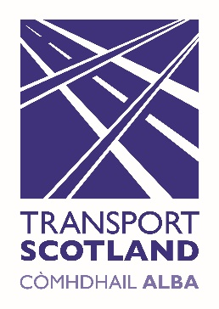  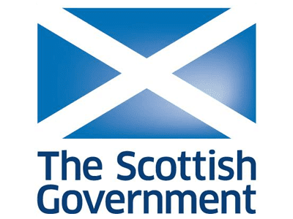 | Transport Scotland wants to launch a new transport scheme  Transport Scotland is a part of the Scottish Government
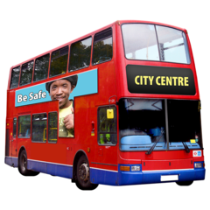 | The new transport scheme would give everyone under the age of 19 years old free bus travel
 | This means young people would not need to pay any money to go on the bus
 | The consultation says why the Scottish Government want to do it and how it might work
 | The consultation is trying to find out what people think so they can make the ideas better
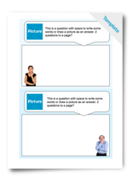 | There are questions at the end of the easy read you can answer
 | The first part of this read explains some things about the consultation
 | The second part gives you the questions to answer
How can I send my answers back?
You can e-mail your answers to

Under19Consultation@transport.gov.scot
You can post your answers to

Under 19 Consultation
Bus, Accessibility and Active Travel
Transport Scotland
Buchanan House
58 Port Dundas Road
Glasgow
G4 0HF
You can use the consultation hub which can be found at

https://consult.gov.scot/transport-scotland/consultation-free-bus-travel-for-people-under19
 | You can send your answers back until the consultation closes on 7th December
Why do the Scottish Government want to make bus travel free for under 19s?
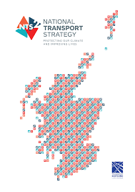 | This idea is part of Scotland’s national strategy for transport.
 | A strategy is a big plan with lots of things to do
 | They want transport to be affordable
 | This means people should be able to pay for transport without it costing too much
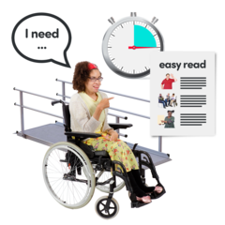 | They want transport to be accessible
 | This means transport should be able to be used by as many people as possible
 | This will help people who do not have lots of money
 | They want to make bus travel free for people under 19 years old
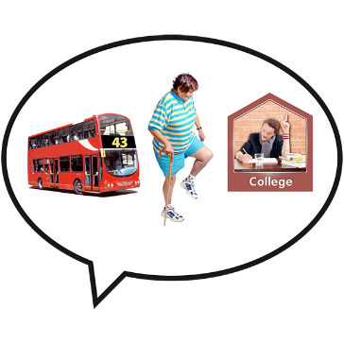 | This will make it easier for them to travel if they go to college or university
 | This will make it easier for them to travel if they have a job
 | This will make it easier to do to fun things like playing sport
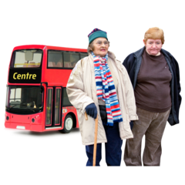 | If people use the bus when they are younger they might use it more when they are older
 | They hope it means people might use the bus instead of a car
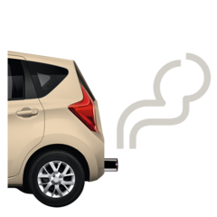 | This would be good for the environment and make the air cleaner
Who would be able to use the free bus travel?
 | There are 770,000 people under 19 years old who would be able to use the bus for free
 | Children under the age of 5 years old are already able to use the bus for free
How would the free bus travel work?
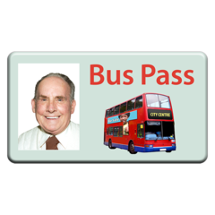 | They want the scheme to work like free buses do for older and disabled people
 | Young people would get a smart card to let them use the bus for free
 | This is a special type of card that can have information and data on it
 | Using smart cards means we can count how many people use the free bus travel scheme
 | A parent or guardian might need to say it is ok for younger children to get a smart card
 | A company or organisation that controls how the buses work is called a bus operator
 | Bus operators will have to get money for all the young people that use the scheme
What about the pandemic?
 | The coronavirus has meant less people are using the bus
 | The free bus travel scheme should still happen in 2021
 | The pandemic might mean changes in how free bus travel scheme works
What difference will free bus travel for young people? make
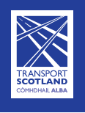 | The Scottish Government want to know if free bus travel for young people makes things better for people
 | They want free bus travel for young people to make Scotland fairer and more equal
 | There are certain things about people that we protect to stop them being treated unfairly
 | We call these things protected characteristics. There are 9 of them.
 | Age is a protected characteristic
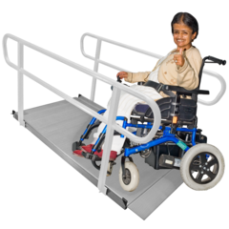 | Disability is a protected characteristic
 | They want free bus travel to make things better for people with protected characteristics
What are the questions that Transport Scotland are asking?
 | This is the part of the easy read with the questions to answer
 | You do not have to answer all of the questions. You can answer just the ones you want to
1.
Do you think extending national concessionary travel to include free bus travel for under 19s in Scotland will contribute towards our objectives to increase opportunities and reduce inequalities?
- Yes
- No
Please Explain
 | This question is asking if free bus travel for young people will make it easier for people who have problems using transport
2.
Do you think there are any disadvantages to introducing free bus travel for under 19s in Scotland?
Yes
No
If yes, please explain
 | This question is asking if free bus travel for young people would mean any bad things
3.
Should a smart card, such as the widely used Young Scot card, be used to establish eligibility for free bus access?
- Yes
- No
Please explain
 | This question is asking if young people should need to use a smart card for free bus travel
4. | Should children under a certain age need to have their application for a travel card approved by a parent or guardian?  - Yes  - No  Please explain
 | This question is asking if a parent or guardian would need to say it is ok before a young person can go on the bus for free
5. | If you answered ‘yes’ to question 4, at what age should parental or guardian approval be required?
 | If you said yes what age should a young person be when they still need to ask their parent to get free bus travel?
6 | Are there any likely impacts the proposals contained within this Consultation may have on particular groups of people, with reference to the ‘protected characteristics’ listed above? Please be as specific as possible.
 | Protected characteristics include things like age and disability. Do you think free bus travel under 19s will make a difference to these people?
7.
Do you think the proposals contained within this Consultation may have any additional implications on the rights, wellbeing and safety of children and young people that is not picked up above?
 | This question is asking if it will make any differences to young people being safe and well
8. | Do you think the proposals contained in this Consultation are likely to increase or reduce the costs and burdens for bus companies, public bodies, third sector organisations or businesses? Please be as specific as possible.
 | This is about whether it will make it cost more money and be more difficult for bus companies
9.
Are there any other issues you wish to raise which are not covered in the points or questions above?
 | This question means you can write down anything else you think is important
What information does the Scottish Government need about you?
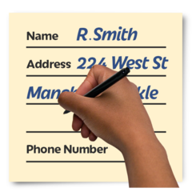 | You need to fill in some information when you send back your answers
You can click here to find out how they keep your information private
https://beta.gov.scot/privacy/
Are you answering these questions as an individual person or are you representing an organisation?

Tick the box that best suits you.

Individual

Organisation

 | You should tick organisation if you are filling in the form for another group that you work with
 | What is your phone number?
 | What is your e-mail address?
 | What is your postal address?
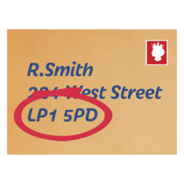
 | The Scottish Government would like to know something about. So they know how the change will impact on you. Tick the box that describes you
I am under 19 years old

I am the parent or carer of someone under 19 years old

I work or volunteer with people under 19 years old. This could be like a teacher or social worker

The Scottish Government would like to know how often you normally use buses. They mean how much you used buses before the pandemic.

Tick a box to say how much you use buses
I use buses every week

I use buses around once a month

I use buses once or twice a year

I never use buses

The Scottish Government would like to show your name and your answers.

Tick a box to say what you want
 | Show my name and my answers
 | Show my answers but not my name
 | Do not show my answers or my name
The Scottish Government might like to contact you to ask you some other questions about this. Would this be ok?
 | Yes
 | No

Follow us:
transcotland @transcotland
© Crown copyright 2020
You may re-use this information (excluding logos and images) free of charge in any format or medium, under the terms of the Open Government Licence. To view this licence, visit http://www.nationalarchives.gov.uk/doc/open-government-licence or e-mail: psi@nationalarchives.gsi.gov.uk
Where we have identified any third party copyright information you will need to obtain permission from the copyright holders concerned.
Further copies of this document are available, on request, in audio and visual formats and in community languages. Any enquiries regarding this document / publication should be sent to us at info@transport.gov.scot
This document is also available on the Transport Scotland website: www.transport.gov.scot Published by Transport Scotland, November 2020
transport.gov.scot

