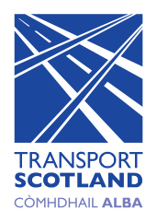
Register for updates
Transport Scotland and our consultants are able to send you updates about the Aviemore to Carrbridge Non-Motorised User (NMU) Route Study, for example invitations to future public engagement events, which will remain virtual events while the current restrictions are in place. To register for these updates, please provide us with your contact details. Your personal data will be deleted on completion of the project and you can opt out of receiving updates about the study from Transport Scotland at any time by contacting the project team. The provision of any of the below details is optional and you are not required to register for updates.

Name:
Address:

Postcode:
Email:
Signature (or typed name): Date:

Transport Scotland and its agents will process any personal information provided on this form and it will be recorded solely for the purpose of the Aviemore to Carrbridge Non-Motorised User (NMU) Route Study and in accordance with the General Data Protection Regulation (GDPR).

