A9 North Kessock to Tore Study

Preliminary Appraisal:  
Public Consultation

Contents

Introduction and background 4

Methodology 4

Tell us what you think 6

Short Term Package A 7

Option A1 - Review Tore Roundabout direction signs and make pedestrian crossing more visible 7

Option A2 - Amend road signage for Cromarty at Munlochy junction. 7

Option A3 - Enhanced road markings at Tore Roundabout 8

Option A4 - Enhanced signage for cyclists 8

Short Term Package B 10

Option B1 - Illuminated Road Studs around the B9161 Munlochy Junction 10

Option B2 - Installation of Street Lighting around the B9161 Munlochy Junction 11

Option B3 - Vehicle Activated Signs 12

Short term package C 14

Option C1 - Speed limit reduction at Munlochy 14

Option C2 - Speed limit reduction on all approaches to Tore Roundabout 14

Option C3 - Speed limit reduction along whole study area 16

Option C4 - Install safety cameras - A9 southbound 17

Option C5 - Install 50mph Average Speed Cameras 18

Option C6 - Prohibit right-turns onto the A9 from Allangrange, Arpafeelie, Artafallie and Glackmore junctions 20

Option C7 - Prohibit U-turns at junctions 22

Option C8 - Prohibit right turns from the B9161 at Munlochy Junction onto the A9 northbound (traffic can still turn right from the A9 onto the B9161) 23

Option C9 - Prohibit all right turns at B9161 Munlochy Junction (no right turn from A9 to B9161 and no right turn from B9161 to A9) 24

Medium term options (D) 26

Option D1 - Improve active travel facilities and integration with bus stops at Tore 26

Option D2 - Improve pedestrian routes - controlled crossing at Tore Roundabout 27

Option D3 - Pedestrian bridge or underpass at Tore Roundabout 28

Option D4 - Improved southbound merge at B9161 Munlochy Junction 29

Option D5 - Install traffic signals at Tore Roundabout 30

Long term options (E) 32

Option E1 - Widen the central reserve at junctions 32

Option E2 - Convert the B9161 Munlochy and Artafallie junctions into a single roundabout 33

Option E3 - Create single improved junction at Munlochy Junction 34

Option E4 - Extend the right turn lane from the A9 to the B9161 35

Option E5 - Grade separation at the B9161 Munlochy Junction 36

Option E6 - New road connection between Munlochy and North Kessock junction 37

What happens next? 39

# Introduction and background

Transport Scotland is carrying out a study of the A9 between north of the North Kessock Junction up to, and including, the Tore Roundabout.

This considers the safety and operational performance of both the A9 and also the junctions that connect to local communities.

To understand any issues and opportunities both now and in the future, the impacts of existing traffic and predicted traffic growth in the wider area are being taken into account, as well as considering the strategic role the A9 plays for connectivity to the north of Scotland.

This consultation forms part of a Preliminary Appraisal of this study.  The stage prior to this was the Initial Appraisal where we looked to establish whether there was a 'Case for Change' at this stretch of the A9.  The findings of this Appraisal and the initial case for change report can be found at the following link: <https://www.transport.gov.scot/publication/stag-appraisal-case-for-change-report-march-2021-a9-north-kessock-to-tore-study/>

As part of a Transport Scotland STAG appraisal, it is important that we understand the wider views of the people who use the route regularly. Whilst working alongside stakeholder groups in the development of this study, we are now keen to hear your views on the options we have so far identified. More information on the background to this study is available here: [Road Safety (transport.gov.scot)](https://www.transport.gov.scot/transport-network/roads/road-safety/#64653)

# Methodology

This study follows the structure and methodology set out in the [Scottish Transport Appraisal Guidance (STAG)](https://www.transport.gov.scot/our-approach/industry-guidance/scottish-transport-analysis-guide-scot-tag/#42948). All major changes to the transport system funded by the Scottish Government require an appraisal  based on evidence and is led by objectives. The aim of this appraisal is to understand and evidence the issues and opportunities, consider a range of options that could address these and determine which option, or options, would best meet the Transport Planning Objectives (TPOs).

The TPOs are defined specifically for this study in conjunction with a wide range of stakeholders based on the evidence available as well as considering wider policies, aims and strategies.

TPO 1: A reduction in conflicts for active modes (walking, cycling, wheeling) at the junctions along the A9 between North Kessock and Tore to encourage the use of active travel modes.

TPO 2: To achieve an improvement in vehicular road safety and a reduction in conflicts at the Munlochy Junction (A9/B9161) in the short (3 years), medium (3-10 years) and longer term (beyond 10 years).

TPO 3: To achieve an improvement in vehicular road safety and a reduction in conflicts at Tore Roundabout (A9/A832/A835) in the short (3 years), medium (3-10 years) and longer term (beyond 10 years).

TPO 4: To achieve an improvement in vehicular road safety and a reduction in conflicts at intermediate junctions along the A9 from north of the North Kessock junction up to but not including the Tore Roundabout in the short (3 years), medium (3-10 years) and longer term (beyond 10 years).

TPO 1 aims to reduce conflicts for those walking, cycling and wheeling in the study area, while TPOs 2, 3 and 4 aim to improve vehicular road safety at the B9161 Munlochy Junction, the Tore Roundabout and the intermediate junctions respectively. As options are developed further, these are tested against the objectives, as well as other important criteria, to see how well they perform.

The Case for Change is the first stage of the STAG Process. The findings of this stage were published in March 2021 and the full report is available on [Transport Scotland’s website](https://www.transport.gov.scot/publication/stag-appraisal-case-for-change-report-march-2021-a9-north-kessock-to-tore-study/). This stage identified problems and opportunities along the A9 between North Kessock and the Tore Roundabout and produced the TPOs explained earlier. The conclusion was that there was sufficient evidence to support a change to the A9. As part of the stakeholder consultations involved in this stage, a long-list of options was developed.

We are now working on the second stage: the Preliminary Appraisal.

During the Preliminary Appraisal a qualitative assessment of the options generated during the Case for Change phase is carried out to consider the likelihood of the options meeting the TPOs and other criteria, such as safety, environmental impacts, feasibility of construction and affordability. Those that perform best will then be subject to a more rigorous assessment in the Detailed Appraisal.  An initial sift with stakeholders has informed the consolidation of the long list of options into five options, three of which are short term, one medium term and the other longer term.

# Tell us what you think

We will shortly look at the five packages of Options developed from our earlier stakeholder engagement, along with input from road safety engineers. An explanation for each Option is provided, along with the potential delivery timescales involved.

We are now keen to hear your views on each option - you can say if you like or dislike each option, or have no opinion. There is also the opportunity to provide additional thoughts on your selection by completing the attached Respondent Information Form with areas for each responses. Please note some Options will work best in conjunction with others.

Your views will help us understand which options are preferable to the wider public and will help inform any future intervention and investment on this stretch of the A9.

This process is an essential part of any future investment to ensure we understand wider public views on this stretch of the A9.

# Short Term Package A

Short-term package A includes four options, which can be delivered between six to eighteen months. These can be implemented within current budgets, are relatively simple to design and construct and are not expected to require any legal processes or acquisition of additional land. The interventions in this package includes improving visibility at the Tore Roundabout, enhanced road signs and markings, and improved pedestrian routes.

## Option A1 - Review Tore Roundabout direction signs and make pedestrian crossing more visible

This option involves a review to be carried out at Tore Roundabout to make the roundabout and crossing points clearer to drivers.

The signing on the approaches to Tore will be reviewed to see if improvements to the signing can be made whether by increasing or reducing the number of signs to develop a clear and consistent signing strategy, particularly for drivers unfamiliar with the area. Options to increase drivers' awareness of the pedestrian crossing point on the A9 will also be considered.

Advantages:

Improved driver perception of the roundabout and crossing points, resulting in improved road safety for pedestrians and drivers.

Disadvantages:

No significant disadvantages have been identified at this stage.

## Option A2 - Amend road signage for Cromarty at Munlochy junction.

Amend road signage for Cromarty at Munlochy junction to encourage non-local travellers to use the A9 and A832 to travel to the Cromarty area, rather than turning right from the A9 to the B9161. The numbers of vehicles that may take this alternative route are anticipated to be low since regular travellers will know of the alternative route already.

Advantages:

By encouraging traffic heading to the Cromarty area to remain on the A9, there will likely be a reduction in right turn manoeuvres at the B9161 junction, and fewer conflicts at its junction with the A832 in Munlochy.

Disadvantages:

An increase in traffic through Tore, resulting in increased noise and pollution. Satellite navigation systems will likely continue to direct users along the B9161 as there will be no physical prevention from turning right from the A9.

## Option A3 - Enhanced road markings at Tore Roundabout

Enhanced road markings aimed at reducing conflicts on the roundabout and exits of Tore roundabout.

This option will investigate lining of Tore roundabout and potential improvements including lane markings on the roundabout and destinations marked on all approach lanes. This will be similar to Longman Roundabout, where drivers should follow the lane lines on the roundabout to their chosen exit.

Advantages:

Improved driver perception of the roundabout on approach, resulting in a reduction in pedestrian and vehicle conflicts.

Disadvantages:

No significant disadvantages have been identified at this stage.

## Option A4 - Enhanced signage for cyclists

Concerns were raised that the cycle signing was not clear to ensure cyclists were guided towards the National Cycle Network Route 1 (NCN1).

To encourage cyclists to use the National Cycle Network route parallel to the A9, as an alternative to cycling on the carriageway, additional signs will be considered and installed at strategic locations.

Advantages:

Increase in safety of all road users by encouraging cyclists away from the A9 and towards quieter side roads.

Disadvantages:

No significant disadvantages have been identified at this stage

# Short Term Package B

Short-term package B includes three options which can be delivered between six months and four years. These are options which are more technically complex or potentially need prioritisation with other projects within Transport Scotland’s road safety budget. These interventions include forms of lighting, vehicle activated signage and/or improved footpaths.

## Option B1 - Illuminated Road Studs around the B9161 Munlochy Junction

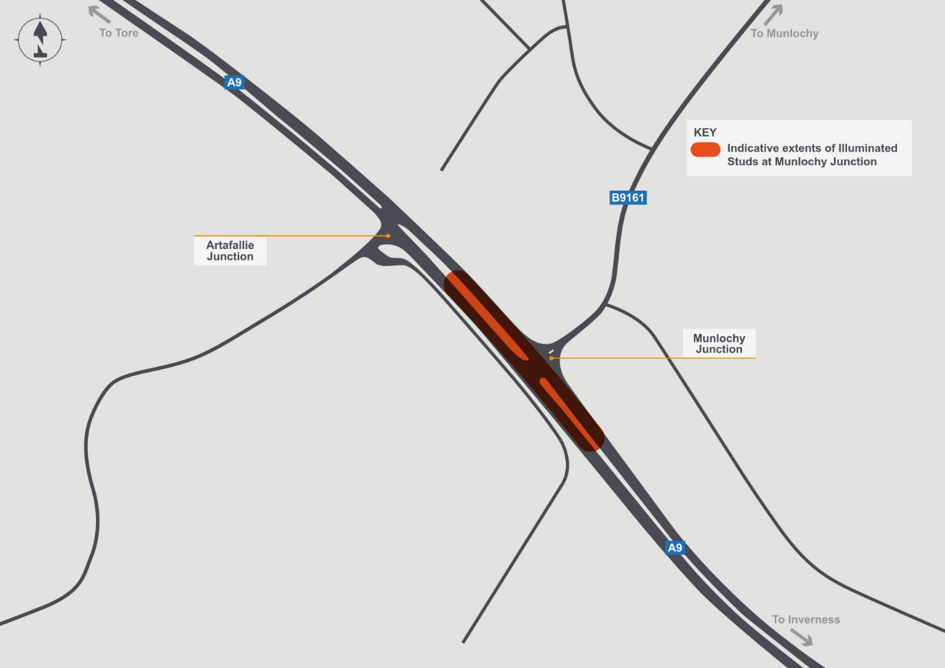

Safety concerns were raised about the visibility of the B9161 Munlochy junction during the hours of darkness

This option is to investigate the potential of replacing the current road studs around the junction with more prominent illuminated versions. Similar studs were installed at the B9163 junction at Conon Bridge in 2020 to better define the area. These solar studs will light up and highlight the approaches to the junction during the hours of darkness.

Advantages:

Clearer road layout for users, particularly travellers who are unfamiliar with the area. Illuminated studs are generally longer-lasting than traditional studs.

Disadvantages:

Illuminated studs are more expensive that traditional studs.

## Option B2 - Installation of Street Lighting around the B9161 Munlochy Junction

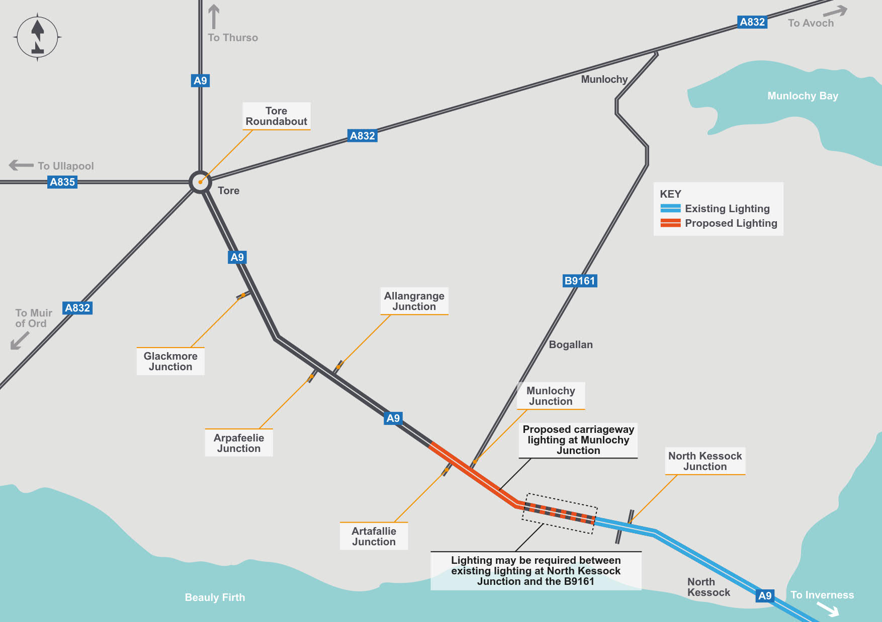

Safety concerns were raised about the visibility of the B9161 Munlochy junction during the hours of darkness.

This option is to investigate the possibility of installing street lighting on the approaches to Munlochy junction, on both the A9 and B9161. This will provide illumination during darkness to help drivers see the junction layout more clearly and help to emphasise the junction more during the daytime. Depending on the extents, it may include the section from North Kessock to the B9161 Munlochy junction to avoid a short section of darkness.

Advantages:

Clearer road layout for users approaching and within the junction, particularly travellers who are unfamiliar with the area. This applies particularly at night, when the lighting would be illuminated, but could also bring benefits by emphasising the junction more clearly.

Disadvantages:

Increased light pollution in the surrounding area.

## Option B3 - Vehicle Activated Signs

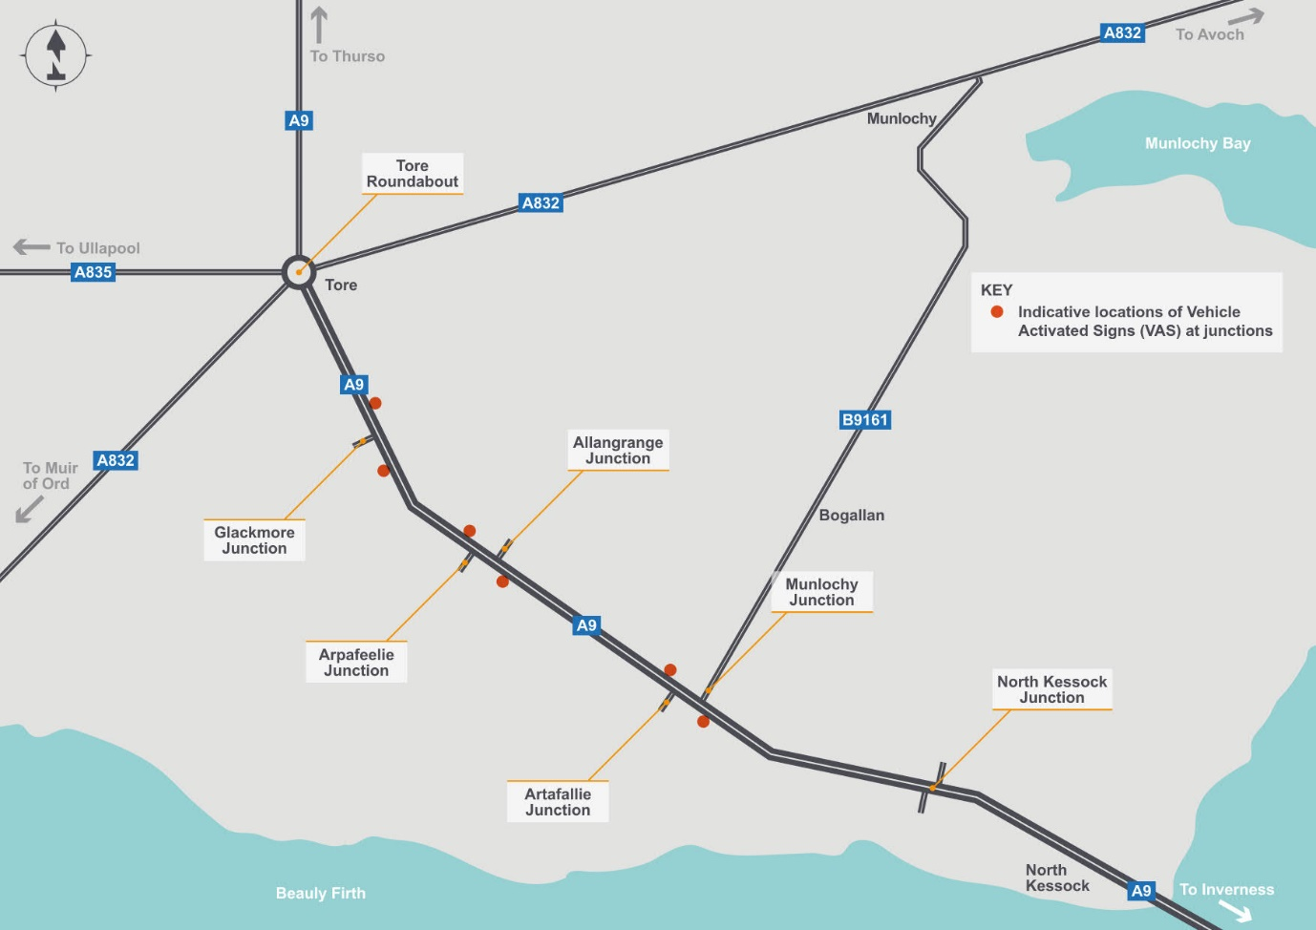

This option considers all the junctions between North Kessock and Tore for the installation of Vehicle Activated Signs. These signs detect vehicles (including buses and agricultural vehicles) approaching the A9 from the side road and illuminate to warn drivers on the A9 that a vehicle could emerge. This would only be a warning, drivers joining the A9 must still give way to traffic already on the road.

Advantages:

Reduce conflicts between traffic on the A9 and side road traffic by providing advance warning.

Disadvantages:

At peak times, the signs may be activated regularly, potentially diminishing their effectiveness.

# Short term package C

Short-term package C includes eight options which are relatively straightforward to construct but require a Legal Order to take effect. Part of the process of making an Order usually involves a public consultation and anyone adversely affected by the proposed order can object. We would aim to resolve any objections, however this takes time and occasionally the objection cannot be overcome, prompting independent arbitration. Timescales are less certain as a result, mainly due to the unknown number and nature of any objections.

Options include speed limit reductions, the use of safety cameras and prohibition of certain manoeuvres.

## Option C1 - Speed limit reduction at Munlochy

Concerns were raised that the speed of vehicles that approached the B9161 Munlochy Junction on both north and south approaches were going too fast

This option is to reduce the speed limit around the B9161 Munlochy junction – effectively extending the existing 50mph speed limit at North Kessock to the north side of Munlochy junction.

Advantages:

Assuming drivers comply with the lower speed limit, drivers will have additional time to judge their manoeuvre the A9 from the B9161, or from the B9161 to the A9. Traffic noise may also be reduced.

Disadvantages:

Assuming drivers comply, travel times between North Kessock and Tore Junctions will increase slightly. Slower vehicles can travel closer together, potentially resulting in fewer gaps for vehicles to turn or join the A9. The A9 is designed for a 70mph speed limit and the physical layout of the road will not be changed, meaning drivers are less likely to comply.

## Option C2 - Speed limit reduction on all approaches to Tore Roundabout

Concerns were raised that the speed of vehicles approaching Tore roundabout were high. Further concerns were raised with regards to speeds along the A835 at the Tore Primary School junction.

We can either consider reducing the speed limit on immediate approach to the Tore Roundabout or extend that speed limit reduction to around a one mile radius of the Tore Roundabout, notwithstanding any existing lower limits that would remain. Both options are similar as they both are looking at the possibility of lowering the speed limit on the approaches to Tore roundabout. The extents and speed limits are not defined at this stage but they could potentially be extended along the A835 to include the junction into Tore Primary school.

Advantages:

Assuming drivers comply with the lower speed limit, reduced speeds on the approach to the roundabout will give pedestrians more time to judge when it is safe to cross the A9 and reduce the likelihood and severity of pedestrian/vehicle accidents. Traffic noise may also be reduced.

Disadvantages:

Assuming drivers comply, travel times between North Kessock and Tore Junctions will increase slightly.

## Option C3 - Speed limit reduction along whole study area

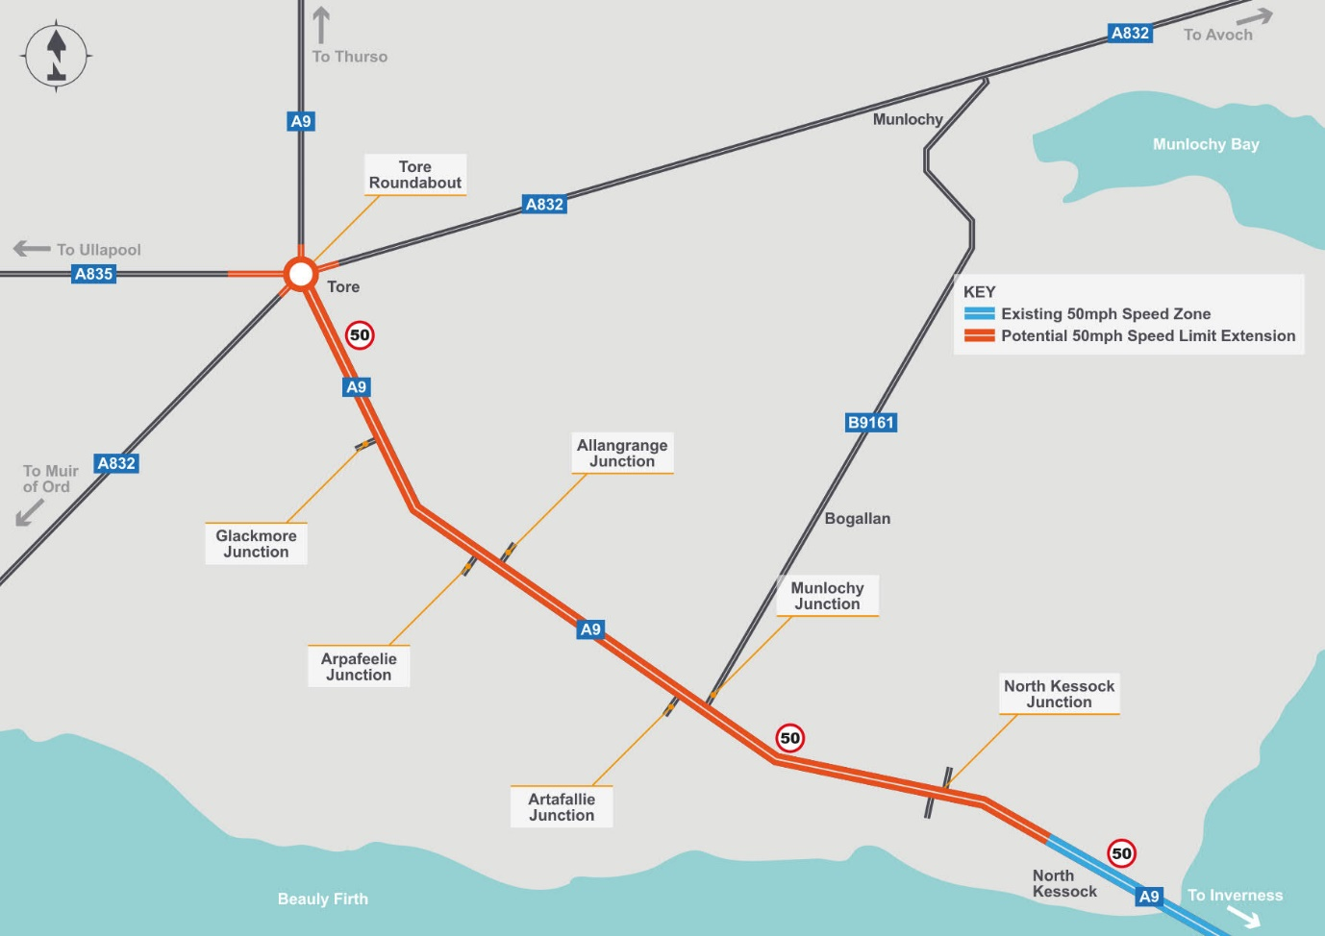

Concerns were raised at the speed of traffic over the whole study area from North Kessock to Tore roundabout.

This option is to look at potentially installing a speed limit of 50mph from the existing speed limit at North Kessock to Tore roundabout a distance of approximately 6.4km (4 miles).

Advantages:

Assuming drivers comply with the lower speed limit, drivers will have additional time to judge their manoeuvre the A9 from the side road, or from the side road to the A9. Traffic noise may also be reduced.

Disadvantages:

Assuming drivers comply, travel times between North Kessock and Tore Junctions will increase slightly. Slower vehicles can travel closer together, potentially resulting in fewer gaps for vehicles to turn or join the A9. The A9 is designed for a 70mph speed limit and the physical layout of the road will not be changed, meaning drivers are less likely to comply.

## Option C4 - Install safety cameras - A9 southbound

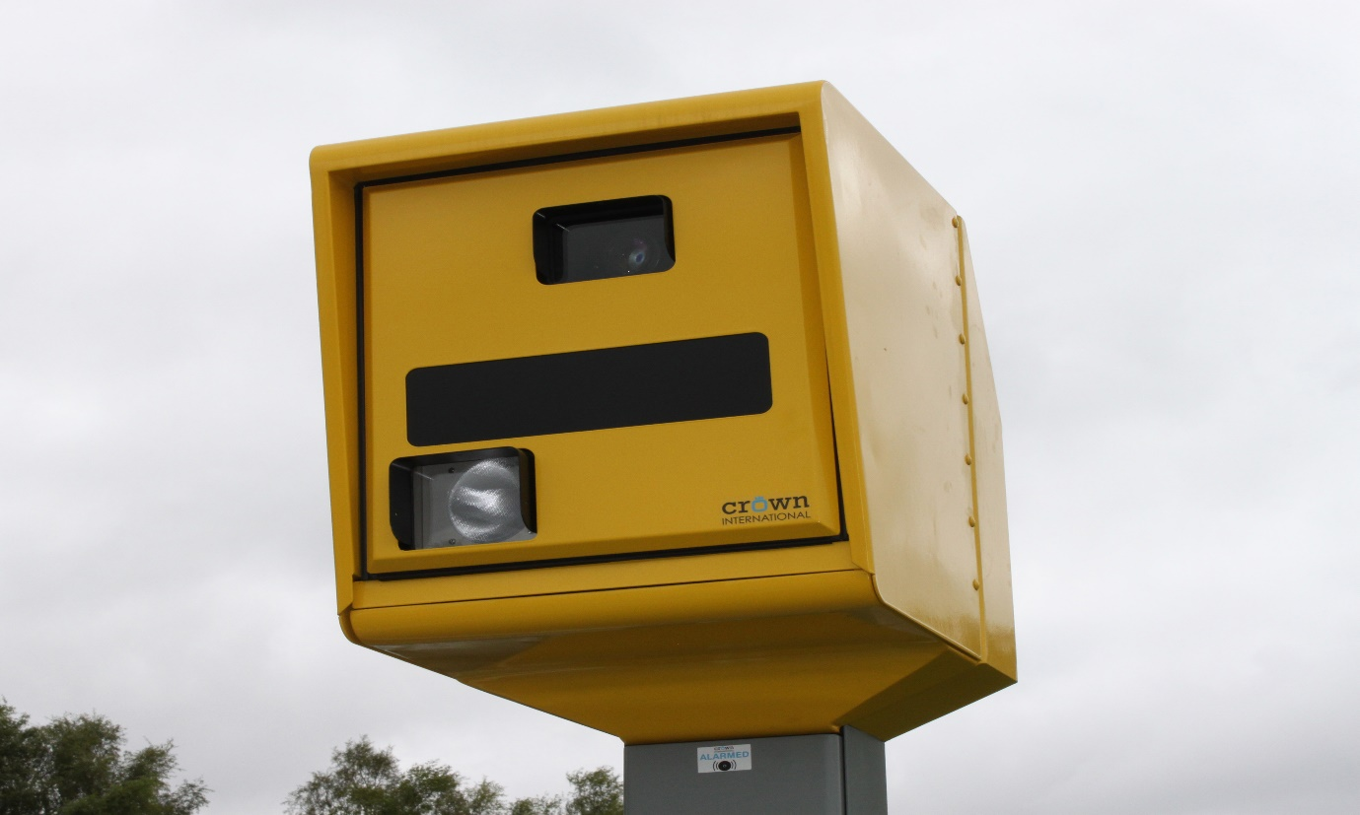This option, C4 and the next option C5 are both dependent on an independent assessment by the Scottish Safety Camera Partnership. The installation of safety cameras is a decision based on data and evidence as part of an annual site selection process. This option was raised as part of our earlier stakeholder engagement but remains subject to a separate and independent assessment.

Across Scotland, safety cameras are deployed through the Scottish Safety Camera Programme primarily where they have the greatest potential to reduce injury collisions and where there is evidence of both collisions and speeding. This is in accordance with criteria contained in the Scottish Safety Camera Handbook link: <https://www.transport.gov.scot/publication/scottish-safety-camera-programme-handbook/>

An annual site prioritisation process is undertaken each year to determine new safety camera sites across our road network. This national exercise acts to ensure the right camera technology is in the right place at the right time. It involves a range of partners including the three regional safety camera units, all thirty-three road authorities and Police Scotland, and acts to identify potential new camera sites which meet the minimum criteria, while at the same time assessing the performance of existing enforcement strategies.

A safety camera site selection process is underway for 2021 which will look at all routes across Scotland, and should this location be identified as one which meets minimum requirements then a camera deployment will be considered.

Advantages:

Increased compliance will reduce the number of drivers travelling at excessive speed. Drivers will have additional time to judge their manoeuvre the A9 from the B9161, or from the B9161 to the A9

Disadvantages:

The speeds of traffic travelling at, or below, the current speed limit is unaffected.

## Option C5 - Install 50mph Average Speed Cameras

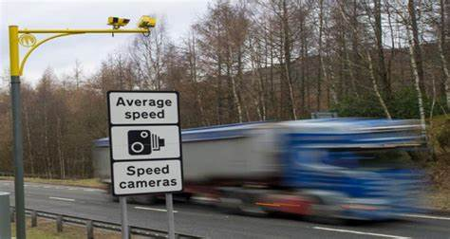

This option, C5 and the previous option C4 are both dependent on an independent assessment by the Scottish Safety Camera Partnership. The installation of safety cameras is a decision based on data and evidence as part of an annual site selection process. This option was raised as part of our earlier stakeholder engagement but remains subject to a separate and independent assessment.

Across Scotland, safety cameras are deployed through the Scottish Safety Camera Programme primarily where they have the greatest potential to reduce injury collisions and where there is evidence of both collisions and speeding. This is in accordance with criteria contained in the Scottish Safety Camera Handbook link: <https://www.transport.gov.scot/publication/scottish-safety-camera-programme-handbook/>

An annual site prioritisation process is undertaken each year to determine new safety camera sites across our road network. This national exercise acts to ensure the right camera technology is in the right place at the right time. It involves a range of partners including the three regional safety camera units, all thirty-three road authorities and Police Scotland, and acts to identify potential new camera sites which meet the minimum criteria, while at the same time assessing the performance of existing enforcement strategies.

A safety camera site selection process is underway for 2021 which will look at all routes across Scotland, and should this location be identified as one which meets minimum requirements then a camera deployment will be considered.

Advantages:

Increased compliance will reduce the number of drivers travelling at excessive speed. Drivers will have additional time to judge their manoeuvre the A9 from the side roads, or from the side roads to the A9.

Disadvantages:

The speeds of traffic travelling at, or below, the current speed limit is unaffected.

## Option C6 - Prohibit right-turns onto the A9 from Allangrange, Arpafeelie, Artafallie and Glackmore junctions

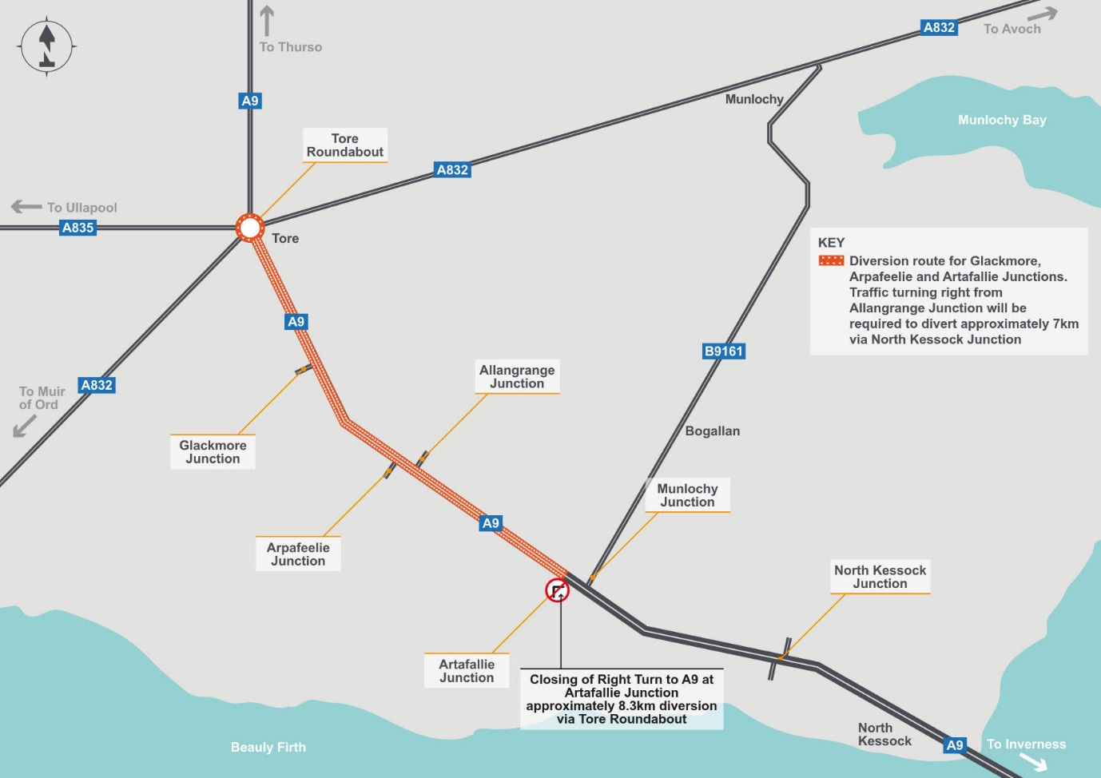

Concerns were raised that vehicles turning right from the four intermediate junctions between the B9161 and Tore roundabout were overhanging the central reserve into the fast lane due to the narrow central reserve and the size of the vehicle.

This Option would be prohibit right turns from side roads at Artafallie, Allangrange, Arpafeelie and Glackmore onto the A9 to prevent conflicts, particularly with longer and agricultural vehicles. The diversion route would be to turn left into the A9 and turn at either Tore roundabout or North Kessock junction before continuing with the journey. This should be combined with Option C7 to prevent mis-use of junctions nearby.

The following confirms the potential diversion route taken, the distance they are diverted and the estimated number of journeys affected per day, based on traffic surveys carried out at these junctions

* Artafallie – vehicles would have to turn left and head north to Tore roundabout on the A9 and return south on the A9 a diversion of 8.3km (5.2 miles) and will affect approximately 60 journeys per day
* Allangrange – vehicles would have to turn left and head south to North Kessock grade separated junction on the A9 and return north on the A9 a diversion of 7.6km (4.6 miles) and will affect approximately 16 journeys per day
* Arpafeelie– vehicles would have to turn left and head north to Tore roundabout on the A9 and return south on the A9 a diversion of 4.9km (3 miles) and will affect approximately 12 journeys per day
* Glackmore– vehicles would have to turn left and head north to Tore roundabout on the A9 and return south on the A9 a diversion of 2.7km (1.7 miles) and will affect approximately 13 journeys per day

Advantages:

Conflicts resulting from traffic emerging from the side roads to cross the A9 will be eliminated.

Disadvantages:

Traffic emerging from the side road will be required to drive longer distances than currently, with longer journey times, increased emissions and a slight increase in traffic on the A9.

## Option C7 - Prohibit U-turns at junctions

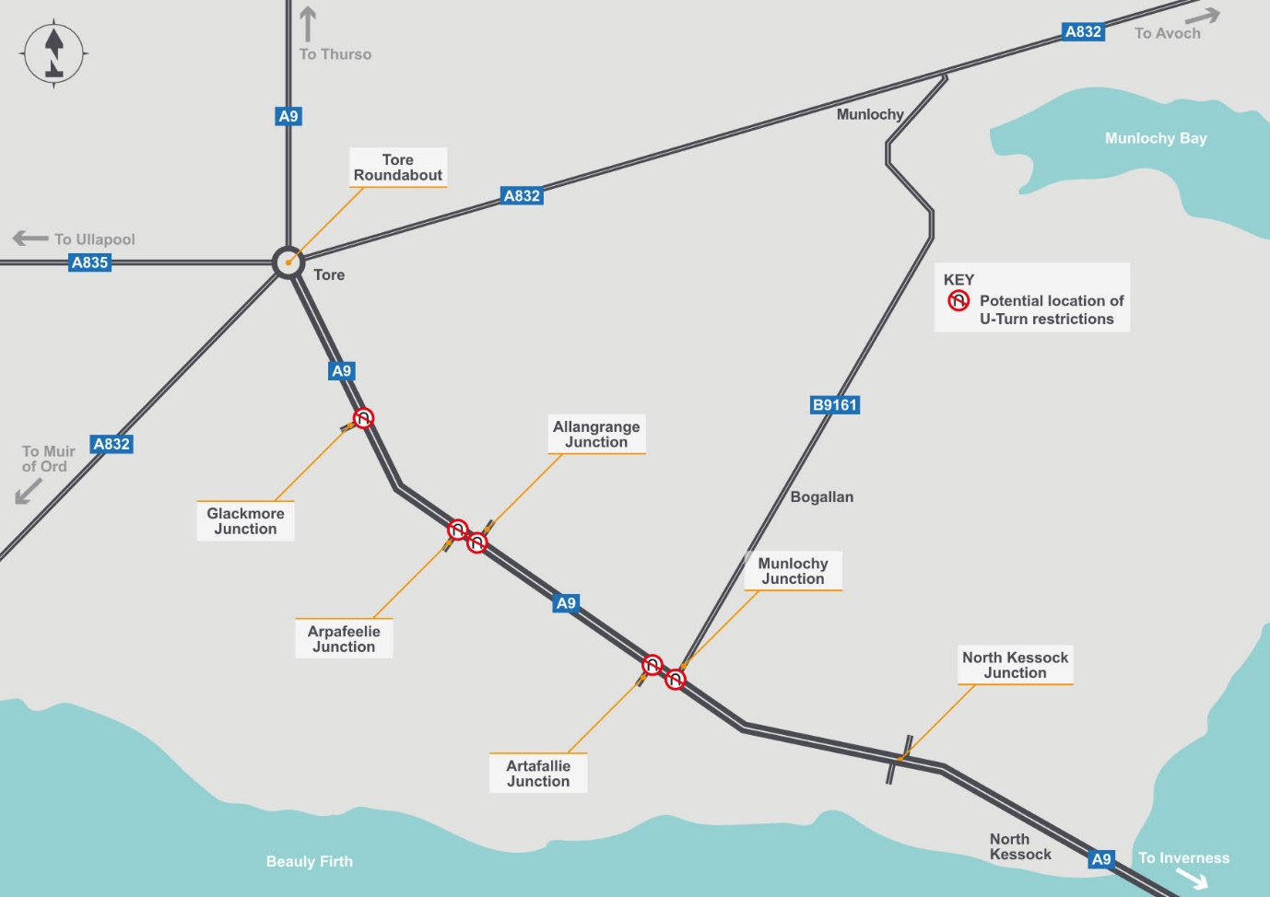

Safety concerns were raised that some vehicles were carrying out U-turns at some of the junctions.

This option is to prohibit U-turns at all junctions (including Munlochy Junction) to avoid conflicts and prevent manoeuvres that the junctions were not designed to accommodate. Drivers wishing to turn will need to use Tore roundabout or the North Kessock junction. Our traffic surveys show this will affect a very low number of journeys.

Advantages:

Conflicts resulting from traffic performing U-turns will be eliminated, provided drivers comply with the restriction.

Disadvantages:

No significant disadvantages have been identified at this stage.

## Option C8 - Prohibit right turns from the B9161 at Munlochy Junction onto the A9 northbound (traffic can still turn right from the A9 onto the B9161)

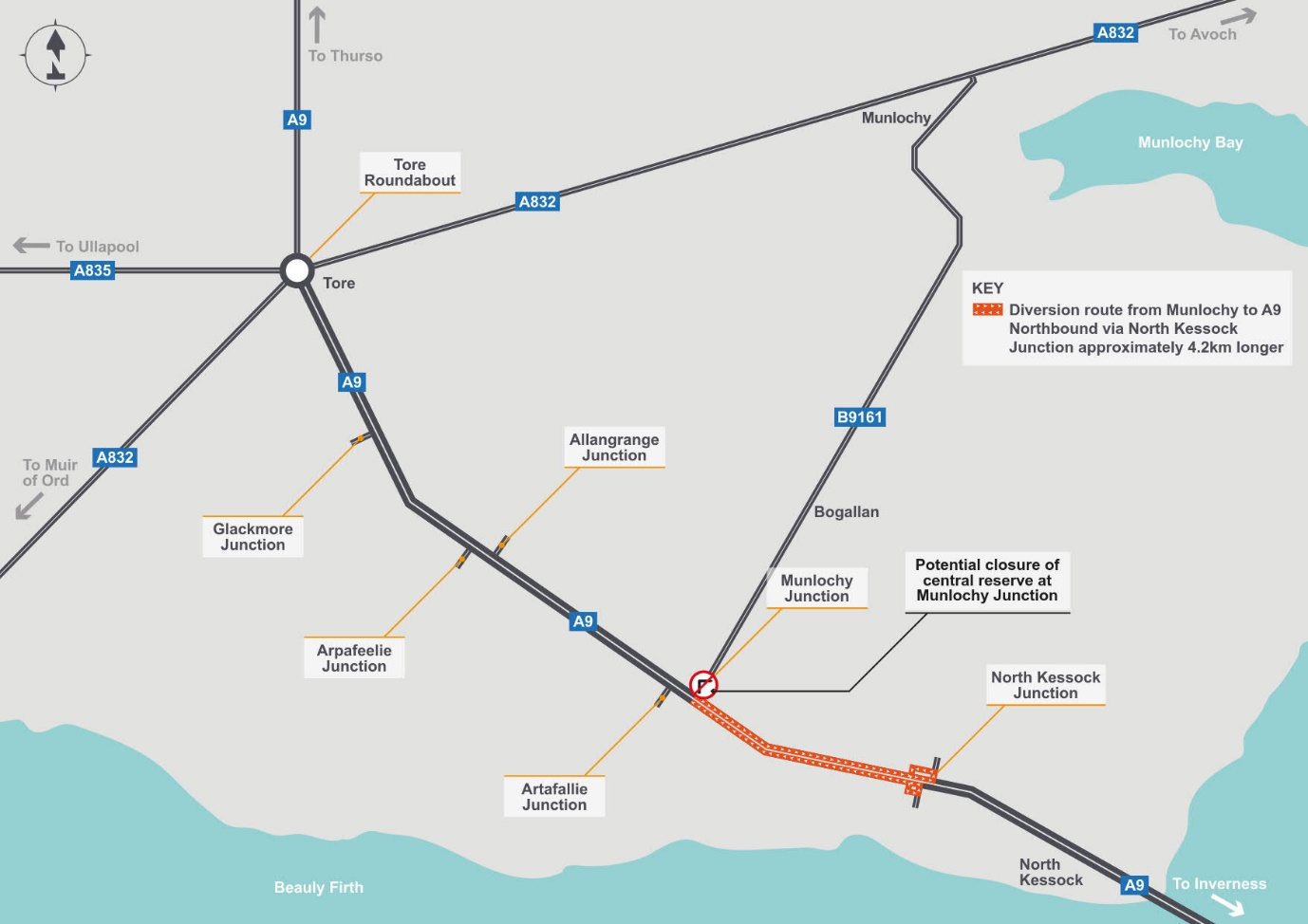Concerns have been raised about vehicles turning right from the B9161 at Munlochy Junction onto the A9 northbound.

This option would prohibit vehicles turning right from the B9161 to the A9 northbound. As a result, approximately 36 vehicles a day would be diverted onto the A9 southbound to the North Kessock Junction and then return on the northbound carriageway, resulting in a diversion of approximately 4.2km (2.6 miles).

Advantages:

Conflicts resulting from traffic emerging from the B9161 to cross the A9 will be eliminated.

Disadvantages:

Traffic emerging from the B9161 will be required to travel via North Kessock – this will result in longer journey times, increased emissions and a slight increase in traffic on the A9. Drivers may use other junctions along this section as an alternative, resulting in increases in traffic on local roads.

## Option C9 - Prohibit all right turns at B9161 Munlochy Junction (no right turn from A9 to B9161 and no right turn from B9161 to A9)

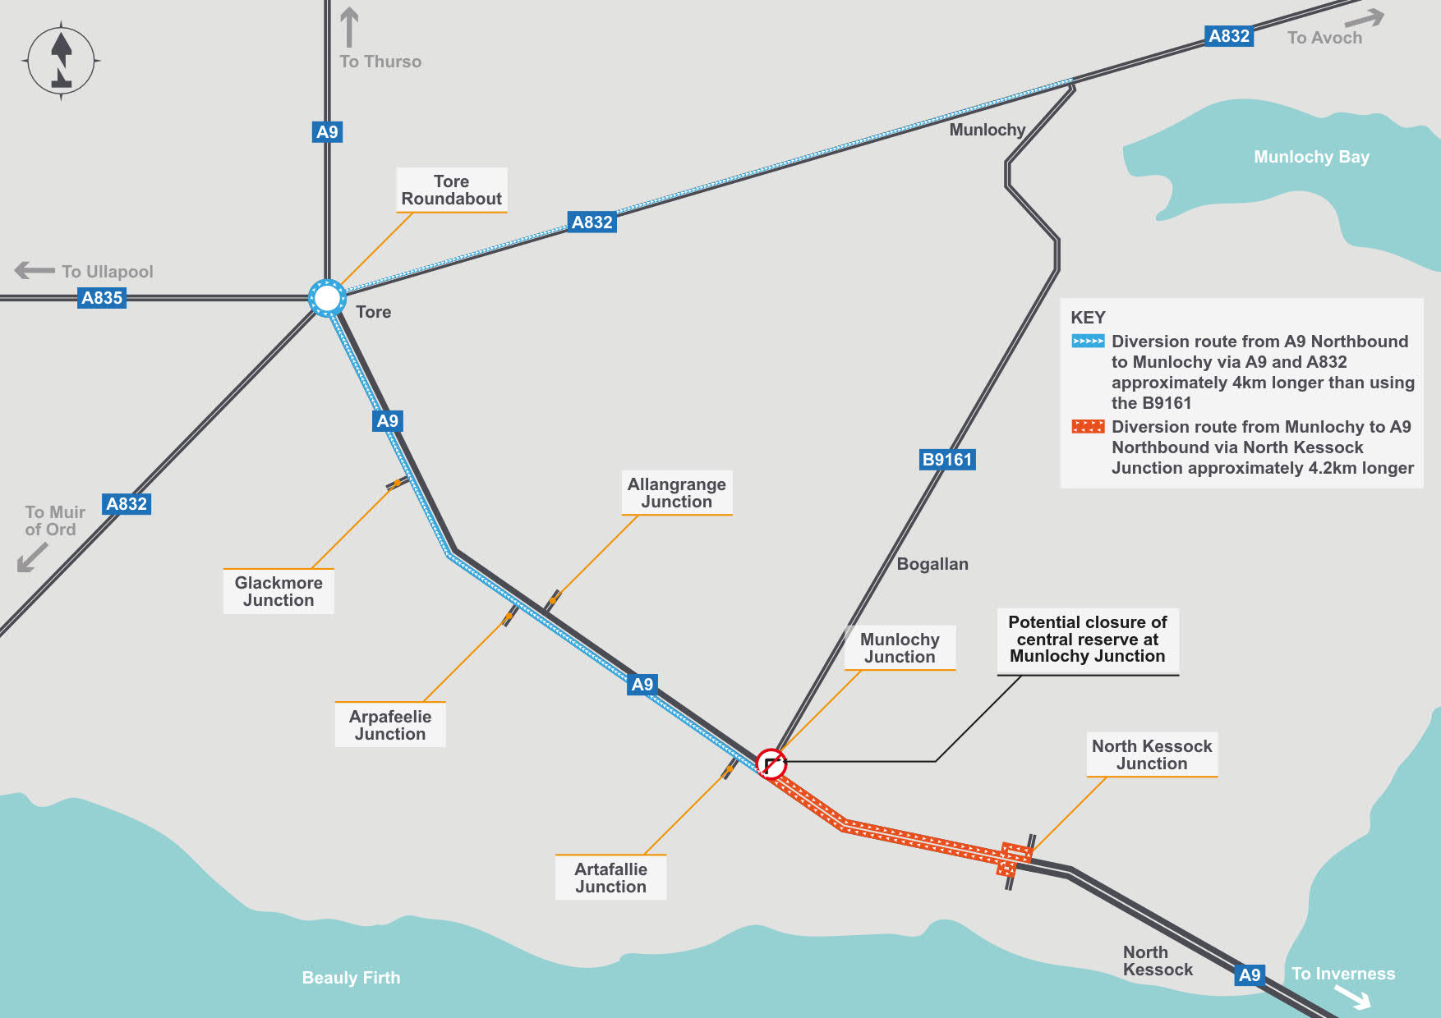There are concerns that there are safety risks from vehicles turning right at the A9/B9161 junction.

This option includes the prohibition on right turns from the B9161 to the A9 (Option C8) and adds another prohibition on right turns from the northbound A9 into the B9161. This reduces conflict and eliminates the queuing in the right turn lane on the A9. The right turn lane would be removed and the central reserve filled-in.

Over 2100 journeys per day currently turn right from the A9 per day would continue north to Tore and then along the A832 which would mean a diversion of 4km (2.5 miles) to the B9161/A835 junction, although many journeys could continue on the A832 rather than return to the B9161.

36 journeys per day were surveyed turning right from the B9161. these would instead have to drive south on the A9 to North Kessock, turn, and then back northwards along the A9. This means a diversion of 4.2km (2.6 miles).

This should be combined with Option C7 to prevent mis-use of junctions nearby.

Advantages:

Queuing in the right turn lane, which can reach onto the fast lane of the A9 will be eliminated, along with conflicts resulting from traffic crossing the southbound carriageway. In addition, conflicts resulting from traffic emerging from the B9161 to cross the A9 will be eliminated.

Disadvantages:

Traffic emerging from the B9161 will be required to travel via North Kessock, whilst those turning into the B9161 from the A9 will need to travel via Tore roundabout – this will result in longer journey times, increased emissions and a slight increase in traffic on the A9. Drivers may use other junctions along this section as an alternative, resulting in increases in traffic on local roads.

# Medium term options (D)

The following five medium-term options are estimated to be capable of delivery between three to seven years.  Some of these options will require comprehensive planning and design works and in some cases, land may require to be purchased to allow development to commence.  There may also be departures from engineering and design standards due to site-specific constraints which would otherwise make a specific improvement unfeasible.  Whilst some of these options may not appear complicated, any departure from standards requires a rigorous safety assessment and will also require to offer best value for public money.  All of these factors contribute to the estimated timescales.

## Option D1 - Improve active travel facilities and integration with bus stops at Tore

Stakeholders raised concerns that pedestrians have difficulty crossing the roads around Tore Roundabout. Bus operators also report that it is difficult at times for buses to enter and leave the bus lay-bys.

This option is to review current footway provision around Tore roundabout and enhance these to encourage walking, cycling and wheeling. As part of this, the locations of bus stops in the area would be reviewed to consider if relocation would better serve bus passengers and operators, as well as make access to/from these bus stops more attractive.

Alternative bus-stop locations may require land to be purchased.

This option could be combined with options D2, D3 or D5.

Advantages:

Ensuring crossing points are appropriately located will improve pedestrian safety by maximising visibility for pedestrians and drivers. Improvements to footways will enhance facilities for active travel to encourage uptake and better located bus stops allows for safer, easier access and egress for public transport, minimising conflict with other vehicles.

Disadvantages:

Crossing point will be remain uncontrolled and pedestrians will not be able to interrupt the traffic flow. Alternative bus stop locations may result in some users being required to cross the A9 more often that at present.

## Option D2 - Improve pedestrian routes - controlled crossing at Tore Roundabout

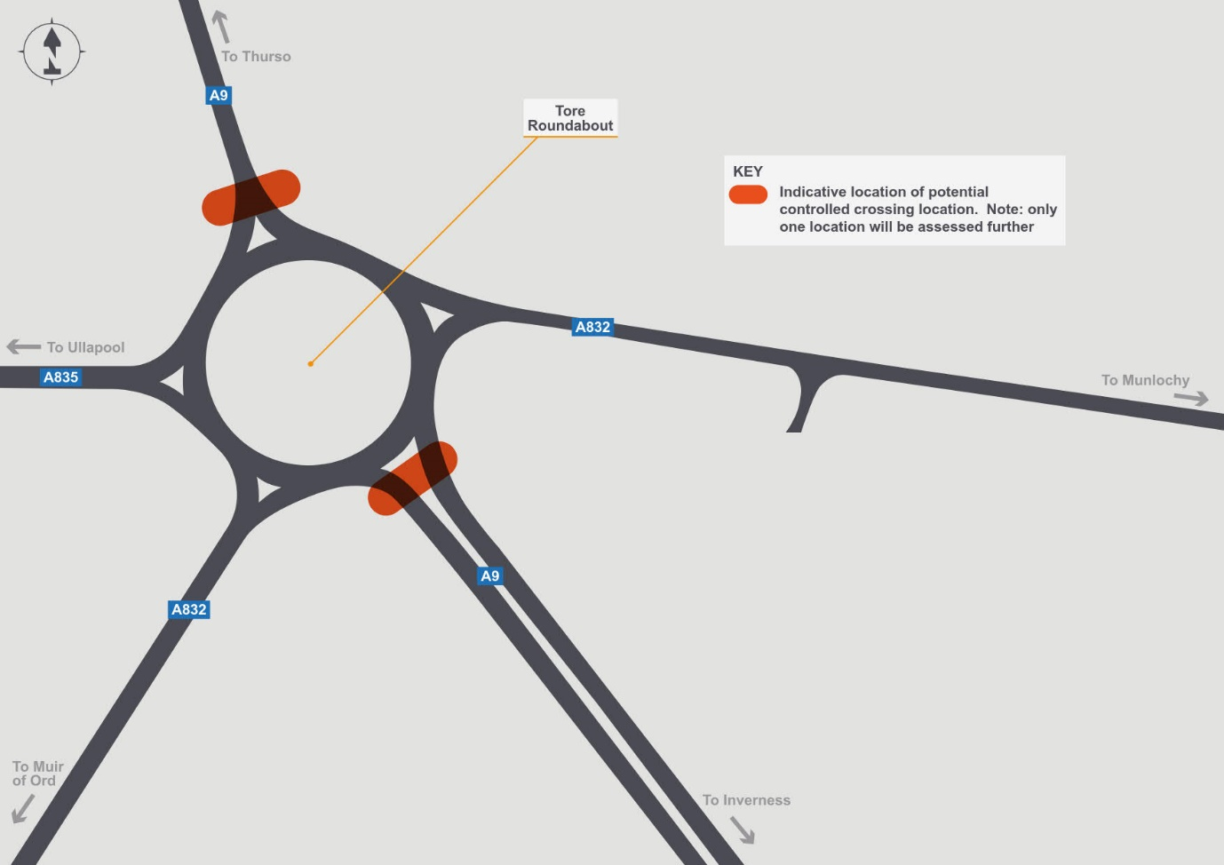

Safety concerns were raised regarding pedestrians crossing the approaches to Tore roundabout including access to the bus stops.

This proposal is to look at the installation of a pedestrian crossing on the A9 on either the north or south side of the roundabout, depending on where demand for a crossing is greatest. This option will require the reduction of the speed limit. Traffic entering and leaving the roundabout would not be controlled by signals, therefore the location would need to consider visibility to reduce the risk of drivers going through a red light.

Advantages:

The crossing point will be controlled, allowing pedestrians to stop traffic for the duration of the crossing.

Disadvantages

Traffic at the roundabout would be stopped for longer, potentially with some delays and queuing. To ensure drivers leaving the roundabout have adequate visibility and time to react to a red light, the crossing may need to be located off from the most direct route taken by pedestrians.

## Option D3 - Pedestrian bridge or underpass at Tore Roundabout

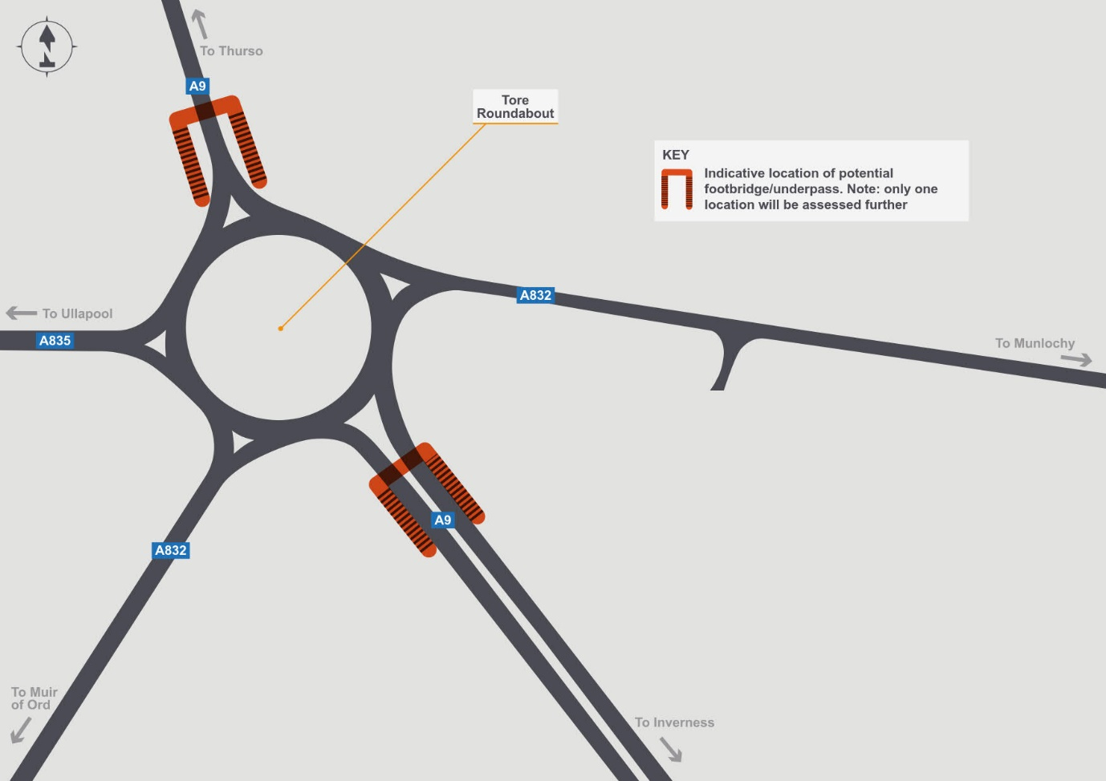

Safety concerns were raised regarding pedestrians crossing the approaches to Tore roundabout including access to the bus stops.

This proposal is to look at the installation of a pedestrian bridge or underpass on the A9 on either the north or south side of the roundabout, depending on where demand for a crossing is greatest.

The choice of bridge or underpass would take account of the views of those in the local community as well as engineering feasibility. It is likely that land acquisition will be required.

Advantages:

* A footbridge or underpass would remove conflict between traffic and pedestrians.
* There would be no need to interrupt traffic flows, therefore journey times would not be impacted.

Disadvantages:

* Purchase of adjacent land may be required.
* A bridge or underpass would not be as direct as crossing the carriageway, therefore there will be an increase in distance and journey time for some non-motorised users

## Option D4 - Improved southbound merge at B9161 Munlochy Junction

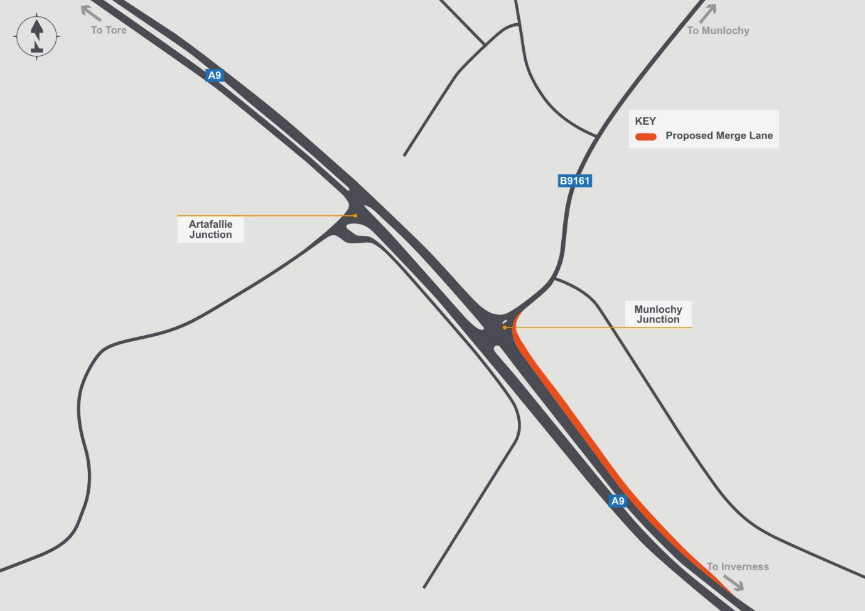

Following the conflict analysis carried out as part of the Case for Change report a large number of conflicts were witnessed when vehicles were merging from the B9161 onto the A9 southbound carriageway.

This option is to lengthen the southbound merge slip at the B9161 Munlochy Junction to assist vehicles joining the southbound carriageway. Due to the road being on a left hand bend, careful design will be needed to optimise visibility and review the feasibility of minimum requirements in road design standards.

In addition, the acquisition of additional land may be required, along with service diversions.

Advantages:

The additional length will allow merging traffic more time to join the faster moving A9 southbound traffic.

Disadvantages:

This option may require the purchase of adjacent land to widen the carriageway.

## Option D5 - Install traffic signals at Tore Roundabout

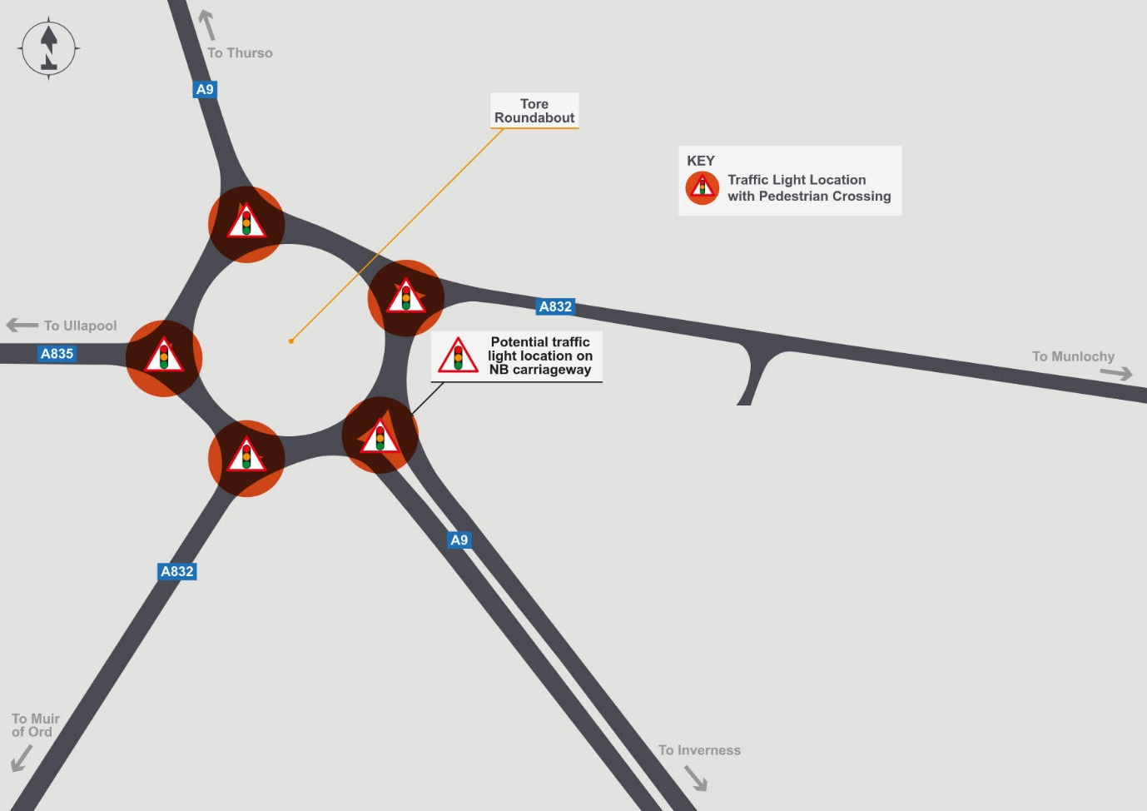

Safety concerns were raised for pedestrians crossing the approaches to Tore roundabout including access to the bus stops for school children. To assist with the movement of pedestrians the installation of traffic signals will be investigated.

This option is to install traffic signals at the Tore Roundabout, similar to the Longman Roundabout, including crossings, to control traffic through the roundabout, reducing conflicts and enhancing facilities for walking, cycling and wheeling. Delays at the roundabout may increase, although the traffic signals would be optimized to minimize delays to all users.

Advantages:

The crossing point will be controlled, allowing pedestrians to stop traffic for the duration of the crossing. The traffic signals will also control access to the roundabout for vehicles, reducing conflicts.

Disadvantages

Traffic at the roundabout would be stopped for longer, potentially with minor negative impacts on throughput, meaning journey times and emissions will increase slightly.

# Long term options (E)

The following six long-term options are those which can be delivered between five to ten years. These are options which will require significant investment and construction works, comprehensive planning and design and in some cases, land may require to be purchased.  Some options will require legal processes to be followed including public consultations. Some of these options could be combined, whilst others are different options for the same location.

## Option E1 - Widen the central reserve at junctions

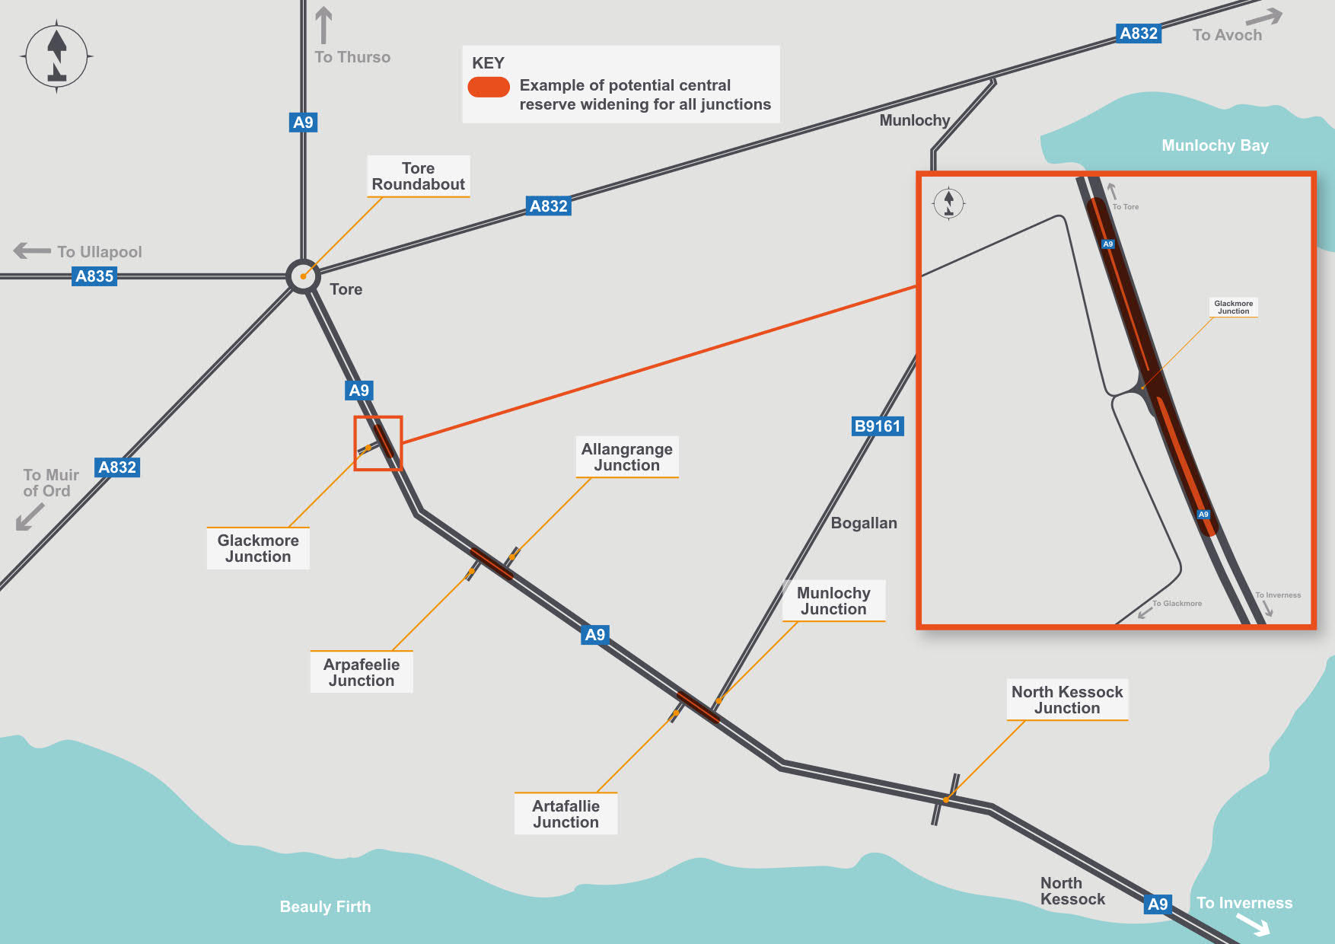

Concerns were raised that vehicles turning right from the four intermediate junctions between the B9161 and Tore Roundabout were overhanging the central reserve into the fast lane due to the narrow central reserve and the length of the vehicle

This option is to widen the central reserve at B9161 Munlochy, Artafallie, Allangrange, Arpafeelie and Glackmore to accommodate larger vehicles waiting to join the A9.

This option will require land acquisition and possible service diversions.

Advantages:

The likelihood of vehicles overhanging the fast lane is minimised, reducing conflicts.

Disadvantages:

Purchase of adjacent land may be required in order to realign the carriageway so that the central reserve can be widened.

## Option E2 - Convert the B9161 Munlochy and Artafallie junctions into a single roundabout

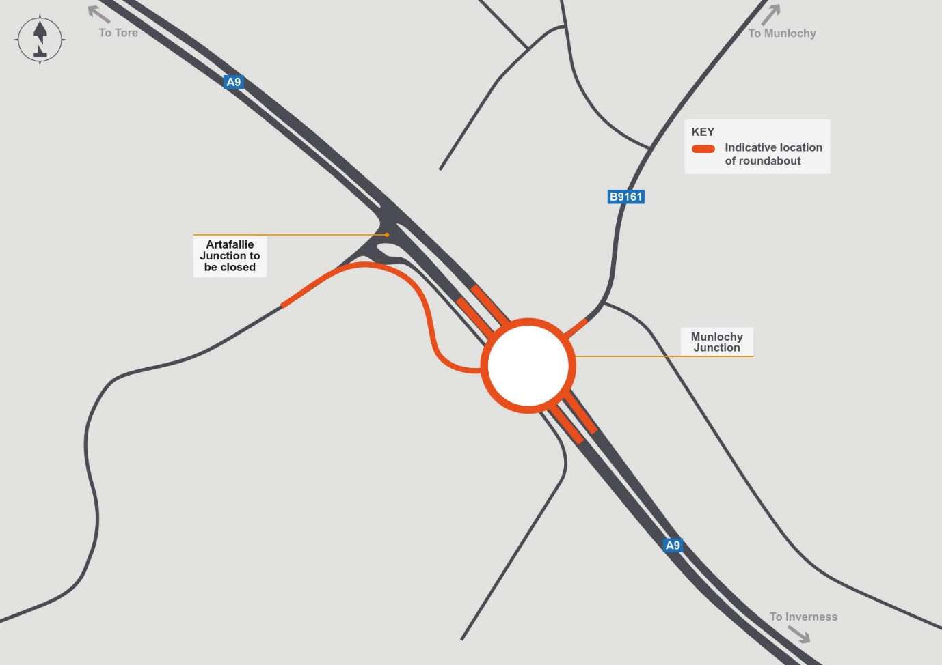

The installation of a single junction in the form of a roundabout would remove the need to turn right into side roads off the A9. Careful design would be needed to ensure that side road traffic was able to join effectively at peak times. Due to the proximity of the two junctions, a link to Artafallie would be included. The construction of a roundabout will require land and possibly service diversions, along with the legal orders required to construct a new road.

Advantages:

The roundabout would eliminate the right turn conflicting manoeuvres, along with the risk of queuing traffic in the right turn lane.

Disadvantages:

Journey times would be increased as all traffic would be required to slow down on approach to the roundabout, rather than the current layout which gives priority to the dominant (A9) flow. Joining the roundabout from the B9161 at peak times could be challenging due to the flow on the A9. Cyclists would still be required to negotiate the roundabout. Purchase of adjacent land would be required due to the increase in the footprint of the A9 and the provision of a link road to Artafallie Junction.

## Option E3 - Create single improved junction at Munlochy Junction

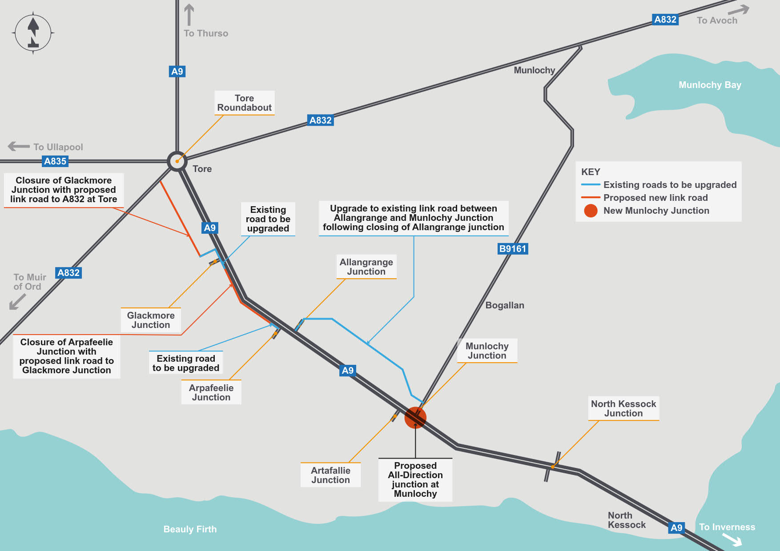

This option would consider closing Arpafeelie and Glackmore junctions, with traffic currently using these re-routing to Tore Roundabout on a new route linking existing local roads together to join the A9. In addition, the Artafallie and Allangrange junctions would be closed and traffic diverted to the B9161 Munlochy junction using existing local roads. This could be combined with either option E2 (roundabout at B9161 junction) or E5 (grade separation at B9161 junction).

Land acquisition would be necessary, along with legal processes to construct new roads and close existing junctions.

Advantages:

Removal of access to the A9 from the side road will improve road safety be reducing vehicle conflict.

Disadvantages:

Increased traffic on the local road network as well as an increase in journey time for existing users of the junctions.

## Option E4 - Extend the right turn lane from the A9 to the B9161

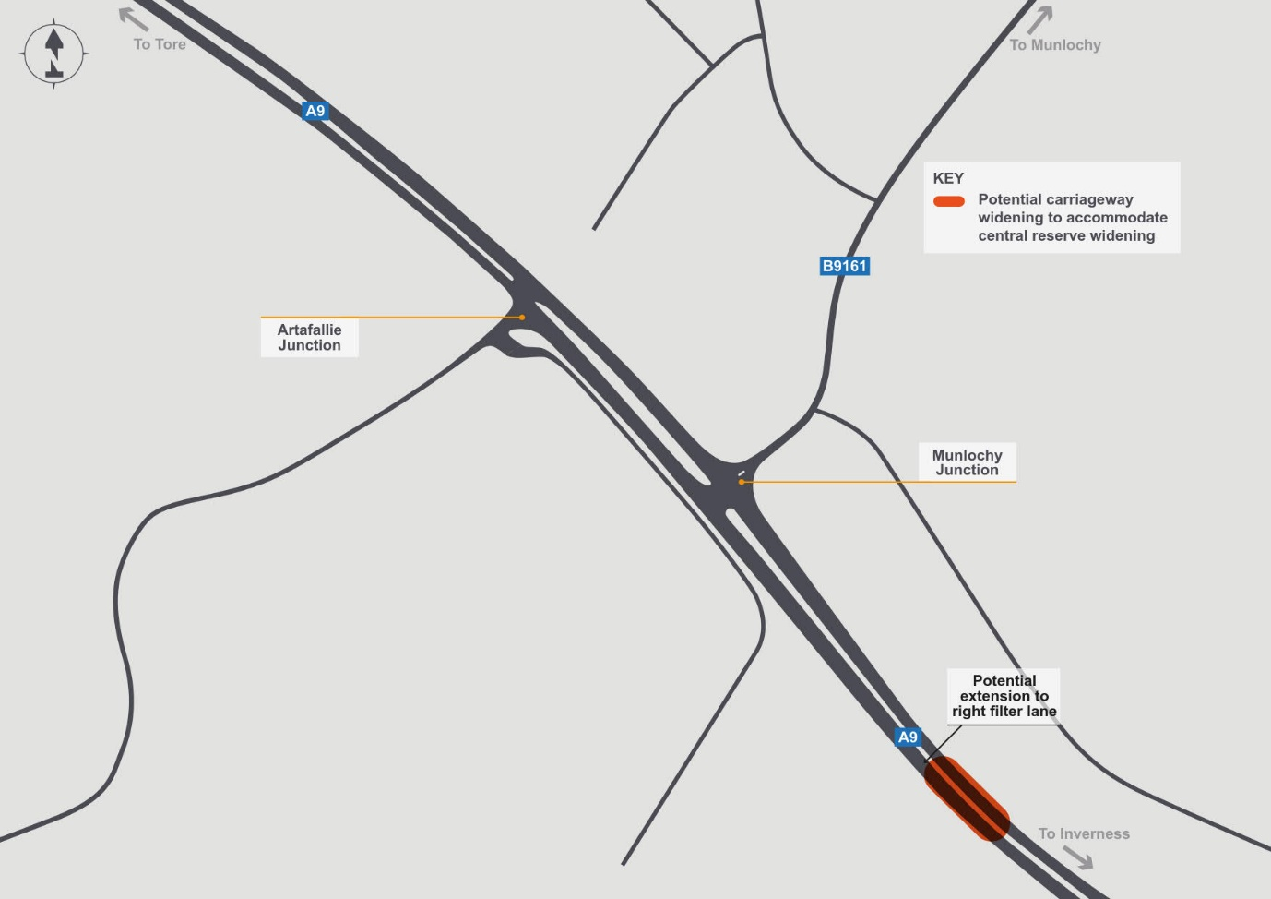

This option looks at increasing the length of the existing right turn lane on the A9 at the B9161 junction.

This could allow more vehicles to wait before they can turn right onto the B9161 and reduces the potential of traffic queuing into the fast lane of the A9. To accommodate this extension the A9 northbound might need to be realigned to allow for widening of the central reserve to accommodate the right turn lane. This may require the acquisition of additional land and service diversions.

Advantages:

The likelihood of vehicles queuing in the fast lane is reduced, reducing conflicts.

Disadvantages:

Purchase of adjacent land may be required in order to realign the carriageway so that the central reserve can be widened. In the event of an abnormal number of left turning vehicles, the queue could still reach the A9 fast lane.

## Option E5 - Grade separation at the B9161 Munlochy Junction

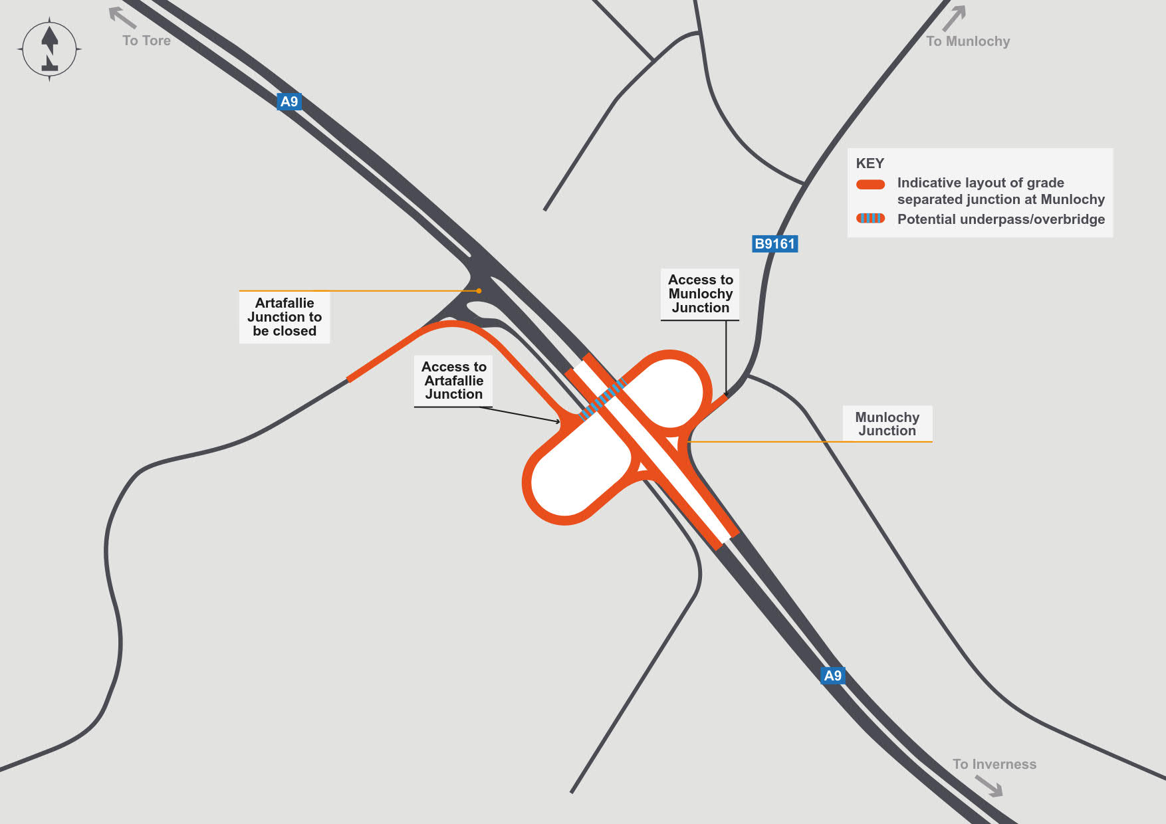

This option would consider the construction of a grade separated junction at the B9161 Munlochy and Artafallie junctions, would provide slip roads to the side roads, similar to North Kessock. This would remove the need to turn right to either road. The existing B9161 and Artafallie junctions would then be closed. This option requires additional land and possibly service diversions, along with the legal orders necessary to construct a new road.

Advantages:

The grade separation will eliminate right turn conflicts between A9 traffic and those entering or emerging from the side roads at B9161 Munlochy Junction and Artafallie Junction. Journey times for A9 traffic will be unaffected. Cyclists and other non-vehicular users would be separated from A9 traffic.

Disadvantages:

Purchase of adjacent land would be required due to the increase in the footprint of the A9 and the provision of a link road to Artafallie Junction.

## Option E6 - New road connection between Munlochy and North Kessock junction

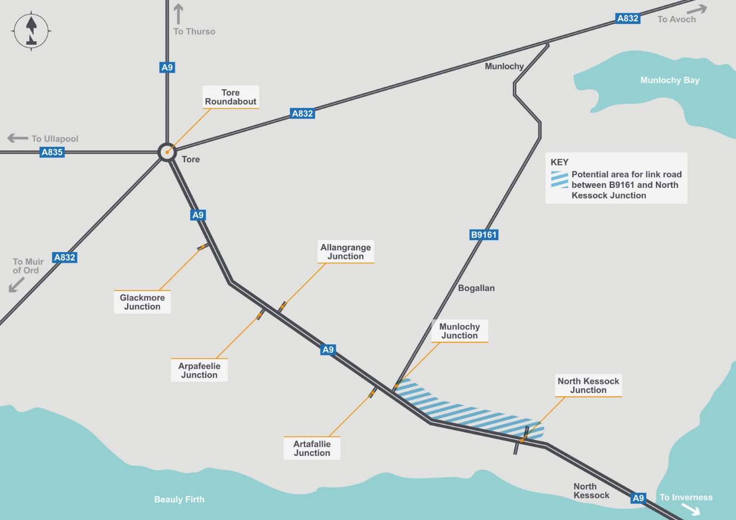

The final option is a new road connection between the B9161 Munlochy and North Kessock junctions, with a partial or full closure of the B9161 Munlochy junction. This would allow the Munlochy junction to be rationalised, with the gap in the central reserve closed to make it left-in-left out only, or close the junction with the A9 altogether.

Diverted traffic would be diverted to the proposed new road which may run parallel to the A9. This option will require land and possible service diversions, along with the legal orders required to construct a new road.

Advantages:

Full closure will eliminate conflicts between A9 traffic and those entering or emerging from the B9161.

Disadvantages:

Purchase of adjacent land would be required to facilitate the new link road. More traffic would be diverted via North Kessock Junction.

# What happens next?

The feedback we receive from this public consultation process will be assessed in line with previously established Transport Planning Objectives.  Once we have established any option which meets those criteria, we will progress this study onto the next stage of this process, the Detailed Appraisal (Part 2 Appraisal).

If you need additional assistance with this consultation please contact WSP, Transport Scotland’s consultant, on 0141 418 7309 or by e-mail: [A9-North-Kessock-to-Tore-Study@wsp.com](mailto:A9-North-Kessock-to-Tore-Study@wsp.com).

© Crown copyright 2021

You may re-use this information (excluding logos and images) free of charge in any format or medium, under the terms of the Open Government Licence. To view this licence, visit http://www.nationalarchives.gov.uk/doc/open-government-licence or e-mail: [psi@nationalarchives.gsi.gov.uk](mailto:psi@nationalarchives.gsi.gov.uk)

Where we have identified any third party copyright information you will need to obtain permission from the copyright holders concerned.

Further copies of this document are available, on request, in audio and visual formats and in community languages. Any enquiries regarding this document / publication should be sent to us at info@transport.gov.scot

This document is also available on the Transport Scotland website: www.transport.gov.scot

Published by Transport Scotland, June 2021

Follow us:

transcotland @transcotland

