- Out of Scope Options
This note sets out the position regarding what interventions and projects were out of scope for STPR2. This note builds on the original STPR2 brief, discussions with Transport Scotland’s Strategy and Analysis Directorate and feedback from the STPR2 Project Board and Transport Scotland’s Investment Decision Making (IDM) Board. The note also takes cognisance of measures and interventions being considered by Transport Scotland and the Scottish Government, particularly in light of the COVID-19 pandemic. A number of the interventions or projects listed below are out of scope as they cannot be directly delivered or facilitated by Transport Scotland or within the direct powers of Scottish Ministers.
The following options are out of scope.
- All matters reserved to UK Ministers.
ROADS AND CAR PARKS
- Local roads are out of scope, unless:
- they provide access to major ports or airports - major airports are currently defined as Edinburgh, Glasgow, Aberdeen and Inverness; Prestwick is currently included from a freight perspective only. The list of major ports is currently being finalised with the Aviation, Maritime, Freight and Canals Directorate at Transport Scotland but will, as a minimum, include all ports that handle over one million tonnes of cargo annually;
- they provide access to nationally significant National Planning Framework (NPF4) sites, however, see text below on planning;
- amendments are required to support or facilitate changes to the strategic road network including the provision of bus priority or active travel.
- Reclassification of roads from local road to trunk road or vice versa;
- Car parking is out of scope unless associated with a strategic intervention.
PUBLIC TRANSPORT
- Enhanced passenger security or safety on public transport;
- Any public transport project or option that is revenue based;
- Options related to the operational aspects of transport provision, such as, but not limited to, vehicle design and rolling stock layouts are out of scope.
FERRY / FIXED LINKS
- Ferry routes that do not form part of the Clyde and Hebrides Ferry Service (CHFS) or Northern Isles Ferry Service (NIFS);
- Fixed links are out of scope unless they:
- connect the mainland to an island; and/or
- reduce the operating costs of the CHFS or NIFS network; and/or
- are required to address a strategic problem as identified through evidence-based appraisal that cannot be addressed by a reasonable alternative.
- Water-based transport on canals and estuaries (for example, water taxis);
- Options related to the operational aspects of transport provision, such as, but not limited to, vessel deck space reconfiguration or vehicle quotas are out of scope.
AVIATION
- Options related to air services, including operation/expansion of airports and new flights/changes to existing flights are out of scope. This includes inter-island and island – mainland air services.
FUNDING, FARES AND SUBSIDIES
- Revenue funding for public transport is out of scope, including concessionary travel, free public transport, reduced public transport fares or changes to existing concessionary travel schemes and Road Equivalent Tariff;
- Options related to the Air Discount Scheme are out of scope;
- Any proposals to consider the ‘ring-fencing’ of local authority budgets for transport and/or simplification of funding mechanisms (for example, fewer challenge funds) are not in scope for STPR2;
- Local authority funding of transport-related services.
DIGITAL
- The delivery of digital connectivity/5G or subsequent successors is out of scope.
LEGISLATION, REGULATORY AND GOVERNANCE
- Options which require legislative change;
- Workplace Parking Levies (note - there is already provision for local authorities to undertake this in the Transport Act);
- Changes to transport regulation;
- Day to day operational matters for transport providers and operators;
- Changes in vehicle regulation and vehicle excise duty are out of scope;
- Planning led initiatives (for example, changes to the statutory planning process) are out of scope.
MAINTENANCE
- Revenue funded routine and cyclic maintenance measures, for all modes and assets, are out of scope.
ALTERNATIVE FUELS AND DECARBONISATION
- The low carbon energy or alternative fuel delivery pathways for Scotland will be led by the energy sector and are therefore not in scope for STPR2. Decarbonisation of the transport system is, however, in scope.
COMMITTED PROJECTS AND PLANNING
- Projects that may be deemed as Committed were dealt with on a case-by-case basis, dependent on their development status, but were generally considered to be out of scope;
- Growth Deal projects were dealt with on a case-by-case basis but were generally considered to be committed if they have a Scottish Government approved strategic business case;
- Where investment is required to mitigate the impact of development on the strategic transport network, it is expected that the cost of the mitigation measures required to ensure the continued safe and effective operation of the network will require to be met by the developer. This is also the case for NPF4 national developments: STPR2 does not negate the need, in line with Scottish Planning Policy, for development proposals that have the potential to affect the performance or safety of the strategic transport network to be fully assessed by the promotor of the site to determine their impact, or appraised by Planning authorities through the Development Planning process.
COMPLEMENTARY MEASURES
- Enforcement measures as a standalone option are out of scope; but if captured as part of specific projects, for example bus priority, this can be in scope;
- Options related to training, skills development or employment practices;
- Cycle parking as a standalone option is out of scope but if captured as part of a specific option, for example mobility hubs/interchange facilities, can be in scope.
- Revised Draft NPF4 National Developments
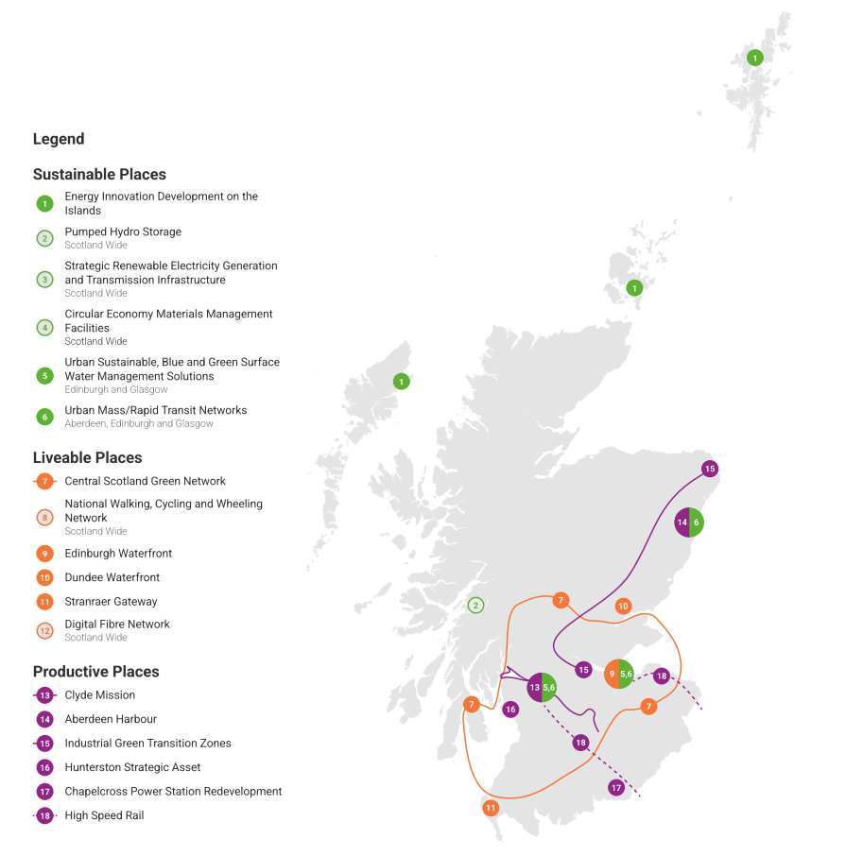
Figure B.1 – Revised Draft NPF4 National Developments Overview
(Source: National Planning Framework 4: Revised Draft, Scottish Government, November 2022, https://www.gov.scot/publications/national-planning-framework-4-revised-draft/)
- SEA and Impact Assessment Objectives

SEA Topics and Objectives
Climatic Factors
- Reduce emissions from Scotland’s transport sector by reducing the need to travel and encouraging modal shift and help meet Scotland’s wider targets to reduce greenhouse gas emissions;
- Adapt the transport network to the predicted effects of climate change.
Air Quality
- Reduce all forms of transport-related air pollution and improve air quality throughout Scotland.
Population and Human Health
- Improve quality of life and human health and increase sustainable access to essential services, employment and the natural environment;
- Reduce noise and vibration associated with the transport network;
- Promote, invest in, build and maintain infrastructure to support the development of high-quality places;
- Improve safety on the transport network.
Material Assets
- Promote and improve the sustainable use of the transport network;
- Reduce use of natural resources.
Water Environment
- Protect, maintain and improve the quality of water bodies and wetlands that could be directly or indirectly affected by transport infrastructure (with respect to Water Framework Directive targets) and protect against the risk of flooding.
Biodiversity
- Protect, maintain and enhance biodiversity and ecosystem services, avoiding damage to, or loss of, designated and undesignated wildlife or geological sites.
Soil
- Safeguard and improve soil quality in Scotland, particularly high-value agricultural land and carbon-rich soil.
Cultural Heritage
- Protect and enhance (where appropriate) historic and archaeological sites and other culturally and historically important features, landscapes and their settings.
Landscape and Visual Amenity
- Safeguard and enhance the character and diversity of the Scottish landscape and areas of valuable landscape.

Social and Equalities Impact Assessments Topics and Objectives
Population
- Promote greater equality of opportunity for all of Scotland’s residents to promote a fairer, more inclusive society.
Deprivation
- Deliver an accessible and affordable transport system that reduces inequalities of outcome resulting from multiple deprivation and supports the regeneration of disadvantaged or deprived areas.
Employment
- Deliver an effective and integrated transport system that improves access to employment and economic opportunities for all.
Income and Wealth
- Deliver an effective and integrated transport system that promotes economic opportunity for all.
Education and Skills
- Enhance access to education and training opportunities across Scotland to reduce socio-economic and geographic disparities in educational attainment.
Health and Health Inequality
- Maintain, or provide opportunities to improve, human health for all demographic groups and communities across Scotland and minimise health inequalities.
Transport Accessibility and Connectivity
- Ensure the provision of adequate and affordable transport infrastructure, services and facilities to meet identified population and economic needs and minimise barriers to travel for all people, in particular those facing socio-economic disadvantage.
Safety and Security
- Improve the safety, security and health of people by reducing the risk of death, injury or illness arising from transport, and by promoting travel modes that are beneficial to health.

Children and Young People
- Safeguard the rights of children and allow young people to reach their full potential.
Island Communities
- Increase the economic prosperity of, and address the unique challenges faced by, Scotland’s island communities.
- Engagement and Consultation Details
The key elements of the engagement process can be summarised as follows:
- Some 600 individual stakeholders engaged in 22 regional problems and opportunities workshops in the Summer of 2019, representing almost 300 organisations;
- Over 150 Regional Structured Interviews;
- 20 Regional Option Generation workshops in October/November 2019;
- 10 national workshops in August/September 2019;
- Three Business focussed engagement events in October 2019;
- Over 3,000 responses to national survey between 02 December 2019 and 10 January 2020;
- 655 pupils involved in 30 engagement sessions with schools across Scotland;
- Over 100 responses from the Case for Change Consultation, 50 Organisations and 50+ individuals;
- Seven rounds of Regional Working Group meetings which were a mix of face to face and online between 2019 – 2021;
- One Virtual STPR2 Information session for MSPs in February 2021;
- One Virtual Business focused Information session in March 2021;
- Five Statutory Impact Assessment workshops in March 2021;
- Comments forms published in February 2021 to capture feedback: 394 responses to Phase 1 and the National Case for Change chapter.
During the 12-week consultation period (20 January 2022 to 15 April 2022), 30 Information sessions were undertaken. These were designed to promote the consultation exercise, providing an overview of STPR2 and the 45 draft recommendations and further details on how stakeholders could feed into the consultation process.
The key elements of the statutory consultation process can be summarised as follows:
- Eight Presentations;
- 10 Regional Transport Working Group (RTWG) Sessions;
- Three Business Information Sessions;
- Three Wider Stakeholder Information Sessions (one British Sign Language (BSL) interpreted);
- One MSP Information Session;
- Five Environmental and Equalities Information Sessions;
- One Strategic Environmental Assessment (SEA) Statutory Consultees Technical session;
- One Equalities Impact Assessment and Fairer Scotland Duty Assessment;
- One Island Communities Impact Assessment;
- Two SEA and Equalities Impact Assessments (both BSL Interpreted).

- Appraisal Approach and Criterion Descriptions

Preliminary Appraisal Scoring
Significant Positive Effect (+ +)
The Grouping contributes significantly to the achievement of the objective/criteria. In relation to aspects of deliverability, the assessment is very positive with minimal projected risk, and strong supporting evidence/examples can be provided.
Minor Positive Effect (+)
The Grouping contributes to the achievement of the objective/criteria, but not significantly. In relation to aspects of deliverability, the overall assessment is positive with relatively low risk, and some evidence/examples can be provided.
Neutral Effect (0)
The Grouping is related to, but does not have any effect on, the achievement of the objective/criteria, or the assessment of the category is neither positive nor negative.
Minor Negative Effect (-)
The Grouping detracts from the achievement of the objective/criteria, but not significantly. In relation to aspects of deliverability, the overall assessment is negative with some identified risks and/or uncertainty.
Significant Negative Effect (- -)
The Grouping detracts significantly from the achievement of the objective/criteria. In relation to aspects of deliverability, the overall assessment is strongly negative with multiple identified risks and/or a high degree of uncertainty.
Uncertain Effect (?)
The Grouping has an uncertain relationship with the objective/criteria or the relationship is dependent on the way in which the aspect is managed. In addition, for some limited interventions insufficient information may be available to enable an assessment to be made.
No or negligible relationship (~)
There is no clear relationship between the Grouping and the achievement of the objective/criteria or the relationship is negligible.

Deliverability Criteria
Feasibility
Appraises whether the Grouping can be implemented and operated using proven construction methods or technology, without significant risk. Risks may include unexpected cost, delay, or departure from design standards.
Affordability
Appraises the overall cost of the Grouping, the likely availability of funding, the level of risk associated with funding, the ongoing cost of operation and maintenance, and any ongoing revenue from operation.
Public Acceptability
Appraises the likely acceptability of the Grouping to the public, based on consultation and stakeholder engagement.
Table E.1 – Cost Bands for Preliminary Appraisal
COST BAND | VALUE
1 | £0
2 | £0-5 million
3 | £5-10 million
4 | £10-25 million
5 | £25-50 million
6 | £50-100 million
7 | £100-250 million
8 | £250-500 million
9 | £500-1,000 million
10 | Over £1,000 million

Detailed Appraisal Scoring
(as defined by STAG)
Major benefit (+++)
These are benefits or positive impacts which, depending on the scale of benefit or severity of impact, the practitioner feels should be a principal consideration when assessing an option’s eligibility for funding.
Moderate benefit (++)
The option is anticipated to have only a moderate benefit or positive impact. Moderate benefits and impacts are those which taken in isolation may not determine an option’s eligibility for funding, but taken together do so.
Minor benefit (+)
The option is anticipated to have only a small benefit or positive impact. Small benefits or impacts are those which are worth noting, but the practitioner believes are not likely to contribute materially to determining whether an option is funded or otherwise.
No benefit or impact (0)
The option is anticipated to have no or negligible benefit or negative impact.
Small minor cost or negative impact (-)
The option is anticipated to have only a minor cost or negative impact. Minor costs/negative impacts are those which taken in isolation may not determine an option’s eligibility for funding, but taken together could do so.
Moderate cost or negative impact (--)
The option is anticipated to have only a moderate cost or negative impact. Moderate costs/negative impacts are those which taken in isolation may not determine an option’s eligibility for funding, but taken together could do so.
Major cost or negative impact (---)
These are costs or negative impacts which, depending on the scale of cost or severity of impact, the practitioner should take into consideration when assessing an option’s eligibility for funding.

Table E.2 – Mapping of Previous and Revised STAG Criteria
PREVIOUS STAG CRITERIA | PREVIOUS STAG SUB-CRITERIA | REVISED STAG CRITERIA | REVISED STAG SUB-CRITERIA
Environment | - Noise and Vibration  - Global Air Quality - carbon dioxide (CO2)  - Local Air Quality - particulates (PM10) and nitrogen dioxide (NO2)  - Water Quality, Drainage and Flood Defence  - Geology  - Biodiversity and Habitats  - Landscape  - Visual Amenity  - Agriculture and Soils  - Cultural Heritage | Environment  Climate Change | Environment:  - Biodiversity and Habitats  - Geology and Soils  - Land Use (including Agriculture and Forestry)  - Water, Drainage and Flooding  - Air Quality  - Historic Environment  - Landscape  - Noise and Vibration  Climate Change:  - Greenhouse Gas Emissions  - Vulnerability to Effects of Climate Change  - Potential to Adapt to Effects of Climate Change
Safety | - Accidents  - Security | Health, Safety and Wellbeing | - Accidents  - Security  - Health  - Access to Health and Wellbeing Infrastructure  - Visual Amenity
Economy | - Transport Economic Efficiency  - Wider Economic Impacts | Economy | - Transport Economic Efficiency  - Wider Economic Impacts
Integration | - Transport Integration  - Transport and Land-Use Integration  - Policy Integration | Equality and Accessibility | - Public Transport Network Coverage  - Active Travel Network Coverage  - Comparative Access by People Group  - Comparative Access by Geographic Location  - Affordability
Accessibility and Social Inclusion | - Community Accessibility (Public Transport Network Coverage; Local Accessibility)  - Comparative Accessibility (by People Group and Geographic Location)

