Strategic Transport Projects Review 2
STPR2

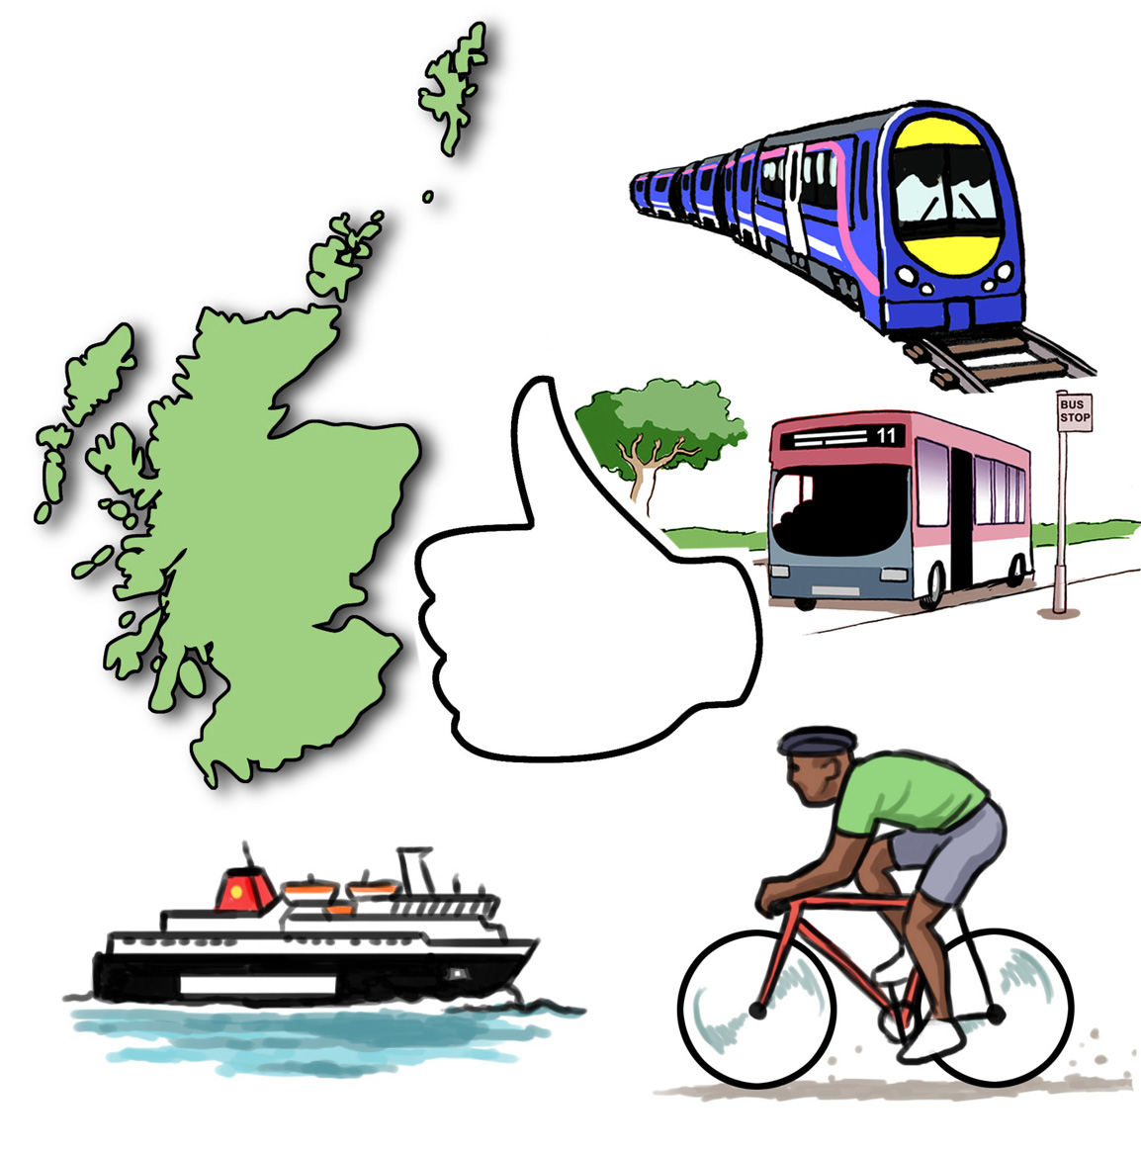

Easy Read Version
- Introduction
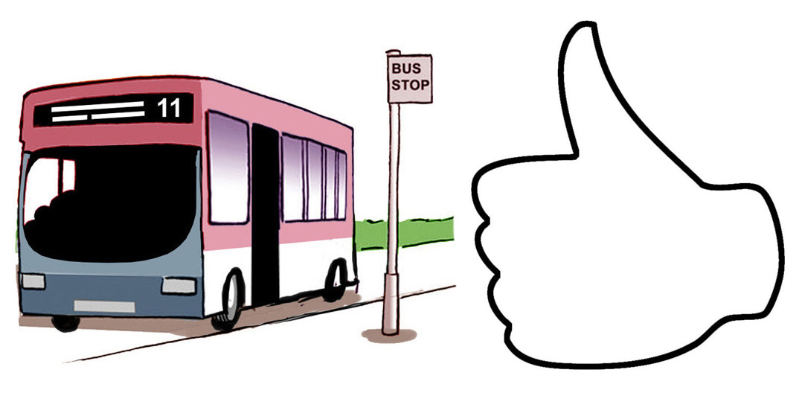

Transport is important. It helps us access education, jobs, healthcare, goods and services.

Transport is changing. The pandemic has made us think about how we get around. Many people have made changes some big some small. That has meant more working from home, more local walking and cycling.

Technology is also changing. Buses, trains and ferries are becoming better for the environment.

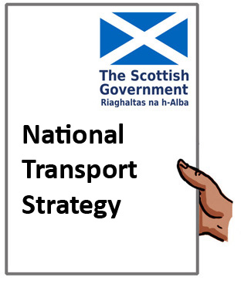

The second National Transport Strategy says how transport can reduce inequalities, help the economy, improve health and wellbeing, and help the climate.

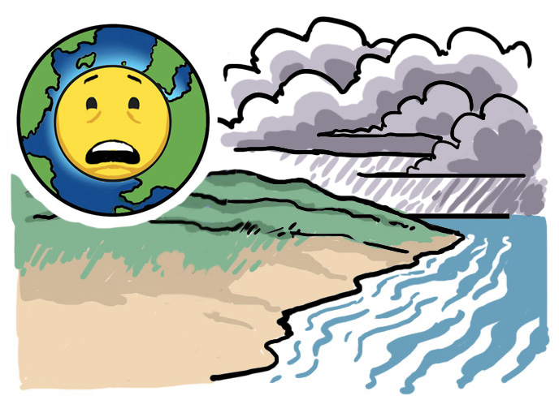

The climate is the weather we expect to have every year. Climate change is when the climate is changing too fast and damaging the environment.

We need to change our travel habits and have better travel options. These need to be good and accessible.

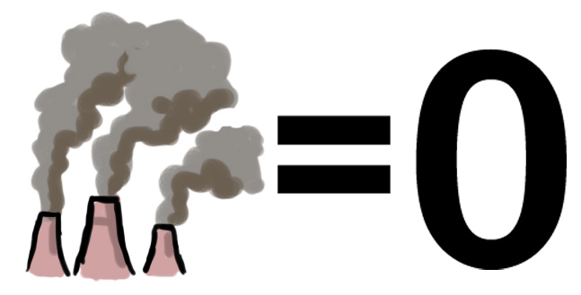
The Scottish Government plans to reach net zero emissions by 2045. Net zero means taking out as much harmful gas from the atmosphere as we put into it. This needs to happen if we are going to tackle climate change.
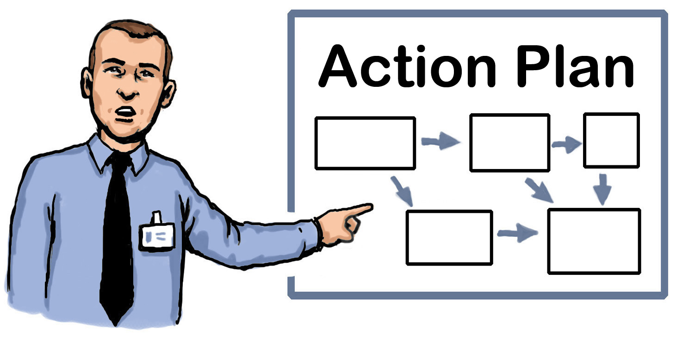

The second Strategic Transport Projects Review (STPR2) is a big part of this plan.
- What is STPR2?

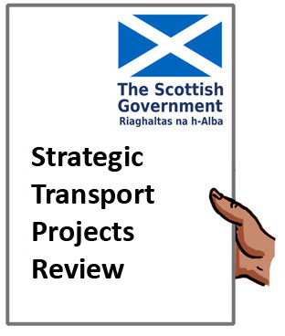

Transport Scotland did the first Review in 2008.

A second review was started in 2019 – this is STPR2.

This review will recommend how money could be spent on transport projects in Scotland for the next 20 years. Scottish Ministers can use the review to make decisions about future transport projects.

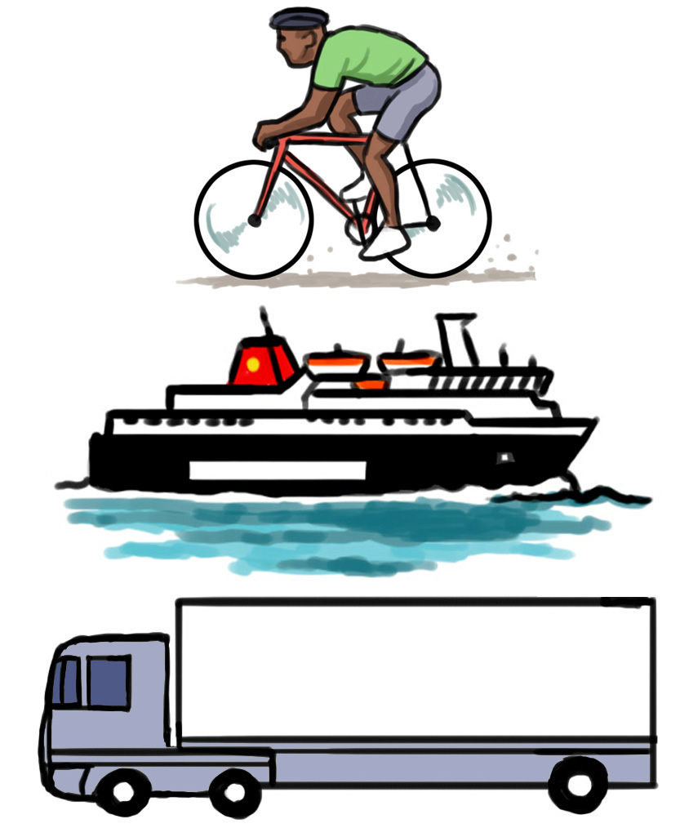

It looks at the transport needs of Scotland’s people and communities. This includes active travel (walking, wheeling, cycling), bus, ferry, rail, motorways and major roads as well as passenger and freight access to major ports and airports.

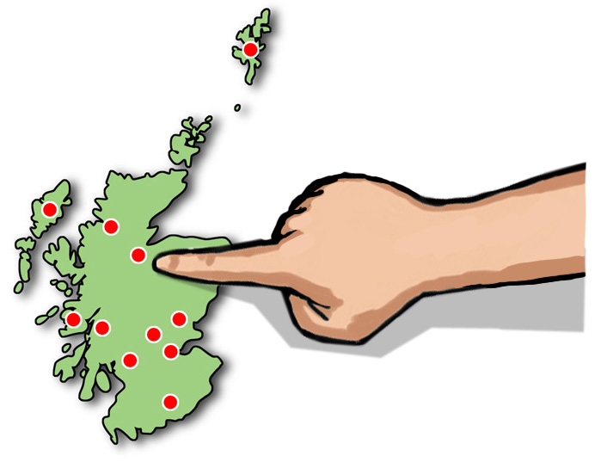

It looks at the different travel needs of different parts of the country and different communities.

The goals of STPR2 cover these topics:
- take climate action

- less inequality and more accessibility

- improve health and wellbeing

- support financial growth

- better safety and more reliable.

These topics make sure that STPR2 recommendations:

- are in line with Scottish Government policies and plans
- help reach the goals set out in the second National Transport Strategy.
- How was the STPR2 developed?

We worked with organisations to come up with ideas for future transport projects. We had events and surveys which were open to the public.

Local Working Groups have been made with local council, national park and transport partnerships.

All of this helped us to decide which projects we should do. They had to make the transport system better. We also had to afford them. This is important when there is less public money to spend.

COVID-19 has changed how we travel. The future of transport is uncertain. The review has to be flexible. It can change as we get a better idea of how people will travel in the future.

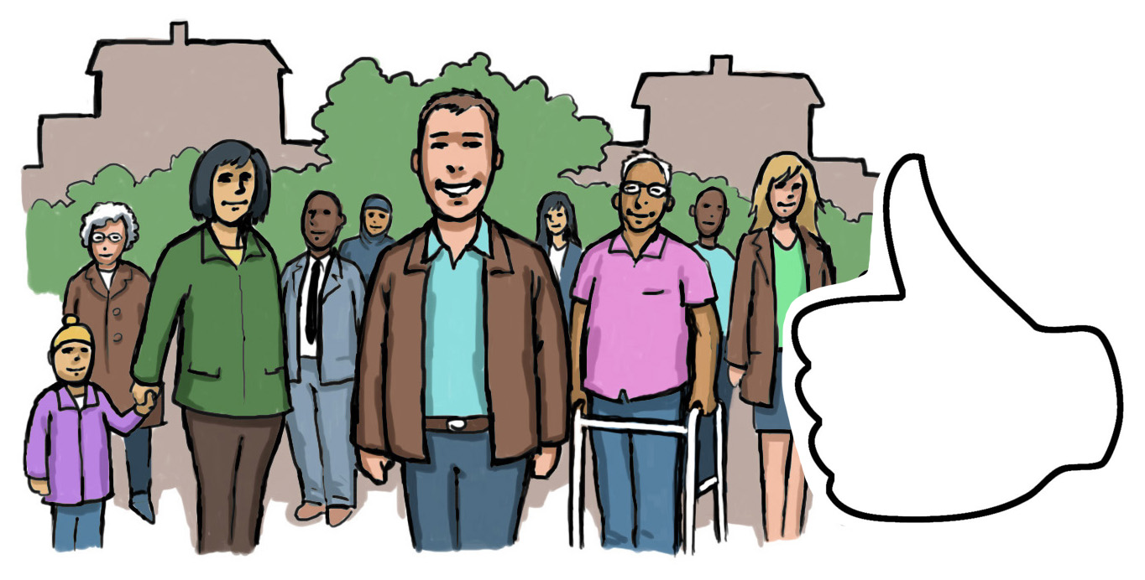
STPR2 also looks at how future transport projects might have an impact on the environment. It looks at things like equalities, children’s wellbeing and island communities. It makes sure plans make things better for all groups in our society.

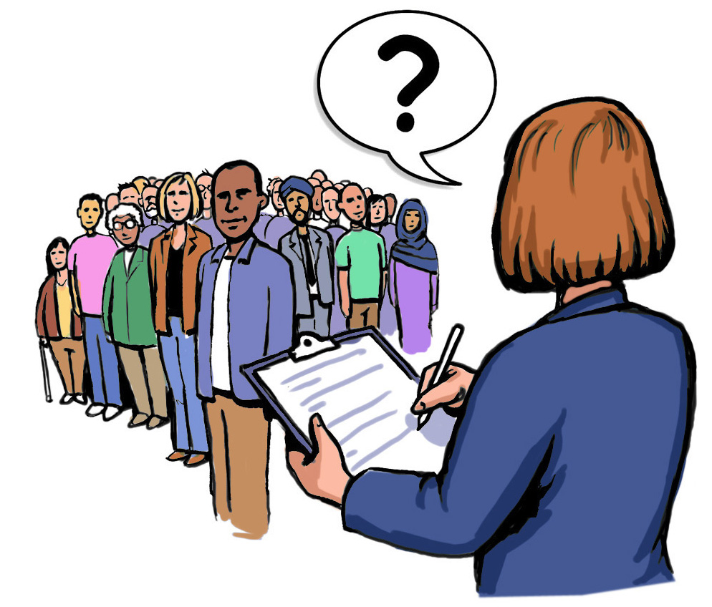
We published our draft report in January and asked everyone for their thoughts on the recommendations. We received approximately 500 responses, and most people agreed with the recommendations. Because of this, our final recommendations are the same as those published earlier in the year.

- Recommendations

STPR2 recommendations are in 6 themes:

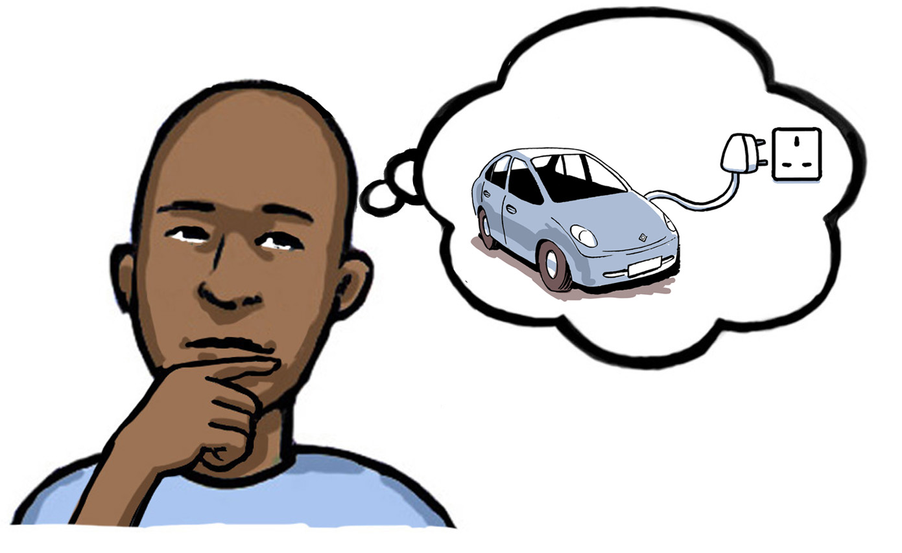
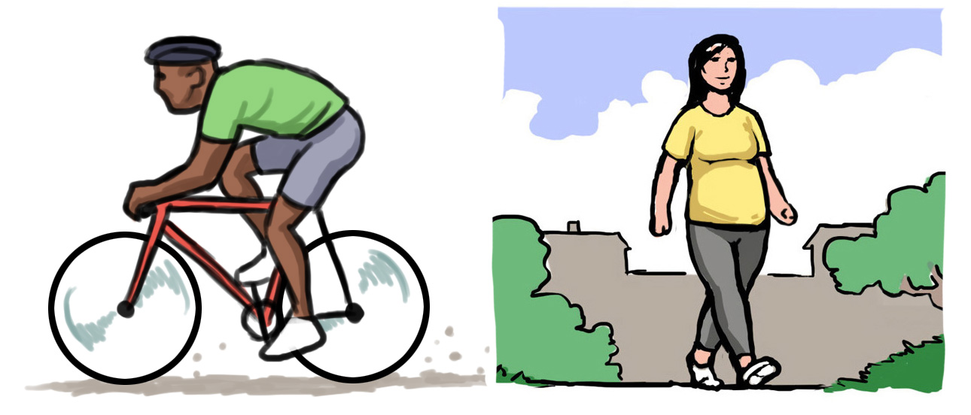
- Make it easier for people to use active travel (walk, wheel and cycle)
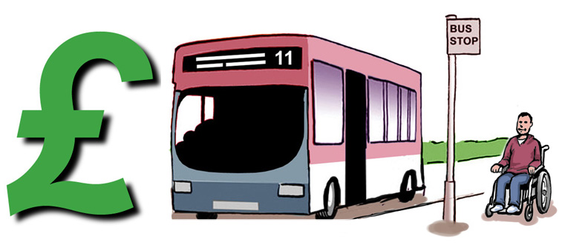
- Change travel choices and behaviours
- Make access to affordable public transport easier
- Stop using fossil fuels which put harmful gases into the atmosphere
- Make the transport network safer and hard-wearing (needing less repair, less often)
- Make better long-distance connections within Scotland and to other countries).

The recommendations cover the whole of Scotland. But the recommendations then need to meet the needs of different parts of the country.

Make it easier for people to use active travel (walk, wheel and cycle)

Getting people to walk, wheel and cycle more often:
- cuts air pollution
- reduces inequality as better access to jobs, services and leisure
- makes communities nicer places to be
- improves health
- is good for the economy

Better active travel routes are helpful for people who can feel left out of society. This can be disabled, young and older people, and those without a car.

The STPR2 recommendations would need local councils and Regional Transport Partnerships to work together.

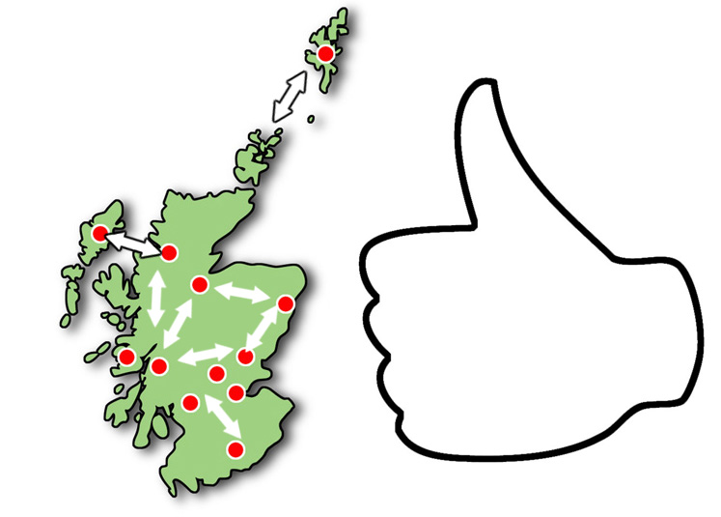
This would result in a high quality, safe nationwide active travel network connecting Scotland’s communities.
Changing travel choices and behaviours

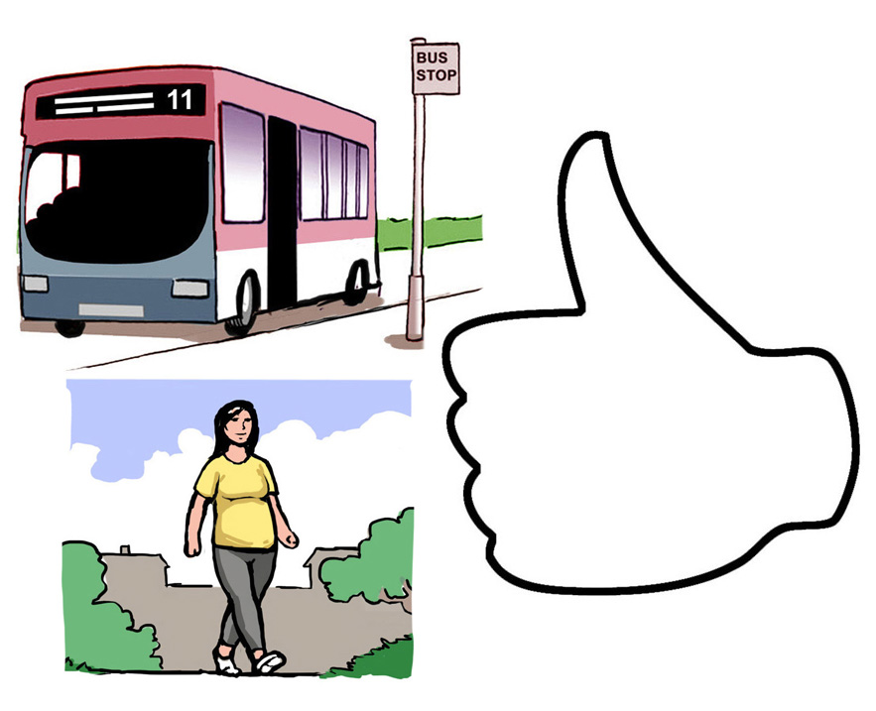
Getting people to make healthier, reliable and safer travel choices.

The recommendations encourage people to make use of active (walk, wheel or bike) and public transport.

They include:
- campaigns to change behaviour
- increasing active travel (walk, wheel and bike) to school
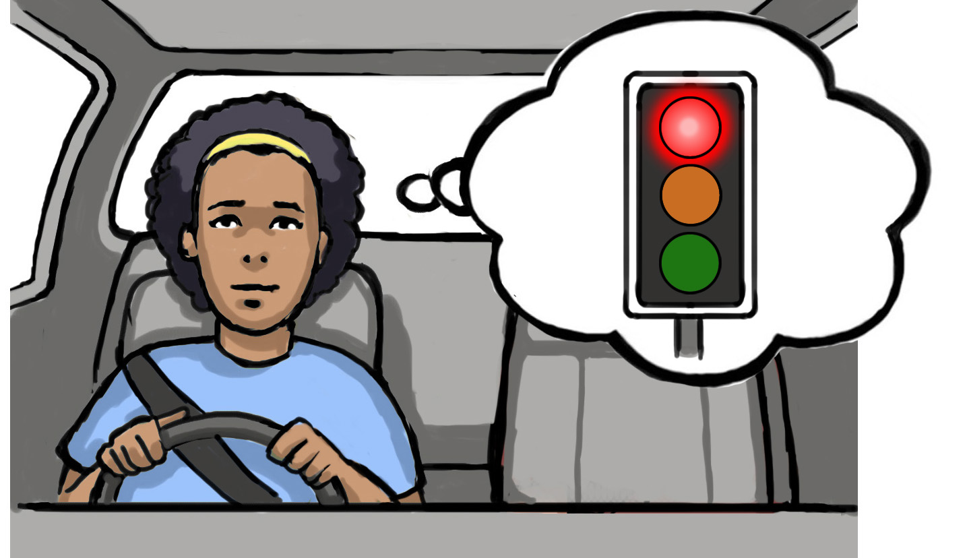
- more access to bikes
- changing road user behaviour
- more 20mph limits and zones on roads
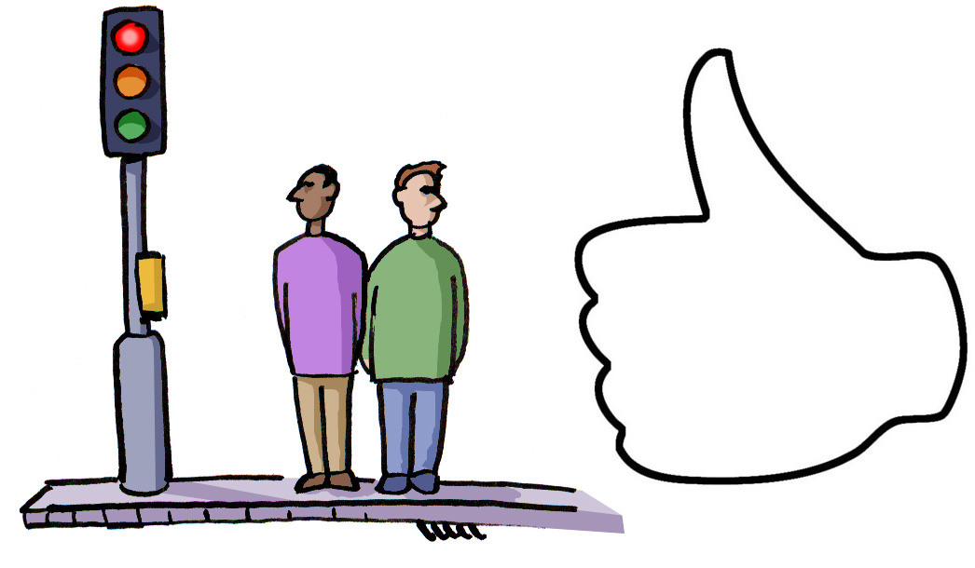
These recommendations aim to make roads safer. This will mean fewer accidents and will mean people are happier to use active travel.

For these STPR2 recommendations to work, many public, private and community organisations would have to work together.
Make access to affordable public transport easier
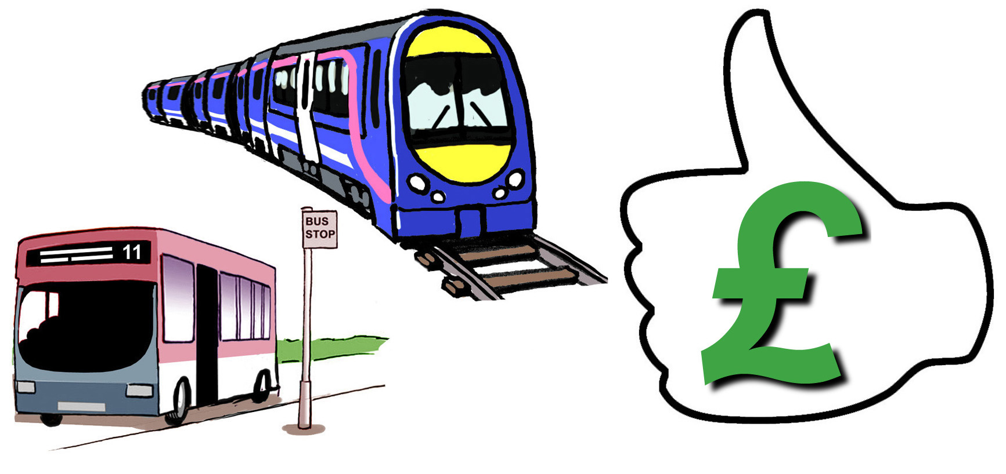
Many people need access to affordable and reliable public transport so they can access jobs and key services like shops. This is for those living in rural areas as well as towns and cities.

Spending money on better public transport would encourage more people to use it. This would mean less use of cars and less air pollution.

Different people have different needs. We need a range of ideas to meet the challenges and barriers of everyone travelling by public transport.

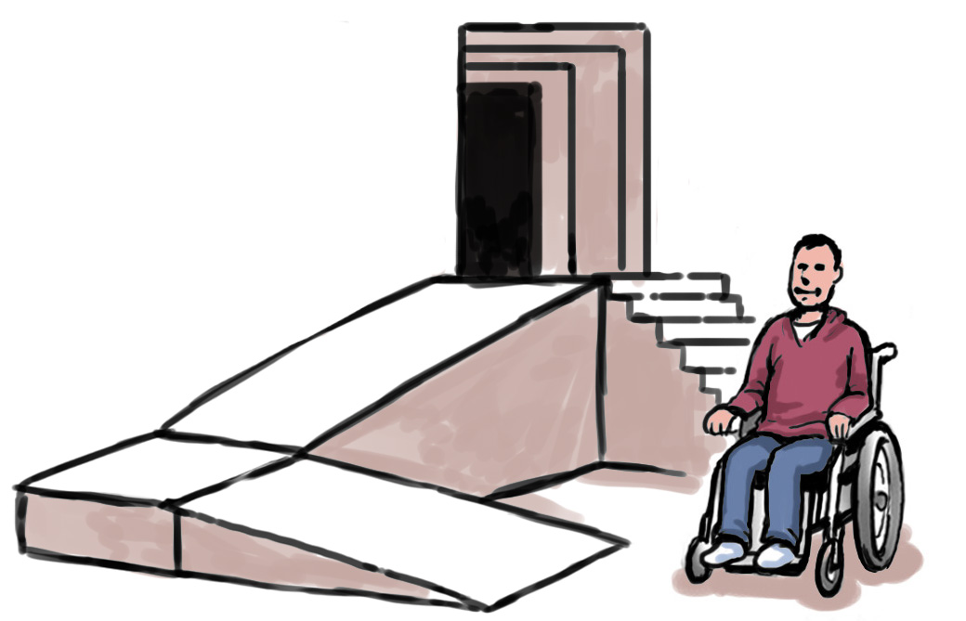
This includes better transport stations and joining up public transport ticketing. This would make all public transport services more accessible and affordable.

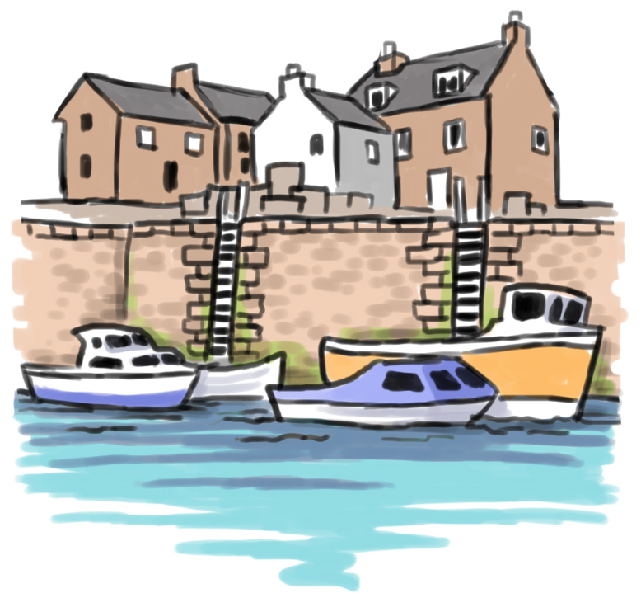
There are different recommendations for cities and country-side communities. People have different needs in these areas.

Stop using fossil fuels which put harmful gases into the atmosphere
The Scottish Government has made a commitment that there must be net-zero greenhouse gas emissions by 2045. Net zero means we take out as much harmful gas from the atmosphere as we put into it.

We have to do this if we are to meet the targets for climate change.

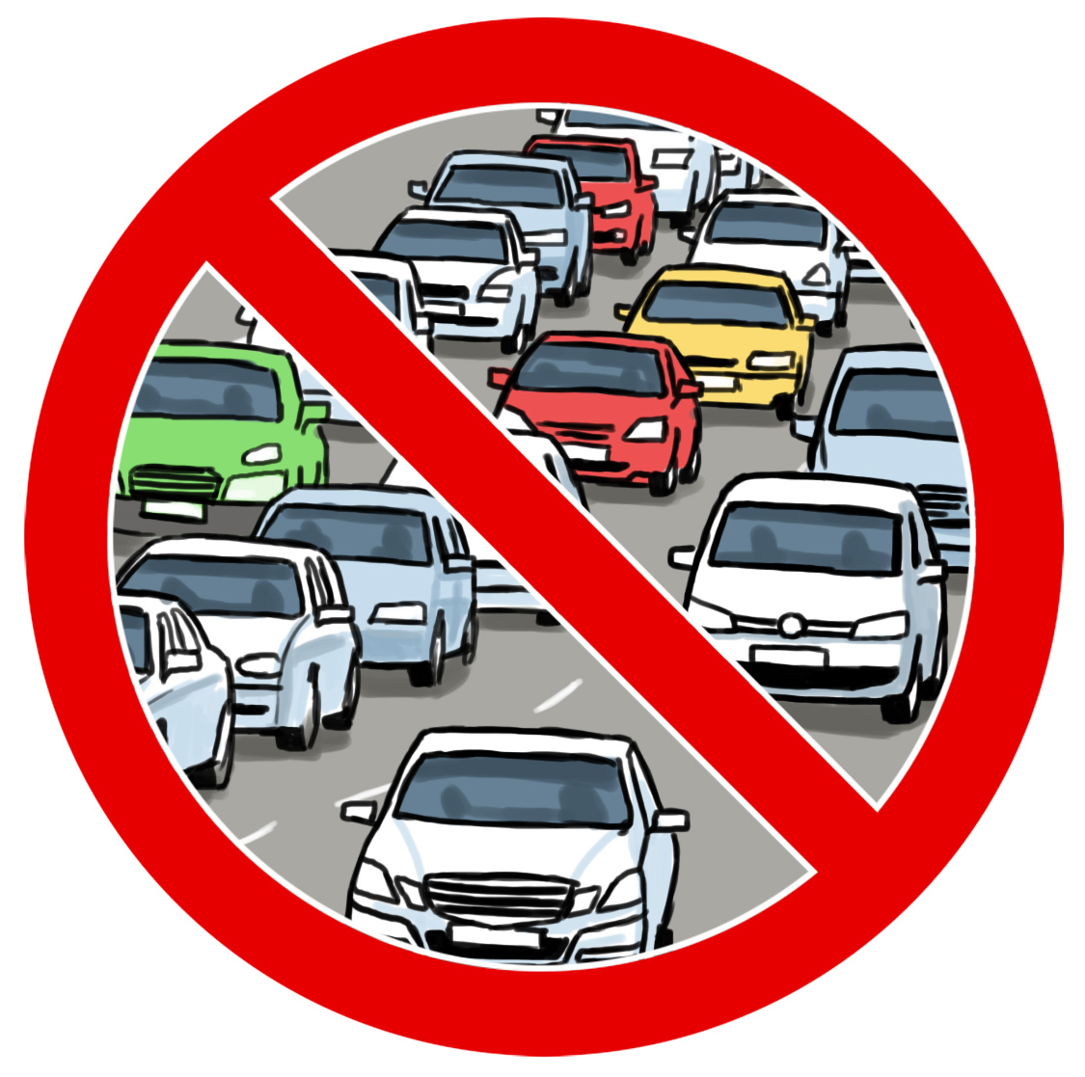

Transport is now the largest source of harmful gas emissions. Cars make the most gas.

The only way the net-zero target can be reached is by:
- stopping use of fossil fuels in cars and lorries
- getting more people to use public transport and active travel
- getting people to take shorter trips or no trips at all.

Make the transport network safer and hard-wearing (needing less repair, less often)

The STPR2 recommendations look at ways to make transport safe and hard-wearing.

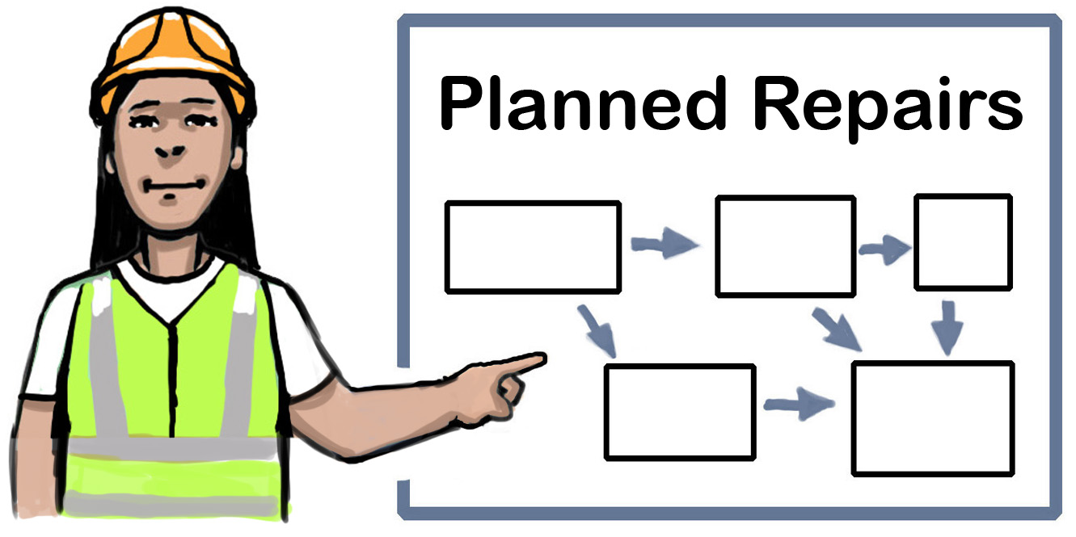
Transport Scotland will keep checking the roads and plan for repairs. These will look at safety and climate change impacts and make roads better.

STPR2 has identified areas that need looked at first.

There are recommendations looking at speed on major roads and their impact on communities. These would mean less accidents and be better for the local environment.

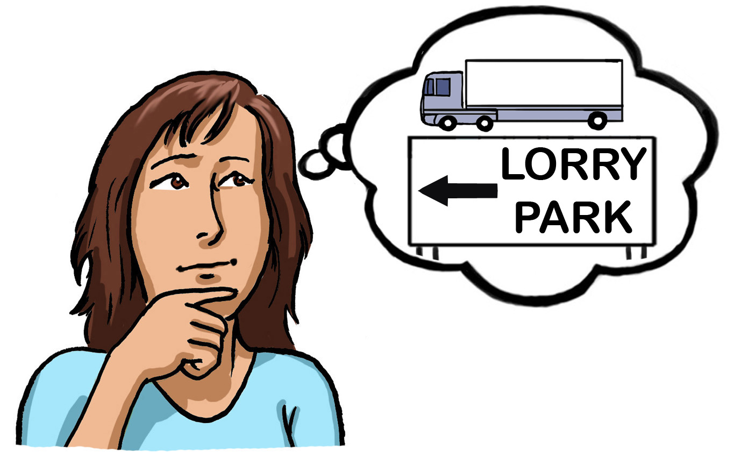
STPR2 understands that goods vehicles like lorries and their drivers have their own needs. A national review of lorry parks is recommended to look at barriers stopping their development.

Make better long-distance connections

It is important that long distance connections are made better. It should be easier to travel within Scotland and across its borders.

STPR2 makes recommendations about better access to large seaports.

STPR2 recommends spending money on ports to support new greener ferries. This will give island communities better links to the mainland.

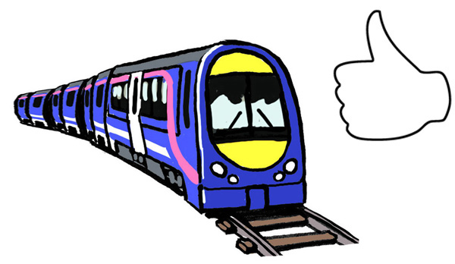

STPR2 looks at how important rail is for longer journeys for passengers and goods.

- If you want more information

This an Easy Read summary of the STPR2 Summary Report. The full set of 45 recommendations can be found in the Summary Report.

We have more detailed reports available on the Transport Scotland website transport.gov.scot/stpr2/ and printed versions are available on request:

Email:
info@transport.gov.scot

