Cycling Framework and Delivery Plan - Business and Regulatory Impact Assessment (BRIA)
Screening Report

Transport Scotland

20/07/2022

Quality information
Prepared by |  | Checked by |  | Verified by |  | Approved by
Andy Keba |  | Laura Walker |  | Richard Adams |  | Yannis Kontolaimakis

Revision History
Revision | Revision date | Details | Authorized | Name | Position
Draft | 20/07/2022 | For client review |  | Yannis Kontolaimakis | Associate Director

Distribution List
# Hard Copies | PDF Required | Association / Company Name

Prepared for:
Transport Scotland
Victoria Quay
Edinburgh
EH6 6QQ

Prepared by:
Andy Keba
Principal Consultant - Transport
E: andy.keb@aecom.com

‌AECOM Limited
1 Tanfield,
Edinburgh,
EH3 5DA
United Kingdom

T: +44 (0)131 301 8600
aecom.com

© 2022 AECOM Limited. All Rights Reserved.
This document has been prepared by AECOM Limited (“AECOM”) for sole use of our client (the “Client”) in accordance with generally accepted consultancy principles, the budget for fees and the terms of reference agreed between AECOM and the Client. Any information provided by third parties and referred to herein has not been checked or verified by AECOM, unless otherwise expressly stated in the document. No third party may rely upon this document without the prior and express written agreement of AECOM.

Table of Contents
1. Introduction 1
1.1 Purpose 1
1.2 Cycling Framework and Delivery Plan for Active Travel 1
1.3 Business and Regulatory Impact Assessments (BRIAs) 3
2. Methodology 4
2.1 Introduction 4
2.2 Review of the BRIA toolkit 4
2.3 Screening Impact Assessment 4
3. Rationale for Intervention 6
3.1 Market Failure 6
3.2 Supply and Demand 6
4. Screening Summary 7
4.1 Businesses 7
4.2 Local Authorities 7
4.3 Consumers 7
4.4 Organisations in the third sector 7
Appendix A : Cycling Framework BRIA Screening Tables i

Figures
Figure 1-1 Timeline for BRIA activities 1
Figure 1-2 NTS Vision and Priorities 2020-22 2
Figure 1-3 Cycling Framework Policy Relationships 3

Tables
Table 2-1 Screening assessment guide 4

Introduction

Purpose
AECOM has been commissioned by Transport Scotland (TS) to undertake a series of impact assessments on the Cycling Framework and Delivery Plan for Active Travel (the Cycling Framework). This includes the following:
- Equality Impact Assessment (EqIA);
- Children’s Rights and Wellbeing Impact Assessment (CRWIA);
- Fairer Scotland Duty Assessment (FSDA);
- Island Communities Impact Assessment (ICIA);
- Health Inequality Impact Assessment (HIIA); and
- Business and Regulatory Impact Assessment (BRIA).
This report sets out a screening assessment of the headline actions within the Cycling Framework based on existing evidence and previous assessment work.
This report will be updated and expanded following a 12 week period of consultation and the feedback and findings of the consultation will contribute towards completing a full assessment. Figure 1-1 sets out the key activities and timescales for undertaking the assessment.
Figure 1-1 Timeline for BRIA activities
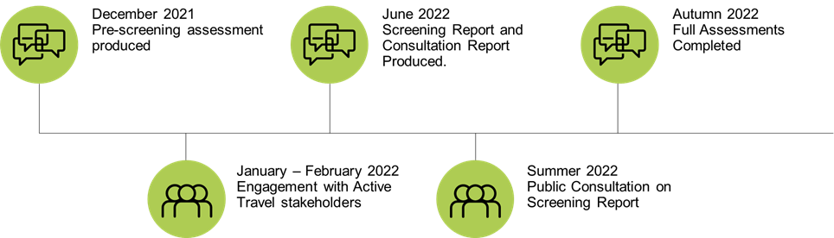

Cycling Framework and Delivery Plan for Active Travel
Cycling Framework and Delivery Plan sets out 38 Actions, under five strategic themes, which are aimed at achieving the cycling elements within the five Active Travel objectives within Transport Scotland’s Active Travel Framework:
- Cut carbon emissions and other pollution
- Delivering liveable, more pleasant communities
- Better health and safer travel for all
- Reducing inequalities - jobs, services, leisure
- Supporting delivery of sustainable economic growth

By helping to achieve the objectives of the Active Travel Framework, the actions within the Cycling Framework will contribute to achieving the Vision and the Priorities of Scotland’s second National Transport Strategy (NTS2). The Vision and the Priorities of NTS2 are shown in Figure 1-2.

Figure 1-2 NTS Vision and Priorities 2020-22
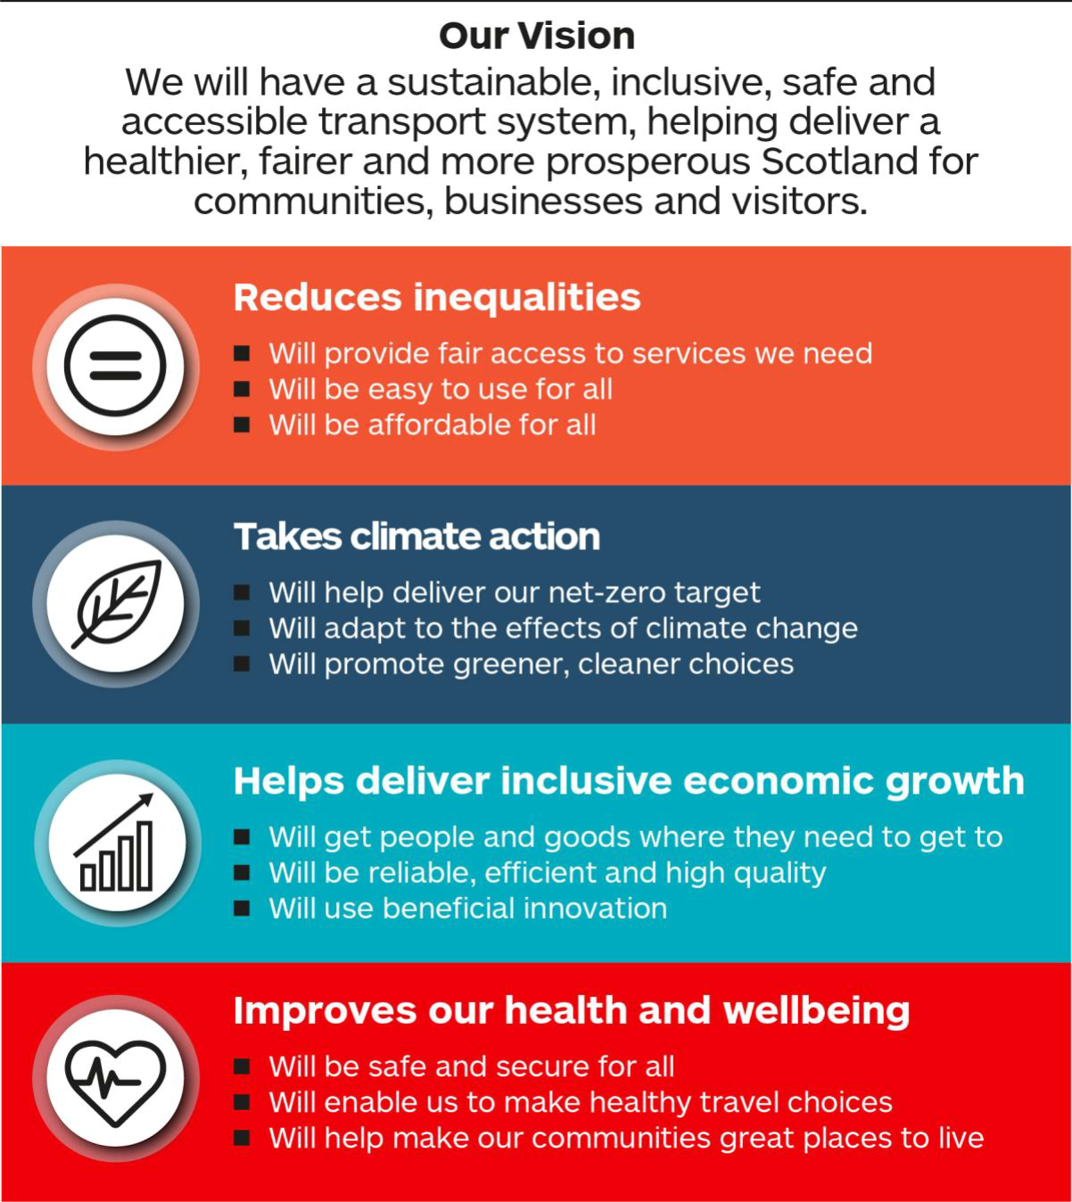

Alongside the Climate Change Plan and Scotland’s fourth National Planning Framework NTS2 provides the strategic policy basis for the active travel interventions detailed in the Cycling Framework. These relationships are summarised in Figure 1-3.
Figure 1-3 Cycling Framework Policy Relationships
Scotland’s National Performance Framework
National Transport Strategy 2
National Planning Framework 4
Climate Change Plan update
Active Travel Framework
STPR2
Cycling Framework and Delivery Plan
NTS2 Delivery Plan

The Climate Change Plan update (CCPu) provides emissions reduction pathways for the transport sector equating to a halving of emissions by 2028, 70% reduction by 2040 and net-zero by 2045. The CCPu outlines eight policy outcomes designed to achieve the required level of emissions reduction. Active travel interventions contribute directly to CCPu Outcome 1 (Reduce car kilometres by 20% by 2030). Impact assessments have been produced and are available here.
NPF4 sets out how the planning system will help to deliver on the net-zero carbon reduction target under its overarching spatial strategy and strategic policies. The Cycling Framework will help support the delivery of NPF4 strategic policies 7 (Local living) and 10 (Sustainable Transport). Impact assessments have been produced and are available here.
The Second Strategic Transport Projects Review (STPR2) will provide a suite of transport interventions intended to deliver the outcomes of NTS2 over the coming two decades. STPR2 will include a raft of active travel interventions which are likely to be delivered, in part, via the delivery mechanisms proposed in the Cycling Framework. Impact assessments have been produced and are available here.

Business and Regulatory Impact Assessments (BRIAs)
BRIAs help to assess the likely costs, benefits and risks of any proposed primary or secondary legislation, voluntary regulation, codes of practice, guidance, or policy changes that may have an impact on the public, private or third sector. The Scottish Government recommends and encourages the completion of a BRIA as best practice to assess the impact of new legislation, as well as other changes such as voluntary guidance or policy changes, even where they do not necessarily present additional obvious burdens. In such cases it can either help confirm understanding that the impact will not change or identify and address unintended impacts which have not been identified. The content of a BRIA should be proportionate to the problem involved and the size of the proposal. A Business and Regulatory Impact Assessment Toolkit and Template have been developed to provide guidance and information.
The BRIA will assess the likely impacts, costs, benefits and risks of the Cycling Framework on the public, private or third sector organisations. The information gathered through the consultation process will be used to revise the estimates of any costs and benefits of the actions prepared at the screening stage where applicable.

Methodology

Introduction
The approach for undertaking this BRIA and compiling this screening report follows a two-stage process:
- Review of the BRIA toolkit – a review of guidance and tools to identify the best case approach for assessing the impacts associated with the Cycling Framework;
- Screening Impact Assessment – A high level assessment of screening impacts – informed by a consideration of the key issues and evidence.

Review of the BRIA toolkit
A review of guidance and the BRIA toolkit has been undertaken to ensure that the overall approach taken ensures that data collected aligns with the requirements of the official BRIA template.

Screening Impact Assessment
This BRIA screening assessment presents an initial review of each of the strategic policies within the Cycling Framework and provides an initial high-level assessment as to whether the action has potential to differentially or disproportionately affect each of the groups with protected characteristics and other groups identified through the assessments.
Table 2-1 provides the guide questions used to undertake the screening assessment. Where there is not enough information to make a screening assessment, this has been noted within the screening table and will be updated as part of the screening assessment following stakeholder engagement as appropriate.
Table 2-1 Screening assessment guide
Potential impacts and risks | Businesses  - Will the action/policy have an impact on the competitiveness of Scottish companies within the UK / Europe / globally?  - What are the relevant businesses, sectors, markets, products or services that might be affected by the action?  - Will the action restrict or increase competition in these markets?  - Will it make it harder for new firms to enter a market?  - Will it impact suppliers (number / range / competitiveness)?  - Could impacts be different for different parts of an industry or different parts of a supply chain?  - Will micro and small businesses be impacted differently? (Consider regulatory burden, compliance flexibility options, distribution of benefits, cost penalties of non-compliance)
Local authorities
- What is the impact on local authorities?
Consumers – includes users of public services
- Will the quality, availability or price of goods or services in a market be affected?
- Does the action affect the essential services market, such as energy or water?
- Does the action involve storage or increased use of consumer data?
- Could there be increased opportunities for third parties to take advantage of government initiatives to target consumers whose circumstances make them more vulnerable?
- Could the action add complexity in a market, which could lead to information asymmetries or make it more difficult for consumers to understand their rights?
- Could the action affect routes for consumers to seek advice or raise complaints on consumer issues?
- Will it limit the choices and information available to consumers?
Regulators
- What is the impact on regulators?
Organisations in the third sector
- What is the impact on organisations in the third sector?
Environment
- Will there be disproportionate impacts on the environment, including disproportionate cost of compliance and monitoring?
General
- Have any new forms been introduced as a result of the action?
Moving to digital / online | - Does the action take account of changing digital technologies and markets?  - Will the action be applicable in a digital / online context?  - Will the action potentially have an adverse impact on traditional or offline businesses?  - If the action can be applied in an offline and online environment, will this in itself have any adverse impacts on incumbent operators?
Costs and Benefits | - What will the costs and benefits of the action be, relative to the status quo were the action not introduced (i.e. will they be additional and monetised)?

Rationale for Intervention
The Climate Change (Emissions Reduction Targets) (Scotland) Act 2019 sets legally binding net-zero greenhouse gas (GHG) emissions targets of 100% lower than the baseline by 2045 with interim targets for 2030 and 2040 of 75% and 90% reduction respectively. Emissions from transport currently account for approximately 25% of overall GHGs in Scotland. Of these, cars accounted for 39%, goods vehicles contributed 25%, while aviation and shipping accounted for 15% and 16%, respectively.
In the past four decades, car traffic on major roads in Scotland has tripled, with 2019 recording the highest ever number of vehicle kilometres travelled on all roads. As such, transport emissions are not on track to meet Scotland's emissions reduction targets and measures to reduce the emissions from transport and shift towards more sustainable modes, must be advanced.

Market Failure
Cycle journeys confer societal benefits in terms of health improvement, congestion reduction, climate change and air quality improvement, among others . However, cycle journeys are not currently being supplied at a rate which optimises these benefits to society. This failure to capture the potential for journeys to be made by bicycle can be described as a net welfare loss to society. Government intervention can therefore be justified on the basis that the market has failed to deliver the best outcome and that intervention may be able to unlock benefits that would otherwise remain hidden. When it comes to the allocation of road space for safe cycling infrastructure, there is no meeting of supply and demand through a price mechanism, because roads are publicly funded through general taxation. Therefore, there is a missing market for road space and in order to allocate this common resource efficiently for the maximum public benefit, government intervention is justified.

Supply and Demand
The Cycling Action Plan for Scotland (CAPS) set a vision of 10% of journeys to be made by bicycle by the year 2020. The Scottish Government invested nearly £300 million in active travel between 2010 and 2019 and £80 million per year in 2018-19 alone. This budget is shared across 32 local authorities in Scotland and is broadly split into a capital grant, allocated for construction of traffic free cycle facilities and a revenue fund, aimed at changing individual behaviour by encouraging ‘smarter choices’.
Capital and revenue programmes broadly fall either side of supply or demand side of economic theory. Funding for cycle infrastructure seeks to increase the supply of safe cycle infrastructure, thereby increasing the number of journeys taken, while smarter choices measures are intended to increase demand for cycle journeys, by promoting active travel and thereby increasing individual’s willingness to choose a cycle journey over the alternative.
Despite the levels of investment to date, the share of journeys undertaken by bicycle is currently around 1.2%. More, therefore needs to be done to shift the balance of demand for cycle journeys and supply of safe cycle routes, in order to achieve a fundamental shift large enough to support the target set by the Climate Change Plan to reduce car kilometres by 20% by 2030.

Screening Summary
This section summarises the results of the screening exercise which are presented in full in Appendix A. Below is a summary of the screening exercise, drawing out the potential impacts (positive and negative) from the actions within the delivery plan.

Businesses
Overall, actions within the Cycling Framework are expected to have a broadly positive impact on business, by encouraging local journeys to small retailers and the high-street, as opposed to out of town shopping centres, which are more easily accessed by car. Building on the network of long-distance routes which connect to the national cycle network (NCN), and promoting cycling through communication campaigns, will have a positive impact on businesses operating in the tourism sector, while integration with events such as the cycling world championships will further encourage inward investment and opportunities for economic activity. Actions aimed at enabling greater use of cargo-bike deliveries could help to remove barriers to market entry for smaller scale last-mile logistics companies, which could help to grow the sector in a sustainable way. In addition, support for the bicycle industry could help to grow this sector in Scotland.
Some businesses, sectors, markets, products or services may be affected by the infrastructure provision for active travel if, for example, it removes space for other travel modes (adverse effect) or improves access for a wider range of employees and consumers (positive effect). Micro and small businesses may be more vulnerable to any potential adverse effects. Some uncertainty remains around the potential impacts of changes to Traffic Regulation Orders (TROs) as it is not clear at this stage whether the proposed changes will retain and enhance statutory minimum levels of consultation and engagement. Similarly, if fast-track procurement of land outwith existing legal processes does not include sufficient facility for consultation and engagement with local land owners and businesses, this proposed action could have potentially significant negative impacts. The travel demand management measures set out in the national route map for car km reduction may also have significant impacts on business, depending on how it is delivered, and the role of the cycling framework in supporting this is not clear. More information is therefore needed in order to understand the potential impacts of this large shift in travel behaviour.
Potentially negative impacts on smaller private bus operators are possible if additional requirements are placed upon them. Private bus operators in rural and island communities may or may not have the means to retrofit buses with the required facilities to carry bicycles and so this requires further consideration. Potential reductions in school bus provision as a result of actions within the Cycling Framework could impact on smaller bus operators and coach companies who rely in-part on school bus contracts.

Local Authorities
As statutory roads authorities, Local Authorities are fundamental to the successful delivery of cycle infrastructure and are also key partners in behaviour change activities. Long-term funding arrangements, the removal of barriers to funding and the provision of appropriate resource will provide Local Authorities the capacity needed to fulfil these aspirations.

Consumers
Consumers could potentially benefit from actions aimed at increasing access to bikes, if these measures enable choice and support the retail sector. Schemes delivered though commercial retailers, such as the cycle to work scheme, have been shown to be of economic value to participants and the industry.

Organisations in the third sector
The Cycling Framework lists third sector organisations as lead delivery partners under several actions. Though the impacts of the Cycling Framework on the third sector are difficult to quantify, the capacity for third sector partners to deliver these actions must be considered carefully and resourced proportionately.

- : Cycling Framework BRIA Screening Tables
Strategic Theme | Action | Ref. | How is the Action likely to impact on Business, Local Authorities, Regulators or Third Sector partners? | Comments and evidence relating to these groups with regards to the action
Safe Cycling Infrastructure | Produce active travel strategies and maps for each local authority area setting out plans to improve active travel networks and facilities to 2030 using a robust evidence-led approach to network planning. The active travel strategies will provide the basis for funding applications by local authorities. | CI.1 | ✓ | Business:  Evidence shows that active travel can positively influence retail footfall at a local level. If active travel networks are planned with local economic interests in mind and with the support of local businesses, there are positive benefits to retailers:  - https://www.sustrans.org.uk/media/5224/common-misconceptions-of-active-travel-investment.pdf  - https://www.livingstreets.org.uk/media/3890/pedestrian-pound-2018.pdf  - https://www.tandfonline.com/doi/abs/10.1080/01944363.2019.1638816 ;  - https://publications.iass-potsdam.de/rest/items/item_6000977_2/component/file_6000978/content ;  - https://www.tcat.ca/wp-content/uploads/2016/12/Bike-Lanes-On-Street-Parking-and-Business_-A-Study-of-Queen-Street-West-in-Toronto%E2%80%99s-Parkdale-Neighbourhood.pdf  Local Authorities:  Local authorities are key partners in delivering the action and will require local authority resource to deliver the action.
 | Produce an active travel network ‘blueprint’ for Scotland, including the future network of Active Freeways and is informed by Local Authority Active Travel Strategies. | CI.2 | ? | The action has an uncertain relationship to business and regulation / the relationship is dependent on the way in which the aspect is managed.
 | Build and maintain a dense network of connected cycling infrastructure in every town and city that is separate from traffic and integrated with public transport, and rural routes that link to these networks and interface with the trunk road network and NCN. | CI.3 | ✓ | The impact of this on businesses within the tourist industry could be broadly positive if it results in increased cycle tourism on the NCN and this links tourists to local towns and villages:  - https://www.cycling.scot/mediaLibrary/other/english/2548.pdf  https://transform.scot/wp/wp-content/uploads/2018/06/Routes-to-Growth-Transform-Scotland-report-version-2018-06-22.pdf
 | Work with other policy areas to introduce active travel networks as part of a larger package- such as 20 mph limits to create efficiencies. | CI.4 | ? | The action has an uncertain relationship to business and regulation / the relationship is dependent on the way in which the aspect is managed.
 | Use the information in the active travel strategies to prioritise investment in the creation of cycling infrastructure integrated with public transport in every town and city, and inter-urban / rural routes that link to these networks. This will build on the National Cycle Network and proposals for Active Freeways in STPR2. | CI.5 | ? | The action has an uncertain relationship to business and regulation / the relationship is dependent on the way in which the aspect is managed.
 | Avoid delays in implementation of cycling infrastructure by revising the TRO process. | CI.6 | ✕ | Some businesses, sectors, markets, products or services may be affected by the infrastructure provision for active travel if, for example, it removes space for other travel modes (adverse effect) or improves access for a wider range of employees and consumers (positive effect). Micro and small businesses may be more vulnerable to any potential adverse effects. At present the TRO process mandates statutory minimum levels of consultation and objections must be addressed. Any changes to the process that erode this requirement could negatively impact on specific businesses unless other effective means of input into the process are in place.
 | Develop an action plan to make it safer to walk, cycle and wheel across and along trunk roads, especially where they pass through towns and villages. | CI.7 | ? | The action has an uncertain relationship to business and regulation / the relationship is dependent on the way in which the aspect is managed.
 | Continue to support fast implementation of temporary cycling infrastructure, introducing Experimental Traffic Orders to support road space reallocation and street trials. | CI.8 | ✕ | The Road Traffic Regulation Act 1984 has recently been amended by the Traffic Regulation Orders (Procedure) (Miscellaneous Amendments) (Scotland) Regulations 2021:  - https://www.legislation.gov.uk/ssi/2021/348/pdfs/ssipn_20210348_en.pdf.  The amendment removes the requirement for publication of a proposed ETRO and allows for objections to be made whilst the ETRO is in place, where an order is made to give permanent effect to an ETRO. A new procedure has been introduced to make an ETRO permanent, without a further objection and consultation period.  Some businesses, sectors, markets, products or services may be affected by the infrastructure provision for active travel if, for example, it removes space for other travel modes (adverse effect) or improves access for a wider range of employees and consumers (positive effect). Micro and small businesses may be more vulnerable to any potential adverse effects. An ETRO can remain in place for six months while objections are addressed and, while in practice it is likely every effort will be made to mitigate any potential impacts on businesses, there remains the possibility that negative impacts could take effect within the six month trial period.
 | Enhance permitted development rights for cycling facilities and infrastructure | CI.9 | - | The Town and Country Planning (General Permitted Development) (Scotland) Order 1992 details 'permitted development' types. This Order was amended in 2014  - https://www.legislation.gov.uk/uksi/1992/223/contents/made  The order relates to householders, rather than planning authorities and is unlikely to impact on businesses.
 | Respond to the needs of local people by expanding the resources needed to support more people to cycle, including appropriate cycle storage for every household. | CI.10 | ✓ | Potential for positive impacts on suppliers and manufacturers of cycle storage facilities.
 | Introduce fast-track powers to acquire land for cycling infrastructure. | CI.11 | ✕ | Section 22 of the Land Reform (Scotland) Act 2003 contains provision for a core path to be enforced via means of a path order  - https://www.gov.scot/publications/part-1-land-reform-scotland-act-2003-guidance-local-authorities-national-park-authorities/documents/).  Reallocation of land for cycling infrastructure within the limits of the adopted road network is within the powers of local authorities via the TRO process. The Acquisition of Land (Authorisation Procedure) (Scotland) Act 1947 provides for the compulsory purchase of land by a public body (Acquiring Authority), if confirmed by Scottish Ministers. The Land Reform (Scotland) Act 2003 also extends the powers of an Acquiring Authority to some non-public bodies. These powers extended to any development, including land for cycling infrastructure. However, this is a costly and lengthy process.  Procurement of land outwith the above legal processes would be subject to negotiation with individual private land owners. Fast-track powers which do not include a sufficient element of consultation and engagement with local land owners, and businesses could have potentially significant negative impacts.
 | Provide ongoing development and governance of design guidance, including mitigation of unintended impacts vulnerable road users and that infrastructure is suitable for adaptive bikes e.g. pedestrians. | CI.12 | - | The action is expected to have a broadly neutral relationship to business and regulation / the relationship is dependent on the way in which the aspect is managed.
 | Develop a national approach to the creation of quiet road/cycle friendly roads in rural areas with everyday journeys prioritised. | CI.13 | - | The action is expected to have a broadly neutral relationship to business and regulation / the relationship is dependent on the way in which the aspect is managed.
 | Designate the active travel network as a national development. | CI.14 | ✓ | The Draft National Planning Framework (NPF4) includes a designation of the National Walking, Cycling and Wheeling network as a national development.  - https://www.transformingplanning.scot/national-planning-framework/draft-npf4/?id=3904#?id=3904  The impact of this on businesses within the tourist industry could be broadly positive if it results in increased cycle tourism.
 | Update design and asset management guidance to enable national, consistent principles of infrastructure | CI.15 | - | The action is expected to have a broadly neutral relationship to business and regulation / the relationship is dependent on the way in which the aspect is managed.
 | Support cycling journeys, to and from public transport hubs as part of a multi-modal journey | CI.16 | - | The action is expected to have a broadly neutral relationship to business and regulation / the relationship is dependent on the way in which the aspect is managed.
 | Promote cargo bikes as the normal choice for local deliveries | CI.17 | ✓ | Pilot projects have shown that, where the right operating conditions exist, cargo-bike delivery start-ups can flourish in the already highly competitive sector of first mile/last mile deliveries:  - https://sestran.gov.uk/news/e-cargo-bikes-to-explore-transforming-logistics-in-edinburgh/  Both potentially positive and negative effects therefore exist for businesses operating in the first mile/last mile freight delivery sector. Incumbent operators which do not switch to some deliveries by cargo-bike may lose market share to those that do. However, overall, this measure will help to introduce healthy competition to this sector.
 | Support government funded agencies to remove on-site car parking spaces and replace them with cycle parking | CI.18 | - | Government funded agencies may include organisations in the public and third sector. Broadly, this measure is unlikely to have any strong impact organisationally.
 | Promote the new Highway Code and implement requirements for cycle training | CI.19 | - | The action is expected to have a broadly neutral relationship to business and regulation / the relationship is dependent on the way in which the aspect is managed.
 | Support the various deliverables set out in Scotland’s Road Safety Framework 2030. Delivery Plans under its Active and Sustainable Travel Strategic Action | CI.20 | ✓ | Road collisions cost the Scottish economy around £1 billion per year.  - https://www.transport.gov.scot/media/49193/scotlands-road-safety-framework-to-2030.pdf  Some of these costs are in lost output and direct damage to property, both of which significantly impact on business. Road safety improvements therefore are likely to have an overwhelmingly positive impact on businesses.
Effective Resourcing | Provide multi-year long-term funding for infrastructure and behaviour change programmes, include trials for road space reallocation linked to active strategies and active travel network plans. | ER.1 | ✓ | Local authorities are key partners in delivering the aspirations within NTS2. Long-term funding arrangements, supported by appropriate resource will provide Local Authorities the capacity needed to fulfil these aspirations.
 | Provide appropriate level of resource to support local authorities to develop and deliver active travel strategies ensuring that cycling for transport is prioritised appropriately. | ER.2 | ✓ | Local authorities are key partners in delivering the aspirations within NTS2. Long-term funding arrangements, supported by appropriate resource will provide Local Authorities the capacity needed to fulfil these aspirations.
 | Work with manufacturers, social enterprises and industry vocational partners to increase cycle and cycle parts production in Scotland, including e-bikes and e-cargo bikes and with Scottish businesses to grow the bike refurbishment industry especially through support for bike recycling and re-use enterprises. | ER.3 | ✓ | Though the estimated value of bicycle and parts manufacture in Scotland is estimated to be low (around £2m per year), this action has the potential to help grow the industry in a sustainable way.  - https://www.cycling.scot/mediaLibrary/other/english/2548.pdf  Impacts on bicycle refurbishment and fabrication businesses will be positive. Although this action needs to be explored further, though engagement with the sector, in order to fully understand it's reach.
Fair Access | Expand access to bikes, including adaptive bikes. | FA.1 | - | The action is expected to have a broadly neutral relationship to business and regulation / the relationship is dependent on the way in which the aspect is managed.
 | Review funding criteria to ensure that fair access is appropriately weighted and improving accessibility is given an appropriate level of priority. | FA.2 | - | The action is expected to have a broadly neutral relationship to business and regulation / the relationship is dependent on the way in which the aspect is managed.
 | Improve quality and level of service of carriage of bikes on trains and require rural & island bus services to carry cycles, wherever possible | FA.3 | ✕ | Potentially negative impact on smaller private bus operators if additional requirements are placed upon them. Private bus operators in rural and island communities may or may not have the means to retrofit buses with the required facilities to carry bicycles. Arrangements for bicycle carriage could, however, be considered as part of Bus Service Improvement Plans (BSIPs)  https://www.transport.gov.scot/public-transport/buses/bus-partnership-fund/criteria/
 | Implement safe cycle routes to public transport interchanges and increase the provision of high quality bike storage. | FA.4 | - | The action is expected to have a broadly neutral relationship to business and regulation / the relationship is dependent on the way in which the aspect is managed.
Training and Education | Provide a comprehensive cycle training offer for all life stages, including learning to ride in pre-school, learning to ride on-road through school bikeability training, and for adults of all ages, including cycle awareness training. | TE.1 | ? | Uncertain effect depending on how the training will be delivered and by which organisations. Local authorities and third sector partners are likely to be key service providers in delivering the action and will require sufficient resource to deliver the action. Note that resourcing is covered in action ER.2.
 | Provide a free bike to all children of school age who cannot afford one | TE.2 | ✓ | Potentially positive effect on bicycle industry and retailers, if such bicycles are made available through retailers, rather than as bulk purchases made directly by the government. Schemes delivered though commercial retailers, such as the cycle to work scheme, have been shown to be of economic value to participants and the industry  https://www.employment-studies.co.uk/system/files/resources/files/509.pdf
 | Support communities to introduce Play Streets, enabling roads to be closed to allow for small events and sports and introduce legislation to enable Auto Number Plate Recognition for the closure of school streets | TE.3 | - | The action is expected to have a broadly neutral relationship to business and regulation / the relationship is dependent on the way in which the aspect is managed.
 | Use the Cycling World Championships to inspire people, especially young people to cycle. | TE.4 | - | The action is expected to have a broadly neutral relationship to business and regulation / the relationship is dependent on the way in which the aspect is managed.
 | Introduce pilot schemes at schools to provide an alternative to the school bus with segregated cycle routes, cycle training, provision of bikes, facilities at school | TE.5 | ✕ | Potential reduction in school bus provision could impact on smaller bus operators and coach companies who rely in-part on school bus contracts.
 | Develop a long-term communication plan that represents cycling as something that anyone can do, including with assistance/adaption and is a transport mode that brings many benefits to Scotland | TE.6 | ✓ | The action is expected to have a broadly neutral relationship to business and regulation / the relationship is dependent on the way in which the aspect is managed.
Network Planning & Monitoring | Support the travel demand management measures aligned with the national 20% car km reduction route map | NPM.1 | ? | The travel demand management measures set out in the national route map for car km reduction may have significant impacts on business and the role of the cycling framework in supporting this is not clear. Therefore, more information is needed in order to understand the potential impacts of this large shift in travel behaviour.
 | Conduct research on the social, environmental and economic factors influencing network planning, for example pandemic recovery and climate change impacts. | NPM.2 | - | The action is expected to have a broadly neutral relationship to business and regulation / the relationship is dependent on the way in which the aspect is managed.
 | Continuously monitor and evaluate the impact of active travel infrastructure and embed learning in future investment decisions . | NPM.3 | - | The action is expected to have a broadly neutral relationship to business and regulation / the relationship is dependent on the way in which the aspect is managed.
 | Review how active travel/cycling schemes are appraised – broaden the benefits to include social, economic and equality benefits. | NPM.4 | - | The action is expected to have a broadly neutral relationship to business and regulation / the relationship is dependent on the way in which the aspect is managed.
 | Expand and where possible align monitoring and reporting of cycling levels at local, city, regional and national level and share learning | NPM.5 | - | The action is expected to have a broadly neutral relationship to business and regulation / the relationship is dependent on the way in which the aspect is managed.

aecom.com

Transport Scotland, Active Travel Framework https://www.transport.gov.scot/media/47158/sct09190900361.pdf
Transport Scotland (2019) National Transport Strategy https://www.transport.gov.scot/media/47052/national-transport-strategy.pdf
Update to The Climate Change Plan 2018 - 2032 https://www.gov.scot/publications/securing-green-recovery-path-net-zero-update-climate-change-plan-20182032/
The Scottish Government (2021) Draft National Planning Framework (NPF4) https://www.transformingplanning.scot/news/news/draft-national-planning-framework-npf4-published/
Transport Scotland (2022) Draft Equality Impact Assessment - A route map to achieve a 20 per cent reduction in car kilometres by 2030
Transport Scotland (2021) Scotland 2045: fourth National Planning Framework - draft: society and equalities impact assessment
Transport Scotland (2022) Strategic Transport Projects Review 2 - Equalities & Statutory Impact Assessments
Scottish Government (2018) Business and Regulatory Impact Assessment Toolkit https://www.gov.scot/publications/business-regulatory-impact-assessments-toolkit/
Scottish Government (2018) Business and Regulatory Impact Assessment Template https://www.gov.scot/publications/business-regulatory-impact-assessments-template/
The Climate Change (Emissions Reduction Targets) (Scotland) Act 2019 https://www.legislation.gov.uk/asp/2019/15/contents/enacted
The Scottish Government (2021) Scottish Greenhouse Gas statistics: 1990-2019 (Published June 2021) https://www.gov.scot/binaries/content/documents/govscot/publications/statistics/2021/06/scottish-greenhouse-gas-statistics-1990-2019/documents/scottish-greenhouse-gas-emissions-2019/scottish-greenhouse-gas-emissions-2019/govscot%3Adocument/scottish-greenhouse-gas-emissions-2019.pdf?forceDownload=true
Transport Scotland Scottish Transport Statistics (2020) Scottish Transport Statistics) No. 39 https://www.transport.gov.scot/media/49874/scottish-transport-statistics-2020-may-2021.pdf
Committee on Climate Change (2020) Reducing emissions in Scotland – 2020 Progress Report to Parliament https://www.theccc.org.uk/publication/reducing-emissions-in-scotland-2020-progress-report-to-parliament/
Davis (2014) Claiming the Health Dividend: a summary and discussion of value for money estimates from studies of investment in walking and cycling https://www.gov.uk/government/publications/economic-case-for-active-travel-the-health-benefits
Transport Scotland (2019) Active Travel Budget Allocation 2018 – 19, https://www.transport.gov.scot/media/43939/active-travel-budget-allocation-2018-2019.pdf
Cycling Scotland (2021) Annual Cycling Monitoring Report. https://www.cycling.scot/what-we-do/making-cycling-better/monitoring-cycling-in-scotland

