Cycling Framework and Delivery Plan - Island Communities Impact Assessment (ICIA)
Screening Report

Transport Scotland

20/07/2022

Quality information
Prepared by |  | Checked by |  | Verified by |  | Approved by
Andy Keba |  | Laura Walker |  | Richard Adams |  | Yannis Kontolaimakis

Revision History
Revision | Revision date | Details | Authorized | Name | Position
Draft | 20/07/2022 | For client review | YK | Yannis Kontolaimakis | Associate Director

Distribution List
# Hard Copies | PDF Required | Association / Company Name

Prepared for:
Transport Scotland
Victoria Quay
Edinburgh
EH6 6QQ

Prepared by:
Andy Keba
Principal Consultant - Transport
E: andy.keb@aecom.com

‌AECOM Limited
1 Tanfield,
Edinburgh,
EH3 5DA
United Kingdom

T: +44 (0)131 301 8600
aecom.com

© 2022 AECOM Limited. All Rights Reserved.
This document has been prepared by AECOM Limited (“AECOM”) for sole use of our client (the “Client”) in accordance with generally accepted consultancy principles, the budget for fees and the terms of reference agreed between AECOM and the Client. Any information provided by third parties and referred to herein has not been checked or verified by AECOM, unless otherwise expressly stated in the document. No third party may rely upon this document without the prior and express written agreement of AECOM.

Table of Contents
1. Introduction 1
1.1 Purpose 1
1.2 Cycling Framework and Delivery Plan for Active Travel 1
1.3 Relevant Legislation 3
2. Methodology 6
2.1 Introduction 6
2.2 Review of key issues and evidence 6
2.3 Screening impact assessment 6
2.4 Next Steps 7
3. Key Issues and Evidence 8
3.1 Introduction 8
3.2 Travel Behaviours 8
3.3 Transport Poverty 9
3.4 Tourism 9
4. Screening Summary 10
Appendix A : Cycling Framework ICIA Screening Tables i

Figures
Figure 1-1 Timeline for ICIA activities 1
Figure 1-2 NTS Vision and Priorities 2020-22 2
Figure 1-3 Cycling Framework Policy Relationships 3
Figure 1-4 ICIA seven step process 5

Introduction

Purpose
AECOM has been commissioned by Transport Scotland (TS) to undertake a series of impact assessments on the Cycling Framework and Delivery Plan for Active Travel (the Cycling Framework). This includes the following:
- Equality Impact Assessment (EqIA);
- Children’s Rights and Wellbeing Impact Assessment (CRWIA);
- Fairer Scotland Duty Assessment (FSDA);
- Island Communities Impact Assessment (ICIA);
- Health Inequality Impact Assessment (HIIA); and
- Business and Regulatory Impact Assessment (BRIA).
This report sets out a ICIA screening assessment of the strategic policies within the Cycling Framework based on existing evidence and previous assessment work.
This report sets out a screening assessment of the headline actions within the Cycling Framework based on existing evidence and previous assessment work.
This report will be updated and expanded following a 12 week period of consultation and the feedback and findings of the consultation will contribute towards completing a full assessment. Figure 1-1 sets out the key activities and timescales for undertaking the assessment.

Figure 1-1 Timeline for ICIA activities
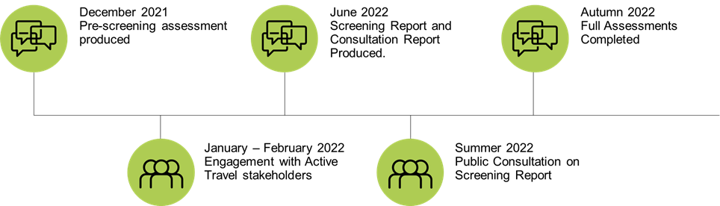

Cycling Framework and Delivery Plan for Active Travel
Cycling Framework and Delivery Plan sets out 38 Actions, under five strategic themes, which are aimed at achieving the cycling elements within the five Active Travel objectives within Transport Scotland’s Active Travel Framework:
- Cut carbon emissions and other pollution
- Delivering liveable, more pleasant communities
- Better health and safer travel for all
- Reducing inequalities - jobs, services, leisure
- Supporting delivery of sustainable economic growth

By helping to achieve the objectives of the Active Travel Framework, the actions within the Cycling Framework will contribute to achieving the Vision and the Priorities of Scotland’s second National Transport Strategy (NTS2). The Vision and the Priorities of NTS2 are shown in Figure 1-2.

Figure 1-2 NTS Vision and Priorities 2020-22
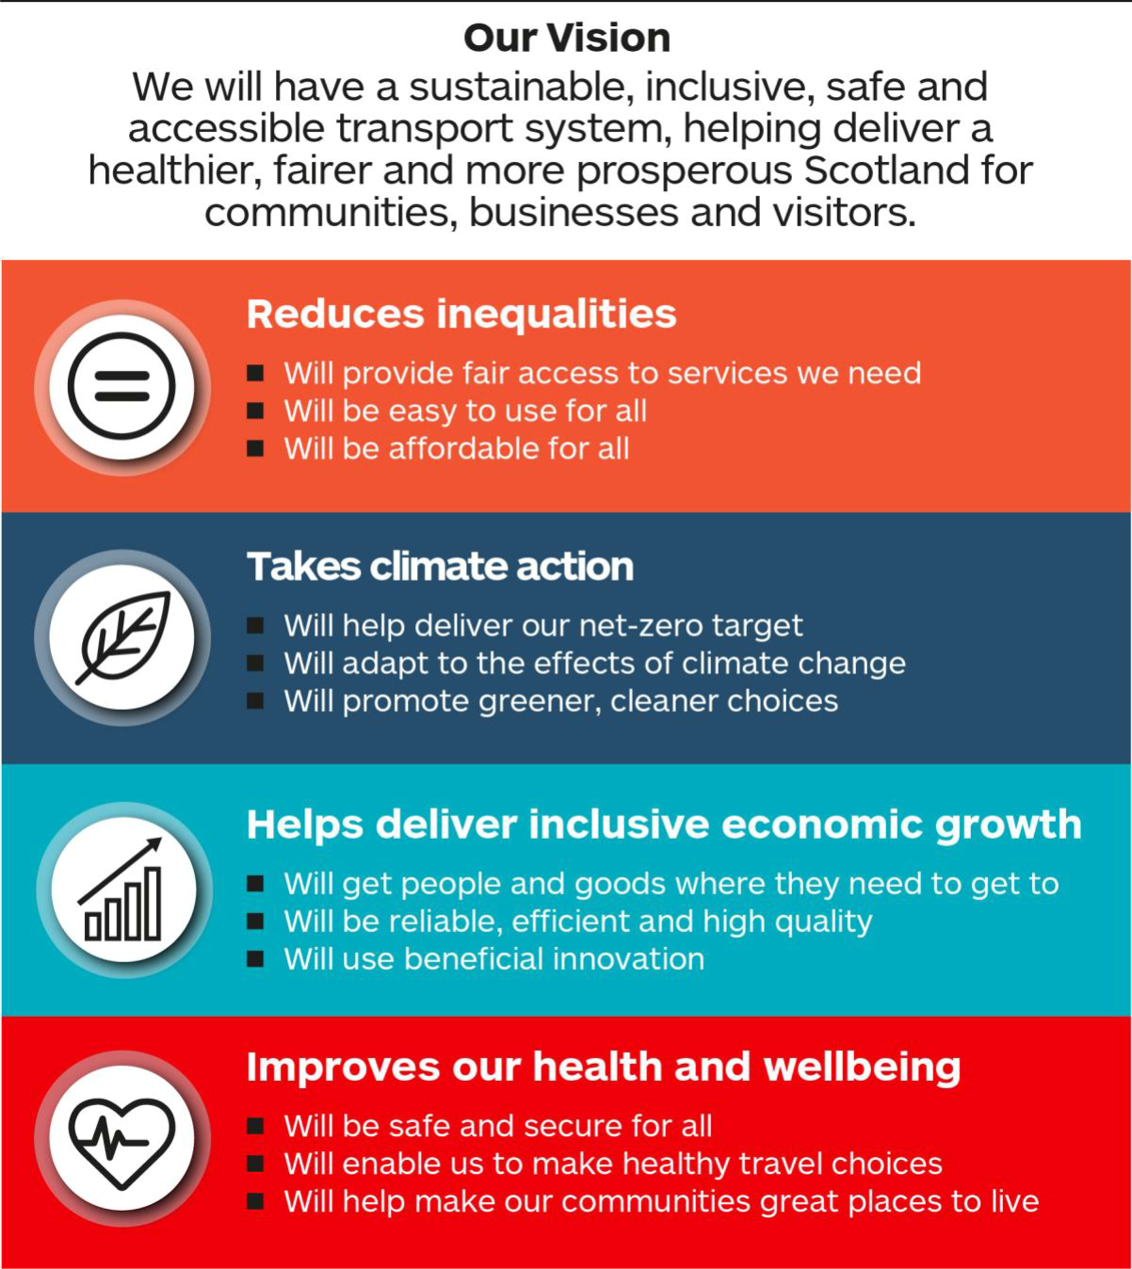

Alongside the Climate Change Plan and Scotland’s fourth National Planning Framework NTS2 provides the strategic policy basis for the active travel interventions detailed in the Cycling Framework. These relationships are summarised in Figure 1-3.
Figure 1-3 Cycling Framework Policy Relationships
Scotland’s National Performance Framework
National Transport Strategy 2
National Planning Framework 4
Climate Change Plan update
Active Travel Framework
STPR2
Cycling Framework and Delivery Plan
NTS2 Delivery Plan

The Climate Change Plan update (CCPu) provides emissions reduction pathways for the transport sector equating to a halving of emissions by 2028, 70% reduction by 2040 and net-zero by 2045. The CCPu outlines eight policy outcomes designed to achieve the required level of emissions reduction. Active travel interventions contribute directly to CCPu Outcome 1 (Reduce car kilometres by 20% by 2030). Impact assessments have been produced and are available here.
NPF4 sets out how the planning system will help to deliver on the net-zero carbon reduction target under its overarching spatial strategy and strategic policies. The Cycling Framework will help support the delivery of NPF4 strategic policies 7 (Local living) and 10 (Sustainable Transport). Impact assessments have been produced and are available here.
The Second Strategic Transport Projects Review (STPR2) will provide a suite of transport interventions intended to deliver the outcomes of NTS2 over the coming two decades. STPR2 will include a raft of active travel interventions which are likely to be delivered, in part, via the delivery mechanisms proposed in the Cycling Framework. Impact assessments have been produced and are available here.

Relevant Legislation
The ICIA assesses the impacts of each of the policies within the NTS2 Delivery Plan and will help to demonstrate TS’s compliance with the Islands (Scotland) Act 2018, which it has a legal duty to consider in the delivery of its policies, programmes and projects.

The Islands (Scotland) Act 2018
Section 3 of The Islands (Scotland) Act 2018 (Scottish Parliament, 2018) required Scottish Ministers to prepare a National Islands Plan to set out the duty of relevant authorities within the meaning of the Act to consider the impacts of policies, strategies, and services on island communities.
Part 2 - Section 3 lists the outcomes considered in the National Islands Plan for improving island communities. These include:
- increasing population levels,
- improving and promoting—
  - sustainable economic development,
  - environmental wellbeing,
  - health and wellbeing, and
  - community empowerment.
- improving transport services,
- improving digital connectivity,
- reducing fuel poverty,
- ensuring effective management of the Scottish Crown Estate (that is, the property rights and interests to which section 90B(5) of the Scotland Act 1998 applies), and
- enhancing biosecurity (including protecting islands from the impact of invasive non-native species).
Part 3 - Section 7 outlines relevant authorities’ duty to have regard to island communities in carrying out its functions. Section 8 of this Act requires the Scottish Ministers, as a relevant authority, to prepare an island communities impact assessment in relation to a policy, strategy, or service, which, in the authority's opinion, is likely to have an effect on an island community which is significantly different from its effect on other communities (including other island communities) in the area in which the authority exercises its functions.
An ICIA must:
- describe the likely significantly different effect of the policy, strategy, or service (as the case may be), and
- assess the extent to which the authority considers that the policy, strategy or service (as the case may be) can be developed or delivered in such a manner as to improve or mitigate, for island communities, the outcomes resulting from it.

The National Islands Plan 2019
In December 2019, Scottish Ministers published the first ever National Islands Plan which was created with the input of many islanders and those with a strong interest in Scotland’s islands.
The Plan sets out 13 Strategic Objectives which are critical to improving the quality of life for island communities.
Fairness is a key value that underpins the National Islands Plan and reflects the Scottish Government’s commitment to equality and human rights. The Plan recognises that every member of society has a right to live with dignity and to enjoy high quality public services wherever they live. This commitment is also included as a National Outcome within Scotland’s National Performance Framework.

Island Communities Impact Assessments: Guidance and Toolkit
In October 2020, the Scottish Government issued guidance on ICIA under Section 11 of the Islands (Scotland)
Act 2018 and relates to the duty imposed by Section 7 of the Act. The guidance shows how to assess and take into account the impacts policies, strategies or services might have on island communities in Scotland through a seven step process as shown Figure 1-4.

Figure 1-4 ICIA seven step process
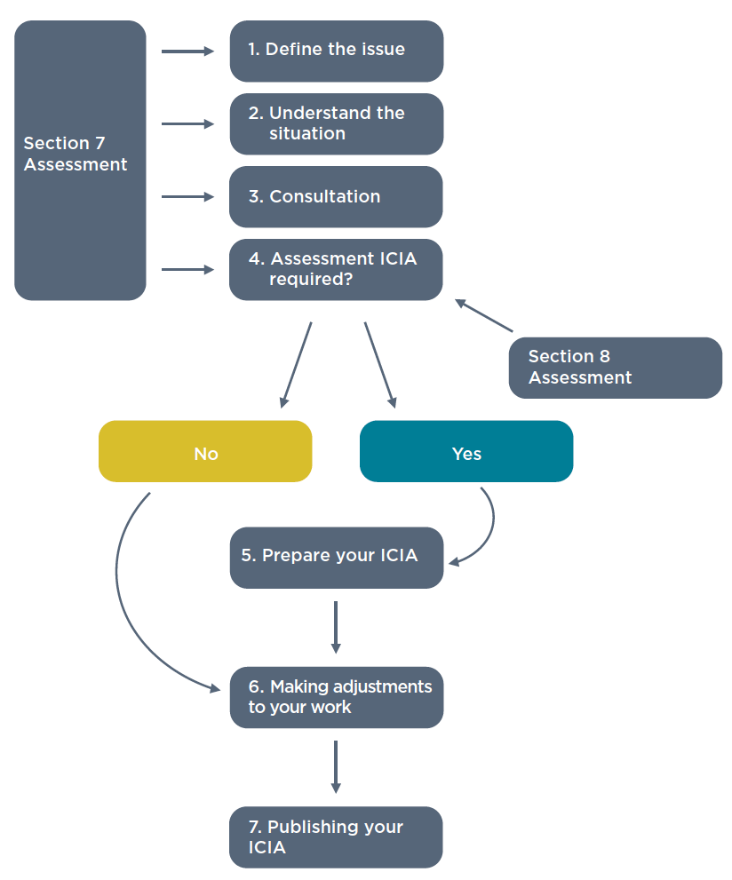

Methodology

Introduction
The approach for undertaking this ICIA and compiling this screening report follows a three-stage process:
- Review of the Island Communities Impact Assessments: Guidance and Toolkit
- Key issues and evidence – a review of potential impacts relating to transport for island communities using key datasets and where available considering future trends;
- High level assessment of screening impacts – informed by a consideration of the key issues and evidence.

Review of key issues and evidence
Evidence with regards to potential equality impacts as reviewed using the following sources of information:
- The Equality Evidence Finder;
- The National Islands Plan;
- Transport Transition Plan – EqIA Interim Update; and
- NTS2 Delivery Plan ICIA Screening Assessment.
Whilst for this report, existing evidence has been used and referenced in the screening assessment, a full key issues and evidence section outlining the most recent research and findings will be included with the ICIA screening report.

Screening impact assessment
The ICIA screening assessment has reviewed each of the actions within the Cycling Framework and provides an initial high-level assessment as to if and how the action has potential to affect island communities.
Screening guide questions used to undertake the screening assessment are set out below.
- How are islands identified for the purpose of the action?
- Is there evidence of different circumstances or different expectations or needs, or different experiences of outcomes (such as different levels of satisfaction or different rates of participation for island communities?)
- Should delivery mechanisms/mitigations vary in different communities?
- Could alternative delivery mechanisms improve or mitigate outcomes for island communities?
- Do we need to consult with island communities in respect of mechanisms or mitigations?
- Any potential barriers to engagement with island communities?
- Have any island-specific indicators/targets been identified that require monitoring?
- Will there be any unique impacts on island communities?
- Consider the intended impacts/outcomes and potential unintended impacts and how do these potentially differ in the islands.
- If the action is a regional or area-based one or if it is intended to have the same impact across the region or area, think about whether there are potential island impacts which differ from the regional impact or whether there are any barriers which may unfairly disadvantage islanders.
- For actions which are wholly or mainly aimed at island communities, consider whether there is a need to adapt your plans to account for variations across island communities. Island communities are unique and there can be lots of variation across things like proximity to services, transport links and infrastructure.
- If the action is mainland focused, is there a corresponding need in island communities, and has this been taken into account or catered for?
- Identify any benefits for the island community, such as better access to services.
- Are these potential impacts significant/likely? Could they result in disadvantage for island communities compared to the mainland or between island groups?
- Can the action be developed or delivered in such a manner as to improve or mitigate, for island communities, the outcomes arising from it?

Key Issues and Evidence
  - Introduction
The section provides a summary of key transport issues pertinent to the ICIA. A full key issues and evidence section will be provided as part of the final ICIA following feedback from stakeholders.
The Islands (Scotland) Act 2018 defines an island community as a community which consists of two or more individuals, all of whom permanently inhabit an island (whether or not the same island), and is based on common interest, identity or geography.
Island communities face challenges compared to mainland and urban areas with regards to transport. Engagement undertaken as part of the development of NTS2 identified the following concerns and unique challenges relevant to island communities:

- centralisation of public transport and limited provision in peripheral areas;
- poor journey connections, lack of seamlessness and lack of ticket integration;
- car dependencies due to poor public transport links;
- insufficient active travel infrastructure on islands;
- limited evening and weekend public transport services, resulting in difficulties accessing services and participating in social/community activities;
- incoherent, inconsistent and confusing public transport timetables across all modes;
- the ability of public transport to meet the needs and expectations of tourists and visitors, especially to Scotland’s islands;
- higher costs of accessibility on islands and in rural areas;
- imbalance of service provision and demand to meet concessionary transport needs; and
- call for more flexible and pro-active support needed for the berthing of cruise ships at ports.

Island communities have similar issues to those living in remote and rural areas, but in many cases the challenges can be greater. Research has shown that the minimum income that households require for an acceptable standard of living in Scotland’s island communities is well above that required in the rest of the UK, and in many cases higher than in other areas of rural Scotland. Island rurality can exacerbate inequality already experienced by certain groups including those facing socio-economic disadvantage or those with protected characteristics. The ICIA for NTS2 identified that factors resulting in additional costs for households in island communities compared to the rest of the UK include:

- longer commuting distances compounded by higher fuel prices;
- issues around integrated timetabling;
- the additional cost incurred with the need to make occasional trips to the mainland;
- additional ferry/air costs for inter-island travel. Island communities can also face additional freight costs, such as to get goods, including farming and seafood produce, to market or to import energy sources or building materials and labour. Additional charges for deliveries can also be a challenge.
  - Travel Behaviours
For school-aged children, walking is the most common mode of travelling for school across Scotland (in excess of 40% mode share for Primary and Secondary schools), which contrasts to travel behaviours of working age adults who generally travel to work by either car or van. Pupils attending Secondary and Special Educational Needs educational facilities are significantly more likely to travel by bus rather than be driven by car to school.

Young people in island and rural areas are noted to be particularly reliant on Public Transport to access educational, employment opportunities as well as for leisure and recreational purposes. However, the high cost and low provision of services and facilities in island and rural areas presents a significant barrier for young people to access employment, leisure, health and education facilities. Therefore, having a driving licence and being able to afford a car is sometimes a necessity for large swathes of young people across Scotland, most notably in island and rural locations. Lack of cycle infrastructure and the long distances needed to travel in order to access services and facilities can often mean that cycling is a less favourable option. For short journeys within island communities, cycle journeys are often made on narrow roads, where availability of land and road space is limited.

The situation is more complex for people on low incomes living in rural areas. People in rural areas drive more frequently than those in urban areas. The issue of ‘forced’ car ownership has been identified in both rural and urban areas but is particularly pronounced in rural areas where lack of public transport means that people can be forced into running a car even if it puts real pressures on their budget.

Bus use is higher in urban areas and lower in rural areas with The Scottish Household Survey travel diary highlighting that 53 per cent of those who used the bus the previous day lived in large urban areas compared to three per cent of users living in remote rural areas. (This compares to population estimates of 35% living in large urban areas and 6% living in remote rural areas.)
Research by Citizens Advice Scotland in 2016 found that the price varied across Scotland’s bus routes ranging from 7p per mile to £1.80 per mile. The costs of travel to essential services were generally much higher in remote rural areas; the average return cost of travelling to college in Scotland was £6, for example, but was £10.50 in remote rural areas.
  - Transport Poverty
Work undertaken by Sustrans highlights around one million people across Scotland live in ‘high risk’ zones and are vulnerable to transport poverty. A high risk of transport poverty is identified as being greatest in regions with (relatively) low income, high car availability and limited access to essential services by public transport. The majority of high-risk data zones for transport poverty (that is, nearly 30% of high-risk data zones) are located in accessible rural areas and small towns (28%). Only 20% are located in remote rural areas, 13% in remote small towns/very remote small towns, and 9% in remote/very remote small towns, and 9% in large/other urban areas. Of the 16 data zones allocated the maximum risk score, all are located within rural areas located predominantly in Council Areas covering the Scottish Islands. Over 90 per cent of the zones considered within the Na h-Eileanan Siar council area categorised as being high risk, other local council areas with island communities such as Argyll and Bute and Orkney also had a notable proportion of zones categorised as high risk for transport poverty.
  - Tourism
In the years preceding the COVID-19 pandemic, visitor spend in the Highlands and Islands region was worth around of £1.5bn and, in some areas, jobs in tourism represented up to 43% of the workforce. Estimates place cycle tourism at £345 million per annum across Scotland. These two tourism themes intersect via long distance routes on the National Cycle Network (NCN) such as the Caledonia Way in Argyll and on the Hebridean Way in Na h-Eileanan Siar. There is further evidence that sustainable growth in the cycle tourism sector can be brought about by further investment in the NCN and that this could bring further benefits to island communities .

Screening Summary
This section summarises the results of the screening exercise which are presented in full in Appendix A. Below is a summary of the screening exercise, drawing out the potential impacts (positive and negative) from the actions within the delivery plan.
Overall, actions as set out within the Cycling Framework are expected to have a broadly positive impact on island communities by encouraging greater use of cycling for shorter journeys and improving integration of active travel facilities and infrastructure with public transport. Increasing provision of cycle storage on bus services could have particular benefits for rural and island communities where longer-distances are often a necessity and cannot be easily covered by bicycle alone. However, support for small bus companies must also be considered within this.
Support for development of active travel networks which build on the national cycle network could also encourage sustainable tourism, which could also bring benefits to island communities while actions to improve cycling safety along the trunk road network will have potentially significant benefits for residents of the Isle of Skye.
There are expected to be benefits of increasing awareness, understanding and competency of maintaining and riding bicycles across all use groups through providing training opportunities as well as providing free bicycles to all school aged children. However, it must be noted that some local authorities containing rural and island communities have previously adapted their cycle training programme to their local circumstances and dispersed communities and this could be acknowledged further in the Cycling Framework.
Potential adverse impacts for island communities could be incurred if funding for active travel is based on strategies which favour an approach to network planning more suited to dense urban centres. Similarly, it is unlikely that conurbations within island communities would lend themselves to measures such as active freeways and it must be ensured that island communities do not experience a differential level of cycle provision as a result. Active travel strategies guidance should, therefore, contain provision for infrastructure to be planned for the specific circumstances of island communities.
There remains some uncertainty over the impact that changes to statutory processes such as land acquisition and traffic regulation orders could have on island communities. If such changes alter the ability of island communities to influence decisions about land or road space allocation, impacts could be either positive or negative.

- : Cycling Framework ICIA Screening Tables
Strategic Theme | Action | Ref. | How is the Action likely to impact on island communities? | Comments and evidence relating to these groups with regards to the action
 |  |  | ICIA
Safe Cycling Infrastructure | Produce active travel strategies and maps for each local authority area setting out plans to improve active travel networks and facilities to 2030 using a robust evidence-led approach to network planning. The active travel strategies will provide the basis for funding applications by local authorities. | CI.1 | ? | Though it is not given in detail, this action has the potential to negatively impact island communities by favouring an approach to network planning which is more suited to dense urban centres than dispersed populations. Island communities would therefore be at a disadvantage in funding applications, when compared to more urban Local Authority areas. AT strategies guidance should contain provision for infrastructure to be planned for the specific circumstances of island communities. Perhaps different intervention rates should be applied in island and rural communities.
 | Produce an active travel network ‘blueprint’ for Scotland, including the future network of Active Freeways and is informed by Local Authority Active Travel Strategies. | CI.2 | ? | There is some uncertainty around the way in which such a blueprint would be implemented in island communities. It is unlikely that conurbations within island communities would lend themselves to measures such as active freeways and it must be ensured that island communities do not experience a differential level of cycle provision as a result. This detail may be picked up through guidance on active travel strategies and perhaps this should be referenced.
 | Build and maintain a dense network of connected cycling infrastructure in every town and city that is separate from traffic and integrated with public transport, and rural routes that link to these networks and interface with the trunk road network and NCN. | CI.3 | ✓ | The impact on residents and businesses could be generally positive if Active Travel demand increases at a local level. The option could also further encourage sustainable tourism through linking with existing National Cycle Network routes, settlements and popular tourism destinations. Option would however, in its current wording, would disproportionately benefit urban settlements and impacts may not be experienced in more rural island locations.
 | Work with other policy areas to introduce active travel networks as part of a larger package- such as 20 mph limits to create efficiencies. | CI.4 | ? | Further information on type and scale of measures that could feasibly be delivered for island communities would need to be provided to enable the potential impacts to be assessed.
 | Use the information in the active travel strategies to prioritise investment in the creation of cycling infrastructure integrated with public transport in every town and city, and inter-urban / rural routes that link to these networks. This will build on the National Cycle Network and proposals for Active Freeways in STPR2. | CI.5 | ✓ | This option should have positive impacts through improving accessibility and attractiveness of multi-modal journeys, particularly over longer distances. As well as considering opportunities to increase access to educational, health, employment and leisure opportunities for existing communities the option could further improve transport offering for the tourism sector.
 | Avoid delays in implementation of cycling infrastructure by revising the TRO process. | CI.6 | ? | Island communities may be either positively or negatively impacted by this proposed action, if any changes to the TRO process result in alteration to the level of consultation required.
 | Develop an action plan to make it safer to walk, cycle and wheel across and along trunk roads, especially where they pass through towns and villages. | CI.7 | ✓ | As the A87 trunk road travels along the length of the Isle of Skye, this action has the potential to positively impact on communities living on Skye, where provision for cyclists beyond the trunk road network is sparse.
 | Continue to support fast implementation of temporary cycling infrastructure, introducing Experimental Traffic Orders to support road space reallocation and street trials. | CI.8 | ? | Island communities may be either positively or negatively impacted by this proposed action, if changes to the ETRO process result in alteration to the level of consultation required.
 | Enhance permitted development rights for cycling facilities and infrastructure | CI.9 | - | The Town and Country Planning (General Permitted Development) (Scotland) Order 1992 details 'permitted development' types. This Order was amended in 2014  - https://www.legislation.gov.uk/uksi/1992/223/contents/made  The order relates to householders, rather than planning authorities and is unlikely to impact on island communities in particular.
 | Respond to the needs of local people by expanding the resources needed to support more people to cycle, including appropriate cycle storage for every household. | CI.10 | ✓ | Increasing provision of cycle storage will provide positive impacts in locations where cycling is a viable method of travel.
 | Introduce fast-track powers to acquire land for cycling infrastructure. | CI.11 | ? | Section 22 of the Land Reform (Scotland) Act 2003 contains provision for a core path to be enforced via means of a path order  - https://www.gov.scot/publications/part-1-land-reform-scotland-act-2003-guidance-local-authorities-national-park-authorities/documents/).  Reallocation of land for cycling infrastructure within the limits of the adopted road network is within the powers of local authorities via the TRO process. The Acquisition of Land (Authorisation Procedure) (Scotland) Act 1947 provides for the compulsory purchase of land by a public body (Acquiring Authority), if confirmed by Scottish Ministers. The Land Reform (Scotland) Act 2003 also extends the powers of an Acquiring Authority to some non-public bodies. These powers extended to any development, including land for cycling infrastructure. However, this is a costly and lengthy process.  Procurement of land outwith the above legal processes would be subject to negotiation with individual private land owners. Fast-track powers which do not include a sufficient element of consultation and engagement with local communities, including crofters could have potentially significant negative impacts.
 | Provide ongoing development and governance of design guidance, including mitigation of unintended impacts vulnerable road users and that infrastructure is suitable for adaptive bikes e.g. pedestrians. | CI.12 | ? | This action has the potential to impact island communities by favouring an approach to network planning which is more suited to dense urban centres, unless specific provision island communities is considered.
 | Develop a national approach to the creation of quiet road/cycle friendly roads in rural areas with everyday journeys prioritised. | CI.13 | ✓ | Could have significantly positive impacts for Island communities, where additional road space is unavailable for segregated or remote cycle routes.
 | Designate the active travel network as a national development. | CI.14 | ✓ | The Draft National Planning Framework (NPF4) includes a designation of the National Walking, Cycling and Wheeling network as a national development. Delivery is expected to specifically deliver tourism benefits and integrate with existing maritime gateways across the Islands, as well as primarily increasing Active Travel offering withing principal settlements. Impact on rural communities will be less pronounced and may be negligible in some instances.
 | Update design and asset management guidance to enable national, consistent principles of infrastructure | CI.15 | ? | This action has the potential to impact island communities by favouring an approach to network planning which is more suited to dense urban centres, unless specific provision island communities is considered.
 | Support cycling journeys, to and from public transport hubs as part of a multi-modal journey | CI.16 | ✓ | This would benefit those who live and work near to these transport hubs, predominantly in urban areas, through being offered a wider offering of transport modes. This option has the potential benefit of increasing accessibility to other modes (e.g. Bus) and facilitate longer distance journeys.
 | Promote cargo bikes as the normal choice for local deliveries | CI.17 | ? | This may alter how goods are delivered across the Islands, especially for communities which are more-remote than other areas. Further information would be required to understand potential impacts.
 | Support government funded agencies to remove on-site car parking spaces and replace them with cycle parking | CI.18 | ? | Consideration needs to be made to travel demand and patterns across Island communities, where travelling via car or van is sometimes the only practical option. Further information would be required on this option to understand the potential impacts on access to services, facilities and employment opportunities.
 | Promote the new Highway Code and implement requirements for cycle training | CI.19 | ✓ | Improving safety for all road users should increase driver behaviours and encourage increased awareness when driving.
 | Support the various deliverables set out in Scotland’s Road Safety Framework 2030. Delivery Plans under its Active and Sustainable Travel Strategic Action | CI.20 | ✓ | The total cost of collisions to Scotland was £1billion in 2018 compared to a GDP of £180billion.  https://www.transport.gov.scot/media/46069/reported-road-casualties-scotland-2018.pdf  Reducing Road Traffic Collisions through delivering safety improvements will benefit a wide range of user-groups across Island communities, particularly when considered with high-levels of car ownership and access across Island households.
Effective Resourcing | Provide multi-year long-term funding for infrastructure and behaviour change programmes, include trials for road space reallocation linked to active strategies and active travel network plans. | ER.1 | ✓✓ | low-carbon and low-cost transport mode choice to be implemented, specifically targeted to benefit unique needs of user groups across island communities.
 | Provide appropriate level of resource to support local authorities to develop and deliver active travel strategies ensuring that cycling for transport is prioritised appropriately. | ER.2 | ✓✓ | Would catalyse AT strategy delivery and encourage more sustainable travel behaviours to decarbonise the transport sector, also health benefits and improving access to services, facilities and amenities.
 | Work with manufacturers, social enterprises and industry vocational partners to increase cycle and cycle parts production in Scotland, including e-bikes and e-cargo bikes and with Scottish businesses to grow the bike refurbishment industry especially through support for bike recycling and re-use enterprises. | ER.3 | ✓ | Would stimulate enterprise and encourage economic growth within Island communities, further diversifying economic offering. However, the challenge of distribution of goods, people and services between some island communities needs to be considered.
Fair Access | Expand access to bikes, including adaptive bikes. | FA.1 | ✓ | Option likely to increase access to cycling, although services are generally located in urban areas and consideration needs to be applied to how such an offering could be delivered to serve both rural and urban communities in the Islands. Offering could also be twinned with tourism offering to further encourage sustainable tourism in some areas.
 | Review funding criteria to ensure that fair access is appropriately weighted and improving accessibility is given an appropriate level of priority. | FA.2 | ✓ | Some island communities suffer from Transport Poverty and have identified needs to improve accessibility for alternative transport modes to move away from reliance on travel by car / van. Whilst in some instances this mode will be required for some communities, improving accessibility with and between settlements across the islands will provide a positive benefit.
 | Improve quality and level of service of carriage of bikes on trains and require rural & island bus services to carry cycles, wherever possible | FA.3 | ✓ | Lack of rail services on Scotland's Islands means that this option only applies for Bus Services. Option would enable more multi-modal trips to be made. However, need for increased provision would need to be considered in context of existing passenger capacity, particularly on smaller, yet crucial, services. Enables more multi modal trips. Needs to consider impact on passenger capacity on busy routes. Potential to also benefit tourism sector through offering increased access to popular destinations.
 | Implement safe cycle routes to public transport interchanges and increase the provision of high quality bike storage. | FA.4 | ✓ | Expected to have a positive impact, particularly within existing settlements across the Islands for both residents and visitors to increase accessibility by cycle to access Public Transport modes. Increase share of multi modal journeys, can be coupled with gateways to provide tourism benefits. Improving access to Public Transport hubs will enable a wider network of Active Travel infrastructure to be considered and developed.
Training and Education | Provide a comprehensive cycle training offer for all life stages, including learning to ride in pre-school, learning to ride on-road through school bikeability training, and for adults of all ages, including cycle awareness training. | TE.1 | ✓✓ | This option will enable the development of an awareness, understanding and proficiency in riding and maintaining a bicycle. This will encourage low-carbon journeys, particularly over shorter distances and increase accessibility to health, educational, employment and educational facilities and services. Potential to alleviate transport poverty which exists across island communities through enabling low-cost journeys to be made. Such opportunities in Island communities are not always readily accessible via cycling and consideration would need to be applied of the potential benefits for more rural households.
 | Provide a free bike to all children of school age who cannot afford one | TE.2 | ✓✓ | Likely to increase access to cycling for young people across all income levels, however for some young people due to the distance of travel required it would still not be potentially feasible nor practical to cycle to school. However, the option is likely to increase access to wider opportunities and provide a low-cost form of travel to young people, in communities where Public Transport fares are generally high.
 | Support communities to introduce Play Streets, enabling roads to be closed to allow for small events and sports and introduce legislation to enable Auto Number Plate Recognition for the closure of school streets | TE.3 | ? | Whilst the option is recognised as a positive intervention, further information in relation to baseline conditions to understand whether this specific intervention is required for island communities where travel demand patterns are different to that of more-urbanised communities in the Scottish Mainland.
 | Use the Cycling World Championships to inspire people, especially young people to cycle. | TE.4 | ✓ | Action aimed at encouraging young people to take up cycling, which may provide them with wider opportunities. The relative remoteness of some Island communities means that the impact may not be particularly significant.
 | Introduce pilot schemes at schools to provide an alternative to the school bus with segregated cycle routes, cycle training, provision of bikes, facilities at school | TE.5 | ✓✓ | The distances to some educational facilities in Island communities means that it is not sometimes viable, nor practical to travel by Active Mode. Whilst segregated cycle routes may not be practical in some instances due to existing identified challenges and constraints, particularly in rural areas, other suggested measures will encourage sustainable travel behaviours - particularly in urban areas where shorter trips by cycle are more feasible and practical.
 | Develop a long-term communication plan that represents cycling as something that anyone can do, including with assistance/adaption and is a transport mode that brings many benefits to Scotland | TE.6 | ✓ | Communication may raise awareness and understanding across various user groups, particularly those wishing to cycle more. However, consideration would need to be applied to message in the context of Island communities, particularly recognising that cycling as a transport mode is not always a viable and practical option.
Network Planning & Monitoring | Support the travel demand management measures aligned with the national 20% car km reduction route map | NPM.1 | ? | This target is noted to broadly apply to reducing the frequency of short-distance car trips, primarily within heavily urbanised areas and underlying issues that are sought to be addressed may not be fully representative at an island-community level. Further information would be required to enable the potential impacts to be considered.
 | Conduct research on the social, environmental and economic factors influencing network planning, for example pandemic recovery and climate change impacts. | NPM.2 | ✓ | Likely to provide positive benefits for how network planning is considered at an Islands perspective, however assessment criteria may need to be expanded to reflect differing processes undertaken in island communities at both an urban and rural scale.
 | Continuously monitor and evaluate the impact of active travel infrastructure and embed learning in future investment decisions . | NPM.3 | ✓ | Would increase knowledge sharing of best practice when considering and developing future Active Travel facilities and infrastructure, however future investment decisions must be informed by a variety of case studies and consideration must be applied to include relevant references from infrastructure and facilities delivered across the Islands.
 | Review how active travel/cycling schemes are appraised – broaden the benefits to include social, economic and equality benefits. | NPM.4 | ✓ | This option would support Active Travel appraisal for interventions were they have broadly low Value for Money (i.e. Benefit-to-Cost ratio) but have much wider health, equality and socio-economic benefits. This option would complement the recent Green Book Update by HM Treasury which emphasised the role and importance of the Strategic Fit of development proposals, moving away from solely focusing on the Value for Money criteria.
 | Expand and where possible align monitoring and reporting of cycling levels at local, city, regional and national level and share learning | NPM.5 | ✓ | Option likely to improve data at local and regional level across Islands and their communities, consideration would need to be made to how monitoring and reporting can be expanded to gain a representative sample size of user groups and prevent process disproportionately collecting data solely in urban areas.

aecom.com

Transport Scotland, Active Travel Framework https://www.transport.gov.scot/media/47158/sct09190900361.pdf
Transport Scotland (2019) National Transport Strategy https://www.transport.gov.scot/media/47052/national-transport-strategy.pdf
Update to The Climate Change Plan 2018 - 2032 https://www.gov.scot/publications/securing-green-recovery-path-net-zero-update-climate-change-plan-20182032/
The Scottish Government (2021) Draft National Planning Framework (NPF4) https://www.transformingplanning.scot/news/news/draft-national-planning-framework-npf4-published/
Transport Scotland (2022) Draft Equality Impact Assessment - A route map to achieve a 20 per cent reduction in car kilometres by 2030
Transport Scotland (2021) Scotland 2045: fourth National Planning Framework - draft: society and equalities impact assessment
Transport Scotland (2022) Strategic Transport Projects Review 2 - Equalities & Statutory Impact Assessments
Scottish Government (2019) National Islands Plan. Available online at https://www.gov.scot/publications/national-plan-scotlands-islands/
Scottish Government (2020) Island Communities Impact Assessments: Guidance And Toolkit. Available online at https://www.gov.scot/publications/stakeholder-consultation-document-island-communities-impact-assessment/
Available online at http://www.equalityevidence.scot/
Available online at Transport Transition - EQIA Interim Update: September 2020
Available online at https://www.transport.gov.scot/consultation/nts2-delivery-plan-impact-assessments-consultation/
Highlands and Islands Enterprise (2013) A Minimum Income Standard for Remote Rural Scotland: Summary and Key Findings. Available online at https://www.hie.co.uk/media/3191/aplusminimumplusincomeplusstandardplusforplusremoteplusruralplusscotlandplus-plussummaryplusandpluskeyplusfindings.pdf
Sustrans (2020) Hands Up Survey Scotland National Summary Report https://www.sustrans.org.uk/media/9168/hands-up-scotland-survey-2020_national-summary-report.pdf
Scottish Transport Statistics No.39 2020 Edition, Transport Scotland, 2020, https://www.transport.gov.scot/publication/scottish-transport-statistics-no-39-2020-edition/
Round The Bend, Citizens Advice Scotland, 2016, https://www.cas.org.uk/publications/round-bend
Transport Poverty in Scotland, Sustrans, 2016, https://www.sustrans.org.uk/media/2880/transport_poverty_in_scotland_2016.pdf
Highlands and Islands Enterprise (2015) Sustainable Tourism Growth Sector Baseline https://www.hie.co.uk/media/6432/sustainableplustourismplusreport.pdf
Transform Scotland (2018) The Value of Cycling to Scotland’s Economy https://www.cycling.scot/mediaLibrary/other/english/2548.pdf
Sustrans (2020) The Caledonia Way https://www.sustrans.org.uk/find-other-routes/the-caledonia-way
Sustrans (2020) The Hebridean Way https://www.sustrans.org.uk/find-other-routes/the-hebridean-way
Transform Scotland (2018) Routes to Growth. Developing Scotland’s Cycle Tourism Sector https://transform.scot/wp/wp-content/uploads/2018/06/Routes-to-Growth-Transform-Scotland-report-version-2018-06-22.pdf

