SEA Environmental Report Appendix C: National Baseline
December 2022

Contents
1. National-Level Environmental Baseline 1
1.1. Background 1
2. Climatic Factors 2
2.1. Baseline 2
2.2. Inter-relationships with other SEA Topics 9
2.3. Evolution of the Baseline and Trends 11
3. Air Quality 11
3.1. Baseline 11
3.2. Interrelationship with other SEA Topics 14
3.3. Evolution of the Baseline and Trends 15
4. Population and Human Health 16
4.1. Baseline 16
4.2. Interrelationship with other SEA Topics 21
4.3. Evolution of the Baseline and Trends 23
5. Material Assets 24
5.1. Baseline 24
5.2. Interrelationships with other SEA Topics 29
5.3. Evolution of the Baseline and Trends 29
6. Water Environment 34
6.1. Baseline 34
6.2. Interrelationships with other SEA Topics 36
6.3. Evolution of the Baseline and Trends 37
7. Biodiversity, Flora and Fauna 39
7.1. Baseline 39
7.2. Interrelationships with other SEA Topics 42
7.3. Evolution of the Baseline and Trends 42
8. Soils 44
8.1. Baseline 44
8.2. Interrelationships with other SEA Topics 49
8.3. Evolution of the Baseline and Trends 50
9. Cultural Heritage 52
9.1. Baseline 52
9.2. Interrelationships with other SEA Topics 54
9.3. Evolution of the Baseline and Trends 55
10. Landscape and Visual 57
10.1. Baseline 57
10.2. Interrelationships with other SEA Topics 58
10.3. Evolution of the Baseline and Trends 60

National-Level Environmental Baseline

Background
It is a requirement of the Environmental Assessment (Scotland) Act 2005 that plan-making authorities provide details of the character of the environment which may be affected by their plan, including any existing pressures and the likely evolution of the environment in the absence of the plan. STPR2 will be assessed against this baseline to provide an indication of the type and significance of any environmental impacts that could arise.
There are many requirements for environmental protection and enhancement detailed within existing legislation, policies, plans and strategies at the international, UK and national levels across all the SEA topics. These requirements form the context for the SEA. Under each SEA topic, a high-level summary of the existing environmental protection requirements is provided in Appendix B (Plans, Programmes & Strategies).
The environmental baseline covered in this appendix applies to the whole of Scotland. Presenting the baseline at national level allows the SEA to reflect on the interaction of the STPR2 with wider environmental trends. The baseline provided in Appendix D is at the regional scale and relates to each of the 11 STPR2 regions described in the main Environmental Report.
Current trends and pressures will be explored further for each SEA topic scoped into the assessment, and information will be drawn from a range of sources, including the Scottish Government, NatureScot, Historic Environment Scotland (HES), the Scottish Environmental Protection Agency (SEPA), and Scotland’s Environment Web, amongst others.
Scotland includes a wide range of natural capital assets, including, forests, moorland, rivers, lochs, farmland, coastal areas as well as the seabed. As stated in the Natural Capital Asset Index, a range of benefits or ecosystem services can be derived from these assets and these will be set out in the baseline.

Climatic Factors

Baseline
Greenhouse Gas Emissions
There is consensus in the scientific community that anthropogenic climate-change poses an ongoing threat to the planet. The uninhibited consumption of fossil fuels since the industrial revolution has steadily increased the atmospheric concentration of greenhouse gases to unprecedented levels. This increasing concentration has amplified the ‘greenhouse effect’ where the carbon dioxide (CO₂) traps heat from the sun, resulting in higher average global temperatures. A minor increase in global temperature threatens to imbalance delicate tipping points, causing uncontrollable and irreversible changes to ecosystems, such as melting permafrost that would release significant amounts of methane and the melting of polar ice caps, causing sea-level rise.
Climate-related risks for natural and human systems are higher for global warming of 1.5°C than at present. There is a fifty-fifty chance that global warming will exceed 1.5°C in the next two decades, and unless there are immediate, rapid and largescale reductions in GHG emissions, limiting warming to 1.5°C or even 2°C by the end of the century will be beyond reach. The COVID-19 pandemic led to an unprecedented 5.4 per cent drop in global fossil carbon dioxide (CO₂) emissions in 2020. At the time of writing, the effects of the Covid-19 pandemic and associated travel restrictions on Scotland’s greenhouse gas emissions are not entirely clear. However, a report undertaken by Element Energy for Transport Scotland has found that, while the immediate impact of the pandemic has been very large, the longer-term impacts, which might still be felt by 2030, are small when compared to the level of economy wide change needed to meet Scotland’s emissions targets. One of the key reasons why the pandemic is not expected to radically increase or decrease emissions is because it is very unlikely that we transition to a future where predominantly emission positive or emission negative changes prevail.
Some of the key trends in climate change worldwide are shown in Figure 1.
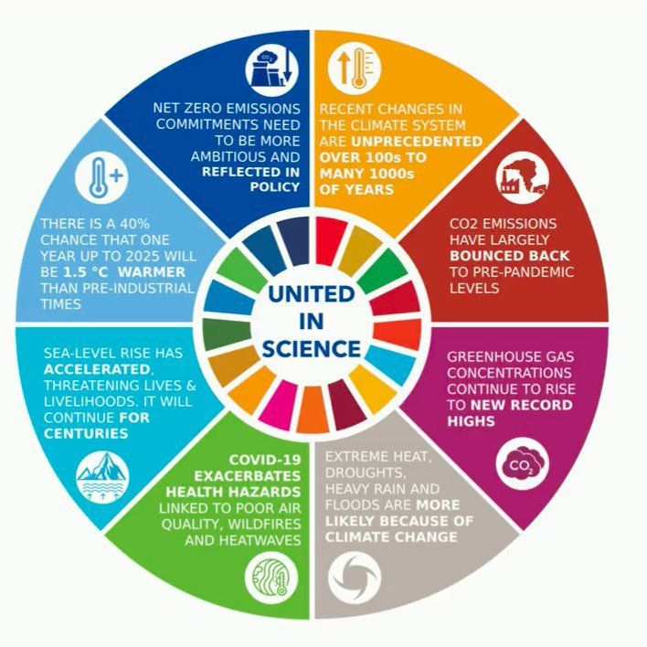
Figure 1. Global climate change trends. Source: WMO, 2021
Transport accounted for 35.6% of Scotland’s total greenhouse gas emissions in 2018, with cars being the highest emitting transport mode of the year, accounting for 39% of all transport emissions, as shown in Figure 2 below. Goods vehicles (heavy and large) accounted for 26% of transport emissions in 2018, while aviation and shipping accounted for 15% and 16% respectively, and other transport modes accounted for 5%. However, 2018 also marked the first year since 2013 that emissions decreased in Scotland, with transport emissions in 2018 being 1.1% lower than in 2017, and 0.5% lower than in 1990. Despite this, between 1990 and 2018 car emissions increased by 1%, reportedly due to an increase in activity, and partially offset by improvements in vehicle efficiency. Furthermore, Large Goods Vehicle (LGV) emissions saw the largest percentage increase (93.7%) of all transport modes during this period, while aviation and rail emissions also increased substantially (by 58.9% and 27% respectively) between 1990 and 2018.
Estimates of CO₂ emissions per passenger-km for different modes of transport are available only for GB/UK as a whole. The lowest emitting modes of transport per passenger-kilometre (km) are national coaches and national rail, with approximately 28 and 47 grams of CO₂e respectively. Air travel tends to be the highest emitter per passenger-km, particularly domestic flights, which account for 141 grams of CO₂e per passenger-km.
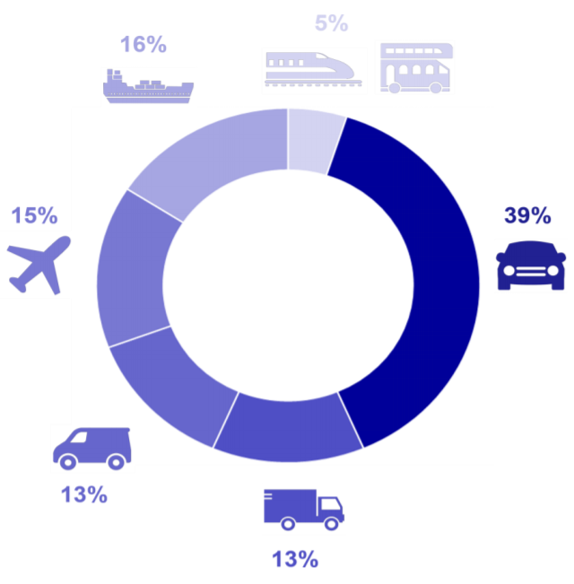
Figure 2. Modal share of Scottish greenhouse gas emissions in 2018
Action that sets out to decarbonise the transport sector through increased electrification, particularly for road transport, could deliver significant climate benefits. However, the demand for electricity is expected to increase modestly as a result of the electrification of transport, to around 8% greater than the current UK wide peak demand by 2046.
In Scotland, soils and peatland are the biggest terrestrial store of carbon. Peatlands alone hold approximately 1.6 billion tonnes of carbon, which is 60 times more carbon than stored by trees and other vegetation. Water also acts as a large store for blue carbon, with 18 (MtC) or organic carbon stores found in the top 10cm of sediments throughout Scotland’s seas. 9.4Mt of organic carbon and 47.8 Mt of inorganic carbon is also found within surface inshore sediments of Special Areas of Conservation and Nature Conservation Marine Protected Areas and the habitats they support.
In response to the global climate emergency, Scotland’s Climate Change Plan Update in 2020 set out a commitment to reduce car kilometres by 20 per cent by 2030. Scotland’s Climate Change Plan update states clearly that while technological solutions will be key in in some areas, transformational change is also required with behavioural change and demand management needed to meet the country’s stretching targets.
The 26th UN Climate Change Conference of the Parties (COP26) took place in Glasgow between 31 October and 12 November 2021. The COP26 summit brought parties together to accelerate action towards the goals of the Paris Agreement and the UN Framework Convention on Climate Change. Scotland’s climate change legislation sets a target date for net zero emissions of all greenhouse gases by 2045. The aim of the UK COP26 Presidency was to keep alive the hope of limiting the rise in global temperature to 1.5°C, which is recognised in the Glasgow Climate Pact.
Scotland has signed up to the following ‘Clean Transportation’ commitments through the Under 2° Climate Group, which includes over 260 governments globally:
- Promote sustainable communities that provide a range of affordable housing and transportation options that increase access to opportunity and reduce vehicle miles travelled
- 100% ZEV new light-duty sales by 2035
- 100% zero-emission med- & heavy-duty public fleets by 2040, where technically feasible
- 100% zero-emission light-duty public fleets by 2035,* or
- Where electric grid reliability is a concern, 100% zero-emission and plug-in hybrid public fleets by 2030, or
- 100% of new public fleet purchases are zero-emission by 2030 in developing regions.
- Reduce national car kms travelled by 20% (based on 2019 levels) by 2030.
Climate Change Trends and Impacts
The impacts of climate change will vary around the planet, with the worst consequences expected for the equatorial and polar regions. Low lying coastal areas are also at risk of rising sea levels and stronger storm surges. The Committee on Climate Change published the UK Climate Change Risk Assessment (CCRA3), which highlighted the costs of damage to key infrastructure from extreme weather events. Individual weather events are not attributable to climate change, rather climate change is the long-term trend in extreme weather. Flooding remains a key risk to infrastructure in Scotland, with little changing since CCRA2. Many high-profile events, such as storms Ciara and Dennis, and the 2020 breach of the Union Canal which resulted in significant damage to the
Edinburgh-Glasgow rail line have highlighted, with increasing confidence, the magnitude of such risks and their interactions and consequences. However, it is also evident that some limited progress has been made across the infrastructure sector in both assessing and adapting to the risk via a suite of flood protection measures.
Scotland has experienced an increase of approximately 1ºC in recent decades and annual rainfall has also increased about 13% above the average for the early 1900s. Northern Scotland has experienced a 70% increase in rainfall and the country as a whole has experienced 20% more rainfall since 1960. River flow analysis between 1961-2004 shows significant change in Scottish river flows in winter but no noticeable change in summer flows. Sea level rise in Edinburgh is predicted to be between 0.08-0.49m (low emission scenario) and 0.30-0.90m (high emission scenario). The frequency of sea level extremes such as storminess and storm surges are expected to be significantly worse by 2100. The frequency of extreme weather events has also increased; nine of the 10 warmest years in Scotland have taken place since 2002. The projected impacts of climate change on the transport network are described in the ‘material assets’ section of the baseline (Section 5). The 2018 UK Climate Projections (UKCP18), produced by the Met Office Hadley Centre, provide up-to-date information about the potential future climate in Scotland. The projections provide a range of potential climate outcomes, based on a set of four pathways for greenhouse gas emissions: a low emissions scenario (RCP2.6); two medium emissions scenarios (RCPs 4.5 and 6.0); and a high emissions scenario (RCP8.5).
Across all emission scenarios presented in UKCP18, there is a general consensus that Scotland’s future climate will be characterised by:
- Average temperatures increasing across all seasons;
- Our weather will remain variable and may become more variable;
- Typical summers will be warmer and drier;
- Typical winters will be milder and wetter;
- Intense, heavy rainfall events will increase in frequency in both winter and summer;
- Rising sea levels; and
- Fewer days / periods of frost and snowfall.
- The UKCP18 projections for temperature and rainfall in Scotland by 2070 are shown on
- 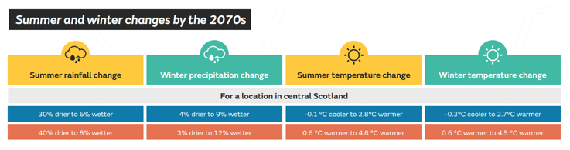
- Figure 3.
Figure 3. Summer and winter climate changes by the 2070s.
The risks of climate change on Scottish transport infrastructure include the following,:
- More flooding (of the road and surrounding land) and erosion (mainly focused on the surrounding soils rather than the transport infrastructure itself): a challenge for drainage systems and erosion protection (on embankments) and for the design and maintenance of culverts and bridges.
- Landslides and avalanches: occurring more frequently, at new locations and with a higher share of ‘wet’ landslide types, such as slush avalanches and debris flow.
- Droughts and high summer temperatures may pose problems for asphalt surfacing, due to softening, but also for run-off conditions, due to lower permeability.
- Drier and hotter weather could lead to more incidents of infrastructure subsidence and heat damage to pavements and structures.
- Effects of sea-level rise on coastal stability and importance of ensuring sufficient elevation for roads, railways, quays, bridges and entrance levels for sub-sea tunnels.
- Sea level rise could make some areas temporarily or permanently inaccessible.
- Heavy snowfall in mountainous areas, causing trouble for winter maintenance and operation under difficult conditions.
- The need for better risk management and efficient procedures for initiating remedial actions after a weather-related event occurs, as existing protective measures may not be sufficient and that the planning of remedial measures requires time.
- Disruption of the network by storm events (rain, flash floods, snow, lightning, high temperatures).
- Damage to infrastructure or ancillary infrastructure, such as gantries or signage, by high winds.
- Damage to roads through deterioration, deformation and subsidence.
- Impacts of climate change such as extreme temperatures on traffic control centres, ICT and other transport-related infrastructure.
- An increase in the range, quantities and consequences of pests, pathogens and invasive species, negatively affecting terrestrial, freshwater and marine priority habitats species, forestry and agriculture. This could subsequently affect the transport network, for example if the spread of tree diseases affects tree stability and trees require maintenance or removal (as required for ash dieback).
- There are also potential impacts on transport infrastructure associated with meeting Scotland’s Net Zero goals, which will require significant changes in energy generation and transport, as shown below.

Examples of changes associated with Net Zero | Implications for UK infrastructure risk
Electrification of rail and road transport (electric vehicles) including smart charging infrastructure.  Use of alternative fuels. Hydrogen for rail; low carbon alternatives such as biokerosene for aviation.  Increased active travel (walking, cycling etc.).  Increased use of public transport.  Increased use of blue infrastructure | Increased reliance on electricity and ICT, with associated potential for cascading risks from weather-related damage and disruption to this infrastructure.  New flood risks to new infrastructure (e.g. electric vehicle charge points).  As yet unassessed risks associated with new infrastructure (e.g. Hydrogen production, distribution and storage).  Health and safety risks to increased numbers of cyclists and pedestrians from extreme weather.

Inter-relationships with other SEA Topics
SEA Topic | RElationship with Climatic factors
Biodiversity | Habitats in Scotland have significant carbon sequestration value but are also important for biodiversity - for example, grassland habitats, coastal habitats, woodland and peatland. Any positive or negative effects of STPR2 on these natural assets would therefore affect both SEA topics. The impacts on biodiversity will depend on the temperature change (as shown in Figure 4) below, as well as the other climatic changes described in Section 2.1.  Any increase in salt spreading to counteract ice or extreme hot temperatures could potentially affect water quality and aquatic biodiversity through surface water runoff.
Air Quality | Air quality and climate change are inherently linked. Extreme weather events as a result of climate change can negatively impact air quality. For example, during heat waves, areas of high pressure create stagnant air that concentrates air pollutants in one area, and dry, dusty air during hot weather periods increases the level of particulate pollution.
Soils | Soils may be altered by changes to rainfall patterns, erosion and increased temperatures due to climate change, while the release of CO₂ sequestered in peat and carbon-rich soils from development contributes to climate change. The conservation of carbon-rich soils is therefore essential for climate change mitigation. Climate change may result in changes to rainfall patterns and the frequency of flooding. This in turn may cause erosion or change the frequency and severity of landslide events which could affect transport infrastructure.
Material Assets | The materials required to construct STPR2 interventions have embodied carbon emissions that will be released in the manufacture of components of the infrastructure. If natural material assets are within the footprint of these interventions (e.g. woodland, peat soils), these will have a high carbon sequestration and sink value and therefore need to be protected as far as possible.
Water environment | Climate projections indicate that Scotland will experience wetter winters and more regular high intensity rainfall thereby affecting the resilience of STPR2 interventions.  Any increase in salt spreading to counteract ice or extreme hot temperatures could potentially affect water quality through surface water runoff.
Cultural Heritage | Climate Change can threaten cultural heritage through erosion, flooding and wetter, warmer conditions. Through waterlogging, climate change could also influence landslide risk, soil creep and erosion levels (e.g. gully erosion) and hence any cultural heritage resources within soil.

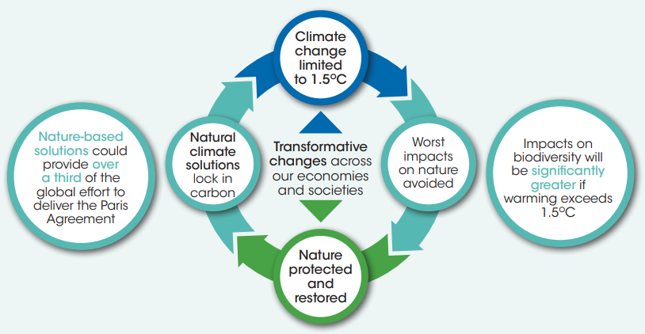
Figure 4. Climate and Biodiversity Relationship. Source: Scottish Government

Evolution of the Baseline and Trends
Climate change projections indicate that the climate trends observed over the last century will continue and intensify over the coming decades. Key long-term climate change trends for Scotland are that weather may become more variable, typical summers will be hotter and drier, winter and autumn will be milder and wetter and sea levels will continue to rise. Increases in summer heat waves, extreme temperatures and drought, as well as an increase in the frequency and intensity of extreme precipitation events, are also expected.
The Climate Change Committee’s 2020 annual progress report to the Scottish Parliament on emission reduction advised the Scottish Government to accelerate investments in low-carbon and climate adaptation infrastructure to stimulate the economy, build long-term productive capacity and improve climate resilience. In response, the Scottish Government’s 2020/21 Budget announced a £2 billion Low Carbon Fund - the first £165 million includes £25m for bus priority infrastructure and £15m for zero emission buses. Scotland’s Infrastructure Investment Plan includes £150m additional adaptation funds for flood risk management, £12m for sea level rise and £60m for the trunk road network.

Air Quality

Baseline
Poor air quality can have detrimental impacts on human health and quality of life. Air pollution stems from the release of substances into the atmosphere from a variety of sources, including organic and man-made sources. Regulations on pollutant sources and advancements in combustion technology have led to Scotland currently experiencing the best air quality since pre-industrial revolution times. Despite this, air quality is still a concern for many in the country, particularly those living in urban and industrial areas. The UK government estimates that air pollution reduces the life expectancy of every person in the UK by 7-8 months, with related costs of up to £20 billion to the economy annually.
Air pollution from human activities originates from combustion of fossil fuels in transport, industrial processes and agriculture. Air pollution from natural sources includes organic compounds from vegetation, sea salt, suspended dust particles and forest fires. The main air pollutants of concern in Scotland are nitrogen oxides (NO_{x}), particulate matter (PM₁₀ and PM_{2.5}), sulphur dioxide (SO₂), non-methane volatile organic compounds (NMVOCs), ground-level ozone (O₃) and ammonia (NH₃). Particles from brake, tyre & road surface wear formed 54% & 55% (by mass) of PM_{2.5} & PM₁₀ road transport emissions in 2018.
Particulates, NO_{x}, SO₂ and low-level ozone are the air pollutants considered to have the biggest impact on human health and the environment. Transport is a significant contributor to NO_{x}, PM₁₀ and PM_{2.5} emissions and the transport sector is the most significant source of air pollution in the UK. Transport generates just over one-sixth of Scotland’s total particulate matter and over one-third of the total emissions of nitrogen oxides. The majority of these emissions are caused by road transport. Emissions of NO_{x} from road transport are reducing but not at the expected rate. Between 1990 and 2018, transport emissions of NO_{x}, PM₁₀ and PM_{2.5} declined by 67%, 82%, and 82% respectively.
Traffic congestion in urban centres causes localised problems, particularly in areas where air flow is limited by buildings and narrow streets, so-called canyoning. Although transport emissions have been in decline, the rate of decline has plateaued, requiring additional measures to prevent an increase. The EU annual mean limit value for NO₂ (40μg/m³) is also still being exceeded at some city centre locations.
Ships and other marine vessels are also major contributors of air pollution including NO_{x}, sulphur oxides (SO_{x}), PM and VOCs, especially in regions with major ports. Particulate emissions from ships measured by the UK National Atmospheric Emissions Inventory domain remained stable between 2011 and 2020. In the same period, SO₂ decreased from 40% to 14% of total emissions and NOx increased from 45% to 73%.
Section 29(1) of the Environment Act 1995 requires local authorities to designate Air Quality Management Areas (AQMA) where air quality objectives are not being met. Scotland has declared 38 AQMAs, with 14 out of the 32 Local Authorities having declared at least one zone, almost all of which are located in urban areas due to emissions of NO_{x} and PM_{2.5/10} primarily originating from road transport. Appendix D specifies how many AQMAs have been declared within each of the 11 STPR2 regions.
Cleaner air provides multiple benefits and action taken, such as a shift towards a low or zero emissions transport and energy sources should provide mutual benefits for both air quality and climate change. Additionally, the decarbonisation of transport and reducing vehicle emissions should support wider Scottish Government objectives, particularly those seeking to improve health, through improving air quality.
To address air quality issues in urban areas, Scotland is committed to introducing Low Emission Zones (LEZs) in its four major cities, Glasgow, Edinburgh, Dundee and Aberdeen, between February 2022 and May 2022. LEZs work by imposing penalties on vehicles that do not meet the required standards if they enter the zone. Current air quality has been assessed as moderate, with most pollutants being within the safe limits, however there are still localised areas where limits are exceeded.
There are 100 automatic air quality monitoring sites that monitor air pollution around the country across a range of urban and rural locations, some of which are shown on Figure 5. The data gathered is processed in the Scottish Air Quality Database and is used to assess the state of and trends in air quality for Scotland.
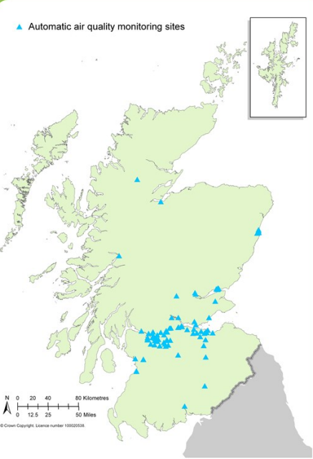
Figure 5. Air Quality Monitoring Sites

Interrelationship with other SEA Topics
SEA Topic | RElationship with Air Quality
Climatic Factors | Air quality and climate change are inherently linked. Extreme weather events as a result of climate change can negatively impact air quality. For example, during heat waves, areas of high pressure create stagnant air that concentrates air pollutants in one area, and dry, dusty air during hot weather periods increases the level of particulate pollution.
Population and Human Health | The link between air pollution and poor health has been set out in Section 3.1. There is potential for inter-relationships to arise with air quality and other population effects; for example, noise and vibration, visual impacts, or impacts on accessibility. A combination of impacts arising as a result of STPR2 has the potential for cumulative effects on population receptors; such effects will be considered throughout the design development of interventions and reduced where practicable through appropriate avoidance and mitigation measures.
Biodiversity | In relation to ecological receptors, air pollution can impact on the functioning of ecosystems; for example, the growth of trees and other fauna can be affected by acid and nitrogen deposition and sulphur dioxide. Air quality effects in relation to biodiversity are discussed in Section 7 (Biodiversity) of this appendix.

Evolution of the Baseline and Trends
Air quality in Scotland has improved considerably over the last few decades. Between 1990 and 2017 there were decreases of 15% for ammonia, 84% for carbon monoxide (CO), 71% for NOx, 65% for non-methane volatile organic compounds (NMVOCs), 63% for PM₁₀, 68% for PM_{2.5}, 96% for SO₂ and 97% for lead. However, data gathered from Scotland’s automatic air quality monitoring sites in 2012 showed that 22% of sites exceeded the national objectives for NO₂ and 16% for PM, although there are large fluctuations caused by traffic, making it difficult to highlight clear trends. Nevertheless, environmental trends suggest that, without mitigation, concentrations of air pollution may increase in the future, particularly in urban or industrial areas. Climate changes, such as higher humidity, could also potentially exacerbate the risks of worsening air quality to human health. Air pollution is still estimated to reduce the life expectancy of every person in the UK by an average of 7–8 months.
The ongoing Covid-19 pandemic has resulted in several short-term impacts on energy use, emissions, and some air pollutants in Scotland. During the first six months of the pandemic (March to September 2020), car traffic, bus patronage and rail patronage decreased by 25%, 15% and 8% respectively compared to 2019 levels, while cycling activity was higher than 2019 levels for most of the first six months of the pandemic. However, evidence suggests that such impacts have largely been driven by changes in societal behaviour (e.g. spending more time at home, changes to commuting habits etc.) rather than any environmental factors. At the time of writing, it is uncertain whether these short-term impacts on air quality in Scotland will continue, or if they will contribute to any longer-term environmental outcomes. Any changes will be dependent on the evolution of the pandemic itself, and if any of the positive societal behaviour changes observed are maintained.

Population and Human Health

Baseline
Scotland’s population was estimated at approximately 5.5 million in 2020, an increase of 2,700 people (0.05%) since 2019 and is expected to rise to approximately 5.7 million by 2041., The population is also projected to age as the large number of people around age 50 in 2016 become age 75 by 2041. Life expectancy has been increasing for several decades, but this upward trend has slowed in the recent past.
Scotland’s cities are where 70% of the population live, which accounts for just 2% of the land surface. Scotland’s major cities of Edinburgh, Glasgow, Dundee and Aberdeen are in the central belt and on the east coast. Approximately 12.4% of the population live in smaller towns of less than 10,000. Seventy percent of the people within the smaller towns are within a 30-minute drive of large settlements, with the remaining 30% of people being located remotely. However, due to the ongoing Covid-19 pandemic and consequent increased ability to work from home and diminished appeal of living in central hubs, new trends are emerging across the property market as people seek to relocate from city centres to suburban areas. As a result, there has been a significant increase in both the number of homes available for rent in cities across the UK, and in letting agency enquiries about suburban properties from people who have previously rented. In the last quarter of 2020, the number of renters in Edinburgh enquiring about relocating out of the city increased by 12% compared to the same period in 2019.
Human health is reliant on a number of environmental factors, including employment, high quality greenspaces and recreation facilities and access to services such as health and education. Environments with clean and high-quality air, soil and water act as significant contributors to strong health and well-being.
The population and human health topic considers potential impacts on health from air quality and noise, as well as inequalities, population density and access to services. Exposure to air pollution can exacerbate health inequalities between different demographics. Air quality is explored as a standalone topic in Section 3. However, there are significant impacts from air quality on human health.
For example, short-term increases in PM levels are associated with acute health effects:
- Increased use of medication (e.g. asthma inhalers);
- Days off work and days with restricted activity;
- Hospital admission for lung and heart diseases; and
- Risk of death from asthma, COPD, heart disease.
The long-term risks of exposure to PM_{2.5} comprise:
- Increased deaths from all causes, heart attack, chronic lung disease, stroke and lung cancer; and
- Estimated reduction in average life expectancy of 3-4 months in Scotland (COMEAP 2010).
Another vehicle pollutant, nitrogen dioxide (NO₂), has been associated with adverse effects on hospital admissions for various diagnoses, decrements in measures of lung function and lung function growth, increases in respiratory symptoms, asthma prevalence and incidence, cancer incidence, adverse birth outcomes and mortality (Public Health Wales, 2018).
Although no figure has been calculated for the combined impact of PM_{2.5} and NO₂ on attributable deaths in Scotland, based on the PM_{2.5} estimate and taking into consideration internationally derived risk estimates, around 2,000 attributable deaths annually may be a reasonable number.
Reducing traffic related air pollution can improve our sense of well-being as well as physical health and the quality of the environment. Transport is a significant contributor to poor air quality in urban areas and although emissions from transport have declined over the years, the rate of the decline has started to level off. Some studies have shown that if vehicle-derived emissions of particulates are reduced, there can be tangible health benefits. For example, a US study found that vehicle-related PM_{2.5} attributable deaths decreased from 27,700 in 2008 to 19,800 in 2017; however, had per-mile emission factors remained at 2008 levels, 48,200 deaths would have occurred in 2017. This decrease was influenced by a number of variables, including changes in the number of vehicle kilometres travelled and changes in fleet composition.
Many pieces of research looking at the relationship between air quality and COVID-19 have been undertaken around the world since the start of the pandemic. A number of these studies have identified an association between air pollution and both exacerbated symptoms and mortality levels attributed to COVID-19. However, further research is required to in order to draw robust conclusions on the overall impacts of air pollution on total cases and numbers of deaths.
Due to several common sources, most notably road traffic in urban areas, there is also a close relationship between air quality and environmental noise. The European Environmental Noise Directive (2002/449/EC) relates to the assessment and management of environmental noise and is the primary instrument for identifying areas where noise pollution is an issue and takes action at EU level and at individual member state level. Environmental noise is defined as “unwanted or harmful outdoor noise creased by human activities, including noise emitted by means of transport, road traffic, rail traffic, and from sites of industrial activity. Noise from transportation is the biggest source of environmental noise in Scotland. Figures provided in Appendix A show road noise levels during the daytime, evening and night-time periods in each of the 11 STPR2 regions.
There are three focus areas of the Environmental Noise Directive: determination of environmental noise exposure; ensuring that information on environmental noise and its effects is available to the public; and preventing and reducing environmental noise where necessary, as well as preserving environmental noise levels where it is good. The EU directive requires member states to publish noise maps and noise management action plans every five years for areas with more than 100,000 residents, roads with more than three million vehicles annually, major railways with more than 30,000 trains annually and major airports with more than 50,000 aircraft movements annually. The Scottish government has published eight Noise Action Plans as required by the EU Parliament to cover the following areas:
- Aberdeen agglomeration Noise Action Plan;
- Dundee agglomeration Noise Action Plan;
- Edinburgh agglomeration Noise Action Plan;
- Glasgow agglomeration Noise Action Plan;
- Transportation Noise Action Plan;
- Aberdeen airport Noise Action Plan;
- Edinburgh airport Noise Action Plan; and
- Glasgow airport Noise Action Plan.
The Scottish Index of Multiple Deprivation(SIMD) 2020 is a tool used to identify areas where poverty and inequality exist within Scotland to allow targeted investment. The population is split into 6,976 data zones with near equal populations. Using 38 different indicators of deprivation, the data zones are ranked from most to least deprived. The index shows that the area with the largest local share of deprivation is Inverclyde, with 45% of its data zones amongst the 20% most deprived areas in Scotland. Other areas with high shares of deprivation include Glasgow City, North Ayrshire, West Dunbartonshire and Dundee City.
Strong links between deprivation and life expectancy are apparent. People living in deprived areas are predicted to have a shorter life than those in less deprived areas. Between the 20% most deprived areas and the 20% lead deprived areas, a 7.8 year gap for females and 10.5 year gap for males in life expectancy was found.Scotland’s obesity rates continue to be amongst the highest in the developed world and are a significant public health issue. In particular, women and children in the most deprived areas are affected by more extreme obesity. In 2016, 29% of children in Scotland were at risk of becoming overweight (including obese) and 65% of adults were overweight, including 29% classed as obese. There are a range of factors that can impact on levels of exercise, and these include the built environment and transport systems that encourage active living and regular physical activity. Links exist between areas with higher levels of obesity and lower socio-economic status, which has harmful effects on health such as diabetes, heart disease and some cancers. Thirty two percent of adults in the most deprived areas are obese, which is higher when compared to the least deprived areas with 20% of adults being obese. This gap has been reported to be increasing for children. It was also found that adults in the most deprived areas were 32% more likely to have low activity levels, again higher than the least deprived with 12%. Access to active travel is an important factor in combating obesity as well as having beneficial impacts on mental health and wellbeing. Investment in active travel and cycling is up from £39.2 million in 2017/18 to £80 million in 20018/19 and 2019/20. Transport Scotland invests over £1 billion annually in active and sustainable transport, accounting for 43% of the total transport budget.
Green infrastructure can provide multiple environmental and health benefits. Green infrastructure, green spaces and recreation facilities support active travel and exercise. Greenspaces in particular create areas for people to connect and support a sense of community. Overall, they are important contributors to improving physical health, mental health and well-being. However, it has been reported that people living in the most deprived areas are less likely to be within a 5-minute walk to their closest greenspace when compared to people in the least deprived areas. Appendix D provides an overview of the active travel routes (e.g. core paths, heritage paths, National Cycle Network routes) in each of the 11 STPR2 regions.
In addition to providing functions such as active travel networks and habitat creation, green infrastructure can contribute to climate change mitigation by absorbing CO₂ from the atmosphere and increase accessibility and connectivity. Approximately 34% of all car journeys in Scotland are less than two miles in length and could be covered by bicycle or on foot instead. Access to integrated transport infrastructure is also a key issue within rural communities, and increasing connectivity between modes of transport can provide a number of benefits, such as reducing congestion and supporting more sustainable modes of transport.
Barriers to accessing healthcare is an influencing factor for causing health inequalities. Affordability and adequate provision of public transport, as well as integrated public transport, act as barriers to those on lower incomes or in certain areas accessing healthcare facilities. In rural regions, there is greater reliance on private vehicles due to a lack of regular public services and road travel being the only method of transport. In urban areas, people tend to gain greater benefit from public transport.
The Covid-19 pandemic led to an increase in walking and cycling as people sought to exercise and avoid public transport. However, these walking and cycling levels are likely to have dropped significantly due to government restrictions to movement being lifted. In a survey of public attitudes to public transport in the wake of the Covid-19 pandemic, 53% of survey respondents agree that they will walk and cycle more now that pandemic restrictions have been lifted.

Interrelationship with other SEA Topics
SEA Topic | RElationship with Population and Human Health
Air Quality | STPR2 has the potential to affect air quality. Exposure to air pollution can exacerbate health inequalities between different demographic groups, and there are significant effects from air quality on human health both in the short term and the long term.
Climatic Factors | STPR2 has the potential to affect climatic factors through carbon emissions and changes to flood risk in the vicinity of interventions during and after their construction. Climate change affects many of the social and environmental determinants of health, such as clean air, safe drinking water, sufficient food supplies and secure shelter. In addition, people living in flood prone areas, or remote or island communities, can be particularly susceptible to extreme weather events, the severity of which is exacerbated by climate change. More frequent flood events, storms and strong winds can cause damage and disruption to such communities, limiting access to vital services and impacting on people’s physical and mental health.
Material Assets | The population relies upon material assets for everyday functions. Built transport assets are used to facilitate travel. Disruption to the transport network or loss of material assets, as a result of infrastructure construction or maintenance could result in effects on the population, such as journey delays.  Natural assets such as forestry and peat provide a range of benefits for people, including as energy sources, and as carbon sequestration for mitigating against the effects of climate change. The natural environment also provides important health and wellbeing benefits.
Biodiversity, Cultural Heritage, Landscape and Visual Amenity | Connections exist between the Population and Human Health topic and the Biodiversity, Cultural Heritage, Landscape and Visual Amenity SEA topics due to the numerous health and wellbeing benefits provided by access to nature, cultural heritage and greenspaces, providing people with opportunities to participate in recreational activities and experience the local landscape qualities of the region. This is of particular importance during the ongoing Covid-19 pandemic, especially for those without or with limited access to such spaces. STPR2 has the potential to affect all of these topics and therefore result in effects on population and human health.

Evolution of the Baseline and Trends
Scotland’s population is forecast to reach 5.58 million in 2026 and 5.69 million in 2041. Barriers to health equality will persist unless action to remove them is taken – for example, relating to accessing health care services or affordable public transport.
Twenty-four of Scotland’s 32 council areas are forecasted to increase in population over the next 10 years. Midlothian is predicted to have the largest increase in population at 13%, followed by East Lothian with a 9% increase, and the City of Edinburgh and East Renfrewshire with an 8% increase each. Contrastingly, a concentration of areas in the west of Scotland are predicted to experience a decrease in population over the same period. The region projected to have the largest decrease in population is Na h-Eileanan Siar with a predicted 5% decrease, followed by Inverclyde with a 4% decrease, and Argyll and Bute with a 3% decrease. Unless mitigating action is taken, air quality levels (e.g., odour, dust and fine particulates) and noise pollution could worsen, particularly in urban areas. A combination of these impacts could also affect quality of life. Obesity could continue to increase without mitigation. Inequalities and deprivation, including transport poverty, could also continue to affect some population groups more than others. The impacts on Protected Characteristic Groups such as these are discussed in more detail in the EqIA.
Climate change may result in populations and their health experiencing risks and benefits unevenly. Examples include densely built-up areas being more susceptible to surface water flooding and heat stress; and remote coastal communities facing higher risks of having their livelihoods and services disrupted as a result of rising sea levels and extreme weather events. The effects of climate change will likely impact vulnerable people the most, such as the older population, as they are less able to adapt to climate change and consequential weather events. People in areas of high deprivation are also expected to experience disproportional effects to their health due to their limited resilience.

Material Assets

Baseline
Material assets is a wide-ranging topic, considering the natural and built environment, including housing and critical infrastructure. See Figure 6 below which highlights this. STPR2 interventions have the potential to have significant influence on policy decisions on how existing infrastructure is utilised and on any proposed new construction. Material assets also include finite minerals, aggregates and fossil fuel resources. The baseline data for Scotland’s built material assets has largely been drawn from the Scottish Household Survey 2019. In terms of the national transport baseline, 53% of journeys are made by driving a car or van, 22% by walking, 12% by passenger of a car or van, 7% by bus, and 2% by rail. Both travel by car/van and rail have increased since 2012, while walking and bus journeys have both decreased over the same period. Across Scotland, 72% of households have access to one or more cars or vans for private use, and 34% have access to at least one bicycle. A record 71% of adults aged 17 and over held a driving licence in 2019, an increase of 3% since 2009.
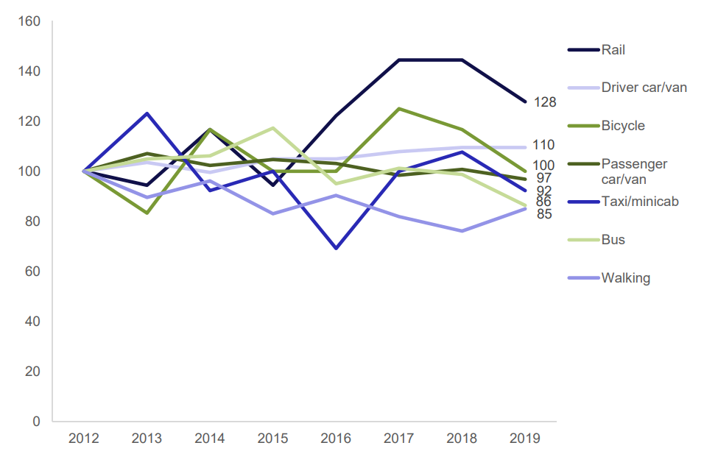
Figure 6. Scottish Transport Modal Trends 2012-2019
The number of bus journeys made has declined from 420 million in 2012/2013 to 366 million in 2019. As expected, bus usage is highest in urban areas, where 54% of people take the bus at least once per month, compared to just 19% in small remote towns, and 20% in remote rural areas. The National Concessionary Travel Scheme that was introduced in 2006 allows individuals aged 60+ and those with a disability to travel for free on buses across Scotland. This has led to 1.4 million people having National Concessionary Travel Card in Scotland, resulted in those eligible accounting for 36% of all bus journeys made.
Scotland’s primary train operator; Scotrail, recorded 96.4 million passenger journeys in 2019, down from 97.8 million in 2018. Train usage was highest amongst those in high-income households. Forty three percent of those on household incomes of over £50,000/yr had used the train in the last month compared to between 21 and 23% on household incomes of up to £20,000/yr. Glasgow Central is the busiest station in Scotland, with 32 million passenger journeys in 2019-2020. Edinburgh Waverley station is the second busiest, with 23 million and Glasgow Queen Street handling 17 million during the same period. In terms of infrastructure, the Scottish rail network is 2,758 kilometres, of which 893km is electrified and there are 359 stations around the country.
Air travel has increased, with 29 million air terminal passengers in 2019, down 2% since 2018. Edinburgh airport is Scotland’s busiest by passenger numbers, handling 14.7 million passengers in 2019, a 3% increase in numbers from the year before. In the same period, Glasgow handled 8.8 million passengers (down 8%), Aberdeen 2.9 million (down 5%) and Inverness 0.9 million (up 5%).
Road freight is the largest transporter of goods; before 2011, coastwise shipping used to transport the most freight. 97.8 million tonnes of goods were transported by road freight in Scotland in 2019. Rail freight decreased between the period of 1960 and 1994-5, and increased again up until 2005, when it started to decrease again. See Figure 7 below for the modal share of freight in Scotland:
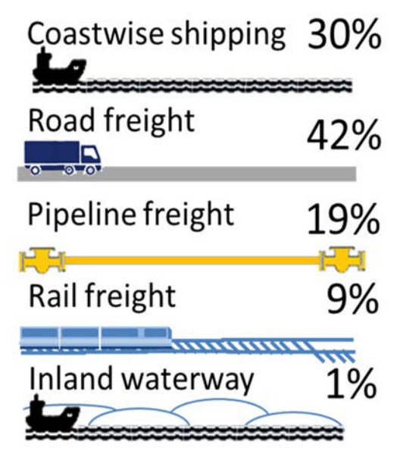
Figure 7. Amount of freight carried by each method in tonne-kilometres
EU legislation and standards aim to reduce emissions of CO₂, NO₂ and particulate matter, and the automotive and shipping industries are two examples where the benefits of designing for a circular economy can be seen, partially as a result of extended producer responsibility via the End-of-Life Vehicle Directive. The re-use of infrastructure is a key objective in Scottish Government policies such as Making Things Last and the Revised Draft NPF4. Additionally, the food and drink industry and the broader bio economy, have been identified as key Scottish Industries that could play a greater role in energy recovery. The Scottish Biofuel Programme is a partnership of leading research institutions in the biofuel sector developing opportunities to convert low value residues into bioenergy and biofuels.
Network Rail published a Weather Resilience and Climate Change Adaptation (WRCCA) based on assessments of the vulnerability of the rail network to weather related vulnerabilities. Figure 8 below shows the annual performance costs to Network rail between 2006-2014 due to impacts on train performance from severe weather. During the recorded period, weather accounted for 12% of all rail days.
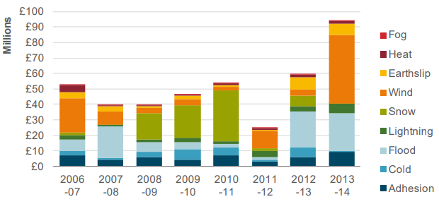
Figure 8. Costs to Network Rail from weather (Scotland)
National infrastructure networks work interdependently with each other as transport is reliant on fuel and power supplies, which are reliant on the roads. Cross-sector vulnerabilities to the impacts of climate change require careful infrastructure planning to build resilience against weather extremes and a shifting climate.
As mentioned in SEPA’S SEA guidance, material assets also include natural assets such as minerals, watercourses, natural flood management processes, forestry and woodlands, soils, agricultural land and related features such as field boundaries. Natural assets are also discussed in the soils, water and biodiversity sections of this appendix. Agriculture is Scotland’s dominant use of land, covering approximately 80% of the country, with woodlands and forests covering 12.5%. The importance of Scotland’s water environment and soils are outlined in Sections 6.1 and 8.1 respectively. Due to the importance of forestry in climate change mitigation, these resources are described below. Climate change aspects relating to water and soils are also described in Sections 6.1 and 8.1.
Scotland’s forestry and woodland covers an area of more than 1.4 million hectares and consists of a variety of woodland types and tree species, including traditional mixed Highland estates, urban forests, Atlantic woodlands and native Caledonian pinewoods. Due to this diversity, forestry provides significant economic and environmental benefits to Scotland. The forestry sector has been providing nearly £1 billion every year to Scotland’s economy. Key economic activities include timber and wood fibre production and forest-based recreation and tourism, such as mountain biking. Forests and woodlands also help mitigate the impacts of climate change by absorbing substantial amounts of carbon, with an estimated 12 million tonnes of carbon dioxide removed from Scotland’s atmosphere in 2016 alone. Scotland’s forests and woodlands also support a diverse range of species, including 172 protected species and an estimated 75% of the UK’s red squirrel population. Scotland’s forests and woodlands are of vital importance to the environment, helping to purify water and air, reduce flood risks, improve slope and riverbank stability, and decontaminate soils. In addition, they form a key component of Scotland’s renowned landscapes and also provide opportunities to help people improve their health and wellbeing.
In 2017, 83 percent of households in Scotland had access to superfast broadband with speeds of 35 megabits per second, compared to rural Scotland with 46 percent of households and speeds of 15 megabits per second. The Scottish Government have a strategy set out which aims to provide the whole nation with high quality broadband with a minimum of 30 Megabytes per second by 2021, as well as aiming to ensure areas with no 4G mobile are addressed. The Covid-19 pandemic has highlighted the increasing use and demand for high-speed internet; in April 2020, nearly 50 percent of people did some work remotely, with 86 percent of these people working remotely due to the pandemic. The usage a number of online platforms has also increased; the platforms with the largest increase in usage being Zoom and Microsoft Teams. As a result of the increase in remote working and internet/ platform usage, it is likely there has been changes to commuting patterns across Scotland.

Interrelationships with other SEA Topics
SEA Topic | RElationship with Material assets
Climate | Carbon emissions originate from the materials used to construct the project, emissions from construction activities and operational emissions from end-users. Changes to land-use resulting from the construction of any STPR2 interventions would affect the carbon mitigation potential from natural sequestration from the soils and forestry. These carbon emissions add to the cumulative atmospheric carbon concentration that amplifies the greenhouse effect, causing climate change.
Soils | Natural material assets encompass agricultural land and soils. The natural capital value of soil underpins the ecosystem functions that the soils provide to several other SEA topics.
Water environment | Natural material assets encompass watercourses and natural flood management. Construction of STPR2 interventions could potentially remove natural material assets that regulate the water cycle, but also have the potential to enhance the water environment, for example through the installation of Sustainable Drainage Systems.

Evolution of the Baseline and Trends
Most of the transport sector’s energy demand is provided by fossil fuels, predominantly by road transport, and the uptake of electric transport on a large scale is likely to place extra pressure on the electricity system, and on the networks’ ability to generate, store and deliver the capacity necessary to meet peak demand.
Advances in technology are likely to continue, such as more efficient engines with associated benefits. For example, average CO₂ emissions in Scotland for new car registrations fell by 15% between 2009 and 2019, and by 2% between 2018 and 2019 alone. Demand management such as ITS, will also continue to play a key role with potential benefits including improved air quality through reduced emissions and congestion, in addition to increased integration across different modes of transport.
In the coming years, the digitalisation of transport and ITS in particular are likely to take a leap forwards, including new technologies to support the move to more connected, cooperative and potentially more autonomous vehicles and the concept of Mobility as a Service (MaaS). MaaS integrates various forms of transport services into a single mobility service accessible by users on demand, potentially changing the way people travel.
Road and rail transport are generally more vulnerable to a changing climate than air and water transport and flooding is anticipated to be the most significant impact. Flooding poses the greatest long-term climate related risk to infrastructure performance, but the growing risks posed from heat, water scarcity and slope instability caused by severe weather could also prove significant. High river flows caused by increased rainfall and flash flooding will continue to cause localised riverbank erosion, undermining structures such as bridges that carry services (gas, telecoms, power) as well as people and road/rail traffic. Loss of bridges can therefore have multiple impacts, including to cultural heritage as many road and rail bridges in Scotland are listed buildings. Bridge scour is noted as a key risk in the Scottish Climate Change Adaptation Programme. Transport Scotland has developed an ongoing programme of scour repair and resilience works based on inspections of known scour issues.
The impact of flooding on infrastructure can have several significant cascading impacts to all infrastructure assets, including buildings, and all the sectors they serve. For example, power or IT outages caused by extreme weather can affect the ability to provide health and social care in hospitals and care facilities, and disruption to transport infrastructure (for example roads being flooded) can cause transport delays impacting ambulance and emergency vehicles.
Low-lying transport infrastructure in the coastal zone is also vulnerable to coastal erosion and flooding – particularly as much of this infrastructure was built before these threats became apparent. Due to the predicted risk of erosion, consideration needs to be given as to how the trunk road and railway will be affected. Realignment is likely to be required before erosion undermines the infrastructure.
In terms of temperature, the 2018 heatwave caused a 40-50% increase in rail asset failure. At 27°C there is an increased risk of rail buckling. An increased frequency of high or extreme temperature episodes, or increased number of hot days can lead to the over-heating of infrastructure and equipment and affect road speeds and more demand for air conditioning in vehicles. An increase in average summer temperatures can also lead to road rutting.
The rail network is particularly vulnerable to periods of high temperatures. Average summer temperatures in Scotland are expected to increase by 1.5-5.7°C by the 2080s. Hot weather has the potential to cause train service cancellations and speed restrictions, and require de-rating of overhead power lines. High temperatures can also affect what maintenance can be performed, for example making tensioning rail track difficult due to thermal expansion or by new road tarmac drying too quickly. More extreme temperatures are projected to result in a threefold increase in the number of days where track maintenance cannot be carried out. Overhead power cables also sag in hot weather, increasing frequency of ‘dewirement’ (i.e. trains becoming disconnected from their power source). The exposure of staff working outdoors to heat stress may also increase. Adaptation in the rail sector is difficult, due to the extent of exposure and the costs of upgrading track and lineside equipment. The risk of heat-related impacts has been assessed as part of the Network Rail’s Scotland Route Climate Change Adaptation Plan and assigned a ‘medium’ priority, below high wind and flooding, which already cause significantly greater problems. Cold weather (including snow and ice) is a major cause of disruption to transport services, and electricity transmission and distribution. For example, snow and ice account for 13% of weather-related impacts to the UK high voltage electricity distribution network. The average number of extreme cold days is likely to diminish over the course of the century. Cold winters will still be possible, but are expected to become increasingly unlikely. There may be opportunities arising from fewer snow and ice days reducing winter disruption and maintenance costs.
Transport infrastructure is likely to become increasingly vulnerable to subsidence. Falling and rising moisture levels - particularly in clay-rich soils - cause shrink-swell subsidence, the most damaging geohazard in Britain today (£300 million annual costs, BGS 2014). Combinations of drought and periods of intense rainfall can exacerbate embankment stability issues. This could potentially impact infrastructure on or next to steep-sided slopes, such as the A83, which is the focus of a separate project, the Access to Argyll and Bute (A83) project (including SEA), to help address resilience issues. The combined effect of increased winter rainfall and extreme rainfall events leads to ground saturation and slope or embankment failures. There were on average 12 earthwork failures a year across the rail network between 2003/04 and 2013/14 in Scotland. Increased incidences of natural and engineering slope failure affecting the road and rail network in the winters of 2012/2013 and 2013/2014 demonstrate their vulnerability to the type of intense rainfall events that are expected. A passenger train derailment in Scotland in 2020, caused by embankment failure following a period of heavy rainfall, tragically led to a loss of life and subsequently the closure of the railway line between Aberdeen and Dundee for almost three months. Landslide disruptions have been noted to block roads and cause disruption to business in Scotland. For example, the Stob Coire Sgriodain landslide in June 2012 resulted in a goods train being derailed. In addition to the A83, the British Geological Survey has also documented landslides in the past 10 years at Glen Ogle and Penicuik. More action is needed to locate and remediate slopes, embankments and cuttings at risk of failure.
An increase in the frequency of extreme weather events will cause damage and disruption to roads, rail, ports, airports and other transport infrastructure. High tides and stormy seas can disrupt ferry services to islands for several weeks each year causing raw material delivery problems, fuel supply issues and difficulty in shipping finished goods. In Scotland, high winds are the largest cause of weather-related disruption to the rail network and the electricity grid from trees bringing down cables and falling onto lines. High winds also cause severe disruption to road and ferry operations, closing bridges and suspending ferry crossings. This disruption amounts to unreliable journey times and knock-on economic effects. An increase in storminess and high wind speeds can also lead to:
- increased incidence of damage (e.g. to bridges, signs, etc), blocking roads and rail etc.;
- increases in problems for suspension bridges and high sided vehicles; and
- increases in interference to asphalting and concreting as wind chill cools the surface too quickly.
Individual wind events are less problematic to those caused by storms where the wind is accompanied by intense precipitation where the impacts of wind are compounded by additional flooding.
The number of faults to the electricity grid caused by lightning strikes is anticipated to increase between 4 and 36% by 2080.
Climate change will also impact on Scotland’s natural material assets, including those adjacent to transport infrastructure. The increased length of the growing season could affect tree stability along transport routes. Longer growing seasons due to warmer weather will increase vegetation growth rates generally and without additional management, disruption to the electricity and rail networks from falling trees is anticipated to increase. Another example is changes to climate that exacerbate the spread of invasive species or tree diseases that could ultimately require large-scale felling or clearing of dead wood.
Anticipated changes to the water environment and soils are outlined in Section 6.2 and Section 8.2 respectively.

Water Environment

Baseline
Figure 9. Scotland's Water Environment in Numbers
The water environment is one of Scotland’s greatest natural assets, supporting the country’s wildlife, health and wellbeing, and the sustainable growth of the economy. Figure 9 above shows Scotland’s water environment in numbers. Scotland has approximately 19,000 km of coastline, and the area from Scotland’s coast to its fishery limits is 470,000 km². This area is around six times the size of Scotland’s land area and underpins the country’s coastal fishing communities. Water is also used for industrial processes such as whisky production, hydroelectricity generation and recreational activities.
Scotland’s freshwater environment includes more than 125,000 km of rivers and streams and a 220km canal network. There are also more than 30,000 freshwater lochs in Scotland, ranging from small lochans to large lochs such as Loch Ness, most of which are located in the western and northern Highlands. Of all of Scotland’s lochs, Loch Morar is the deepest, at 310m, Loch Lomond has the largest surface area at 71 km², and Loch Ness is the largest by volume at 7.4 million m³ which is more than all English and Welsh lakes combined. Scotland’s rivers and lochs contain 90% of the entire UK’s freshwater and cover 2% of the land area, making Scotland vital to the UK’s water supply. In Scotland, a substantial number of water bodies are designated as protected areas. This is due to their value in supporting wildlife conservation, provision of drinking water supply, shellfish harvesting and bathing. Groundwater also supports Scotland’s wetlands and river flows during dry spells and is therefore critical to the maintenance of their ecology and biodiversity.
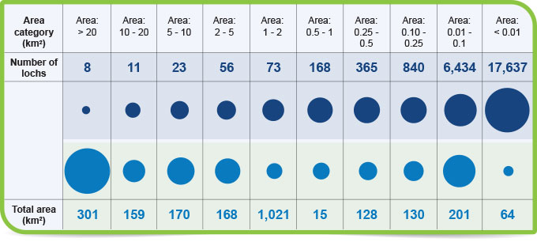
Figure 10. Overview of Scotland's Lochs
With respect to the Water Framework Directive (2000/60/EC), 97% of the country’s coastal waters and 85% of estuaries are in good or excellent condition, having improved significantly over time, although there remain localised areas of concern. To be classed as in good condition, the water must be free from pollutants at concentrations that would harm supported species and not negatively affected by invasive non-native species. The challenges to the water environment include loss of habitat from development, agricultural nitrate run-off, hydroelectric schemes disrupting watercourses, overfishing and pollutant release events.
Inland and coastal flooding have significant impacts on communities from property damage that can take years to recover from. Figure 11 below shows the rising trend in annual rainfall since the 1960s, with summers becoming warmer and wetter and winters becoming warmer and drier as a result of climate change. High intensity rainfall events test the ability of the drainage network to clear surface water in urban areas, which can result in flooding to infrastructure. Flooding from surface waters and sea makes approximately 284,000 homes, businesses and services vulnerable to damage of material assets, as well as posing risks to population and human health through the spread of infectious diseases and leading to a loss of habitats, resulting from erosion. In the summer of 2019, there were several instances of intense periods of rainfall overwhelming drainage in urban and rural areas, causing significant disruption to rail and road networks. In one instance, the West Highland Mainline route was closed for a week after heavy rainfall washed away the ballast under the railway.
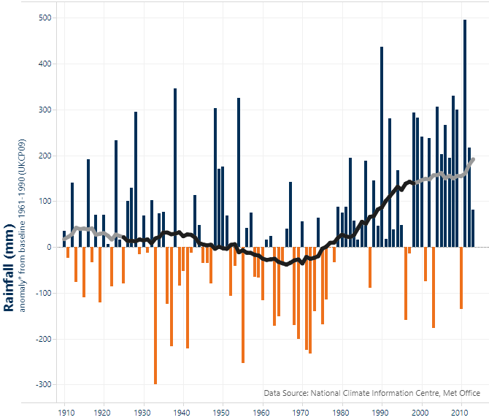
Figure 11. Annual rainfall trends from 1910 to 2013
The development and operation of new transport infrastructure has the potential to negatively impact on water quality, either during construction or via pollution run-off. Fragments of microplastics from tyres, road surfaces and brakes will also flow into rivers, and ultimately the sea. New structures on land can also affect the capacity of flood plains or the effectiveness of flood defences.

Interrelationships with other SEA Topics
SEA Topic | RElationship with the wATER ENVIRONMENT
Climate | There is potential for changes to flood risk and hydrology as a result of climate change.
Population and human health | Changes to flood risk may impact receptors including population, residential and non-residential buildings and critical and non-critical infrastructure and facilities. Effects are dependent on the extent of the change and could result in positive or negative impacts.
Biodiversity, flora and fauna | Changes to water quality and hydromorphology may impact upon aquatic ecology.
Soils | Soil run-off or transportation of contaminated soils may impact upon water quality.
Cultural heritage | Increases to flood risk may impact cultural heritage assets. Effects are dependent on the extent of the change and could result in positive or negative impacts.
Landscape and visual amenity | Changes to channel morphology, additional structures, channel realignment or changes to hydrology may also result in impacts to their amenity value and have the potential to affect the integrity of a landscape.

Evolution of the Baseline and Trends
Ongoing key pressures on the surface water environment include urbanisation and intensive agriculture/aquaculture. Development of infrastructure can lead to a loss of floodplains and potentially increase flood risk. Rural and urban diffuse pollution also remains a concern for water quality, particularly in relation to agriculture, forestry, and urban development. Surface water runoff from transport infrastructure could also affect water quality, unless this impact is mitigated.
Climate change will exacerbate flood events, with rising sea levels increasing the risk of coastal flooding. More frequent, high-intensity rainfall will increase the risk of flash flooding from surface water or sewers for inland communities.
The predicted effects of climate change such as increased temperatures and changes to rainfall patterns could affect flows in rivers and impact on water resource availability. Conversely, the banks of rivers and other water courses may also be breached by rising water levels. A changing climate is also expected to have ecological impacts, such as warmer sea temperatures and an increasing risk of non-native species spreading and becoming established in aquatic environments. Increased waterborne travel, passengers and freight, could present greater potential for accidental spills with negative impacts on the marine environment.
Climate change impacts have the potential to exacerbate poor water quality, for example through extreme weather and flash flooding dispersing urban and agricultural pollutants and debris into watercourses, or through increased water temperatures leading to an increase in algal blooms or invasive species. Worsening water quality could in turn adversely affect aquatic biodiversity and human health.

Biodiversity, Flora and Fauna

Baseline
Biodiversity is a common measure of ecosystem health and helps to provide the ecosystem services that are the basis of life, including the regulation of air and water, soil formation, nutrient cycling, flood regulation and pollination. This topic has key interrelations with soil and the water environment, that provide habitat for the diverse range of species across the land and in surrounding waters.
To protect the natural environment, legislation and policies relating to biodiversity, flora and fauna are implemented to protect habitats from damage and disturbance by identifying areas of value. The policies define a hierarchy of protection, from an international level down to a local level. At EU level, the Natura 2000 network of sites aims to protect key assets under the Habitats and Birds Directives. Natura 2000 sites include Special Areas of Conservation (SACs) and Special Protection Areas (SPAs). According to NatureScot, as of 2021 the country’s nationally designated sites comprise:
- 1,422 Sites of Special Scientific Interest (SSSIs);
- 243 SACs;
- 153 SPAs;
- 51 Ramsar Sites (wetlands);
- 43 National Nature Reserves (NNRs).
- 30 Marine Protected Areas (MPAs); and
- Two UNESCO designated Biosphere Reserves.
These designated sites are shown on Figure 12 and listed in Appendix D.
The Scottish Government has commissioned NatureScot to extend the area protected
for nature in Scotland to at least 30% of the country’s land area by 2030, as part of the Scottish Biodiversity Strategy Post 2020 Statement of Intent.
The UK Biodiversity Action Plan has identified 39 priority habitats and 197 priority species either occurring or known to have occurred until recently within Scotland. In March 2021, 78.3% of natural features on nationally protected nature sites were reported as being in “favourable” condition, up from 76% in 2007 but down from 79.8% in 2018. Valuable areas of biodiversity are not confined to designated areas. Green spaces around the country within urban and rural areas support a range of species that have important functions and roles such as urban greenspace, green corridors, parks, gardens woodlands and allotments. Improving green infrastructure and cycling and walking networks can promote active travel, helping to reduce transport emissions and build networks of priority habitats with positive impacts on biodiversity.

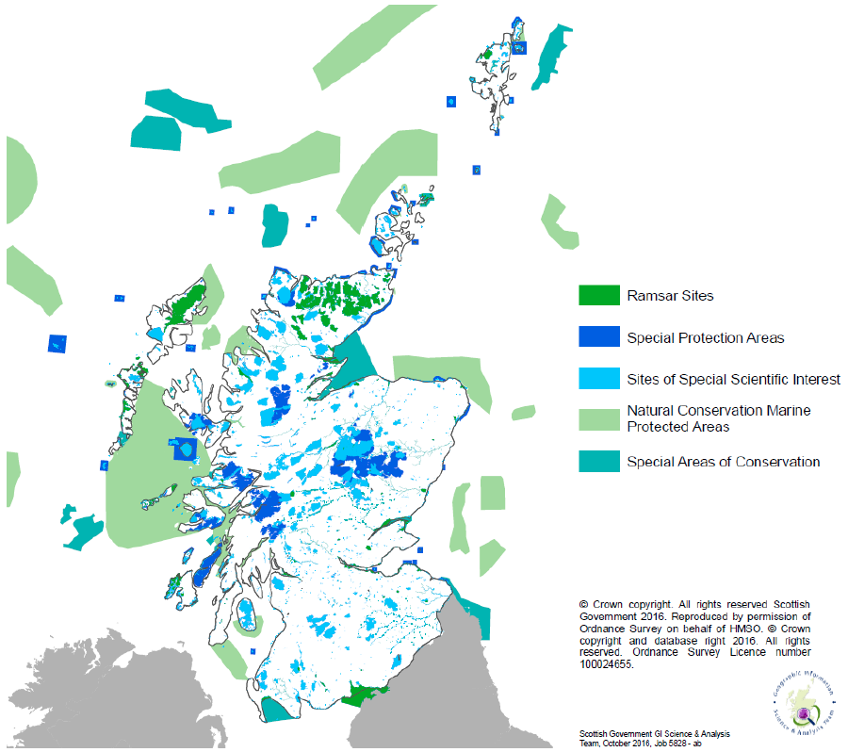
Figure 12. Scotland’s Designated and Protected Areas 2016
Biodiversity is impacted by human activities, of which infrastructure is a key factor due to the scale of long linear assets such as railways and roads and non-linear infrastructure such as stations and airports. Due to the spread of protected sites, it is inevitable that disturbance takes place due to construction or maintenance of transport infrastructure. Where construction in a designated site or protected area is unavoidable, an Environmental Impact Assessment (EIA) must be carried out to identify potential significant effects and provide mitigation to minimise the adverse impacts. Licenses and derogations must be sought from statutory bodies such as SEPA and NatureScot to allow certain activities in protected area who will then issue licenses such as Controlled Activities Regulations (CAR) licenses.

Interrelationships with other SEA Topics
SEA Topic | RElationship with Biodiversity
Air quality | Changes to air quality resulting from constructing STPR2 interventions could impact the resilience of biodiversity. Nitrogen deposition due to vehicle emissions can impact on the functioning of ecosystems and growth of trees.
Climate | Changes to climate and the increasing occurrence of extreme weather events could alter available resources, environmental conditions and species life cycles within the corridor. Trees, woodlands and peatlands act as ‘carbon sinks’ by sequestering more carbon from the atmosphere than they release. These flora and habitats provide a useful contribution to mitigating climate change. Deforestation and degradation of peatlands results in the release of carbon into the atmosphere, which fuels further climate change.
Landscape and visual amenity | Landscape changes could alter habitats and their connectivity, which could result in negative or positive interactions with biodiversity. Any mitigation and enhancement measures implemented for landscape and visual amenity could have biodiversity benefits, and vice versa. Therefore, any mitigation planting proposals should be developed with input from both disciplines.
Noise and vibration | An increase in noise and vibration resulting from constructing STPR2 interventions could cause disturbance to species of conservation interest, which could result in avoidance or abandonment of species from important habitats.
Soil | Soils and peat provide habitats and support biodiversity. Soil biodiversity is essential to most soil functions and affects the sustainability of species and habitats which rely on soils, as well as controlling several biogeochemical processes vital for functions such as nutrient cycles, greenhouse gas emissions, pollution control, and soil structural stability and development. Soil sealing would reduce the capacity of the soil to support habitats and biodiversity and potentially affect the sustainability of species and habitats and the biogeochemical processes that rely on this soil.
Water environment | Changes to water quality and hydromorphology, including groundwater, could impact biodiversity.

Evolution of the Baseline and Trends
Biodiversity loss has been well documented over the last 50 years, and today there are a range of pressures with the potential to impact on Scotland’s wildlife and biodiversity. Key ongoing issues include land use pressures (i.e. loss or damage of natural habitats), and the pollution of air, water, and land as well as climate change.
Scotland's trunk road network supports approximately 40% of all national traffic movements and this volume of traffic can have a significant impact on local wildlife. In 2019, the estimated volume of traffic on Scotland’s roads was at its highest ever level. Development of transport infrastructure may impact biodiversity through damage to nature conservation sites, as well as the fragmentation or loss of habitats. Secondary impacts can occur through air and water pollution. Noise and light disturbance from transport activity can also impact on biodiversity.
The installation of new energy and transport infrastructure required to meet GHG emissions reduction commitments has the potential for negative environmental effects at the local level. However, the impacts of not taking action to reduce climate change include:
- Spread of non-native invasive species that can out-compete native species due to changing habitat conditions.
- Changes in distribution and abundance of species, the timing of seasonal events and habitat use. As a consequence, there are likely to be changes in the composition of plant and animal communities.
- Habitats and ecosystems are also likely to change character by, for example, showing altered water regimes, increased rates of decomposition in bogs and higher growth rates in forests.

Soils

Baseline
Soil is often overlooked as one of a country’s most important assets. It is a non-renewable resource that supports a range of natural processes as well as providing environmental, societal and economic benefits for the human population.
The term soil quality is conventionally defined as the ability or fitness of a specific kind of soil to carry out one or several of the following functions, as listed in the Scottish Soil Framework:
- Providing the basis for food, forestry and other biomass production.
- Controlling and regulating environmental interactions - regulating water flow and quality.
- Storing carbon and maintaining the balance of gases in the air.
- Providing valued habitats and sustaining biodiversity.
- Preserving cultural and archaeological heritage.
- Providing raw material.
- Providing a platform for buildings and infrastructure.
These soil functions contribute to the provision of ecosystem services that enable life on Earth. Some of the principal soil functions are shown in Figure 13.
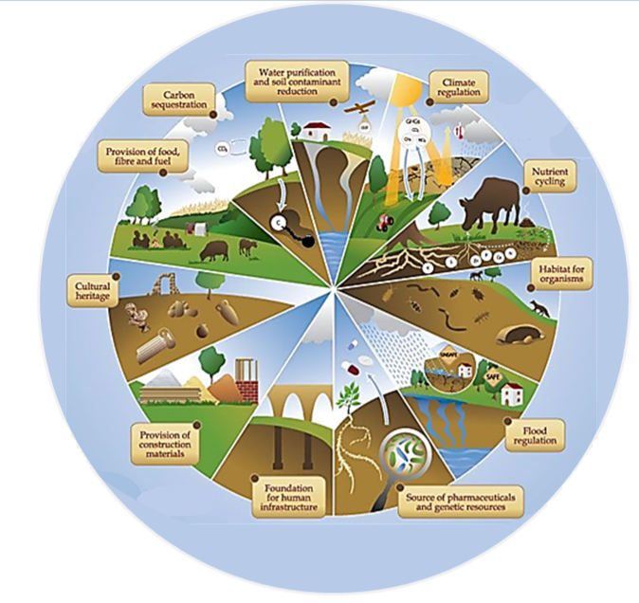

Figure 13: Soil functions
When soils are healthy, they can perform all the functions listed above, making them a vital component of a living ecosystem that supports plants, animals, and humans. Soil health also contributes to the capture and sequestration of greenhouse gases and carbon. Additionally, there is a positive correlation between soil health and soil biodiversity, with soil biodiversity supporting above-ground communities and controlling biogeochemical processes vital for functions such as nutrient cycles, greenhouse gas emissions, pollution control, and soil structural stability and development. Therefore, it is essential to protect, preserve, and further enhance soil health and resilience. However, soil health is threatened by the climate crisis and the loss of biodiversity, which are primarily the result of human activities.
Scotland has a diverse range of soils, which are generally more organic, more acidic, more leached and wetter than those of most other European countries. The Central Valley is dominated by mineral soils, whereas the Highlands and Southern Uplands are dominated by peaty soils (peat, peaty gleys and peaty podzols) especially in the west. The soil types of Scotland are shown on the figures included in Appendix A.
Arable crops are primarily located in the eastern half of the country and improved grassland in the south-west. These land uses are almost entirely associated with mineral soils. Although these soils are not particularly distinctive and are similar to cultivated soils elsewhere in the UK, they are valuable for their agricultural productivity. The remainder of the (undeveloped) countryside is under semi-natural vegetation, such as heather moorland, native woodland, blanket bog and montane habitats, land covers which are dominant in upland Scotland. These habitats are associated with highly organic soils.
Scotland’s soils are rich in organic matter and act as a carbon sink which stores vast quantities of CO₂. It is estimated that Scotland’s soils store 3bn tonnes of CO₂, accounting for over 50% of the UK’s soil carbon. A significant amount of Scotland’s soil is comprised of peatland, which is a key part of the landscape and cultural heritage. Peatlands cover more than 20% of the country’s land area, storing 1.6bn tonnes of CO₂ through carbon sequestration. It is estimated that over 80% of Scotland’s peatlands are degraded, and they emit more CO₂ than they sequester. If all the carbon stored within peatlands was to be released, it would be the equivalent of 120 times greater than Scotland’s national greenhouse gas emissions. Peatland restoration is therefore encouraged to help remove GHG from the atmosphere and combat climate change. The Scottish Government's climate change plan 2018-2032 update aims to restore at least 250,000 hectares of degraded peatland by 2030. Peatland restoration has many other benefits, including providing an internationally important habitat, improving water quality and reducing flood risk. In addition to peat, other soils also provide an important carbon sink. Soil organic carbon content is higher in the North-West Highlands and Islands and Shetland, and the uplands of southern Scotland. The role of healthy peatland in sequestering soil carbon, helping to reduce downstream flood risk and providing benefits to biodiversity is recognised in Scotland’s National Peatland Plan.
Due to their importance in climate change mitigation, planning authorities in Scotland are required to include carbon-rich soils, deep peat and priority peatland habitat in their spatial planning frameworks – and to afford these areas significant protection.
In general, the most versatile agricultural land in Scotland is located in the east. Higher quality agricultural land suitable for a moderate range of crops is found from the eastern Scottish Borders and Tay Cities up to the north-east of Scotland and some coastal areas of the Highlands and Islands. Further west, Ayrshire, the Clyde Valley and parts of Dumfries and Galloway also contain good quality arable land. Most land in Scotland is suitable for use as improved grassland or rough grazing.
The total amount of derelict and urban vacant land in Scotland has decreased by 716 hectares (6%) in the latest year, from 11,753 hectares in 2017 to 11,037 hectares in 2018. Of the 11,037 hectares of derelict and urban vacant land recorded in the 2018 survey 1,992 hectares (18%) were classified as urban vacant and 9,044 hectares (82%) were classified as derelict. East Ayrshire has the largest area of derelict and urban vacant land, at 1,810 hectares - 16% of the Scotland total. Glasgow City has the largest area of the City Authorities, at 1,005 hectares, which represents 9% of the Scotland total.
Evidence suggests that the way soils are currently used degrades the resource (e.g. by soil erosion) resulting in loss of soil quantity and quality, along with the functions that soils support and the ecosystem goods and services delivered by these functions. Land-use changes such as urbanisation, infrastructure development, deforestation and using land for agriculture, with the associated impacts of using pesticides and fertilisers, can all adversely affect soils. This can result in significant costs, not only to immediate users of soils but also to society as a whole.
Scotland’s soils are under pressure from the effects of changes in land-use and land management and climate change. Land use changes, such as construction of infrastructure, can lead to soil sealing, compaction, erosion, contamination or loss of organic matter. Such changes affect the structure, stability, biological, physical and chemical characteristics of soil, which will also impact on soil biodiversity. Combustion of fossil fuels can cause soil contamination through deposition in dissolution in rainwater by acids, metals and organic chemicals. Spillage from fuel pipelines or storage facilities are significant contamination sources. Quarrying, mining and fossil fuel extraction are also sources of localised soil contamination as well as larger scale contamination through atmospheric contamination and subsequent deposition.
The impacts of climate change include temperature change, soil moisture changes and run-off erosion from high-intensity rainfall which leads to soil degradation.
Soil erosion by water is the dominant erosion process in Scotland. Notable soil erosion events are triggered by either high intensity rainfall; prolonged, low intensity rainfall; or rapid snowmelt. Land uses affected include forests and agriculture. Soil erosion contributes to increased suspended sediments and turbidity in Scottish watercourses, which can diminish water quality and damage aquatic life, including salmon spawning grounds and freshwater pearl mussel beds.

Interrelationships with other SEA Topics
SEA Topic | RElationship with soil
Climatic Factors | Soils and peat store carbon and help maintain the balance of gases in the air. There is potential for carbon loss to the atmosphere through exposure of and disturbance to organic soils. Sealing of soils would reduce the capacity to assimilate carbon. Compaction/structural degradation and erosion can result in loss of carbon storage function and flux of greenhouse gases, thus affecting climactic factors.
Population and human health | Soils and peat support the agriculture and forestry industries and provide resources and means of employment for the population thus also supporting human health and well-being.
Material assets | Soils and peat are important natural assets that underpin other ecosystem services. Loss of organic matter and soil sealing would have the potential to result in loss of nutrients which in turn would lead to loss of fertility/productivity.
Water environment | Soils and peat regulate the flow of water and also provide water storage. They also filter and buffer pollutants. There is a strong interrelation between soil deterioration and the increased number of extreme floods as soils sealing, soil compaction and capping exacerbates flooding as the capability of soils to absorb water decreases and water runs off more quickly. Soil erosion and runoff from compacted/degraded soils can lead to transportation of contaminated soils which can adversely affect water quality as well as changing hydrological regimes, which also has the potential to affect flood risk.
Biodiversity | There is an important relationship between soil and biodiversity, as one-quarter of the world's biodiversity consists of organisms living in soil and interacting in a complex food web. These organisms play a crucial role in maintaining clean water and air, healthy plants, and moderate water flow. Consequently, these biological systems rely primarily on healthy soils.  Additionally, soils and peat provide habitats and support biodiversity. Soil biodiversity is essential to most soil functions and affects the sustainability of species and habitats which rely on soils. However, due to natural and human interference, such as climate change, the nature crisis, soil erosion, or soil sealing, the capacity of soils to support habitats and biodiversity has reduced.
Cultural heritage | Soils and peats preserve cultural and archaeological heritage. Soil sealing or loss/disturbance of peat may result in loss of cultural heritage resources.
Landscape and visual amenity | Soil is closely linked with landscape and visual amenity. It is a significant part of the landscape, and has a significant influence on visual amenity, for example through its influence on vegetation types and extent. Soil-landscape processes include, for example, the redistribution of mass at and below the surface. This affects topography, vegetation development and land stability. Loss of organic matter through soil erosion, or soil sealing renders soil infertile, resulting in changes in habitats and land use that have a further negative impact on visual amenity and landscape character.

Evolution of the Baseline and Trends
Scotland’s soils will continue to face pressure from climate change effects, including:
- Temperature change, leading to drying out, cracking and subsequent erosion;
- Degradation of peatlands, leading to further release of greenhouse gases;
- Increased run-off, erosion and landslides, leading to soil loss and degradation; and
- Loss of soil through all other sources of flooding.
Climate change and loss of organic matter pose significant threats to Scottish soils, with both likely to affect soil function, including loss of soil carbon. The loss of valued soils has the potential for national impacts which will be difficult to reverse. In the case of climate change, these impacts have the potential to be felt on a global scale. Climate change projections for Scotland indicate more heavy rainfall days and an increase in winter rainfall, leading to greater risks of soil erosion in the future, making the status of soils and agriculture in Scotland of ‘high concern’.
Changes in land use and land management practices are an ongoing key pressure on soil. These include activities such as transport and development, including road building and the expansion of agriculture and forestry.
There is uncertainty and a lack of quantitative data on threats to soil functions and ecosystem services, particularly the extent of soil sealing, changes in soil biodiversity and soil compaction. Soil sealing is increasing in all of Scotland’s river catchments and sealed surfaces were estimated to cover around 2% of Scotland’s land in 2019. The Forth, Clyde, North-East Scotland and Tay catchments had the most soil sealing.

Cultural Heritage

Baseline
Scotland contains a unique and varied selection of irreplaceable historical sites and historic landscape that contributes to quality of life, the character of the country, cultural identity, education and economy. Scotland’s historic assets attracted 18 million visitors in 2018 and over five million paying visitors, providing an educational role and a significant contribution to the tourist economy. A 2018 cultural heritage audit undertaken by Historic Environment Scotland (HES) showed that 35% of adults had visited a historic site in the year up to the audit. This had increased from 28% in 2012.
The important role of cultural heritage is set out in the Historic Environment Policy for Scotland (HEPS), which recognises that heritage is at the heart of a thriving and sustainable Scotland and is also central to people’s everyday lives, sense of place, identity and wellbeing. The HEPS also highlights that cultural heritage includes natural as well as built features and can be valued for its tangible and intangible aspects. More information on the HEPS is provided in Appendix B of this Environmental Report.
An estimated £1.2bn was spent on repairing and maintaining the historic environment in 2017, with private investment accounting for 75% of total funding. To protect valuable historic assets, there is also a process of designation which aims to identify the significance of the historic environment and protect it for future generations to enjoy. According to Historic Environment Scotland (HES), Scotland’s historic environment generated £4.2bn for the economy in 2017 and supports 66,000 full-time jobs. Globally, Scotland is ranked 12th out of 50 countries ranked for its reputation of having a rich cultural heritage.
Cultural heritage assets are distributed around the country but can be found in clusters around historic settlements and on the coast. Scotland’s protected heritage assets (including natural heritage) comprise the following:
- Six World Heritage Sites (WHS);
- 8,121 Scheduled Monuments;
- 46,954 Listed Buildings;
- 668 Conservation Areas;
- 363 Gardens and Designed Landscapes;
- Eight Scheduled Wrecks (below Mean Low Water);
- Eight historic Marine Protected Areas (MPAs);
- 40 nationally important battlefields; and
- 336 Properties in Care of HES.
Scotland’s WHS are diverse – they comprise:
- Edinburgh Old and New Towns;
- New Lanark;
- The Forth Bridge
- The ‘Heart of Neolithic Orkney’;
- The Antonine Wall; and
- St Kilda - mixed cultural and natural WHS.
In 2021, there were 2,270 on the Buildings at Risk Register (BARR) for Scotland. The general condition of cultural heritage in Scotland is reflected in the following statistics:
- 67% of pre-1919 housing stock is in need of critical repairs
- 83% of scheduled monuments are perceived to be in an optimal or generally satisfactory condition.
- 750 historic buildings on the BARR have been saved between 2009 and 2018 and more than 200 others are in the process of being restored. Almost 2,000 buildings have been saved since 1990 when BARR began.
Scotland has two National Parks and 40 National Scenic Areas., These also contain many important features of the historic environment and are described further in the landscape baseline of this appendix.
Undesignated sites account for 95% of the historic environment but still provide contextual information to help better understand designated sites. Most of these undesignated sites are privately owned. Although some are designated, many railways and railway stations and other industrial heritage, graveyards and churches are also undesignated. Ancient woodland and historic battlefields are also an important part of the historic environment and these sites often have high amenity, cultural and biodiversity value.
The condition of undesignated historic heritage is largely unknown, while that of designated sites is generally moderate.
Inappropriate development is a key pressure on the historic environment, from direct damage to designated, undesignated and undiscovered assets. It can also cause impacts on setting. Pressure also comes from visitors, land-use changes, lack of maintenance and investment and climate change.

Interrelationships with other SEA Topics
SEA Topic | RElationship with Cultural Heritage
Soil | The Soil SEA topic is relevant to cultural heritage as peat soils could potentially contain undiscovered archaeological remains and organic remains. These remains could provide information on the past environment.
Climate change | Climate Change can threaten the cultural heritage resource through erosion, flooding and wetter, warmer conditions. Through waterlogging, climate change could also influence landslide risk, soil creep and erosion levels (e.g. gully erosion) and hence any cultural heritage resources within the soil.
Landscape | The Landscape SEA topic is relevant, as historic activities have sometimes created a landscape (e.g. historic field systems) or cultural heritage resources could form an integral part of the landscape. Cultural heritage resources are also an important visual amenity and help to create a sense of place.
Population and Human Health | The long-term viability of Listed Buildings and other cultural heritage resources is very important to local communities and visitors. Cultural heritage resources are therefore also related to the Population and Human Health SEA topic as they contribute to the understanding of the history of places, as well as the sense of place and visitor experience.

Evolution of the Baseline and Trends
Inappropriate development will continue to be a key pressure on the historic environment and cultural heritage, unless mitigation is implemented. For example, the development of new transport routes, signage, lighting and other infrastructure can affect historic landscapes and may cause direct physical damage or indirect impacts on heritage assets or their setting. Increasing levels of congestion will also continue to affect historic towns, cities and the countryside. Although levels of pollutants have fallen over recent decades, their effects continue to cause damage, particularly to materials such as sandstone, resulting in these materials being vulnerable to ongoing decay.
Lack of investment and maintenance or confusion of roles over responsibility for maintenance could also lead to the continued deterioration in heritage assets.
Measures to reduce the need to travel, manage demand and encourage modal shift, have the potential to enhance cultural heritage in urban and rural areas through an associated reduction in traffic levels. For example, there are opportunities to improve active travel and other sustainable transport access to historic sites. Removal of existing car park space or avoiding the need for additional car parking could also improve the setting of cultural heritage assets.
Increased visitor numbers to heritage sites will also continue lead to pressures unless managed appropriately e.g. visitors can cause damage to heritage sites by wearing down the footpaths across sensitive features, or by lighting fires.
It is projected that Scotland will become warmer and wetter as a result of climate change, resulting in the increased weathering of stone, rotting timbers, and corrosion of metals, risk of dampness, condensation and fungal growth, vegetation growth, and accelerated decay. Average rainfall in Scotland has risen by more than 20 percent since the 1960s, with historic buildings particularly susceptible to the accelerated decay this can cause. Changing weather patterns could also change the types and distribution of plant species, which may impact the character of historic gardens and landscapes.
Historic landscapes and sites located within coastal zones are particularly vulnerable to rising sea levels and increased storm events may increase coastal erosion, endangering historic landscapes, structures, buildings and archaeology in the coastal zone. The extent and rate of coastal erosion have already increased above historic levels and they are expected to broaden and quicken further in coming decades. Erosion-enhanced flooding is also likely to increase.
Some of Scotland’s unique and special heritage sites, such as the Brora Saltpans, are at significant risk from coastal erosion. This threat will grow in the future, given the predictions of future climate change impacts.

Landscape and Visual

Baseline
Rich in diversity, Scotland’s landscapes are internationally renowned. Landscapes are a significant part of the country’s cultural and national heritage, contributing to the economy and the wellbeing of the population.
The character and quality of Scotland’s landscape provides various benefits and underpins most types of ecosystem services. It is a fundamental component of supporting services, but also contributes to provisioning, regulating and cultural services. These include improving the population’s health by providing space for recreation, exercise and general wellbeing. Attractive, accessible landscapes, including urban greenspace, can make an important contribution to quality of life. Landscape inspires art and culture, contributing to a sense of place and belonging. Alongside supporting Scotland’s economy, attracting investment and adding value, landscape makes an important contribution to quality of life and local distinctiveness and identity.,
There are currently two national parks (Loch Lomond and the Trossachs and the Cairngorms) and 40 National Scenic Areas (NSAs) that cover over 13% of Scotland. NSAs include mountain ranges and other unique and picturesque landscapes. Local Landscape Areas have also been established at a local level by several local authorities. Areas that are designated locally or for conservation purposes are also afforded protection from inappropriate development.
Wild land character is displayed in some of Scotland’s more remote upland, mountain and coastal areas that show minimal signs of human influence. Areas with stronger wild land characteristics are more commonly found in the north and west, although additional areas of wild land are present in other areas of Scotland.
Scotland’s planning system safeguards the special qualities of NSAs, with NatureScot acting in an advisory capacity. NatureScot has a Landscape Policy Framework that strives to ‘safeguard and enhance the distinct identity, the diverse character, and the special qualities of Scotland’s landscapes as a whole.
“Fitting Landscapes” is a Transport Scotland policy statement that has been formulated to address landscape design and management in Scotland’s transport corridors, with the following four themes:
- ensure high quality of design and place;
- enhance and protect natural heritage;
- use resources wisely; and
- build in adaptability to change.
These measures ensure that consideration is given to ensure operations or interventions will fit in the landscape setting in which they pass through.

Interrelationships with other SEA Topics
SEA Topic | RElationship with Landscape and Visual Amenity
Climatic Factors | Climate change affects landscape directly and indirectly through coastal erosion, flooding, wetter, warmer conditions, as well as droughts and more frequent storm events. In the long term it can alter landform, landscape pattern and character, influence the plant species composition and distribution within land cover or damage existing landscape elements and features. Climate change can contribute to the spread of pests and diseases, which in turn affects the landscape and visual amenity (e.g. when a large number of trees dies off as a result of pest or disease and need to be felled). Furthermore, climate change mitigation measures affect the landscape and visual receptors through the increasing introduction of renewable energy infrastructure into previously remote landscapes. Landscape elements, such as trees, woodlands and moorlands, act as ‘carbon sinks’ making a useful contribution to mitigating climate change. Conversely, any deforestation equates to the carbon being released and contributing to climate change.
Air Quality | Landscape elements such as trees and other vegetation absorb pollutants and particulate matter through their leaves and needles and thereby help to improve air quality. Less plant cover means less filtering capacity to clean the air.
Biodiversity | The Biodiversity SEA topic is relevant to landscape, as landscape provides creating habitat for wildlife. Changes to the landscape resource can alter habitats and their connectivity, which can result in both positive and negative effects on biodiversity, flora and fauna. Conversely, any mitigation and enhancement measures relevant to biodiversity can have an impact on the landscape and visual amenity. For these reasons, any landscape or planting proposals put forward as part of mitigation are normally prepared in consultation with Biodiversity specialists. Biodiversity Net Gain assessment results can be factored into landscape design considerations to deliver more environmentally sustainable designs.
Water Environment | The Water Environment SEA topic is relevant to landscape as landscape elements and features rely on the water environment and can be damaged by flooding or being subjected to prolonged waterlogging. Conversely, landscape elements such as woodland intercept rainfall, increase transpiration, increase the filtration of surface water and slow the flow of water.
Cultural Heritage | Landscape incorporates cultural heritage resources (assets), which help to shape the historic landscape character. Cultural heritage and landscape both contribute to a sense of place. Cultural heritage assets include inventory gardens and designed landscapes. Some cultural heritage resources also act as landmarks or key viewpoints in the landscape, influence cultural associations of a place and affect the sensitivity of landscape receptors. Cultural heritage assets can also contribute to the visual amenity of the area. Landscape and visual mitigation and enhancement measures can have an effect on cultural heritage assets so should be prepared in consultation with cultural heritage specialists.
Population and Human Health | The Population and Human Health SEA topic is relevant as green and open spaces in the landscape provide opportunities for people to exercise as well as enjoy and experience nature, enhancing their quality of life and improving their physical and mental health and wellbeing. Although anecdotal evidence of the latter has long been known, there is a growing body of scientific research related to this interrelationship and its importance has become highlighted during the COVID-19 pandemic. In addition, tourism and consequently the economic welfare of local communities often rely on the rich, scenic landscapes of the area. Residential properties, core paths, hill walking trails, long distance walking and cycling routes and roads all serve as locations from which people (i.e. visual receptors) experience views and any changes to them.
Material Assets | Landscape elements (e.g. trees and woodland) provide numerous ecosystem services (i.e. processes by which the environment produces natural resources utilised by us all, such as clean air, water, food and raw materials). These are increasingly recognised and accounted for as Scottish natural capital (i.e. natural assets that humans derive a wide range of services from) and as such comprise Material Assets.
Soil | Soil supports the growth of plants and trees which constitute part of the landscape resource.

Evolution of the Baseline and Trends
Scotland’s landscapes are constantly changing and evolving in response to both natural processes and the changing demands of society. Changes in landscape tend to occur over long periods of time, and gradual change as a result of development, for example, housing, and changes in farming and forestry practice, can be difficult to determine. Waste management and extraction processes can also lead to significant changes in landscape.
The two main direct pressures that influence the character of the landscape are land use and the intensification of land use and management, such as incremental and on-going development and action to increase maximum yields in agriculture. The expansion of many towns and cities and their associated infrastructure, such as roads and railways, is seen as a pressure and the distinctive landscape setting of many towns and cities is being lost as a result of settlement expansion and the need for associated infrastructure, such as roads and railways. Measures that seek to reduce the need to travel, manage demand and encourage modal shift, could in turn reduce the need for new infrastructure and consequently, reduce the likelihood of disturbance to the landscape posed by new construction.
Climate change is expected to lead to extensive landscape change across Scotland, with the greatest changes likely to occur in lowland and coastal areas where human population is highest. Direct impacts are likely as a result of changing temperatures and patterns of precipitation, weather events, and sea level change. The coast and foreshore are under many pressures particularly from climate change, rising sea levels and coastal erosion. However, climate change mitigation and adaptation measures are expected to have a greater influence on Scotland's landscapes and quality of life than the direct effects of climate change. For example, the development of renewable energy (such as wind farms and hydro schemes) is seen by many as a pressure on both visual amenity and the character of many rural landscapes. Indirect climate change effects, such as pathogen impacts on trees, could also potentially affect landscapes.

NatureScot (2021) Natural Capita Asset Index [Online] Available at: https://www.nature.scot/professional-advice/planning-and-development/social-and-economic-benefits-nature/natural-capital-asset-index (accessed 08/07/2020).
IPCC (2018) Summary for Policymakers. In: Global Warming of 1.5°C. An IPCC Special Report on the impacts of global warming of 1.5°C above pre-industrial levels and related global greenhouse gas emission pathways, in the context of strengthening the global response to the threat of climate change, sustainable development, and efforts to eradicate poverty [Masson-Delmotte, V., P. Zhai, H.-O. Pörtner, D. Roberts, J. Skea, P.R. Shukla, A. Pirani, W. Moufouma-Okia, C. Péan, R. Pidcock, S. Connors, J.B.R. Matthews, Y. Chen, X. Zhou, M.I. Gomis, E. Lonnoy, T. Maycock, M. Tignor, and T. Waterfield (eds.)] [Online] Available at: https://www.ipcc.ch/site/assets/uploads/sites/2/2019/05/SR15_SPM_version_report_LR.pdf
United Nations Environment Programme (2021). Emissions Gap Report 2021: The Heat Is On – A World of Climate Promises Not Yet Delivered – Executive Summary. Nairobi. [Online] Available at: https://wedocs.unep.org/bitstream/handle/20.500.11822/36991/EGR21_ESEN.pdf
Element Energy (2021) Decarbonising the Scottish transport sector. Final report for Transport Scotland, September 2021. [Online] Available at: https://www.transport.gov.scot/media/50354/decarbonising-the-scottish-transport-sector-summary-report-september-2021.pdf
WMO 2021. United in Science 2021 (World Meteorological Organization). Available at: https://library.wmo.int/doc_num.php?explnum_id=10794
Transport Scotland (2020) Carbon Account for Transport No. 12: 2020 Edition [Online] Available at: https://www.transport.gov.scot/media/48199/sct07209535161.pdf (accessed 18/06/2021).
Transport Scotland (2018) Scottish Transport Statistics No 36: 2017 Edition [Online] Available at: https://www.transport.gov.scot/publication/scottish-transport-statistics-no-36-2017-edition/ (accessed 19/11/2019).
Transport Scotland (2018) Scottish Transport Statistics No 36: 2017 Edition [Online] Available at: https://www.transport.gov.scot/publication/scottish-transport-statistics-no-36-2017-edition/ (accessed 19/11/2018).
Transport Scotland (2020) Carbon Account for Transport No. 12: 2020 Edition [Online] Available at: https://www.transport.gov.scot/media/48199/sct07209535161.pdf (accessed 18/06/2021).
Scottish Government (2017) Draft Climate Change and Energy Strategies: joint strategic environmental assessments [Online] Available at: http://www.gov.scot/Publications/2017/01/9030 (accessed 26/02/2019).
House of Commons Library (2021) Electric Vehicles and Infrastructure [Online] Available at: https://researchbriefings.files.parliament.uk/documents/CBP-7480/CBP-7480.pdf
SNH (n.d) Benefits of healthy peatlands [online]: https://www.nature.scot/climate-change/takingaction/carbon-management/restoring-scotlands-peatlands/benefits-healthy-peatlands (accessed 05/11/2021)
SNH (n.d) Managing nature for carbon capture [online]: https://www.nature.scot/climatechange/taking-action/carbon-management/managing-nature-carbon-capture (accessed 05/11/2021)
SNH (2014) SNH Commissioned Report 761 – Assessment of carbon budgets and potential blue carbon stores in Scotland’s coastal and marine environment [online]: https://www.nature.scot/snh-commissionedreport-761-assessment-carbon-budgets-and-potential-blue-carbon-stores-scotlands (accessed 05/11/2021)
SNH (2017) SNH Commissioned Report No. 957: Assessment of Blue Carbon Resources in Scotland’s Inshore Marine Protected Area Network [online]: https://www.nature.scot/snh-commissioned-report-957-assessmentblue-carbon-resources-scotlands-inshore-marine-protected-area (accessed 05/11/2021)
Scottish Government (2020) Securing a green recovery on a path to net zero: climate change plan 2018-2032 update. Available at: https://www.gov.scot/publications/securing-green-recovery-path-net-zero-update-climate-change-plan-20182032/pages/9/
Under 2° Climate Group – Clean Transportation. Available at https://www.theclimategroup.org/clean-transportation (accessed 06/01/2021).
SNIFFER (2021) Evidence for the third UK Climate Change Risk Assessment – Summary for Scotland [Online] Available at: https://www.adaptationscotland.org.uk/application/files/4314/7792/6358/UK-CCRA-2017-Scotland-National-Summary.pdf (accessed 18/07/2022).
SNIFFER (2021) Evidence for the third UK Climate Change Risk Assessment – Summary for Scotland [Online] Available at: https://www.adaptationscotland.org.uk/application/files/4314/7792/6358/UK-CCRA-2017-Scotland-National-Summary.pdf (accessed 18/07/2022).
SNH: Trend Note (2011) [Online] Available at: https://www.nature.scot/sites/default/files/B1043758%20-%20Natural%20Heritage%20Trends%20-%20Climate%20change%20and%20rivers%20-%20PDF.pdf (accessed 19/11/2019).
Met Office and DEFRA (2018) UK Climate Projections 2018 (UKCP18): Marine summary report [online]: https://www.metoffice.gov.uk/binaries/content/assets/metofficegovuk/pdf/research/ukcp/ukcp18-infographic-headline-findings-marine.pdf
Met Office (n.d.) How is Climate Linked to Extreme Weather? https://www.metoffice.gov.uk/weather/climate/climate-and-extreme-weather (accessed 05/11/2021)
Adaptation Scotland, Climate trends and projections, 2020. Available at: https://www.adaptationscotland.org.uk/why-adapt/climate-trends-and-projections (accessed 26/08/2021).
Adapted from Met Office (2021). Available at: https://www.metoffice.gov.uk/binaries/content/assets/metofficegovuk/pdf/research/ukcp/ukcp18-infographic-headline-findings-land.pdf
Adapted from ROADEX, Climate Change Adaptation, 2000-2012. Available at: https://www.roadex.org/wp-content/uploads/2014/01/Climate-Change-Adaptation-2012.pdf (accessed 26/08/2021) and Orrey et al, 2019: Climate Change Risks Facing Scotland’s Transport Infrastructure (Scottish Transport Applications and Research). Available at: https://starconference.org.uk/star/2019/Toplis.pdf (accessed 13/09/2021).
SNIFFER (2021). Evidence for the third UK climate change risk assessment: Summary for Scotland. Available at: https://www.ukclimaterisk.org/wp-content/uploads/2021/06/CCRA-Evidence-Report-Scotland-Summary-Final-1.pdf, accessed 18/07/22.
SNIFFER (2021). Evidence for the third UK climate change risk assessment: Summary for Scotland. Available at: https://www.ukclimaterisk.org/wp-content/uploads/2021/06/CCRA-Evidence-Report-Scotland-Summary-Final-1.pdf, accessed 18/07/22.
Scottish Government (2020) Environment Strategy for Scotland. Available at: https://www.gov.scot/publications/environment-strategy-scotland-vision-outcomes/documents/
Scottish Government (2021e) Infrastructure Investment Plan for Scotland 2021-2022 to 2025 -2026. Available from: https://www.gov.scot/policies/government-finance/infrastructure-investment/, accessed 10 December 2021.
Scottish Government (2021). Scottish climate change adaptation programme: progress report 2021 [Online] Available at: https://www.gov.scot/binaries/content/documents/govscot/publications/progress-report/2021/05/scottish-climate-change-adaptation-programme-progress-report-2021/documents/scottish-climate-change-adaptation-programme-progress-report-2021/scottish-climate-change-adaptation-programme-progress-report-2021/govscot%3Adocument/scottish-climate-change-adaptation-programme-progress-report-2021.pdf (accessed 24/06/2021).
Air Quality in Scotland (2019) [online]. Available at: http://www.scottishairquality.scot/air-quality/
Transport Scotland, 2020. Scottish Transport Statistics No. 39 2020 edition [Online] Available at: https://www.transport.gov.scot/media/49177/scottish-transport-statistics-2020-publication-final-version.pdf (accessed 18/06/2021).
Transport Scotland (2020). Scottish Transport Statistics No. 39 2020 edition [Online] Available at: https://www.transport.gov.scot/media/49177/scottish-transport-statistics-2020-publication-final-version.pdf (accessed 18/06/2021).
Cleaner air for Scotland: the road to a healthier future [Online] Available at: https://www.gov.scot/publications/cleaner-air-scotland-road-healthier-future/pages/9/ (accessed 18/06/2021).
Ramsay, C.N. (2019) Air Pollution and Health Impacts: A Scottish Context. Cleaner Air for Scotland Review, 10th January 2019 [Online] Available at: http://www.scottishairquality.scot/assets/documents/Colin_Ramsay.pdf (accessed 23/09/19).
Defra (2020) Impacts of shipping on UK air quality. [online] Available at: https://uk-air.defra.gov.uk/assets/documents/reports/cat11/1708081025_170807_Shipping_Report.pdf (accessed 25/11/21).
Environment Act 1995, c.25 [Online] Available at: http://www.legislation.gov.uk/ukpga/1995/25/introduction (accessed 23/09/19).
Air Quality in Scotland (2021) Air Quality Management Areas [online] Available at: http://www.scottishairquality.scot/laqm/aqma (accessed 08/11/2021)
Scottish Government (2015) Cleaner Air for Scotland – The Road to a Healthier Future [Online] Available at: http://www.gov.scot/Publications/2015/11/5671 (accessed 17/01/2019).
Scottish Government (2017) Strategic Environmental Assessment Environmental Report on the Draft Climate Change Plan and Draft Scottish Energy Strategy [Online] Available at: http://www.gov.scot/Publications/2017/01/9030 (accessed 22/03/2019).
Low Emission Zones Scotland (2021) Local Low Emission Zones [Online] Available at: https://www.lowemissionzones.scot/about/local-zones (accessed 18/06/2021).
Air Quality in Scotland (2021) Air Pollution Levels Across Scotland Updated Hourly [Online] Available at: http://www.scottishairquality.scot/ (accessed 08/11/2021).
Scotland’s Environment (2014) Scotland’s State of the Environment Report 2014 – 3 Air Quality [Online] Available at: https://www.environment.gov.scot/media/1170/state-of-environment-report-2014.pdf (accessed 23/09/19).
Scotland’s Environment (2014) Scotland’s State of the Environment Report 2014 – 3 Air Quality [Online] https://www.environment.gov.scot/media/1170/state-of-environment-report-2014.pdf (accessed 18/06/2021).
Scottish Government (2019) Scottish emissions of air pollutants 2017 [Online] Available at: https://www.gov.scot/news/scottish-emissions-of-air-pollutants-2017/ (accessed 18/06/2021).
Scottish Government (2015) Air Quality - Air Pollutant Emissions, High Level summary of Statistics Trend [Online] Available at: http://www.scotland.gov.uk/Topics/Statistics/Browse/Environment/trendairpollutants (accessed 20/10/2019).
Scottish Government (2021) Scotland’s Wellbeing: The Impact of COVID-19 – Chapter 6: Environment, International [Online] Available at: https://nationalperformance.gov.scot/scotlands-wellbeing-impact-covid-19-chapter-6-environment-international (accessed 18/06/2021).
National Records of Scotland (2021) Mid-Year Population Estimates Scotland [Online] Available at: https://www.nrscotland.gov.uk/statistics-and-data/statistics/statistics-by-theme/population/population-estimates/mid-year-population-estimates/mid-2020 (accessed 27/07/2021).
National Records of Scotland (2020) Mid-2019 Population Estimates Scotland [Online] Available at: https://www.nrscotland.gov.uk/statistics-and-data/statistics/statistics-by-theme/population/population-estimates/mid-year-population-estimates/mid-2019 (accessed 18/06/2021).
National Records of Scotland (2017) Projected Population of Scotland (2016-based) [Online] Available at: https://www.nrscotland.gov.uk/files//statistics/population-projections/2016-based-scot/pop-proj-2016-scot-nat-pop-pro-pub.pdf (accessed 23/09/19).
National Records of Scotland (2018) Scotland’s population 2017 [Online] Available at: https://www.nrscotland.gov.uk/news/2018/scotlands-population-2017 (accessed 23/09/19).
Scotland’s Environment (2014)Scotland’s State of the Environment Report 2014 – 7 People and the environment [Online] Available at: https://www.environment.gov.scot/media/1170/state-of-environment-report-2014.pdf
Rightmove (2021) Home-hunters swap city centres for the suburbs [Online] Available at: https://www.rightmove.co.uk/news/articles/property-news/rightmove-rental-trends-suburbs (accessed 24/06/2021)
Ramsay, C.N. (2019) Air Pollution and Health Impacts: A Scottish Context. Cleaner Air for Scotland Review, 10th January 2019 [Online] Available at: http://www.scottishairquality.scot/assets/documents/Colin_Ramsay.pdf (accessed 23/09/19).
Ramsay, C.N. (2019) Air Pollution and Health Impacts: A Scottish Context. Cleaner Air for Scotland Review, 10th January 2019 [Online] Available at: http://www.scottishairquality.scot/assets/documents/Colin_Ramsay.pdf (accessed 23/09/19).
Grey C, Brunt H, Jones S, Azam S, Charles J, Porter T, Jones A, Knight T and Price S (2018). Making a Difference: Reducing health risks associated with road traffic air pollution in Wales. Public Health Wales, Cardiff ISBN 978-1-910768-79-2. Available at: https://phw.nhs.wales/services-and-teams/knowledge-directorate/research-and-evaluation/publications/making-a-difference-reducing-health-risks-associated-with-road-traffic-pollution-in-wales/ (accessed 31/03/22).
Scottish Government (2021) Cleaner Air for Scotland 2: Towards a better place for everyone. Available at: https://www.gov.scot/publications/cleaner-air-scotland-2-towards-better-place-everyone/documents/ (accessed 31/03/22).
Scotland’s Environment (undated) Air quality and health [Online] Available at: https://www.environment.gov.scot/our-environment/air/ (accessed 15/01/2019).
Scotland’s Environment (undated) Air quality and health [Online] Available at: https://www.environment.gov.scot/our-environment/air/ (accessed 15/01/2019).
Choma, E.F., Evans, J.S., Gómez-Ibáñez, J.A., Di, Q., Schwartz, J.D., Hammitt, J.K. and Spengler, J.D., 2021. Health benefits of decreases in on-road transportation emissions in the United States from 2008 to 2017. Proceedings of the National Academy of Sciences, 118(51). Available at: https://www.pnas.org/doi/pdf/10.1073/pnas.2107402118 (accessed 31/03/22).
Scottish Government (2021) Cleaner Air for Scotland 2: Towards a better place for everyone. Available at: https://www.gov.scot/publications/cleaner-air-scotland-2-towards-better-place-everyone/documents/ (accessed 31/03/22).
Scottish Government (2021) Cleaner Air for Scotland 2: Towards a better place for everyone. Available at: https://www.gov.scot/publications/cleaner-air-scotland-2-towards-better-place-everyone/documents/ (accessed 31/03/22).
European Commission (2016) Noise – Environmental Noise Directive [Online] Available at: http://ec.europa.eu/environment/noise/directive_en.htm (accessed 21/11/2019).
Transport Scotland (2018) Transportation Noise Action Plan 2019-2023 [Online] Available at: https://www.transport.gov.scot/media/43657/transportation-noise-action-plan-2019-2023-december-2018.pdf
SIMD (2016) [Online]. Available at: https://simd.scot/2016/#/simd2016/BTTTFTT/9/-4.0000/55.9000/
National Records of Scotland (2017) Life Expectancy for Areas within Scotland 2014-2016 [Online] Available at: https://www.nrscotland.gov.uk/files//statistics/life-expectancy-areas-in-scotland/14-16/life-expect-publication.pdf (accessed 15/11/2021).
Scottish Government 2017) A healthier future – action and ambitions on diet, activity, and healthy weight: consultation [Online] available at: https://beta.gov.scot/publications/healthier-future-action-ambitions-diet-activity-healthy-weight-consultation-document/ (accessed 06/02/2019).
NHS Health Scotland (2018) Diet and obesity [Online] Available at: http://www.healthscotland.scot/health-topics/diet-and-obesity/obesity (accessed 06/02/2019).
NHS Health Scotland (2018) Diet and obesity [Online] Available at: http://www.healthscotland.scot/health-topics/diet-and-obesity/obesity (accessed 06/02/2019).
NHS Health Scotland (2018) Diet and obesity [Online] Available at: http://www.healthscotland.scot/health-topics/diet-and-obesity/obesity (accessed 06/02/2019).
Scottish Government (2018) Scottish Health Survey 2018: Key Findings [online] https://www.gov.scot/publications/scottish-health-survey-2018-summary-key-findings/documents/ (accessed 15/11/2021).
Scottish Government (2018). Scottish Budget 2019-2020 [Online] Available at: https://www.gov.scot/binaries/content/documents/govscot/publications/corporate-report/2018/12/scottish-budget-2019-20/documents/scottish-budget-2019-20/scottish-budget-2019-20/govscot%3Adocument/scottish-budget-2019-20.pdf (accessed 29/03/2019).
Scottish Government (2021) National Indicator Performance [online] https://nationalperformance.gov.scot/measuring-progress/national-indicator-performance (accessed 16/11/2021).
ibid
Central Scotland Green Network (undated) About Us [Online] Available at: http://www.centralscotlandgreennetwork.org/about (accessed 29/03/2019).
Transport Scotland (undated) Walking and cycling [Online] Available at: https://www.transport.gov.scot/our-approach/active-travel/walking-and-cycling/#42959 (accessed 12/03/2019).
Transport Scotland (2021) COVID-19 Public Attitudes Survey Data: Wave 20. [Online] Available at: https://www.transport.gov.scot/publication/covid-19-public-attitudes-survey-data-wave-20/ (accessed 23/08/2022).
World Health Organisation (WHO) (2018) Climate change and health. Available from https://www.who.int/news-room/fact-sheets/detail/climate-change-and-health [Accessed 21 January 2021].
Scottish Government (2019) Climate Ready Scotland: climate change adaptation programme 2019-2024.
National Records of Scotland (2017) Projected Population of Scotland (2016-based) [Online] Available at: https://www.nrscotland.gov.uk/files//statistics/population-projections/2016-based-scot/pop-proj-2016-scot-nat-pop-pro-pub.pdf (accessed 12/03/2019).
The Scottish Parliament (2012) SPICe Briefing: Climate Change and Health in Scotland [Online] Available at: https://www.transformingplanning.scot/media/1294/national-planning-framework-4-integrated-impact-assessment-scoping-report-appendix-a-environment-baseline-information.pdf (accessed 15/11/2021).
Scottish Government (2019) Scottish Household Survey 2019 [Online] Available at: https://www.gov.scot/publications/scottish-household-survey-2019-annual-report/ (accessed 21/06/2021).
Scottish Government (2019) Scottish Household Survey 2019 [Online] Available at: https://www.gov.scot/publications/scottish-household-survey-2019-annual-report/ (accessed 21/06/2021).
Scottish Government (2019) Scottish Household Survey 2019 [Online] Available at: https://www.gov.scot/publications/scottish-household-survey-2019-annual-report/ (accessed 21/06/2021).
Scottish Transport Statistics (2020) Scotland Transport Statistics No. 39 2020 Edition [Online] Available at: https://www.transport.gov.scot/media/49874/scottish-transport-statistics-2020-may-2021.pdf (accessed 21/06/2021).
Scottish Government (2019) Scottish Household Survey 2019 [Online] Available at: https://www.gov.scot/publications/scottish-household-survey-2019-annual-report/ (accessed 21/06/2021).
Scottish Transport Statistics (2020) Scotland Transport Statistics No. 39 2020 Edition [Online] Available at: https://www.transport.gov.scot/media/49874/scottish-transport-statistics-2020-may-2021.pdf (accessed 21/06/2021).
Scottish Transport Statistics (2020) Scotland Transport Statistics No. 39 2020 Edition [Online] Available at: https://www.transport.gov.scot/media/49874/scottish-transport-statistics-2020-may-2021.pdf (accessed 21/06/2021).
Scottish Transport Statistics (2020) Scotland Transport Statistics No. 39 2020 Edition [Online] Available at: https://www.transport.gov.scot/media/49874/scottish-transport-statistics-2020-may-2021.pdf (accessed 21/06/2021).
Scottish Transport Statistics (2020) Scotland Transport Statistics No. 39 2020 Edition [Online] Available at: https://www.transport.gov.scot/media/49874/scottish-transport-statistics-2020-may-2021.pdf (accessed 21/06/2021).
Scottish Transport Statistics (2020) Scotland Transport Statistics No. 39 2020 Edition [Online] Available at: https://www.transport.gov.scot/media/49874/scottish-transport-statistics-2020-may-2021.pdf (accessed 21/06/2021).
Scottish Government (2016) SEA of Making Things Last: A Circular Economy for Scotland [Online] Available at: http://www.gov.scot/Publications/2016/02/1761/downloads (accessed 24/03/2019).
Scottish Government (2016). Making Things Last – A Circular Economy Strategy for Scotland [Online]. Available at: https://www.gov.scot/binaries/content/documents/govscot/publications/strategy-plan/2016/02/making-things-last-circular-economy-strategy-scotland/documents/00494471-pdf/00494471-pdf/govscot%3Adocument/00494471.pdf (accessed 24/03/2019).
Scottish Government (2022) National Planning Framework 4 (Revised Draft). Available from: https://www.transformingplanning.scot/national-planning-framework/ , accessed 09/11/2022
Scottish Government (2016). Making Things Last – A Circular Economy Strategy for Scotland [Online]. Available at: https://www.gov.scot/binaries/content/documents/govscot/publications/strategy-plan/2016/02/making-things-last-circular-economy-strategy-scotland/documents/00494471-pdf/00494471-pdf/govscot%3Adocument/00494471.pdf (accessed 24/03/2019).
Network rail (2014). Climate Change adaptation – Route weather resilience plans 2014-2019 (Scotland) [Online]. Available at: https://www.networkrail.co.uk/communities/environment/climate-change-and-weather-resilience/climate-change-adaptation/
SEPA (2019) Strategic Environmental Assessment SEPA: Guidance Note 4 [Online] Available at: https://www.sepa.org.uk/media/219432/lups-sea-gu4-consideration-of-material-assets-in-sea.pdf 9 (accessed -2/12/2021).
Scottish Government (2021) Land Use and Rural Policy: Subject Profile [Online] Available at: https://digitalpublications.parliament.scot/ResearchBriefings/Report/2021/8/19/fd352596-863e-4e0f-9a5e-84af26856d74-1 (accessed 01/12/2021).
Scottish Government (2019) Scotland’s Forestry Strategy 2019-2029 [Online] Available at: https://www.gov.scot/binaries/content/documents/govscot/publications/strategy-plan/2019/02/scotlands-forestry-strategy-20192029/documents/scotlands-forestry-strategy-2019-2029/scotlands-forestry-strategy-2019-2029/govscot%3Adocument/scotlands-forestry-strategy-2019-2029.pdf (accessed 05/08/2021).
CJC Consulting (2015) The Economic Contribution of the Forestry Sector in Scotland [online] Available at: https://forestry.gov.scot/images/corporate/pdf/economic-contribution-forestry-2015.pdf (accessed 16/11/2021).
CJC Consulting (2015) The Economic Contribution of the Forestry Sector in Scotland [online] Available at: https://forestry.gov.scot/images/corporate/pdf/economic-contribution-forestry-2015.pdf (accessed 16/11/2021).
CJC Consulting (2015) The Economic Contribution of the Forestry Sector in Scotland [online] Available at: https://forestry.gov.scot/images/corporate/pdf/economic-contribution-forestry-2015.pdf (accessed 16/11/2021).
Scottish Government (2021) Realising Scotland’s full potential in a digital world – a digital strategy for Scotland: a progress report 2017 to 2021 [online] Available at: https://www.gov.scot/publications/realising-scotlands-full-potential-digital-world-digital-strategy-scotland-progress-report-2017-2021/ (accessed 02/12/2021).
Office for National Statistics (2020) Coronavirus and Homeworking in the UK: April 2020 [online] Available at: https://www.ons.gov.uk/employmentandlabourmarket/peopleinwork/employmentandemployeetypes/bulletins/coronavirusandhomeworkingintheuk/april2020 (accessed 02/12/2021).
Ofcom (2020) UK’s Internet Use Surges to Record Levels [online] https://www.ofcom.org.uk/about-ofcom/latest/media/media-releases/2020/uk-internet-use-surges (accessed 02/12/2021).
Scottish Government (2017) Scottish Energy Strategy: The Future of Energy in Scotland [Online] Available at: https://beta.gov.scot/publications/scottish-energy-strategy-future-energy-scotland-9781788515276/ (accessed 24/03/2019).
Transport Scotland (2020) Scottish Transport Statistics No 39: 2020 Edition [Online] Available at: https://www.transport.gov.scot/media/49874/scottish-transport-statistics-2020-may-2021.pdf (accessed 21/06/2021).
Transport Scotland (2017) Scotland’s Trunk Road and Motorway Network, Future Intelligent Transport Systems Strategy 2017 [Online] Available at: https://www.transport.gov.scot/media/40406/its-strategy-2017-final.pdf (accessed 06/03/2019).
ibid
HR Wallingford, AMEC Environment & Infrastructure UK Ltd, The Met Office, Collingwood Environmental Planning, Alexander Ballard Ltd, Paul Watkiss Associates, Metroeconomica (2012) A Climate Change Risk Assessment for Scotland, DEFRA
Committee on Climate Change (2017) UK Climate Change Risk Assessment 2017 Evidence Report – Summary for Scotland [Online] Available at: https://www.adaptationscotland.org.uk/application/files/4314/7792/6358/UK-CCRA-2017-Scotland-National-Summary.pdf (accessed 26/02/2019).
Climate Change Committee (2021). Independent Assessment of UK Climate Risk. [Online] Available at: https://www.theccc.org.uk/wp-content/uploads/2021/07/Independent-Assessment-of-UK-Climate-Risk-Advice-to-Govt-for-CCRA3-CCC.pdf (accessed 25/06/2021).
NatureScot (2019). Looking ahead: planning for coastal change. [Online] Available at: https://www.nature.scot/sites/default/files/2019-05/Planning%20ahead%20for%20coastal%20change%20guidance.pdf (accessed 25/06/2021).
Climate Change Committee (2021). Independent Assessment of UK Climate Risk. [Online] Available at: https://www.theccc.org.uk/wp-content/uploads/2021/07/Independent-Assessment-of-UK-Climate-Risk-Advice-to-Govt-for-CCRA3-CCC.pdf (accessed 25/06/2021).
Chapman, L (undated). Infrastructure report card. Transport: road transport (incl. cycling and walking). Available at: https://nerc.ukri.org/research/partnerships/ride/lwec/report-cards/infrastructure-source02/ (accessed 25/06/2021).
Committee on Climate Change (2017) UK Climate Change Risk Assessment 2017 Evidence Report – Summary for Scotland [Online] Available at: https://www.adaptationscotland.org.uk/application/files/4314/7792/6358/UK-CCRA-2017-Scotland-National-Summary.pdf (accessed 26/02/2019).
Committee on Climate Change (2017) UK Climate Change Risk Assessment 2017 Evidence Report – Summary for Scotland [Online] Available at: https://www.adaptationscotland.org.uk/application/files/4314/7792/6358/UK-CCRA-2017-Scotland-National-Summary.pdf (accessed 26/02/2019).
Chapman, L. Infrastructure report card (undated). Transport: road transport (incl. cycling and walking). Available at: https://nerc.ukri.org/research/partnerships/ride/lwec/report-cards/infrastructure-source02/ (accessed 25/06/2021).
Committee on Climate Change (2017) UK Climate Change Risk Assessment 2017 Evidence Report – Summary for Scotland [Online] Available at: https://www.adaptationscotland.org.uk/application/files/4314/7792/6358/UK-CCRA-2017-Scotland-National-Summary.pdf (accessed 26/02/2019).
SEPA (2018) State of Scotland’s Water Environment 2018 Summary Report. [online]: https://www.sepa.org.uk/media/484107/state-of-scotlands-water-environment-2018-summary-report.pdf
Scotland’s Environment (2014) Water [Online] Available at: https://www.environment.gov.scot/media/1172/water.pdf (accessed 21/06/2021).
NatureScot (2021) Freshwater lochs [Online] Available at: https://www.nature.scot/landscapes-and-habitats/habitat-types/lochs-rivers-and-wetlands/freshwater-lochs (accessed 05/08/2021).
Scotland’s Environment (2019) Scotland’s freshwater [Online] Available at: https://www.environment.gov.scot/our-environment/water/scotland-s-freshwater/# (accessed 05/08/2021).
Scotland’s Environment (2019) Scotland’s freshwater [Online] Available at: https://www.environment.gov.scot/our-environment/water/scotland-s-freshwater/# (accessed 05/08/2021).
Scotland’s Environment (2019) Scotland’s freshwater [Online] Available at: https://www.environment.gov.scot/our-environment/water/scotland-s-freshwater/# (accessed 05/08/2021).
Scotland’s Environment (2019) Scotland’s freshwater [Online] Available at: https://www.environment.gov.scot/our-environment/water/scotland-s-freshwater/# (accessed 05/08/2021).
Adaptation Scotland (2018). Climate trends and projects [Online] Available at: https://www.adaptationscotland.org.uk/why-adapt/climate-trends-and-projections (accessed 21/06/2021).
Adaptation Scotland (2018). Climate trends and projects [Online] Available at: https://www.adaptationscotland.org.uk/why-adapt/climate-trends-and-projections (accessed 21/06/2021).
Scottish Government (2020) Climate Change Plan 2018-2032 – update: strategic environmental assessment – draft [Online] Available at: https://www.gov.scot/publications/update-climate-change-plan-2018-2032-draft-strategic-environmental-assessment/ (accessed 21/06/2021).
Scotland’s Environment (2014) State of the Environment Report 2014 [online] Available at: https://www.environment.gov.scot/media/1170/state-of-environment-report-2014.pdf (accessed 15/03/2019)
SEPA (2015) The river basin management plan for the Scotland river basin district: 2015–2027 [online] Available at: https://www.sepa.org.uk/media/163445/the-river-basin-management-plan-for-the-scotland-river-basin-district-2015-2027.pdf (accessed 16/01/2018).
Scottish Government (2019) National Transport Strategy 2 – Draft for Consultation: Strategic Environmental Assessment Environmental Report [Online] Available at: https://www.transport.gov.scot/media/45122/national-transport-strategy-2-strategic-environmental-assessment-environmental-report.pdf (accessed 21/06/2021).
NatureScot (2021) Sites of Special Scientific Interest (SSSIs) [Online] Available at: https://www.nature.scot/professional-advice/protected-areas-and-species/protected-areas/national-designations/sites-special-scientific-interest-sssis (accessed 21/06/2021).
NatureScot (2021) Special Areas of Conservation (SACs) [Online] Available at: https://www.nature.scot/professional-advice/protected-areas-and-species/protected-areas/international-designations/european-sites/special-areas-conservation-sacs (accessed 21/06/2021).
NatureScot (2021) Special Protection Areas (SPAs) [Online] Available at: https://www.nature.scot/professional-advice/protected-areas-and-species/protected-areas/international-designations/european-sites/special-protection-areas-spas (accessed 21/06/2021).
NatureScot (2021) Ramsar sites [Online] Available at: https://www.nature.scot/professional-advice/protected-areas-and-species/international-designations/ramsar-sites (accessed 21/06/2021).
ibid
NatureScot (2021) National Designations [Online] Available at: https://www.nature.scot/professional-advice/protected-areas-and-species/protected-areas/national-designations (accessed 21/06/2021).
NatureScot (2021) Biosphere reserve. [Online] Available at: https://www.nature.scot/professional-advice/protected-areas-and-species/protected-areas/international-designations/biosphere-reserve (accessed 21/11/2021).
Scottish Government (2020) Scottish Biodiversity Strategy Post 2020: A Statement of Intent. [Online] Available at: https://www.gov.scot/publications/scottish-biodiversity-strategy-post-2020-statement-intent/documents/ (accessed 06/09/2021).
Scottish Government (2016) Key Scottish Environment Statistics 2016 [Online] Available at: https://www.gov.scot/publications/key-scottish-environment-statistics-2016-9781786525505/ (accessed 21/06/2021).
Scottish Government (2016) Key Scottish Environmental Statistics 2016: Map of Nature Conservation Areas [Online] Available at: https://www.gov.scot/publications/key-scottish-environment-statistics-2016-9781786525505/pages/11/
NatureScot (2019) Climate change impacts in Scotland [Online] Available at: https://www.nature.scot/climate-change/climate-change-impacts-scotland (accessed 21/06/2021).
Transport Scotland (2017) Wildlife and roads [Online] Available at: https://www.transport.gov.scot/our-approach/environment/landscape-and-biodiversity/ (accessed 16/11/2019).
Scottish Government (2017) Transport and Travel in Scotland 2019: Results from the Scottish Household Survey [Online] Available at: https://www.transport.gov.scot/media/48317/sct09201490081.pdf (accessed 21/06/2021).
Scottish Government (2019) National Transport Strategy 2 – Draft for Consultation: Strategic Environmental Assessment Environmental Report [Online] Available at: https://www.transport.gov.scot/media/45122/national-transport-strategy-2-strategic-environmental-assessment-environmental-report.pdf (accessed 21/06/2021).
Scottish Government (2017) Strategic Environmental Assessment Environmental Report on the Draft Climate Change Plan and Draft Scottish Energy Strategy [Online] Available at: http://www.gov.scot/Publications/2017/01/9030 (accessed 22/11/2019).
Scottish Government (2009) The Scottish Soil Framework [online] Available at: https://www.gov.scot/publications/scottish-soil-framework/ (accessed 01/12/21)
FAO (2015) Soil Functions [online] Available at: https://www.fao.org/3/ax374e/ax374e.pdf (accessed 27/05/21)
FAO (2015) Soil Functions [online] Available at: https://www.fao.org/3/ax374e/ax374e.pdf (accessed 27/05/21)
Scottish Government (2009) The Scottish Soil Framework [online] Available at: https://www.gov.scot/publications/scottish-soil-framework/ (accessed 01/12/21)
Scottish Government (2009) The Scottish Soil Framework [online] Available at: https://www.gov.scot/publications/scottish-soil-framework/ (accessed 01/12/21)
Scotland’s Soils – part of Scotland’s Environment (2019) State of Scotland’s soils – State of Scotland’s Soil Report 2011 [Online] Available at: http://soils.environment.gov.scot/soils-in-scotland/state-of-scotlands-soils/ (accessed 14/04/2020).
Scotland’s soils – peatland restoration (2019). Available at: https://soils.environment.gov.scot/resources/peatland-restoration/ (accessed 14/04/2020).
Scottish Government (2019) Scotland’s Soils: Peatland Restoration. Available at: https://soils.environment.gov.scot/resources/peatland-restoration/#:~:text=Scotland's%20peat%20soils%20cover%20more,storing%20carbon%20in%20the%20soil. (accessed 21/08/2021).
James Hutton Institute (2021) Open Topsoil Organic Matter Tool. Available at: https://om.hutton.ac.uk/OM_Hutton.html (accessed 21/08/2021).
SNH (NatureScot) (2015). Scotland’s National Peatland Plan: Working for our future. Available at: https://www.nature.scot/doc/scotlands-national-peatland-plan-workingourfuture#:~:text=Scotland's%20National%20Peatland%20Plan%20provides,which%20are%20damaged%20or%20degraded (accessed 21/08/2021).
Scottish Government Draft Peatland and Energy Policy Statement (2016). Available at: https://www.gov.scot/publications/peatland-and-energy-draft-policy-statement/ (accessed 24/06/2021).
James Hutton Institute (2020). Available at https://www.hutton.ac.uk/learning/exploringscotland/soils-and-sustainability/land-capability-for-agriculture (accessed 14/04/2020).
Scottish Government (2019). Scottish vacant and derelict land survey 2018. [Online] Available at: https://www.gov.scot/publications/scottish-vacant-derelict-land-survey-2018/, (accessed 14/04/2020).
Scottish Government (2020) Developing a method to estimate the costs of soil erosion in high-risk Scottish catchments: final report. Available at: https://www.gov.scot/publications/developing-method-estimate-costs-soil-erosion-high-risk-scottish-catchments/ (accessed 24/06/2021).
Committee on Climate Change (2019) Final assessment: The first Scottish climate change adaptation programme. Available at: https://www.theccc.org.uk/wp-content/uploads/2019/03/Final-Assessment-of-the-first-SCCAP-CCC-2019.pdf (accessed 24/06/2021).
EC (2016) JRC Technical Report, Soil Threats in Europe, Status, methods, drivers and effects on ecosystem services [online] Available at: http://esdac.jrc.ec.europa.eu/public_path/shared_folder/doc_pub/EUR27607.pdf (accessed 16/03/2019).
Scotland’s Environment (State of the Environment/ Indicator 13: Soil sealing [online] Available at: https://www.environment.gov.scot/our-environment/state-of-the-environment/ecosystem-health-indicators/resilience-indicators/indicator-13-soil-sealing/ (accessed 24/06/2021).
HES (2018): Scotland’s Historic Environment in Numbers 2018 [online]. Available at: https://www.historicenvironment.scot/archives-and-research/publications/publication/?publicationId=11a63865-9bd4-4d26-9fd4-ab9e0093460e (accessed 17/09/2021).
Historic Environment Scotland (2020) Scotland’s Historic Environment Audit 2018 [online] Available at: https://www.historicenvironment.scot/archives-andresearch/publications/publication/?publicationId=11a63865-9bd4-4d26-9fd4-ab9e0093460e (accessed 01/12/2021)
Cultural heritage is an expression of the ways of living developed by a community and passed on from generation to generation. It can include customs, practices, places, objects, artistic expressions and values, aesthetic, historic, scientific, social or spiritual aspects. (ICOMOS 2002).
HES (2019) Historic Environment Policy for Scotland. Available at: https://www.historicenvironment.scot/advice-and-support/planning-and-guidance/historic-environment-policy-for-scotland-heps/ (accessed 24/06/2021).
HES (2018): Scotland’s Historic Environment in Numbers 2018 [online]. Available at: https://www.historicenvironment.scot/archives-and-research/publications/publication/?publicationId=7821f0c5-cf3f-4ecc-87e4-a9a601032e54 (accessed 24/06/2021).
These are divided into Grade A (around 8% of the total), Grade B (around 50%) and Grade C (around 42%).
A ‘property in care’ is an ancient monument or historic building that is cared for by HES under the terms of the Ancient Monuments and Archaeological Areas Act 1979.
BARR (2021) Buildings at Risk Register for Scotland. [Online] Available at https://buildingsatrisk.org.uk/ (accessed 17/09/2021).
HES (2018): Scotland’s Historic Environment in Numbers 2018 [online]. Available at: https://www.historicenvironment.scot/archives-and-research/publications/publication/?publicationId=11a63865-9bd4-4d26-9fd4-ab9e0093460e (accessed 17/09/2021).
SNH (2021) National Park [Online] Available at: https://www.nature.scot/professional-advice/protected-areas-and-species/protected-areas/national-designations/national-park (accessed 27/07/2021).
SNH (2021) National Scenic Areas [Online] Available at: https://www.nature.scot/professional-advice/protected-areas-and-species/protected-areas/national-designations/national-scenic-areas (accessed 27/07/2021).
Historic Scotland (undated). A Review of existing information for Scotland’s Historic Environment Audit (SHEA). [Online] Available at: https://www.historicenvironment.scot/media/2398/shea_report.pdf (accessed 27/07/2021).
Scotland’s Environment (2021) Historic Environment. Available at: https://www.environment.gov.scot/our-environment/people-and-the-environment/historic-environment/ accessed 25/06/2021).
Scotland’s Environment (2021) Historic Environment. Available at: https://www.environment.gov.scot/our-environment/people-and-the-environment/historic-environment/ (accessed 25/06/2021).
HES (2018) Climate change risk assessment. Available at: https://www.historicenvironment.scot/archives-and-research/publications/publication/?publicationId=55d8dde6-3b68-444e-b6f2-a866011d129a (accessed 25/06/2021).
Historic Environment Scotland (2018) Climate Change Risk Assessment [online) Available at: https://www.historicenvironment.scot/archives-andresearch/publications/publication/?publicationId=55d8dde6-3b68-444e-b6f2-a866011d129a (accessed 01/12/2021).
NatureScot (2019). Looking ahead: planning for coastal change. Available at: https://www.nature.scot/sites/default/files/2019-05/Planning%20ahead%20for%20coastal%20change%20guidance.pdf (accessed 25/06/2021).
Scotland’s Environment (2021) Historic Environment. Available at: https://www.environment.gov.scot/our-environment/people-and-the-environment/historic-environment/ accessed 25/06/2021).
NatureScot (2021) Landscape Character [online] Available at: https://www.nature.scot/professionaladvice/ landscape/scotlands-landscape-charter (accessed 01/12/2021)
NatureScot (undated) Importance of Geodiversity [online] Available at: https://www.nature.scot/landforms-and-geology/importance-geodiversity (accessed 01/12/2021)
NatureScot (2017) Landscape Policy and Guidance [online] Available at: https://www.nature.scot/professional-advice/landscape/landscape-policy-and-guidance (accessed 01/12/2021)
NatureScot (2014) Mapping Scotland's Wildness and Wild Land [online] Available at: https://www.nature.scot/doc/wild-land-areas-map-and-descriptions-2014 (accessed 01/12/2021)
SNH (2005) Statement: SNH’s Landscape Policy Framework [online] Available at: http://www.snh.gov.uk/docs/A147583.pdf
Scotland’s Environment (2016) Landscape [Online] Available at: https://www.environment.gov.scot/media/1196/land-landscape.pdf (accessed 18/05/2019).
Scotland’s Environment (2016) Landscape [Online] Available at: https://www.environment.gov.scot/media/1196/land-landscape.pdf (accessed 18/05/2019).
Scotland’s Environment (2016) Landscape [Online] Available at: https://www.environment.gov.scot/media/1196/land-landscape.pdf (accessed 18/05/2019).
SNH (2017) Landscape: climate change [Online] Available at: https://www.nature.scot/professional-advice/landscape-change/landscape-policy-and-guidance/landscape-climate-change (accessed 18/05/2019).
Scotland’s Environment (2016) Landscape [Online] Available at: https://www.environment.gov.scot/media/1196/land-landscape.pdf (accessed 18/05/2019).
SNH (2017) Landscape: climate change [Online] Available at: https://www.nature.scot/professional-advice/landscape-change/landscape-policy-and-guidance/landscape-climate-change (accessed 18/05/2019).

