Appendix H: Detailed Packaging - Appraisal Summary Tables

December 2022
Contents
1. Regional Context 5
1.1. Geographic Context 5
1.2. Social Context 5
1.3. Economic Context 6
1.4. Environmental Context 6
2. Problems and Opportunities 7
2.1. Problems 7
2.2. Opportunities 8
3. Regional Recommendations 10
4. Fit with Established Policy 11
5. STPR2 Transport Planning Objectives (TPOs) Assessment 12
6. STAG Assessment 22
6.1. Environment 22
6.2. Climate Change 23
6.3. Health, Safety & Wellbeing 24
6.4. Economy 26
6.5. Equality & Accessibility 27
7. Deliverability 29
7.1. Feasibility 29
7.2. Affordability 29
7.3. Public Acceptability 29
8. Statutory Impact Assessment Criteria 30
8.1. Strategic Environmental Assessment (SEA) 30
8.2. Equalities Impact Assessment (EqIA) 31
8.3. Island Communities Impact Assessment (ICIA) 32
8.4. Child Rights and Wellbeing Impact Assessment (CRWIA) 32
8.5. Fairer Scotland Duty Assessment (FSDA) 33
Annexes 34
Annex A: NAPTAT Mapping 35
Annex B: Traffic Modelling Outputs 42

Ayrshire & Arran Region Appraisal Summary Table
An Appraisal Summary Table (AST) has been developed for each of the eleven STPR2 Regions alongside the National AST. The ASTs are set out to provide:
- Regional Context, Problems and Opportunities – drawing on data presented in the Initial Appraisal: Case for Change reports, this summarises geographic, social, economic, environmental and transport matters in the Region as well as the identified problems and opportunities. In line with STAG, appraisals are expected to explore location-specific problems and opportunities. Local problems and opportunities have been considered to gain a full understanding of the regional and national issues, however some of these may not be within the scope of this strategic study.
- Regional Recommendations - this presents the package of recommendations that were included in the detailed appraisal for the Region.
- Fit with Policy – provides a summary of how well the appraised packages fit with key national policies, including the second National Transport Strategy, Climate Change Plan Update, the Revised Draft Fourth National Planning Framework (Revised Draft NPF4) and relevant regional policies.
- Transport Planning Objectives (TPO) Assessment – An assessment against each of the five TPOs is provided with quantified metrics, where appropriate, under the Low growth sensitivity with a 20% reduction policy ambition on car kilometres scenario (hereafter referred to as Low scenario) and High growth sensitivity with no policy ambition on car kilometres scenario (hereafter referred to as High scenario) (further information about these scenarios is provided in Appendix F of the Technical Report). A seven point scoring scale is adopted for each TPO which is:
  - + + + = major positive (3 plus signs)
  - + + = moderate positive
  - + = minor positive
  - 0 = neutral
  - - = minor negative
  - - - = moderate negative
  - - - - = major negative (3 minus signs).
- STAG Criteria assessment – as above for the TPO assessment, key points regarding the performance of the package against each of the STAG criteria is presented with quantified metrics provided where appropriate.
- Deliverability – commentary is provided on the assessment of the package in terms of its feasibility, affordability and public acceptability. Note that due to the nature of a number of the STPR2 interventions, and the stage in the business case process STPR2 is at, it has not been possible to derive cost estimates on a regional basis. However, broad capital spending ranges have been estimated over the period 2022 to 2042 at a national level.
- Statutory Impact Assessment Criteria – a summary of the performance of the packages against the Strategic Environment Assessment (SEA), the Equalities Impact Assessment (EqIA), Island Communities Impact Assessment (ICIA), Fairer Scotland Duty Act (FSDA) and Child Rights and Wellbeing Impact Assessment (CRWIA) is provided. The seven point scoring scale is adopted in these assessments where appropriate.

Summary of Assumptions
Quantification of the costs and benefits in the packages has been provided through a modelling exercise. Further information is provided in Appendix F of the Technical Report on the modelling scenarios that have informed the assessment of the STPR2 interventions. A summary of the key assumptions is provided here:
- Population projections are based on the NRS Population Projections (2018-based).
- Economic projections are a combination of projections by Oxford Economics, 2019, the Scottish Fiscal Commission forecasts and more recently the OBR post-COVID estimates.
- Land-use plans are based on data collected for Transport Scotland’s Assembly of Planning Policy Inputs in 2018 from Scotland’s 34 Planning Authorities.
- Permitting of vacant office and retail floorspace to be converted or redeveloped as housing post 2030.
- Working age is taken to be 16-64 (as a constant) to avoid difficulties with changing state pension age (and to reflect non-mandatory retirement).
- The economic results are presented as discounted values in 2010 prices, as is standard within appraisal.

Modelling Tools
For the purposes of modelling accessibility by public transport, NaPTAT (National Public Transport Accessibility Tool) has been used. This allows an assessment of journey time to be compared between the with and without STPR2 package.
Due to the strategic and national nature of STPR2, the national Transport Model for Scotland (TMfS) has been used. TMfS is a national scale model with a focus on inter-urban trips. As such, whilst TMfS provides a suitable level of robustness at this stage of the appraisal for most of the larger infrastructure based interventions, there are limitations associated with the modelling of smaller/discrete interventions and also some of the larger infrastructure interventions that involve changes to the existing road network and are more urban in nature. Separate forecasts of the potential impacts of active travel recommendations on walking and cycling mode share have therefore been made. As the recommended interventions are developed through the business case process, more detailed modelling will be undertaken using regional and / or local models as appropriate.
When considering the outputs presented in this AST, please note the following metrics with respect to the model outputs:
- CO₂ emissions: Likely to underestimate the benefits associated with public transport interventions due to the more limited representation of transport systems in urban areas and a degree of insensitivity to mode shift in TMfS.
- Mode Share: Likely shift to public transport modes underestimated in urban areas due to the more limited representation of urban transport systems and a degree of insensitivity to mode shift in TMfS.
- Change in vehicle kilometres travelled: Likely to underestimate the benefits of reducing vehicle kilometres travelled, particularly for short distance journeys due to the more limited representation of urban transport systems and the relative coarseness of the model zone system.
- Lost time due to congestion: Likely to underestimate the benefits associated with interventions that would reduce roadspace due to the under-representation of the local/secondary road network in TMfS.
- Change in accidents: Likely to underestimate the benefits associated with mode shift to public transport interventions due to the more limited representation of urban transport systems and a degree of insensitivity to mode shift in TMfS.
- Present Value of Benefits: Likely to underestimate the benefits to public transport users due to the more limited representation of urban transport systems. Likely to overestimate the dis-benefits to car-based trips due to the under-representation of the junctions and local/secondary road network in TMfS.

- Regional Context
  - Geographic Context
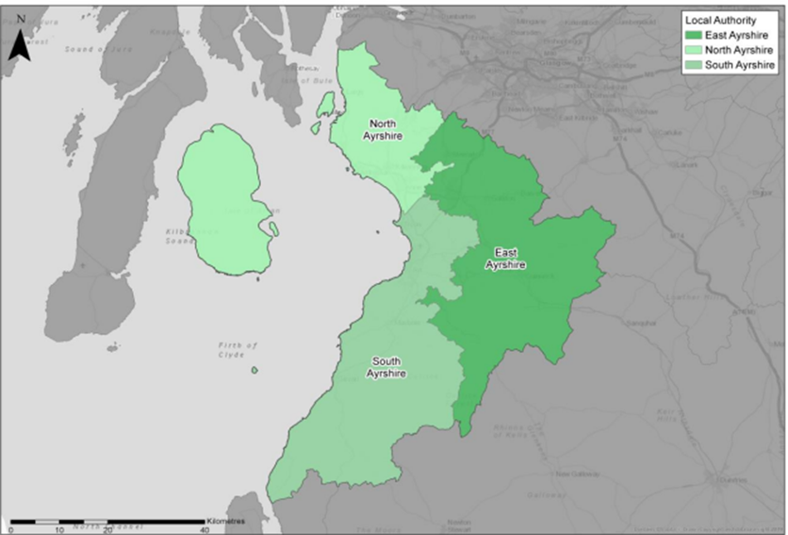
The Ayrshire & Arran Region (herein referred to as ”the Region”) comprises the three local authorities of South Ayrshire, East Ayrshire and North Ayrshire, including the islands of Arran and Cumbrae. The Region includes a mix of urban and rural areas, with The Scottish Government Urban Rural Six-Fold Classification showing the following breakdown in the Region: Other Urban Areas (61%), Accessible Small Towns (15%), Remote Small Towns (5%), Accessible Rural (15%) and Remote Rural (5%). The Region’s transport network comprises active travel routes, rail, bus and road networks, and ferry links to Arran and Cumbrae. Ardrossan and Brodick have also been identified as major ports for the purposes of STPR2. The ports at Cairnryan are also identified as major; although located outwith the Region, the A77 does form the principal north-south route to access the ports. The Region is also home to Glasgow Prestwick Airport, which is identified as a major airport in STPR2 from a freight perspective.
  - Social Context
According to the National Records of Scotland’s Mid-year Population Estimates Scotland, the total population in the Region was 369,360 in 2019 (7% of the total Scotland population). The Region’s population has decreased by 1.2% since the 2011 Scottish Government Census compared to an increase of 3.2% across Scotland. Ayr is the largest settlement in the Region, followed by Kilmarnock and Irvine. There are a number of accessible small towns across the Region including Saltcoats, Ardrossan, Stevenston, Largs, Cumnock, Troon and Dalry.
As outlined in the 2011 Scottish Government Census, 71% of households in the Region have access to a car (higher than the national average of 69%) with travel to work modal share dominated by car; 68% of people in the Region commute to work by car, 8% walk, 7% use the bus, 4% use rail, and 1% cycle. The census also captures that a lower proportion of residents in the Region travel less than 10 kilometres to work compared to across Scotland (40% compared to 49%). Conversely, a considerably higher proportion of residents travel between 10 kilometres and 60 kilometres compared to across Scotland (36% compared to 27%), reflecting the strong trend for travel to the Glasgow City Region from Ayrshire & Arran for accessing employment.
According to the SIMD (Scottish Index Multiple Deprivation) there are areas of deprivation across the Region, most notably within urban areas such as parts of Ayr, Irvine, Kilmarnock, Kilwinning and the Three Towns (Ardrossan, Saltcoats and Stevenston). Within the Region, 150 data zones are ranked amongst the 20% most deprived for employment across Scotland; equivalent to 30% of the Region’s total. This indicates that there is a higher proportion of more deprived data zones in the Region compared to Scotland as a whole.
  - Economic Context
The Region has underperformed in economic terms compared to Scotland as a whole, with high rates of unemployment in the Region in 2019 (4.8% compared to 3.5% nationally). Over the 5-year period 2013 to 2018, Gross Value Added (GVA) increased by 14.9%, which was 0.3 percentage points higher than the overall Scotland increase. However, the Region records high levels of transport poverty and a higher than average number of benefit claimants compared to Scotland as a whole.
  - Environmental Context
The Region has many areas classified as environmentally sensitive, with varying levels of statutory protection. Environmental designations include biodiversity, landscape and heritage designations which fall either wholly or partly within the Region. In addition, the Region contains a significant number of historic assets, including Sites of Special Scientific Interest, Special Protection Areas, Conservation Areas and Scheduled Monuments. The greatest modelled noise levels are located in the north of the Region, primarily associated with the M77 and strategic road corridors around Kilmarnock, together with the rail network along the west coast. Settlements at greatest risk of coastal flooding are along the Firth of Clyde and include coastal communities along the eastern extents of Arran, including Brodick, and within Great Cumbrae, in addition to towns along the Ayrshire coast such as Prestwick, Ayr, Troon and Largs. There are no Air Quality Management Areas (AQMAs) within the Region due to the rural and coastal nature of the landscape, along with a lack of densely populated urban areas. In 2018, CO₂ emissions from transport within the Region constituted 5.9% of Scotland’s total transport emissions.

- Problems and Opportunities
The following transport-related problems and opportunities have been identified for the Ayrshire & Arran region.
  - Problems
- Active Travel Facilities and Safety: mode of travel to work by bicycle and foot is lower in the Region compared to the Scottish average. This may in part be due to a lack of active travel facilities, including segregated cycle infrastructure for commuting purposes and on-board bike carrying facilities on trains and buses. Safety was also highlighted as a concern and accident data shows that there were 188 cyclist related casualties in Ayrshire & Arran between 2014 and 2018, with 2 fatal, 52 serious and 134 slight casualties.

- Accessibility: there are parts of the Region where there is limited access to public transport, particularly in rural areas. Analysis from TRACC – a multimodal accessibility and journey time analysis tool – demonstrates the problem; limited public transport accessibility restricts people’s access to key services, with 90% of the Region’s population able to access an employment centre by public transport within 60 minutes and only 65% within 30 minutes; 73% of the population can access an accident and emergency hospital site (key hospital site) by public transport within 60 minutes and only 17% within 30 minutes.

- Connectivity and Journey Times: limited connectivity and long journey times were highlighted as a problem between Ayrshire and the M74 (via the non-trunk A70 and A71) and south of Ayr to access the ports at Cairnryan via the A77. On the A77 between Cairnryan and Ayr, average speeds are around 38mph, thus lengthening journey times. Long journey times were noted to impact the economic competitiveness of the Region, including longer journey times by bus. For example, journey time between Troon and Glasgow by car is approximately 50 minutes compared to 1 hour 10 minutes by bus, while travel between Cumnock and Glasgow is typically between 1 hr 20 mins and 1 hr 30 mins by bus, compared to around 55 minutes by car.

- Resilience: in the event of A77 route closure, the diversionary route has been noted to be long and sub-standard for the volume and type of vehicles using it (e.g. HGVs). The A78 is also prone to flooding which leads to closure. Some 81% of all incidents recorded on the Region’s trunk roads between 2015-2018 were on the A77 or A78. Similarly, ferry cancellations can have an adverse impact on residents accessing key services and, more widely, on the economy. During the period September 2019 to August 2020, almost 13% of scheduled sailings were cancelled between Ardrossan and Brodick, with the highest percentage of cancelations (38%) recorded in February 2020.

- Capacity Constraints and Congestion: capacity constraints and congestion have been identified at Bellfield Interchange (A77 at Kilmarnock), which has recorded long queue lengths, the A77/A78 at Ayr at Monkton, Dutch House and Whitletts Roundabouts at Prestwick / Ayr and the A737/A738 at Kilwinning. Capacity issues, linked to the introduction of Road Equivalent Tariff (RET), have also been recorded on the Ardrossan to Brodick ferry route. The Ardrossan to Brodick route has experienced vehicle deck capacity issues on peak sailings, with 26% of all sailings in 2015-16 having a car deck utilisation of greater than 80%. In addition, the number of cars carried on the Ardrossan to Brodick route increased by 34% between 2008-2018 and by 18% on the Largs to Cumbrae route over the same period.

- Frequency and Fragility of Public Transport: limited public transport coverage prevents access to services and can lead to forced car ownership. There is limited integration between public transport, particularly in rural areas, and limited interconnectivity between bus, rail and ferries with low frequency and limited operating hours. Bus patronage has fallen in recent years and bus mileage, connectivity and quality have been cited as contributory factors to this decline.

- Transport Poverty and Affordability: transport spend and poverty is generally higher in rural parts of the Region with 58% of data zones in the Region classified as being at high risk for transport poverty compared to 38% in Scotland. The cost of bus travel in the Region was noted to be high compared to car (and taxi) and there is a perceived lack of funding to encourage modal shift.

  - Opportunities
- Economic Development: the signed Ayrshire Growth Deal Agreement document details the different areas and projects being taken forward as part of the £251 million deal to support economic development in the Region. The Economic Infrastructure Programme includes the following projects: HALO Kilmarnock, Ayrshire Engineering Park, Ayrshire Manufacturing Investment Corridor (AMIC) and the i3 Irvine Enterprise Area. The document also outlines other allocation areas, such as for an Energy, Circular Economy and Environment Programme, Digital and Skills and Inclusion. The Revised Draft Fourth National Planning Framework (Revised Draft NPF4) also identifies Hunterston as a national development site; this supports the repurposing of Hunterston port as well as the adjacent former nuclear power station site. The location and infrastructure offer potential for electricity generation from renewables, and a variety of commercial uses including port, research and development, aquaculture and the circular economy.

- Tourism: growing the active travel tourism market through the development and promotion of NCN type infrastructure across the Region was raised as a major opportunity by stakeholders, with areas such as Galloway Forest commonly referred to as an ‘untapped resource’. There are also opportunities to support The Coig, which forms tourist trails across Ayrshire, Arran, Argyll & Bute and Inverclyde in seeking to emulate the success of the North Coast 500. Reflective of the aspirations to grow the number of visitors to the Region, the Ayrshire Growth Deal also includes reference to a Tourism Programme, which includes funding for the development of The Great Harbour of up to £14 million and investment in Marine Tourism of up to £9.5 million.
- Journey Time Reduction, Journey Quality and Improved Connectivity: the Region’s road network, including trunk roads, is largely single carriageway and this has been linked to adversely impacting journey times and journey quality. Stakeholders have suggested that improvements in journey time, journey quality and improved connectivity would make the Region more attractive to investors.

- Travel Planning, Behaviour Change and Low Carbon: there are opportunities in the Region to promote improved travel planning, behaviour change and a shift towards the use of low carbon technologies. Several areas in the south of South Ayrshire are between 10 to 20 miles from an Electric Vehicle charging point. A low carbon rail network features as part of the Rail Services Decarbonisation Action Plan, which sets out the plan to decarbonise the rail network by 2035, including electrification of parts of the network and alternative traction for rail services between Girvan and Stranraer. Opportunities also exist to promote digital connectivity and there is the potential for more people to work from home. Access to Super-Fast Broadband ranges between 40% to 64% in the Region, with North Ayrshire experiencing the highest levels in the Region with 64% of residential premises having access.

- Improved Route Resilience: improving route resilience is primarily related to the economy and how frequent route closures, arising from planned and unplanned closures, are often exacerbated by a lack of high quality diversionary routes. This can have an adverse impact on the local economy, and depending on the route affected, the regional and national economy.

- Regional Recommendations
The following is a list of interventions that form a package of recommendations that are relevant to this Region.
Regional Recommendations
- Connected neighbourhoods (Recommendation 1)
- Village-town active travel connections (Recommendation 3)
- Connecting towns by active travel (Recommendation 4)
- Long-distance active travel network (Recommendation 5)
- Behavioural change initiatives (Recommendation 6)
- Changing road user behaviour (Recommendation 7)
- Increasing active travel to school (Recommendation 8)
- Improving access to bikes (Recommendation 9)
- Expansion of 20mph limits and zones (Recommendation 10)
- Provision of strategic bus priority measures (Recommendation 14)
- Supporting integrated journeys at ferry terminals (Recommendation 18)
- Infrastructure to provide access for all at railway stations (Recommendation 19)
- Investment in Demand Responsive Transport and Mobility as a Service (Recommendation 20)
- Improved public transport passenger interchange facilities (Recommendation 21)
- Framework for the delivery of mobility hubs (Recommendation 22)
- Smart, integrated public transport ticketing (Recommendation 23)
- Ferry vessel renewal and replacement, and progressive decarbonisation (Recommendation 24)
- Decarbonisation of the rail network (Recommendation 25)
- Decarbonisation of the bus network (Recommendation 26)
- Behavioural change and modal shift for freight (Recommendation 27)
- Zero emission vehicles and infrastructure transition (Recommendation 28)
- Trunk road and motorway safety improvements to progress towards ‘Vision Zero’ (Recommendation 30)
- Trunk road and motorway network climate change adaptation and resilience (Recommendation 31)
- Trunk Road and motorway network renewal for reliability, resilience and safety (Recommendation 32)
- Future intelligent Transport Systems (Recommendation 33)
- Traffic Scotland System Renewal (Recommendation 34)
- Intelligent Transport System renewal and replacement (Recommendation 35)
- Strategy for improving rest and welfare facilities for hauliers (Recommendation 36)
- Improving active travel on trunk roads through communities (Recommendation 37)
- Speed Management Plan (Recommendation 38)
- Access to Stranraer and the ports at Cairnryan (Recommendation 40)
- Investment in port infrastructure to support vessel renewal and replacement, and progressive decarbonisation (Recommendation 42)
- Rail freight terminals and facilities (Recommendation 44)

- Fit with Established Policy
The interventions included within this package support a wide range of national, regional and local policy documents in which transport improvements play a key role in both the enabling and delivery of outcomes.
Key policies supported include the Programme for Government, Infrastructure Investment Plan, NTS2, the Climate Change Plan Update 2018 - 2032, SPT’s Regional Transport Strategy, the Ayrshire Timber Transport Strategy, North Ayrshire Local Transport Strategy, and Ayrshire and Strathclyde Freight Strategies, as well as non-transport-specific plans, such as the Ayrshire Growth Deal and East Ayrshire Economic Development Strategy.
Interventions in this package also have the potential to support improved transport connectivity to Hunterston, which has been identified as a national development site within the Revised Draft NPF4.
The policy framework for the Region has a strong emphasis on delivering strengthened connectivity to support a sustainable economy. This includes providing travel choices which promote equality and social inclusion and which promote modal shift away from private car, increase walking and cycling opportunities, and provide an attractive place for visitors and businesses to invest and grow; the package therefore closely aligns with established policy directives.

Package Performance Against NTS2 Priorities and Outcomes:

Reduce inequalities
Will provide fair access to services we need: Moderate Positive
Will be easy to use for all: Major Positive
Will be affordable for all: Minor Positive

Takes climate action
Will help deliver our net-zero target: Major Positive
Will adapt to the effects of climate change: Minor Positive
Will promote greener, cleaner choices: Major Positive

Helps deliver inclusive economic growth
Will get people and goods where they need to get to: Major Positive
Will be reliable, efficient and high quality: Major Positive
Will use beneficial innovation: Major Positive

Improves our Health and Wellbeing
Will be safe and secure for all: Major Positive
Will enable us to make healthy travel choices: Moderate Positive
Will help make our communities great places to live: Major Positive
- STPR2 Transport Planning Objectives (TPOs) Assessment

TPO1 A sustainable strategic transport system that contributes significantly to the Scottish Government’s net-zero emissions target

TPO Performance Summary
Carbon dioxide equivalent (CO₂eq) is treated as a nationally important pollutant. As such, although it can be appraised at the national level (commentary below), it has not been appraised for individual regions.
The national and all regional packages overall will contribute significantly to the net-zero emissions target by:
- Enabling more passenger journeys to be made by active modes and public transport.
- Decarbonising most if not all public transport operations.
- Facilitating uptake of electric vehicles.
- Enabling road freight to switch to rail or other low carbon modes.
Further commentary is provided below.
National CO₂eq emissions are forecasted to decrease year-on year. This is due to decreasing vehicle exhaust (non-traded) emissions as the number of internal combustion engine vehicles reduces. This is reflected in the volume of traded grid emissions from charging increased numbers of battery-electric vehicles, and specifically in the Low scenario. It is noted that traded emissions of CO₂eq are associated with electrical generation to supply plug-in vehicles, both BEV (battery electric vehicles) and PHEV (plug-in hybrid vehicles).
The electricity grid is expected to be using predominantly renewable sources in the future and so increasing adoption of electric vehicles and a shift from direct, non-traded, emission to traded grid-based technology (i.e. battery) will support reducing CO₂eq emissions.
Across both Low and High scenarios the interventions would reduce emissions of CO₂eq.
Significantly higher overall emissions are predicted in the High scenario, either with, or without, the national and all regional packages. There is a relatively smaller overall reduction of emissions due to the interventions in the Low scenario due to the lower overall emissions. The economic impacts associated with air quality were assessed using the Department for Environment Food & Rural Affairs (DEFRA) Damage Costs Appraisal Toolkit. The larger economic benefit from the High scenario is due to the greater overall emissions with, or without, the package, although the proportional change is lower.
Overall Scoring:
Low and High Scenarios: Moderate Positive

Metric 1: Change in CO₂eq (non-traded and traded emissions from regional road transport inc. grid emissions from charging light-duty vehicles)- Figures below are a National calculation
Low Scenario Commentary:
- 0.5% decrease (27,700 tonnes CO₂eq) in 2030.
- 2.8% decrease (21,600 tonnes CO2eq) in 2045.
- 1.3 million tonnes reduction, of which 1.1 million were traded, for the 60-year appraisal period from 2030 to 2089.
- The net economic benefits for the 60-year appraisal period in 2010 prices and values would be in the range £10 million to £25 million for the Low scenario.
High Scenario Commentary:
- 0.4% decrease (31,300 tonnes CO₂eq) in 2030.
- 1.3% decrease (65,300 tonnes CO₂eq) in 2045.
- 3.7 million tonnes reduction, of which 452,000 were traded, for the 60-year appraisal period from 2030 to 2089.
- The net economic benefits for the 60-year appraisal period in 2010 prices and values would be in the range £100 million to £250 million for the High scenario.

Metric 2: Change in mode share by active travel for all journeys
Low and High Scenarios Commentary:
- Potential increase in walking from 18% mode share to 22% mode share (4 percentage points).
- Potential increase in cycling from 0.4% mode share to 17% mode share (17 percentage points).

The package will increase the proportions of journeys undertaken by active modes. If all the active travel and behaviour change interventions were fully implemented in every relevant location in the Region, mode shares of walking and cycling "with STPR2 package" proportions are shown alongside the mode share without package.

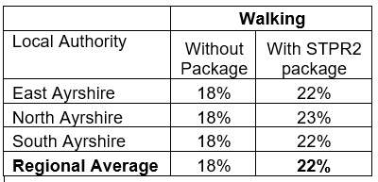

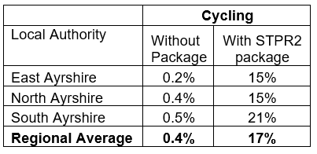
Note that the cycling and walking growth forecasts have been developed independently of each other. Growth in use of one active mode is likely to abstract at least some trips from the other, but this effect is not accounted for within these forecasts.

Metric 3: Change in motorised vehicle kilometres travelled
Low Scenario Commentary:
- Reduction of 37.0 million motorised vehicle kilometres (2% decrease) (see Annex B).
High Scenario Commentary:
- Reduction of 37.3 million motorised vehicle kilometres (1% decrease) (see Annex B).

TPO2 An inclusive strategic transport system that improves the affordability and accessibility of public transport

TPO Performance Summary
Interventions included in this package would be anticipated to improve the inclusiveness of the transport system by:
- Improving conditions for people walking, wheeling and cycling, the most inclusive transport modes, with particular benefits for people most often excluded (including children, older and disabled people, and people on low incomes).
- Improving inclusive accessibility to public transport stops/stations.
- Seeking to promote public transport use and reduce operating costs, hence enhancing network sustainability.
Overall Scoring:
Low and High Scenarios: Minor Positive

Metric 1: Change in transport poverty risk
Low and High Scenarios Commentary:
Although the STPR2 interventions do not impact on the direct costs of travel (e.g. fares, fuel price), the package of interventions would see a small reduction in transport poverty, due to the overall improvements in public transport availability.

Metric 2: Change in Accessibility - population catchments increases to key services by journey time by public transport
Low and High Scenarios Commentary:
The largest change in population accessibility of all the destination types considered was to accident and emergency hospitals, whereby an additional 4,500 of the population in the Region woud be able to access the nearest site in a journey time of 30 minutes or less by public transport. This represents a 1.4 percentage point increase from 29.3% in the without package assessment to 30.7% with the package in place. The improvements are predominately shown to the north of Ayr, with particular improvements observed in both Irvine and Kilmarnock, where the accessibility to an accident and emergency hospital site within a 30 minute public transport journey would increase by 6.6 and 4.4 percentage points compared to the without package assessment, which equates to a population of 1,800 and 1,700 respectively. This is shown by the map output in Annex A.
There were also population accessibility improvements observed in the Region for accessing key destinations within a journey of 30 minutes, which include major shopping centres, higher education, secondary schools and large food stores. The accessibility improvements and the corresponding additional population that are able to access those destinations within a journey time of 30 minutes compared to the without package assessment are summarised below:
- 4,500 additional people are able to access an accident and emergency hospital site by public transport in under 30 minutes, which represents a 1.4 percentage point increase in accessibility levels from 29.3% in the without package assessment to 30.7% with the package in place.

- 3,900 additional people are able to access the nearest higher education site by public transport, as shown by the map output in Annex A, which represents a 1.3 percentage point increase in accessibility levels from 56.3% in the without package assessment to 57.6% with the package in place.

- 4,500 additional people are able to access a major shopping centre by public transport, which represents a 1.5 percentage point increase in accessibility levels from 48.3% in the without package assessment to 49.8% with the package in place.

- 3,000 additional people are able to access a large food store by public transport, which represents a 1.0 percentage point increase in accessibility levels from 81.3% in the without package assessment to 82.3% with the package in place.

- 500 additional children (aged 11 to 18) are able to access the nearest secondary school, which represents a 1.6 percentage point increase in accessibility levels from 70.5% in the without package assessment to 72.1% with the package in place.

In terms of additional destinations (cities, rail stations and airports) considered in the model:

- 3,300 additional people are able to access their closest city within a 60 minute public transport journey, which represents a 1.1 percentage point increase in accessibility levels from 36.4% in the without package to 37.5% with the package in place.
- 1,200 additional people are able to access their closest rail station within a 30 minute public transport journey, which represents a 0.4 percentage point increase in accessibility levels from 77.0% in the without package to 77.4% with the package in place.
- 21,600 additional people are able to access their closest international airport within a 60 minute public transport journey, which represents a 7.0 percentage point increase in accessibility levels from 57.1% in the without package to 64.1% with the package in place.

Mapping outputs are shown in Annex A.

TPO3 A cohesive strategic transport system that enhances communities as places, supporting health and wellbeing

TPO Performance Summary
The package will improve communities as places, supporting health and wellbeing by enabling more journeys to be made by active and sustainable modes, and by improving road safety. This will:
- Improve many people’s physical health and mental wellbeing, with particular benefits for people most often excluded (including children, older and disabled people, and people on low incomes).
- Reduce the adverse impacts of car use on communities and health (including reduced air pollution, noise, accident risk and perceived road danger).
The analysis shows that through improved uptake of walking and cycling, there would be a forecast reduction of 16 premature deaths per annum due to the health benefits arising from active travel.
Overall Scoring:
Low and High Scenarios: Moderate Positive

Metric 1 Change in mode share by active travel for all journeys
Low and High Scenarios Commentary:
- Potential increase in walking from 18% mode share to 22% mode share (4 percentage points).
- Potential increase in cycling from 0.4% mode share to 17% mode share (17 percentage points).
These forecasts are subject to all active travel interventions being delivered in all relevant areas in the Region.
Cycling and walking growth forecasts have been developed independently. Growth in use of one active mode is likely to abstract at least some trips from the other, but this effect is not accounted for within these forecasts.

Metric 2 Potential for Change in 'Place'
Low and High Scenarios Commentary:
The package will tend to improve the quality of the Region’s places by improving local accessibility and reducing the adverse impacts of road traffic.
Particular benefits may arise in neighbourhoods where active travel allows easier walking and cycling conditions, particularly in areas of the Region which are within walking / cycling distance to key destinations.

Metric 3 Change in Health Benefits
Low and High Scenarios Commentary:
The health benefits of increased rates of active travel as a result of the package have been quantified using the WHOs Health Economic Assessment Tool (HEAT). HEAT estimates the health and economic impacts of increased walking and cycling, providing assessments of the health and economic impacts of walking and cycling on premature mortality and on exposure to air pollution. Outputs from the tool shows the following benefits by Local Authority:
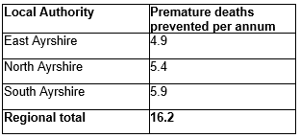

TPO4 An integrated strategic transport system that contributes towards sustainable inclusive growth in Scotland

TPO Performance Summary
The package will contribute to sustainable inclusive growth in Scotland by:
- Improving integration of transport modes (especially between active modes and public transport) and between transport and major developments.
- Improving journey time reliability.
- Enabling more people to travel by improving the accessibility and affordability of the transport system, through greater mode choice and reduced reliance on the private car. This enables more people to access local retail and services, and opportunities for employment and education / training.
Encouraging modal shift to sustainable modes and reducing the volume of vehicles on the road network is anticipated to improve journey time reliability for all vehicles, providing benefits to businesses across the Region. A reduction in vehicle hours of between 34,000 and 39,000 hours is anticipated in the respective growth scenarios for business and commercial travel, contributing towards sustainable inclusive growth in Scotland.
Overall Scoring:
Low and High Scenarios: Moderate Positive

Metric 1: Increased labour catchment by sustainable travel (PT/Active Travel)
Low and High Scenarios Commentary:
Access to local employment, which represents accessibility to key employment opportunities located in the surrounding area within a 40 minute public transport journey time, observed a minor improvement across the Region; noticeably in Prestwick and Stewarton, parts of Ayr, Kilwinning and Irvine. In Prestwick particularly, the package on average enables an additional 2,800 of existing jobs to be accessed by public transport under the with package assessment. This is shown by the map output in Annex A.
Access to regional employment, which represents the accessibility of key employment opportunities located in Glasgow City and Ayr within a 60 minute journey time using public transport, observed improvements, particularly in the north of the Region which is more associated with employment movements to Glasgow. The modelling shows that the package on average enables an additional 7,300 of existing jobs to be accessed in the Region within a 60 minute journey time by public transport. North Ayrshire and East Ayrshire observed the highest increase, whereby an additional 11,800 jobs and 8,400 existing jobs are able to be accessed respectively. This is shown by the map output in Annex A.

Metric 2: Change in lost time due to congestion (for business / commercial transport)
Low Scenario Commentary:
- 4% decrease (equivalent to reduction of 34,500 hours).
High Scenario Commentary:
- 2% decrease (equivalent to reduction of 38,900 hours).

TPO5 A reliable and resilient strategic transport system that is safe and secure for users

TPO Performance Summary
The package will improve reliability, safety and personal security on the transport system by:
- Improving journey time reliability, including through reduced likelihood of significant network disruptions.
- Reducing the risk of road accidents at hotspot locations on the trunk road network e.g. through targeted infrastructure improvements such as carriageway realignment and widening, the provision of overtaking opportunities and junction improvements (it should be noted that replacing a priority junction with a signalised junction could increase the overall number of accidents, however the severity of accidents occurring should reduce).
- Reducing perceived risks to road safety and to personal security, so enabling more people (particularly children, women and older people) to travel independently
- Changing attitudes of road users, through behavioural change campaigns. This is anticipated to increase awareness of interactions with those walking, wheeling and cycling.
- Improving active travel provision and providing more dedicated and segregated routes for walking, cycling and wheeling.
Overall Scoring:
Low and High Scenarios: Moderate Positive

Metric 1 Change in accidents (PIA and ‘damage-only’)
Low Scenario Commentary:
- Accident reduction related to motorised vehicle kilometres is forecast to be 3%.
High Scenario Commentary:
- Accident reduction related to motorised vehicle kilometres is forecast to be 2%.
Low and High Scenarios Commentary:
Whilst the number of accidents involving motorised vehicles is anticipated to reduce following the introduction of the interventions within this package, it is anticipated that the package would increase walking and cycling journeys. The number of accidents involving these modes is therefore anticipated to increase, although each individual journey is anticipated to be significantly safer.

Metric 2 Percentage accident change for Targeted Infrastructure Improvements over 60 years, using default accident rate (PIA only)
Low and High Scenarios Commentary:
Accident benefits were estimated using the Department for Transport (DfT) recommended software programme COBA-LT (Cost and Benefit to Accidents – Light Touch) for targeted road safety improvements, based on default parameters, but using Scotland specific accident rates. A range of accident benefits were calculated for the various improvement options being considered. This provided the upper and lower bound of estimated percentage change in accidents, respectively. These ranges are shown below and provide the anticipated upper and lower bounds of impact on accidents that would be anticipated from typical interventions of this type:
- Sections of Realignment/Widening – reduction of 23% to 59%.
- Sections of Overtaking Opportunities – reduction of 35% to 73%.
- Locations of Junction Improvements – change of 42% (increase) to 64% (decrease).

It should be noted that junction accidents are forecast to increase in the event that a junction is upgraded from a priority to a signalised junction. This is due to an increase in the number of slight accidents that are likely to occur as a result of shunts in queuing traffic on the mainline approach to the traffic signals, which could previously travel unopposed. However, the accident severity can be expected to reduce as a result of this type of improvement. Any improvement scheme would be subject to further consideration.

Metric 3 Change in lost time due to congestion
Low Scenario Commentary:
- 8% decrease (101,000 hours) in lost time due to congestion (see Annex B).
High Scenario Commentary:
- 5% decrease (190,000 hours) in lost time due to congestion (see Annex B).

Metric 4 Journey Time Reliability / Availability of alternatives (modes/routes)
Low and High Scenarios Commentary:
This package is forecast to reduce overall motorised vehicle kilometres by 3% and 2% under the Low and High scenarios respectively, thus reducing the risk of accidents occurring as a result of travel reductions, whilst improving resilience by reducing the number of road closures associated with accidents.
Targeted improvements at junctions where safety is a problem are forecast to reduce accidents and associated road closures, thereby improving reliability. The provision of targeted improvements such as carriageway realignment and widening and the provision of overtaking opportunities is also designed to improve journey time reliability and the risk of accidents which can impact route resilience. Improvements in terms of renewals and climate change adaptation to protect the operation of the trunk road and motorway network would also positively impact on the reliability of the network.
Encouraging modal shift to sustainable modes and reducing the volume of vehicles on the network is anticipated to improve journey time reliability, as indicated by reducing time lost to congestion of 101,000 and 190,000 hours in the Low and High scenarios respectively.
- STAG Assessment
  - Environment

Environment

Air Quality
Performance Summary:
Total emissions of NO_{X} (a group of gases that are mainly formed during the combustion of fossil fuels) were predicted to decrease in future in both the High and Low scenarios.
Total emissions of NO_{X} are predicted to be effectively zero in 2045 in the Low scenario, and by 2052 in the High scenario either with, or without, the proposed package. It is the change brought about by the projected transition of the vehicle fleet to zero-emission vehicles that contribute to the majority of air quality benefits, and in this instance outweighs the positive mode change contributions from the regional package.
Total emissions of Particulate Matter (PM), which is made up of a collection of solid and / or liquid materials, were predicted to increase in future, predominantly due to non-exhaust emissions from road, tyre and brake-wear.
However, the package will reduce harmful emissions slightly. Over the 60-year appraisal period, there was a predicted 100% reduction in NO_{X}, 1.1% reduction in PM10 and 1.2% reduction in PM2.5 in the Low scenario, and a 2.2% reduction in PM10 and a 2.2% reduction in PM2.5 in the High scenario.
Low Scenario Scoring: Minor Positive
High Scenario Scoring: Minor Positive

Noise and Vibration
Performance Summary:
The anticipated modal shift is also expected to reduce levels of noise and vibration associated with the transport network. There is potential for localised negative effects on noise and vibration due to the construction and operation of specific interventions, however the magnitude of effect will depend on the design and location of the intervention.
Low Scenario Scoring: Minor Positive
High Scenario Scoring: Minor Positive

Biodiversity and Habitats: Geology and Soils; Land Use (including Agriculture and Forestry); Water, Drainage and Flooding; Historic Environment; and Landscape
Low and High Scenarios Commentary:
Please refer to SEA performance summary text in the ‘Statutory Impact Assessment Criteria’ section below. Please note the scoring has been based on the SEA methodology for scoring, which has been agreed with the SEA Consultation Authorities.
  - Climate Change

Climate Change

Performance Summary (applicable to all Climate Change Sub-Criteria)
Carbon dioxide equivalent (CO₂eq) is treated as a nationally important pollutant. As such, although it can be appraised at the national level (commentary below), it has not been appraised for individual regions.
National CO₂eq emissions are forecasted to decrease year-on year, with decreasing direct (non-traded) exhaust emissions and increasing traded grid emissions associated with increased adoption and charging of battery-electric vehicles, and specifically in the Low scenario. It is noted that traded emissions of CO2eq are associated with electrical generation to supply plug-in vehicles, both BEV (battery electric vehicles) and PHEV (plug-in hybrid vehicles).
Across both scenarios, the package will reduce emissions of CO₂eq, although the change is greater in the High scenario due to overall higher emissions.
Key recommendations within the package have a focus on identifying vulnerabilities to the effects of climate change on the transport system, as well as identifying measures to assist in the adaptation to the effects of climate change, including unplanned events, such as flooding, landslides and high winds. Climate change adaptation and network resilience would address existing and predicted climate change impacts and support the changes that are necessary to reach the Scottish Government’s net zero target for greenhouse gas emissions. Improving the climate resilience of the transport network will also align with the Scottish Government’s commitment to develop Scotland’s next statutory climate adaptation programme.
The above summary is applicable across all the sub-criteria, as outlined below. The specific performance against each sub-criteria is scored against both the Low and High scenarios.

Greenhouse Gas Emissions
Low Scenario Scoring: Major Positive
High Scenario Scoring: Major Positive

Vulnerability to Effects of Climate Change
Low Scenario Scoring: Minor Positive
High Scenario Scoring: Minor Positive

Potential to Adapt to Effects of Climate Change
Low Scenario Scoring: Minor Positive
High Scenario Scoring: Minor Positive
  - Health, Safety & Wellbeing

Health, Safety & Wellbeing

Performance Summary (applicable to all Health, Safety & Wellbeing Sub-Criteria)
The package will reduce the number and severity of accidents through targeted infrastructure improvements and by encouraging modal shift away from private car, resulting in reduced accident risk due to reduced conflicts. Whilst the number of accidents involving motorised vehicles is anticipated to reduce following the introduction of the interventions within this package, it is anticipated that the package would increase walking and cycling journeys. The number of accidents involving these modes is therefore anticipated to increase, although each individual journey is anticipated to be significantly safer.
Mode shift to sustainable modes will, by improving natural surveillance, make paths, bus stops, interchanges, and services safer, reduce the perception of isolation and this, accompanied by improved quality of facilities, will improve perceived security.
The package will improve communities as places, supporting health and wellbeing, by encouraging modal shift away from private car and towards active travel. This will improve placemaking through reduced noise and better air quality due to reduced traffic, and reduced accident risk. It will also benefit many people’s physical health and mental wellbeing.

Accidents (PIA and ‘damage-only’)
Low Scenario Commentary:
- Accident reduction related to motorised vehicle kilometres is forecast to be 3%.
High Scenario Commentary:
- Accident reduction related to motorised vehicle kilometres is forecast to be 2%.

Percentage accident change for Targeted Infrastructure Improvements over 60 years using default accident rate (PIA only)
Low and High Scenarios Commentary:
Accident benefits were estimated using the Department for Transport (DfT) recommended software programme COBA-LT (Cost and Benefit to Accidents – Light Touch) for targeted road safety improvements, based on default parameters, but using Scotland specific accident rates. A range of accident benefits were calculated for the various improvement options being considered. This provided the upper and lower bound of estimated percentage change in accidents, respectively. These ranges are shown below and provide the anticipated upper and lower bounds of impact on accidents that would be anticipated from typical interventions of this type:
- Sections of Realignment/Widening – reduction of 23% to 59%.
- Sections of Overtaking Opportunities – reduction of 35% to 73%.
- Locations of Junction Improvements – change of 42% (increase) to 64% (decrease).

It should be noted that junction accidents are forecast to increase in the event that a junction is upgraded from a priority to a signalised junction. This is due to an increase in the number of slight accidents that are likely to occur as a result of shunts in queuing traffic on the mainline approach to the traffic signals, which could previously travel unopposed. However, the accident severity can be expected to reduce as a result of this type of improvement. Any improvement scheme would be subject to further consideration.

Security
Low and High Scenarios Commentary:
The package will, by increasing the number of people travelling actively, tend to improve natural surveillance and through improvements to lighting and urban realm will tend to reduce the number of locations at which security is a concern. Options related to improving public transport passenger facilities and enhancing stations, such as improvements to waiting facilities, would consider security as part of interventions.

Health Outcomes
Low and High Scenarios Commentary:
By increasing rates of active travel and hence physical activity, the package will improve both health and wellbeing outcomes. The estimated value of health benefits to the Region’s population, appraised over a 60-year period, is in the range £500 million to £1,000 million.
By encouraging car journeys to switch to less polluting modes, the package will also tend to improve local air quality, and hence health outcomes.

Access to Health and Wellbeing Infrastructure
Low and High Scenarios Commentary:
An additional 4,500 of the population in the Region are forecast to be able to access an accident and emergency hospital site by public transport in a journey time of under 30 minutes with the package in place compared to the without package assessment. This represents a 1.4 percentage point increase from 29.3% in the without package assessment to 30.7% with the package in place. This is shown by the map output in Annex A.

Public transport journey times to the nearest accident and emergency hospital site showed an improvement in both North Ayrshire and South Ayrshire, with some localities reporting reductions of up to 10 minutes.

Visual Amenity
Low and High Scenarios Commentary:
The package should have a positive impact on visual amenity through improvements to walking and cycling infrastructure and an improved sense of ‘place’.
  - Economy

Economy

Performance Summary
The majority of economic benefits that accrue are as a result of the sustainable transport interventions in the Region’s package to enable and encourage mode shift to public transport modes. The public transport interventions including Bus Priority Infrastructure, and to a lesser extent the Rail and Interchange interventions, are the main contributors to the public transport user benefits in the Low scenario. The remainder of the benefits are largely due to the increase in public transport operator revenue as a result of the increased patronage levels arising from the mode shift away from car.
The level of public transport user benefits are reduced in the High scenario, although this is partially offset by an increase in road user benefits. Nevertheless, even under this scenario, the sustainable transport interventions contribute to the majority of user benefits.
In terms of accident savings, the level of benefits is similar in both the Low and High scenarios. This is due to the reduction in road-based vehicle kilometres travelled in the Region, as a result of the active travel and public transport interventions encouraging a mode shift away from private car.
Note that due to the nature of a number of the STPR2 interventions, it has not been possible to derive indicative cost estimates on a regional basis.

User Benefits (2010 prices and values for a 60 year appraisal period)
Low Scenario Commentary:
- Present Value of Benefits (PVB) of approximately £100 million to £250 million.
- Accidents Present Value of Benefits (PVB) of approximately £10 million to £25 million.
High Scenario Commentary:
- Present Value of Benefits (PVB) of approximately £100 million to £250 million.
- Accidents Present Value of Benefits (PVB) of approximately £10 million to £25 million.
  - Equality & Accessibility

Equality & Accessibility

Performance Summary (applicable to all Equality & Accessibility Sub-Criteria)
The package will improve accessibility to public transport by improving the coverage of the walking, cycling and public transport networks. This will provide particular benefits for people often excluded from transport, including older and young people, women, disabled people, and people living in more deprived communities.
The package will also improve affordability by reducing forced car ownership, and situations where taxi is the only viable mode for people without access to a car.
With regards to deprived areas in the Region, these areas observed an improvement in population accessibility by public transport to the nearest accident and emergency hospital site, and also for higher education, albeit to a lesser extent.

Public Transport Network Coverage
Low and High Scenarios Commentary:
Improving the active travel network and interchanges may provide users with access to a wider public transport network, by enabling easier access to multi-modal trips.

Active Travel Network Coverage
Low and High Scenarios Commentary:
Improvements to the Region’s active travel network, both within and between settlements, mean that many more people will have convenient, high-quality and safe infrastructure for walking, wheeling and cycling journeys.

Comparative Access by People Group
Low and High Scenarios Commentary:
Improvements to active travel networks and public transport will provide positive impacts on groups who are less likely to have access to a car and are more likely rely on public transport, walking and cycling for their journeys. This includes women, children and young people, older people, some ethnic minority groups and disabled people.

Comparative Access by Geographic Location
Low and High Scenarios Commentary:
For deprived areas in the Region, (identified as part of the 20% most deprived areas in Scotland), an additional 4,100 people can access the nearest accident and emergency hospital site in under 60 minutes by public transport in the with STPR2 package assessment compared to in the without package assessment. This represents a 4.5 percentage point increase in accessibility levels from 85.5% in the without package assessment to 90.0% with the package in place.

The access to regional employment, which represents the accessibility of key employment opportunities located in Glasgow City and Ayr within a 60 minute journey time using public transport, improved from deprived areas (20% most deprived in Scotland) in the Region. The improvements were largely observed in East Ayrshire and particularly North Ayrshire, whereby the package on average would enable an additional 3,300 and 15,500 existing jobs located in the key urban areas to be accessed, though likely located in Glasgow due to most of the improvements being observed to the North of the Region. Furthermore, the package would further enable an additional 2,800 and 5,300 existing jobs from deprived areas within East Ayrshire and North Ayrshire respectively to be accessed in a journey time of two hours or less.
All results are shown in the mapping outputs found in Annex A.

Affordability
Low and High Scenarios Commentary:
Although the STPR2 interventions do not impact on the direct costs of travel (e.g. fares, fuel price), the package of interventions would see a small reduction in transport poverty, due to the overall improvements to access and connectivity between modes.

- Deliverability
  - Feasibility

Feasibility
Summary Assessment:
The package has been developed with feasibility considerations in mind. The package mostly makes use of existing, proven technology and would generally be expected to largely operate inside existing design standards. There will be further work required on the feasibility of larger infrastructure provision including road improvements. Additionally, road space allocation across modes will need consideration if multiple modes are competing for similar road space.
  - Affordability

Affordability
Summary Assessment:
The package would require substantial capital and operational funding. Some aspects of the package may generate revenue, which could be used to offset some of these costs.
  - Public Acceptability

Public Acceptability
Summary Assessment:
The package is expected to improve accessibility, connectivity, choice and make transport cleaner, more efficient and more attractive across the Region, which is considered to be positively received. There may be concerns in areas of congestion where road space reallocation or priority interventions are proposed, however the behavioural change elements of the package should help to mitigate this. There may also be acceptability concerns where construction works are expected to cause disruption or require land-take.
- Statutory Impact Assessment Criteria
  - Strategic Environmental Assessment (SEA)

SEA
Performance Summary:
The package supports modal shift to more sustainable modes of transport. Improved access to major ports and airports, the creation of mobility hubs/interchanges, the improvements to passengers’ services and facilities seeks to encourage modal shift, and, as a result, reduce levels of transport related air pollution and carbon emissions. The decarbonisation of the ferry, rail and bus networks and freight deliveries will also support a reduction in greenhouse gas emissions and an improvement in air quality.
The package provides an opportunity to adapt the transport network to the predicted effects of climate change, with one intervention focused on this adaptation and promotes a more sustainable usage of the existing transport network.
Positive effects are anticipated on population and human health due to an expected increase in sustainable access to essential services, increased travel choice and improved connectivity and planning for the future capacity of public transport. Active travel interventions will have positive outcomes for the SEA Population and Human Health topic - for example through expected improvements in air quality and increased uptake of physical exercise through walking, wheeling and cycling.
Road interventions are anticipated to have positive effects on safety. Trunk road improvements which are focused on junction improvements, realignment / widening and overtaking opportunities are also not anticipated to have a notable impact on traffic volumes or mode share and subsequently transport-based emissions, in the majority of locations. The construction and operation of these interventions may result in minor negative effects on population and human health with the potential for an increase in noise and vibration during construction and operation. This is dependent on the location and design of individual schemes. There is also potential for a negative effect on material assets due to the use of natural resources.
The freight interventions are anticipated to result in minor negative effects on material assets as several interventions proposed involve enhancements to rail freight, terminals and facilities and will therefore require the use of natural resources.
The multi modal interventions are also anticipated to result in minor negative effects on material assets as one of the interventions proposed involves renewal and improvement of the resilience of the trunk road and motorway network, including preventative and programmed structural renewals of carriageways and network structures and therefore will require the use of natural resources.
Where other new infrastructure is required, including harbour upgrade requirements and road and rail interventions, this could result in negative effects on biodiversity, soil, landscape, water, cultural heritage and material assets (natural resource requirements); however the magnitude of effect is uncertain at this stage and will be determined by the design (and physical footprint) of the interventions.
As the design and development of interventions in this region progresses, further environmental assessments will determine the magnitude of the different positive and negative environmental effects and mitigation measures will be developed where appropriate.
  - Equalities Impact Assessment (EqIA)

EqIA
Performance Summary:
The package could improve public transport and active travel accessibility to key destinations and services including employment, education, healthcare and shopping for people living in the area. This will have a major positive impact on certain protected characteristic groups who are less likely to have access to a car and more likely to depend on public transport and active travel to make their journeys. This includes women, children and young people, older people, disabled people and people from certain ethnic minority groups.
By encouraging modal shift to more sustainable modes, this package could also contribute to improving local air quality. Improved health outcomes as a result of better air quality are of particular benefit to those who are more vulnerable to air pollution, including children, older people, disabled people and pregnant women.
The package will reduce the severity of accidents through targeted infrastructure improvements and by encouraging modal shift away from private car, resulting in reduced accident risk due to reduced conflicts. Some protected characteristic groups are more likely to be involved in road accidents, for example, children as pedestrian casualties and young males involved as car drivers and as such the package would have positive impacts on these groups.
Mode shift to sustainable modes will reduce the perception of isolation on paths, bus stops, stations and services, and this, accompanied by improved quality of facilities, will improve perceived security. This is likely to provide some benefit to those for whom security is of particular concern including women, the LGBTQ+ community and those from religious backgrounds most subject to hate crime.
The package would therefore be anticipated to have a minor positive impact on this criterion overall.
  - Island Communities Impact Assessment (ICIA)

ICIA
Performance Summary:
Further to the overall benefits of the package, the investment into the decarbonisation of the ferry network would drive island connectivity improvements across the Clyde and Hebrides Ferry Service (CHFS) leading to a beneficial impact on island communities served by these routes. This could lead to a reduction in poor air quality for island communities within close proximity to ports and harbours. Further benefits may be realised through the procurement of new ferry vessels and infrastructure which would potentially be designed to increase accessibility standards than current. The potential for capital funding investment into DRT would be likely to have a positive impact on island communities by providing more flexible public transport services meeting the needs of dispersed and remote island communities.
The package would therefore be anticipated to have a minor positive impact on this criterion overall.
  - Child Rights and Wellbeing Impact Assessment (CRWIA)

CRWIA
Performance Summary:
By encouraging modal shift to more sustainable modes, this package could contribute to improving local air quality. Improved health outcomes as a result of better air quality are of particular benefit to those who are more vulnerable to air pollution, including children.
The package could also improve public transport and active travel accessibility to higher education institutions and employment opportunities for young people living in the area.
Safety is a key issue for children with regards to transport, with child pedestrian casualties recorded in Scotland in 2019 accounting for 44% of all pedestrian casualties.
The package will reduce the severity of accidents through targeted infrastructure improvements and by encouraging modal shift away from private car, resulting in reduced accident risk due to reduced conflicts.
The package would therefore be anticipated to have a minor positive impact against this criterion overall.
  - Fairer Scotland Duty Assessment (FSDA)

FSDA
Performance Summary:
This Region contains some areas included within the 10% most deprived in Scotland. The package has the potential to improve public transport connectivity and can therefore support regeneration and economic development and reduce inequalities caused by socio-economic disadvantage by improving accessibility to employment for deprived communities or communities where transport options are limited.
The package would therefore be expected to have a minor positive impact on this criterion overall.

Annexes

Annex A: NAPTAT Mapping
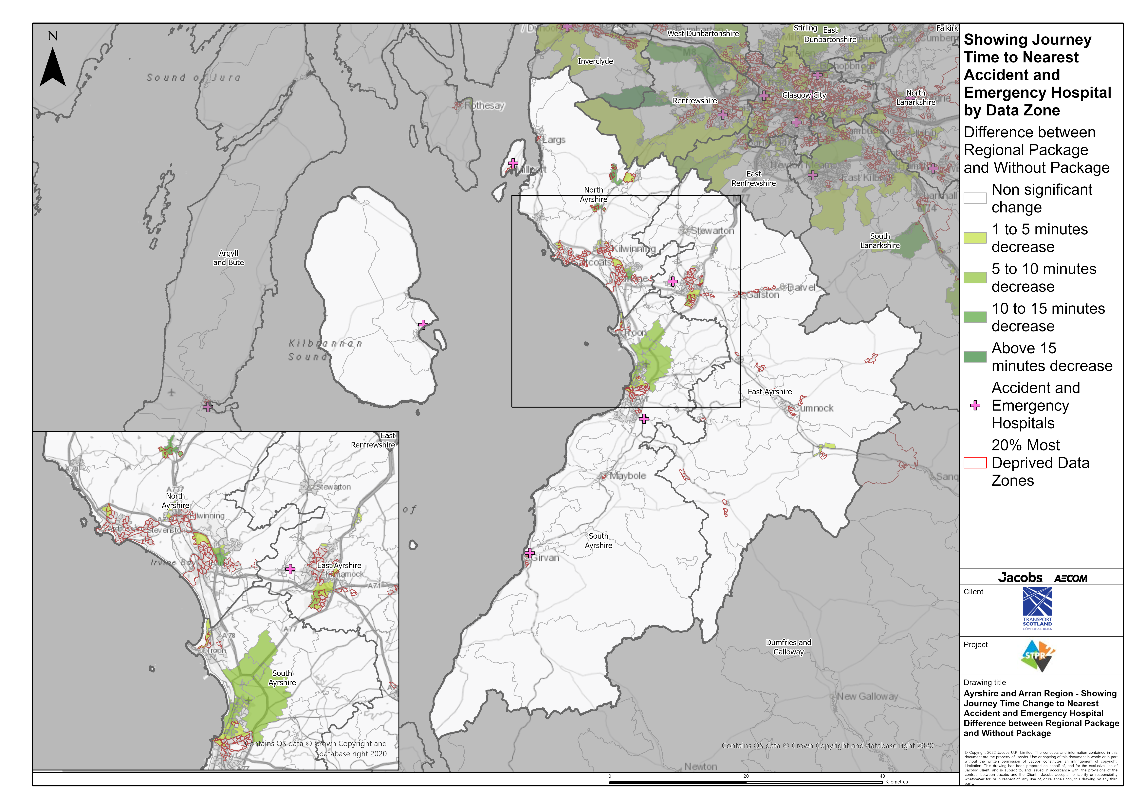
Ayrshire & Arran Region – Showing Journey Time Change to Nearest Accident and Emergency Hospital Difference between Regional Package and Without Package
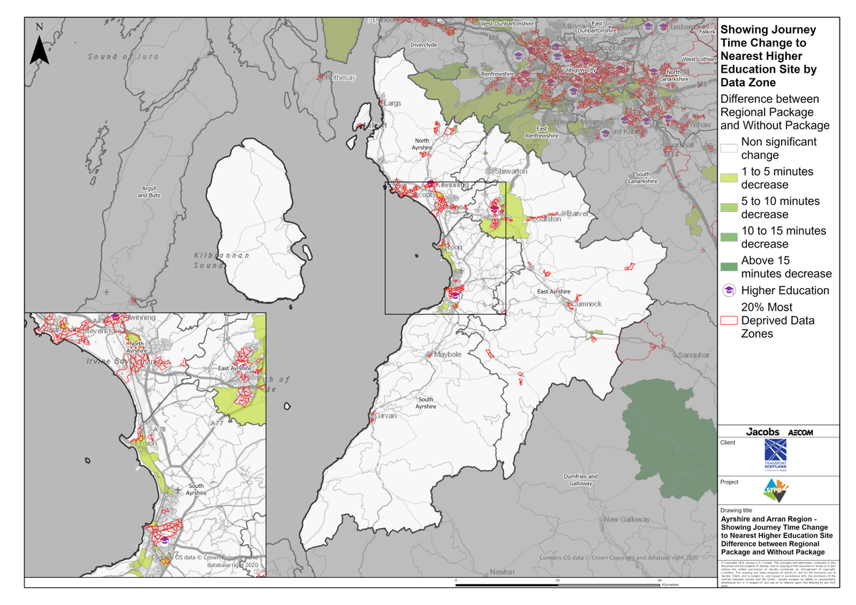
Ayrshire & Arran Region – Showing Journey Time Change to Nearest Higher Education Site Difference between Regional Package and Without Package
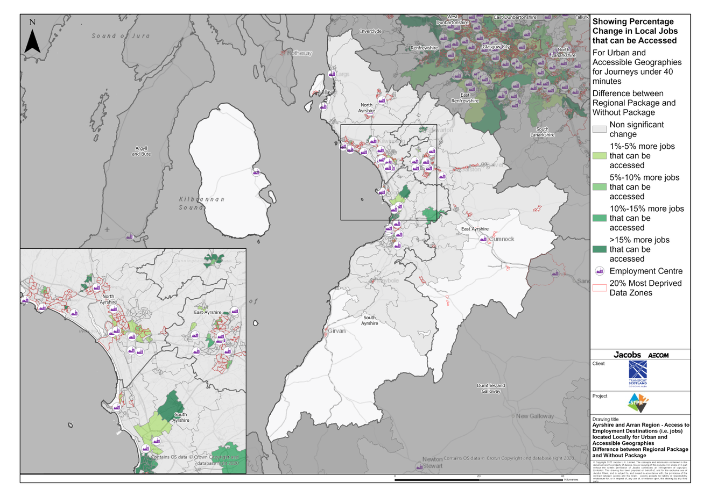
Ayrshire & Arran Region – Access to Employment Destinations (i.e. jobs) located Locally for Urban and Accessible Geographies Difference for journeys under 40 minutes between Regional Package and Without Package
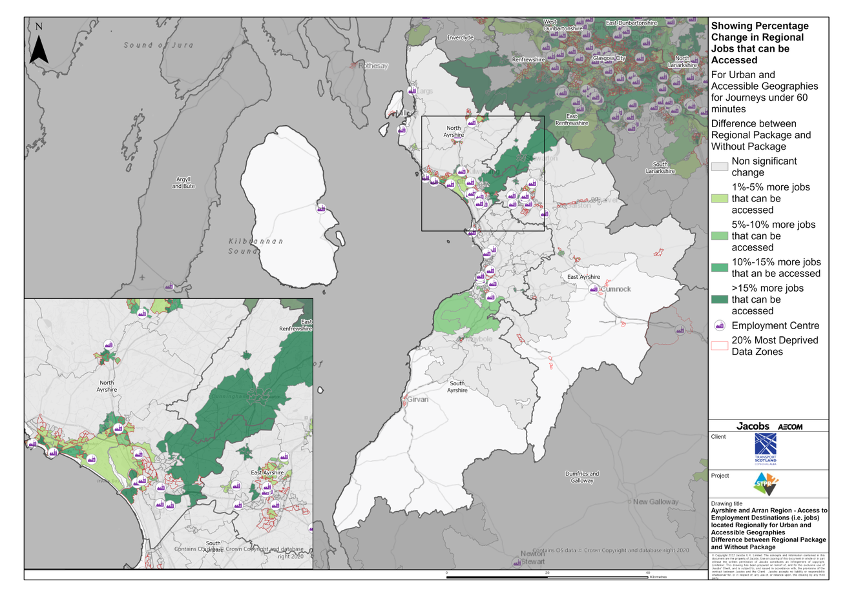
Ayrshire & Arran Region – Access to Employment Destinations (i.e. jobs) located Regionally for Urban and Accessible Geographies for journeys under 60 minutes Difference between Regional Package and Without Package
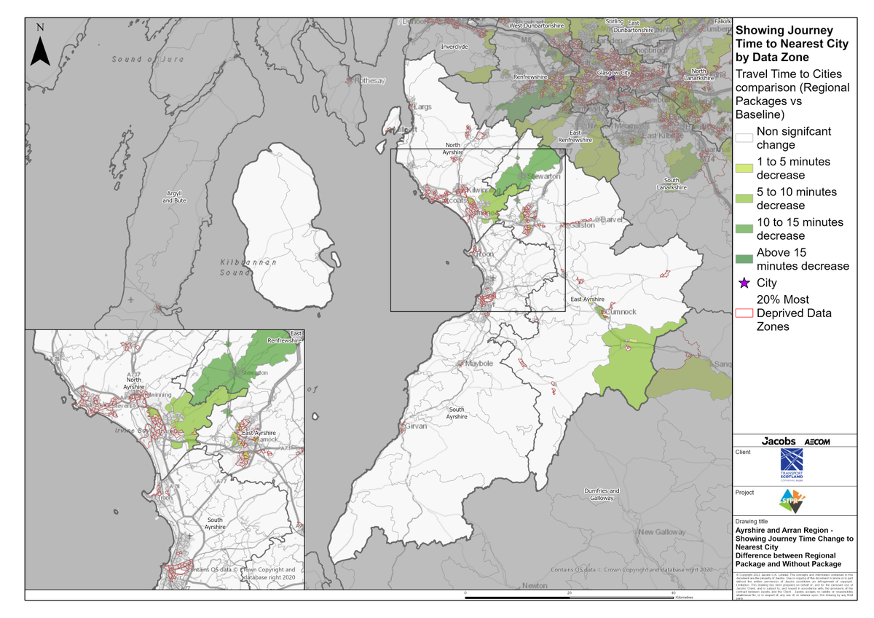
Ayrshire & Arran Region – Showing Journey Time Change to Nearest City Difference between Regional Package and Without Package
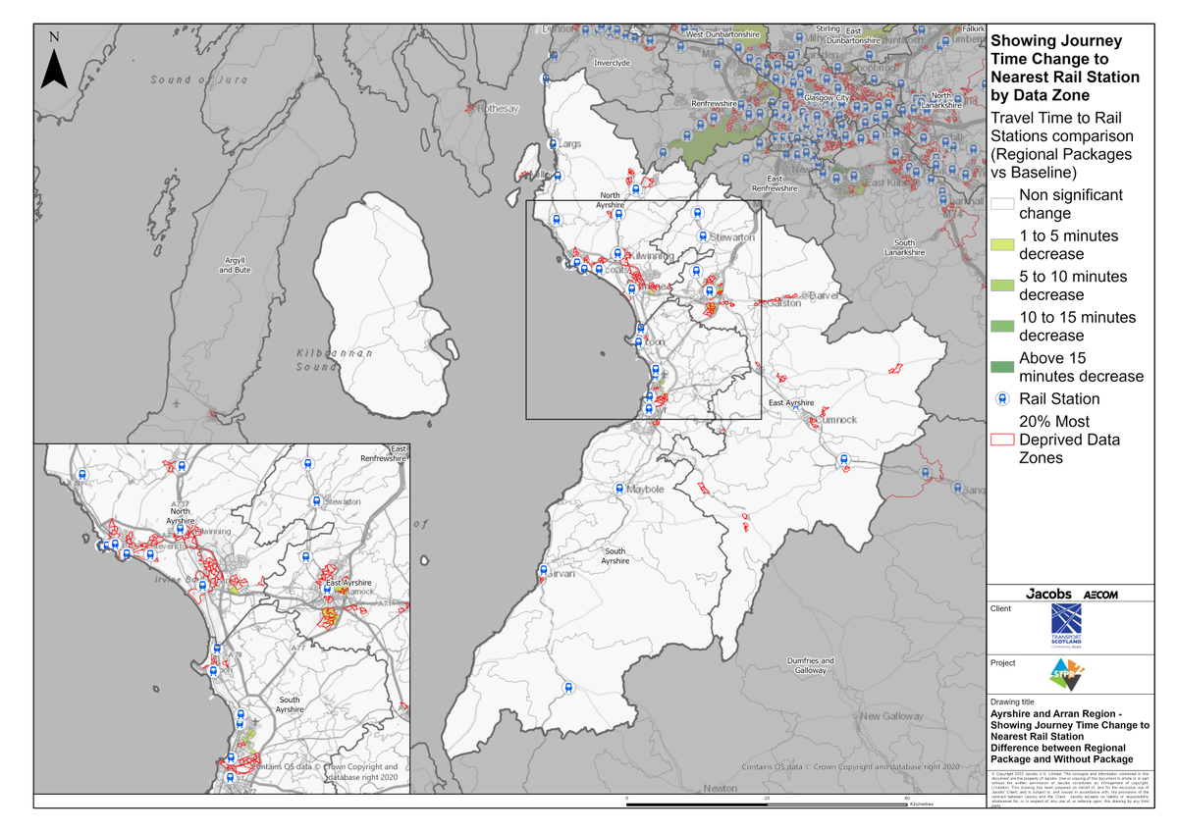
Ayrshire & Arran Region – Showing Journey Time Change to Nearest Rail Station Difference between Regional Package and Without Package
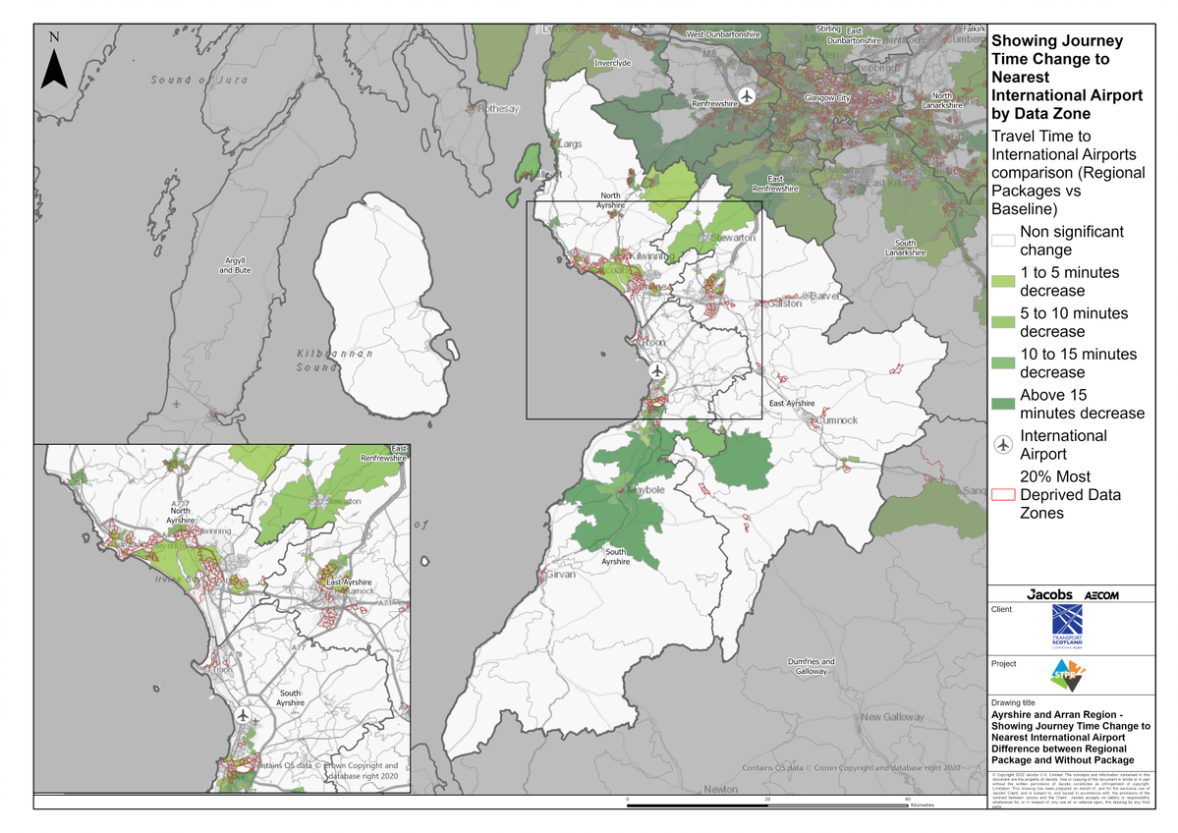
Ayrshire & Arran Region – Showing Journey Time Change to Nearest International Airport Difference between Regional Package and Without Package

Annex B: Traffic Modelling Outputs
