Appendix H: Detailed Packaging - Appraisal Summary Tables

December 2022

Contents
1. Regional Context 5
1.1. Geographic Context 5
1.2. Social Context 5
1.3. Economic Context 6
1.4. Environmental Context 6
2. Problems and Opportunities 8
2.1. Problems 8
2.2. Opportunities 8
3. Regional Recommendations 10
4. Fit with Established Policy 11
5. STPR2 Transport Planning Objectives (TPOs) Assessment 12
6. STAG Assessment 21
6.1. Environment 21
6.2. Climate Change 22
6.3. Health, Safety & Wellbeing 23
6.4. Economy 25
6.5. Equality & Accessibility 26
7. Deliverability 28
7.1. Feasibility 28
7.2. Affordability 28
7.3. Public Acceptability 28
8. Statutory Impact Assessment Criteria 29
8.1. Strategic Environmental Assessment (SEA) 29
8.2. Equalities Impact Assessment (EqIA) 30
8.3. Island Communities Impact Assessment (ICIA) 30
8.4. Child Rights and Wellbeing Impact Assessment (CRWIA) 31
8.5. Fairer Scotland Duty Assessment (FSDA) 31
Annexes 32
Annex A: NAPTAT Mapping 33
Annex B: Traffic Modelling Outputs 39

Forth Valley Region Appraisal Summary Table
An Appraisal Summary Table (AST) has been developed for each of the eleven STPR2 Regions alongside the National AST. The ASTs are set out to provide:
- Regional Context, Problems and Opportunities – drawing on data presented in the Initial Appraisal: Case for Change reports this summarises geographic, social, economic, environmental and transport matters in the region as well as the identified problems and opportunities. In line with STAG, appraisals are expected to explore location-specific problems and opportunities. Local problems and opportunities have been considered to gain a full understanding of the regional and national issues, however some of these may not be within the scope of this strategic study.
- Regional Recommendations – this presents the package of recommendations that were included in the detailed appraisal for the region.
- Fit with Policy – provides a summary of how well the appraised packages fit with key national policies including the second National Transport Strategy, Climate Change Plan Update, the Revised Draft Fourth National Planning Framework (Revised Draft NPF4) and relevant regional policies.
- Transport Planning Objectives (TPO) Assessment – An assessment against each of the five TPOs is provided with quantified metrics, where appropriate, under the Low growth sensitivity with a 20% reduction policy ambition on car kilometres scenario (hereafter referred to as Low scenario) and High growth sensitivity with no policy ambition on car kilometres scenario (hereafter referred to as High scenario) (further information about these scenarios is provided in Appendix F of the Technical Report). A seven point scoring scale is adopted for each TPO which is:
  - + + + = major positive (3 plus signs)
  - + + = moderate positive
  - + = minor positive
  - 0 = neutral
  - - = minor negative
  - - - = moderate negative
  - - - - = major negative (3 minus signs)
- STAG Criteria assessment – as above for the TPO assessment, key points regarding the performance of the package against each of the STAG criteria is presented with quantified metrics provided where appropriate.
- Deliverability – commentary is provided on the assessment of the package in terms of its feasibility, affordability and public acceptability. Note that due to the nature of a number of the STPR2 interventions, and the stage in the business case process STPR2 is at, it has not been possible to derive cost estimates on a regional basis. However, broad capital spending ranges have been estimated over the period 2022 to 2042 at a national level.
- Statutory Impact Assessment Criteria – a summary of the performance of the packages against the Strategic Environment Assessment (SEA), the Equalities Impact Assessment (EqIA), Island Communities Impact Assessment (ICIA), Fairer Scotland Duty Act (FSDA) and Child Rights and Wellbeing Impact Assessment (CRWIA) is provided. The seven point scoring scale is adopted in these assessments where appropriate.

Summary of Assumptions
Quantification of the costs and benefits in the packages has been provided through a modelling exercise. Further information is provided in Appendix F of the Technical Report on the modelling scenarios that have informed the assessment of the STPR2 interventions. A summary of the key assumptions is provided here:
- Population projections are based on the NRS Population Projections (2018-based).
- Economic projections are a combination of projections by Oxford Economics, 2019, the Scottish Fiscal Commission forecasts and more recently the OBR post-COVID estimates.
- Land-use plans are based on data collected for Transport Scotland’s Assembly of Planning Policy Inputs in 2018 from Scotland’s 34 Planning Authorities.
- Permitting of vacant office and retail floorspace to be converted or redeveloped as housing post 2030.
- Working age is taken to be 16-64 (as a constant) to avoid difficulties with changing state pension age (and to reflect non-mandatory retirement).
- The economic results are presented as discounted values in 2010 prices as is standard within appraisal.

Modelling Tools
For the purposes of modelling accessibility by public transport, NaPTAT (National Public Transport Accessibility Tool) has been used. This allows an assessment of journey time to be compared between the with and without STPR2 package.
Due to the strategic and national nature of STPR2, the national Transport Model for Scotland (TMfS) has been used. TMfS is a national scale model with a focus on inter-urban trips. As such, whilst TMfS provides a suitable level of robustness at this stage of the appraisal for most of the larger infrastructure based interventions, there are limitations associated with the modelling of smaller/discrete interventions and also some of the larger infrastructure interventions that involve changes to the existing road network and are more urban in nature. Separate forecasts of the potential impacts of active travel recommendations on walking and cycling mode share have therefore been made. As the recommended interventions are developed through the business case process, more detailed modelling will be undertaken using regional and / or local models as appropriate.
When considering the outputs presented in this AST, please note the following metrics with respect to the model outputs:
- CO₂ emissions: Likely to underestimate the benefits associated with public transport interventions due to the more limited representation of transport systems in urban areas and a degree of insensitivity to mode shift in TMfS.
- Mode Share: Likely shift to public transport modes underestimated in urban areas due to the more limited representation of urban transport systems and a degree of insensitivity to mode shift in TMfS.
- Change in vehicle kilometres travelled: Likely to underestimate the benefits of reducing vehicle kilometres travelled particularly for short distance journeys due to the more limited representation of urban transport systems and the relative coarseness of the model zone system.
- Lost Time due to congestion: Likely to underestimate the benefits associated with interventions that would reduce roadspace due to the under-representation of the local/secondary road network in TMfS.
- Change in accidents: Likely to underestimate the benefits associated with mode shift to public transport interventions due to the more limited representation of urban transport systems and a degree of insensitivity to mode shift in TMfS.
- Present Value of Benefits: Likely to underestimate the benefits to public transport users due to the more limited representation of urban transport systems. Likely to overestimate the dis-benefits to car-based trips due to the under-representation of the junctions and local/secondary road network in TMfS.

- Regional Context
  - Geographic Context
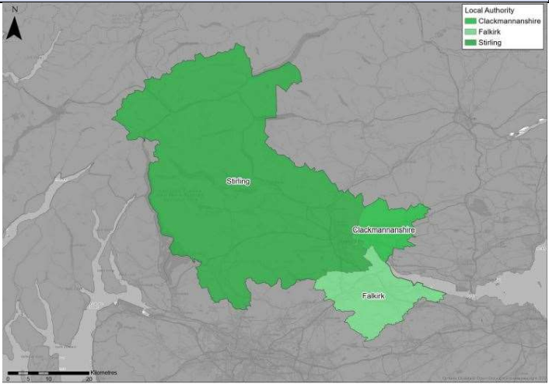
The Forth Valley Region comprises the three local authorities of Clackmannanshire, Falkirk and Stirling and is a mix of urban and rural settlements and areas.
The Scottish Government Urban Rural Six-Fold Classification identifies the regional population residing in each category as follows: Other Urban Areas (70%), Accessible Rural (15%), Accessible Small Towns (13%), and Remote Rural (2%). The majority of the region’s population reside in the larger settlements in the south and south east (e.g. Stirling, Falkirk and Alloa) with a sizeable proportion in accessible small towns (e.g. Clackmannan, Dunblane and Callander). The classifications highlight the mix between rural and urban in the region, particularly in the Stirling local authority, and the importance of connectivity between rural northern areas and less rural central and south.
The region has an extensive transport network, including active travel, rail, bus and road networks and park and ride facilities. Several motorways, including the M9, M80 and M876, route through the region and facilitate connections to travel hubs in Edinburgh and Glasgow. Grangemouth is identified as a major port in the context of STPR2.
  - Social Context
According to the National Records of Scotland’s Mid-year Population Estimates Scotland, in 2019, the Forth Valley Region had a population of 306,640, which was an increase of 6,240 (2.1%) from 2014. This represented 5.6% of Scotland’s total population. In 2019, approximately 63.6% of people were of working age, 17.1% were aged 15 and under and 19.3% were aged over 65 (a similar profile to Scotland).
The net migration figures show that between 2011 and 2016, just under 12,000 people moved into the Forth Valley, with just under 8,750 moving out - a total net increase of almost 3,250. All three council areas recorded an increase in population due to net migration.
According to the 2011 Scottish Government Census, access to a car or van varies across the Forth Valley Region, with access to 1 car or van in the area similar to the national average, although the percentage of households without access to a car or van is 6 percentage points lower than the national average (24% vs 31%), and the percentage of those with 2 cars is 4 percentage points higher than the national average (26% vs 22%). Households in Stirling recorded the highest (77.7%) access to one or more cars / vans, followed by Clackmannanshire (75.1%) and Falkirk (74.8%).
At a regional level, according to the 2011 Scottish Government Census, travel to work mode share is largely consistent with the national average with residents who work from home (10%), cycle to work (1%) or travel to work by train (4%). A higher proportion of residents in the Forth Valley Region use car or van as their main mode of commuting (70%) compared to the Scottish equivalent (62%). A lower proportion of residents in the region walk (7%) or travel to work by bus (5%) compared to the Scottish equivalent (10% for each).
The Scottish Index of Multiple Deprivation (SIMD) rankings highlight that 16.7% of all data zones in the region were within the 20% most deprived in Scotland. The main pockets of deprivation are most evident within Alloa, Stirling, Falkirk and Bonnybridge. SIMD Health rankings indicate that health quality throughout the Forth Valley Region is similar to Scotland as a whole, with 19.3% of the population limited in their day-to-day activities by a disability or long term health problem (Scotland is19.6%).
  - Economic Context
In 2018, unemployment rates (from NOMIS) in the region stood at 2.7% which is lower than Scotland (at 4.4%). In terms of Gross Value Added (GVA), the Forth Valley region contributed £7.8 billion which accounts for 5.5% of Scotland’s GVA according to ONS Regional GDP. This was an increase of 14.4% between 2013 and 2018. In the same period the national figure increased by 14.6%. From Scottish Index of Multiple Deprivation (SIMD), the level of income deprivation in the Forth Valley Region indicates that 51% of data zones are classed as ‘high risk’ for Transport Poverty which compares to 50% of data zones nationally. The proportion of ‘medium risk’ data zones (14%) is below the national proportion (18%), with the proportion of ‘low risk’ data zones in the Forth Valley Region (35%) higher than the national proportion (31%).
  - Environmental Context
Within the Forth Valley Region, there are many areas classified as environmentally sensitive, with varying levels of statutory protection. Environmental designations within the region include biodiversity, landscape and heritage designations which fall either wholly or partly within the region. In addition, Historic Environment Scotland shows the region contains a significant number of designated areas, including one National Park (Loch Lomond and the Trossachs) and four National Nature Reserves. In addition, the Antonine Wall World Heritage Site stretches across the Central Belt, encompassing the Forth Valley. Data from the Scottish Government’s Scotland Noise Map indicates that the greatest modelled noise levels are located in the south of the region, primarily associated with the trunk road and motorway corridors around Stirling, Larbert and Grangemouth (i.e. M9, M80, M876 and A9) and the rail routes through this area. Settlements at greatest risk of coastal flooding are located along the Firth of Forth and River Forth, including Stirling, Grangemouth and Culross. Areas at medium and high risk of river flooding are predominantly located in the vicinity of the River Forth, River Devon and River Teith. These include Stirling, Aberfoyle, Callander and Alloa. Areas at high and medium risk of surface water flooding are typically associated with Lochs within The Loch Lomond and the Trossachs National Park. These are typically associated with surface water features, such as lochs, and are located predominantly within less populated areas of the region. There are four Air Quality Management Areas (AQMAs) within the Forth Valley Region, concentrated in the industrial areas around the Grangemouth oil refinery and the cement and plastics factories. In 2018, CO₂ emissions from transport within the Forth Valley Region equated to 6.9% of Scotland’s total transport emissions overall.

- Problems and Opportunities
The following transport-related problems and opportunities have been identified for the Forth Valley Region.
  - Problems
- Active Accessibility: this has been identified as a problem across the Forth Valley Region, but most significantly in the areas outwith urban centres, predominantly to the northwest of the region. Much of the Forth Valley Region is ranked in the bottom 50% for geographic access in the SIMD, in terms of accessibility to services and transport modes, with 29% of Stirling’s data zones in the bottom 20%, compared to 18% of Falkirk’s and 14% of Clackmannanshire’s. This highlights the inequality of access between the Forth Valley Region’s rural and urban locations.

- Connectivity: public transport context has highlighted a lack of connectivity in areas between settlements in the Forth Valley Region and to neighbouring areas like Edinburgh and parts of Lanarkshire. Rail travel is a key problem in the northwest of the region due to limited accessibility to Tyndrum and Crianlarich stations which have only a limited service to Glasgow and Fort William or Oban and no direct connections to the southwest of the Forth Valley Region, such as Stirling and Dunblane, which are well served by rail in comparison to the north.

- Road user experience: has been identified primarily in relation to the quality and maintenance of existing infrastructure, slow journey times and network ‘pinch-points’ in the Forth Valley Region. Maintenance of existing infrastructure has been identified as an issue on local roads in for example Stirling. Slow journey times are experienced on roads such as the A84 between Lochernhead and Stirling. Network ‘pinch-points’ are seen in the more urban areas such as Stirling, Falkirk, Dunblane and Bridge of Allan, as well as at key entry and exit points to the M80 and M9.

- Barriers to Active Travel: where cycle routes are available in the Forth Valley Region, they are frequently classified as on-road routes, leading to perceived safety issues. Physical constraints such as the A91 act as barriers to walking and cycling from eastern villages and there are limited safe walking and cycling routes in the countryside to local facilities and services.

  - Opportunities
- Publicity around the Climate Emergency is considered to provide a base upon which sustainable interventions that do not favour private car use would be more publicly acceptable.
- Active travel with a focus on realising the potential of connecting settlements which are located in close proximity of each other and in so doing fulfilling the strong political and policy environment for travel which helps people make healthy living choices and reduce their dependence on the private car.

- Technology offers potential for better ways to work, connect and inform people of transport choices, alongside advances in lower emission fuels.

- Public transport interchange, accessibility and connectivity through which making it easier for people to choose more sustainable modes of transport. The Forth Valley Region’s proximity to the trunk road, motorway and rail networks offers an opportunity to facilitate direct interchange.

- Grangemouth Investment Zone contains important infrastructure, high value employment and manufacturing of materials that are currently vital for everyday life. As this role will continue in the long term, the zone must seek to decarbonise to contribute to the significant reduction of industrial carbon emissions required to meet Scotland’s net zero targets. There are opportunities to improve sustainable transport access to contribute towards this aim for both people and freight, in consultation with the Grangemouth Futures Industry Board (GFIB). Grangemouth Investment Zone also forms part of the draft fourth National Planning Framework (NPF4) Industrial Green Transition Zones national development.

- Grangemouth Port constitutes a major port in the context of the Strategic Transport Projects Review 2. A background review of port connectivity issues in Scotland has been undertaken that has reinforced the important economic and social role contributed by our maritime links to key markets. The diverse range of ports around our coastline play a fundamental role in supporting economic activity at the local, regional and national level. Grangemouth has the largest freight volume of all major ports and as such there is an opportunity to increase the sustainability of freight movements regionally but also nationally.

- Regional Recommendations
The following is a list of interventions that form a package of recommendations that are relevant to this Region.

Regional Recommendations
- Connected neighbourhoods (Recommendation 1)
- Active freeways and cycle parking hubs (Recommendation 2)
- Village-town active travel connections (Recommendation 3)
- Connecting towns by active travel (Recommendation 4)
- Long-distance active travel network (Recommendation 5)
- Behavioural change initiatives (Recommendation 6)
- Changing road user behaviour (Recommendation 7)
- Increasing active travel to school (Recommendation 8)
- Improving access to bikes (Recommendation 9)
- Expansion of 20mph limits and zones (Recommendation 10)
- Provision of strategic bus priority measures (Recommendation 14)
- Edinburgh/Glasgow-Perth/Dundee Rail Corridor Enhancements (Recommendation 17)
- Infrastructure to provide access for all at railway stations (Recommendation 19)
- Investment in Demand Responsive Transport and Mobility as a Service (Recommendation 20)
- Improved public transport passenger interchange facilities (Recommendation 21)
- Framework for the delivery of mobility hubs (Recommendation 22)
- Smart, integrated public transport ticketing (Recommendation 23)
- Decarbonisation of the rail network (Recommendation 25)
- Decarbonisation of the bus network (Recommendation 26)
- Behavioural change and modal shift for freight (Recommendation 27)
- Zero emission vehicles and infrastructure transition (Recommendation 28)
- Trunk road and motorway safety improvements to progress towards ‘Vision Zero’ (Recommendation 30)
- Trunk road and motorway network climate change adaptation and resilience (Recommendation 31)
- Trunk road and motorway network renewal for reliability, resilience and safety (Recommendation 32)
- Future Intelligent Transport Systems (Recommendation 33)
- Traffic Scotland System Renewal (Recommendation 34)
- Intelligent Transport System renewal and replacement (Recommendation 35)
- Strategy for improving rest and welfare facilities for hauliers (Recommendation 36)
- Improving active travel on trunk roads through communities (Recommendation 37)
- Speed Management Plan (Recommendation 38)
- Sustainable access to Grangemouth Investment Zone (Recommendation 39)
- Rail freight terminals and facilities (Recommendation 44)

- Fit with Established Policy
The interventions included within this package support a wide range of national, regional and local policy documents in which transport improvements play a key role in both the enabling and delivery of outcomes.
Key policies supported include the Programme for Government, Infrastructure Investment Plan, NTS2, the Climate Change Plan Update 2018-2032, Tactran and Sestran Regional Transport Strategies (2008-21 and 2008- 23); as well as non-transport-specific plans, such as the Stirling and Clackmannanshire City Region Deal, and also the Falkirk Growth Deal that includes transport elements where the heads of terms were agreed in December 2021 but the full Deal is yet to be concluded.
Interventions included in this package will also support more resilient and sustainable connections to the Revised Draft Fourth National Planning Framework (Revised Draft NPF4) national development at Grangemouth Investment Zone for people and freight, and the Industrial Green Transition Zones.
The policy framework for the Forth Valley Region has a strong emphasis on delivering strengthened connectivity to support a sustainable economy. This includes providing travel choices which promote equality and social inclusion and which promotes modal shift away from private car, increases walking and cycling opportunities, and provides an attractive place for visitors and businesses to invest and grow; the package therefore closely aligns with established policy directives.

Package Performance Against NTS2 Priorities and Outcomes:

Reduce inequalities
Will provide fair access to services we need: Moderate Positive
Will be easy to use for all: Moderate Positive
Will be affordable for all: Minor Positive

Takes climate action
Will help deliver our net-zero target: Major Positive
Will adapt to the effects of climate change: Minor Positive
Will promote greener, cleaner choices: Major Positive

Helps deliver inclusive economic growth
Will get people and goods where they need to get to: Major Positive
Will be reliable, efficient and high quality: Major Positive
Will use beneficial innovation: Major Positive

Improves our Health and Wellbeing
Will be safe and secure for all: Major Positive
Will enable us to make healthy travel choices: Moderate Positive
Will help make our communities great places to live: Major Positive
- STPR2 Transport Planning Objectives (TPOs) Assessment

TPO1 A sustainable strategic transport system that contributes significantly to the Scottish Government’s net-zero emissions target

TPO Performance Summary
Carbon dioxide equivalent (CO₂eq) is treated as a nationally important pollutant. As such, although it can be appraised at the national level (commentary below), it has not been appraised for individual regions.
The national and all regional packages will contribute to the net zero emissions target by:
- Enabling more passenger journeys to be made by active modes and public transport.
- Decarbonising some public transport operations.
- Facilitating uptake of electric vehicles.
- Enabling some road freight to switch to rail or other low carbon modes.
Further commentary is provided below.
National CO₂eq emissions are forecasted to decrease year-on year. This is due to decreasing vehicle exhaust (non-traded) emissions as the number of internal combustion engine vehicles reduces. This is reflected in the volume of traded grid emissions from charging increased numbers of battery-electric vehicles, and specifically in the Low scenario. It is noted that traded emissions of CO₂eq are associated with electrical generation to supply plug-in vehicles, both BEV (battery electric vehicles) and PHEV (plug-in hybrid vehicles).
The electricity grid is expected to be using predominantly renewable sources in the future and so increasing adoption of electric vehicles and a shift from direct, non-traded, emission to traded grid-based technology (i.e. battery) will support reducing CO₂eq emissions.
Across both scenarios the interventions would reduce emissions of CO₂eq.
Significantly higher overall emissions are predicted in the High scenario, either with, or without, the national and all regional packages. There is a relatively smaller overall reduction of emissions due to the interventions in the Low scenario due to the lower overall emissions. The economic impacts associated with air quality were assessed using the Department for Environment Food & Rural Affairs (DEFRA) Damage Costs Appraisal Toolkit. The larger economic benefit from the High scenario is due to the greater overall emissions with, or without, the package, although the proportional change in emissions is lower.
Overall Scoring:
Low and High Scenarios: Minor Positive

Metric 1: Change in CO₂eq (non-traded and traded emissions from regional road transport inc. grid emissions from charging light-duty vehicles) - Figures below are a National calculation
Low Scenario Commentary:
- 0.5% decrease (27,700 tonnes CO₂eq) in 2030.
- 2.8% decrease (21,600 tonnes CO₂eq) in 2045.
- 1.3 million tonnes reduction, of which 1.1 million were traded, for the 60-year appraisal period from 2030 to 2089.
- The net economic benefits for the 60-year appraisal period in 2010 prices and values would be in the range £10 million to £25 million for the Low scenario.
High Scenario Commentary:
- 0.4% decrease (31,300 tonnes CO₂eq) in 2030.
- 1.3% decrease (65,300 tonnes CO₂eq) in 2045.
- 3.7 million tonnes reduction, of which 452,000 were traded, for the 60-year appraisal period from 2030 to 2089.
- The net economic benefits for the 60-year appraisal period in 2010 prices and values would be in the range £100 million to £250 million for the High scenario.

Metric 2: Change in mode share by active travel for all journeys
Low and High Scenarios Commentary:
- Potential increase in walking from 18% mode share to 23% mode share (5 percentage points).
- Potential increase in cycling from 0.5% mode share to 21% mode share (20.5 percentage points).

The package will increase the proportions of journeys undertaken by active modes. If all the active travel and behaviour change interventions were fully implemented in every relevant location in the Region, mode shares of walking and cycling "with STPR2 package" proportions are shown alongside the mode share without package.

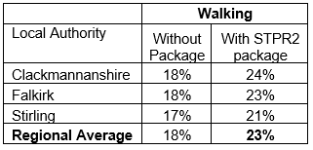
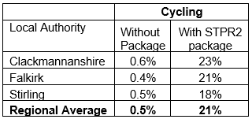
Note that the cycling and walking growth forecasts have been developed independently. Growth in use of one active mode is likely to abstract at least some trips from the other, but this effect is not accounted for within these forecasts.

Metric 3: Change in motorised vehicle kilometres travelled
Low Scenario Commentary:
- Reduction of 32.5 million motorised vehicle kilometres (2% decrease) (see Annex B).
High Scenario Commentary:
- Reduction of 29.9 million motorised vehicle kilometres (1% decrease) (see Annex B).

TPO2 An inclusive strategic transport system that improves the affordability and accessibility of public transport

TPO Performance Summary
The package will improve the inclusiveness of the transport system by:
- Improving conditions for people walking, wheeling, and cycling, the most inclusive transport modes, with particular benefits for people most often excluded (including children, older and disabled people, and people on low incomes).
- Improving active travel connections between settlements.
- Improving inclusive accessibility to public transport stops/stations.
- Seeking to promote public transport use and reduce operating costs, hence enhancing network sustainability.
Overall Scoring:
Low and High Scenarios: Minor Positive

Metric 1: Change in transport poverty risk
Low and High Scenarios Commentary:
Although the STPR2 interventions don’t impact on the direct costs of travel (e.g. fares, fuel price), the package of interventions would see a small reduction in transport poverty nationally, due to the overall improvements to access and connectivity between modes.

Metric 2: Change in Accessibility - population catchments increases to key services by journey time by public transport
Low and High Scenarios Commentary:
The largest change in population accessibility of all the destination types considered was to accident and emergency hospital, whereby an additional 4,200 of the population in the Forth Valley Region would be able to access the nearest site in a journey time of 60 minutes or less by public transport compared to the without package. This represents a 1.7 percentage point increase in accessibility levels from 87.6% in the without package assessment to 89.3% with the package in place. The improvements are largely observed in Falkirk Local Authority, particularly in Bo’Ness. This is shown by the map output in Annex A.
The accessibility improvements and the corresponding additional population that are able to access those destinations within a journey time of 30 minutes compared to the without package assessment are summarised below:
- 1,800 additional people are able to access the nearest higher education site by public transport, as shown by the map output in Annex A, which represents a 0.7 percentage point increase in accessibility levels from 66.9% in the without package assessment to 67.6% with the package in place.
- 600 additional people are able to access a major shopping centre by public transport, which represents a 0.3 percentage point increase in accessibility levels from 77.8% in the without package assessment to 78.1% with the package in place.
In terms of additional destinations (cities, rail stations and airports) considered in the model:
- 4,700 additional people are able to access their closest city within a 60 minute public transport journey, which represents a 1.8 percentage point increase in accessibility levels from 91.9% in the without package to 93.7% with the package in place.
- No significant change was observed in relation to the number of people who are able to access their closest rail station within a 30 minute public transport journey, remaining at 84.4% of the population.
- 20,500 additional people are able to access their closest international airport within a 60 minute public transport journey, which represents a 6.1 percentage point increase in accessibility levels from 17.9% in the without package to 26.0% with the package in place.
- 12,500 additional people are able to access their closest international airport within a 90 minute public transport journey, which represents a 5.0 percentage point increase in accessibility levels from 70.3% in the without package to 75.3% with the package in place.

Mapping outputs are shown in Annex A.

TPO3 A cohesive strategic transport system that enhances communities as places, supporting health and wellbeing

TPO Performance Summary
The package will improve communities as places, supporting health and wellbeing by enabling more journeys to be made by active and sustainable modes, and by improving road safety. This will:
- Improve many people’s physical health and mental wellbeing, with particular benefits for people most often excluded (including children, older and disabled people, and people on low incomes).
- Reduce the adverse impacts of car use on communities and health (including reduced air pollution, noise, accident risk and perceived road danger).

The health benefits of increased rates of walking and cycling as a result of the package have been quantified to reduce premature deaths by around 15 people per annum.
Overall Scoring:
Low and High Scenarios: Moderate Positive

Metric 1 Change in mode share by active travel for all journeys
Low and High Scenarios Commentary:
- Potential increase in walking from 18% mode share to 23% mode share (5 percentage points).
- Potential increase in cycling from 0.5% mode share to 21% mode share (20.5 percentage points).
These forecasts are subject to all active travel interventions being delivered in all relevant areas in the Region.
Cycling and walking growth forecasts have been developed independently. Growth in use of one active mode is likely to abstract at least some trips from the other, but this effect is not accounted for within these forecasts.

Metric 2 Potential for Change in 'Place'
Low and High Scenarios Commentary:
The package will tend to improve the quality of the Forth Valley Region’s places by improving local accessibility and reducing the adverse impacts of road traffic. Particular benefits may arise in neighbourhoods where active travel allows easier walking and cycling such as Alloa, Falkirk and Stirling.

Metric 3 Change in Health Benefits
Low and High Scenarios Commentary:
The health benefits of increased rates of active travel as a result of the package have been quantified using the WHOs Health Economic Assessment Tool (HEAT). HEAT estimates the health and economic impacts of increased walking and cycling, providing assessments of the health and economic impacts of walking and cycling on premature mortality and on exposure to air pollution. Outputs from the tool shows the following benefits by Local Authority:
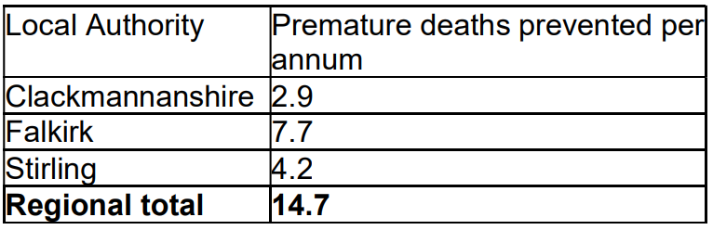
The Forth Valley Region is expected to benefit from a reduction of around 15 premature deaths per annum.

TPO4 An integrated strategic transport system that contributes towards sustainable inclusive growth in Scotland

TPO Performance Summary
The package will contribute to sustainable inclusive growth in Scotland by:
- Improving integration of transport modes (especially between active modes and public transport) and between transport and major developments.
- Improving journey time reliability.
- Enabling more people to travel by improving the accessibility and affordability of the transport system, so enabling more people to access local retail and services, and opportunities for employment and education/training.
Encouraging modal shift to sustainable modes and reducing the volume of vehicles on the road network is anticipated to improve journey time reliability for all vehicles, providing benefits to businesses across the regions. A reduction in vehicle hours of between 40,000 and 52,000 hours is anticipated in the respective growth scenarios for business and commercial travel, contributing towards sustainable inclusive growth in Scotland.
Overall Scoring:
Low and High Scenarios: Moderate Positive

Metric 1: Increased labour catchment by sustainable travel (PT/Active Travel)
Low and High Scenarios Commentary:
Access to local employment, which represents the accessibility of key employment opportunities located in the surrounding area within a 40 minute public transport journey time, showed relatively minor improvements in the Forth Valley Region. The improvements were observed in particular locations such as Larbert, Polmont, Grangemouth and Denny, with all reporting that the package on average enables an additional 2,000 of existing jobs located in the surrounding area to be accessed. This is shown by the map output in Annex A.
Access to regional employment, which represents the accessibility of key employment opportunities located in Glasgow, Edinburgh and Stirling within a 60 minute using public transport journey time, showed a level of improvement in most Local Authorities within the region, but particularly in Falkirk. The modelling shows that the package on average enables an additional 6,400 of existing jobs to be accessed in the Forth Valley Region within 60 minutes journey time by public transport. Falkirk observed the highest increase, whereby the package on average enables an additional 11,300 of existing jobs to be accessed. This is shown by the map output in Annex A.
The rural population observed no direct change in journey times to the nearest employment site by public transport.

Metric 2: Change in lost time due to congestion (for business/ commercial transport)
Low Scenario Commentary:
- 4% decrease (equivalent to reduction of 40,000 hours).
High Scenario Commentary:
- 3% decrease (equivalent to reduction of 52,000 hours).

TPO5 A reliable and resilient strategic transport system that is safe and secure for users

TPO Performance Summary
The package will improve reliability, safety and personal security on the transport system by:
- Improving journey time reliability, including through reduced likelihood of significant network disruptions
- Reducing the risk of road accidents at hotspot locations on the Trunk Road network e.g. through targeted infrastructure improvements such as carriageway realignment and widening, the provision of overtaking opportunities and junction improvements.
- Reducing perceived risks to road safety and to personal security, so enabling more people (particularly children, women and older people) to travel independently
- Changing attitudes of road users, through behavioural change campaigns. This is anticipated to increase awareness of interactions with those walking, wheeling and cycling
- Improving active travel provision and providing more dedicated and segregated routes for walking, cycling and wheeling
Overall Scoring:
Low and High Scenarios: Moderate Positive

Metric 1 Change in accidents (PIA and ‘damage-only’)
Low Scenario Commentary:
- Accident reduction related to motorised vehicle kilometres is forecast to be 3%.
High Scenario Commentary:
- Accident reduction related to motorised vehicle kilometres is forecast to be 2%.
Low and High Scenarios Commentary:
Whilst the number of accidents involving motorised vehicles is anticipated to reduce following the introduction of the interventions within this package, it is anticipated that the package would increase walking and cycling journeys. The number of accidents involving these modes is therefore anticipated to increase, although each individual journey is anticipated be significantly safer.

Metric 2 Percentage accident change for Targeted Infrastructure Improvements over 60 years, using default accident rate (PIA only)
Low and High Scenarios Commentary:
Accident benefits were estimated using the Department for Transport (DfT) recommended software programme COBA-LT (Cost and Benefit to Accidents – Light Touch) for targeted road safety improvements, based on default parameters, but using Scotland specific accident rates. A range of accident benefits were calculated for the various improvement options being considered. This provided the upper and lower bound of estimated percentage change in accidents, respectively. These ranges are shown below and provide the anticipated upper and lower bounds of impact on accidents that would be anticipated from typical interventions of this type:
- Sections of Realignment/Widening - reduction of 23% to 59%.
- Sections of Overtaking Opportunities - reduction of 35% to 73%.
- Locations of Junction Improvements - change of 42% (increase) to 64% (decrease).

It should be noted that junction accidents are forecast to increase in the event that a junction is upgraded from a priority to a signalised junction. This is due to an increase in the number of slight accidents that are likely to occur as a result of shunts in queuing traffic on the mainline approach to the traffic signals, which could previously travel unopposed. However, the accident severity can be expected to reduce as a result of this type of improvement. Any improvement scheme would be subject to further consideration.

Metric 3 Change in lost time due to congestion
Low Scenario Commentary:
- 8% decrease (122,000 hours) in time lost due to congestion (see Annex B).
High Scenario Commentary:
- 4% decrease (198,000 hours) in time lost due to congestion (see Annex B).

Metric 4 Journey Time Reliability /Availability of alternatives (modes/routes)
Low and High Scenarios Commentary:
The package is forecast to reduce overall motorised vehicle kilometres by 2% and 1% under the Low and High scenarios respectively, thus reducing the risk of accidents occurring as a result of travel reduction, whilst improving resilience by reducing the number of road closures associated with accidents.
Targeted improvements on the trunk road and motorway network where safety is a problem is forecast to reduce accidents and the associated reduction in road closures from such incidents would also help improve reliability. Improvements in terms of renewals and climate change adaptation to protect the operation of the trunk road and motorway network would also positively impact on the reliability of the network.
Targeted infrastructure improvements such as carriageway realignment and widening, the provision of overtaking opportunities and junction improvements, are anticipated to reduce the number and severity of accidents on the trunk road network. It should be noted that replacing a priority junction with a signalised junction could increase the overall number of accidents, however the severity of accidents occurring should reduce.
Encouraging modal shift to sustainable modes and reducing the volume of vehicles on network is anticipated to improve journey time reliability, as indicated by reducing time lost to congestion by 122,000 and 198,000 hours in the Low and High travel demand scenarios respectively.

- STAG Assessment
  - Environment

Environment

Air Quality
Performance Summary:
Total emissions of NO_{X} (a group of gases that are mainly formed during the combustion of fossil fuels) were predicted to decrease in future in both the High and Low scenarios.
Total emissions of NO_{X} were predicted to be effectively zero in 2045 in the Low scenario, and 2053 in the High scenario either with, or without, the proposed package. It is the change brought about by the projected transition of the vehicle fleet to zero-emission vehicles that contribute to the majority of air quality benefits, and in this instance outweighs the positive mode change contributions from the regional package.
Total emissions of Particulate Matter (PM), which is made up of a collection of solid and / or liquid materials, were predicted to increase in future predominantly due to non-exhaust emissions from road, tyre and brake-wear.
However, the package will reduce harmful emissions slightly. Over the 60-year appraisal period there was a predicted 100% reduction in NO_{X}, 1.4% reduction in PM10 and 1.5% reduction in PM2.5 in the Low scenario, and a 2.3% reduction in PM10 and PM2.5 in the High scenario.
Low Scenario Scoring: Minor Positive
High Scenario Scoring: Minor Positive

Noise and Vibration
Performance Summary:
The anticipated modal shift is also expected to reduce levels of noise and vibration associated with the transport network. There is potential for a localised negative effects on noise and vibration due to the construction and operation of specific interventions incl South East Trunk Road, North East Trunk Road, North West Trunk Road and Motorway Network however the magnitude of effect will depend on the design and location of the intervention.
Low Scenario Scoring: Minor Positive
High Scenario Scoring: Minor Positive

Biodiversity and Habitats: Geology and Soils; Land Use (including Agriculture and Forestry); Water, Drainage and Flooding; Historic Environment; and Landscape
Low and High Scenarios Commentary:
Please refer to SEA performance summary text in the ‘Statutory Impact Assessment Criteria’ section below. Please note the scoring has been based on the SEA methodology for scoring, which has been agreed with the SEA Consultation Authorities.

  - Climate Change

Climate Change

Performance Summary (applicable to all Climate Change Sub-Criteria)
Carbon dioxide equivalent (CO₂eq) is treated as a nationally important pollutant. As such, although it can be appraised at the national level (commentary below), it has not been appraised for individual regions.
National CO₂eq emissions are forecasted to decrease year-on year, with decreasing direct (non-traded) exhaust emissions and increasing traded grid emissions associated with increased adoption and charging of battery-electric vehicles, and specifically in the Low scenario. It is noted that traded emissions of CO₂eq are associated with electrical generation to supply plug-in vehicles, both BEV (battery electric vehicles) and PHEV (plug-in hybrid vehicles).
Across both scenarios the package will reduce emissions of CO₂eq, although the change is greater in the High scenario due to overall higher emissions.
Key recommendations within the package have a focus on identifying vulnerabilities to the effects of climate change on the transport system, as well as identifying measures to assist in the adaptation to the effects of climate change, including unplanned events, such as flooding, landslides and high winds. Climate change adaptation and network resilience would address existing and predicted climate change impacts and support the changes that are necessary to reach the Scottish Government’s net zero target for greenhouse gas emissions. Improving the climate resilience of the transport network will also align with the Scottish Government’s commitment to develop Scotland’s next statutory climate adaptation programme..
The above summary is applicable across all the sub-criteria, as outlined below. The specific performance against each sub-criteria is scored against both the Low and High scenarios.

Greenhouse Gas Emissions
Low Scenario Scoring: Major Positive
High Scenario Scoring: Major Positive

Vulnerability to Effects of Climate Change
Low Scenario Scoring: Minor Positive
High Scenario Scoring: Minor Positive

Potential to Adapt to Effects of Climate Change
Low Scenario Scoring: Minor Positive
High Scenario Scoring: Minor Positive
  - Health, Safety & Wellbeing

Health, Safety & Wellbeing

Performance Summary (applicable to all Health, Safety & Wellbeing Sub-Criteria)
The package will reduce the number and severity of accidents through targeted infrastructure improvements and by encouraging modal shift away from private car, resulting in reduced accident risk due to reduced conflicts. Whilst the number of accidents involving motorised vehicles is anticipated to reduce following the introduction of the interventions within this package, it is anticipated that the package would increase walking and cycling journeys. The number of accidents involving these modes is therefore anticipated to increase, although each individual journey is anticipated be significantly safer.
Mode shift to sustainable modes will, by improving natural surveillance, make paths, stops, stations and services less isolated and this, accompanied by improved quality of facilities will improve perceived security.
The package will improve communities as places, supporting health and wellbeing, by encouraging modal shift away from private car and towards active travel. This will improve placemaking through reduced noise and better air quality due to reduced traffic, and reduced accident risk. It will also benefit many people’s physical health and mental wellbeing.

Accidents (PIA and ‘damage-only’)
Low Scenario Commentary:
- Accident reduction related to motorised vehicle kilometres is forecast to be 3%.
High Scenario Commentary:
- Accident reduction related to motorised vehicle kilometres is forecast to be 2%.

Percentage accident change for Targeted Infrastructure Improvements over 60 years using default accident rate (PIA only)
Low and High Scenarios Commentary:
Accident benefits were estimated using the Department for Transport (DfT) recommended software programme COBA-LT (Cost and Benefit to Accidents – Light Touch) for targeted road safety improvements, based on default parameters, but using Scotland specific accident rates. A range of accident benefits were calculated for the various improvement options being considered. This provided the upper and lower bound of estimated percentage change in accidents, respectively. These ranges are shown below and provide the anticipated upper and lower bounds of impact on accidents that would be anticipated from typical interventions of this type:
- Sections of Realignment/Widening – reduction of 23% to 59%.
- Sections of Overtaking Opportunities – reduction of 35% to 73%.
- Locations of Junction Improvements – change of 42% (increase) to 64% (decrease).

It should be noted that junction accidents are forecast to increase in the event that a junction is upgraded from a priority to a signalised junction. This is due to an increase in the number of slight accidents that are likely to occur as a result of shunts in queuing traffic on the mainline approach to the traffic signals, which could previously travel unopposed. However, the accident severity can be expected to reduce as a result of this type of improvement. Any improvement scheme would be subject to further consideration.

Security
Low and High Scenarios Commentary:
The package will, by increasing the number of people travelling actively, tend to improve natural surveillance and will, through improvements to lighting and urban realm, tend to reduce the number of locations at which security is a concern.

Health Outcomes
Low and High Scenarios Commentary:
The package will, by increasing rates of active travel and hence physical activity, improve both health and wellbeing outcomes. The estimated value of health benefits to the Forth Valley Region’s population, appraised over a 60-year period, is in the range £500 million to £1,000 million.
The package will also tend, by encouraging car journeys to switch to less polluting modes, to improve local air quality, and hence health outcomes.
This may support improving Air Quality Management Areas in Grangemouth, Banknock & Haggs, Falkirk Town Centre and Falkirk AQMA no. 5.

Access to Health and Wellbeing Infrastructure
Low and High Scenarios Commentary:
An additional 4,200 of the population in the Forth Valley Region are forecast to be able to access an accident and emergency hospital site under a journey time of 60 minutes by public transport with the package in place compared to the without package assessment. This represents a 1.7 percentage point increase in accessibility levels from 87.6% in the without package assessment to 89.3% with the package in place. This is shown by the map output in Annex A.

These accessibility to accident and emergency hospital improvements were reported in most Local Authority areas within the Forth Valley Region though particularly in Falkirk, most of which is located in Bo’Ness. This is the equivalent of journey time reductions of up to 10 minutes for areas compared to without package assessment.

Visual Amenity
Low and High Scenarios Commentary:
The package should have a positive impact on visual amenity through improvements to walking and cycling opportunities and an improved sense of ‘place’. - Well designed infrastructure and public realm improvements would potentially improve visual amenity but ‘infrastructure’ on their own will not.
  - Economy

Economy

Performance Summary
The majority of economic benefits that accrue are as a result of the sustainable transport interventions in the Forth Valley Region’s package to enable and encourage mode shift to public transport modes. The public transport interventions including Bus Priority Infrastructure, and to a lesser extent the Rail and Interchange interventions, are the main contributors to the public transport user benefits total in the Low scenario. The remainder of the benefits are largely due to the increase in public transport operator revenue as a result of the increased patronage levels arising from the mode shift away from car.
The level of public transport user benefits are reduced in the High scenario, although this is partially offset by an increase in road user benefits. Nevertheless, even under this High motorised travel demand scenario the sustainable transport interventions contribute to the majority of user benefits.
In terms of accident savings, the level of benefits is similar in both the Low and High scenarios. This is due to the reduction in road-based vehicle kilometres travelled in the Forth Valley Region, as a result of the active travel and public transport interventions encouraging a mode shift away from private car.
Note that due to the nature of a number of the STPR2 interventions it has not been possible to derive indicative cost estimates on a regional basis.

User Benefits (2010 prices and values for a 60 year appraisal period)
Low Scenario Commentary:
- Present Value of Benefits (PVB) of approximately £100 million to £250 million
- Accidents Present Value of Benefits (PVB) of approximately £1 million to £10 million
High Scenario Commentary:
- Present Value of Benefits (PVB) of approximately £100 million to £250 million
- Accidents Present Value of Benefits (PVB) of approximately £1 million to £10 million
  - Equality & Accessibility

Equality & Accessibility

Performance Summary (applicable to all Equality & Accessibility Sub-Criteria)
The package will improve accessibility to public transport by improving the coverage of the walking, cycling and public transport networks. This will provide particular benefits for people often excluded from transport, including older and young people, women, disabled people, and people living in more deprived communities.
The package will also improve affordability by reducing forced car ownership, and situations where taxi is the only viable mode for people without access to a car. By encouraging modal shift to more sustainable modes, the package has the potential to increase demand for public transport, improving commercial performance/viability, which could indirectly reduce ticket costs.

Public Transport Network Coverage
Low and High Scenarios Commentary:
The Forth Valley Region is expected to see minor benefits from public transport coverage; however, this will generally be in the less rural areas. Improving the active travel network and interchanges may provide users with access to a wider public transport network, by enabling easier access to multi-modal trips.

Active Travel Network Coverage
Low and High Scenarios Commentary:
Improvements to the Forth Valley Region’s active travel network, both within and between settlements, mean that many more people will have a more convenient, high-quality and safe infrastructure for walking, wheeling and cycling journeys.

Comparative Access by People Group
Low and High Scenarios Commentary:
Improvements to active travel networks and public transport will provide positive impacts on groups who are less likely to have access to car and more likely to rely on public transport, walking and cycling for their journeys. This includes women, children and young people, older people, some ethnic minority groups and disabled people.Improvements to the Forth Valley Region’s active travel network, both within and between settlements, mean that many more people will have more convenient, high-quality and safe infrastructure for walking, wheeling and cycling journeys.

Comparative Access by Geographic Location
Low and High Scenarios Commentary:
For deprived areas in the Forth Valley Region, (identified as part of the 20% most deprived areas in Scotland), an additional 600 people can now access the nearest accident and emergency hospital under 60 minutes by public transport in the with STPR2 package assessment compared to that in the without package. This represents a 1.6 percentage point increase in accessibility levels from 97.2% in the without package assessment to 98.8% with the package in place.
Access to regional employment, which represents the accessibility of key employment opportunities located in Stirling, Edinburgh City and Glasgow City within a 60 minute journey time using public transport, improved from deprived areas (20% most deprived in Scotland) in the Forth Valley Region. The improvements were largely observed in Falkirk Local Authority, where the package would enable on average an additional 14,600 of existing jobs located in the cities are able to be accessed within 60 minutes by public transport.
All results are shown in the mapping outputs found in Annex A.

Affordability
Low and High Scenarios Commentary:
Although the STPR2 interventions don’t impact on the direct costs of travel (e.g. fares, fuel price), the package of interventions would see a small reduction in transport poverty, due to the overall improvements to access and connectivity between modes.

- Deliverability
  - Feasibility

Feasibility
Summary Assessment:
The package has been developed with feasibility considerations in mind. The package mostly makes use of existing, proven technology and would generally be expected to largely operate inside existing design standards.
  - Affordability

Affordability
Summary Assessment:
The package would require substantial capital and operational funding. Some aspects of the package may generate revenue, which could be used to offset some of these costs.
  - Public Acceptability

Public Acceptability
Summary Assessment:
Public acceptability of the package is likely to be mixed. The package is expected to improve accessibility, connectivity, and choice and to make transport cleaner, more efficient and more attractive. There may be concerns in areas of congestion where road space reallocation or priority Interventions are proposed however the behavioural change elements of the package should also help to mitigate this. There may also be acceptability concerns where construction works are expected to cause disruption or require land-take.

- Statutory Impact Assessment Criteria
  - Strategic Environmental Assessment (SEA)

SEA
Performance Summary:
The package supports modal shift to more sustainable modes of transport. The creation of mobility hubs/interchanges, improvements to the strategic rail network and the improvements to passengers’ services and facilities seeks to encourage modal shift, and, as a result, reduce levels of transport related air pollution and carbon emissions. The decarbonisation of the rail and bus network and freight deliveries will also help reduce greenhouse gas emissions and improve air quality.
The package provides an opportunity to adapt the transport network to the predicted effects of climate change, with one intervention focused on this adaptation. The package also promotes a more sustainable usage of the existing transport network.
Positive effects are anticipated on population and human health due to an expected increase in sustainable access to essential services, increased travel choice and improved connectivity and planning for the future capacity of public transport.
Active travel interventions will also have positive outcomes on health through expected improvements in air quality and increased uptake of physical exercise through walking, wheeling and cycling.
There is potential for a negative effect on natural resources as some freight interventions proposed involve enhancements to rail freight, terminals and facilities and therefore will require the use of natural resources.
Road interventions are anticipated to have positive effects on safety. Trunk road improvements which are focused on junction improvements, realignment / widening and overtaking opportunities are also not anticipated to have a notable impact on traffic volumes or mode share and subsequently transport-based emissions in the majority of locations. The construction and operation of these interventions may result in result in minor negative effects on population and human health with the potential for in an increase in noise and vibration during construction and operation. This is dependent on the location and design of individual schemes. There is also potential for a negative effect on material assets due to the use of natural resources.
Where new infrastructure is required this could result in negative effects on biodiversity, soil, landscape, water, historic environment however the magnitude of effect is uncertain at this stage and will be determined by the design (and physical footprint) of the interventions.
As the design and development of interventions in this region progresses, further environmental assessments will determine the magnitude of the different positive and negative environmental effects and mitigation measures will be developed where appropriate.
  - Equalities Impact Assessment (EqIA)

EqIA
Performance Summary:
The package could improve public transport and active travel accessibility to key destinations and services including employment, education, healthcare and shopping for people living in the area. This will have a major positive impact on certain protected characteristic groups who are less likely to have access to a car and more likely to depend on public transport and active travel to make their journeys. This includes women, children and young people, older people, disabled people and people from certain ethnic minority groups.
By encouraging modal shift to more sustainable modes, this package could also contribute to improving local air quality. Improved health outcomes as a result of better air quality are of particular benefit to those who are more vulnerable to air pollution, including children, older people, disabled people and pregnant women.
The package will reduce the severity of accidents through targeted infrastructure improvements and by encouraging modal shift away from private car, resulting in reduced accident risk due to reduced conflicts. Some protected characteristic groups are more likely to be involved in road accidents, for example, children as pedestrian casualties and young males involved as car drivers and as such would have positive impacts on these groups.
Mode shift to sustainable modes will make paths, bus stops, stations and services less isolated and this, accompanied by improved quality of facilities will improve perceived security. This is likely to provide some benefit to those for whom security is of particular concern including women, the LGBTQ+ community and those from religious backgrounds most subject to hate crime.
The package would therefore be anticipated to have a minor positive impact on this criterion.
  - Island Communities Impact Assessment (ICIA)

ICIA
Performance Summary:
The package is not relevant to islands and would therefore have a negligible impact on addressing this criterion.
  - Child Rights and Wellbeing Impact Assessment (CRWIA)

CRWIA
Performance Summary:
By encouraging modal shift to more sustainable modes, this package could contribute to improving local air quality. Improved health outcomes as a result of better air quality are of particular benefit to those who are more vulnerable to air pollution, including children.
The package could also improve public transport and active travel accessibility to higher education institutions and employment opportunities for young people living in the area.
Safety is a key issue for children with regards to transport with child pedestrian casualties recorded in Scotland in 2019, accounting for 44% of all pedestrian casualties. In particular children from deprived areas and certain ethnic groups are more at risk.
The package will reduce the severity of accidents through targeted infrastructure improvements and by encouraging modal shift away from private car, resulting in reduced accident risk due to reduced conflicts.
The package would therefore be anticipated to have a minor positive impact overall on this criterion.
  - Fairer Scotland Duty Assessment (FSDA)

FSDA
Performance Summary:
The package has the potential to improve public transport connectivity, including through rail corridor enhancements, and can therefore support regeneration and economic development and reduce inequalities caused by socio-economic disadvantage by improving accessibility for deprived communities or communities where transport options are limited. The access to regional employment, which represents the accessibility of key employment opportunities located in Stirling, Edinburgh City and Glasgow City within a 60 minute journey time using public transport, improved from deprived areas (20% most deprived in Scotland) in the Forth Valley Region. The improvements were largely observed in Falkirk Local Authority, where the package would enable on average an additional 14,600 of existing jobs located in the cities are able to be accessed within 60 minutes by public transport.
The package would therefore be expected to have a minor positive impact on this criterion.

Annexes

Annex A: NAPTAT Mapping
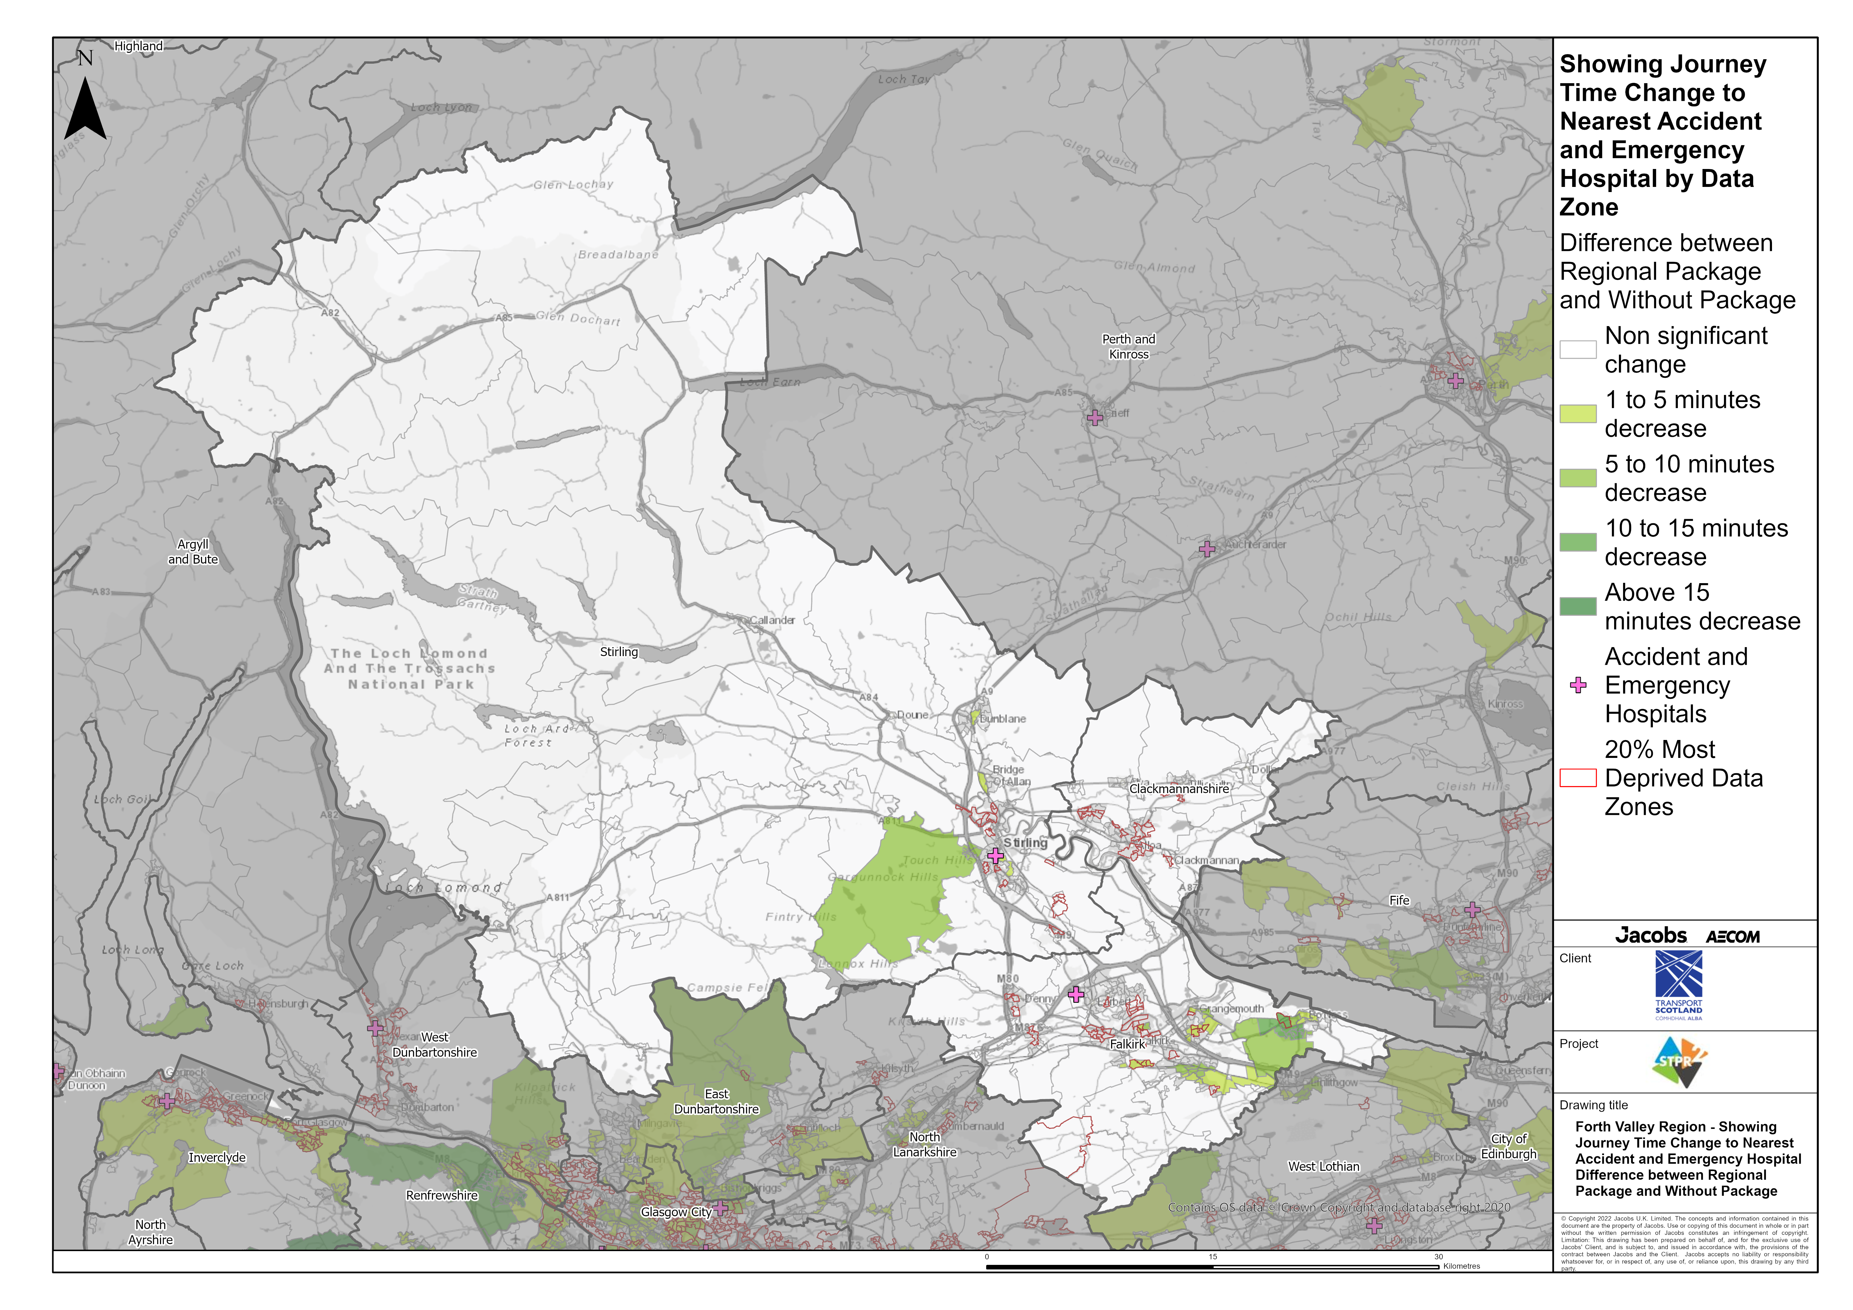
Forth Valley Region – Showing Journey Time Change to Nearest Accident and Emergency Hospital Difference between Regional Package and Without Package
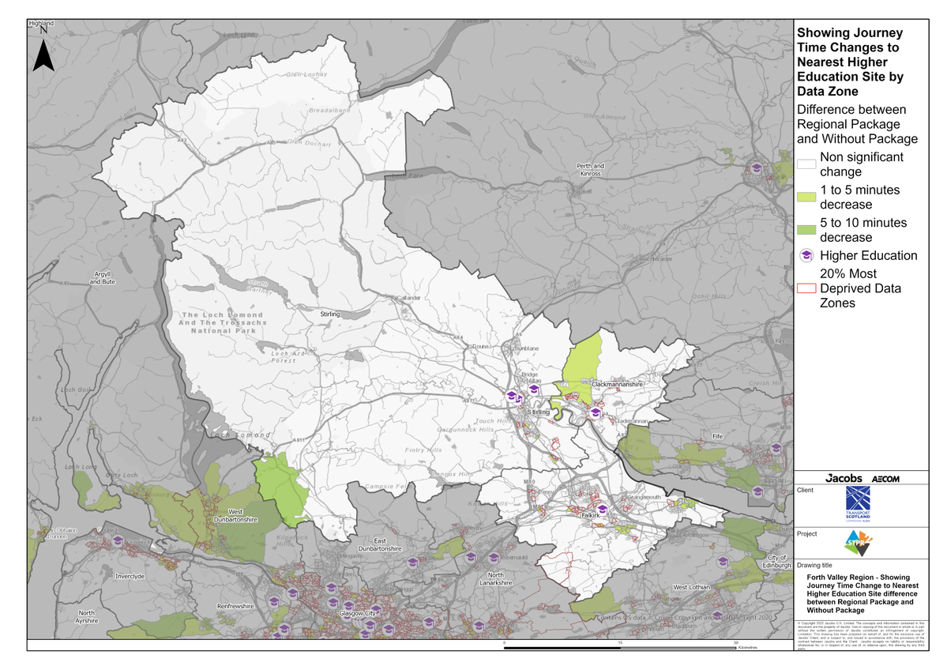
Forth Valley Region – Showing Journey Time Change to Nearest Higher Education Site Difference between Regional Package and Without Package
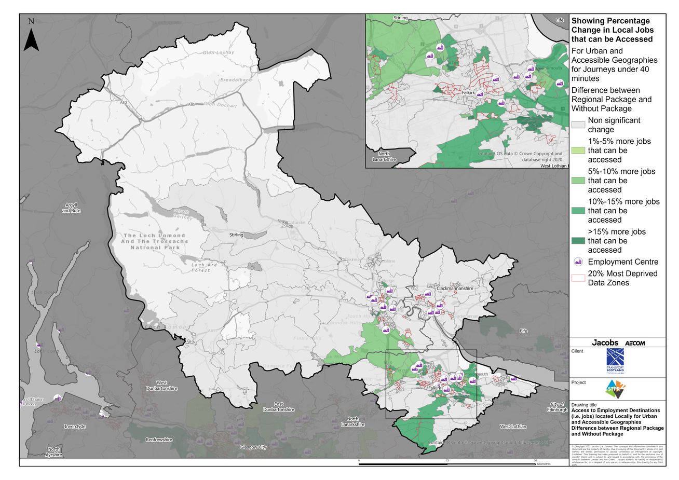
Forth Valley Region – Access to Employment Destinations (i.e. jobs) located Locally for Urban and Accessible Geographies for journeys under 40 minutes Difference between Regional Package and Without Package
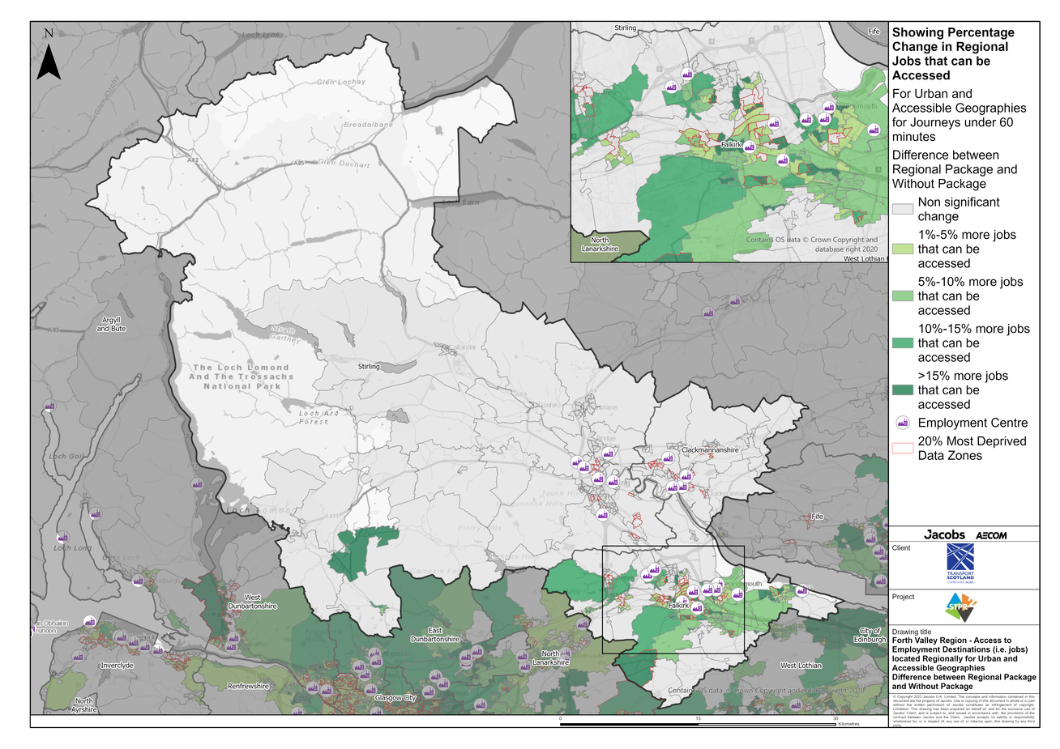
Forth Valley Region – Access to Employment Destinations (i.e. jobs) located Regionally for Urban and Accessible Geographies for journeys under 60 minutes Difference between Regional Package and Without Package
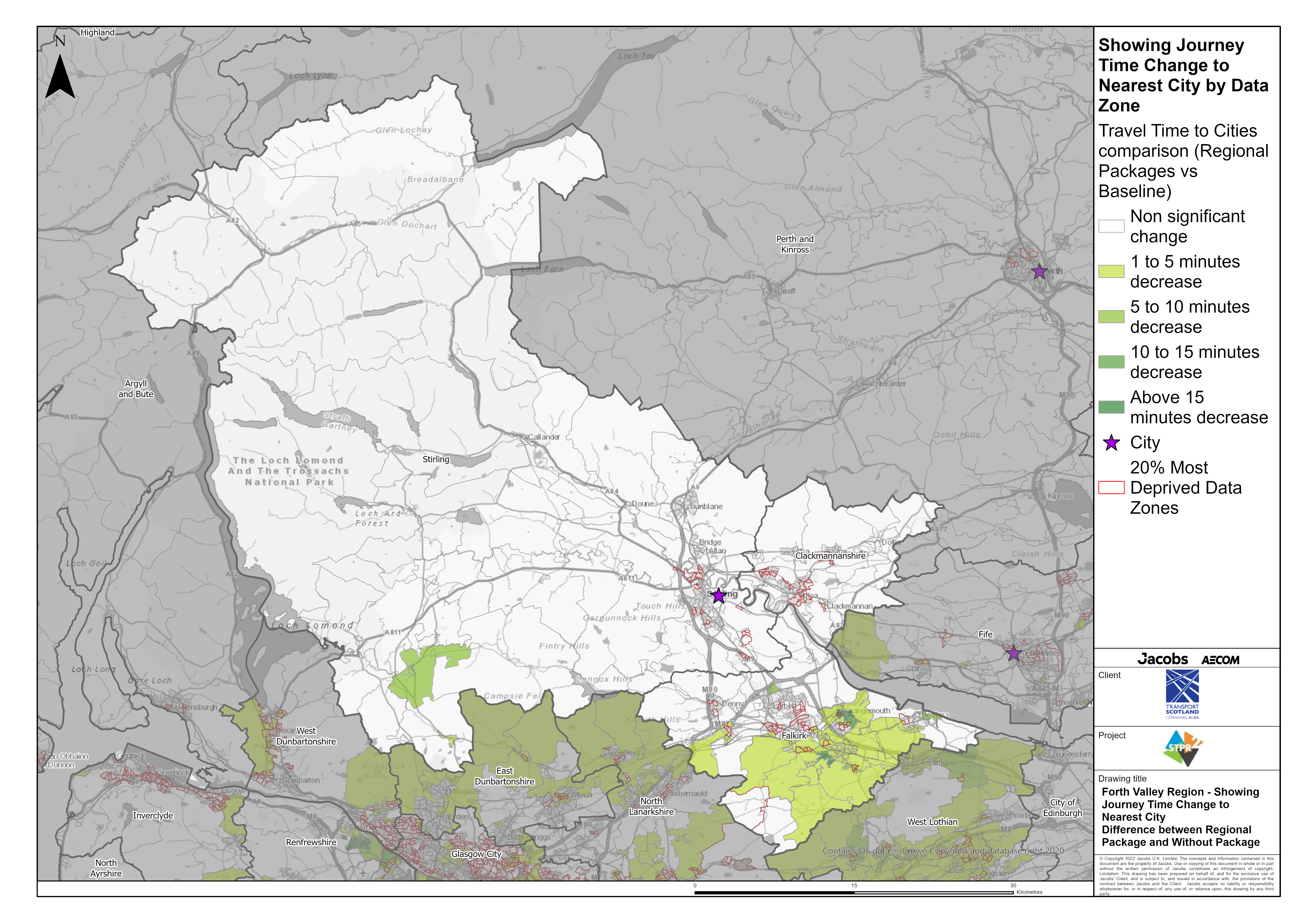
Forth Valley Region – Showing Journey Time Change to Nearest City Difference between Regional Package and Without Package
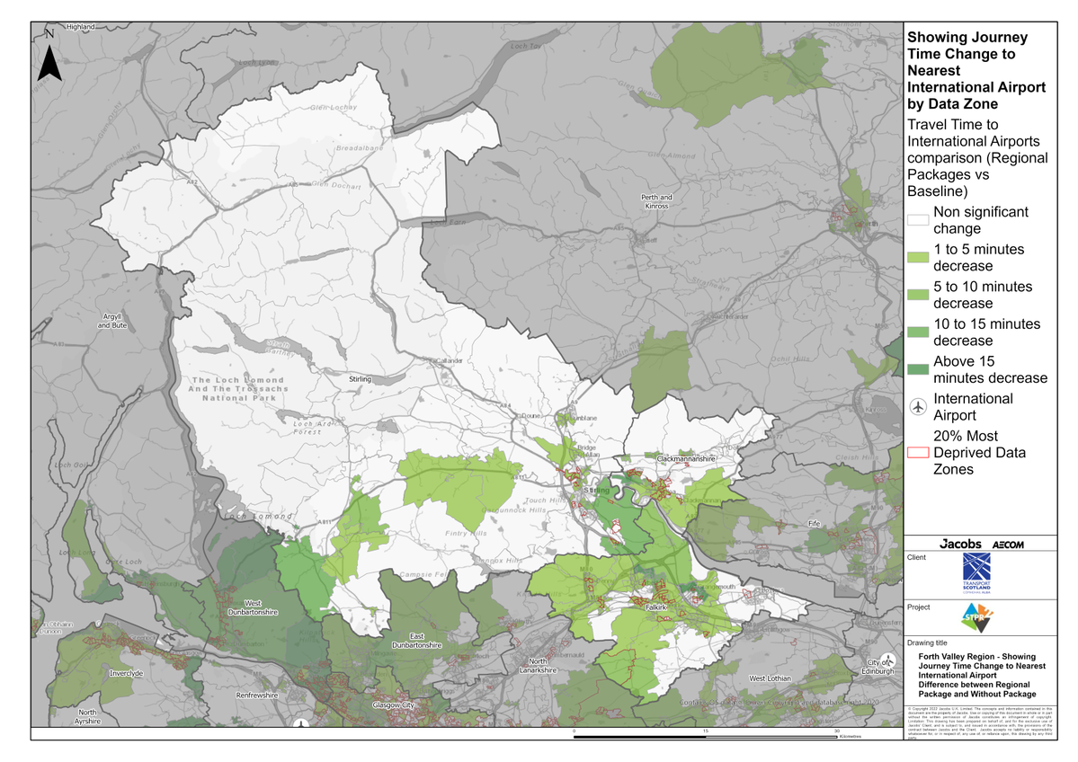
Forth Valley Region – Showing Journey Time Change to Nearest International Airport Difference between Regional Package and Without Package

Annex B: Traffic Modelling Outputs
