Appendix H: Detailed Packaging - Appraisal Summary Tables

December 2022
Contents
1. Regional Context 5
1.1. Geographical Context 5
1.2. Social Context 6
1.3. Economic Context 6
1.4. Environmental Context 7
2. Problems and Opportunities 8
2.1. Problems 8
2.2. Opportunities 9
3. Regional Recommendations 11
4. Fit with Established Policy 12
5. STPR2 Transport Planning Objectives (TPOs) Assessment 13
6. STAG Assessment 22
6.1. Environment 22
6.2. Climate Change 23
6.3. Health, Safety & Wellbeing 24
6.4. Economy 26
6.5. Equality & Accessibility 27
7. Deliverability 29
7.1. Feasibility 29
7.2. Affordability 29
7.3. Public Acceptability 29
8. Statutory Impact Assessment Criteria 30
8.1. Strategic Environmental Assessment (SEA) 30
8.2. Equalities Impact Assessment (EqIA) 31
8.3. Island Communities Impact Assessment (ICIA) 31
8.4. Child Rights and Wellbeing Impact Assessment (CRWIA) 32
8.5. Fairer Scotland Duty Assessment (FSDA) 32
Annexes 33
Annex A: NAPTAT Mapping 34
Annex B: Traffic Modelling Outputs 42

North East Region Appraisal Summary Table
An Appraisal Summary Table (AST) has been developed for each of the eleven STPR2 Regions alongside the National AST. The ASTs are set out to provide:
- Regional Context, Problems and Opportunities – drawing on data presented in the Initial Appraisal: Case for Change reports this summarises geographic, social, economic, environmental and transport matters in the region as well as the identified problems and opportunities. In line with STAG, appraisals are expected to explore location-specific problems and opportunities. Local problems and opportunities have been considered to gain a full understanding of the regional and national issues, however some of these may not be within the scope of this strategic study.
- Regional Recommendations – this presents the package of recommendations that were included in the detailed appraisal for the region.
- Fit with Policy – provides a summary of how well the appraised packages fit with key national policies including the second National Transport Strategy, Climate Change Plan Update, the Revised Draft Fourth National Planning Framework (Revised Draft NPF4) and relevant regional policies.
- Transport Planning Objectives (TPO) Assessment – An assessment against each of the five TPOs is provided with quantified metrics , where appropriate, under the Low growth sensitivity with a 20% reduction policy ambition on car kilometre scenario (hereafter referred to as Low scenario) and High growth sensitivity with no policy ambition on car kilometre scenario (hereafter referred to as High scenario) (further information about these scenarios is provided in Appendix F of the Technical Report). A seven point scoring scale is adopted for each TPO which is:
  - + + + = major positive (3 plus signs)
  - + + = moderate positive
  - + = minor positive
  - 0 = neutral
  - - = minor negative
  - - - = moderate negative
  - - - - = major negative (3 minus signs)
- STAG Criteria assessment – as above for the TPO assessment, key points regarding the performance of the package against each of the STAG criteria is presented with quantified metrics provided where appropriate.
- Deliverability – commentary is provided on the assessment of the package in terms of its feasibility, affordability and public acceptability. Note that due to the nature of a number of the STPR2 interventions, and the stage in the business case process STPR2 is at, it has not been possible to derive cost estimates on a regional basis. However, broad capital spending ranges have been estimated over the period 2022 to 2042 at a national level.
- Statutory Impact Assessment Criteria – a summary of the performance of the packages against the Strategic Environment Assessment (SEA), the Equalities Impact Assessment (EqIA), Island Communities Impact Assessment (ICIA), Fairer Scotland Duty Act (FSDA) and Child Rights and Wellbeing Impact Assessment (CRWIA) is provided. The seven point scoring scale is adopted in these assessments where appropriate.

Summary of Assumptions
Quantification of the costs and benefits in the packages has been provided through a modelling exercise. Further information is provided in Appendix F of the Technical Report on the modelling scenarios that have informed the assessment of the STPR2 interventions. A summary of the key assumptions is provided here:
- Population projections are based on the NRS Population Projections (2018-based).
- Economic projections are a combination of projections by Oxford Economics, 2019, the Scottish Fiscal Commission forecasts and more recently the OBR post-COVID estimates.
- Land-use plans are based on data collected for Transport Scotland’s Assembly of Planning Policy Inputs in 2018 from Scotland’s 34 Planning Authorities.
- Permitting of vacant office and retail floorspace to be converted or redeveloped as housing post 2030.
- Working age is taken to be 16-64 (as a constant) to avoid difficulties with changing state pension age (and to reflect non-mandatory retirement).
- The economic results are presented, as is standard within appraisal as discounted values in 2010 prices.

Modelling Tools
For the purposes of modelling accessibility by public transport, NaPTAT (National Public Transport Accessibility Tool) has been used. This allows an assessment of journey time to be compared between the with and without STPR package.
Due to the strategic and national nature of STPR2, the national Transport Model for Scotland (TMfS) has been used. TMfS is a national scale model with a focus on inter-urban trips. As such, whilst TMfS provides a suitable level of robustness at this stage of the appraisal for most of the larger infrastructure based interventions, there are limitations associated with the modelling of smaller/discrete interventions and also some of the larger infrastructure interventions that involve changes to the existing road network and are more urban in nature. Separate forecasts of the potential impacts of active travel recommendations on walking and cycling mode share have therefore been made. As the recommended interventions are developed through the business case process, more detailed modelling will be undertaken using regional and / or local models as appropriate.
When considering the outputs presented in this AST, please note the following metrics with respect to the model outputs:
- CO₂ emissions: Likely to underestimate the benefits associated with public transport interventions due to the more limited representation of transport systems in urban areas and a degree of insensitivity to mode shift in TMfS.
- Mode Share: Likely shift to public transport modes underestimated in the urban areas due to the more limited representation of urban transport systems and a degree of insensitivity to mode shift in TMfS.
- Change in vehicle kilometres travelled: Likely to underestimate the benefits of reducing vehicle kilometres travelled particularly for short distance journeys due to the more limited representation of urban transport systems and the relative coarseness of the model zone system.
- Lost time due to congestion: Likely to underestimate the benefits associated with interventions that would reduce roadspace due to the under-representation of the local/secondary road network in TMfS.
- Change in accidents: Likely to underestimate the benefits associated with mode shift to public transport interventions due to the more limited representation of urban transport systems and a degree of insensitivity to mode shift in TMfS.
- Present Value of Benefits: Likely to underestimate the benefits to public transport users due to the more limited representation of urban transport systems. Likely to overestimate the dis-benefits to car-based trips due to the under-representation of the junctions and local/secondary road network in TMfS.

- Regional Context
  - Geographical Context
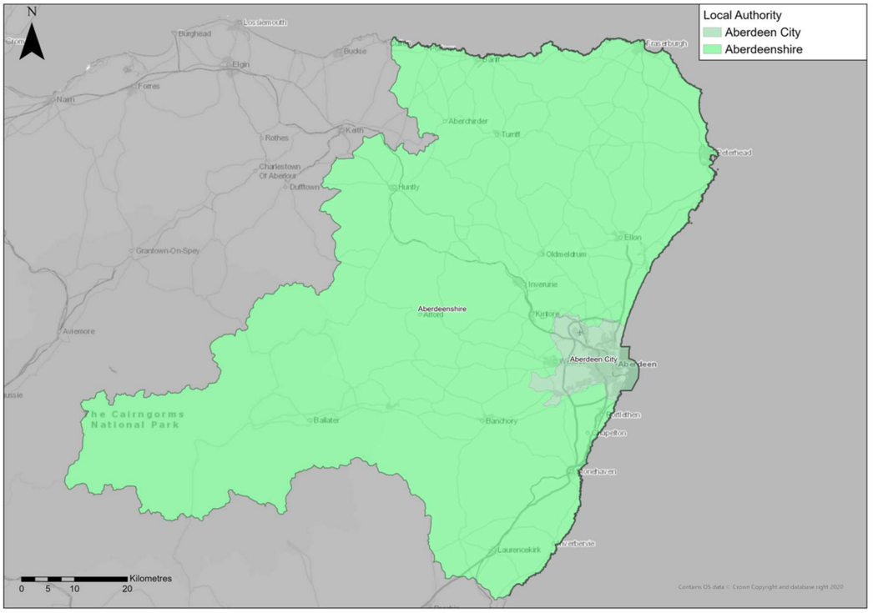
The North East Region is one of three ‘advanced Regions’ to have had their Case for Change studies undertaken ahead of STPR2. In these Regions the Case for Change was established based on Pre/Initial Appraisal studies, which included identification of problems and opportunities as well as option generation and sifting (which were informed by significant stakeholder engagement and data analysis). To ensure consistency with the other Case for Change exercises, the option sifting exercise for the three ‘advanced Regions’ was revisited in 2020 through the STPR2 option sifting framework to cross-check the results; this confirmed broadly the same list of options to be recommended for further appraisal through STPR2. To assist with this further appraisal, the baseline data gathered during the ‘advanced studies’ was updated to match that used for all other Regions for STPR2. In order to align with the wider process for establishing the Case for Change across Scotland, and to update the context for the Region, this Appraisal Summary Table therefore refers to some of this more recent data – this has not, however, led to a change in the nature of problems and opportunities established, or options generated and sifted, from those identified previously.
The North East Region comprises the two local authorities of Aberdeenshire and Aberdeen City. It is a mix of urban and rural settlements and areas. The Scottish Government Urban Rural Six-Fold Classification identifies the population of Aberdeen City residing in each category as follows: Large Urban Areas (93%), Accessible Small Towns (5%) and Accessible Rural (1%). The population of Aberdeenshire residing in each category is as follows: Other Urban Areas (30%), Accessible Small Towns (14%), Remote Small Towns (7%), Accessible Rural (35%) and Remote Rural (13%). This demonstrates that whilst the Region is dominated by the large densely populated urban area of Aberdeen City and the immediate adjacent areas, there are also areas of rural nature within the Region with less than a third considered Urban. The urban areas that do exist are spread across the Region although positioned mainly on the approaches to Aberdeen, for example Stonehaven, Ellon and Inverurie. Peterhead and Fraserburgh are located to the far north eastern part of the Region. There are also several ‘accessible small towns’ such as Banchory, Oldmeldrum and Chapelton.
The Region has an extensive transport network, including active travel, bus, rail and road networks, park and ride facilities. In the context of STPR2 major ports are located at Aberdeen, Peterhead and Fraserburgh and ferry links to Kirkwall and Lerwick from Aberdeen and an International Airport.
  - Social Context
According to the National Records of Scotland’s Mid-year Population Estimates Scotland, Aberdeen City and Aberdeenshire Council areas had populations of 228,670 and 261,210 respectively as of 2019, bringing the total population in the Region to 489,880 (9% of the total Scotland population), a 3.0% increase since the 2011 Scottish Government Census. This growth was similar to that of the Scottish national profile at 3.2%. The city of Aberdeen is the largest settlement within the Region with almost half (approximately 46.7%) of its population. In terms of age structure, 15% of residents in Aberdeen City were children (15 and under), 69% were of working age (Census defines this as 16 to 64), and 16% were 65 and over. In Aberdeenshire, 19% of residents were children (15 and under), 62% were of working age (aged 16 to 64), and 20% were 65 and over. This is broadly similar to Scotland as a whole, where the 2011 Scottish Government Census also showed 17% of residents were children (15 and under), 65% were of working age (aged 16 to 64), and 18% were 65 and over.
Performance against socio-economic indicators varies across the Region. Overall, the proportion of households with no access to a car is significantly lower in Aberdeenshire compared to Scotland as a whole (14% compared to 31%, based on 2011 Census), however the proportion for Aberdeen City (32%) was similar to the national figure. According to Aberdeen City Region Deal Strategic Transport Appraisal, travel to work by car is the dominant mode in the North East Region. Aberdeen City has higher car mode share compared to other Scottish cities, with 58% of people driving to work, and Aberdeenshire has significantly higher car mode share (70%) compared to the Scottish average (62%). 12% of commuting trips in Aberdeen City are by bus, which is higher than the Scottish average (10%), however bus accounts for only 4% of commuting trips in Aberdeenshire. Rail accounts for 1% in both local authority areas. 15% of people walk and 2% cycle to work in Aberdeen City, whilst 8% walk and 1% cycle in Aberdeenshire. Travel for work tends to be within the Region, with 95% of people working in the North East also living in the Region.
Overall 6.6% of people in Aberdeen City and 5.8% of people in Aberdeenshire had no qualifications in 2011 data from NOMIS Local Authority Profile shows; considerably lower than the 9.8% of people in Scotland. SIMD data demonstrates that there are pockets of deprivation across the Region, most notably in Aberdeen City where 10.2% of data zones in Aberdeen City are within the 20% most deprived compared to and 2.6% in Aberdeenshire. SIMD Health rankings indicate that health quality throughout the North East Region is varied: in Aberdeenshire, 0.3% of data zones are ranked within the lowest quintile (20% most deprived) for health in Scotland, whilst in Aberdeen City has 10.2% data zones within the lowest quintile.
  - Economic Context
Economic activity refers to an estimation of whether usual residents aged 16 to 64 were in work or actively looking for work. The North East Region contributed approximately 11.7% of Scottish Gross Value Added (GVA) in 2019 in evidence from ONS Regional GDP. Whilst there are pockets of deprivation across the Region (predominantly located within Aberdeen City), the Region benefits from high levels of economic activity and high educational attainment. Aberdeen City Region Deal Strategic Transport Appraisal points to Aberdeen City and Aberdeenshire have economic activity rates of 78% and 84% respectively compared to the Scottish national figure of 77% in 2017. Aberdeenshire had one of the lowest unemployment rates in Scotland in 2017, with only 2.8% of people unemployed. Aberdeen City had a slightly higher unemployment rate (4.2%) in the NOMIS Local Authority Profile, however this rate was similar to the Scottish average (4.1%). Aberdeenshire Council’s Regional Economic Strategy highlights the Region’s economy has a wide spread of activity with high levels of employment in professional, scientific and technical activities; wholesale and retail trade, repair of motor vehicles and motorcycles; human health and social work activities; and mining and quarrying.
  - Environmental Context
Within the North East, there are many areas classified as environmentally sensitive, with varying levels of statutory protection. Environmental designations within the Region include biodiversity, and landscape and heritage designations which fall either wholly or partly within the Region. In addition, the Region contains a significant number of Category A-B Listed buildings and a high concentration of designated cultural heritage assets, as expected in a large urban area. Data from the Scottish Government’s Scotland Noise Map and Aberdeen Airport’s Noise Action Plan 2018-2023 indicates that the greatest noise levels are located around Aberdeen City, primarily associated with the trunk road network corridors and Aberdeen Airport, together with the rail routes through the Region. Settlements at greatest risk of coastal flooding are located along coastal boundary of the Region. Areas at medium and high risk of river flooding include those located in the vicinity of the River Dee and River Don. Areas at high and medium risk of surface water flooding are scattered throughout the region. There are three Air Quality Management Areas (AQMAs) within the North East Region, at the City Centre, Wellington Road and Anderson Drive. In 2018, CO₂ emissions from transport within the North East Region equated to 8.9% of Scotland’s total transport emissions overall in data from UK Government’s local authority and regional carbon dioxide emissions national statistics.
Linked to the above context and extensive stakeholder engagement exercise undertaken for the Aberdeen City Region Strategic Transport Appraisal, the following key problems and opportunities were identified for the region. As highlighted earlier, the regions Case for Change was undertaken in advance of STPR2, and therefore in advance of the full scope of STPR2 being known. Therefore some of the problems and opportunities identified for the Region are out with the scope of STPR2 but repeated here for consistency:

- Problems and Opportunities
The following transport-related problems and opportunities have been identified for the North East region.
  - Problems
- Accessibility: this is impacted by long journey times to key destinations, both within the Region and to / from other regions. The local geography also constrains ability to create an efficient accessible transport system; it is bounded to the north and east by the North Sea, to the west by sparsely populated and mountainous areas and to the south it is relatively remote from other regions of Scotland. Additionally the access to the airport from Dyce Rail Station is perceived to be poor as the two are divided by a runway.

- Active Travel: there is perceived to be a lack of high quality connected active travel provision across the region. This is against a backdrop of favourable conditions to travel actively, particularly into / out of Aberdeen with direct routes (generally via key traffic routes and relatively short distances to / from key settlements around Aberdeen. There is also a perceived lack of safe routes on or alongside key traffic routes and road safety concerns can therefore hinder active travel uptake as a result.

- Connectivity: relatively long distances and journey times to other parts of Scotland, particularly the central belt, lead to a perception of relative isolation of the Region. There is also a perception of poor inter-town connectivity within the region; key settlements generally link well to / from Aberdeen but not as well between them. While connectivity has improved with the Aberdeen Western Peripheral Route, connectivity issues still exist. There is a lack of quality accessible multi-modal interchanges away from the main public transport hub around Aberdeen Rail Station and a lack of high speed internet access, particularly in more rural parts of the region.

- Public Transport: public transport options are perceived by many as not being a competitive alternative to the private car, in terms of journey times, reliability and cost. This is compounded by a general lack of public transport accessibility, principally outside Aberdeen and a lack of public transport capacity on key corridors. It can be difficult for vulnerable users to access public transport and there is limited scope for public sector funding for improved bus provision.

- Road: key corridors in the Region suffer journey time reliability issues, particularly during peak times. The low cost and relative ease of parking in the city centre can also contribute to this issue through increased traffic volumes in and around the city centre. Road infrastructure in some areas is perceived as not suitable for freight movements, particularly around the city’s harbour and approaches from the south. There are also general safety issues associated with road network exacerbated by a poor perception of road maintenance on a road network that is constrained in parts and has a general lack of alternative vehicular routes. Vehicles are seen to be the dominant mode around the city and there is an associated perception of unsafe driver behaviour, particularly for non-motorised users.

- Socio-economic: over-reliance on car as main mode of travel has generally associated with high car ownership levels, and general access to one or more vehicles in the region. Historically there has been a perceived lack of integration between land use and transport meaning the car is often the easiest choice, even for short trips. High car use and congested conditions in parts of the city have led to negative health impacts associated with vehicle emissions, particularly around the three AQMA areas, and there is a growing and ageing population who may be more likely to use private vehicles. The local economy has long been dominated by the oil and gas industries and this has led to a skills shortage for other key industries. A lack of investment in tourism infrastructure is perceived to limit growth in what could otherwise be a high performing sector given the regions natural beauty and numerous attractions.

  - Opportunities
- Accessibility: opportunities exist to better connect the Region as a whole and specifically the City Centre Masterplan has the potential to considerably improve the sense of place and ease of movement around the city centre. There could be economic benefit of an airport well integrated with the city region, for both business and leisure travel, and coupled with improved regional accessibility and a change towards more sustainable movements more generally the accessibility of the transport system could become more sustainable. There is also a significant opportunity now to design the new harbour to provide efficient access for all modes.

- Economy & Development: there is a perception that sustainable economic growth can be achieved in the Region through economic diversification (with support from the Aberdeen City Region Deal). There is also an eagerness to increase collaboration between government and business across many areas as a means of achieving efficiencies and growth. There is a move towards higher density and well located developments to reduce the need to travel by car. The new harbour has the potential to generate significant growth economically and in employment and tourism. There is a local existing high skills base and high quality of life in the Aberdeen City Region which offer strong opportunities to support this and the transition to a low carbon economy.

- Connectivity: recent digital connectivity improvements can reduce the need to travel and to work and shop from home.

- Active Travel: evidence from elsewhere shows strongly that quality sustainable travel provision can increase uptake of these modes. The health benefits associated with an increase in walking and cycling are understood to be significant and the incorporation of high quality active travel provision as part of the City Centre Masterplan could be a good showcase for demonstrating this in the region.

- Public Transport: positive perceptions around the opening of Kintore railway station, planned rail enhancements, increase in rail patronage (pre-COVID) and successful park & ride sites have added to the positive perceptions of sustainable transport in the region.

- Environment: technology is available and can play a major part in improving transport network efficiency and reducing emissions, which in turn can improve air quality.

- Road: desire to see the benefits of AWPR locked in, not just relieved routes filling up with traffic again but a move towards a less car dependent region. AWPR is also considered to offer major freight efficiency benefits, along with road safety improvements.

- Regional Recommendations
The following is a list of interventions that form a package of recommendations that are relevant to this Region.

Regional Recommendations
- Connected neighbourhoods (Recommendation 1)
- Active freeways and cycle parking hubs (Recommendation 2)
- Village-town active travel connections (Recommendation 3)
- Connecting towns by active travel (Recommendation 4)
- Long-distance active travel network (Recommendation 5)
- Behavioural change initiatives (Recommendation 6)
- Changing road user behaviour (Recommendation 7)
- Increasing active travel to school (Recommendation 8)
- Improving access to bikes (Recommendation 9)
- Expansion of 20mph limits and zones (Recommendation 10)
- Aberdeen Rapid Transit (Recommendation 13)
- Provision of strategic bus priority measures (Recommendation 14)
- Perth-Dundee-Aberdeen Rail Corridor Enhancements (Recommendation 16)
- Supporting integrated journeys at ferry terminals (Recommendation 18)
- Infrastructure to provide access for all at railway stations (Recommendation 19)
- Investment in Demand Responsive Transport and Mobility as a Service (Recommendation 20)
- Improved public transport passenger interchange facilities (Recommendation 21)
- Framework for the delivery of mobility hubs (Recommendation 22)
- Smart, integrated public transport ticketing (Recommendation 23)
- Ferry vessel renewal and replacement and progressive decarbonisation (Recommendation 24)
- Decarbonisation of the rail network (Recommendation 25)
- Decarbonisation of the bus network (Recommendation 26)
- Behavioural change and modal shift for freight (Recommendation 27)
- Zero emission vehicles and infrastructure transition (Recommendation 28)
- Trunk road and motorway safety improvements to progress towards ‘Vision Zero’ (Recommendation 30)
- Trunk road and motorway network climate change adaptation and resilience (Recommendation 31)
- Trunk road and motorway network renewal for reliability, resilience and safety (Recommendation 32)
- Future Intelligent Transport Systems (Recommendation 33)
- Traffic Scotland System Renewal (Recommendation 34)
- Intelligent Transport System renewal and replacement (Recommendation 35)
- Strategy for improving rest and welfare facilities for hauliers (Recommendation 36)
- Improving active travel on trunk roads through communities (Recommendation 37)
- Speed Management Plan (Recommendation 38)
- Investment in port infrastructure to support vessel renewal and replacement, and progressive decarbonisation (Recommendation 42)
- Rail freight terminals and facilities (Recommendation 44)
- Fit with Established Policy
The interventions included within this package support a wide range of national, regional and local policy documents in which transport improvements play a key role in both the enabling and delivery of outcomes.
Key policies supported include the Programme for Government, Infrastructure Investment Plan, NTS2, the Climate Change Plan Update 2018 - 2032, the Aberdeen City Region Deal, the NESTRANS Regional Transport Strategy, the City and Shire Strategic Development Plan, and Aberdeen City and Aberdeenshire Local Transport Strategies.
The Revised Draft NPF4 includes the Region within its North East transition area, along with Moray. It proposes that priorities for the North East area include actively planning the transition from oil and gas to a net zero future.
The framework is underpinned by the ambition to provide affordable, sustainable, inclusive, innovative, and reliable transport options to provide an attractive place for visitors, to provide opportunities for businesses to invest and grow, and to empower the Region’s communities to thrive, the package therefore closely aligns with established policy directives.

Package Performance Against NTS2 Priorities and Outcomes:

Reduce inequalities
Will provide fair access to services we need: Major Positive
Will be easy to use for all: Major Positive
Will be affordable for all: Minor Positive

Takes climate action
Will help deliver our net-zero target: Major Positive
Will adapt to the effects of climate change: Minor Positive
Will promote greener, cleaner choices: Major Positive

Helps deliver inclusive economic growth
Will get people and goods where they need to get to: Major Positive
Will be reliable, efficient and high quality: Major Positive
Will use beneficial innovation: Major Positive

Improves our Health and Wellbeing
Will be safe and secure for all: Major Positive
Will enable us to make healthy travel choices: Major Positive
Will help make our communities great places to live: Major Positive
- STPR2 Transport Planning Objectives (TPOs) Assessment

TPO1 A sustainable strategic transport system that contributes significantly to the Scottish Government’s net-zero emissions target

TPO Performance Summary
Carbon dioxide equivalent (CO₂eq) is treated as a nationally important pollutant. As such, although it can be appraised at the national level (commentary below), it has not been appraised for individual regions.
The the national and all regional packages will contribute significantly to the net-zero emissions target by:
- Enabling more passenger journeys to be made by active modes and public transport.
- Decarbonising most public transport operations.
- Facilitating uptake of electric vehicles.
- Enabling some road freight to switch to rail or other low carbon modes.
Further commentary is provided below.
National CO₂eq emissions are forecasted to decrease year-on year. This is due to decreasing vehicle exhaust (non-traded) emissions as the number of internal combustion engine vehicles reduces. This is reflected in the volume of traded grid emissions from charging increased numbers of battery-electric vehicles, and specifically in the Low scenario. It is noted that traded emissions of Carbon Dioxide equivalence (CO₂eq) are associated with electrical generation to supply plug-in vehicles, both BEV (battery electric vehicles) and PHEV (plug-in hybrid vehicles).
The electricity grid is expected to be using predominantly renewable sources in the future and so increasing adoption of electric vehicles and a shift from direct, non-traded, emission to traded gridbased technology (i.e. battery) will support reducing CO₂eq emissions.
Across both Low and High scenarios the interventions would reduce emissions of CO₂eq.
Significantly higher overall emissions are predicted in the High scenario, either with, or without the national and all regional packages. There is a relatively smaller overall reduction of emissions due to the interventions in the Low scenario due to the lower overall emissions. The economic impacts associated with air quality were assessed using the Department for Environment Food & Rural Affairs (DEFRA) Damage Costs Appraisal Toolkit. The larger economic benefit from the High scenario is due to the greater overall emissions with, or without, the package, although the proportional change is lower.
Overall Scoring:
Low and High Scenarios: Major Positive

Metric 1: Change in CO₂eq (non-traded and traded emissions from regional road transport inc. grid emissions from charging light-duty vehicles)- Figures below are a National calculation
Low Scenario Commentary:
- 0.5% decrease (27,700 tonnes CO₂eq) in 2030.
- 2.8% decrease (21,600 tonnes CO₂eq) in 2045.
- 1.3 million tonnes reduction, of which 1.1 million were traded, for the 60-year appraisal period from 2030 to 2089.
- The net economic benefits for the 60-year appraisal period in 2010 prices and values would be in the range £10 million to £25 million for the Low scenario
High Scenario Commentary:
- 0.4% decrease (31,3000 tonnes CO₂eq) in 2030.
- 1.3% decrease (65,300 tonnes CO₂eq) in 2045.
- 3.7 million tonnes reduction, of which 452,000 were traded, for the 60-year appraisal period from 2030 to 2089.
- The net economic benefits for the 60-year appraisal period in 2010 prices and values would be in the range £100 million to £250 m for the High scenario.

Metric 2: Change in mode share by active travel for all journeys
Low and High Scenario Commentary:
- Potential increase in walking from 20% mode share to 24% mode share (4 percentage points).
- Potential increase in cycling from 1.2% mode share to 19% (17.8 percentage points).
The package will increase the proportions of journeys undertaken by active modes. If all the active travel and behaviour change interventions were fully implemented in every relevant location in the Region, mode shares of walking and cycling "with STPR2 package" proportions are shown alongside the mode share without package.
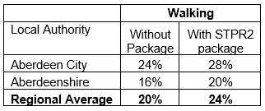
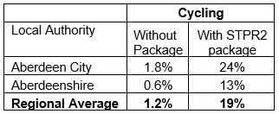
Note that the cycling and walking growth forecasts have been developed independently of each other. Growth in use of one active mode is likely to abstract at least some trips from the other, but this effect is not accounted for within these forecasts.

Metric 3: Change in motorised vehicle kilometres travelled
Low Scenario Commentary:
- Reduction of 72 million vehicle kilometres (3% decrease) (see Annex B).
High Scenario Commentary:
- Reduction of 65 million vehicle kilometres (2% decrease) (see Annex B).

TPO2 An inclusive strategic transport system that improves the affordability and accessibility of public transport

TPO Performance Summary
The package will improve the inclusiveness of the transport system by:
- Improving conditions for people walking, wheeling and cycling, the most inclusive transport modes, with particular benefits for people most often excluded (including children, older and disabled people, and people on low incomes).
- Improving inclusive accessibility to public transport stops/stations.
- Seeking to promote public transport use and reduce operating costs, hence enhancing network sustainability.
Overall Scoring:
Low and High Scenarios: Major Positive

Metric 1: Change in transport poverty risk
Low and High Scenarios Commentary:
Although the STPR2 interventions do not impact on the direct costs of travel (e.g. fares, fuel price), the package of interventions would see a small reduction in transport poverty, due to the overall improvements in public transport availability.

Metric 2: Change in Accessibility - population catchments increases to key services by journey time by public transport
Low and High Scenarios Commentary:
The largest change in population accessibility of all the destination types considered was to key hospitals, whereby an additional 8,900 of the population in the Region would are forecast to be able to access the nearest site in a journey time of 30 minutes or less by public transport with the STPR2 package compared to the without package. This represents a 2.2 percentage point increase in accessibility levels from 48.6% in the without package assessment to 50.8% with the package in place. The improvements were largely observed in Aberdeen City, particularly in Old Aberdeen. Continuing with healthcare, the package would also provide better access in the Region to the nearest GP surgery under a journey time of 30 minutes, most noticeably in Westhill. This is shown by the map output in Annex A.
There are also population accessibility improvements observed in the Region for accessing key destinations using public transport, though more pronounced for journeys under 60 minutes, which included higher education, major shopping centres and secondary schools. The accessibility improvements and the corresponding additional population that are able to access those destinations within a journey time of 60 minutes compared to the without package assessment are summarised below:
- 3,100 additional people are able to access the nearest higher education site by public transport, as shown by the map output in Annex A, which represents a 0.8 percentage point increase in accessibility levels from 75.0% in the without package assessment to 75.8% with the package in place.
- 2,400 additional people are able to access a major shopping centre by public transport, which represents a 0.6 percentage point increase in accessibility levels from 64.3% in the without package assessment to 64.9% with the package in place.
- 700 additional people are able to access the nearest GP surgery by public transport, which represents a 0.1 percentage point increase in accessibility levels from 89.2% in the without package assessment to 89.3% with the package in place.
- 300 additional children (aged 11 to 18) are able to access the nearest secondary school, which represents a 0.7 percentage point increase in accessibility levels from 83.8% in the without package assessment to 84.5% with the package in place.

In terms of additional destinations (cities, rail stations and airports) considered in the model:
- 4,300 additional people are able to access Aberdeen City Centre within a 30 minute public transport journey, which represents a 1.0 percentage point increase in accessibility levels from 43.5% in the without package to 44.5% with the package in place.
- 6,800 additional people are able to access their closest rail station within a 30 minute public transport journey, which represents a 1.6 percentage point increase in accessibility levels from 49.2% in the without package to 50.8% with the package in place.
- 23,800 additional people are able to access their closest international airport within a 30 minute public transport journey, which represents a 5.9 percentage point increase in accessibility levels from 4.4% in the without package to 10.3% with the package in place.
- 55,100 additional people are able to access their closest international airport within a 60 minute public transport journey, which represents a 13.5 percentage increase in accessibility levels from 42.1% in the without package to 55.6% with the package in place.

Map outputs are shown in Annex A.

TPO3 A cohesive strategic transport system that enhances communities as places, supporting health and wellbeing

TPO Performance Summary
The package will improve communities as places, supporting health and wellbeing by enabling more journeys to be made by active and sustainable modes, and by improving road safety. This will:
- Improve many people’s physical health and mental wellbeing, with particular benefits for people most often excluded (including children, older and disabled people, and people on low incomes).
- Reduce the adverse impacts of car use on communities and health (including reduced air pollution, noise, accident risk and perceived road danger).

The analysis shows that through improved uptake of walking and cycling, there would be a forecast annual reduction of around 21 premature deaths due to the health benefits arising from active travel.
Overall Scoring:
Low and High Scenarios: Major Positive

Metric 1 Change in mode share by active travel for all journeys
Low and High Scenarios Commentary:
- Potential increase in walking from 20% mode share to 24% (4 percentage points).
- Potential increase in cycling from 1.2% mode share to 19% (over 17 percentage points).
These forecasts are subject to all active travel interventions being delivered in all relevant areas of the Region.
Cycling and walking growth forecasts have been developed independently. Growth in use of one active mode is likely to abstract at least some trips from the other, but this effect is not accounted for within these forecasts.

Metric 2 Potential for Change in 'Place'
Low and High Scenarios Commentary:
The package will tend to improve the quality of the region’s places by improving local accessibility and reducing the adverse impacts of road traffic. In particular Aberdeen Rapid Transit could result in significant improvements to air quality around the three AQMA areas through reductions in traffic and use of low emission buses

Metric 3 Change in Health Benefits
Low and High Scenarios Commentary:
The health benefits of increased rates of active travel as a result of the package have been quantified using the WHOs Health Economic Assessment Tool (HEAT). HEAT estimates the health and economic impacts of increased walking and cycling, providing assessments of the health and economic impacts of walking and cycling on premature mortality and on exposure to air pollution. Output from the tool shows the following benefits by Local Authority:
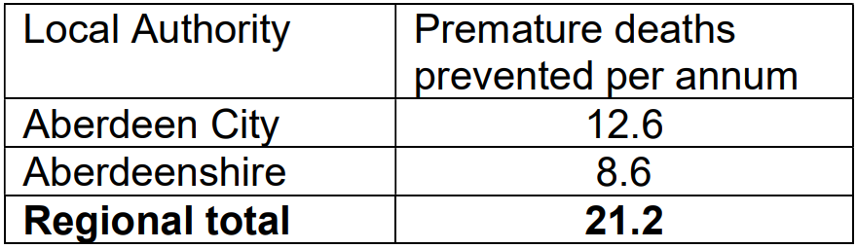

TPO4 An integrated strategic transport system that contributes towards sustainable inclusive growth in Scotland

TPO Performance Summary
The package will contribute to sustainable inclusive growth in Scotland by:
- Improving integration of transport modes (especially between active modes and public transport) and between transport and major developments, particularly in the towns and cities.
- Improving journey time reliability.
- Enabling more people to travel by improving the accessibility and affordability of the transport system, so enabling more people to access local retail and services, and opportunities for employment and education/training. This is particularly relevant in the less rural areas of the Region.
Overall Scoring:
Low and High Scenarios: Moderate Positive

Metric 1: Increased labour catchment by sustainable travel (PT/Active Travel)
Low and High Scenarios Commentary:
Access to local employment, which represents accessibility of key employment opportunities located in the surrounding area within a 40 minute public transport journey time, is forecast to improve across Aberdeen City Local Authority area, whereby the package enabled an additional 6,700 of existing jobs to be accessed within that time period. The accessibility improvements are forecast in Bridge of Don, Seaton, Old Aberdeen, Heathryfold and Middlefield, and Garthdee; and Westhill in Aberdeenshire seeing an increase of 20% in additional existing jobs that can be assessed from within 40 minutes by public transport. This is shown by the map output in Annex A.
Access to regional employment, which represents the accessibility of key employment opportunities located in Aberdeen City within a 60 minute journey time using public transport, was forecast to see the largest increases towards the Aberdeen City Local Authority boundary. For example Bridge of Don and Cove Bay saw an increase, with the latter’s forecasts suggesting an additional 16,000 of existing jobs could be accessed; whilst Westhill, Inverurie and Newmacher showed the biggest forecasted increases in Aberdeenshire (between an additional 13,500 to 15,500 of existing jobs able to be accessed within 60 minutes by public transport). The modelling shows that the package on average enables an additional 4,000 of existing jobs to be accessed in the Region within a 60 minute journey time by public transport. For public transport journey times up to two hours, Peterhead and Fraserburgh saw an average increase of around 9,100 and 4,400, respectively, in existing jobs located in Aberdeen City that could be accessed. This is shown by the map output in Annex A.
The rural population observed little change in journey times to the nearest employment site by public transport.

Metric 2: Change in lost time due to congestion (for business/ commercial transport)
Low Scenario Commentary:
- 16% increase (equivalent to increase of 170,000 hours) in lost time due to congestion.
High Scenario Commentary:
- 25% increase (equivalent to increase of 490,000 hours) in lost time due to congestion.

TPO5 A reliable and resilient strategic transport system that is safe and secure for users

TPO Performance Summary
The package will improve reliability, safety and personal security on the transport system by:
- Improving journey time reliability, including through reduced likelihood of significant network disruptions.
- Reducing the risk of road accidents at hotspot locations on the trunk road network e.g. through targeted infrastructure improvements such as carriageway realignment and widening, the provision of overtaking opportunities and junction improvements. (It should be noted for example that replacing a priority junction with a signalised junction could increase the overall number of accidents, however the severity of accidents occurring should reduce).
- Reducing perceived risks to road safety and to personal security, so enabling more people (particularly children, women and older people) to travel independently.
- Changing attitudes of road users, through behavioural change campaigns. This is anticipated to increase awareness of interactions with those walking, wheeling and cycling.
- Improving active travel provision and providing more dedicated and segregated routes for walking, cycling and wheeling.
Whilst the lost time metric shows a reduction in performance it is considered that is largely due to modelling limitations as noted in the introduction to the appraisal summary table. The model likely overestimates the disbenefits associated with interventions that would reduce roadspace due to the under-representation of the local/secondary road network in TMfS, and in turn may underestimate the related benefits of those interventions.
Overall Scoring:
Low and High Scenarios: Moderate Positive

Metric 1 Change in accidents (PIA and ‘damage-only’)
Low Scenario Commentary:
- Accident reduction related to motorised vehicle kilometres is forecast to be 3%.
High Scenario Commentary:
- Accident reduction related to motorised vehicle kilometres is forecast to be 3%.
Low and High Scenarios Commentary:
Whilst the number of accidents involving motorised vehicles is anticipated to reduce following the introduction of the interventions within this package, it is anticipated that it would increase walking and cycling journeys. The number of accidents involving these modes is therefore anticipated to increase, although each individual journey is anticipated to be significantly safer.

Metric 2 Percentage accident change for Targeted Infrastructure Improvements over 60 years, using default accident rate (PIA only)
Low and High Scenarios Commentary:
Accident benefits were estimated using the Department for Transport (DfT) recommended software programme COBA-LT (Cost and Benefit to Accidents – Light Touch) for targeted road safety improvements, based on default parameters, but using Scotland specific accident rates. A range of accident benefits were calculated for the various improvement options being considered. This provided the upper and lower bound of estimated percentage change in accidents, respectively. These ranges are shown below and provide the anticipated upper and lower bounds of impact on accidents that would be anticipated from typical interventions of this type:

- Sections of Realignment/Widening – reduction of 23% to 59%.
- Sections of Overtaking Opportunities – reduction of 35% to 73%.
- Locations of Junction Improvements – change of 42% (increase) to 64% (decrease).

It should be noted that junction accidents are forecast to increase in the event that a junction is upgraded from a priority to a signalised junction. This is due to an increase in the number of slight accidents that are likely to occur as a result of shunts in queuing traffic on the mainline approach to the traffic signals, which could previously travel unopposed. However, the accident severity can be expected to reduce as a result of this type of improvement. Any improvement scheme would be subject to further consideration.

Metric 3 Change in lost time due to congestion
Low Scenario Commentary:
- 13% increase (342,000 hours) in lost time due to congestion (see Annex B).
High Scenario Commentary:
- 21% increase (1.7 million hours) in lost time due to congestion (see Annex B).

Metric 4 Journey Time Reliability /Availability of alternatives (modes/routes)
The main journey time reliability improvements associated with this package are likely to be associated with Aberdeen Rapid Transit, particularly for public transport journeys.
Targeted improvements on the trunk road network where safety is a problem is forecast to reduce accidents and the associated reduction in road closures from such incidents would also help improve reliability. Improvements in terms of renewals and climate change adaptation to protect the operation of the trunk road and motorway network would also positively impact on the reliability of the network.

- STAG Assessment
  - Environment

Environment

Air Quality
Performance Summary:
Total emissions of NO_{X} (a group of gases that are mainly formed during the combustion of fossil fuels) were predicted to decrease in future in both the High and Low scenarios.
Total emissions of NO_{X} were predicted to be effectively zero in 2045 in the Low scenario, and 2051 in the High scenario either with, or without, the proposed package. It is the change brought about by the projected transition of the vehicle fleet to zero-emission vehicles that contribute to the majority of air quality benefits, and in this instance outweighs the positive mode change contributions from the regional package.
Total emissions of Particulate Matter (PM), which is made up of a collection of solid and / or liquid materials, were predicted to increase in future predominantly due to non-exhaust emissions from road, tyre and brake-wear.
However, the package will reduce harmful emissions slightly. Over the 60-year appraisal period there was a predicted 100% reduction in NO_{X}, 3.3% reduction in PM10 and 3.5% reduction in PM2.5 in the Low scenario, and a 4.1% reduction in PM10 and a 4.2% reduction in PM2.5 in the High scenario.
Low Scenario Scoring: Minor Positive
High Scenario Scoring: Minor Positive

Noise and Vibration
Performance Summary:
The anticipated modal shift is also expected to reduce levels of noise and vibration associated with the transport network. There is potential for a localised negative effects on noise and vibration due to the construction and operation of specific interventions including Aberdeen Rapid Transit and ferry and rail infrastructure improvements however the magnitude of effect will depend on the design and location of the intervention.
Low Scenario Scoring: Minor Positive
High Scenario Scoring: Minor Positive

Biodiversity and Habitats: Geology and Soils; Land Use (including Agriculture and Forestry); Water, Drainage and Flooding; Historic Environment; and Landscape
Low and High Scenarios Commentary:
Please refer to SEA performance summary text in the ‘Statutory Impact Assessment Criteria’ section below. Please note the scoring has been based on the SEA methodology for scoring, which has been agreed with the SEA Consultation Authorities.
  - Climate Change

Climate Change

Performance Summary (applicable to all Climate Change Sub-Criteria)
Carbon dioxide equivalent (CO₂eq) is treated as a nationally important pollutant. As such, although it can be appraised at the national level (commentary below), it has not been appraised for individual regions.
National CO₂eq emissions are forecasted to decrease year-on year, with decreasing direct (non-traded) exhaust emissions and increasing traded grid emissions associated with increased adoption and charging of battery-electric vehicles, and specifically in the Low scenario. It is noted that traded emissions of Carbon Dioxide equivalence (CO2eq) are associated with electrical generation to supply plug-in vehicles, both BEV (battery electric vehicles) and PHEV (plug-in hybrid vehicles).
Across both scenarios the package will reduce emissions of CO₂eq compared to the corresponding baseline, although the change is greater in the High scenario due to overall higher emissions.
Key recommendations within the package have a focus on identifying vulnerabilities to the effects of climate change on the transport system, as well as identifying measures to assist in the adaptation to the effects of climate change, including unplanned events, such as flooding, landslides and high winds. Climate change adaptation and network resilience would address existing and predicted climate change impacts and support the changes that are necessary to reach the Scottish Government’s net zero target for greenhouse gas emissions. Improving the climate resilience of the transport network will also align with the Scottish Government’s commitment to develop Scotland’s next statutory climate adaptation programme.
The above summary is applicable across all the sub-criteria, as outlined below. The specific performance against each sub-criteria is scored against both the Low and High scenarios.

Greenhouse Gas Emissions
Low Scenario Scoring: Major Positive
High Scenario Scoring: Major Positive

Vulnerability to Effects of Climate Change
Low Scenario Scoring: Minor Positive
High Scenario Scoring: Minor Positive

Potential to Adapt to Effects of Climate Change
Low Scenario Scoring: Minor Positive
High Scenario Scoring: Minor Positive
  - Health, Safety & Wellbeing

Health, Safety & Wellbeing

Performance Summary (applicable to all Health, Safety & Wellbeing Sub-Criteria)
The package will reduce the number and severity of accidents through targeted infrastructure improvements and by encouraging modal shift away from private car, resulting in reduced accident risk due to reduced conflicts. Whilst the number of accidents involving motorised vehicles is anticipated to reduce following the introduction of the interventions within this package, it is anticipated that the package would increase walking and cycling journeys. The number of accidents involving these modes is therefore anticipated to increase, although each individual journey is anticipated be significantly safer.
Mode shift to sustainable modes will, by improving natural surveillance, make paths, stops, stations and services feel less isolated and this, accompanied by improved quality of facilities will improve perceived security.
The package will improve communities as places, supporting health and wellbeing, by encouraging modal shift away from private car and towards active travel. This will improve placemaking through reduced noise and better air quality due to reduced traffic, and reduced accident risk. It will also benefit many people’s physical health and mental wellbeing.

Accidents (PIA and ‘damage-only’)
Low and High Scenarios Commentary:
- Accident reduction related to motorised vehicle kilometres is forecast to be 2%.

Percentage accident change for Targeted Infrastructure Improvements over 60 years using default accident rate (PIA only)
Low and High Scenarios Commentary:
Accident benefits were estimated using the Department for Transport (DfT) recommended software programme COBA-LT (Cost and Benefit to Accidents – Light Touch) for targeted road safety improvements, based on default parameters, but using Scotland specific accident rates. A range of accident benefits were calculated for the various improvement options being considered. This provided the upper and lower bound of estimated percentage change in accidents, respectively. These ranges are shown below and provide the anticipated upper and lower bounds of impact on accidents that would be anticipated from typical interventions of this type:

- Sections of Realignment/Widening – reduction of 23% to 59%.
- Sections of Overtaking Opportunities – reduction of 35% to 73%.
- Locations of Junction Improvements – change of 42% (increase) to 64% (decrease).
It should be noted that junction accidents are forecast to increase in the event that a junction is upgraded from a priority to a signalised junction. This is due to an increase in the number of slight accidents that are likely to occur as a result of shunts in queuing traffic on the mainline approach to the traffic signals, which could previously travel unopposed. However, the accident severity can be expected to reduce as a result of this type of improvement. Any improvement scheme would be subject to further consideration.

Security
Low and High Scenarios Commentary:
The package will, by increasing the number of people travelling actively, tend to improve natural surveillance and will, through improvements to lighting and urban realm, tend to reduce the number of locations at which security is a concern. Aberdeen Rapid Transit would consider security as part of stops and station design.

Health Outcomes
Low and High Scenarios Commentary:
The package will, by increasing rates of active travel and hence physical activity, improve both health and wellbeing outcomes. The estimated value of health benefits to the region’s population, appraised over a 60-year period, is in the range £1 billion to £5 billionstpr.
Additionally, there will be health and wellbeing improvements associated with air quality improvements, particularly around the three AQMA areas.

Access to Health and Wellbeing Infrastructure
Low and High Scenarios Commentary:
An additional 8,900 of the population in the Region are forecast to be able to access key hospital in a journey time under 30 minutes by public transport with the package in place compared to the without package assessment. This represents a 2.2 percentage point increase in accessibility levels from 48.6% in the without package assessment to 50.8% with the package in place. This is shown by the map output in Annex A.

The majority of these accessibility to accident and emergency hospital improvements were identified within Aberdeen City, with 8,100 people able to access the nearest site within 30 minutes by public transport.

The package would also provide better access to the nearest GP surgery under a journey time of 30 minutes, most noticeably in Westhill.

Visual Amenity
Low and High Scenarios Commentary:
The package should have a positive impact on visual amenity through improvements to walking and cycling infrastructure and an improved sense of ‘place’. Aberdeen Rapid Transit would require to be designed to enhance the sense of place and not act as a visual barrier. Care would be required in the development of any rail freight facilities to ensure they did not detrimentally impact nearby communities.

  - Economy

Economy

Performance Summary
The majority of economic benefits that accrue are as a result of the sustainable transport interventions in the Region’s package to enable and encourage mode shift to public transport modes. The Aberdeen Rapid Transit intervention, in conjunction with the Bus Priority Infrastructure, Interchange and Rail interventions are the main contributors to the public transport user benefits total in the Low scenario. The remainder of the benefits are largely due to the increase in public transport operator revenue as a result of the increased patronage levels arising from the mode shift away from car.
However, the reallocation of road space that would likely be required in order to implement the Aberdeen Rapid Transit intervention would result in an increased level of disbenefit to road users.
The level of public transport user benefits also reduces in the High scenario. The significantly higher levels of car-based demand would also result in an increased level of disbenefit to road users.
In terms of accident savings, the level of benefits is larger in the High scenario. The benefits arise as a result of the reduction in road-based vehicle kilometres travelled in the region, with the mass transit, active travel and public transport interventions encouraging a mode shift away from private car.
Note that due to the nature of a number of the STPR2 interventions it has not been possible to derive indicative cost estimates on a regional basis.

User Benefits (2010 prices and values for a 60 year appraisal period)
Low Scenario Commentary:
- Present Value of Benefits (PVB) of approximately £250 million to £500 million.
- Accidents Present Value of Benefits (PVB) of approximately £10 million to £25 million.
High Scenario Commentary:
- Present Value of Benefits (PVB) of approximately -£500 million to -£250 million.
- Accidents Present Value of Benefits (PVB) of approximately £10 million to £25 million.
  - Equality & Accessibility

Equality & Accessibility

Performance Summary (applicable to all Equality & Accessibility Sub-Criteria)
The package will improve accessibility to public transport by improving the coverage of the walking, cycling and public transport networks. This will provide particular benefits for people often excluded from transport, including older and young people, women, disabled people, and people living in more deprived communities.
The package will also improve affordability by reducing forced car ownership, and situations where taxi is the only viable mode for people without access to a car.
By encouraging modal shift to more sustainable modes, the package has the potential to increase demand for public transport, improving commercial performance/viability, which could indirectly reduce ticket costs.

Public Transport Network Coverage
Low and High Scenarios Commentary:
The Region is expected to see major benefits from public transport coverage, particularly through the provision of Aberdeen Rapid Transit. This will extend public transport to areas not currently served or not well served and provide connections to key services including hospitals and higher education as well as better connections for employment. This will also improve the journey time and reliability of public transport services on the main radial corridors into and within the City Centre which are known to suffer from congestion.

Active Travel Network Coverage
Low and High Scenarios Commentary:
Improvements to the Region’s active travel network, both within and between settlements, mean that many more people will have more convenient, high-quality and safe infrastructure for walking, wheeling and cycling journeys.

Comparative Access by People Group
Low and High Scenarios Commentary:
Improvements to active travel networks and public transport will provide positive impacts on groups who are less likely to have access to car and more likely rely on public transport, walking and cycling for their journeys. This includes women, children and young people, older people, some ethnic minority groups and disabled people.

Comparative Access by Geographic Location
Low and High Scenarios Commentary:
For deprived areas in the Region, identified as part of the 20% most deprived areas in Scotland, an additional 700 people are forecast to be able to access the nearest accident and emergency hospital under 30 minutes by public transport in the with STPR2 package compared to that in the without package assessment. This represents a 2.9 percentage point increase in accessibility levels from 81.7% in the without package assessment to 84.6% with the package in place.
For access to local employment, which represents the accessibility of key employment opportunities located nearby in the surrounding area within a 40 minute public transport journey time, the package is forecast to, on average, enable an additional 7,300 of existing jobs to be accessed in the Region from areas categorised within the 20% most deprived. All the 20% most deprived areas that would benefit were found to be located within Aberdeen City local authority, whereby the greatest increase in the number of accessible jobs occurred in Seaton, Tillydrone, Heathryfold and Middlefield (15% to 20%); and up to 2% in Torry.
The access to regional employment, which represents the accessibility of key employment opportunities located in Aberdeen City within a 60 minute journey time using public transport, is forecast to improve from deprived areas (20% most deprived in Scotland) in the Region with the package on average enabling access to an additional 3,200 existing jobs located in Aberdeen City. The greatest increases were found in SIMD data zones within Torry (10% to 25% increase); Heathryfold and Middlefield, and Woodside (8% to 10% increase); and Seaton (up to 10% increase).
For access to regional employment within a two hour public transport journey to employment opportunities within Aberdeen City, increases were forecast in Fraserburgh and Peterhead, where an additional 6,000 and 9,000 jobs, respectively, could be accessed from deprived areas in those localities in the with STPR2 package assessment, when compared to the without package assessment.
All results are shown in the mapping outputs found in Annex A.

Affordability
Low and High Scenarios Commentary:
Although the STPR2 interventions do not impact on the direct costs of travel (e.g. fares, fuel price), the package of interventions would see small reduction in transport poverty, due to the overall improvements to access and connectivity between modes.

- Deliverability
  - Feasibility

Feasibility
Summary Assessment:
The package has been developed with feasibility considerations in mind. The package mostly makes use of existing, proven technology and would generally be expected to largely operate inside existing design standards. The technology required to decarbonise the ferry network is one element of this package that is still undergoing research, so may be less feasible than some of the interventions included within this package and there will be further work required on the feasibility of larger infrastructure provision including Aberdeen Rapid Transit. Additionally, road space allocation across modes will need consideration if multiple modes are competing for similar road space.
  - Affordability

Affordability
Summary Assessment:
The package would require substantial capital and operational funding. Some aspects of the package may generate revenue, which could be used to offset some of these costs.
  - Public Acceptability

Public Acceptability
Summary Assessment:
Public acceptability of the package is likely to be mixed. The package is expected to improve accessibility, connectivity, and choice and to make transport cleaner, more efficient and more attractive and would be positively received. There may be concerns in areas of congestion where road space reallocation or priority interventions are proposed, however the behavioural change elements of the package should also help to mitigate this. There may also be acceptability concerns where construction works are expected to cause disruption or require land-take.

- Statutory Impact Assessment Criteria
  - Strategic Environmental Assessment (SEA)

SEA
Performance Summary:
The package supports modal shift to more sustainable modes of transport. An enhanced rail network and the creation of mobility hubs/interchanges and Aberdeen Rapid Transit seek to encourage modal shift, and, as a result, reduce levels of transport related air pollution and carbon emissions. The decarbonisation of the rail and bus networks and freight deliveries will also help reduce greenhouse gas emissions and improve air quality.
The package provides an opportunity to adapt the transport networks to the predicted effects of climate change, with one intervention focused on this adaptation and promotes a more sustainable usage of the existing transport network.
Positive effects are anticipated on population and human health due to an expected increase in sustainable access to essential services, increased travel choice and improved connectivity and planning for the future capacity of public transport. Active travel interventions will have positive outcomes for health, for example through expected improvements in air quality and increased uptake of physical exercise through walking, wheeling and cycling.
Road interventions are anticipated to have positive effects on safety. Trunk road improvements which are focused on junction improvements, realignment / widening and overtaking opportunities are also not anticipated to have a notable impact on traffic volumes or mode share and subsequently transport-based emissions in the majority of locations. The construction and operation of these interventions may result in result in minor negative effects on population and human health with the potential for an increase in noise and vibration during construction and operation. This is dependent on the location and design of individual schemes. There is also potential for a negative effect on material assets due to the use of natural resources. There is potential for negative environmental effects during construction and operation of the Aberdeen Rapid Transit, port upgrades and rail network improvements on noise and vibration, the public realm, safety, the water environment, biodiversity, soil, cultural heritage and landscape and visual amenity. In addition, significant quantities of materials and construction related trips would be required. Depending on the source and type of materials/natural resources used, there is the potential for negative effects on natural resource requirements.
The freight interventions are anticipated to result in minor negative effects on natural resources as several interventions proposed involve enhancements to rail freight, terminals and facilities and therefore will require the use of natural resources.
Where any new infrastructure is required this could result in negative effects on biodiversity, soil, landscape, water, cultural heritage and natural resources, however the magnitude of effect is uncertain at this stage and will be determined by the design (and physical footprint) of the interventions.
As the design and development of interventions in this region progresses, further environmental assessments will determine the magnitude of the different positive and negative environmental effects and mitigation measures will be developed where appropriate.
  - Equalities Impact Assessment (EqIA)

EqIA
Performance Summary:
The package could improve public transport and active travel accessibility to key destinations and services including employment, education, healthcare and shopping for people living in the area. This will have a major positive impact on certain protected characteristic groups who are less likely to have access to a car and more likely to depend on public transport and active travel to make their journeys. This includes women, children and young people, older people, disabled people and people from certain ethnic minority groups.
By encouraging modal shift to more sustainable modes, this package could also contribute to improving local air quality. Improved health outcomes as a result of better air quality are of particular benefit to those who are more vulnerable to air pollution, including children, older people, disabled people and pregnant women.
The package will reduce the severity of accidents through targeted infrastructure improvements and by encouraging modal shift away from private car, resulting in reduced accident risk due to reduced conflicts. Some protected characteristic groups are more likely to be involved in road accidents, for example, children as pedestrian casualties and young males involved as car drivers and as such the package would have positive impacts on these groups.
Mode shift to sustainable modes will reduce the perception of isolation on paths, bus stops, stations and services, and this, accompanied by improved quality of facilities will improve perceived security. This is likely to provide some benefit to those for whom security is of particular concern including women, the LGBTQ+ community and those from religious backgrounds most subject to hate crime.
The package would therefore be anticipated to have a moderate positive impact on this criterion overall.
  - Island Communities Impact Assessment (ICIA)

ICIA
Performance Summary:
In addition to the overall benefits of the package, the investment into decarbonisation of the ferry network would deliver island connectivity improvements across the CHFS and NIFS Ferry Networks leading to a beneficial impact on island communities served by these routes. This could lead to a reduction in poor air quality for island communities within close proximity to ports and harbours.
  - Child Rights and Wellbeing Impact Assessment (CRWIA)

CRWIA
Performance Summary:
By encouraging modal shift to more sustainable modes, this package could contribute to improving local air quality. Improved health outcomes as a result of better air quality are of particular benefit to those who are more vulnerable to air pollution, including children.
The package could also improve public transport and active travel accessibility to higher education institutions and employment opportunities for young people living in the area.
Safety is a key issue for children with regards to transport with child pedestrian casualties recorded in Scotland in 2019, accounting for 44% of all pedestrian casualties. In particular children from deprived areas and certain ethnic groups are more at risk.
The package will reduce the severity of accidents through targeted infrastructure improvements and by encouraging modal shift away from private car, resulting in reduced accident risk due to reduced conflicts.
The package would therefore be anticipated to have a minor positive impact on this criterion overall.
  - Fairer Scotland Duty Assessment (FSDA)

FSDA
Performance Summary:
There are pockets of deprivation across the Region, most notably in Aberdeen City where 10.2% of data zones in Aberdeen City are within the 20% most deprived compared to and 2.6% in Aberdeenshire. The package has the potential to improve public transport connectivity, including through Aberdeen Rapid transit, bus priority measures and rail corridor enhancements and can therefore support regeneration and economic development and reduce inequalities caused by socio-economic disadvantage by improving accessibility for deprived communities or communities where transport options are limited. For local employment that can be reached within 40 minutes by public transport, approximately an additional 7,300 of existing jobs on average are forecast to be accessed from the 20% nationally most deprived areas in the region. This means on average approximately 56,400 local jobs can be accessed from each of those deprived areas, which represents approximately 89% of all local jobs are able to be accessed within 40 minutes of those areas by public transport.
The package would therefore be expected to have a moderate positive impact on this criterion in both Low and High scenarios.

Annexes

Annex A: NAPTAT Mapping
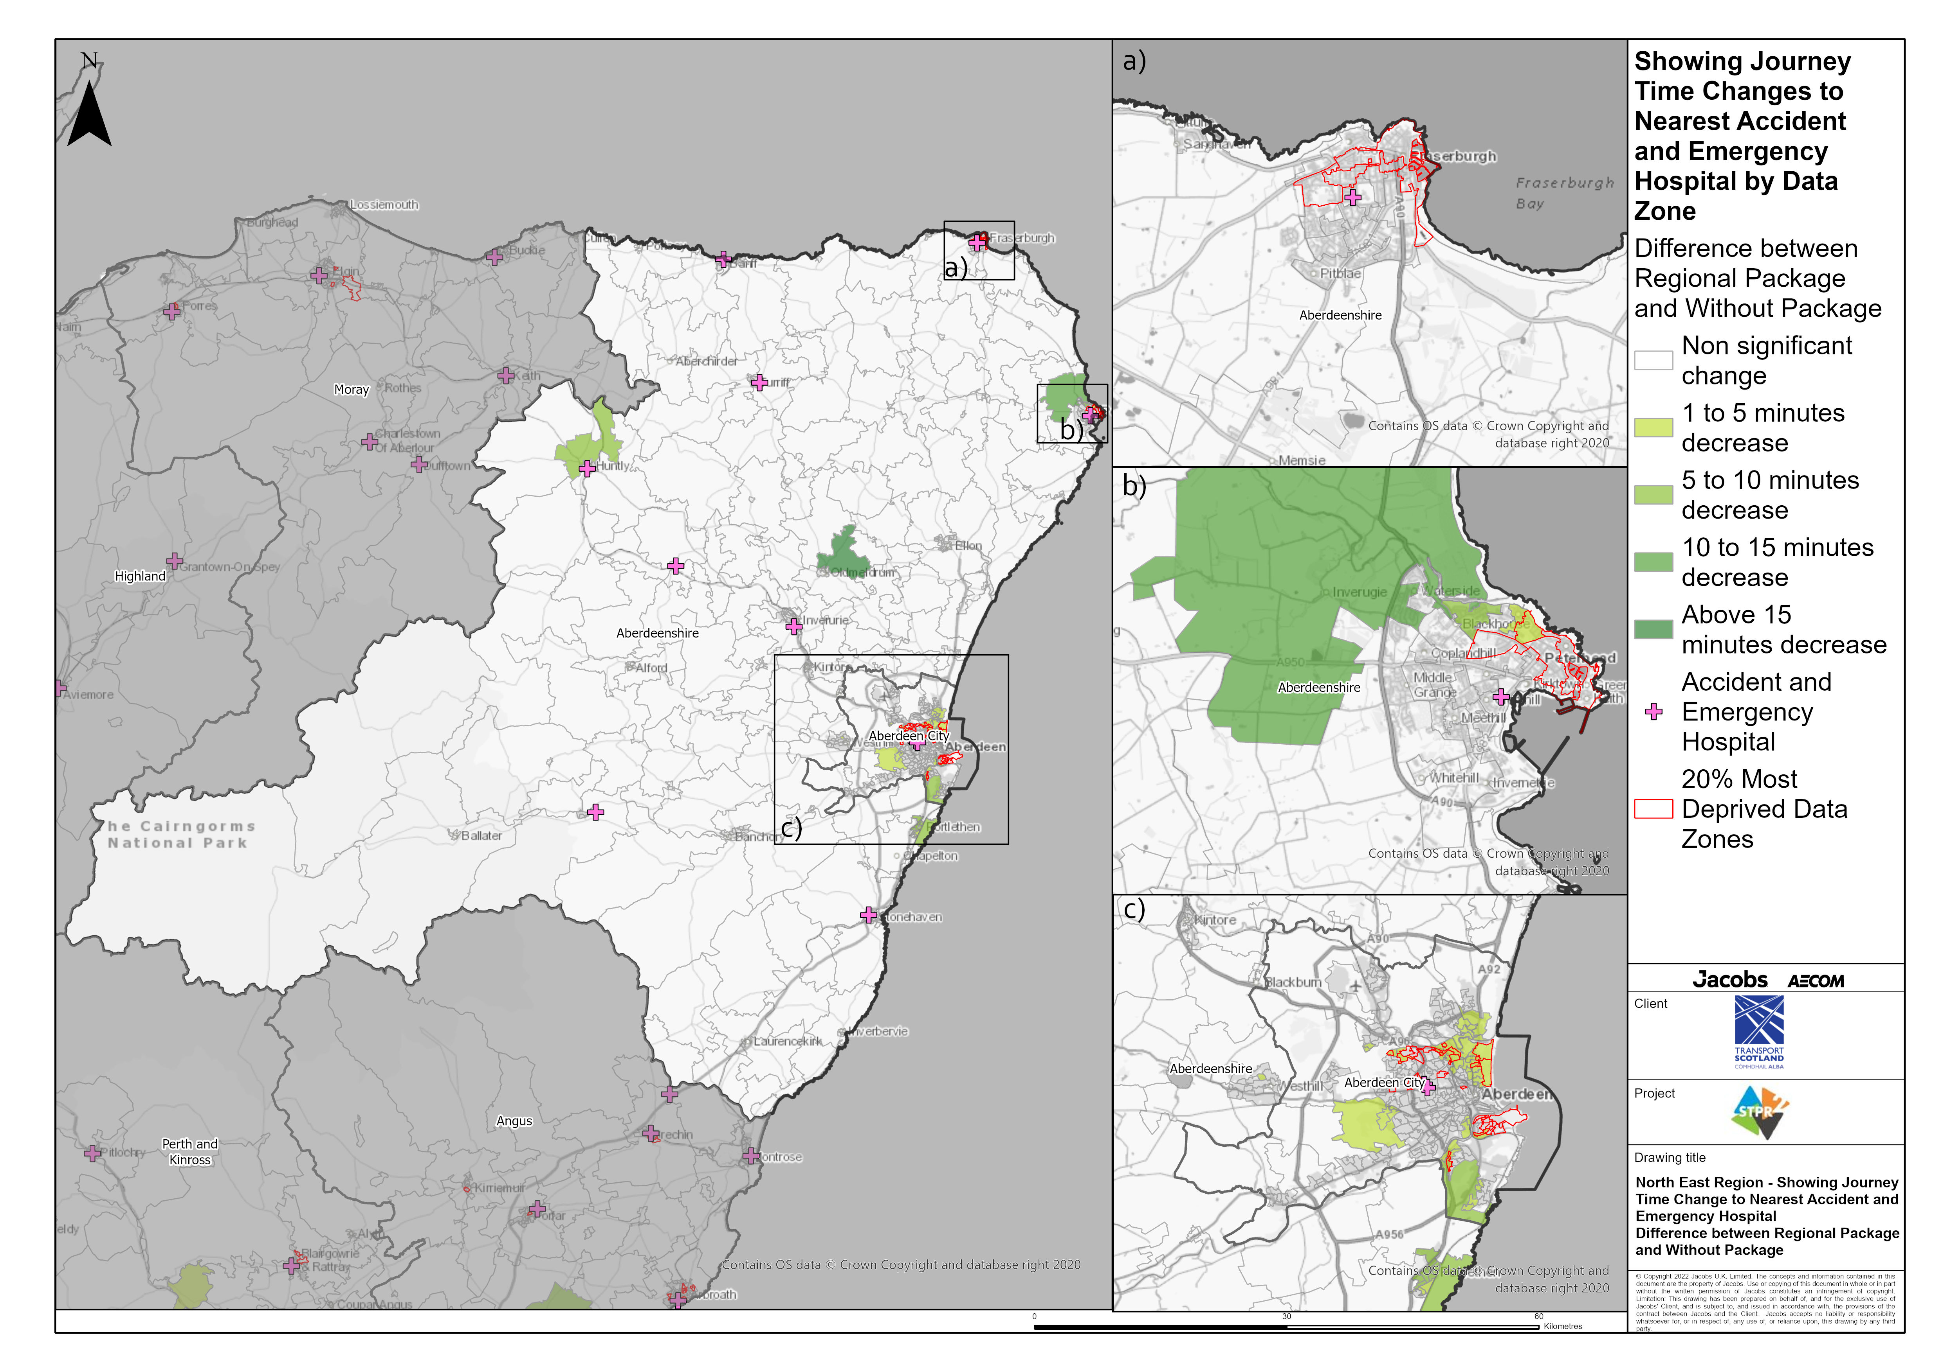
North East Region – Showing Journey Time Change to Nearest Accident and Emergency Hospital Difference between Regional Package and Without Package
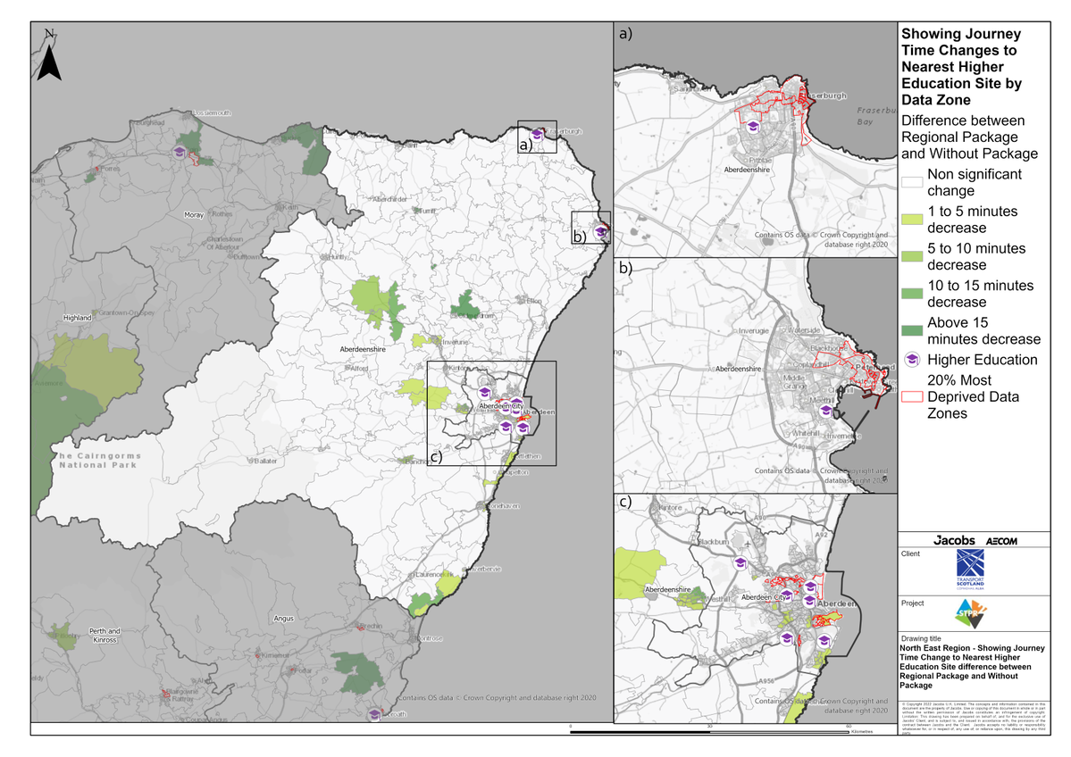
North East Region – Showing Journey Time Change to Nearest Higher Education Site Difference between Regional Package and Without Package
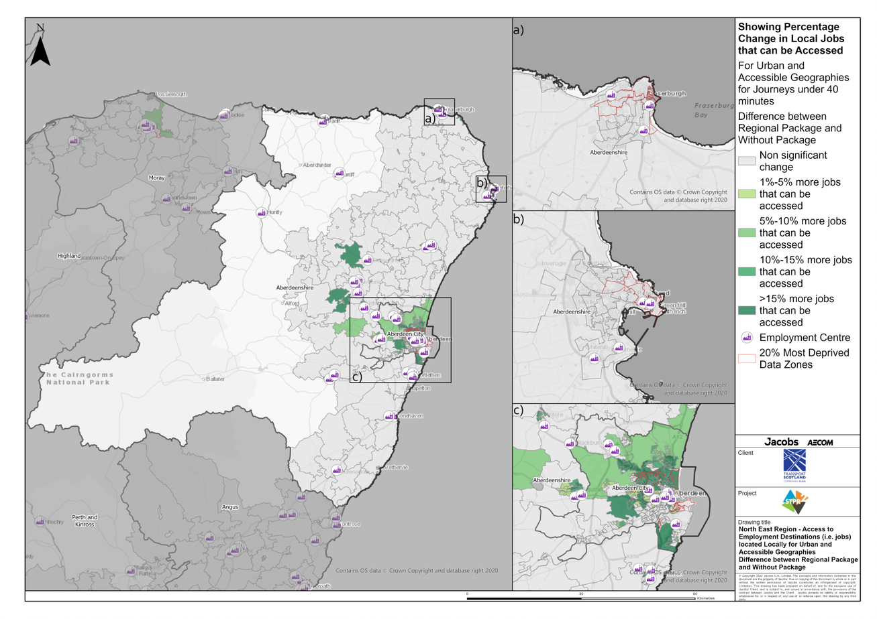
North East Region – Access to Employment Destinations (i.e. jobs) located Locally for Urban and Accessible Geographies for journeys under 40 minutes Difference between Regional Package and Without Package
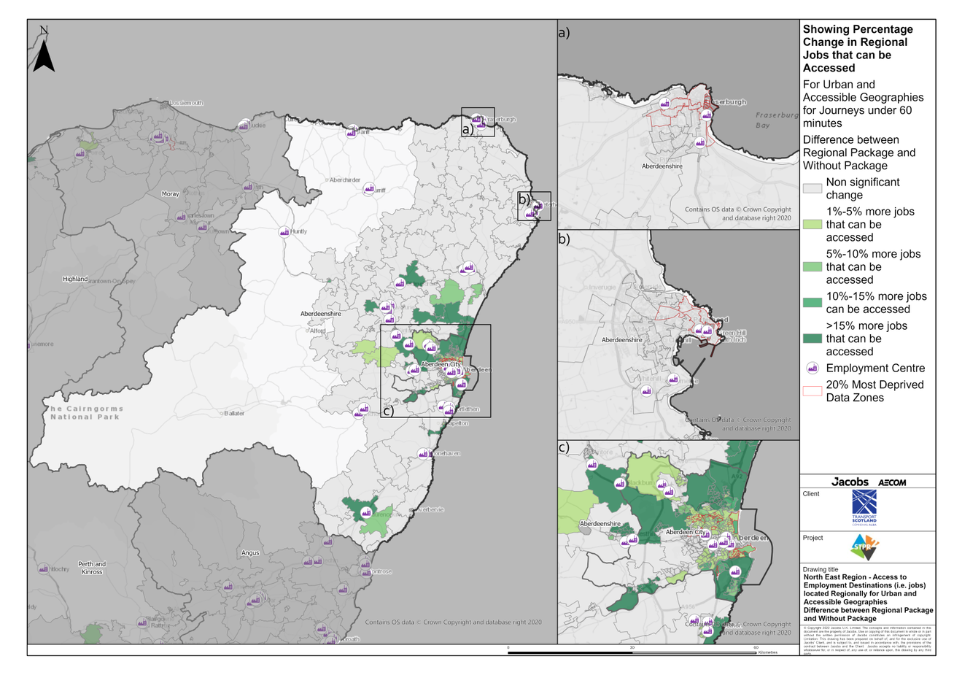
North East Region – Access to Employment Destinations (i.e. jobs) located Regionally for Urban and Accessible Geographies for journeys under 60 minutes Difference between Regional Package and Without Package
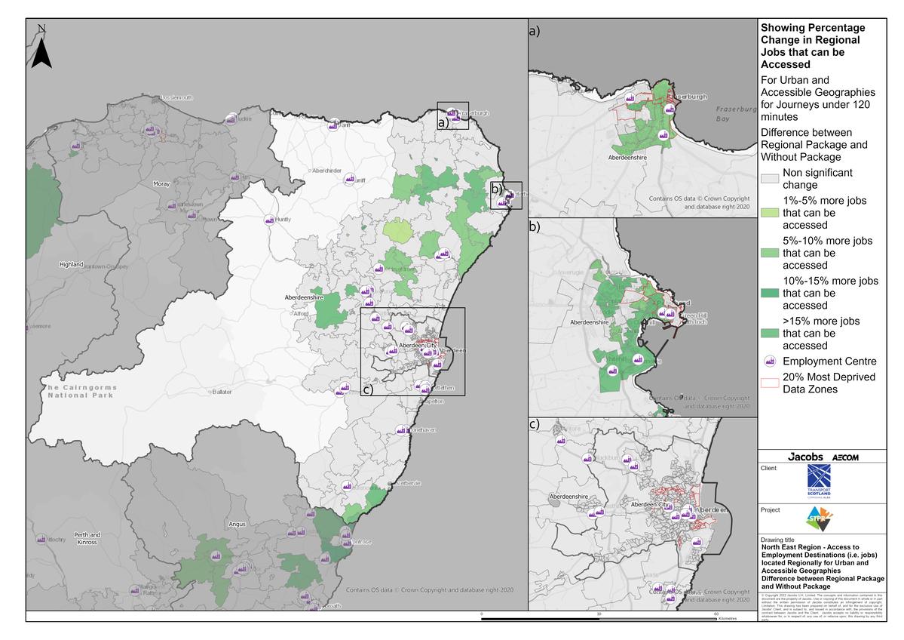
North East Region – Access to Employment Destinations (i.e. jobs) located Regionally for Urban and Accessible Geographies for journeys under 120 minutes Difference between Regional Package and Without Package
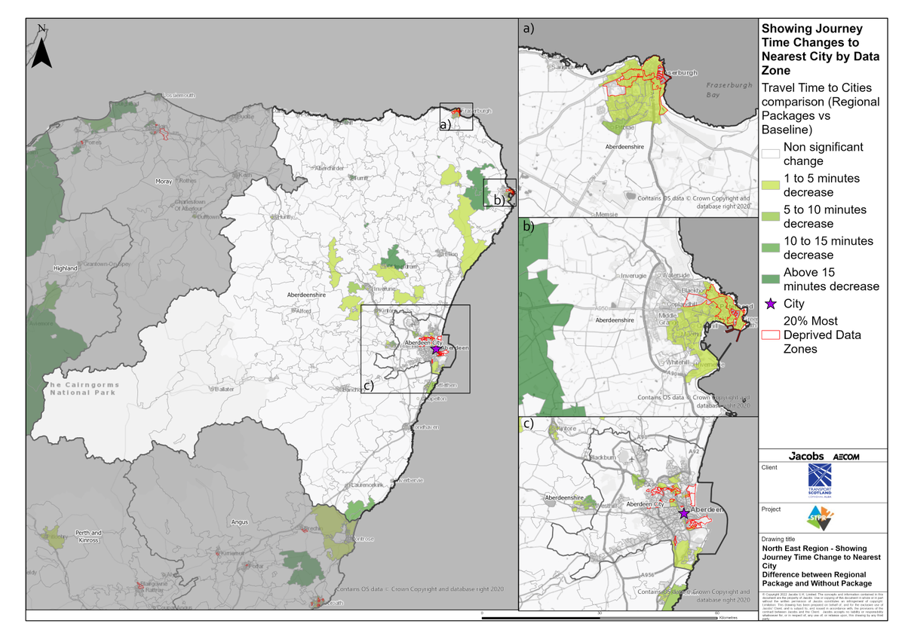
North East Region – Showing Journey Times Change to Nearest City Difference between Regional Package and Without Package
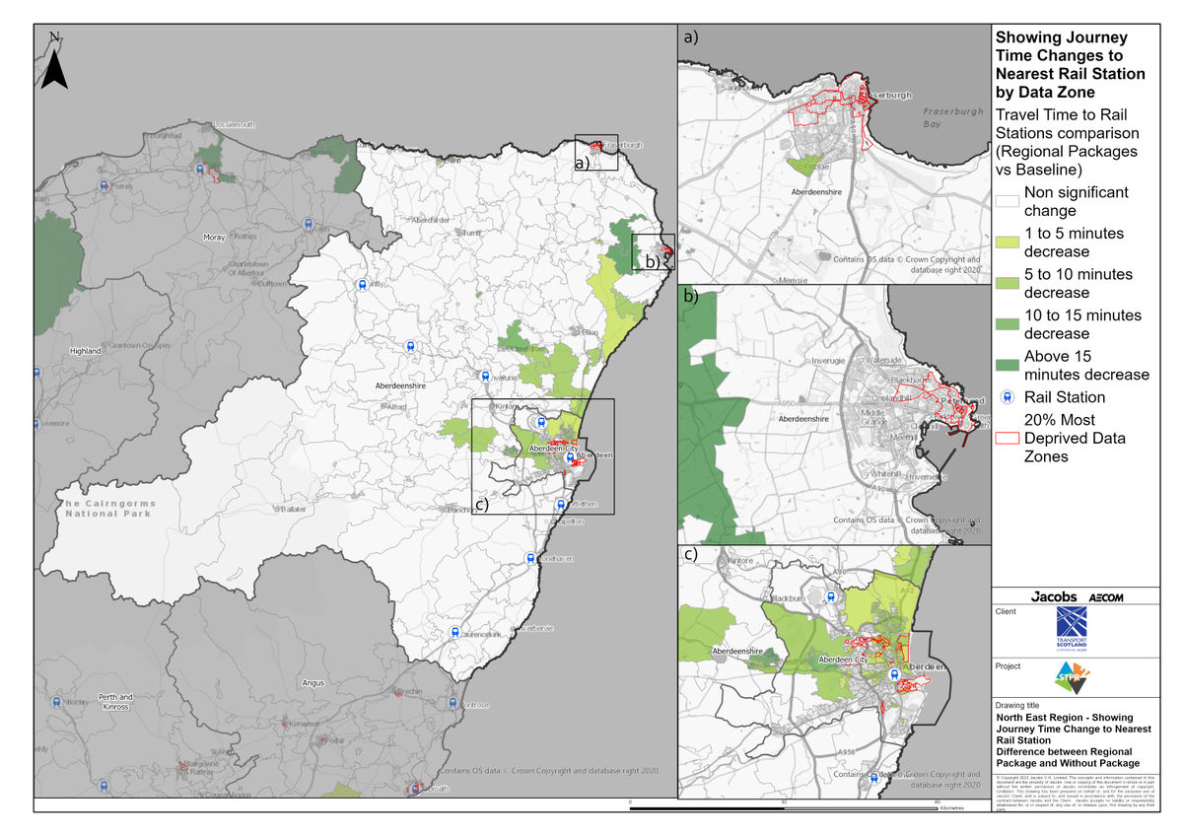
North East Region – Showing Journey Times Change to Nearest Rail Station Difference between Regional Package and Without Package
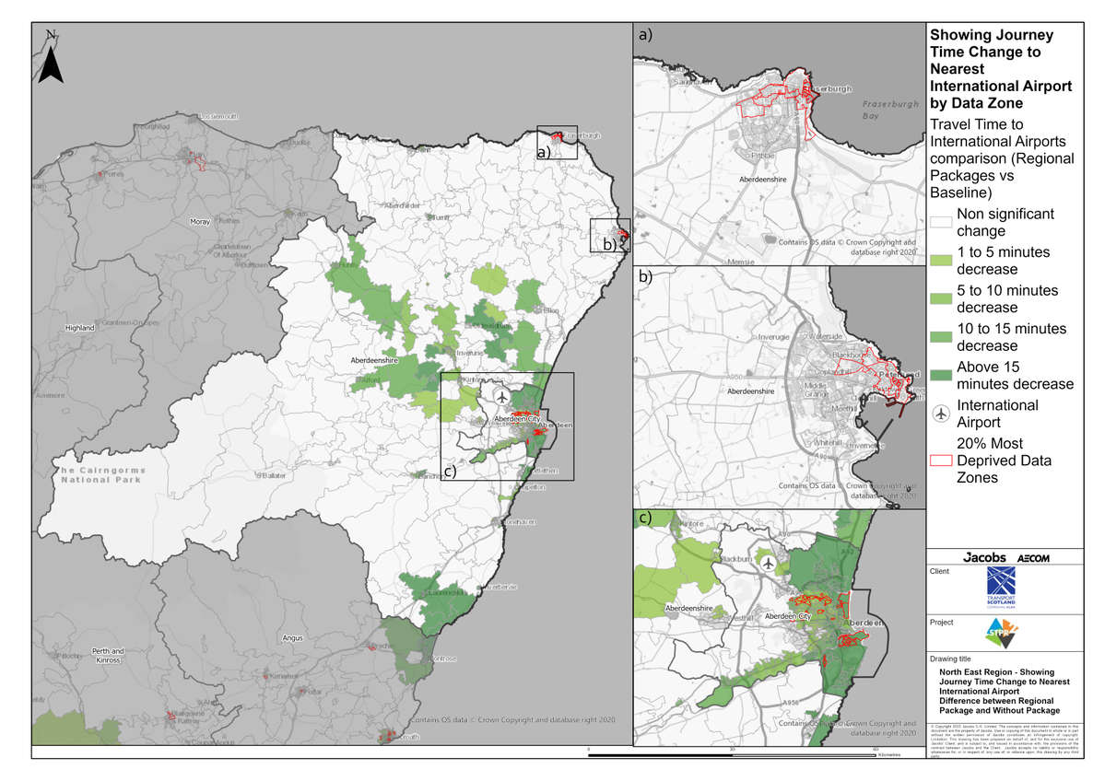
North East Region – Showing Journey Times Change to Nearest International Airport Difference between Regional Package and Without Package

Annex B: Traffic Modelling Outputs
NOTE – Aberdeen Western Peripheral Route is included in the forecasts from 2019 onwards. This is a contributing factor to falls in vehicle kilometres from 2018, under both Low and High scenarios.

