
Respondent information form

This form must be completed and returned with your response.
To find out what we do with your personal data, please see our Privacy Policy


Are you responding as an individual or an organisation?
Individual
Organisation

Full name or organisation’s name:

Phone number:

Address:

Postcode:

Email:

Are you responding as a:

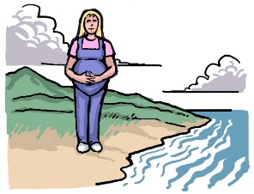
NIFS network resident – Orkney
NIFS network resident – Shetland
NIFS network user – Scottish Mainland
NIFS network business – Orkney
NIFS network business – Shetland
NIFS network visitor or tourist
Other (i.e. responding on behalf of a group)

If you are a business, please tell us what kind of business in the box below:

If you selected other, please give details in the box provided below:

What route in the network do you use most frequently?
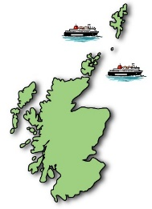

Aberdeen to Lerwick
Aberdeen to Kirkwall
Kirkwall to Lerwick
Scrabster to Stromness

Why do you mainly use ferry network services?

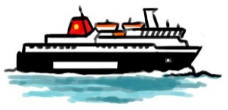
For Business
For Work/Education
For Personal/Leisure
For freight
All of the above
Other

How often do you use ferry services?

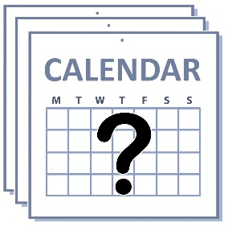
5-7 times a week
2-4 times a week
Once a week
Once every other week
Once a month
Occasionally
Seasonal (Summer Period)
Other

Are you:

Under 16

16 to 18
19 to 21
22 to 34
35 to 44
45 to 54
55 to 64
65 or over
Other

Do you have a disability?
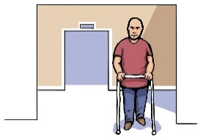
Yes
No

The Scottish Government would like to publish your consultation response. Please tell us what you want us to do:
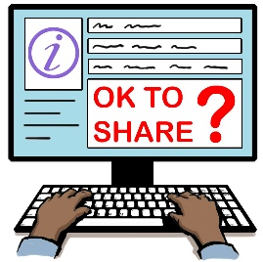
Publish response with name
Publish response only (without name)
Do not publish response

We will share your response with other Scottish Government departments who are working on these issues. They may want to contact you in the future but we need your permission for this. Are you happy for Scottish Government to contact you again about this consultation?

Yes
No

Information for organisations:
The option 'Publish response only (without name)’ is for individuals only. If this option is selected, your organisation name will still be published.

