Inclusive design guidance for town centres and busy streets

Tell us what you think

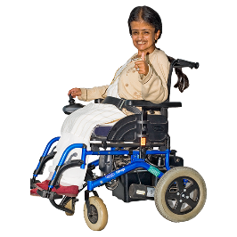
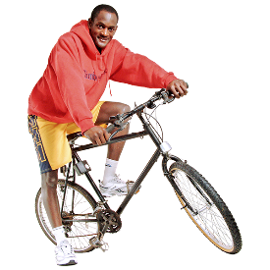
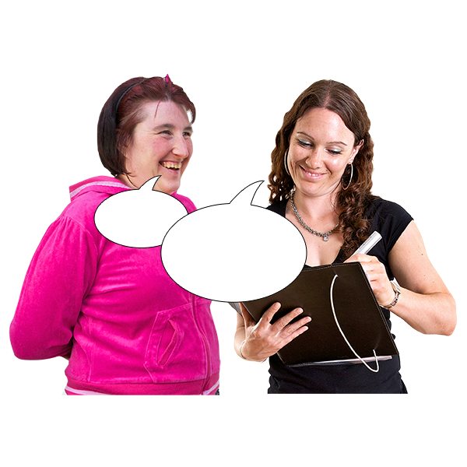

Copyright images © Photosymbols. Prepared by Disability Equality Scotland

Introduction
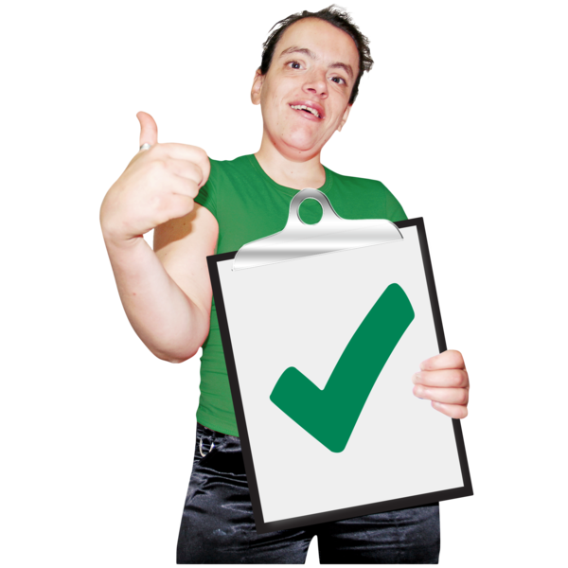 | Inclusive design means making sure that town centres and busy streets are planned:  - so that everyone can use them  - so people feel safe and confident when using them
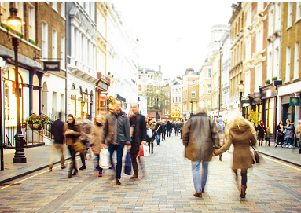 | Busy streets:  - are:  - shopping streets  - areas with a public service building like a school or hospital  - have more traffic than other areas including public transport
We must encourage people to walk, wheel and cycle rather than use their cars.

We must still let people who have to use their cars or taxis use busy streets.

In January 2022 the Highway Code changed to remind all road users that people who walk or wheel may have sight loss, hearing loss or difficulties when moving, and that this may not be clear.

The Highway Code is a set of rules for road users.

Inclusive Design Working Group
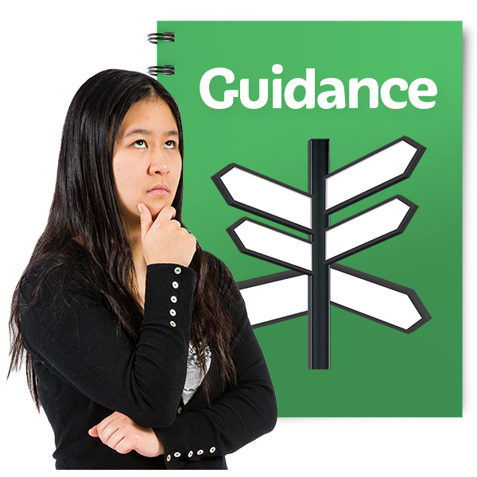 | Draft means it is not the final version.  This draft guidance was made by a working group with a wide range of interests and knowledge about inclusive design in town centre and busy street environments.  The working group will:  - look at the information given to this consultation  - make the final guidance document

How the guidance can be used
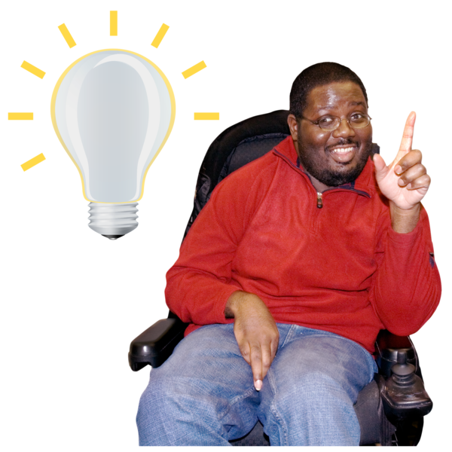  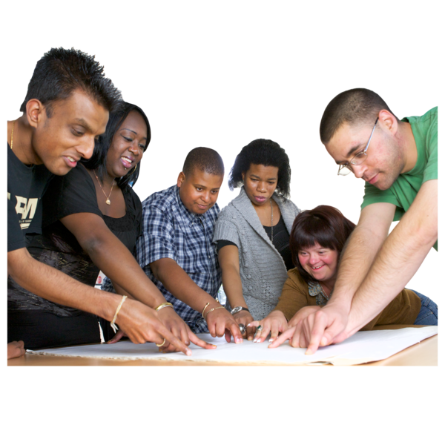 | This guidance is for people:  - planning inclusive spaces  - who need information about:  - how to ask people what they think about a project  - equality duties – treating people fairly  - design features  - who use town centres and busy streets  - who are interested in new street design projects
Principles are what we believe in and how we want to work.

Tell us what you think about each principle in the ‘type your answer here’ spaces.

The space will grow as you type.

Save a new version of this document with your answers in it, then email it to: accessibletravel@transport.gov.scot
by date 29 March 2024.

Part 1 - Inclusive Engagement for Street Design

Principle 1 – Why? The need for engagement.
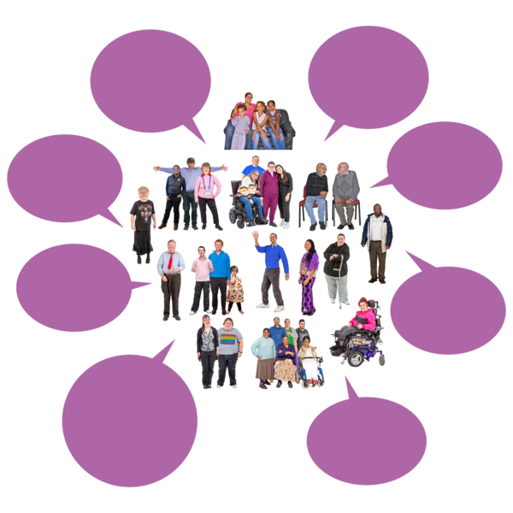  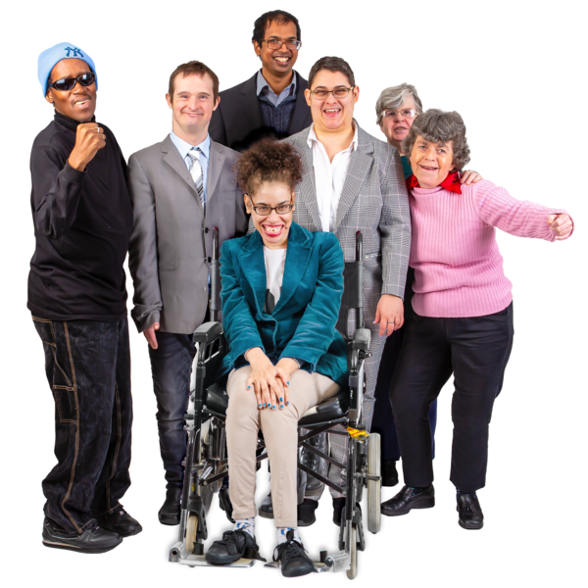 | Engagement means communicating with people to find out what they think and what their experiences are.  We need to:  - listen to and understand what a community needs  - respond to comments and views  Public bodies – organisations that provide public services - must follow:  - the Equality Act 2010  - the Public Sector Equality Duty  People with protected characteristics must be treated fairly.

Please tell us what you think about Principle 1 and what it is trying to make happen.

Type your answer here:

Principle 2 – When?

There must be early and continuing engagement.

Engagement should:

- start when the project is first planned

- continue as the project is built

- include an evaluation of the project when it is finished

We must think about accessibility all the way through the project.

Please tell us what you think about Principle 2 and what it is trying to make happen.

Type your answer here:

Principle 3 – What?

All materials and language used should be accessible.
The ways we ask people what they think and the words we use must be accessible and follow this guidance.

People must have enough time to understand the information before they answer.

Please tell us what you think about Principle 3 and what it is trying to make happen.

Type your answer here:

Principle 4 – How?

You must engage with the people, local communities and groups who use, or may use a place.

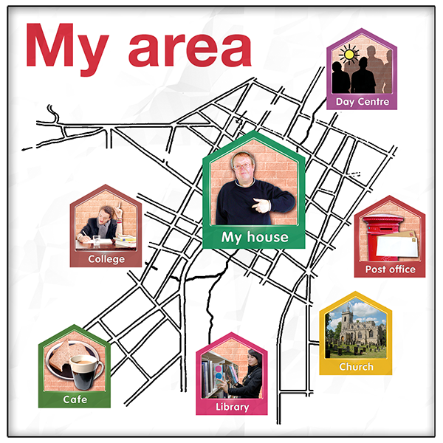  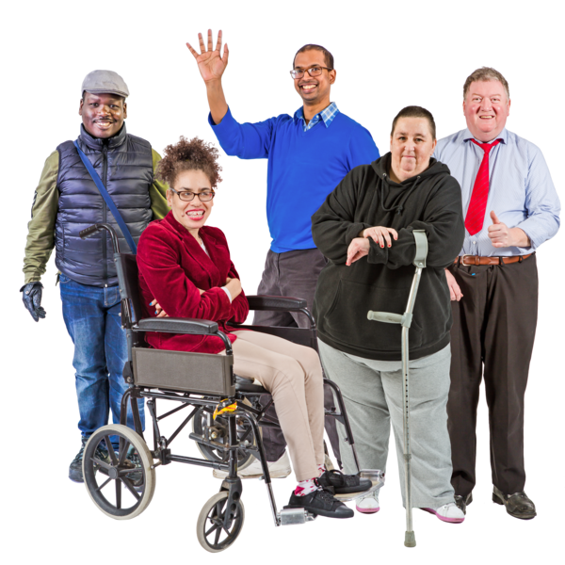 | It is important to include:  - the people who live, work, visit or travel through a place  - national organisations that work for or want inclusion and accessibility  - local Access Panels
Please tell us what you think about Principle 4 and what it is trying to make happen.

Type your answer here:

Principle 5 – Where?

The engagement should be in places where it is easy for all parts of the community to attend.

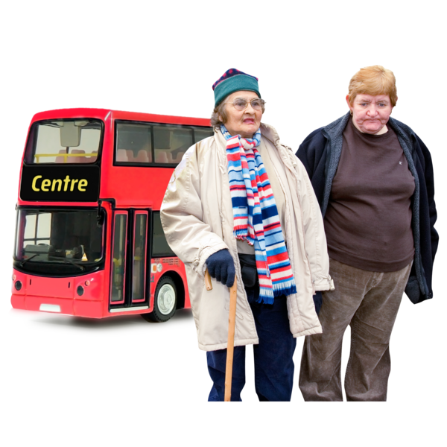 | Engagement should be:  - in accessible places at times that suit local people  - at times when people can use local accessible transport

The 7 National Standards for Community Engagement

Inclusion
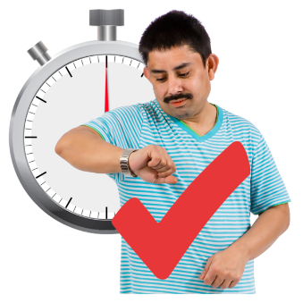  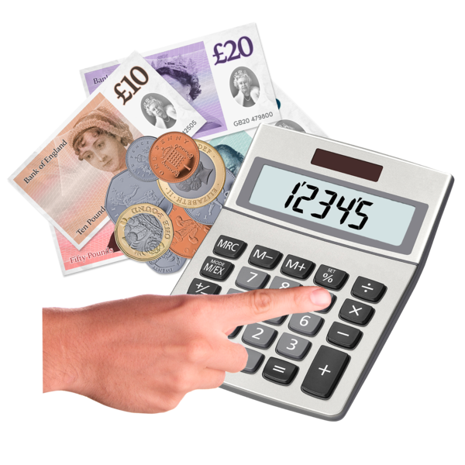 | We will involve people and organisations that are affected by the project.  For street design:  Engagement needs to:  - have enough time and money  - start when the project is planned  - happen at each stage of the project until it is finished
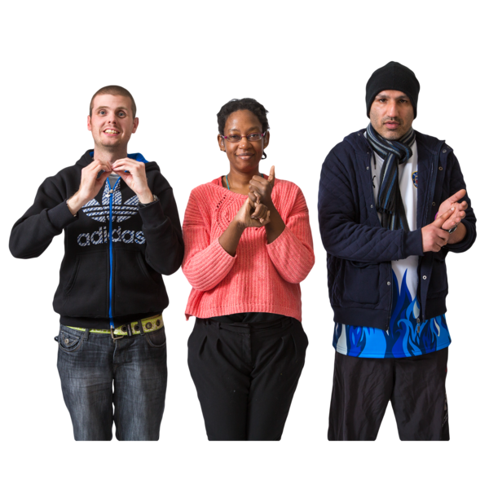 | All communications should be in accessible formats and should reach as many groups as possible.
Support
We will find and change any barriers that stop people taking part.

For street design:

There must be a wide range of ways for people to give their ideas and opinions, including:

- friendly and welcoming events on the street
- online engagement

- individual meetings

Planning
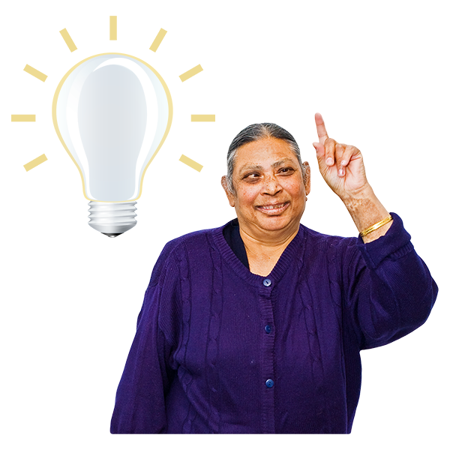 | It must be clear what the engagement is about.  It must be based on understanding what the community needs and wants.
For street design:

There should be a timetable setting out when engagement will happen.

Any changes to design that has been agreed needs more engagement.

All engagement should check accessibility.

Working Together
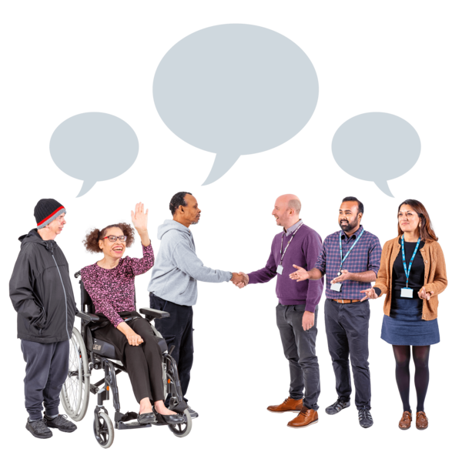 | We will work well together to make the engagement happen.  For street design:  A project plan should:  - be clear about who is responsible for what work  - include all stages of the project  - be shared with the people and groups delivering the project

Methods
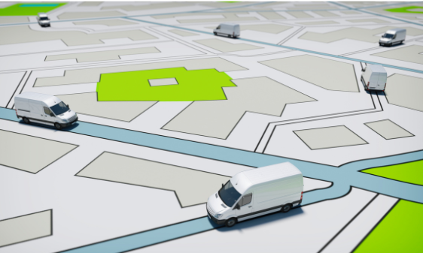 | We will engage with people in ways that are right for them.  For street design:  It is important to have:  - maps, images or models of the street  - material samples that should be checked in different weather conditions
 | - site visits at different times of day and in different lighting conditions to make sure the design and materials are suitable

Communication
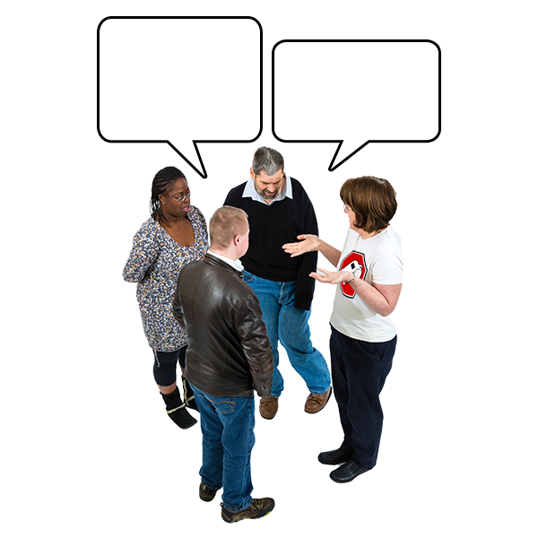  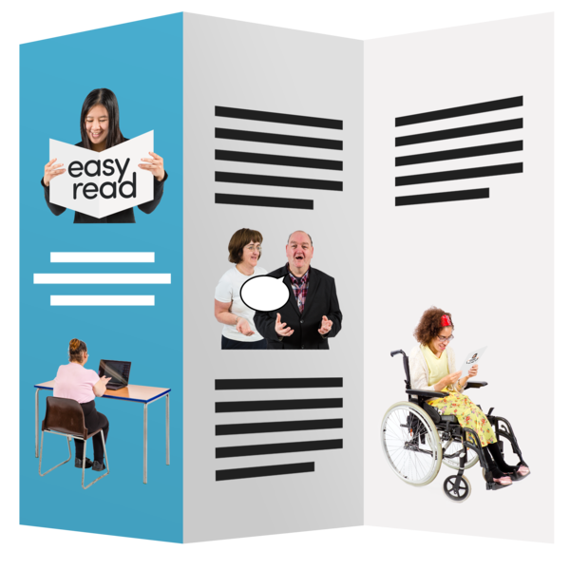 | We will communicate clearly and regularly with the people, organisations and communities affected by the project.  For street design:  All engagement materials must:  - be accessible – including websites and published materials  - suit the different ways people communicate  Different formats must be provided as quickly as possible when they are asked for.

Impact – what difference is it making?
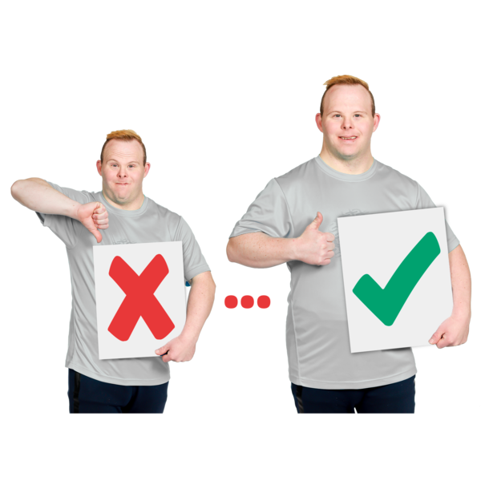 | We will check the impact of the engagement and use what we have learned to make it better in the future.
For street design we will keep records that show:

- how we have listened to people’s ideas and information and included it where possible in our plans

- how the design has developed

- how rules and laws have been followed

Please tell us what you think about Principle 5 and what it is trying to make happen.

Type your answer here:

Part 2 - Physical design measures for inclusive design
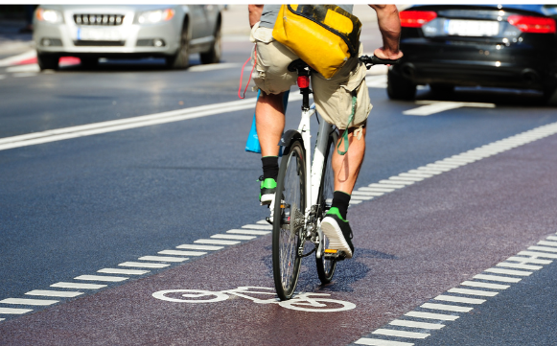 | Design that separates people walking and wheeling from cycles and vehicle routes are good for everyone.
 | Walking and wheeling are the most important, followed by cycling, public transport, taxis, and shared transport with private cars.
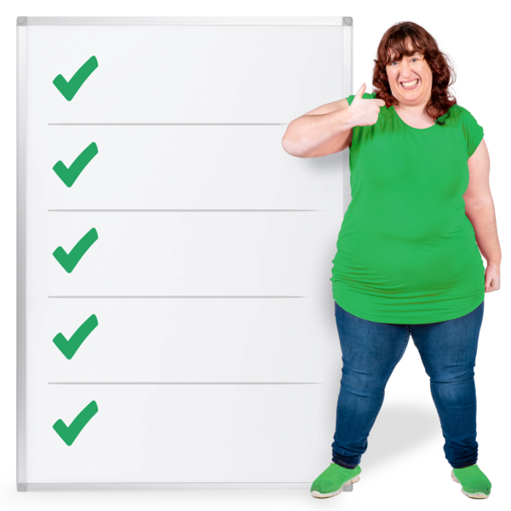  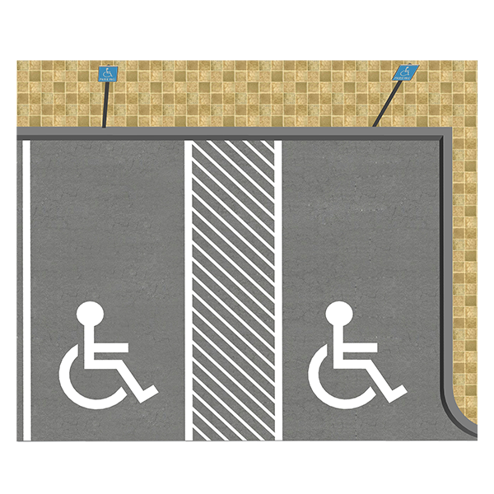 | Street design should be accessible for everyone.  The needs of disabled people should be taken into account, like disabled access and accessible parking.  The next 5 principles and key considerations support inclusive design.  Key considerations are the most important things.

Principle 6 – Good separation between user areas

Good separation between pedestrian, cycle and vehicle zones makes people feel confident and safe.

Key Considerations

The separation of pedestrians, cyclists and vehicles supports access for all street users, particularly those with disabilities.
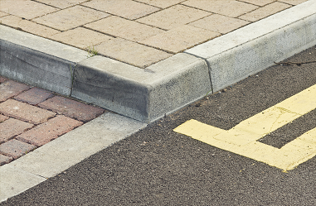 | Most street users like there to be a kerb because:  - it separates the space for walking and wheeling from the cycle and motor vehicle space  - it helps people to feel more confident and safer and it is more accessible
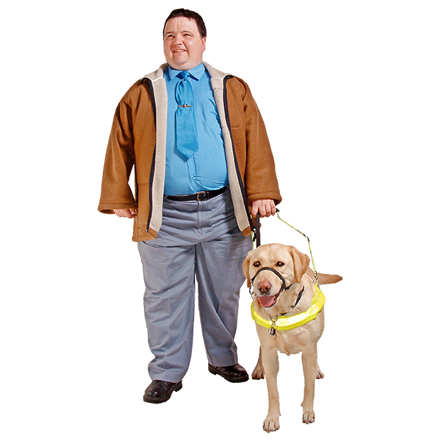 | Kerbs should be at least 60 millimetres above the road so they can be noticed by blind and partially sighted users and assistance dogs.
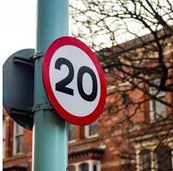  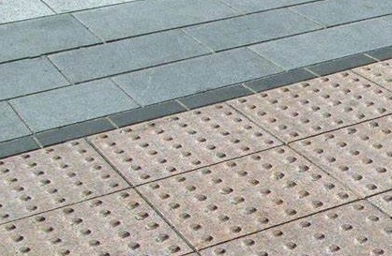  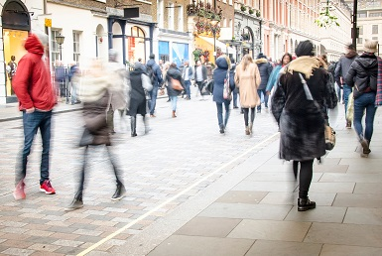 | A level surface street has no kerbs.  It uses tactile paving to separate the pedestrian space from motor traffic.  Tactile paving is a type of pavement that has raised patterns or textures to help visually impaired people get around.  A level surface street should only be considered:  - after asking local people what they think, especially disabled street users including visually impaired people  - in areas where there is not much traffic and the speed limit is low
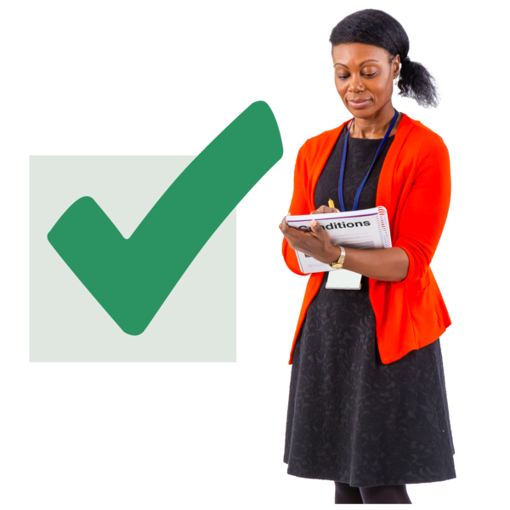 | The reasons for using it must be recorded in the Equality Impact Assessment.  Equality Impact Assessments will show what changes have been made to support access for disabled street users.

Please tell what you think about Principle 6 and what it is trying to make happen.

Type your answer here:

Principle 7 – Clear pedestrian corridors and footways

Pedestrian corridors and footways should be clear and wide enough for people to use them confidently and safely.
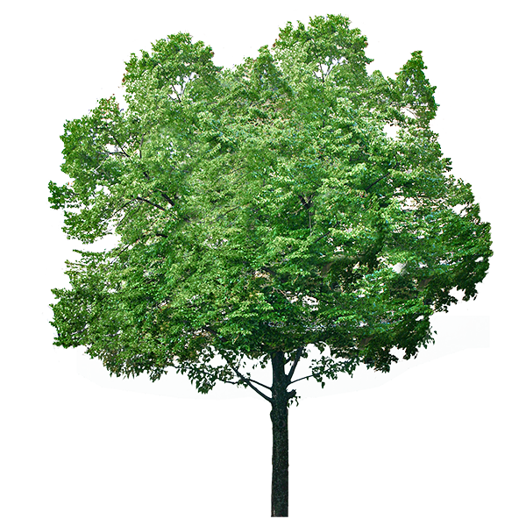  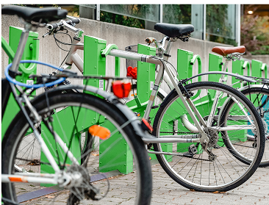  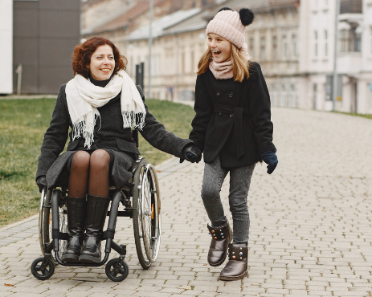 | A pedestrian corridor is the space for people to walk and wheel.  Pedestrian corridors in town centres and busy street areas should be free from things that would get in the way of people walking and wheeling, like:  - litter bins  - benches  - trees  - café seating  - cycle parking  A clear pedestrian corridor should be at least 2 metres wide.
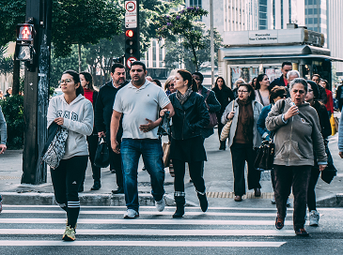 | A wider pedestrian corridor should be considered where there will be a lot of people walking or wheeling - for example, at transport hubs and busy crossing points.
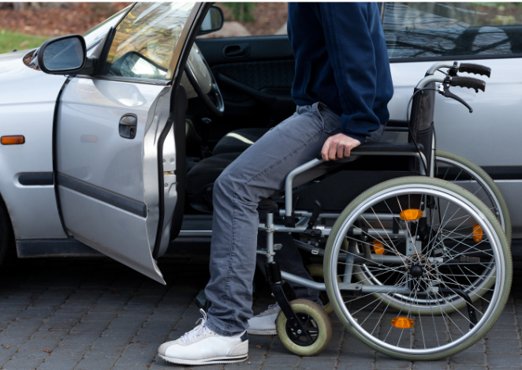 | Pick-up and drop-off areas are important for disabled street users.
 | There should be clear signs and different types of accessible benches and seating outside the pedestrian corridor to give people places to rest.
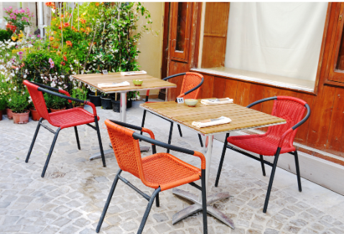 | Pavement cafés should be next to the front of the café building and must not be in the pedestrian corridor.  Screening around pavement cafés should:  - be around 1 metre high with no sharp edges  - be a different colour from the background
- go down to the ground or have a drainage gap small enough that a roller ball on a long cane would not get stuck

Get local guidance from the local planning and roads authorities.

Please tell us what you think about Principle 7 and what it is trying to make happen.

Type your answer here:

Principle 8 – Crossings

Most street users prefer signal-controlled crossings because they give people control and make them feel confident to cross.

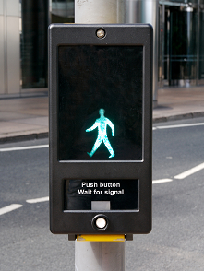 | Key Considerations  All crossings in town centres and busy streets should be accessible and support safe use by all street users.  Crossings must follow laws and guidance, including the Traffic Signs Regulations and General Directions 2016 and the Traffic Signs Manual
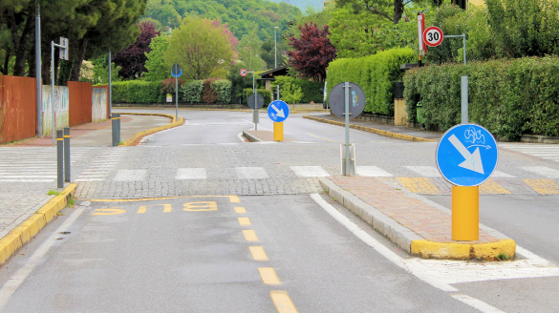 | Staggered crossings have an island in the middle and may be needed where people cross more than 1 traffic lane.  People walking and wheeling must have:  - space to pass at the island  - time to cross safely
Please tell us what you think about Principle 8 and what it is trying to make happen.

Type your answer here:

Principle 9 – Materials

The design of pavements and other street features should consider colour and how easily they can be seen in all weather and light conditions.
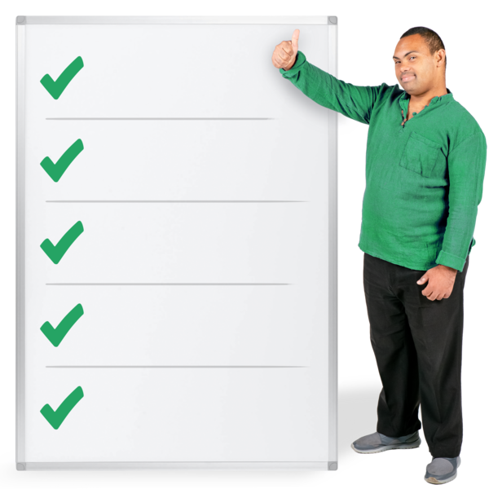 | Key Considerations  Materials used must:  - support accessibility and safety  - be good quality and last for a long time  - not be reflective as the glare can be difficult, especially for people with a visual impairment
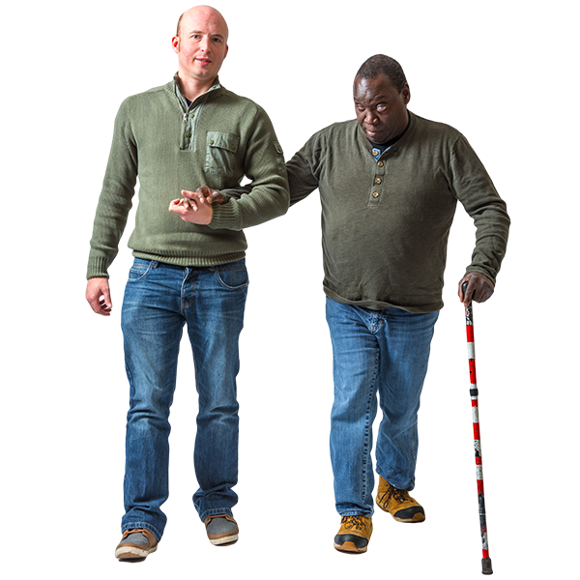 | Plans should think about:  - how landscaping will be looked after and how maintenance will be done  - how access can be given when work needs to be done in the area  - how easily the surface can be repaired  - features that support navigation – things that support visually impaired people to move around  Temporary repairs should not last for more than 6 months.

Please tell us what you think about Principle 9 and what it is trying to make happen.
Type your answer here:

Principle 10 – Consistency in Design

Busy streets support access for all street users and make them feel safer and more confident.

Key Considerations

Each project must be the right design for each area.

Trying out an idea for a short time can help gather information to make the design better.

A finished project can be checked by:

- road safety audits by local councils

- an accessibility assessment by Access Panels, Access Officers, or someone from the National Register of Access Consultants

Evaluation questions for the end of a project include:

- how well does the design work?

- does it do what it needed to do?

- is it accessible for disabled people?

- do people feel safe in the area?

Please tell us what you think about Principle 10 and what it is trying to make happen.

Type your answer here:

If you have anything else you want to tell us about this consultation, please type them here:

Copyright images © Photosymbols. Prepared by Disability Equality Scotland

